Distributed File System
CS 425 MP1
Jon Tedesco – Ben Sommer – Ron Searl
tedesco1 – sommer3 – searl1
Design
Our design was highly decoupled and intended to be easily extensible to support multiple server failures, rapid file requests, and asynchronous communication between the load balancer, client, and servers. We based our high-level design closely on the sample architecture given in the handout, but made strategic design decisions to improve the system.
To begin our process of design, we drafted a high-level architecture of the system, including responsibilities of each set of processes, and an outline of the communication between them.
The first draft our design is shown below:

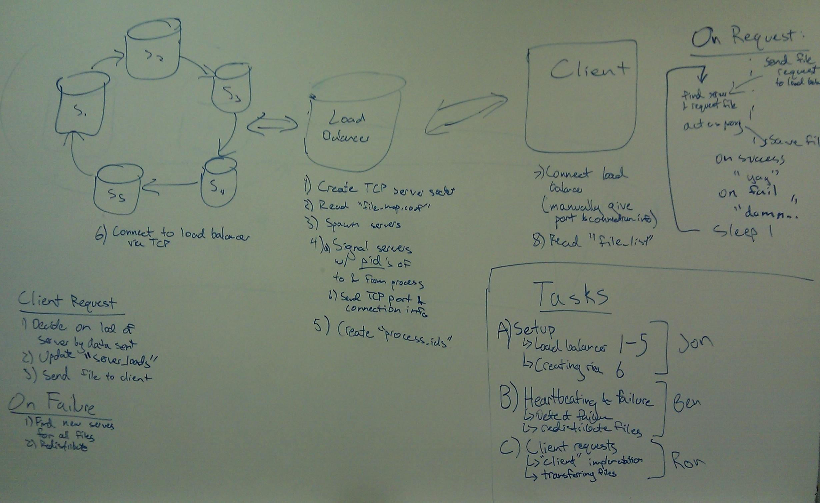
The highlights of our design were:
- Asynchronous communication through load balancer using multi-threaded control mechanisms and shared data structures for file requests, server data, load data, and failure notification
- A fully decentralized, efficient failure detection scheme using TCP sockets for heartbeating
- A ring of n servers that use heartbeating, in one direction only, to detect failures using O(n) messages for failure detection, typically in less than one second
- Improved performance using thread blocking system calls and careful concurrency control

We divided the responsibilities of the logical components of the project as follows:

Load Balancer
- Spawn threads to listen for client transfers, listen for failure notifications, and fulfill file requests from the client
- Parse file_map.conf and initialize data structures to monitor server loads
- Fork all server processes, provide connection data for connecting with the load balancer, and provide data to each server for creating the heartbeating ring
- Initialize process_ids to create an external record of the server pool
- On receiving request, enqueue the request
- Asynchronously, whenever an item is in the queue, contact the server pool for a file and transfer the file to the client
- On detecting a server failure, redistribute the files and update the data structures to recover
Server
- Launch failure detection thread to listen for heartbeating from previous server in the ring, and notify load balancer if heartbeating ceases or TCP connection closes
- Launch failure protection thread to send heartbeats to the next server in the distributed ring
- Sleep, waiting for file requests
Client
- Repeatedly sleep and send requests to load balancer
- Asynchronously listen for responses from file system, and output files as they are received
Data Structures
- Server connection data
- Server load records
- Server lookup data
- Request queue
- Concurrency control structures

Overall, we put an emphasis on asynchronous, efficient communication between the servers, load balancer, and client, using parallel programming and our algorithm design to improve performance.
To maintain a failure detection system, we used a heartbeating scheme in with a logical ring containing the processes of the server pool.
Throughout our implementation, we assume that each of the servers, load balancer, and client, have no means of communication beyond common network protocols. Our implementation uses TCP exclusively for all interprocess communication. This design choice makes our implementation relatively easy to scale to a network of computers, not necessarily connected via LAN.

Load Balancing Scheme
To balance loads between servers in terms of file requests, we keep track of the load in terms of the number of bytes transferred. Specifically, we maintain an array of integers, where each entry corresponded to a particular server, indexed by the server id, and the value at each entry represents the number of bytes that have been transmitted in the lifetime of the server.
When a new file request arrives at the load balancer, we use a hash table indexed by file paths to find the list of servers that have a copy of the given file. The load balancer then requests the file from whichever server has served fewer bytes during its lifetime.
We decided to use this scheme, because we believe the amount of actual data sent by a server is a more accurate gauge of its load than the sheer number of requests that it has received.
However, this load is also affected by the number of files at each server. Since this does not change unless a failure occurs and the files a redistributed, we ignore this aspect until we redistribute the files.

Failure Recovery
For handling file redistribution during failure recovery, we implemented a relatively interesting algorithm to redistribute the files that takes into account both the load in bytes of each server and the number of files on each server.
Specifically, we formed a goal number of files for each server, i.e. an ideal number of files that each server should have, based on each server's number of files currently stored and the amount of data that has been sent by the server during its lifetime.
The goal formula is given by:
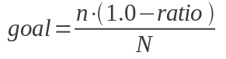
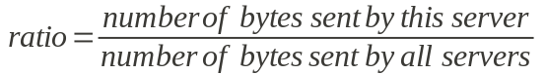
This formula thus first computes the relative usage of each particular server, using the ratio calculation, and then computes the number of estimated number of files that each server should have by multiplying one minus this ratio by the ratio of number of files we need to redistribute to total number of servers. This gives us an inverse relationship between the data load of each server and the number of files it should take, which is precisely the relationship we should try to achieve.
This heuristic intentionally favors the number of files per server, because we want to ensure that each server contains a roughly equal portion of the files. However, we can improve this calculation using the history that we already have for each server, i.e. the past load of each server.
Through our testing, this heuristic consistently divided the files fairly, and correctly took into account the history of file accesses.

Efficiency
Our implementation consistently detects failures using interprocess communication between the servers, and notifies the load balancer within ten seconds of a failure.
To ensure timely detection of process failures, each server heartbeats to one server, and receives heartbeats from another, forming a simple heartbeating ring. This implementation seemed the most straightforward and lightweight implementation to accomplish our goal. Additionally, each server checks if it has received a heartbeat once every second.
A failure is detected when one of the following occurs, whichever happens first:
- A heartbeat is not received after four seconds
- The TCP connection for heartbeats is closed when a server checks if any heartbeat has arrived
- This is typically what triggers failure detection, because a process should close its connection to all other processes when it crashes. The failure is detected instantly upon checking for a heartbeat if it is detected in this way.
Therefore, in the worst case, a failure is detected in four seconds. However, in the average case, a
failure is detected in half a second. Upon failure detection, the load balancer is immediately notified, and the files are redistributed.

Experiment 1
For this first experiment, we assume that there was no server error, and let the client run for sixty seconds, making sixty requests to the file system.
Ultimately, the server_loads file looked similar to the following:
Request | Server 0 | Server 1 | Server 2 | Server 3 | Server 4 | Server 5
1  .  .  .  60 | 0 | 0 bytes  .  .  .  15 | 375245 bytes | 1 | 44277 bytes  .  .  .  8 | 210212 bytes | 0 | 0 bytes  .  .  .  7 | 204424 bytes | 0 | 0 bytes  .  .  .  12 | 268355 bytes | 0 | 0 bytes  .  .  .  4 | 61202 bytes | 0 | 0 bytes  .  .  .  14 | 277401 bytes

So, the average number of files served were 15, 8, 7, 12, 4, and 14, for servers 0-5, respectively. Likewise, the average number of total bytes transferred for the servers were 375245, 210212, 204424, 268355, 61202, and 277401, respectively.
These server loads are not distributed completely evenly because the file requests file did not request files from each server equally. Specifically, the client requested few files that were on servers 1, 2, and 4, as compared with the number of files that were requested on servers 0, 3, and 5. Our load distribution scheme was simply to request a given file from whichever server has the file and has served up fewer bytes during its lifetime.
However, we can tell that the load distribution is working, because we do record all 60 file requests, and ask each server for files repeatedly.
If the load balancer had the opportunity to redistribute the files based on the usage of each server, it would have moved several of the most frequently requested files from servers 0, 3, and 5, to server 4, then fewer to servers 1 and 2. Since we were not allowed to perform this optimization based on server usage, the output above makes sense.

Experiment 2
For this second experiment, we ran our program uninterrupted for thirty seconds, killed server 5, and continued for another thirty seconds.
Again, when our run finished, the server_loads file looked similar to the following:
Request | Server 0 | Server 1 | Server 2 | Server 3 | Server 4 | Server 5
1  .  .  .  29  30  .  .  .  59 | 0 | 0 bytes  .  .  .  3 | 100474 bytes  4 | 129929 bytes  .  .  .  6 | 186479 bytes | 0 | 0 bytes  .  .  .  6 | 173165 bytes  6 | 173165 bytes  .  .  .  9 | 279230 bytes | 0 | 0 bytes  .  .  .  5 | 163796 bytes  5 | 163796 bytes  .  .  .  18 | 526254 bytes | 1 | 2084 bytes  .  .  .  6 | 101333 bytes  6 | 101333 bytes  .  .  .  9 | 190844 bytes | 0 | 0 bytes  .  .  .  6 | 168468 bytes  6 | 168468 bytes  .  .  .  12 | 338576 bytes | 0 | 0 bytes  .  .  .  5 | 131460 bytes  5 | 131460 bytes  .  .  .  5 | 131460 bytes
Note that only fifty nine requests went through during this run, which is a direct result of the single file request sent to server 5 after it was killed. When this request to server 5 propagated to the server pool, server 5 was killed in the time after the client requested this file but before it received a response. However, this error case happens very infrequently, and when it does, we handle it by returning an error to the client.
At thirty seconds into the run, we can see that the servers have served 4, 6, 5, 6, 6, and 5 files respectively, or 129929, 173165, 163796, 101333, 168468, and 131460 bytes, respectively. Clearly, the loads are very evenly distributed between the servers at this point in execution.
Once we kill server 5, as we expected, server 5 is never contacted again, but the usage between servers 0, 1, 2, 3, and 4 remain fairly even. The average file requests served for these four servers are 6, 9, 18, 9, and 12, respectively. Likewise, the average bytes served are 186479, 279230, 526254, 190844, and 338576 bytes, respectively.
Our balancer performed as we expected when one server was killed. When server 5 was killed, the load balancer clearly redistributed its files between severs 0, 1, 2, 3, and 4. The average values for the other servers increased evenly as the final thirty seconds passed.

Division of Labor
Ron
Design, Client, Debugging & Integration
Ben
Design, Server, Debugging & Integration
Jon
Design, Project Setup, Project Writeup, Load Balancer, Debugging & Integration

