Jessica Hall

Module 2.3

CSD200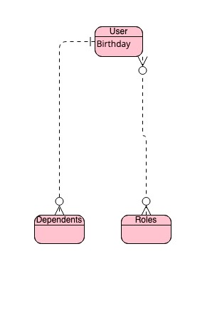

June 5, 2024

{

"UserID": "user1",

"Birthdate": "1999-01-01",

"Roles": [

{

"RoleID": "role1",

"RoleName": "Admin"

},

{

"RoleID": "role2",

"RoleName": "User"

}

],

"Dependents": [

{

"DependentID": "dep1",

"DependentName": "Joe"

},

{

"DependentID": "dep2",

"DependentName": "Antonia"

}

]

}