Justin Ely

ITS 465-MC01

Dr. Umesh Varma

April 12, 2021

**Construction – Twin Peak Billing Software**

**Build and Test Network**

The design of this Access database does not require the construction and testing of a network.

**Build and Test Database**

Managing the Twin Peak Billing Software database is the primary function of record keeping for the business. Simplifying the processes based on the previous two software that were in place was crucial to balancing cash flow in and out. Since the owners of the business considered the software cost too high for managing a small, local gym, creating a solution to member management has led to the following database construction. The testing of the database at this point will include the following: enrolling a new member, cancelling a member, retrieving a report on cancellation and billing, clocking employees in and out, and verifying that all the previous information transfers to the correct tables appropriately. When finished enrolling a new member, the database test was successful with zero errors in the Member Info table. When initializing the test for cancelling a member, it was discovered that the Cancellation Date and Last Bill fields in the Member Cancellation form were not set to Date/Time. This was corrected in the design view of the Member Info table. After the correction, another test was performed, and the cancellation process was successful. Both report retrievals that were being tested came back successful in a well formatted and easy to understand layout. The last test to be conducted was to monitor an employee clocking in and clocking out. Since the form is related to the Employee table, the employee’s time-clock data was transferred and logged successfully for the Accountant and pay purposes. The design of the system did discover a part of the home screen user interface that needed an update. Rather than leaving the Time-Clock button on the main screen, we decided that the employees shall open the form themselves to clock in and out instead of cluttering the Main screen with employee functions.

Test 1 – Enrolling Campbell Camel

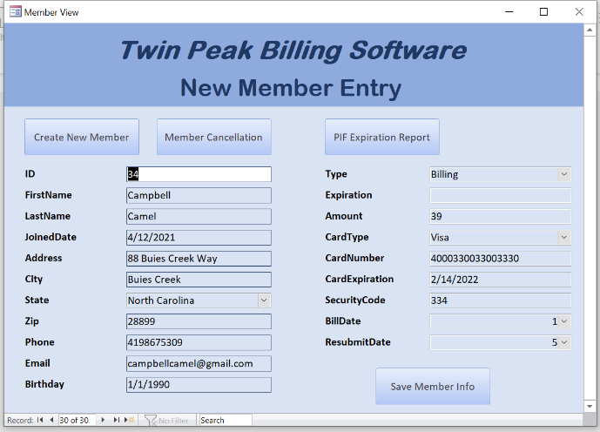

Test 1 – Campbell Camel’s information stored in table

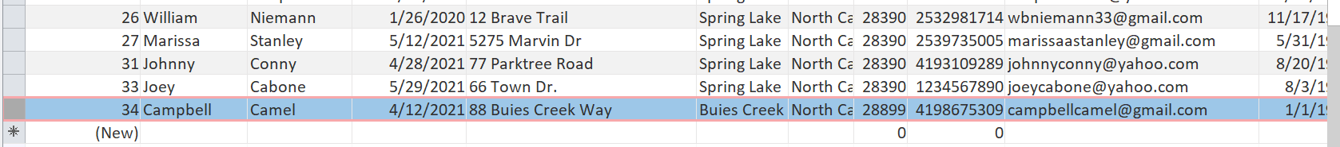

Test 2 – Cancelling Campbell Camel

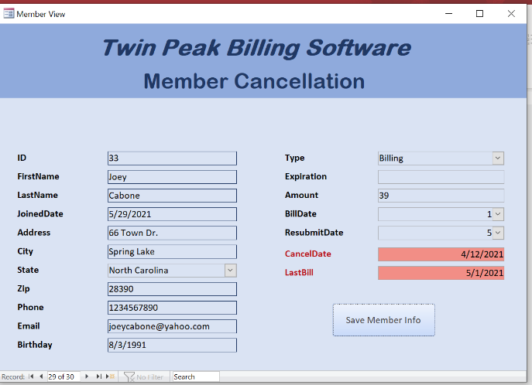

Test 3 – Retrieving Billing and Cancellation Reports

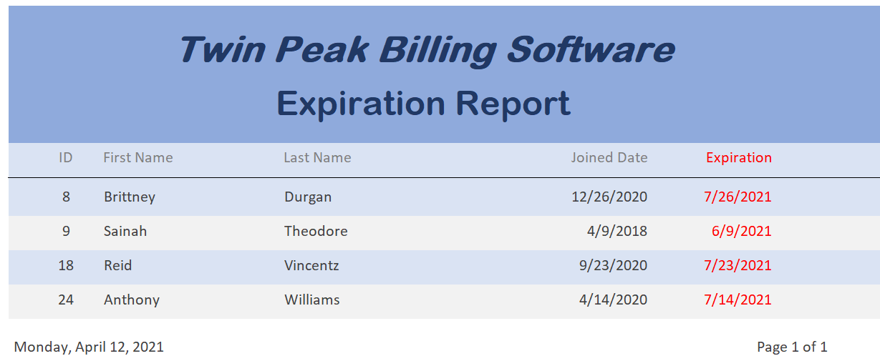

Test 4 – Employee Clock-In/Out

