Justin Ely

ITS 465-MC01

Dr. Umesh Varma

March 29, 2021

Design (Final) – Twin Peak Billing Software

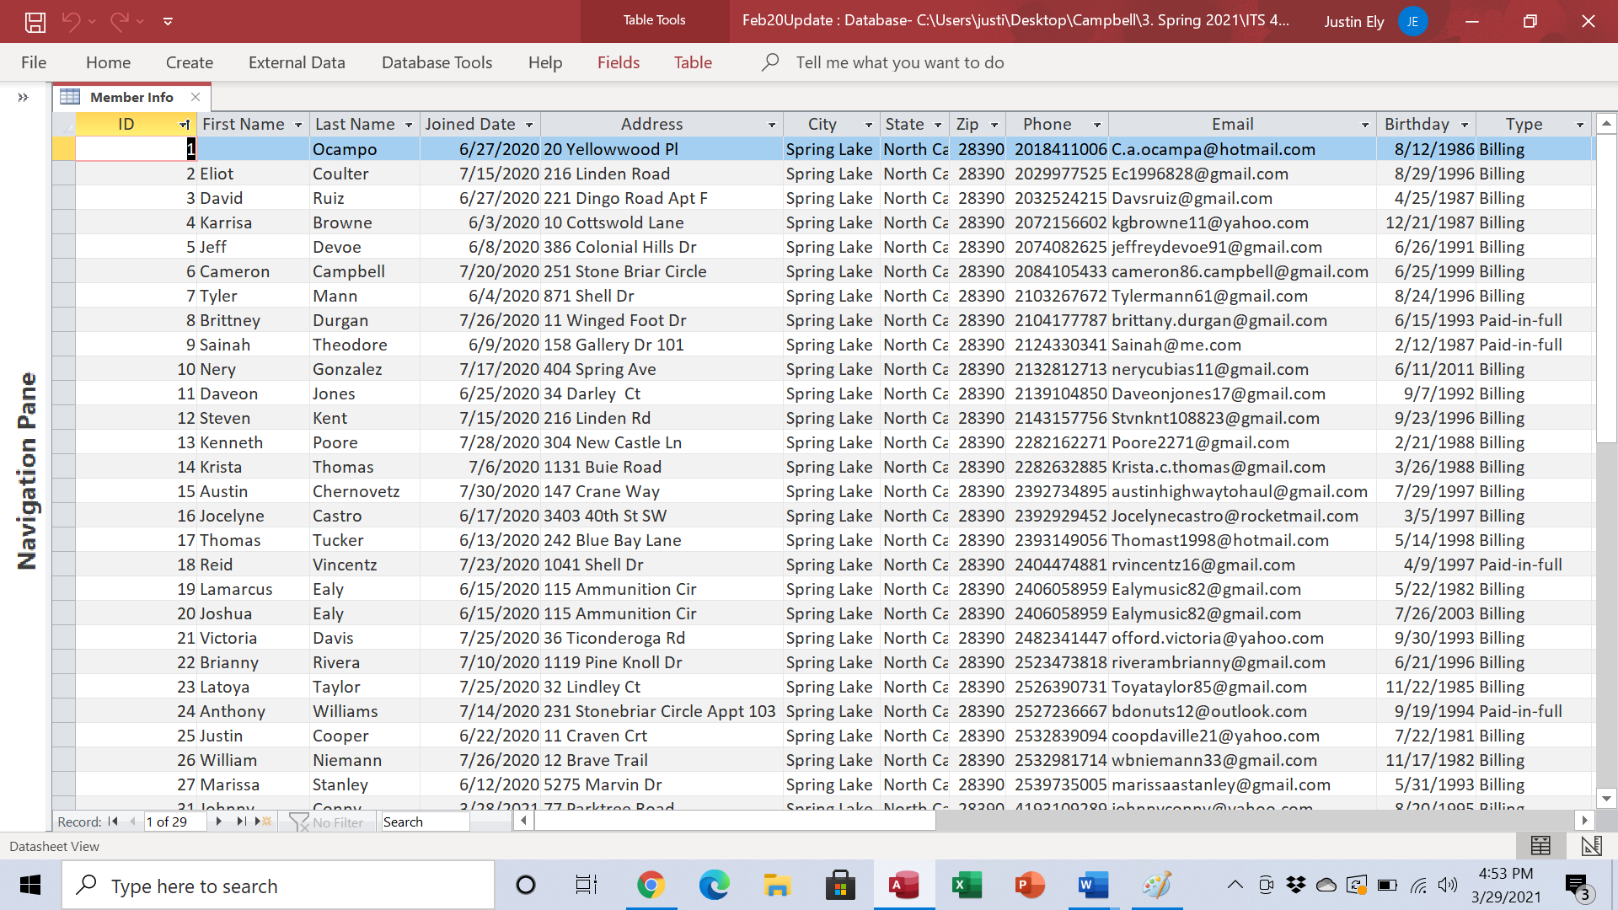

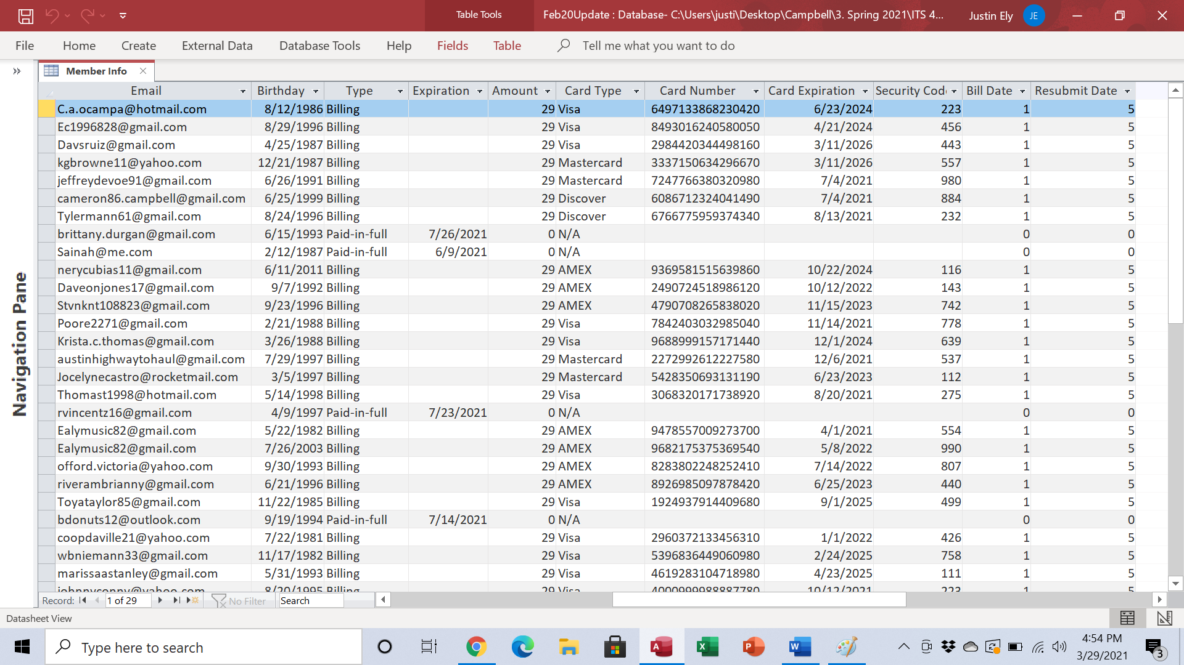

**Use Case**

|  |  |  |
| --- | --- | --- |
| **Employee Self Service System**  **Author**: Justin Ely **Date**: March 29, 2021 | | |
| **Use-Case Name:** | New Member Entry | |
| **Use-Case ID:** | TP-01 | |
| **Priority:** | High | |
| **Source:** | TwinPeak Member Service | |
| **User:** | Employee | |
| **Monitored by:** | Managers | |
| **Description of use-case:** | This use-case describes the user (employee) creating a new member profile within the Twin Peak database. | |
| **Normal Events:** | | |
| **User:** | | **System:** |
| 1. This use-case is initiated when the employee opens the database and is given the new member entry form. | | 1. The system responds by giving the employee a three-tabbed form for entering a new member. Each tab corresponds to a different table within the database that will store specific information on the new member. |
| 1. The employee enters information in the tabs in this order: Member info, Membership, and Billing Info. | | 1. The system will save the information entered into the corresponding table for storage. |
| 1. The employee will then log the new member information into the company’s “Stats Sheet” which is an excel spreadsheet saved on the desktop computer at the front desk. | |  |
| **Alternate Events:** | | |
| 3a. If the member is renewing their paid-in-full membership or re-enrolling in a monthly membership, the employee will simply open the Members info and ensure that their information is correct, updating card information or anything else that has changed since the prior membership ended. | | |
| 5a. If the member is renewing their paid-in-full membership or re-enrolling in a monthly membership, the employee must notate this in the “notes” section of the “Stats Sheet.” | | |
| **Conclusion:** | The “New Member Entry” use-case is important in maintaining the correct information on members as well as tracking all new and renewed memberships. | |
| **Constraints:** | Employees may not be trained well enough to maintain integrity with the Access database, extensive training is pertinent to error-free use. | |

**DFD**



**Activity Diagram**



**Member View Pop-Out Form**

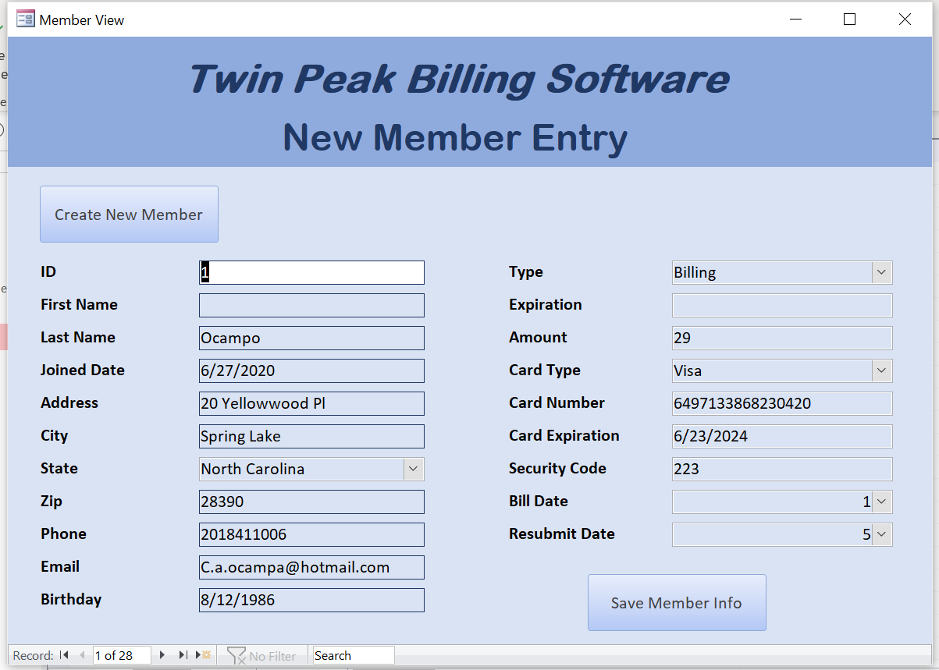

**Creating A New Member**

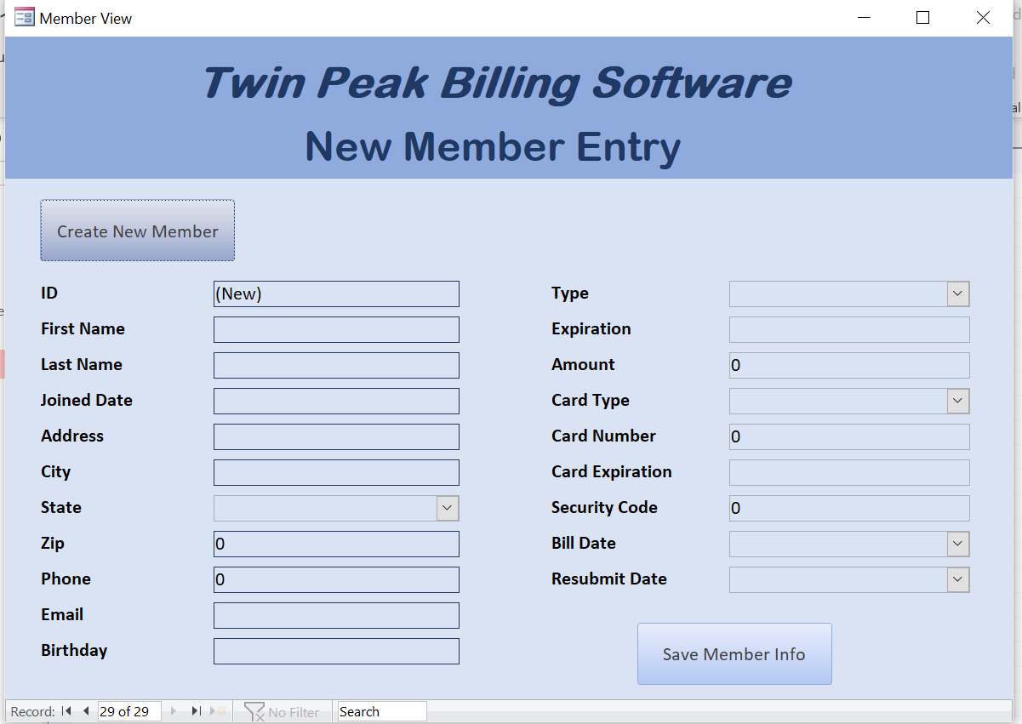

**Saving New Member**

