**Twin Peak Member Management**

Justin T. Ely

Department of Security and Computing, Campbell University

ITS 465: Senior Project

Dr. Umesh C. Varma

April 21, 2021

**Abstract**

At a small, local health club, the owners are attempting to consolidate costs and find ways to work cheaper for more profit. In this assessment, the owners discovered that the current price of the billing and member management software was too high and created the task of building a Microsoft Access database to absorb these costs. The health club has purchased and used two different systems in the past that both provided pros and cons in terms of the ability of the system. The less modern system was very tedious but helped check the boxes to make sure all data had been covered and input correctly. The newer system was more modern, incorporating an app for members and a much better customer service team that primarily dealt with ensuring contracts were met and money was not being left on the table. While the actual functions of billing and collections are being removed from the newly designed database, Twin Peak offers reporting abilities that transfer the correct information to our accountant at the company headquarters. This system stores member information in its own table and employee information in a different table. Using forms, Twin Peak incorporates an easily accessible user interface that will enroll and cancel members at the local health club. Within these forms, there are buttons that are programmed to supply the user with the most important information in the form of queries that produce well-designed reports. The database also includes a form for employee time clock functions that will store hours worked in a separate table for the accountant to submit payroll. Overall, introducing Twin Peak Member Management will provide the health club with the best possibility for member management while creating thousands of dollars in profit immediately. The owners of the health club intend to use these profits in upgrading the facility and providing a more attractive place to work out to attract more members, and more revenue.

**Contents**

Introduction 5

Feasibility Analysis 6

Assumptions and Limitations 8

Detail Study and Analysis of the System 9

Logical Design 11

System Modeling 12

Physical Design 14

User Interface Design 18

Implementation 20

Systems Testing and Evaluation 22

System Support Procedures 23

Future Enhancements 25

Conclusion 26

Appendix A 27

Appendix B 28

Appendix C 31

Appendix D 33

Appendix E 38

**This page left intentionally blank.**

# **Twin Peak Member Management**

Twin Peak Member Management was designed for the purpose of supplying a smaller health club with member management and billing opportunities without paying a software company to do this for them. Throughout this report we will discuss things like feasibility, assumptions, limitations, an analysis of the current system, design, implementation, testing, and opportunities for further design. While there are pros and cons to every system that is being used, the owners of this specific health club are concerned with the cost of purchasing a software to manage their members and the cash flow of the health club. Current systems available for purchase provide excellent functions that seem to be tailored to a large-scale health club and thus are expensive. Since this health club is smaller and more of a local place, there is no need for the owners to continue to pay for a company to handle these functions. The preliminary scope for the design and implementation of Twin Peak Member Management is to produce a system that maintains the most accurate data on members and employees as well as maintaining a regular billing schedule to ensure the maximum amount of income without error. The system must provide a simple way to enroll new members and provide useful reporting features. Also important is the way the health club collects on accounts; the current system relies solely on the employees in making calls to collect on past due balances, whereas Twin Peak will regularly bill accounts on days that will be most likely to collect like typical pay days for our members. The Gantt chart (Figure 1) designed to illustrate the project schedule and layout of deliverables for the project and can be found in Appendix B. While a purchased software would be managed by the selling company and all aspects would relate back to them, the owners of this health club want to assign the auditing of information directly to the General Manager since he or she will be involved in operations daily.

# **Feasibility Analysis**

While analyzing the idea of creating a new system for this health club, the main concerns for the owners are that the new system is technically sound, the continuance of successful operations continue, and economic success is satisfiable. While it is important to understand that the current system is technically sound and does produce successful operations, the main goal of designing a new system is to absorb the current costs that are being paid to the system’s owner. Is Twin Peak Member Management technically sound? Since the design of the system is in-house, the designer is comfortable with the operations of the health club and is essentially designing it with his past work in mind. The owners anticipate this transition to not take longer than the second quarter of the year 2021. The designer of the system has agreed that three months is enough time to complete the design and implementation of the new system. Since the designer of the system has a history of work using Microsoft Access, the owners have agreed to continue with the technicality of the system using this database management system.

Will Twin Peak Member Management encourage future successful operations? While analyzing the system with this mindset, Twin Peak shows that implementing this database will cut labor time in half when accessing functions like enrolling members, cancelling members, and creating reports. Not only will the owners save money on subscriptions to their current software, but Twin Peak also provides clear ways to save on labor costs. The employees of this health club will be able to spend more time on things like lead generation, marketing, participating in events, and getting the name of the health club further into the city. As the owners are overly concerned with cash flow, the operational ability of Twin Peak will cut costs in more ways than just the cost of purchasing a current system.

Will the implementation of Twin Peak Member Management provide economic success? This feasibility analysis is mainly answered in the previous studies of technical and operational feasibility. Technically, the health club will save thousands of dollars monthly by simply designing their own system, a system that is feasible due to the smaller nature of this specific club. Operationally, the current system requires far too much time in completing simple tasks; whereas Twin Peak’s user interface and storage allows employees the opportunity to spend less time on the system and more time generating additional revenue for the club. Also, important to note is the break-even point in the design of this system. Instantaneously upon implementation, the health club will cut thousands of dollars off their costs, while not incurring any new charges for the new system. This means that the design and implementation of Twin Peak will have already broken the even point before implementing the system. Overall, the economic feasibility of implementing this new system was simple due to the many ways that labor will be distributed, and more sales will be generated.

# **Assumptions and Limitations**

Most assumptions in the design and implementation of Twin Peak Member Management can be derived from the limitations of the design and implementation. Limiting the system to use in only one location, the owners are likely to be convinced this system should be implemented in other health clubs that they own as they experience an increase in profit. While the current design of this system may not be the best for a large health club, it is assumed that this specific version is tailored to smaller health clubs with less members. While the system creates potential for use in health clubs producing more revenue, the testing of the system was tailored solely to a health club with a lower member count. Another limitation of Twin Peak Member Management is its ability to be used by multiple users in various locations. This limitation produces an assumption that the system will only be utilized on one computer. This assumption is true as the location of the health club planning to implement the system only contains one desktop computer. This assumption was taken into consideration during the split of the database into a frontend and backend. The backend version of the database is stored on the health club’s desktop while the front end can be copied and utilized by others for data entry using the forms and queries in the user interface. Further design of the system that could not be limited to a smaller health club will be discussed further in Future Enhancements.

# **Detail Study and Analysis of the System**

While analyzing the current system against the idea of Twin Peak, the owners were able to catch multiple things that the gym could benefit from. Eliminating the cost of the current system would increase profits for the owners by over $4,000.00 per month. A good way to think of this is regarding the rent on the space being used to house the gym. The current rent on the property not including insurance is $3,500.00. Creating a database with Microsoft Access that will maintain accuracy of member data while still allowing reporting features that are crucial to growth and sales will essentially pay the rent on the property. Generally, the owner would not be able to create such a database and would have to hire someone to create and maintain it. However, they have an employee who is willing to do it for them. The user interface and member entry procedures must be able to ensure that everything is done properly and that the risk is low regarding errors. During the analysis phase of this design, it was clear that the new member entry process could be redesigned, saving time and money along the way. Using the current system, it took the employee an average of 10 minutes to simply enroll the new member. Using Twin Peak, the same employee was able to enroll new members in half the time. With the current business process in mind, saving chunks of time on each enrollment will give the employees more time to market and generate new leads, adding to the monthly income of the health club.

The reporting features of the current system work efficiently, but in the decision to wipe this system’s cost the owners decided that the in-depth reporting features were not necessary to the business functions of this health club. Simplifying the reporting features to only supply the needed reports will ease the process of producing the needed reports. Built into the main form in the Twin Peak database, there is a specific button programmed to produce the essential reports for expiring members and member billing. The expiring members reports will be crucial to member retention on the part of the health club staff. The billing report is necessary so that the accountant can simply access a list of members who are to be billed on specific days. The newly designed Twin Peak database correctly reports the needed information for the company.

The current system’s user interface is designed for health club’s requiring a vast amount of information. During the enrollment process, the employees are spending more time browsing through different folders containing information they have not been using and storing. With the implementation of Twin Peak, all information needed on a new member is displayed on one page, saving time and confusion while browsing various, unneeded folders. The reports produced by the current system are not well aligned, contain small text that is difficult to read and differentiate between, and includes unneeded information that could cause employees or the accountant to make mistakes. When designing the reports for Twin Peak, easily readable information was of utmost importance. Twin Peak’s reporting function is designed to only include information within the selected date range, removing unneeded information. On top of this, the design of the reports was created so that they are easily readable without error. Each line of member information is displayed in alternating colors to help ensure that the information on each member stays with that member.

# **Logical Design**

The logical design of Twin Peak Member Management is broken down in three ways: the members, the employees, and the finances. Understanding the business process of the health club was pertinent in describing the design of the system logically. Overall, Twin Peak Member Management was designed for a small, local health club that held between 500 and 800 members depending on the time of year and member retention. The main business objective of the health club is supplying a clean and well-kept facility where members can work out and exercise. Since the owners of this location are deeply concerned with daily sales goals and growing the health club to a point of expansion, the employees’ focus is on impressing members and adding more members to impress. The system must store information on all its members such as: personal information, contact information, membership information, and billing information. The system is required to possess a time-clock function to keep track of hours worked for payroll purposes. The system is required to produce two pertinent reports: expiring members, and member billing information by date. With all the above-mentioned requirements, all functions of the business are accounted for: managing members’ accounts, enrolling new members, cancelling current members, updating member information, tracking employees’ hours worked, and producing reports that lead to more success for the health club in the future. Understanding the logical design requirements for Twin Peak Member Management will ensure that the system is properly implemented regardless of the hardware or software design.

# **System Modeling**

Twin Peak Member Management’s design was based on simplifying the use of the current system. As mentioned, this smaller health club does not require the total functionality of the current system, can cut the cost of this software, and increase profits over time after implementing the new system. The context diagram (Figure 2) simplifies Twin Peak to the basics and shows how the system interacts through its life cycle. The main function of the system is the use of the Member Info table and all member-related functions relate back to this table. The Member View form receives all information on all members in the table, and upon creating a new member, cancelling a member, or updating information on a member, sends the correct data back to the table. Queries have been designed to pull select information from the table, so all information on all members is also accessible by the system’s reporting features. The accountant has access to all billing information on the current members as she is responsible for billing those accounts that are due. Lastly, the owners have access to all information on all members, so they can analyze information to produce trends and keep track of all daily sales to ensure the business is functioning properly.

The main display of the designed system will show the Member View form. The only function that needs to be completed outside of this display is utilizing the employee time clock. The activity diagram (Figure 3) in the appendix shows how activity transfers through the system. Initially, the employee opens the database, and the Member View form is displayed. The employee would then decide whether their intention is to utilize the Member View form or the only other option, to clock in or out. If the employee intends to use the time clock, they will select their name and clock in or out, then save the information. If the employee intends to utilize the Member View form, they will decide between enrolling a new member, cancelling a current member, updating member information, or utilizing the reporting feature. Any member change would be documented and saved, and the activity would thus be complete. Should the employee need to access a report, the employee would select which report, the report would display, and the activity would thus be complete.

Since the most important function of Twin Peak has already been coined as enrolling new members, the use case form (Figure 4) is also included for reference. The included use case form references the set of possible sequences of interactions between the user or employee and the system itself in relation to completely enrolling a new member. Referencing the use case, an employee can easily identify the current way to enroll a member and the other possibilities that may deviate from the basic enrollment. As the use case is monitored by the General Manager, any operations other than those listed on the use case should be discussed with him, so that further use cases can be created and posted for reference.

Overall, the system modeling of Twin Peak Member Management aligns with the scope of the design as it simply breaks down processes to what was required by the preliminary scope. The context diagram outlines all the functions of the system while the activity diagram simplifies the order of activities in utilizing the system. The most common function, enrolling a new member, is outlined in the use case form. Should further operations be added to the system, the creation of more extensive system diagrams may be necessary.

# **Physical Design**

The physical design of Twin Peak Member Management includes the following Microsoft Access functions: tables, forms, queries, and reports. The current design of Twin Peak incorporates the use of three different tables: Member Info (Figure 5), Employee (Figure 6), and Time Clock (Figure 7). The Member Info table contains all personal information on the members like names, dates of birth, contact information, addresses, membership types and amounts, and billing information. The Employee table currently only contains the first and last name as well as the “EmployeeID.” The Time Clock table contains all entries recorded from the use of the Time Clock form, which will be discussed further in the following section. In depth analysis has incorporated the necessary fields for each of these tables and leaves tremendous room for growth as the new system is implemented for the health club.

The system currently contains three different forms: Member View (Figure 8), Cancellation (Figure 9), and the Time Clock (Figure 10). The Member View form is the main user interface for the system as previously discussed. This form displays the members and can navigate through the list of members from the Member Info table by using the selection arrows or the search bar. This form contains various buttons that are programmed to complete different tasks. The first button, Create New Member, provides a view of the form that is empty for data entry. The next button, Member Cancellation, opens the Member Cancellation form. The following two buttons, PIF Expiration Report and Billing Report, create a query. Important to note for the physical design of this form, the employee must select the Save Member Info button when finished entering any new information so that is correctly saves the data to the appropriate table. The Cancellation form is a replica of the Member View form, but without navigation buttons as it is only designed to cancel members. This form adds two fields for data entry, Cancel Date and Last Bill. When this form is opened, the employee will need to enter those two dates and select Save Member Info for the newly added data to be transferred to the Member Info table.

The last form, Time Clock, uses information from the Time Clock table as well as the Employee table incorporating the use of primary and foreign keys. The primary key in the Time Clock table is the TimeClockID while the foreign key is the EmployeeID that is referenced from the Employee table. The physical design of this form incorporates a combo box so that the employee can select their name prior to clocking in or out, and that information will be saved in the Time Clock table, so the accountant is aware of who worked when. In their article, “Add a list box or combo box,” Microsoft (n.d.) writes:

“When entering data on forms in Access desktop databases, it can be quicker and easier to select a value from a list than to remember a value to type. A list of choices also helps ensure that the value entered in a field is appropriate. A list control can connect to existing data, or it can display fixed values that you enter when you create the control.”

Since the scope of this design includes easy access for users, implementing a combo box here to select and reference a specific employee produces more accurate records that can easily be linked to specific employees for accounting reference. Through analysis, it was also discovered that the Time Clock form shall not include the user’s ability to enter their own time clock information, as this could lead to integrity issues with payroll. In his YouTube video, “Computer Learning Zone,” Richard Rost (2020) discusses useful information on creating time clock functions in Microsoft Access. Rost introduces the use of the event builder within Access that allows a designer to introduce Visual Basic programing into the functions of a button. Using “TimeIn = Now()” in the event builder has allowed the design of this form to only clock in or out based on the time the button was selected (Rost, 2020). Since this form contains keys for organization as well as buttons programmed to select the current time, payroll for the health club has been made easily understandable with less possibility for malicious entries or errors in pay.

As defined in the scope, it is important that Twin Peak Member Management be designed with reporting features that can increase knowledge of the business functions as well as provide trusted records for billing tasks. Currently, Twin Peak contains the two queries that are most important for the functions of the business: a billing query (Figure 11) and an expiration query (Figure 12). After the design and analysis phases of Twin Peak, the owners decided that it would be best to stick with these two queries for now, and based on their performance and future need, more queries can be specifically designed to produce data sets to fulfill that need. Both queries are designed to accept user input for the date range of the information being requested from the database. In his video, “User Input Queries and Reports,” Sali Kaceli (2018) describes a few different options for requiring the user to enter parameters for a query. Kaceli introduces a method to use in the criteria field of the query design by entering “>=[Start Date] And <=[End Date]” which will create a pop-window where the user is able to enter the date ranges for the query (2018). Implementing this feature in the query design enhances the user’s ability to easily filter data from the Member Info table to produce reports on when members are due to be billed and when paid-in-full members are nearing their expiration and renewal dates.

The last portion of the physical design of Twin Peak Member Management are the reports that are created based on the previous two queries: the billing report (Figure 13) and the expiration report (Figure 14). The billing report is created from the billing query and will clearly lay out the data requested from that query. The most common use of this information will be for accounting purposes. The accountant will open the report either through the report itself or through the shortcut in the Member View form. Upon selecting this report, the accountant will be prompted to enter the billing date, and the report will display all the members and their respective billing information so that the monthly draft can be executed. The expiration report is created from the expiration query and will outline the members who are set to expire between the entered date ranges. The primary use of this report will be for the sales employees of the health club. They will open the report either through the report itself or through the shortcut in the Member View form. The employee will be prompted to enter the expiration date between two date ranges, and the report will display all the members who are expiring between those dates. While larger health clubs may require additional reporting features and the expansion of this health club would also require the same, the reporting features of Twin Peak Member Management are currently sufficient for the success of the business.

# **User Interface Design**

An important part of the design of Twin Peak Member Management is an easily accessible user interface as defined in the scope. During the analysis of the current system, it was discovered that the user interface was confusing, and the multiple folders and vast number of clicks required for a basic enrollment caused minor errors that could be avoided with a new design. Since the software being used is Microsoft Access, the design of the user interface was best suited through a form. The Member View form (Figure 8) is the main hub of the user interface design of Twin Peak and will always be displayed on the computer being used. As noticed in the figure, the user interface design includes variations of blue as the main color schema, breaking the view into two different sections: the upper section that will always display the name, Twin Peak Member Management, and the current function being executed, and the lower portion for data entry or report display. The buttons displayed break the user interface design between the title and the fields for data entry. The buttons displayed are shortcuts to different functions of the system: creating a new member, cancelling a member, or displaying the most common reports. Incorporating these shortcuts in the design will save time and prevent user error based on the current systems reporting steps.

During data entry, the current system allows manual entry of fields that could be selected using drop-down menus or date selectors. To save time and prevent user error, the user interface design uses drop-down menus for the following fields: state, membership type, credit card type, billing date, and resubmit date. Date selectors are available for the following entries: joined date, birthday, membership expiration, and credit card expiration. Allowing these dates to be selected in this way decreases the chance that a date could be input incorrectly by the user or employee. The user interface design meets the requirements as stated in the scope by providing an attractive yet simple layout for the user.

# **Implementation**

Conversion to the new system is scheduled for the first day of May as this is when the new month’s billing will start for half of the health club members. The owners are responsible for managing the closure of the current system by the end of April to ensure no new charges from the software supplier are received for the month of May and moving forward. Also, ensuring that the prior software is cancelled will keep our current members from being billed by the old system and the new system. A situation like this could lead to an increased number of customer service issues that would only add stress on employees as conversion is in progress. Once Twin Peak was deemed operational by the owners, the database was split between backend (BE) and frontend (FE). The backend of the database contains all the hard data being stored in the tables and will be kept on the desktop computer held at the front desk in the gym. The frontend of the database will be copied to employee’s personal computers, so they are able to access the functions of the “Member View” form to create and cancel members. Another copy of the frontend will be placed on the accountant’s computer, so she is able to access the reporting functions of the database. While implementation for a larger health club could be difficult, the transition from the current system to Twin Peak Member Management will prove relatively easy as the use of Access will not require any outside contractual terms to be met prior to utilizing the database.

Since the main goal of creating this new billing and member management was to save on costs of typical software suppliers as well as ease the member entry process in a way that will suit the employees and ensure correct information entry, training employees on proper use will not be as difficult as it was in the past. Proper implementation and training of all users will be crucial to the success of this database to ensure all information is correctly entered and stored for future use and record keeping. For the gym employees, they will need to understand the functionality of the entire system to ensure they understand why it is important to enter data correctly. As their only functions of the system will be creating new members and cancelling members, focus will be put on the original function of the Member View form. When initially opening the form, it will display the first record of the current members. The employee will then need to select the “Create New Member” button to enter the data on the new member. Once this is complete, the employee must understand that they need to select the Save Member button for the information to be converted to the Member Info table. The next function, cancelling a member, will require the employee to select the Member Cancellation button. Twin Peak will then open the same view, but with the additional fields: Cancel Date and Last Bill. The employee would enter the current date as the Cancel Date and enter the following member billing date as the Last Bill. Ensuring that each employee understands the cancellation procedures is crucial to ensure each member is required to pay one last bill before their membership is cancelled. Lastly, just as in creating a new member, the employee must select Save Member Info to ensure the information is transferred to the Member Info table for the accountant’s records.

# **Systems Testing and Evaluation**

The Twin Peak Member Management database has undergone extensive testing primarily geared toward functionality of the database and user entry. During the testing phase the user opened the database in the pop-up Member View form. The user has options at this point depending on what job function they are performing. Most commonly for an employee of the gym, they will begin by selecting Create New Member. All functions of data entry for a new member cleared testing and the information was stored correctly in the Member Info table. When the employee began the process of cancelling a member via the Member Cancellation button, the highlighted fields that would need adjusted were created and the data entered was stored in the Member Info table correctly. As far as a sales representative for the gym goes, those are the only functions required by that level of employee. For the manager, accountant, and owners, the “PIF Expiration Report” and Billing Report were tested for their functionality and correct reporting. Upon selecting the “PIF Expiration Report,” the user is correctly prompted to select the beginning of the date range of expiration as well as the end of the date range. Upon submitting the date range, Twin Peak returned a correctly laid out report of the paid-in-full members who were expiring during the selected date range. The last function of the Member View form is tailored to the accountant who is employed by the owner to handle all billing functions, the Billing Report. Upon selecting the Billing Report button, the accountant is prompted to enter the billing date and upon entering either billing date, Twin Peak successfully produced a well laid out report of the members who needed to be charged on the selected date. The evaluation and testing of Twin Peak Member Management led to the discovery of zero new errors and was deemed ready for implementation.

# **System Support Procedures**

Twin Peak Member Management was designed and implemented using Microsoft Access. The program maintenance on Twin Peak will be broken down into three categories of software maintenance: corrective, adaptive, and perfective. As the implementation of Twin Peak happens in the health club, corrective maintenance will present itself as bugs and flaws arise through the business process. Possibilities include form reconstruction, data field additions or deletions, and additional reporting procedures. Adaptive maintenance will ensure that the Access database continues to work fluently on the computer alongside other software and the operating system. Aligning with adaptive maintenance, should the health club purchase and utilize more hardware, the software must be able to be replicated and used cross platform, this could mean that adaptive maintenance be completed to ensure this process is fluent. Perfective maintenance is inevitable as the health club grows and requires more functionality from the database. There are endless possibilities for growth using Microsoft Access so as new ideas and further development present themselves, perfective maintenance must be completed to ensure the system continues to run as intended.

Twin Peak Member Management has already been split into a front and backend. The frontend is what the employees will utilize daily as they complete tasks required through the business process. To maintain the most secure information, the backend of the database is stored on the desktop computer in the health club. For additional protection, the General Manager will be required to backup all data every other day to ensure if the system crashes, the health club will still have information updated from the previous day. Ideas for the future enhancement of system recovery are currently being analyzed for future implementation.

Automating support for the users of Twin Peak Member Management will provide the best way to support the health club in utilizing the database. The designer of the database will be responsible for producing videos aligning with each part of the business process that includes the use of Twin Peak. Required videos to be produced are enrolling a new member, cancelling a current member, updating current member information, utilizing the employee time clock, retrieving the member billing report, and retrieving the expiring members report. As the designer of the system is also an employee, all employees who need support must first consult the videos, and if requiring additional support, must reach out to the designer. The additional support needed could present further ideas to help the health club employees in understanding and working through daily issues with Twin Peak.

# **Future Enhancements**

The owners are anticipating rapid growth due to the implementation of Twin Peak Member Management. Due to this anticipated growth, they are expecting to rethink the way employees are being paid. The owners would like to implement commissions on each sale, and this would require additional data to be entered into the database. The designer of Twin Peak has already been notified of this enhancement and is working on solutions. The most likely solution to this would be adding fields in the Member Info table so that each enrollment can be tied to a salesperson or employee. Utilizing primary and foreign keys with the Employee table will produce more data aligning with payroll and the calculation of hours worked as the accountant prepares for payroll submission. While the current employees are motivated by their current salary, creating a commission structure will only motivate the employees to generate more sales for the health club.

Another enhancement that is already in planning phase would be the addition of new business processes to align with the potential of paid commissions to the salesperson. In other health clubs, the owners have implemented further requirements for the salesperson in booking free personal training sessions and acquiring referrals from those being enrolled. The owners are planning on adding minimum requirements on referrals and booked sessions for commissions to be paid. This would also require additional fields to be created in the Member Info table to store the data on the number of referrals received and the number of sessions booked. This enhancement would not require a vast amount of work as manipulating the current forms to display and require entry in these fields would suffice. As the implementation of Twin Peak moves forward, there are bound to be more planned enhancements as the business continues to grow and adapt.

# **Conclusion**

The scope of the design for Twin Peak Member Management was derived from the prior analysis of the current system being used by a small health club. As previously mentioned, the current system and the system in use prior to that provided clear pros and cons, so the analysis of the system and the potential improvements based on the functionality of this business came easily. The scope of Twin Peak included a system design that maintained and managed members, an adjustment to the billing schedule, an easily understandable user interface for data entry, and reporting features that supplement the business function needs. Through the phases of the Software Development Life Cycle, the designer of Twin Peak Member Management was able to produce a system that met the needs of the owners and fulfilled the project scope. Using Microsoft Access as the base software for the database, tables, forms, queries, and reports were well designed to meet the expectations of each business function. The testing of the system proved the system ready for implementation with proper training and support in place. While there are already future enhancements in the works, implementation, and the progressive use of the system in the future will likely provide more possibilities for improvement and Access provides the functionality for enhancement. Overall, introducing Twin Peak Member Management will provide the health club with the best possibility for member management while creating thousands of dollars in profit immediately. The owners of the health club intend to use these profits in upgrading the facility and providing a more attractive place to work out to attract more members, and more revenue.

# **Appendix A**

Repository

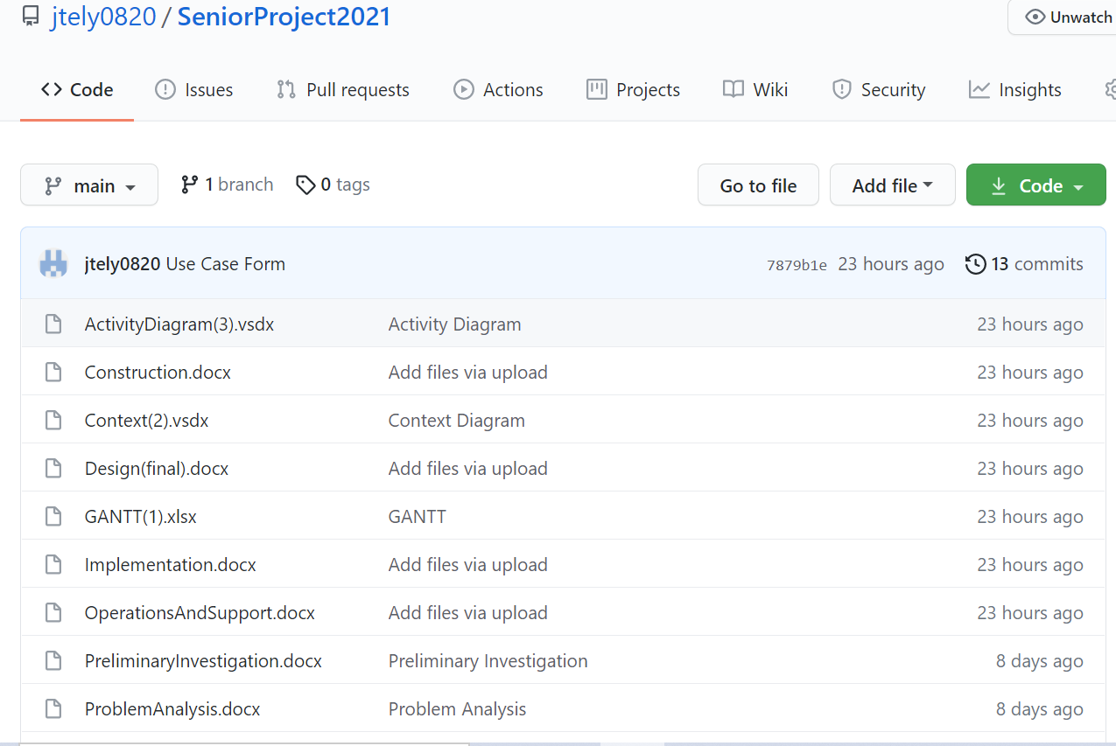

*Note.* The repository for this project is located at https://github.com/jtely0820/SeniorProject2021

# **Appendix B**

System Models

**Figure 1**

*Gantt Chart*

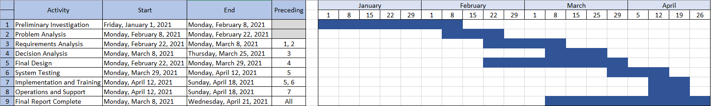

Note. The GANTT Chart illustrates the project schedule for Twin Peak Member Management.

**Figure 2**

*Twin Peak Member Management Context Diagram*



Note. The context diagram shows the entities in the design of Twin Peak Member Management.

**Figure 3**

*Twin Peak Member Management Activity Diagram*



Note. The activity diagram shows the workflow of Twin Peak Member Management.

**Figure 4**

*Use Case Form*

|  |  |  |
| --- | --- | --- |
| **Twin Peak Member Management**  **Author**: Justin Ely **Date**: March 29, 2021 | | |
| **Use-Case Name:** | New Member Entry | |
| **Use-Case ID:** | TP-01 | |
| **Priority:** | High | |
| **Source:** | Twin Peak Member Management | |
| **User:** | Employee | |
| **Monitored by:** | General Manager | |
| **Description of use-case:** | This use-case describes the user (employee) creating a new member profile within the Twin Peak database. | |
| **Normal Events:** | | |
| **User:** | | **System:** |
| 1. This use-case is initiated when the employee opens the database. | | 1. The system responds by displaying the Member Info form. |
| 1. The employee will select the “Create New Member” button. | | 1. The system will respond by creating an empty data entry page. |
| 1. The employee will enter all data on the new member and select the “Save Member Info” button when completed. | | 1. The system will save all information in the Member Info table and return to display mode, showing all members in the Member View form. |
| 1. The employee will then log the new member information into the company’s “Stats Sheet” which is an excel spreadsheet saved on the desktop computer at the front desk. | |  |
| **Alternate Events:** | | |
| 3a. If the member is renewing their paid-in-full membership or re-enrolling in a monthly membership, the employee will simply open the Members info and ensure that their information is correct, updating card information or anything else that has changed since the prior membership ended. | | |
| 7a. If the member is renewing their paid-in-full membership or re-enrolling in a monthly membership, the employee must notate this in the “notes” section of the “Stats Sheet.” | | |
| **Conclusion:** | The “New Member Entry” use-case is important in maintaining the correct information on members as well as tracking all new and renewed memberships. | |
| **Constraints:** | Employees may not be trained well enough to maintain integrity with the Access database, extensive training is pertinent to error-free use. | |

*Note.* This use case shows the requirements for a new member enrollment.

# **Appendix C**

Sample Input

**Figure 8**

*Member View Form*

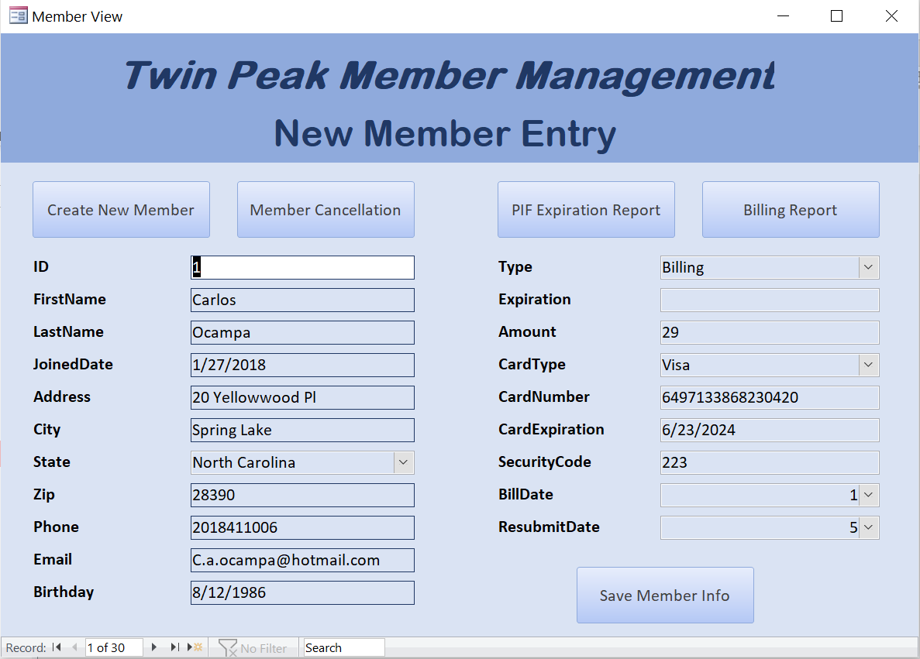

Note. The Member View form is the hub of Twin Peak Member Management.

**Figure 9**

*Cancellation Form*

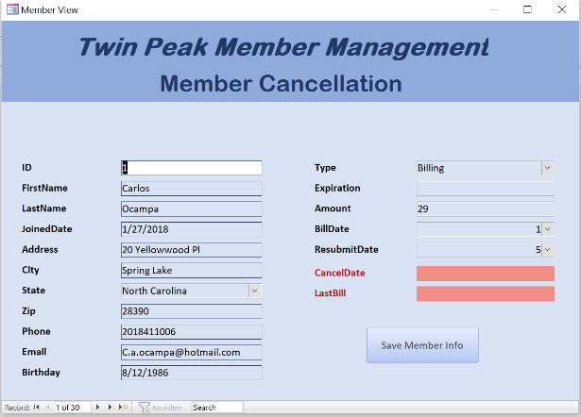

Note. The Cancellation form opens when the user selects Member Cancellation in the Member View form.

**Figure 10**

*Time Clock Form*

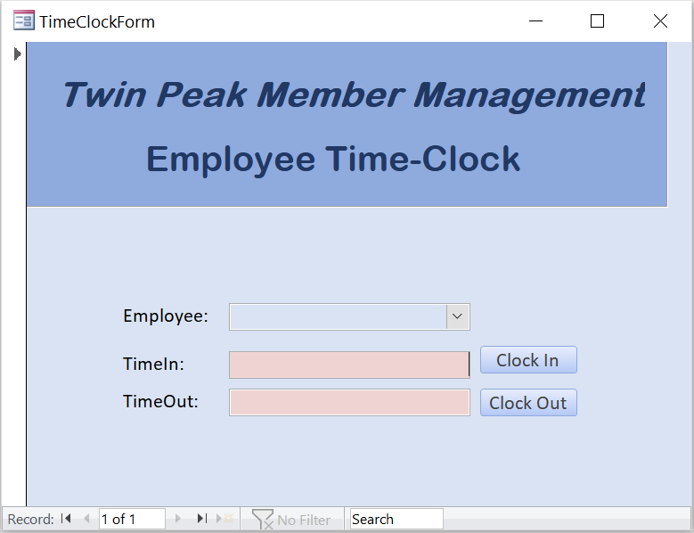

Note. The Time Clock form allows the database to store time clock information on employees.

# **Appendix D**

Sample Output

**Figure 5**

*Member Info Table*

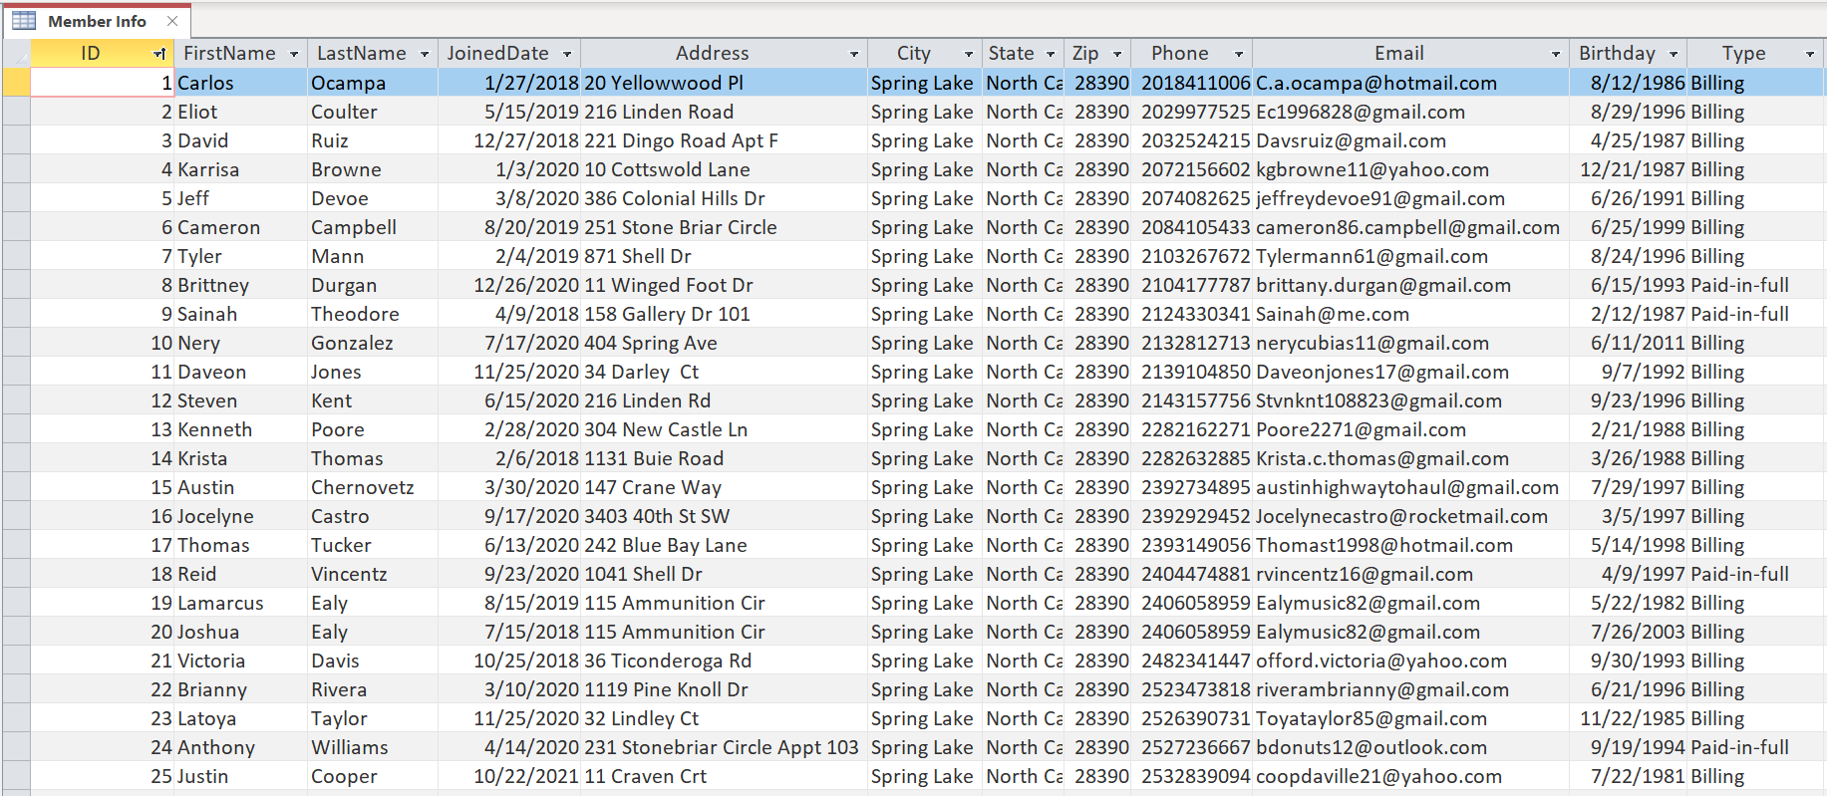

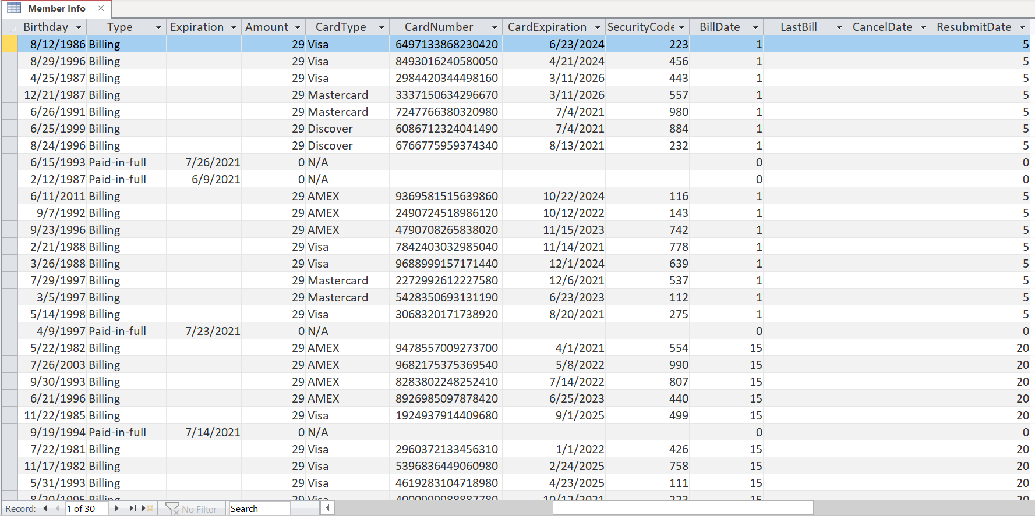

Note. The Member Info table stores all data on all members.

**Figure 6**

*Employee Table*

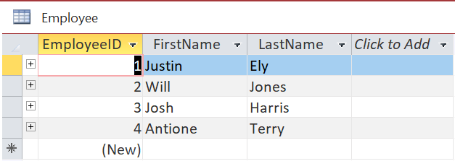

Note. The Employee table stores all information on employees.

**Figure 7**

*Time Clock Table*

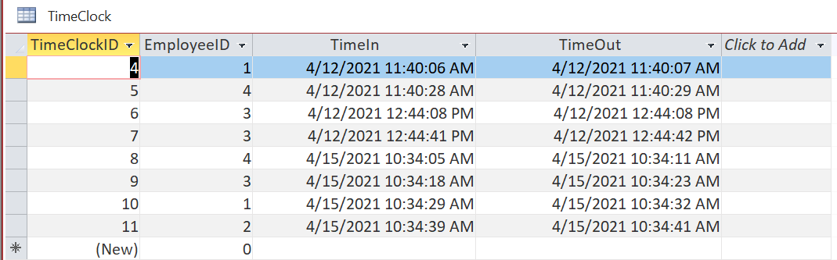

Note. The Time Clock table stores all data input from the Time Clock form.

**Figure 11**

*Billing Query*

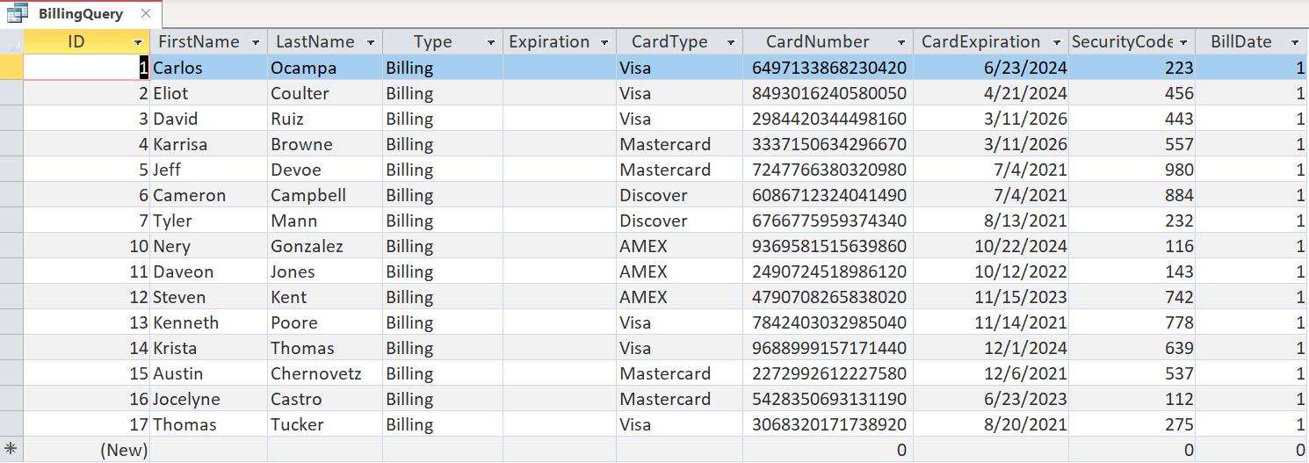

Note. This Billing query lists all members to be billed on the first of the month (BillDate).

**Figure 12**

*Expiration Query*

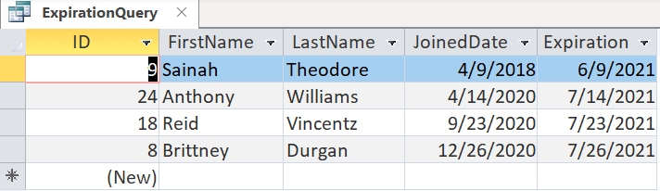

Note. This Expiration query lists all members who are expiring between April 1, 2021 and September 1, 2021.

**Figure 13**

*Billing Report*

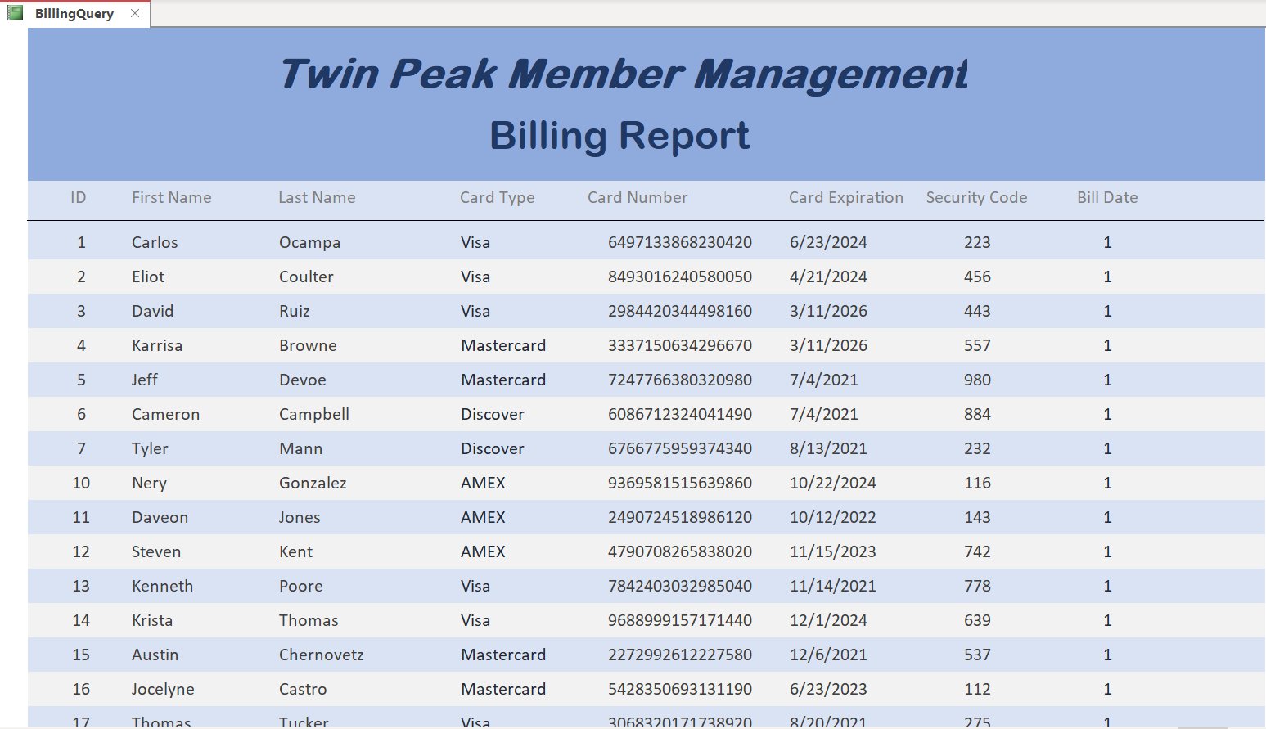

Note. This Billing report lists the members in a report from the query in Figure 11.

**Figure 14**

*Expiration Report*

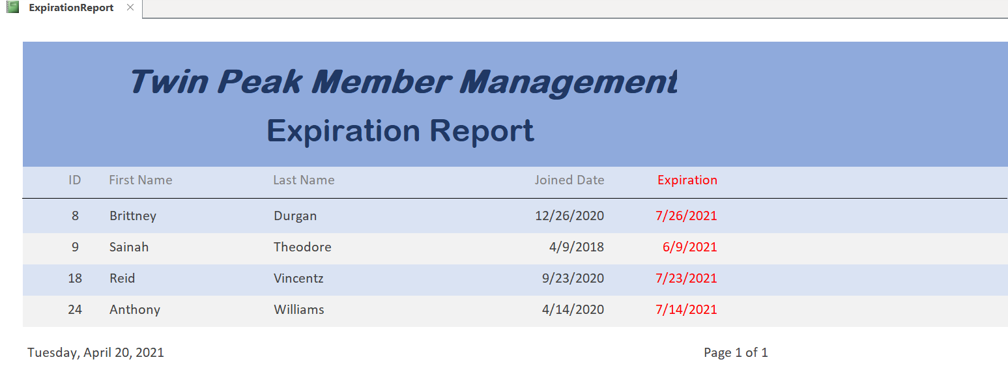

Note. This Expiration report lists all members in a report from the query in Figure 12.

# **Appendix E**

References

Kaceli, S. (2018, August 13). *User input queries and reports with date range in microsoft access 2016* [Video]. YouTube. https://www.youtube.com/watch?v=3E2Pqg1pda4

Microsoft. (n.d.). *Add a list or combo box.* Microsoft Support. https://support.microsoft.com/en-us/office/add-a-list-box-or-combo-box-70abf4a9-0439-4885-9099-b9fa83517603

Rost, R. (2020, October 31). *Create a time clock form in microsoft access* [Video]. YouTube. https://www.youtube.com/watch?v=TTzZRQSJMDo&t=632s