HW #1 Solutions

Sample #21 is the outlier sample when using only the first 100 genes

dat <- read.table(“golubTrain.txt”,header=T)

dimnames(dat)[[1]] <- as.character(dat[,1])
dat <- dat[,-1]

ann.dat2 <- read.table(“golubTrainClass2.txt”,header=T)

# cast data matrix to data frame
dat <- as.data.frame(dat)

# set annotation file values to names of data frame
names(dat) <- ann.dat2[,1]

# subset data frame to top 100 genes
dat <- dat[1:100,]

# correlation plot
dat.cor <- cor(dat)
image(dat.cor,main="Correlation plot of Golub data samples")
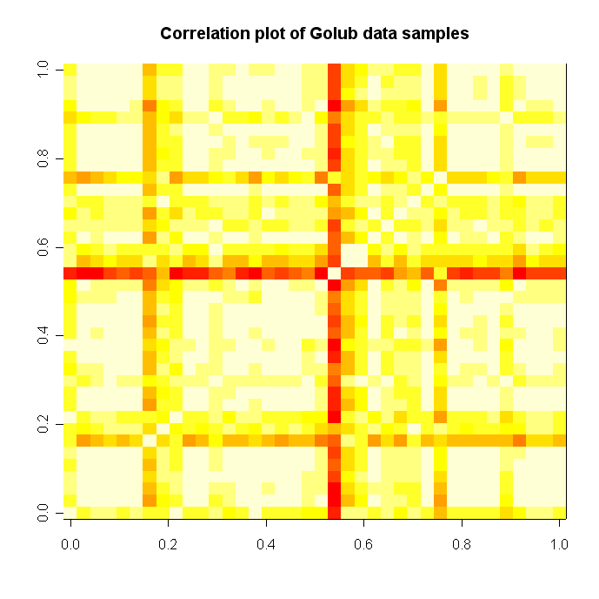

# hierarchical clustering plot
# transpose dat
dat.t <- t(dat)

# get pairwise distances
dat.dist <- dist(dat.t)

# calculate and plot hierarchical tree
plot(hclust(dat.dist), labels=c(1:38),main="Hierarchical Clustering Dendrogram of Golub data samples")

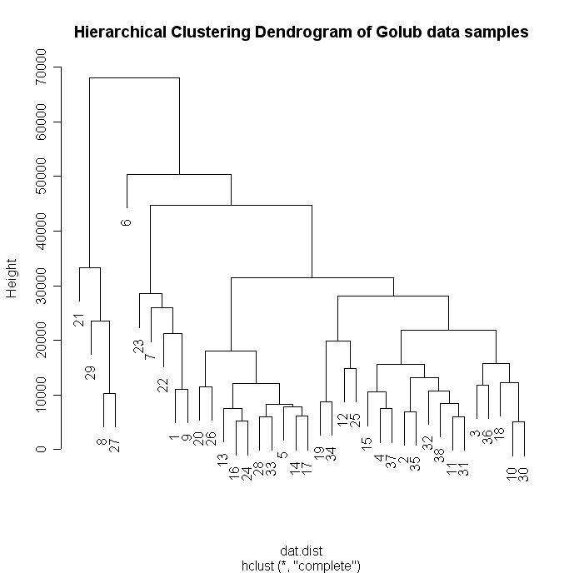

dat.mean <- apply(dat,2,mean)

# calculate samples standard deviations
dat.sd <- apply(dat,2,sd)

# calculate cv of samples
dat.cv <- dat.sd/dat.mean

# create CV plot
plot(dat.mean,dat.cv,main="Sample CV vs. Mean",xlab="Mean",ylab="CV",col='blue',cex=1.5,type=’n’)
text(dat.mean,dat.cv,label=c(1:ncol(dat)))

# or

plot(dat.mean,dat.cv,main="Sample CV vs. Mean",xlab="Mean",ylab="CV",col='blue',cex=1.5,type=’n’)
text(dat.mean,dat.cv,label=names(dat),cex=0.6)

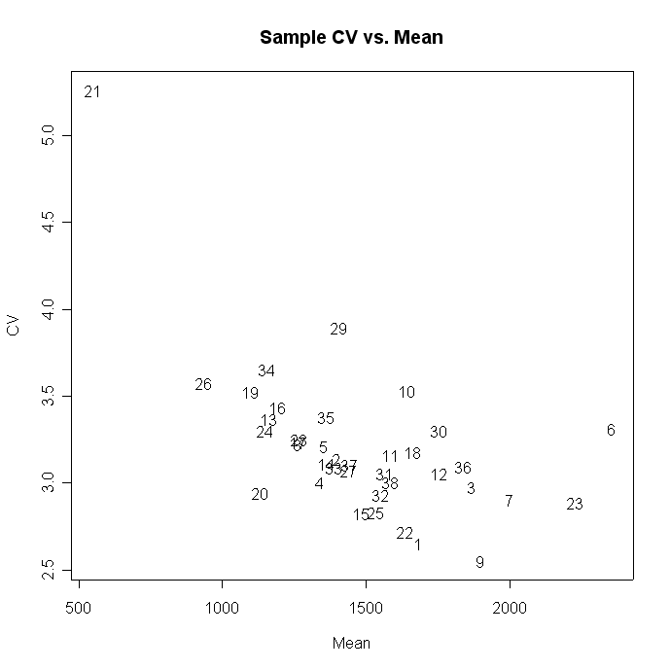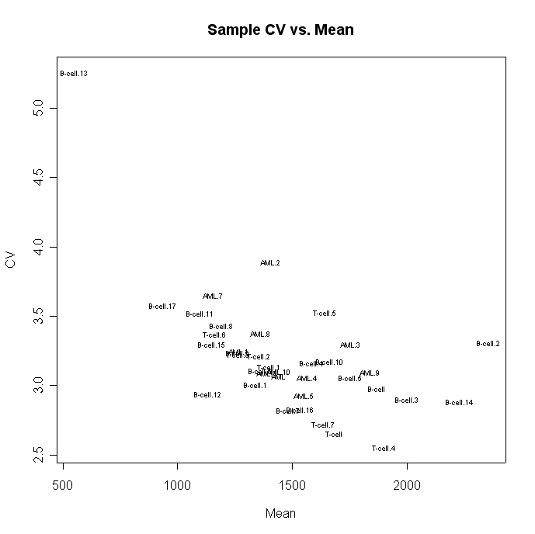

# load up the yeast cell cycle data
dat <- read.table(“C:\\Documents and Settings\\bhiggs\\JHUClass\\data\\spellman.txt”,header=T)
dimnames(dat)[[1]] <- as.character(dat[,1])
dat <- dat[,-1]

# cast to data frame
dat <- as.data.frame(dat)

# get only cdc28 experiment samples
dat <- dat[,47:63]

# get row (gene) means and fill mean values into “NA” values for each row
miss.fill <- function(x) {
if(sum(is.na(as.numeric(x))) ==17 ) {
x[is.na(x)] <-0
}
if(sum(is.na(as.numeric(x))) > 0 & sum(is.na(as.numeric(x))) <17 ) {
x[is.na(x)] <- mean(as.numeric(x[!is.na(x)]))
}
return(x)
}

dat.fill <- as.data.frame(t(apply(dat,1,miss.fill)))
dat.fill <- round(dat.fill,2)
dat<-dat.fill

# calculate kmeans on data set with 10 clusters
cl <- kmeans(dat,centers=10, iter.max=100)

# get cluster membership for each gene
groups <- cl$cluster

# since gene 2 is in group 5 (for this iteration of kmeans clustering-note that it will likely be a different cluster for your calculation), get all other members
group.5 <- groups==5
genes.cluster <- dimnames(dat)[[1]][group.5]
length(genes.cluster)
[1] 1200 # there are 1,200 genes in the same cluster as gene #2

# get distances from genes in cluster 2 to gene #2
gene.dist <- dist(dat[genes.cluster,],method="manhattan")
gene.dist <- as.matrix(gene.dist)

# look for the position of gene #2 by printing out the first 5 columns in the matrix (remember that this should be a symmetric matrix (i.e. 1,200 x 1,200))
> dimnames(gene.dist)[[2]][1:6]
[1] "YAL001C" "YAL002W" "YAL009W" "YAL011W" "YAL013W" "YAL027W"

# don’t include the identity distance (distance from gene #2 to itself).
gene.dist <- gene.dist[c(1,3:nrow(gene.dist)),2]

# get weights for each gene
gene.weight <- as.numeric(gene.dist/sum(gene.dist))

# calculate weighted mean for gene #2, array #1, (remove gene #2 in calculation)
weight.mean <- weighted.mean(dat[genes.cluster[-2],1], gene.weight)

weight.mean
[1] 0.05687651

