Scratchpad Notes

Creating an Eclipse project

Firstly make sure you have LLVM root in your eclipse "workspace" directory (or change your workspace directory in eclipse to point to your LLVM root)

open a terminal.

>>cd $LLVM root
>>cmake -G "Eclipse CDT4 - Unix Makefiles" -D_ECLIPSE_VERSION=4.3 ./llvm/src/docs/

Change Eclipse memory size (so it won't crash when you index llvm)

>>sudo vim eclipse.ini

makesure your variables match as shown below
-Xms512m
-Xmx1024m

Then, open eclipse File->import->Existing projects into Workspace

navigate to $LLVM root and click ok

done :D

You compile your program to LLVM bytecode before you run your pass on it.
See here: http://llvm.org/docs/WritingAnLLVMPass.html#quick-start-writing-hello-world

Compile benchmarks e.g.
>> cd ~/cse231-proj1/extra/benchmarks/welcome
>> clang -O0 -emit-llvm -c welcome.cpp -o welcome.bc
>> llvm-dis welcome.bc

Your module that you will edit lives in:

To compile your MODULE go into the root directory (cd ~/cse231-proj1 )
type >>make llvm

To run a pass of your module on the code you just compiled (make sure you sourced the example source.sh script):

>>opt -load $LLVMLIB/CSE231.so -hello < $BENCHMARKS/welcome/welcome.bc > /dev/null

-load says to load up your module (CSE231.so)
-hello gives a flag to your module
<> gives the input bytecode to your file

You can find how to count instructions in this source file: ~/workspace/cse231-proj1/llvm$ leafpad ./src/lib/Analysis/InstCount.cpp

copied instructions up to this point

cd llvm
$ mkdir build
$ cd build

I had to Create a CmakeLists.txt file in CSE231 directory (unzipped from the CSE bullshit tar)
Here are the instructions on how you modify Cmake (The TA used Make only which is not good)
http://llvm.org/docs/CMake.html

Modify lib/CmakeLists.txt

# `Support' and `TableGen' libraries are added on the top-level CMakeLists.txt

add_subdirectory(IR)
add_subdirectory(IRReader)
add_subdirectory(CodeGen)
add_subdirectory(Bitcode)
add_subdirectory(Transforms)
add_subdirectory(Linker)
add_subdirectory(Analysis)
add_subdirectory(LTO)
add_subdirectory(MC)
add_subdirectory(Object)
add_subdirectory(Option)
add_subdirectory(DebugInfo)
add_subdirectory(ExecutionEngine)
add_subdirectory(Target)
add_subdirectory(AsmParser)
add_subdirectory(CSE231)

Modify lib/CSE231/CmakeLists.txt

# CSE231Module
add_llvm_loadable_module(CSE231
BranchBias.cpp
CountDynamicInstructions.cpp
CountStaticInstructions.cpp
)

set(CMAKE_CXX_FLAGS "-g -Wall")

Next I create a directory:

~/workspace/cse231-proj1/llvm/build

Then I change to that directory and execute:

cmake -G "Eclipse CDT4 - Unix Makefiles" -D_ECLIPSE_VERSION=4.3 ./../../llvm/src/

You will then need to follow the step to import the project:

Change Eclipse memory size (so it won't crash when you index llvm)

>>sudo vim eclipse.ini

makesure your variables match as shown below
-Xms512m
-Xmx1024m

Then, open eclipse File->import->Existing projects into Workspace

navigate to $LLVM root and click ok

After this Eclipse will be able to index your source code. You can build your individual target like this:

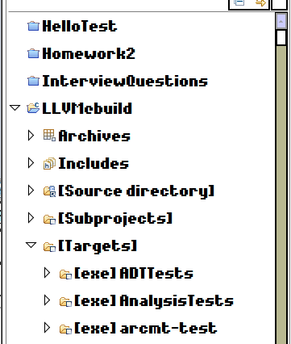
frame-col-ypos:0.000000in; bot-style:none; xpos:2.463194in; wrap-mode:wrapped-both; frame-type:image; ypos:0.000000in; left-style:none; frame-height:2.084722in; top-style:none; position-to:block-above-text; frame-col-xpos:2.463194in; right-style:none; frame-width:1.766667in

That was the project directory. You can find your shit here:

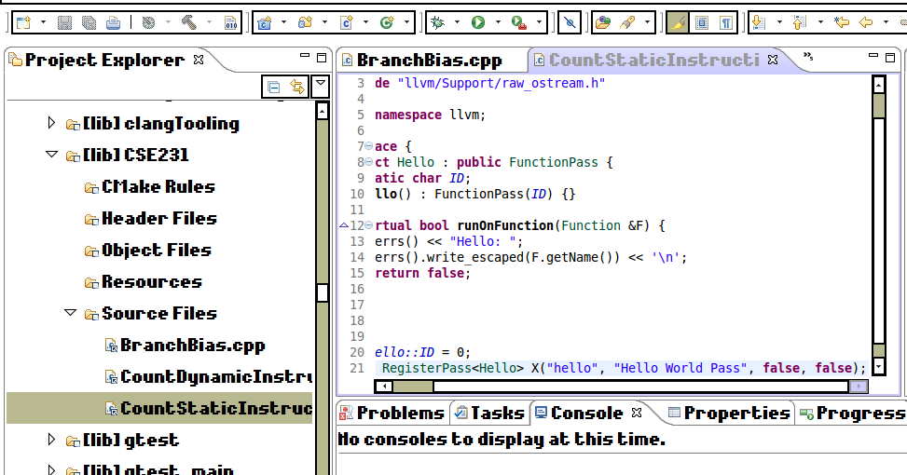
frame-col-ypos:0.000000in; bot-style:none; xpos:0.836111in; wrap-mode:wrapped-both; frame-type:image; ypos:0.000000in; left-style:none; frame-height:2.631250in; top-style:none; position-to:block-above-text; frame-col-xpos:0.836111in; right-style:none; frame-width:5.020833in

This stuff should index just fine now if you press F3 or whatever

after you build you need to compile the shitty examples to get their bytecode

Issue is that the .so does not have the symbols built in to run as a share library.

I tried fixing this in the CmakeLists.txt

you can add libraries to reference. I tried this line which should have the def for FunctionPass
set(LLVM_LINK_COMPONENTS ${LLVM_TARGETS_TO_BUILD} bitreader asmparser bitwriter irreader instrumentation scalaropts objcarcopts ipo vectorize core)

core should have it. But it does not work (found it was core by finding the source file than listing the CmakeLists.txt file in that directory)

