石家庄铁道大学2020年冬季
2017 级寒假作业—信息热词分析
课程名称： 大数据库技术与应用 任课教师： 王建民

- 采集北京市政百姓信件内容；

代码：
package com.lq.webmagic;

import java.io.IOException;
import java.util.ArrayList;
import java.util.List;

import com.gargoylesoftware.htmlunit.*;
import com.gargoylesoftware.htmlunit.html.HtmlDivision;
import com.gargoylesoftware.htmlunit.html.HtmlElement;
import com.gargoylesoftware.htmlunit.html.HtmlPage;
import com.gargoylesoftware.htmlunit.javascript.host.html.HTMLDivElement;
import com.gargoylesoftware.htmlunit.javascript.host.html.HTMLElement;
import com.lq.file.LocalFile;
import com.lq.file.StringHandle;

public class HtmlUnit
{
static List<String> lines_zi=new ArrayList<String>();
static List<String> lines_jian=new ArrayList<String>();
static List<String> lines_tou=new ArrayList<String>();
static String line;
public static void Value_start()
{
WebClient webClient=new WebClient(BrowserVersion.FIREFOX_60);
try {
webClient.getOptions().setActiveXNative(false); //设置是否允许本地ActiveX组件
webClient.getOptions().setJavaScriptEnabled(true);//启用/禁用JavaScript的支持。默认情况下，这个属性被启用。
webClient.getOptions().setDoNotTrackEnabled(true);//启用/禁用“不跟踪”的支持。默认情况下，这个属性被禁用。
webClient.getOptions().setThrowExceptionOnScriptError(false);//更改此Web客户端时出现脚本错误的行为。
webClient.getOptions().setThrowExceptionOnFailingStatusCode(false);//指定是否也不例外将在一个失败的状态代码的情况下被抛出。成功的状态码的范围是200-299。默认值为true。
webClient.getCache().setMaxSize(100); //获取当前正在使用的缓存。
webClient.setAjaxController(new NicelyResynchronizingAjaxController());//设置当前AJAX控制器 NicelyResynchronxxx()：这AjaxController重新同步调用从主线程中调用。这个想法是，异步AJAX调用直接响应于用户动作（因此在“主”线程，而不是在后台任务的线程）进行直接对用户有用的。轻松拥有一个可测试的状态，这些调用同步进行。
webClient.getOptions().setCssEnabled(false);//不支持css
webClient.getOptions().setUseInsecureSSL(true);//如果设置为true，客户端将接受连接到任何主机，而不管他们是否有有效证件或没有。当你试图连接到使用过期或损坏的证书的服务器，这是特别有用的。
webClient.getCookieManager().setCookiesEnabled(true); //返回此web客户端使用cookie管理器。启用/禁用cookie支持。 Cookies是默认启用
webClient.getCache().clear();
webClient.setRefreshHandler(new ImmediateRefreshHandler());//设置每当刷新触发所使用的处理程序 这刷新处理程序后立即刷新指定的页面，使用指定的URL，而忽略了等待时间。
webClient.getOptions().setTimeout(15*1000); //设置WebConnection的超时。设置为2秒
webClient.setJavaScriptTimeout(600*1000); //设置了一个脚本所允许被终止之前执行的毫秒数
webClient.waitForBackgroundJavaScript(600*1000);//安排通过window.setTimeout，window.setInterval或异步的XMLHttpRequest执行JavaScript的任务。决定了后台任务等待（毫秒）延迟
HtmlPage page = webClient.getPage("http://www.beijing.gov.cn/hudong/hdjl/com.web.search.mailList.flow");
HtmlElement a=page.getElementByName("nextPage");
int j=1,lastj=0;
StringHandle sh=new StringHandle();
List<String> lastInfo_zi=new ArrayList<String>();
List<String> lastInfo_jian=new ArrayList<String>();
List<String> lastInfo_tou=new ArrayList<String>();

while(j!=2240) //设置爬取2235页，从现在到2015年1月
{
String nowInfo=page.asXml();
String re="letterdetail\\('.*?','AH[0-9]{11}'\\)";
List<String> infoList_zi=sh.getExpString(re, nowInfo);
int g_size_zi=infoList_zi.size();
if(sh.StringListSameOutStringList(infoList_zi, lastInfo_zi).size()!=g_size_zi&&g_size_zi==6)
{
for(int i=0;i<g_size_zi;i++)
{
String type=sh.getExpToString("(?<=[(]')[^x00-xff]{2}",infoList_zi.get(i));
System.out.println(type);
String type1=new String("建议");
String type2=new String("咨询");
if(type.equals(type1)){type="com.web.suggest.suggesDetail.flow?originalId=";}
else if(type.equals(type2)){type="com.web.consult.consultDetail.flow?originalId=";}
else {type="com.web.complain.complainDetail.flow?originalId=";}
String theWeb=sh.getExpToString("AH[0-9]{11}", infoList_zi.get(i));
theWeb=type+theWeb;
System.out.println(theWeb);
lines_zi.add(theWeb);
System.out.println("-------------------------------------------");

if(i==g_size_zi-1)
{
lastInfo_zi=infoList_zi;
System.out.println(j);
j++;
break;
}

}
page=a.click();
}
}

LocalFile localFile=new LocalFile();
try {
localFile.list_local(lines_zi,"xj_list.txt");
} catch (Exception e) {
e.printStackTrace();
}
}catch (FailingHttpStatusCodeException | IOException e) {
// TODO Auto-generated catch block
e.printStackTrace();
} finally{
webClient.close(); //
}

}
public static void main(String[] args) {
Value_start();
}

}

截图：
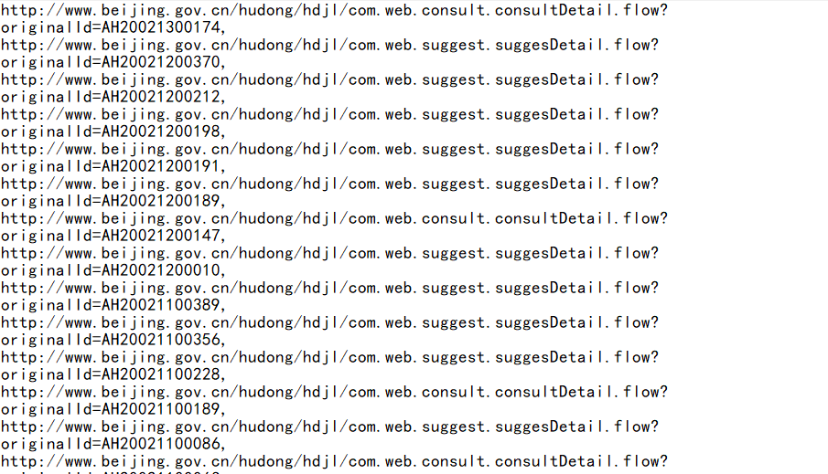
代码：
import requests;
import re
import os
import traceback
from lxml import html
from lxml import etree
from _multiprocessing import send
from _overlapped import NULL

#获取HTML内容
def getHTMLText(url):
access={"User-Agent":"Mozilla/5.0 (Windows NT 10.0; Win64; x64; rv:72.0) Gecko/20100101 Firefox/72.0"}
try:
r=requests.get(url,headers=access)
r.raise_for_status()
r.encoding=r.apparent_encoding
return r.text
except:
return "无法连接"

def get_xinjian_massage(lst,url,fpath):
#url="http://www.beijing.gov.cn/hudong/hdjl/com.web.complain.complainDetail.flow?originalId=AH17071400095"
print(url)
xinjian_html=getHTMLText(url)
soup=etree.HTML(xinjian_html)
#编号
Id=soup.xpath("//a[@class='dex_yes font12']/@onclick")
if "".join(Id)=="":
Id=soup.xpath("//a[@class='dex_yes font12 ']/@onclick")
Id=re.search(r"AH[0-9]{11}","".join(Id))
Id=Id.group(0)
else:
Id=re.search(r"AH[0-9]{11}","".join(Id))
Id=Id.group(0)
#信件类型
type=soup.xpath("//meta[@name='Keywords']/@content")
if "".join(type)=="":
type=soup.xpath("//meta[@name='Keywords ']/@content")
type=re.search(r"^[^x00-xff]{2}","".join(type))
type=type.group(0)
else:
type=re.search(r"^[^x00-xff]{2}","".join(type))
type=type.group(0)
#回复状态
statue=str("已回复")
#信件简略内容
massage=soup.xpath("//div[@class='col-xs-10 col-sm-10 col-md-10 o-font4 my-2']/strong/text()")
if "".join(massage)=="":
massage=soup.xpath("//div[@class='col-xs-10 col-sm-10 col-md-10 o-font4 my-2 ']/strong/text()")
massage="".join(massage)
else:
massage="".join(massage)
#发信人
addresser=soup.xpath("//div[@class='col-xs-10 col-lg-3 col-sm-3 col-md-4 text-muted']/text()")
if "".join(addresser)=="":
addresser=soup.xpath("//div[@class='col-xs-10 col-lg-3 col-sm-3 col-md-4 text-muted ']/text()")
addresser="".join(addresser)
addresser=re.search(r"(?<=来信人：).*","".join(addresser.split()))
addresser=addresser.group(0)
else:
addresser="".join(addresser)
addresser=re.search(r"(?<=来信人：).*","".join(addresser.split()))
addresser=addresser.group(0)
#发信时间
send_time=soup.xpath("//div[@class='col-xs-5 col-lg-3 col-sm-3 col-md-3 text-muted']/text()")
if "".join(send_time)=="":
send_time=soup.xpath("//div[@class='col-xs-5 col-lg-3 col-sm-3 col-md-3 text-muted ']/text()")
send_time=re.search(r"[0-9]{4}-[0-9]{2}-[0-9]{2}","".join(send_time))
send_time=send_time.group(0)
else:
send_time=re.search(r"[0-9]{4}-[0-9]{2}-[0-9]{2}","".join(send_time))
send_time=send_time.group(0)
#网友同问
asker=soup.xpath("//div[@class='col-xs-4 col-lg-3 col-sm-3 col-md-3 text-muted']/label/text()")
if "".join(asker)=="":
asker=soup.xpath("//div[@class='col-xs-4 col-lg-3 col-sm-3 col-md-3 text-muted ']/label/text()")
asker=re.search(r"[0-9]+","".join(asker))
asker=asker.group(0)
else:
asker=re.search(r"[0-9]+","".join(asker))
asker=asker.group(0)
#信件详细内容
details=soup.xpath("//div[@class='col-xs-12 col-md-12 column p-2 text-muted mx-2']/text()")
if "".join(details)=="":
details=soup.xpath("//div[@class='col-xs-12 col-md-12 column p-2 text-muted mx-2 ']/text()")
details="".join(details)
details="".join(details.split())
else:
details="".join(details)
details="".join(details.split())
#回信人
answering=soup.xpath("//div[@class='col-xs-9 col-sm-7 col-md-5 o-font4 my-2']/span/text()")

if "".join(answering)=="":
answering=soup.xpath("//div[@class='col-xs-9 col-sm-7 col-md-5 o-font4 my-2 ']/span/text()")
if "".join(answering)=="":
answering=soup.xpath("//div[@class='col-xs-9 col-sm-7 col-md-5 o-font4 my-2']/text()")
if "".join(answering)=="":
answering=soup.xpath("//div[@class='col-xs-9 col-sm-7 col-md-5 o-font4 my-2 ']/text()")
answering="".join(answering)
answering="".join(answering.split())
else:
answering="".join(answering)
answering="".join(answering.split())
else:
answering="".join(answering)
answering="".join(answering.split())
else:
answering="".join(answering)
answering="".join(answering.split())
#回信时间
answer_time=soup.xpath("//div[@class='col-xs-12 col-sm-3 col-md-3 my-2']/text()")
if "".join(answer_time)=="":
answer_time=soup.xpath("//div[@class='col-xs-12 col-sm-3 col-md-3 my-2 ']/text()")
answer_time=re.search(r"[0-9]{4}-[0-9]{2}-[0-9]{2}","".join(answer_time))
answer_time=answer_time.group(0)
else:
answer_time=re.search(r"[0-9]{4}-[0-9]{2}-[0-9]{2}","".join(answer_time))
answer_time=answer_time.group(0)
#回复内容
replyt=soup.xpath("//div[@class='col-xs-12 col-md-12 column p-4 text-muted my-3']")
reply=replyt[0].xpath("string(.)").strip()
if "".join(reply)=="":
replyt=soup.xpath("//div[@class='col-xs-12 col-md-12 column p-4 text-muted my-3 ']")
reply=replyt[0].xpath("string(.)").strip()
reply="".join(reply)
reply="".join(reply.split())
else:
reply="".join(reply)
reply="".join(reply.split())
#xinjian=Id
xinjian=Id+"&&"+type+"&&"+massage+"&&"+statue+"&&"+send_time+"&&"+addresser+"&&"+asker+"&&"+details+"&&"+answering+"&&"+answer_time+"&&"+reply+"\n"
print(xinjian)
save__file(fpath,xinjian)
return xinjian

#创建文件
#file_path：文件路径
#msg：即要写入的内容
def save__file(file_path,msg):
f=open(file_path,"a",encoding='utf-8')
f.write(msg)
f.close

def Run(out_put_file,fpath):
urls=""
lsts=[]
lst=[]
cond=0
with open(out_put_file,"r") as f:
urls=f.read()
lsts=urls.split(",")
for i in lsts:
xinjian=""
xinjian=get_xinjian_massage(lst,i,fpath)
if xinjian=="":
continue
lst.append(xinjian)
cond+=1
print("\n当前速度：{:.2f}%".format(cond*100/len(lsts)),end="")
return lst

#主函数
def main():
fpath="xinnjian.txt"
out_put_file="xj_list.txt"
if(os.path.exists(fpath)):
os.remove(fpath)
else:
lst=[]
lst=Run(out_put_file, fpath)
for i in lst:
print(i+"aaa")

#程序入口
main()
截图：
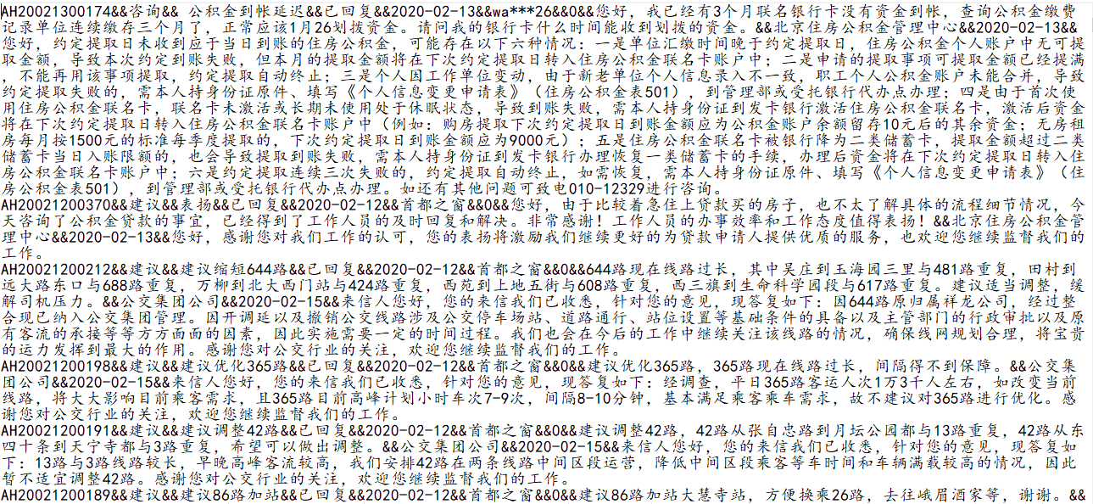

- 分析数据到 MySQL 库；

代码：
package com.lq.dao;

import com.lq.bean.XinJian;
import com.lq.file.LocalFile;

import java.sql.*;
import java.util.List;

public class AddToMySql
{
private static String DriverName="com.mysql.jdbc.Driver";
private static String UName="root";
private static String Upwd="root";
private static String Url="jdbc:mysql://192.168.25.1:3306/xinjian?useUnicode=true&characterEncoding=UTF-8";
public boolean exit(String id) //根据Id查询是否存在 如果存在返回true，不存在返回false
{
//System.out.println(query(id));
return query(id)==1?true:false;
}
public int query(String Id) //查询是否存在;存在return 1;否存在return 0;
{
XinJian xinJian=null;
Connection conn=null;
PreparedStatement pstmt=null;
ResultSet result=null;
int count=-1;
try {
Class.forName(DriverName);
conn=DriverManager.getConnection(Url, UName, Upwd);
String sql="select count(*) from xinjian where Id=?";
pstmt= conn.prepareStatement(sql);
pstmt.setString(1,Id);
result=pstmt.executeQuery();
if(result.next()){
count=result.getInt(1);
System.out.println("已存在");
}
if(count>0)
return count;
}
catch(ClassNotFoundException e)
{
e.printStackTrace();
return count;
}
catch (SQLException e)
{
e.printStackTrace();
return count;
}
catch(Exception e)
{
e.printStackTrace();
return count;
}
finally {
try {
if(result!=null) result.close();
if(pstmt!=null) pstmt.close();
if(conn!=null) conn.close();
}
catch(SQLException e)
{
e.printStackTrace();
}
}
return count;
}
public boolean Add(XinJian xinJian) //添加信息
{
Connection conn=null;
PreparedStatement pstmt=null;
try {
AddToMySql addToMySql=new AddToMySql();
//System.out.println(addToMySql.exit(xinJian.getId()));
if(addToMySql.exit(xinJian.getId())!=true) {
//System.out.println("2");
Class.forName(DriverName);
conn = DriverManager.getConnection(Url, UName, Upwd);
String sql = "insert into xinjian(Id,typet,massage,statue,send_time,addresser,asker,details,answering,answer_time,reply) values(?,?,?,?,?,?,?,?,?,?,?)";
pstmt = conn.prepareStatement(sql);
pstmt.setString(1, xinJian.getId());
pstmt.setString(2, xinJian.getType());
pstmt.setString(3, xinJian.getMassage());
pstmt.setString(4, xinJian.getStatue());
pstmt.setString(5, xinJian.getSend_time());
pstmt.setString(6, xinJian.getAddresser());
pstmt.setString(7, xinJian.getAsker());
pstmt.setString(8, xinJian.getDetails());
pstmt.setString(9, xinJian.getAnswering());
pstmt.setString(10, xinJian.getAnswer_time());
pstmt.setString(11, xinJian.getReply());

int connt = pstmt.executeUpdate();
if (connt > 0) {
System.out.println("保存成功");
return true;

}
else {
System.out.println("已存在");
return false;
}
}
else return false;
}
catch(ClassNotFoundException e)
{
e.printStackTrace();
return false; //系统异常
}
catch(SQLException e)
{
e.printStackTrace();
return false;
}
catch(Exception e)
{
e.printStackTrace();
return false;
}
finally
{
try
{
if(pstmt!=null){
pstmt.close();
conn.close();
}
}
catch(SQLException e)
{
e.printStackTrace();
}
catch(Exception e)
{
e.printStackTrace();
}
}

}
public void Run(){
try {
LocalFile localFile=new LocalFile();
AddToMySql addToMySql=new AddToMySql();
String [] strs = localFile.read_xinjian_local("xinjian.txt");
String[] str=null;
for(int i=0;i<strs.length;i++){
str=strs[i].split("&&");
XinJian xinJian=null;

// System.out.println(str[0]+str[10]);
// System.out.println("------------------------------------------------------");
xinJian=new XinJian(str[0],str[1],str[2],str[3],str[4],str[5],str[6],str[7],str[8],str[9],str[10]);
addToMySql.Add(xinJian);
// System.out.println(xinJian.toString());
}
//System.out.println(str.length);
} catch (Exception e) {
e.printStackTrace();
}
}

public static void main(String[] args){
AddToMySql addToMySql=new AddToMySql();
//addToMySql.exit("AH19080800081");
addToMySql.Run();
System.out.println("finish");
}

}
package com.lq.file;

import com.lq.bean.XinJian;

import java.io.*;
import java.util.ArrayList;
import java.util.List;

public class LocalFile
{
public void Save_local(XinJian xinJian,String files) throws Exception//xieru xinjian de xiangxi xingxi
{
File file=new File("D:\\javaxiangmu\\beiJinXinJian\\WebContent\\outfile"+File.separator+files);

if (!file.getParentFile().exists())
{
file.getParentFile().mkdirs();
}
file.delete();
FileWriter local_file=new FileWriter(file);
BufferedWriter output=new BufferedWriter(local_file);
//Writer output=new FileWriter(local_file,true);

String contents=xinJian.toString()+",\n";
output.write(contents);
output.close();
}

public void list_local(List<String> lists,String files) throws Exception// xieru xinjian de liebiao
{
File file=new File("D:\\javaxiangmu\\beiJinXinJian\\WebContent\\outfile"+File.separator+files);
if (!file.getParentFile().exists())
{
file.getParentFile().mkdirs();
}
file.delete();
FileWriter local_file=new FileWriter(file);
BufferedWriter output=new BufferedWriter(local_file);
//Writer output=new FileWriter(local_file,true);
for(String list:lists){
String url="http://www.beijing.gov.cn/hudong/hdjl/"+list.toString();
String contents=url+",\n";
output.write(contents);
}
output.close();
}

public String[] read_list_local(String files) throws Exception
{
File file =new File("D:\\javaxiangmu\\beiJinXinJian\\WebContent\\outfile"+File.separator+files);
FileReader locla_file=new FileReader(file);
BufferedReader input=new BufferedReader(locla_file);
char bb[]=new char[1024];
String []read_all=null;
while(input.readLine()!=null){
int lines=input.read(bb);
String read=new String(bb,0,lines);
read_all=read.split(",");
}
return read_all;
}

public String[] read_xinjian_local(String files) throws Exception
{
File file =new File("D:\\javaxiangmu\\beiJinXinJian\\WebContent\\outfile"+File.separator+files);
FileReader locla_file=new FileReader(file);
BufferedReader input=new BufferedReader(locla_file);
char bb[]=new char[1024];
String []read_all=null;
String str=null;
int len=-1;
List<String> reads=new ArrayList<String>();
while((len=input.read(bb))!=-1){
String read=new String(bb,0,len);
reads.add(read);

}
StringHandle stringHandle=new StringHandle();
str=stringHandle.ListToString(reads);
read_all=str.split("\\r?\\n");
return read_all;
}

}

截图：
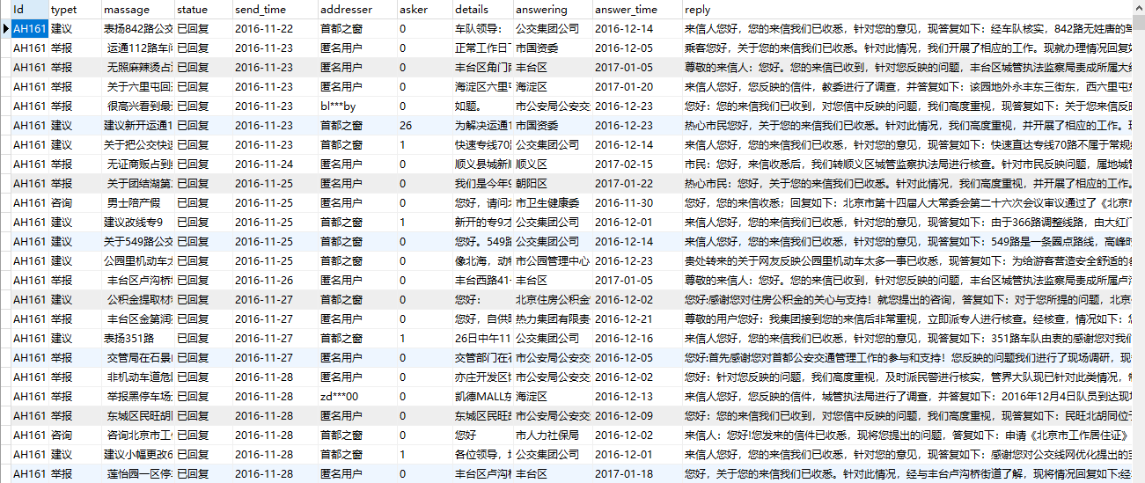
- 开发 JavaWeb+ECharts 完成信件数据图表展示过程。

代码：
package com.lq.servlet;

import java.io.IOException;
import java.io.PrintWriter;
import java.util.ArrayList;
import java.util.List;

import javax.servlet.ServletException;
import javax.servlet.annotation.WebServlet;
import javax.servlet.http.HttpServlet;
import javax.servlet.http.HttpServletRequest;
import javax.servlet.http.HttpServletResponse;

import net.sf.json.JSONArray;
import com.lq.bean.LeiXinTj;
import com.lq.dao.QueryFromMySql;

@WebServlet("/QueryByAnswering")
public class QueryByAnswering extends HttpServlet {
private static final long serialVersionUID = 1L;

/**
* @see HttpServlet#HttpServlet()
*/
public QueryByAnswering() {
super();
// TODO Auto-generated constructor stub
}

/**
* @see HttpServlet#doGet(HttpServletRequest request, HttpServletResponse response)
*/
protected void doGet(HttpServletRequest request, HttpServletResponse response)
throws ServletException, IOException {
QueryFromMySql queryFromMySql=new QueryFromMySql();
ArrayList<LeiXinTj> leiXinTjs=queryFromMySql.QueryByAnswering();
response.setContentType("text/html; charset=utf-8");
JSONArray jsonArray=JSONArray.fromObject(leiXinTjs); //将数据转为json类型
System.out.println(jsonArray.toString());
PrintWriter writer = response.getWriter();
writer.println(jsonArray);
writer.flush();
writer.close();
}

/**
* @see HttpServlet#doPost(HttpServletRequest request, HttpServletResponse response)
*/
protected void doPost(HttpServletRequest request, HttpServletResponse response)
throws ServletException, IOException {
doGet(request, response);
}

}
package com.lq.servlet;

import java.io.IOException;
import java.io.PrintWriter;
import java.util.ArrayList;
import java.util.List;

import javax.servlet.ServletException;
import javax.servlet.annotation.WebServlet;
import javax.servlet.http.HttpServlet;
import javax.servlet.http.HttpServletRequest;
import javax.servlet.http.HttpServletResponse;

import net.sf.json.JSONArray;
import com.lq.bean.LeiXinTj;
import com.lq.dao.QueryFromMySql;

/**
* Servlet implementation class QueryBySend_time
*/
@WebServlet("/QueryBySend_time")
public class QueryBySend_time extends HttpServlet {
private static final long serialVersionUID = 1L;

/**
* @see HttpServlet#HttpServlet()
*/
public QueryBySend_time() {
super();
// TODO Auto-generated constructor stub
}

/**
* @see HttpServlet#doGet(HttpServletRequest request, HttpServletResponse response)
*/
protected void doGet(HttpServletRequest request, HttpServletResponse response)
throws ServletException, IOException {
QueryFromMySql queryFromMySql=new QueryFromMySql();
ArrayList<LeiXinTj> leiXinTjs=queryFromMySql.QueryBySend_time();
response.setContentType("text/html; charset=utf-8");
System.out.println("**************************************");
JSONArray jsonArray=JSONArray.fromObject(leiXinTjs);
System.out.println(jsonArray.toString());
PrintWriter writer = response.getWriter();
writer.println(jsonArray);package com.lq.servlet;

import java.io.IOException;
import java.io.PrintWriter;
import java.util.ArrayList;
import java.util.List;

import javax.servlet.ServletException;
import javax.servlet.annotation.WebServlet;
import javax.servlet.http.HttpServlet;
import javax.servlet.http.HttpServletRequest;
import javax.servlet.http.HttpServletResponse;

import net.sf.json.JSONArray;
import com.lq.bean.LeiXinTj;
import com.lq.dao.QueryFromMySql;

@WebServlet("/QueryByTypet")
public class QueryByTypet extends HttpServlet {
private static final long serialVersionUID = 1L;

public QueryByTypet() {
super();
// TODO Auto-generated constructor stub
}

protected void doGet(HttpServletRequest request, HttpServletResponse response)
throws ServletException, IOException {
QueryFromMySql queryFromMySql=new QueryFromMySql();
ArrayList<LeiXinTj> leiXinTjs=queryFromMySql.QueryByTypet();
response.setContentType("text/html; charset=utf-8");
System.out.println("**************************************");
JSONArray jsonArray=JSONArray.fromObject(leiXinTjs);
System.out.println(jsonArray.toString());
PrintWriter writer = response.getWriter();
writer.println(jsonArray);
writer.flush();
writer.close();

}

protected void doPost(HttpServletRequest request, HttpServletResponse response)
throws ServletException, IOException {
doGet(request, response);
}

}

writer.flush();
writer.close();
}

/**
* @see HttpServlet#doPost(HttpServletRequest request, HttpServletResponse response)
*/
protected void doPost(HttpServletRequest request, HttpServletResponse response)
throws ServletException, IOException {
doGet(request, response);
}

}

截图：
