石家庄铁道大学2020年春季
2017 级课堂测试试卷—数据分析练习
课程名称： 大数据库技术与应用 任课教师： 王建民 考试时间： 实现为止 分钟

- 数据爬取：爬取门户网站上的疫情统计数据，要求具体到各个省的地级市的每日的确诊病例的统计人数，并将上述爬取信息导入到本地数据库中。
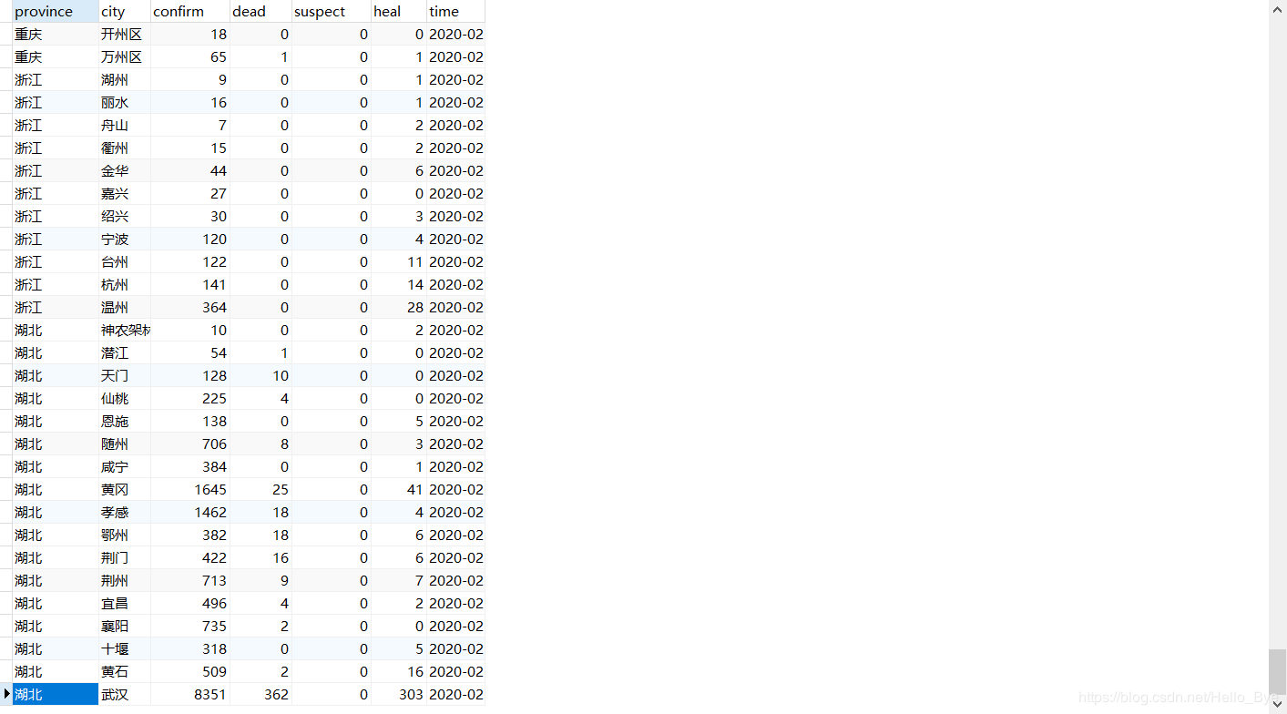
代码：
import requests
import json
import os
import re
import datetime

class item:
def __init__(self):
self.country=list()#国家
self.province = list()#省份
self.area=list()#地区
self.confirm=list()#确诊
self.suspect=list()#疑似
self.heal=list()#治愈
self.dead=list()#死亡
Data_Box=item()#数据盒子

#创建链接数据库
def connect(opt):
config={'host':opt['host'] ,
'user':opt['user'],
'password':opt['password'] ,
'port':opt['port'] ,
'database':opt['database'] ,
'charset':opt['charset']
}
try:
mydb=mysql.connector.connect(**config)#connect方法加载config的配置进行数据库的连接，完成后用一个变量进行接收
except mysql.connector.Error as e:
print('数据库链接失败！',str(e))
else:#try没有异常的时候才会执行
print("数据库连接sucessfully!")
return mydb

# 插入
# sql = "INSERT INTO sites (name, url) VALUES (%s, %s)"
# val = ("RUNOOB", "https://www.runoob.com")
def add(mydb,sql,val):
mycursor = mydb.cursor()
mycursor.execute(sql, val)
mydb.commit() # 数据表内容有更新，必须使用到该语句
print(mycursor.rowcount, "记录插入成功。")

# 查询
# sql="SELECT * FROM sites"
def query(mydb,sql,val):
mycursor = mydb.cursor()
mycursor.execute(sql,val)
myresult = mycursor.fetchall() # fetchall() 获取所有记录
for x in myresult:
print(x)
return myresult

#获取链接内容
def GetHtmlText(url):
try:
res = requests.get(url,timeout = 30)
res.raise_for_status()
res.encoding = res.apparent_encoding
return res.text
except:
return "Error"
#获取数据转为json
def getJson(China):
City_Count_json = json.loads(China)
City_Count_json = City_Count_json["data"]#将json数据中的data字段的数据提取处理
City_Count_json = json.loads(City_Count_json)#将提取出的字符串转换为json数据
return City_Count_json

#获取每日总信息
def getSum(City_Count_json):
lastUpdateTime = City_Count_json["lastUpdateTime"]
lastUpdateTime=re.search(r"[0-9]{4}-[0-9]{2}-[0-9]{2}",lastUpdateTime)
lastUpdateTime=lastUpdateTime.group(0)
chinaTotal_json = City_Count_json["chinaTotal"]#提取处其chinaTotal字段中的数据
confirmCount = str(chinaTotal_json["confirm"])
suspectCount = str(chinaTotal_json["suspect"])
deadCount = str(chinaTotal_json["dead"]) #GetTextCenter(China,r"\"deadCount\": ",r",\n") #疑似人数
cure = str(chinaTotal_json["heal"]) #GetTextCenter(China,r"\"cure\": ",r"\n") #治愈人数
print("更新时间：" + lastUpdateTime + "\n" + "确诊人数为：" + confirmCount + "人\n" + "死亡人数为：" +
deadCount + "人\n" + "疑似人数为：" + suspectCount + "人\n" + "治愈人数为：" + cure +
"人\n" )
sum="。"+lastUpdateTime +","+ confirmCount +","+deadCount + "," +suspectCount +","+cure +"。\n"
return sum

######用于循环中备注信息，防止混淆变量名而出错，然而还是耗费了相当长的时间理清这些变量
#areaTree_json[i]["children"]省份
#areaTree_json[i]["children"][j]["name"]省份名
#areaTree_json[i]["children"][j]["children"][n]省份中的地区 list
#areaTree_json[i]["children"][j]["children"][n]省份中的地区 json
#areaTree_json[i]["children"][j]["children"][n]["name"]省份中的地区名
#areaTree_json[i]["children"][j]["children"][n]["total"]省份中的地区数据json {'confirm': 134, 'suspect': 0, 'dead': 0, 'heal': 4}
#获取各省市信息
def Get_Data_China(City_Count_json):
areaTree_json=City_Count_json["areaTree"]#包含国家、省份、地区的所有信息，且国家为首索引
country_len = len(areaTree_json)
for i in range(0,country_len):
if(areaTree_json[i]["name"]=="中国"): #如果为中国则说明具有省份信息
province_len = len(areaTree_json[i]["children"]) #获取省份长度
for j in range(0,province_len):
area_len=len(areaTree_json[i]["children"][j]["children"])#获取地区长度
for n in range(0,area_len):
total=areaTree_json[i]["children"][j]["children"][n]["total"] #获取地区的总体疫情情况+
Data_Box.country.append("中国")
Data_Box.province.append(areaTree_json[i]["children"][j]["name"])
Data_Box.area.append(areaTree_json[i]["children"][j]["children"][n]["name"])
Data_Box.confirm.append(total["confirm"])
Data_Box.dead.append(total["dead"])
Data_Box.heal.append(total["heal"]) #中国区域获取完毕
return len(Data_Box.area)
#创建文件
#file_path：文件路径
#msg：即要写入的内容
def save__file(file_path,msg):
f=open(file_path,"a",encoding='utf-8')
f.write(msg)
f.close

def Add_Area(fpath,length):
print("国家 省份 地区 确诊人数 治愈人数 死亡人数 ")
for n in range(0,length):
print(Data_Box.country[n]+" "+Data_Box.province[n]+" "+Data_Box.area[n]+" "
+str(Data_Box.confirm[n])+" "+str(Data_Box.heal[n])+" "+ str(Data_Box.dead[n]))
area_yiqing=Data_Box.country[n]+"&&"+Data_Box.province[n]+"&&"+Data_Box.area[n]+"&&"+str(Data_Box.confirm[n])+"&&"+str(Data_Box.heal[n])+"&&"+ str(Data_Box.dead[n])+"\n"
save__file(fpath, area_yiqing)

def main():
fpath="D://javaxiangmu//GZBD//WebContent//outfile/yiqing.txt"
if(os.path.exists(fpath)):
os.remove(fpath)
else:
Get_China=r"https://view.inews.qq.com/g2/getOnsInfo?name=disease_h5"
China = GetHtmlText(Get_China) #获取链接内容
City_Count_json=getJson(China) #获取json数据
sum=getSum(City_Count_json) #获取每日信息
save__file(fpath, sum) #添加每日信息到sum表
length=Get_Data_China(City_Count_json)#获取每个省市信息并获取长度
package com.lq.file;

import com.lq.bean.BinLin;

import java.io.*;
import java.util.ArrayList;
import java.util.List;

public class LocalFile
{

public String[] read_list_local(String files) throws Exception
{
File file =new File("D:\\\\javaxiangmu\\\\GZBD\\\\WebContent\\\\outfile"+File.separator+files);
FileReader locla_file=new FileReader(file);
BufferedReader input=new BufferedReader(locla_file);
char bb[]=new char[1024];
String []read_all=null;
while(input.readLine()!=null){
int lines=input.read(bb);
String read=new String(bb,0,lines);
read_all=read.split(",");
}
return read_all;
}

public String[] read_BinLin_local(String files) throws Exception
{
File file =new File("D:\\javaxiangmu\\GZBD\\WebContent\\outfile"+File.separator+files);
FileReader locla_file=new FileReader(file);
BufferedReader input=new BufferedReader(locla_file);
char bb[]=new char[1024];
String []read_all=null;
String str=null;
int len=-1;
List<String> reads=new ArrayList<String>();
while((len=input.read(bb))!=-1){
String read=new String(bb,0,len);
reads.add(read);

}
StringHandle stringHandle=new StringHandle();
str=stringHandle.ListToString(reads);
read_all=str.split("\\r?\\n");
int cont=1;
for(String read:read_all) {
cont++;
// System.out.println(read);
// System.out.println("--------------------------------------");
System.out.println("第"+cont+"条");
}
// System.out.println(read_all[0]);
return read_all;
}
// public static void main(String[] args) {
// LocalFile localFile=new LocalFile();
// try {
// read_BinLin_local("yiqing.txt");
// } catch (Exception e) {
// // TODO Auto-generated catch block
// e.printStackTrace();
// }
// }
}
package com.lq.dao;

import com.lq.bean.BinLin;
import com.lq.file.LocalFile;
import com.lq.file.StringHandle;

import java.sql.*;
import java.util.List;

public class AddToMySql
{
private static String DriverName="com.mysql.jdbc.Driver";
private static String UName="root";
private static String Upwd="root";
private static String Url="jdbc:mysql://192.168.25.1:3306/xinjian?useUnicode=true&characterEncoding=UTF-8";
public boolean exit(String shen,String diqu,String nd) //根据省名称和时间查询是否存在 如果存在返回true，不存在返回false
{
//System.out.println(query(id));
return query(shen,diqu,nd)==1?true:false;
}
public int query(String shen,String diqu,String nd) //查询是否存在;存在return 1;否存在return 0;
{
BinLin BinLin=null;
Connection conn=null;
PreparedStatement pstmt=null;
ResultSet result=null;
int count=-1;
try {
Class.forName(DriverName);
conn=DriverManager.getConnection(Url, UName, Upwd);
String sql="select count(*) from zbl where shen=? and diqu=? and nd=?";
pstmt= conn.prepareStatement(sql);
pstmt.setString(1,shen);
pstmt.setString(2,diqu);
pstmt.setString(3, nd);
result=pstmt.executeQuery();
if(result.next()){
count=result.getInt(1);
System.out.println("已存在");
}
if(count>0)
return count;
}
catch(ClassNotFoundException e)
{
e.printStackTrace();
return count;
}
catch (SQLException e)
{
e.printStackTrace();
return count;
}
catch(Exception e)
{
e.printStackTrace();
return count;
}
finally {
try {
if(result!=null) result.close();
if(pstmt!=null) pstmt.close();
if(conn!=null) conn.close();
}
catch(SQLException e)
{
e.printStackTrace();
}
}
return count;
}
public boolean Add(BinLin BinLin) //添加信息
{
Connection conn=null;
PreparedStatement pstmt=null;
try {
AddToMySql addToMySql=new AddToMySql();
//System.out.println(addToMySql.exit(BinLin.getId()));
if(addToMySql.exit(BinLin.getShen(),BinLin.getDiqu(),BinLin.getNd())!=true) {
//System.out.println("2");
Class.forName(DriverName);
conn = DriverManager.getConnection(Url, UName, Upwd);
String sql = "insert into zbl values(NULL,?,?,?,?,?,?,?,?,?,?)";
pstmt = conn.prepareStatement(sql);
pstmt.setString(1, BinLin.getNd());
pstmt.setInt(2, BinLin.getConfirm());
pstmt.setInt(3, BinLin.getDead());
pstmt.setInt(4, BinLin.getSuspect());
pstmt.setInt(5, BinLin.getHeal());
pstmt.setString(6, BinLin.getShen());
pstmt.setString(7, BinLin.getDiqu());
pstmt.setInt(8, BinLin.getDconfirm());
pstmt.setInt(9, BinLin.getDheal());
pstmt.setInt(10, BinLin.getDdead());

int connt = pstmt.executeUpdate();
if (connt > 0) {
System.out.println("保存成功");
return true;

}
else {
System.out.println("已存在");
return false;
}
}
else return false;
}
catch(ClassNotFoundException e)
{
e.printStackTrace();
return false; //系统异常
}
catch(SQLException e)
{
e.printStackTrace();
return false;
}
catch(Exception e)
{
e.printStackTrace();
return false;
}
finally
{
try
{
if(pstmt!=null){
pstmt.close();
conn.close();
}
}
catch(SQLException e)
{
e.printStackTrace();
}
catch(Exception e)
{
e.printStackTrace();
}
}

}
public void Run(){
try {
LocalFile localFile=new LocalFile();
AddToMySql addToMySql=new AddToMySql();
String [] strs = localFile.read_BinLin_local("yiqing.txt");
String[] str_country=null;
String[] str_area=null;
System.out.println(strs.length);
String country=strs[0];
country=country.replace("。","");
//System.out.println(country);
str_country=country.split(",");
String nd=str_country[0]; //时间
int confirm=Integer.parseInt(str_country[1]); //全国确诊
int dead=Integer.parseInt(str_country[2]); //全国死亡
int suspect=Integer.parseInt(str_country[3]); //全国疑似
int heal=Integer.parseInt(str_country[4]); //全国治愈

for(int i=1;i<strs.length;i++){
str_area=strs[i].split("&&");
StringHandle stringHandle=new StringHandle();
BinLin BinLin=null;
BinLin=new BinLin(nd, confirm, dead, suspect, heal, str_area[1], str_area[2], Integer.parseInt(str_area[3]), Integer.parseInt(str_area[4]), Integer.parseInt(str_area[5]));
addToMySql.Add(BinLin);
//System.out.println(BinLin.toString());
}
//System.out.println(str_area.length);
} catch (Exception e) {
e.printStackTrace();
}
}

public static void main(String[] args){
AddToMySql addToMySql=new AddToMySql();
//addToMySql.exit("AH19080800081");
addToMySql.Run();
System.out.println("finish");
}

}

Add_Area(fpath,length)
截图；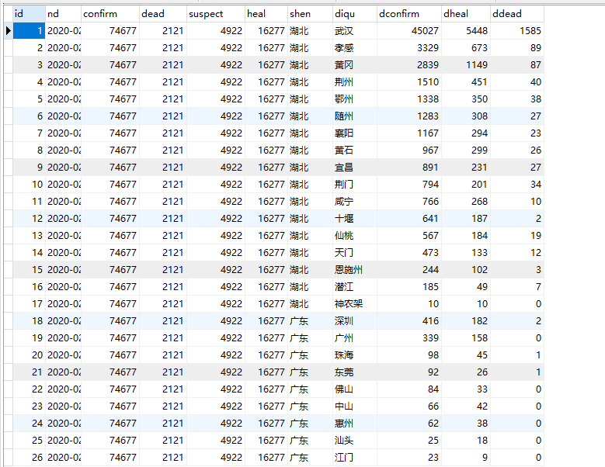
main()

- 疫情分布图可视化展示：要求展示当前的疫情分布情况。单击各个省可以下钻到各个地市的数据显示。
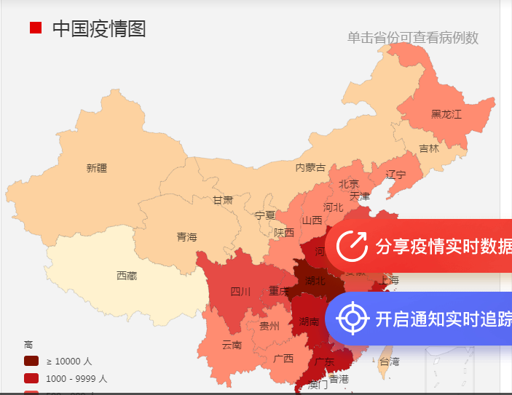
代码：
<%@ page language="java" contentType="text/html; charset=UTF-8"
pageEncoding="UTF-8"%>
<!DOCTYPE HTML>
<html>
<head>
<meta charset="utf-8">
<meta name="renderer" content="webkit|ie-comp|ie-stand">
<meta http-equiv="X-UA-Compatible" content="IE=edge,chrome=1">
<meta name="viewport" content="width=device-width,initial-scale=1,minimum-scale=1.0,maximum-scale=1.0,user-scalable=no" />
<meta http-equiv="Cache-Control" content="no-siteapp" />
<!--[if lt IE 9]>
<script type="text/javascript" src="lib/html5shiv.js"></script>
<script type="text/javascript" src="lib/respond.min.js"></script>
<![endif]-->
<link rel="stylesheet" type="text/css" href="../static/h-ui/css/H-ui.min.css" />
<link rel="stylesheet" type="text/css" href="../static/h-ui.admin/css/H-ui.admin.css" />
<link rel="stylesheet" type="text/css" href="../lib/Hui-iconfont/1.0.8/iconfont.css" />
<link rel="stylesheet" type="text/css" href="../static/h-ui.admin/skin/default/skin.css" id="skin" />
<link rel="stylesheet" type="text/css" href="../static/h-ui.admin/css/style.css" />
<!--[if IE 6]>
<script type="text/javascript" src="lib/DD_belatedPNG_0.0.8a-min.js" ></script>
<script>DD_belatedPNG.fix('*');</script>
<![endif]-->
<title>统计图</title>
</head>
<style>
#list{
min-width:700px;
height:20%;
}
#map{
width:90%;
height:600px;
}
</style>
<!--_footer 作为公共模版分离出去-->
<script type="text/javascript" src="../lib/jquery/1.9.1/jquery.min.js"></script>
<script type="text/javascript" src="../lib/layer/2.4/layer.js"></script>
<script type="text/javascript" src="../static/h-ui/js/H-ui.min.js"></script>
<script type="text/javascript" src="../static/h-ui.admin/js/H-ui.admin.js"></script> <!--/_footer 作为公共模版分离出去-->

<!--请在下方写此页面业务相关的脚本-->
<script type="text/javascript" src="echarts.min.js"></script>
<script type="text/javascript" src="jquery-1.10.2.min.js"></script>
<script type="text/javascript" src="jquery-1.11.3.min.js"></script>
<script type="text/javascript" src="china.js"></script>
<script type="text/javascript">
window.onload=function(){
jQuery(document).ready(function($) {

var myChart = echarts.init(document.getElementById('container'));
var nav=document.getElementById("nav");
var reg = new RegExp("(d=)([a-z]*)");
var str=window.location.search.substr(1).match(reg);
var tr=document.getElementById("country_list");
var tds=tr.getElementsByTagName("td");
var map=document.getElementById("map");
nav.innerHTML='<i class="Hui-iconfont">&#xe67f;</i> 首页 <span class="c-gray en">&gt;</span> 全国实时疫情<span class="c-gray en">&gt;</span> 数据展示 <a class="btn btn-success radius r" style="line-height:1.6em;margin-top:3px" href="javascript:location.replace(location.href);" title="刷新" ><i class="Hui-iconfont">&#xe68f;</i></a>';

var myChartmap = echarts.init(map,'shine');
function randomData() {
return Math.round(Math.random() * 1000);
}

function NumDescSort(a,b){
return a.value-b.value;
}

var option = {
title: [{ //标题
text: '全国确诊病例',
subtext: '数据来自卫健委',
x:'40%',
y:'15%'
}],
tooltip: {
trigger: 'item'
},
visualMap: { //左下角拉条
min: 0,
max: 2500,
left: '20%',
top: '35%',
text: ['目前', '从现在向前推发病地区总况'],
calculable: true,
colorLightness: [0.2, 100],
color: ['#c05050','#e5cf0d','#5ab1ef'],
dimension: 0
},
toolbox: {
show : true,
feature : {
mark : {show: true},
dataView : {show: true, readOnly: false},
magicType : {
show: true,
// type: ['pie', 'funnel']
},
restore : {show: true},
saveAsImage : {show: true}
}
},
series: [{ //地图
z: 1,
name: '全国疫情',
type: 'map',
map: 'china',
left: '35%',
top: '20%',

zoom: 1,
label: {
normal: {
show: true
},
emphasis: {
show: true
}
},
//roam: true,
data:[]
}]
};
myChartmap.setOption(option);

//配置扇形图
var option = {
title : {
text: '各省占比（确诊）',
subtext: '数据来自各省卫健委',
x:'40%',
y:'5%'
},
tooltip : {
trigger: 'item',
formatter: "{a} <br/>{b} : {c} ({d}%)"
},
legend: {
data:[],
orient: 'vertical',
left:'15%',
top:'10%',
name:'各省小组件',
},
toolbox: {
show : true,
feature : {
mark : {show: true},
dataView : {show: true, readOnly: false},
magicType : {
show: true,
// type: ['pie', 'funnel']
},
restore : {show: true},
saveAsImage : {show: true}
}
},
calculable : true,
series : [
{
name:'各省占比（确诊）',
type:'pie',
radius: ['5%', '65%'],
center:['70%','70%'],
max: 40, // for funnel
sort : 'ascending', // for funnel
data:[]
}
]
};

//设置图表
myChart.setOption(option);

$.ajax({
type : "post",
async : true,
url : "../QueryAll",
type:"POST",
data:
{
"method":"shan"
},
dataType:"json",

success:function(result) {
// alert(result.selected);
if(result)
{
var d=result;
var leblist = [];
var valuelist2 = [];
var valuelist1=[];
var list_country={"nd":d[0].nd,"confirm":d[0].confirm,"dead":d[0].dead,"suspect":d[0].suspect,"heal":d[0].heal};
tds[4].innerHTML='<h5>'+list_country["nd"]+'</h5>';
tds[0].innerHTML='<h5>'+list_country["confirm"]+'</h5>';
tds[1].innerHTML='<h5><font color="red">'+list_country["dead"]+'</font></h5>';
tds[2].innerHTML='<h5>'+list_country["suspect"]+'</h5>';
tds[3].innerHTML='<h5><font color="green">'+list_country["heal"]+'</font></h5>';

for(var i=0;i<d.length;i++){

var m={};
var n={};
m["value"]=d[i].dconfirm;
m["name"]=d[i].shen;
valuelist1.push(m);
valuelist2.push(m);
n["name"]=d[i].shen;
leblist.push(n);

}
myChartmap.setOption({
legend: {
data:leblist,
orient: 'vertical',
left:10,
name:'各省小组件',
},
series: [
{
name:'全国疫情',
data: valuelist1
}]
});
// 将数据添加到数据图表中
myChart.setOption({
legend: {
data:leblist
},
series: [
{
name:'各省占比（确诊）',
data: valuelist2
}]
});

}
},
error : function(errorMsg) {
//请求失败时执行该函数
alert("请求数据失败!");
// myChart.hideLoading();
}
});
//获取和处理数据

//myChart.hideLoading();

});
}
</script>
<body>
<nav class="breadcrumb" id="nav">
</nav>
<div id="list">
<div>
<h3 style="text-align:center">全国实时数据</h3>
<table style="align:center">
<tr>
<td align="center"><h4>确诊</h4></td>
<td align="center"><h4>死亡</h4></td>
<td align="center"><h4>疑似</h4></td>
<td align="center"><h4>治愈</h4></td>
<td align="center"><h4>统计时间</h4></td>
</tr>
<tr id="country_list">
<td align="center"></td>
<td align="center"></td>
<td align="center"></td>
<td align="center"></td>
<td align="center"></td>
</tr>
</table>
</div>
</div >
<div id="map">
</div>

<div class="page-container">
<div id="container" style="min-width:700px;height:400px">
</div>
</div>
<footer class="footer mt-20">
<div class="container">
<p>感谢你们的使用 &copy;2020新型冠状病毒统计<br>
本后台系统由<a href="" target="_blank" title="">石家庄铁道大学软件工程</a>提供技术支持</p>

</div>
</footer>
</body>
</html>
</body>
</html>
<%@page import="com.lq.bean.BinLin"%>
<%@page import="java.util.ArrayList"%>
<%@ page language="java" contentType="text/html; charset=UTF-8"
pageEncoding="UTF-8"%>
<!DOCTYPE HTML>
<html>
<head>
<meta charset="utf-8">
<meta name="renderer" content="webkit|ie-comp|ie-stand">
<meta http-equiv="X-UA-Compatible" content="IE=edge,chrome=1">
<meta name="viewport" content="width=device-width,initial-scale=1,minimum-scale=1.0,maximum-scale=1.0,user-scalable=no" />
<meta http-equiv="Cache-Control" content="no-siteapp" />
<!--[if lt IE 9]>
<script type="text/javascript" src="lib/html5shiv.js"></script>
<script type="text/javascript" src="lib/respond.min.js"></script>
<![endif]-->
<link rel="stylesheet" type="text/css" href="/GZBD//static/h-ui/css/H-ui.min.css" />
<link rel="stylesheet" type="text/css" href="/GZBD//static/h-ui.admin/css/H-ui.admin.css" />
<link rel="stylesheet" type="text/css" href="/GZBD//lib/Hui-iconfont/1.0.8/iconfont.css" />
<link rel="stylesheet" type="text/css" href="/GZBD//static/h-ui.admin/skin/default/skin.css" id="skin" />
<link rel="stylesheet" type="text/css" href="/GZBD//static/h-ui.admin/css/style.css" />
<!--[if IE 6]>
<script type="text/javascript" src="lib/DD_belatedPNG_0.0.8a-min.js" ></script>
<script>DD_belatedPNG.fix('*');</script>
<![endif]-->
<title>统计图</title>
</head>
<style>
#list{
min-width:700px;
height:20%;
}
#map{
width:90%;
height:600px;
}
</style>
<!--_footer 作为公共模版分离出去-->
<script type="text/javascript" src="/GZBD//lib/jquery/1.9.1/jquery.min.js"></script>
<script type="text/javascript" src="/GZBD//lib/layer/2.4/layer.js"></script>
<script type="text/javascript" src="/GZBD//static/h-ui/js/H-ui.min.js"></script>
<script type="text/javascript" src="/GZBD//static/h-ui.admin/js/H-ui.admin.js"></script> <!--/_footer 作为公共模版分离出去-->

<!--请在下方写此页面业务相关的脚本-->
<script type="text/javascript" src="/GZBD//charts/echarts.min.js"></script>
<script type="text/javascript" src="/GZBD//charts/jquery-1.10.2.min.js"></script>
<script type="text/javascript" src="/GZBD//charts/jquery-1.11.3.min.js"></script>
<script type="text/javascript" src="/GZBD//charts/china.js"></script>
<script type="text/javascript">
window.onload=function(){
var nav=document.getElementById("nav");
nav.innerHTML='<i class="Hui-iconfont">&#xe67f;</i> 首页 <span class="c-gray en">&gt;</span> 各省实时疫情<span class="c-gray en">&gt;</span> 数据展示 <a class="btn btn-success radius r" style="line-height:1.6em;margin-top:3px" href="javascript:location.replace(location.href);" title="刷新" ><i class="Hui-iconfont">&#xe68f;</i></a>';
var map=document.getElementById("map");
var myChartmap = echarts.init(map,'shine');
var table=document.getElementById('tb');
var tbody=table.tBodies[1];
var trs=tbody.getElementsByTagName("tr");
var yiqins=[];
var diques=[];
for(var i=0;i<trs.length;i++)
{
var m={};
var n={};
var dq=trs[i].cells[0].innerHTML;
var reg = new RegExp("(<h4>)([\u4e00-\u9fa5|0-9].*)(</h4>)");
var diqu=dq.match(reg);
var df=trs[i].cells[1].innerHTML;
var dconfirm=df.match(reg);
m["name"]=diqu[2];
m["value"]=dconfirm[2];
n["name"]=diqu[2];
yiqins.push(m);
diques.push(n);
}
}
</script>
<body>
<nav class="breadcrumb" id="nav">
</nav>
<div id="list">
<%
request.setCharacterEncoding("utf-8");
String shen=request.getParameter("shen");
String diqu=null;
String dconfirm=null;
String dheal=null;
String ddead=null;
%>
<div>
<h3 style="text-align:center"><%=shen %>实时数据</h3>
<table align="center" id="tb">
<tr>
<td align="center" width="150px"><h4>地区</h4></td>
<td align="center" width="150px"><h4>确诊</h4></td>
<td align="center" width="150px"><h4>治愈</h4></td>
<td align="center" width="150px"><h4>死亡</h4></td>

</tr>
<tbody>

<%
ArrayList<BinLin> binLins=(ArrayList<BinLin>)request.getAttribute("binlin");
for(BinLin binLin:binLins){
shen=request.getParameter("shen");
diqu=binLin.getDiqu();
dconfirm=binLin.getDconfirm()+"";
dheal=binLin.getDheal()+"";
ddead=binLin.getDdead()+"";

%>
<tr id="country_list">
<td align="center" width="150px"><h5><%=diqu %></h5></td>
<td align="center" width="150px"><h5><%=dconfirm %></h5></td>
<td align="center" width="150px"><h5><font color="green"><%=dheal %></font></h5></td>
<td align="center" width="150px"><h5><font color="red"><%=ddead %></font></h5></td>
</tr>
<%
}

%>
</tbody>
</table>
</div>
</div >
<div id="map">
</div>
<script>

</script>
<footer class="footer mt-20">
<div class="container">
<p>感谢你们的使用 &copy;2020新型冠状病毒统计<br>
本后台系统由<a href="" target="_blank" title="">石家庄铁道大学软件工程</a>提供技术支持</p>

</div>
</footer>
</body>
</html>
</body>
</html>

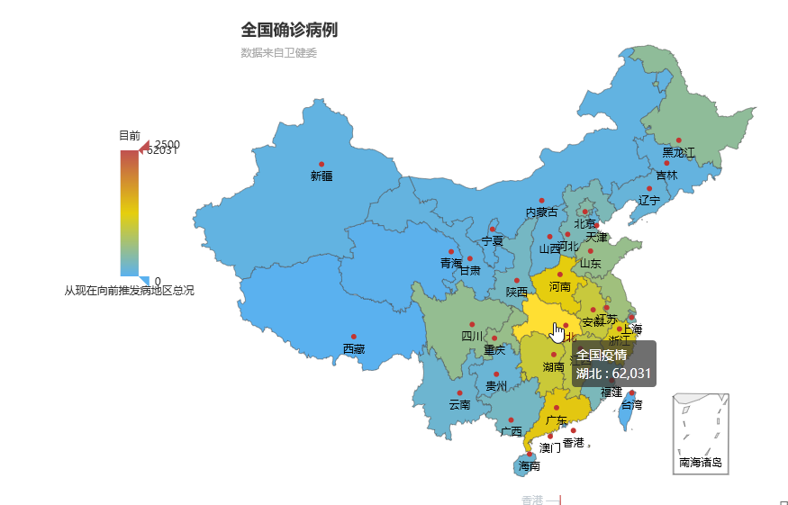
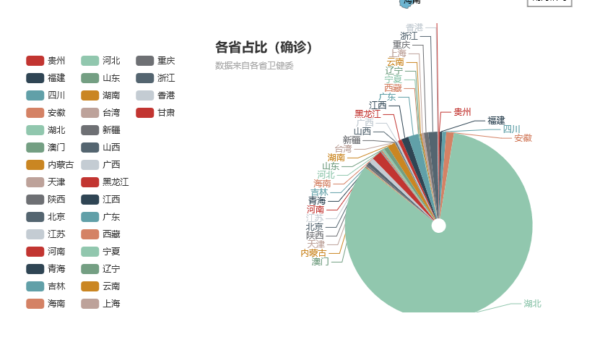
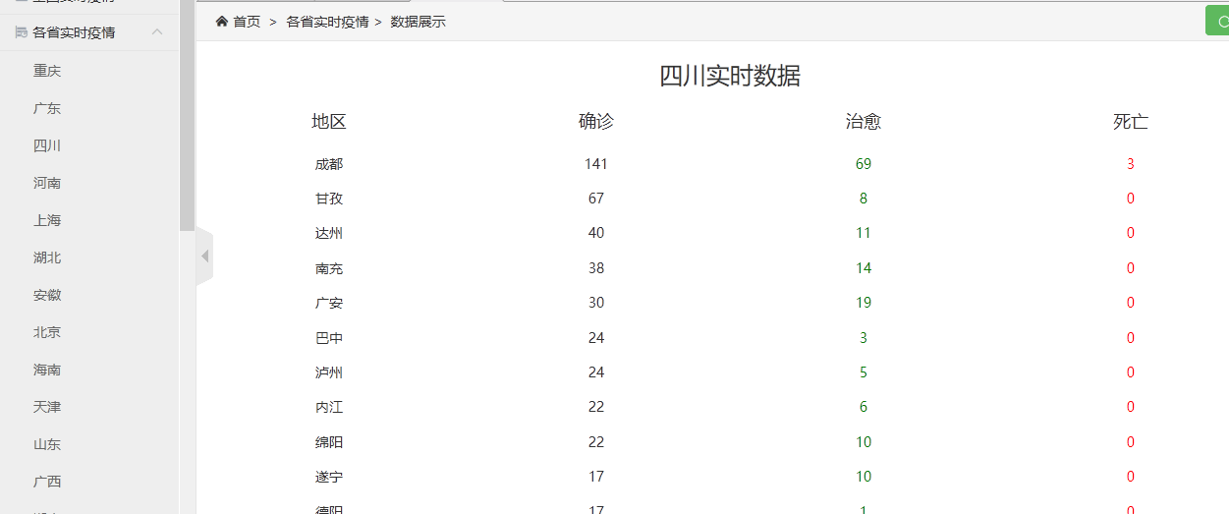
- （选作）疫情扩散可视化展示：要求按照时间轴顺序动态演示疫情扩赛的状况。
