石家庄铁道大学2020年冬季
2017 级寒假作业—信息热词分析
课程名称： 大数据库技术与应用 任课教师： 王建民

一，数据采集：要求从定期自动从网络中爬取信息领域的相关热
词；
代码：
import requests
import json
import re
import os
import traceback
from lxml import html
from lxml import etree
from _multiprocessing import send
from _overlapped import NULL
'''
获取词条的url链接到citiao_list.txt文件
'''
def getUrlText(url,page):
try:
access={"limit": "24",
"timeout": "3000",
"filterTags": "%5B%5D",
"tagId": "76607",
"fromLemma": "false",
"contentLength": "40",
"page": page}
header={"User-Agent":"Mozilla/5.0 (Windows NT 10.0; Win64; x64) AppleWebKit/537.36 (KHTML, like Gecko) Chrome/73.0.3683.103 Safari/537.36"}
r=requests.post(url,data=access,headers=header)
r.raise_for_status()
r.encoding=r.apparent_encoding
print("连接成功")
return r.text
except:
return "连接失败"

def getJson(html,fpath):
date=json.loads(html)
if date and 'lemmaList' in date.keys():
lemmaList= date.get('lemmaList')
for item in lemmaList:
name = item.get('lemmaTitle') #词条名称
name=re.sub(r"\s+", "", name)
Desc=item.get('lemmaDesc') #词条简介
Desc=re.sub(r"\s+", "", Desc)
url = item.get('lemmaUrl') #词条链接
url=re.sub(r"\s+", "",url)
#citiao=name+"&&"+Desc+"&&"+url+"\n"
#citiao=name+"&&"+Desc+"\n"
citiao=url+",\n"
#citiao=Desc+"---------------"
print(citiao)
save__file(fpath,citiao)

#创建文件
#file_path：文件路径
#msg：即要写入的内容
def save__file(file_path,msg):
f=open(file_path,"a",encoding='utf-8')
f.write(msg)
f.close

def main():
url="https://baike.baidu.com/wikitag/api/getlemmas"
#pafph="citiao.txt"
#pfaph="dancitiao.txt"
#pfaph="fenci.txt"
fpath="citiao_list.txt"
page=84
if(os.path.exists(fpath)):
os.remove(fpath)
else:
for page in range(0,501):
html= getUrlText(url,page)
getJson(html,fpath)
paget=page+1
print("第%s页"%paget)

main()import requests;
import re
import os
import traceback
from lxml import html
from lxml import etree
from _multiprocessing import send
from _overlapped import NULL

#获取HTML内容
def getHTMLText(url):
access={"User-Agent":"Mozilla/5.0 (Windows NT 10.0; Win64; x64; rv:72.0) Gecko/20100101 Firefox/72.0"}
try:
r=requests.get(url,headers=access)
r.raise_for_status()
r.encoding=r.apparent_encoding
return r.text
except:
return "无法连接"

def get_citiao_massage(lst,url,fpath):
#url="http://baike.baidu.com/item/COUNTA/7669327"
print(url)
citiao_html=getHTMLText(url)
soup=etree.HTML(citiao_html)
#词条名称dd class="lemmaWgt-lemmaTitle-title" h1 text()
name1=soup.xpath("//dd[@class='lemmaWgt-lemmaTitle-title']/h1/text()")
name2=soup.xpath("//dd[@class='lemmaWgt-lemmaTitle-title']/h2/text()")
name1="".join(name1)
if "".join(name2)=="":
name2=""
else:
name2="".join(name2)
name=name1+name2
#词条详情div class="lemma-summary" text()
desc=soup.xpath("//div[@class='lemma-summary']/div/text()")
desc="".join(desc)
desc=re.sub(r"\s+", "", desc)
url=re.sub(r"\s+", "", url)
#citiao=name+"&&"+desc+"&&"+url+"\n"
citiao=name+"&&"+desc+"\n"
print(citiao)
save__file(fpath,citiao)
return citiao

#创建文件
#file_path：文件路径
#msg：即要写入的内容
def save__file(file_path,msg):
f=open(file_path,"a",encoding='utf-8')
f.write(msg)
f.close

def Run(out_put_file,fpath):
urls=""
lsts=[]
lst=[]
cond=0
with open(out_put_file,"r") as f:
urls=f.read()
lsts=urls.split(",")
for i in lsts:
citiao=""
citiao=get_citiao_massage(lst,i,fpath)
if citiao=="":
continue
lst.append(citiao)
cond+=1
print("\n当前速度：{:.2f}%".format(cond*100/len(lsts)),end="")
return lst

#主函数
def main():
#fpath="citiao.txt"
fpath="dancitiao.txt"
out_put_file="citiao_list.txt"
if(os.path.exists(fpath)):
os.remove(fpath)
else:
lst=[]
lst=Run(out_put_file, fpath)
for i in lst:
print(i+"aaa")

#程序入口
main()
Add_Area(fpath,length)

爬取到文件的截图；
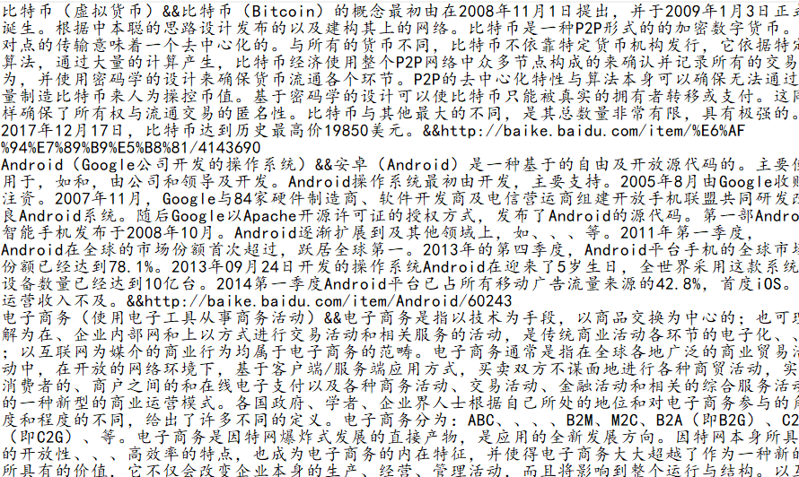

代码：
package com.lq.dao;

import com.lq.bean.CiTiao;
import com.lq.file.LocalFile;
import com.lq.file.StringHandle;

import java.sql.*;
import java.util.List;

public class AddToMySql
{
private static String DriverName="com.mysql.jdbc.Driver";
private static String UName="root";
private static String Upwd="root";
private static String Url="jdbc:mysql://192.168.25.1:3306/xinjian?useUnicode=true&characterEncoding=UTF-8";
public boolean exit(String name) //根据词名称查询是否存在 如果存在返回true，不存在返回false
{
//System.out.println(query(id));
return query(name)==1?true:false;
}
public int query(String name) //查询是否存在;存在return 1;否存在return 0;
{
CiTiao CiTiao=null;
Connection conn=null;
PreparedStatement pstmt=null;
ResultSet result=null;
int count=-1;
try {
Class.forName(DriverName);
conn=DriverManager.getConnection(Url, UName, Upwd);
String sql="select count(*) from citiao where name=?";
pstmt= conn.prepareStatement(sql);
pstmt.setString(1,name);
result=pstmt.executeQuery();
if(result.next()){
count=result.getInt(1);
System.out.println("已存在");
}
if(count>0)
return count;
}
catch(ClassNotFoundException e)
{
e.printStackTrace();
return count;
}
catch (SQLException e)
{
e.printStackTrace();
return count;
}
catch(Exception e)
{
e.printStackTrace();
return count;
}
finally {
try {
if(result!=null) result.close();
if(pstmt!=null) pstmt.close();
if(conn!=null) conn.close();
}
catch(SQLException e)
{
e.printStackTrace();
}
}
return count;
}
public boolean Add(CiTiao CiTiao) //添加信息
{
Connection conn=null;
PreparedStatement pstmt=null;
try {
AddToMySql addToMySql=new AddToMySql();
//System.out.println(addToMySql.exit(CiTiao.getId()));
if(addToMySql.exit(CiTiao.getName())!=true) {
//System.out.println("2");
Class.forName(DriverName);
conn = DriverManager.getConnection(Url, UName, Upwd);
String sql = "insert into citiao values(NULL,?,?,?)";
pstmt = conn.prepareStatement(sql);
pstmt.setString(1, CiTiao.getName());
pstmt.setString(2, CiTiao.getDes());
pstmt.setString(3, CiTiao.getUrl());

int connt = pstmt.executeUpdate();
if (connt > 0) {
System.out.println("保存成功");
return true;

}
else {
System.out.println("已存在");
return false;
}
}
else return false;
}
catch(ClassNotFoundException e)
{
e.printStackTrace();
return false; //系统异常
}
catch(SQLException e)
{
e.printStackTrace();
return false;
}
catch(Exception e)
{
e.printStackTrace();
return false;
}
finally
{
try
{
if(pstmt!=null){
pstmt.close();
conn.close();
}
}
catch(SQLException e)
{
e.printStackTrace();
}
catch(Exception e)
{
e.printStackTrace();
}
}

}
public void Run(){
try {
LocalFile localFile=new LocalFile();
AddToMySql addToMySql=new AddToMySql();
String [] strs = localFile.read_CiTiao_local("citiao.txt");
String[] str=null;
System.out.println(strs.length);
for(int i=0;i<strs.length;i++){
str=strs[i].split("&&");
StringHandle stringHandle=new StringHandle();
CiTiao CiTiao=null;
CiTiao=new CiTiao(str[0],str[1],str[2]);
addToMySql.Add(CiTiao);
System.out.println(CiTiao.toString());
}
//System.out.println(str.length);
} catch (Exception e) {
e.printStackTrace();
}
}

public static void main(String[] args){
AddToMySql addToMySql=new AddToMySql();
//addToMySql.exit("AH19080800081");
addToMySql.Run();
System.out.println("finish");
}

}

数据库截图：
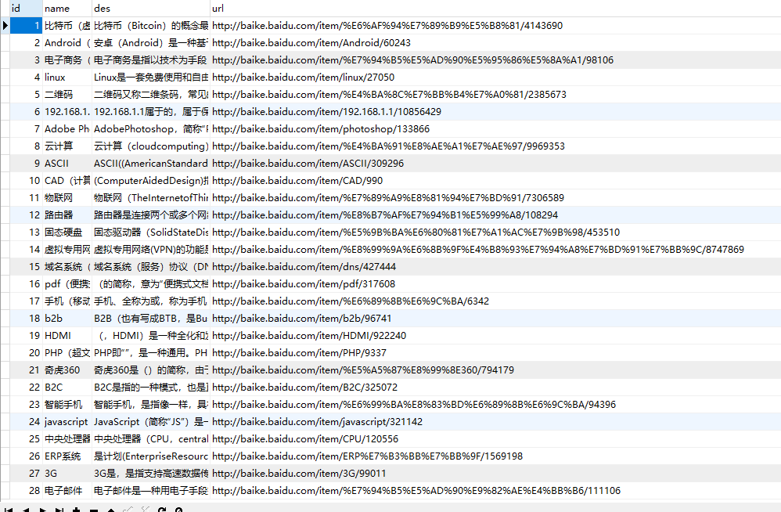

二，数据清洗：对热词信息进行数据清洗，并采用自动分类技术
生成信息领域热词目录；

代码：
public List<CiTiao> SearchByDes(String des) //根据分类查询所有的词条信息
{
List<CiTiao> CiTiaos=new ArrayList<CiTiao>();
CiTiao CiTiao=null;
Connection conn=null;
PreparedStatement pstmt=null;
ResultSet result=null;
try {
Class.forName(DriverName);
conn=DriverManager.getConnection(Url, UName, Upwd);
String sql="select * from citiao where des like ?";
pstmt= conn.prepareStatement(sql);
pstmt.setString(1,"%"+des+"%");
result=pstmt.executeQuery();
while(result.next())
{
String name=result.getString("name"); //词条名称2
des=result.getString("des"); //词条简单内容3
String url=result.getString("url"); //词条链接4

CiTiao=new CiTiao(name,des,url);
CiTiaos.add(CiTiao);
}
return CiTiaos;
}
catch(ClassNotFoundException e)
{
e.printStackTrace();
return null;
}
catch (SQLException e)
{
e.printStackTrace();
return null;
}
catch(Exception e)
{
e.printStackTrace();
return null;
}
finally {
try {
if(result!=null) result.close();
if(pstmt!=null) pstmt.close();
if(conn!=null) conn.close();
}
catch(SQLException e)
{
e.printStackTrace();
}
}
}package com.lq.servlet;

import java.io.IOException;
import java.util.List;

import javax.servlet.ServletException;
import javax.servlet.annotation.WebServlet;
import javax.servlet.http.HttpServlet;
import javax.servlet.http.HttpServletRequest;
import javax.servlet.http.HttpServletResponse;

import com.lq.bean.CiTiao;
import com.lq.dao.QueryFromMySql;

@WebServlet("/QueryByDes")
public class QueryByDes extends HttpServlet {
private static final long serialVersionUID = 1L;

public QueryByDes() {
super();
// TODO Auto-generated constructor stub
}

protected void doGet(HttpServletRequest request, HttpServletResponse response)
throws ServletException, IOException {
QueryFromMySql queryFromMySql=new QueryFromMySql();
request.setCharacterEncoding("utf-8");
String des=request.getParameter("des");
List<CiTiao> ciTiaos=queryFromMySql.SearchByDes(des);
System.out.println(ciTiaos.get(0).toString());
int count=queryFromMySql.query();
System.out.println(count);
request.setAttribute("citiaos", ciTiaos);
request.getRequestDispatcher("/list_sort.jsp").forward(request, response);
}

protected void doPost(HttpServletRequest request, HttpServletResponse response)
throws ServletException, IOException {
doGet(request, response);
}

}

截图：
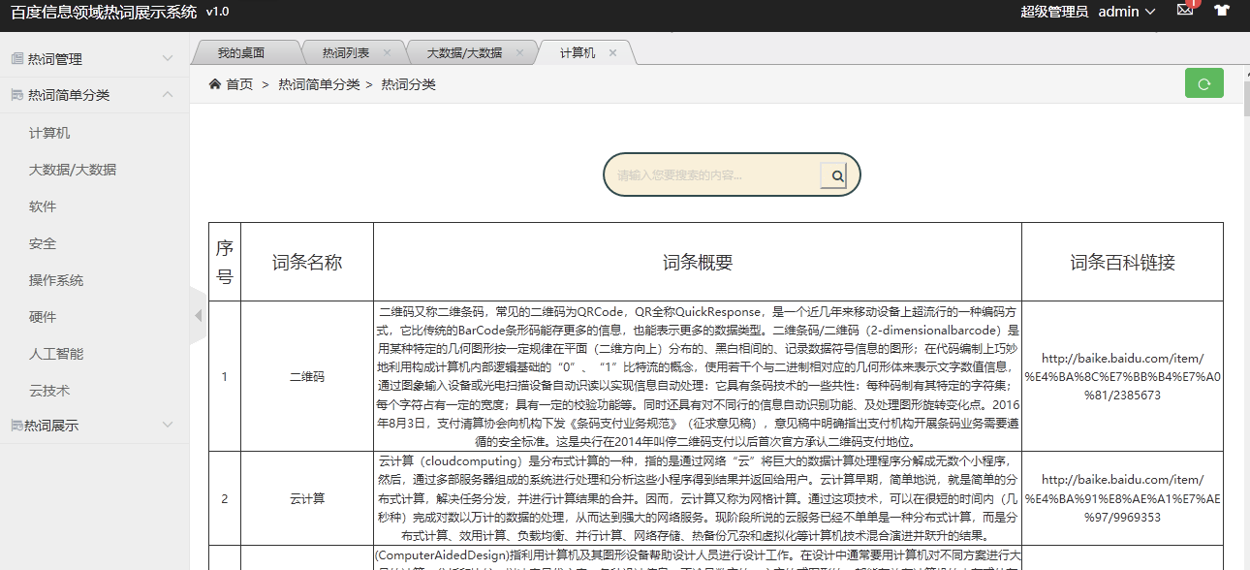
三，热词解释：针对每个热词名词自动添加中文解释（参照百度
百科或维基百科）；

代码：

package com.lq.servlet;

import java.io.IOException;
import java.util.List;

import javax.servlet.ServletException;
import javax.servlet.annotation.WebServlet;
import javax.servlet.http.HttpServlet;
import javax.servlet.http.HttpServletRequest;
import javax.servlet.http.HttpServletResponse;

import com.lq.bean.CiTiao;
import com.lq.dao.QueryFromMySql;

@WebServlet("/QueryAll")
public class QueryAll extends HttpServlet {
private static final long serialVersionUID = 1L;

public QueryAll() {
super();
// TODO Auto-generated constructor stub
}

protected void doGet(HttpServletRequest request, HttpServletResponse response)
throws ServletException, IOException {
QueryFromMySql queryFromMySql=new QueryFromMySql();
request.setCharacterEncoding("utf-8");
List<CiTiao> ciTiaos=queryFromMySql.SearchList();
//System.out.println(xinJians.get(1).toString());
int count=queryFromMySql.query();
System.out.println(count);
request.setAttribute("citiaos", ciTiaos);
request.getRequestDispatcher("/list_all.jsp").forward(request, response);
}

protected void doPost(HttpServletRequest request, HttpServletResponse response)
throws ServletException, IOException {

doGet(request, response);
}

}
package com.lq.servlet;

import java.io.IOException;
import java.util.List;

import javax.servlet.ServletException;
import javax.servlet.annotation.WebServlet;
import javax.servlet.http.HttpServlet;
import javax.servlet.http.HttpServletRequest;
import javax.servlet.http.HttpServletResponse;

import com.lq.bean.CiTiao;
import com.lq.dao.QueryFromMySql;

@WebServlet("/QueryKey")
public class QueryKey extends HttpServlet {
private static final long serialVersionUID = 1L;

public QueryKey() {
super();
// TODO Auto-generated constructor stub
}

protected void doGet(HttpServletRequest request, HttpServletResponse response)
throws ServletException, IOException {
QueryFromMySql queryFromMySql=new QueryFromMySql();
request.setCharacterEncoding("utf-8");
String keyword=request.getParameter("keyword");
List<CiTiao> ciTiaos=queryFromMySql.SearchByName(keyword);
System.out.println(ciTiaos.get(0).toString());
int count=queryFromMySql.query();
System.out.println(count);
request.setAttribute("citiaos", ciTiaos);
request.getRequestDispatcher("/list_key.jsp").forward(request, response);
}

protected void doPost(HttpServletRequest request, HttpServletResponse response)
throws ServletException, IOException {
doGet(request, response);
}

}

<%@page import="com.lq.bean.CiTiao"%>
<%@page import="java.util.List"%>
<%@ page language="java" contentType="text/html; charset=UTF-8"
pageEncoding="UTF-8"%>
<!DOCTYPE HTML>
<html>
<head>
<meta charset="utf-8">
<meta name="renderer" content="webkit|ie-comp|ie-stand">
<meta http-equiv="X-UA-Compatible" content="IE=edge,chrome=1">
<meta name="viewport" content="width=device-width,initial-scale=1,minimum-scale=1.0,maximum-scale=1.0,user-scalable=no" />
<meta http-equiv="Cache-Control" content="no-siteapp" />
<!--[if lt IE 9]>
<script type="text/javascript" src="lib/html5shiv.js"></script>
<script type="text/javascript" src="lib/respond.min.js"></script>
<![endif]-->
<link rel="stylesheet" type="text/css" href="static/h-ui/css/H-ui.min.css" />
<link rel="stylesheet" type="text/css" href="static/h-ui.admin/css/H-ui.admin.css" />
<link rel="stylesheet" type="text/css" href="lib/Hui-iconfont/1.0.8/iconfont.css" />
<link rel="stylesheet" type="text/css" href="static/h-ui.admin/skin/default/skin.css" id="skin" />
<link rel="stylesheet" type="text/css" href="static/h-ui.admin/css/style.css" />
<!--[if IE 6]>
<script type="text/javascript" src="lib/DD_belatedPNG_0.0.8a-min.js" ></script>
<script>DD_belatedPNG.fix('*');</script>
<![endif]-->
<title>词条列表</title>
</head>
<!--_footer 作为公共模版分离出去-->
<style>

div.search {padding: 30px 0;}
table{
text-align: center;
}
form {
position: relative;
width: 300px;
margin: 0 auto;
}

input, button {

outline: none;
}

input {
width: 100%;
height: 42px;
padding-left: 13px;
}

button {
height: 42px;
width: 42px;
cursor: pointer;
position: absolute;
}

.bar7 form {
height: 42px;
}
.bar7 input {
width: 250px;
border-radius: 42px;
border: 2px solid #324B4E;
background: #F9F0DA;
transition: .3s linear;
float: right;
}
.bar7 input:focus {
width: 300px;
}
.bar7 button {
background:url("outfile/button.png");
background-repeat:no-repeat;
width:28px;
height:28px;
top:10px;
right:15px;
}
.bar7 button:before{
font-family: FontAwesome;

}
}
</style>
<script type="text/javascript" src="lib/jquery/1.9.1/jquery.min.js"></script>
<script type="text/javascript" src="lib/layer/2.4/layer.js"></script>
<script type="text/javascript" src="static/h-ui/js/H-ui.min.js"></script>
<script type="text/javascript" src="static/h-ui.admin/js/H-ui.admin.js"></script> <!--/_footer 作为公共模版分离出去-->

<!--请在下方写此页面业务相关的脚本-->
<script type="text/javascript">
window.onload=function(){
var search=document.getElementById("search");
var submit=document.getElementById("submit");
var nav=document.getElementById("nav");
nav.innerHTML='<i class="Hui-iconfont">&#xe67f;</i> 首页 <span class="c-gray en">&gt;</span> 热词管理<span class="c-gray en">&gt;</span> 热词列表 <a class="btn btn-success radius r" style="line-height:1.6em;margin-top:3px" href="javascript:location.replace(location.href);" title="刷新" ><i class="Hui-iconfont">&#xe68f;</i></a>';
submit.onclick=function(){
var keyword=search.value;
if(keyword==""){
alert("请输入搜索词");
}

}
}
</script>
<body>
<nav class="breadcrumb" id="nav">
</nav>
<div class="page-container">
<div class="search bar7">
<form method="post" action="QueryKey">
<input id="search" name="keyword" type="text" placeholder="请输入您要搜索的内容...">
<button type="submit" id="submit"></button>
</form>
</div>
<%
int id=0;
String name=null;
String des=null;
String url=null;

%>
<table rules=all border frame=box>
<thead>
<tr>
<td style="width: 40px align：center"><h4>序号</h4></td>
<td style="width: 100px align：center"><h4>词条名称</h4></td>
<td style="width: 880px align：center"><h4>词条概要</h4></td>
<td style="width: 200px align：center"><h4>词条百科链接</h4></td>
</tr>

</thead>
<%
List<CiTiao> ciTiaos=(List<CiTiao>)request.getAttribute("citiaos");
for(CiTiao ciTiao:ciTiaos){
id=ciTiao.getId();
name=ciTiao.getName();
des=ciTiao.getDes();
url=ciTiao.getUrl();
%>
<tr>
<td style="width: 40px"><%=id %></td>
<td style="width: 100px"><%=name %></td>
<td style="width: 880px"><%=des %></td>
<td style="width: 200px"><a href="<%=url %>"><%=url %></a></td>
</tr>
<%
}

%>
</table>
</div>
<footer class="footer mt-20">
<div class="container">
<p>感谢你们的使用 &copy;2020 信息热词统计<br>
本后台系统由<a href="" target="_blank" title="">石家庄铁道大学软件工程</a>提供技术支持</p>

</div>
</footer>
</body>
</html>

截图；
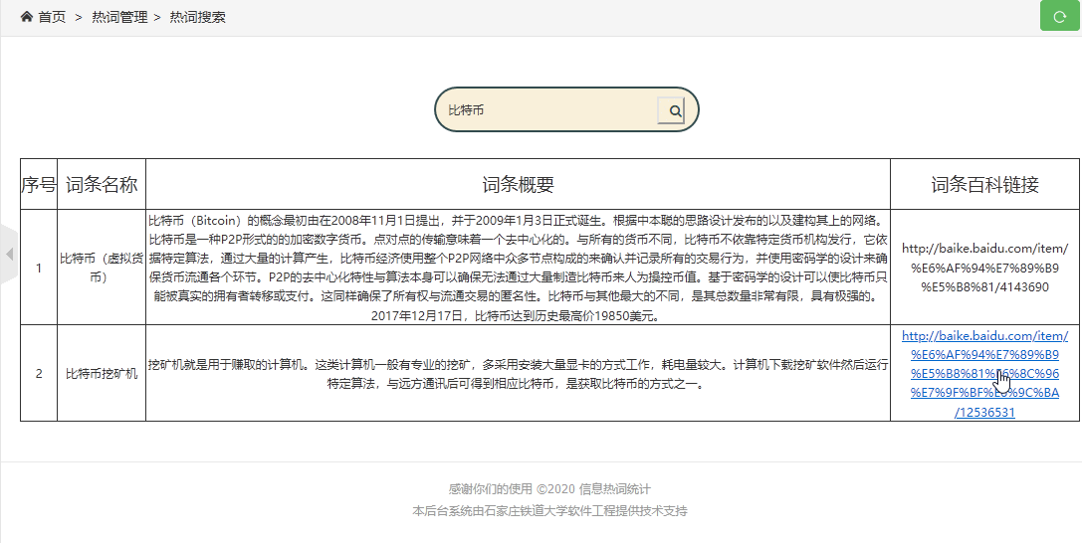

四，热词引用：并对近期引用热词的文章或新闻进行标记，生成
超链接目录，用户可以点击访问；（没有实现）
五，数据可视化展示：
① 用字符云或热词图进行可视化展示；
代码：
import matplotlib
import matplotlib.pyplot as plt #数据可视化
import jieba #词语切割
import wordcloud #分词
from wordcloud import WordCloud,ImageColorGenerator,STOPWORDS #词云，颜色生成器，停止
import numpy as np #科学计算
from PIL import Image #处理图片

def ciyun():
#打开文本
with open('dancitiao.txt','r',encoding='UTF-8') as f: # 打开新的文本转码为utf-8
textfile= f.read() #读取文本内容
wordlist = jieba.cut_for_search(textfile)#切割词语
space_list = ' '.join(wordlist) # 链接词语
backgroud = np.array(Image.open('beijin.png')) #背景图片，只有黑白图才能按照形状生成词云
mywordcloud = WordCloud(width=14000, height=2200,
background_color=None, mode="RGBA",#背景颜色
mask=backgroud, #写字用的背景图，从图片中提取颜色
max_words=500, #最大词语数
stopwords=STOPWORDS,#停止的默认词语
font_path='simkai.ttf',#源码自带字体
max_font_size=200,#最大字体尺寸
random_state=50,#随机角度
scale=1).generate(space_list) #生成词云
image_color = ImageColorGenerator(backgroud)#生成词云的颜色
plt.imshow(mywordcloud) #显示词云
plt.axis('off') #关闭坐标（x,y轴）
plt.savefig('cytu.png') #保存图片
plt.show()#显示

def main():
ciyun()

if __name__ == '__main__':
main()

截图：


② 用关系图标识热词之间的紧密程度。（没有实现）

六，数据报告：可将所有热词目录和名词解释生成 WORD 版报告
形式导出。（没有实现）

