IST687 - Music Classification Project

Team 2 - Sebastian Castro, John Fields, Courtney Smith, Jeremy Wallner

5/13/2019

## Executive Summary

The purpose of this project is to analyze the Million Song Database to predict “Hot” artists and songs based on the attributes such as familiarity, artist location, loudness, terms used, etc. The analysis was done using R software on a 10,000 track subset of the data and our model was able to predict “Hot” songs with ~80% accuracy.

## Table of Contents

Executive Summary Data Analysis Conclusion Final proofing

## Introduction

## Related Work

Thierry Bertin-Mahieux, Daniel P.W. Ellis, Brian Whitman, and Paul Lamere. The Million Song Dataset. In Proceedings of the 12th International Society for Music Information Retrieval Conference (ISMIR 2011), 2011.

## Dataset

#New code from Courtney to change from 3 to 5 categories of artist hotness  
music <- read.csv("~/Intro data science/Music project/newmusic.csv")  
str(music)

## 'data.frame': 9996 obs. of 36 variables:  
## $ ï..artist.hotttnesss : num 0.402 0.417 0.343 0.454 0.402 ...  
## $ artist.id : Factor w/ 3885 levels "AR009211187B989185",..: 1269 2353 2168 715 3606 2128 1249 129 857 2506 ...  
## $ artist.name : Factor w/ 4409 levels "!!!","(hed) p.e.",..: 682 3796 3560 67 1569 1891 3204 4168 3117 802 ...  
## $ artist_mbtags : Factor w/ 277 levels "","0.333","60s",..: 1 52 1 262 1 1 1 1 1 1 ...  
## $ artist_mbtags_count : num 0 1 0 1 0 0 0 0 0 0 ...  
## $ bars_confidence : num 0.643 0.007 0.98 0.017 0.175 0.121 0.709 0.142 0.806 0.047 ...  
## $ bars_start : num 0.585 0.711 0.732 1.306 1.064 ...  
## $ beats_confidence : num 0.834 1 0.98 0.809 0.883 0.438 0.709 0.234 0.44 1 ...  
## $ beats_start : num 0.585 0.206 0.732 0.81 0.136 ...  
## $ duration : num 219 148 177 233 210 ...  
## $ end_of_fade_in : num 0.247 0.148 0.282 0 0.066 ...  
## $ familiarity : num 0.582 0.631 0.487 0.63 0.651 ...  
## $ key : num 1 6 8 0 2 5 1 4 4 7 ...  
## $ key_confidence : num 0.736 0.169 0.643 0.751 0.092 0.635 0 0 0.717 0.053 ...  
## $ latitude : num 37.2 35.1 37.2 37.2 37.2 ...  
## $ location : Factor w/ 1046 levels " "," NC"," UbA!, Minas Gerais",..: 157 584 705 517 705 705 720 150 705 705 ...  
## $ longitude : num -63.9 -90 -63.9 -63.9 -63.9 ...  
## $ loudness : num -11.2 -9.84 -9.69 -9.01 -4.5 ...  
## $ mode : int 0 0 1 1 1 1 1 0 1 0 ...  
## $ mode_confidence : num 0.636 0.43 0.565 0.749 0.371 0.557 0 0.16 0.652 0.473 ...  
## $ release.id : int 300848 300822 514953 287650 611336 41838 25824 8876 358182 692313 ...  
## $ release.name : Factor w/ 7830 levels "'60s Pop Number 1's",..: 2191 1746 3535 2334 4351 4744 1565 2468 4930 6081 ...  
## $ similar : Factor w/ 2837 levels "AR00K8N11C8A41687B",..: 2408 2225 1145 304 2331 1313 1101 1500 2577 715 ...  
## $ song.hotttnesss : num 0.602 NA NA NA 0.605 ...  
## $ song.id : Factor w/ 9996 levels " Polovtsian Dances / Rimsky-Korsakov: Russian Easter",..: 5350 1014 9225 5465 2424 9456 5094 3118 3378 7971 ...  
## $ start_of_fade_out : num 219 138 172 217 199 ...  
## $ tatums_confidence : num 0.779 0.969 0.482 0.601 1 0.136 0.467 0.292 0.121 1 ...  
## $ tatums_start : num 0.285 0.206 0.421 0.563 0.136 ...  
## $ tempo : num 92.2 121.3 100.1 119.3 129.7 ...  
## $ terms : Factor w/ 459 levels "","8-bit","acid jazz",..: 216 34 372 327 325 396 45 329 300 46 ...  
## $ terms_freq : num 1 1 1 0.989 0.887 ...  
## $ time_signature : num 4 4 1 4 4 3 1 3 4 4 ...  
## $ time_signature_confidence: num 0.778 0.384 0 0 0.562 0.454 0 0.408 0.487 0.878 ...  
## $ title : Factor w/ 9705 levels "","'57 Chevrolet",..: 3681 7526 481 7475 2531 8282 4347 2194 6311 4002 ...  
## $ year : int 0 1969 0 1982 2007 0 0 0 1984 0 ...  
## $ artist.hotttnesss.label : Factor w/ 3 levels "Cold","Hot","Warm": 3 3 3 3 3 3 1 2 1 3 ...

colnames(music)[1] <- "artist.hotttnesss"  
  
# New code from Jeremy importing of song list  
newmusic <- read.csv("~/Intro data science/Music project/newmusic.csv")  
#New code from Jeremy importing of song list  
newmusic <- read.csv("~/Intro data science/Music project/newmusic.csv")  
  
#head(newmusic)  
newmusic2 <- newmusic  
newmusic3 <- newmusic2[-c(1:2,4:9,11,13:14,19:20,23,36)]

newmusic3 <- na.omit(newmusic3)  
cmbomusic <- newmusic3  
  
  
##Artist Hotness Histogram  
library(ggplot2)  
ggplot(music, aes(x=artist.hotttnesss)) + geom_histogram(color="black", fill="steelblue", alpha=0.5) + xlab("Artist Hotness") + ggtitle("Histogram: Artist Hotness")

## `stat_bin()` using `bins = 30`. Pick better value with `binwidth`.

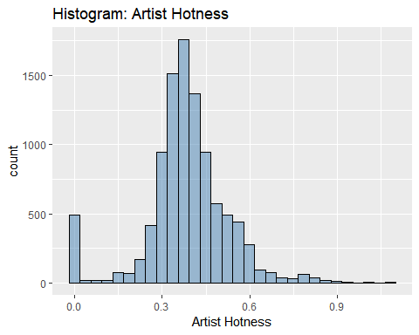

##Function to create descriptive statistics for artist hotness  
descriptive_stats <- function(vector) { library(moments)   
 result <- c(Mean=mean(vector),  
 Median=median(vector),  
 Min = min(vector),  
 Max = max(vector),  
 SD = sd(vector),  
 Quantile = quantile(vector, probs = c(0.25,.50,0.75, 0.95)),  
 Skewness = skewness(vector) )  
 print(result)   
}  
descriptive_stats(music$artist.hotttnesss)

## Mean Median Min Max SD   
## 0.3857065 0.3807564 0.0000000 1.0825026 0.1434688   
## Quantile.25% Quantile.50% Quantile.75% Quantile.95% Skewness   
## 0.3255062 0.3807564 0.4539300 0.6011861 -0.1483509

##Methodology for assigning artist hotness levels - uses quantiles from descriptitive_statistics function  
#95% Quantile: 0.6011861 - Hot  
#75% Quantile: 0.453858 - Warm  
#50% Quantile: 0.3807423 - Tepid  
#25% Quantile: 0.3252656 - Cool  
##Code for assigning labels based on above quantiles  
music$artist.hotness.label <- ifelse(music$artist.hotttnesss >=0.6011861, "Hot",  
 ifelse(music$artist.hotttnesss >=0.453858 & music$artist.hotttnesss <0.6011861, "Warm",  
 ifelse(music$artist.hotttnesss >=0.3807423 & music$artist.hotttnesss <0.453858, "Tepid",  
 ifelse(music$artist.hotttnesss >=0.3252656 & music$artist.hotttnesss <0.3807423, "Cool",  
 ifelse(music$artist.hotttnesss < 0.3252656, "Frigid","Else")))))  
unique(music$artist.hotness.label)

## [1] "Tepid" "Cool" "Warm" "Frigid" "Hot"

#End of new code from Courtney  
#Prior to importing, a new column artist.hotttnesss.label was adding with   
#Hot(>.4590), Warm(<.4590 and >.3357), Cold(<.3357). Four rows with blanks in   
#famiiarity were also deleted.  
music <- na.omit(music)  
#Copy original data to a new dataframe music1 and exclude unneeded data  
music <- music[-c(1:5,7,16,19,21:25,30,34)]  
music$artist.hotness.label <- as.factor(music$artist.hotness.label)   
str(music)

## 'data.frame': 5648 obs. of 22 variables:  
## $ bars_confidence : num 0.643 0.175 0.806 0.873 0.018 0.013 1 0.507 0.125 0.03 ...  
## $ beats_confidence : num 0.834 0.883 0.44 0.873 1 0.699 1 0 0.768 1 ...  
## $ beats_start : num 0.585 0.136 1.226 0.112 0.429 ...  
## $ duration : num 219 210 270 219 245 ...  
## $ end_of_fade_in : num 0.247 0.066 5.3 2.125 0.357 ...  
## $ familiarity : num 0.582 0.651 0.427 0.36 0.545 ...  
## $ key : num 1 2 4 5 7 9 10 7 8 7 ...  
## $ key_confidence : num 0.736 0.092 0.717 0.354 0.07 0.205 0 1 0.041 0.725 ...  
## $ latitude : num 37.2 37.2 37.2 35.2 37.2 ...  
## $ longitude : num -63.9 -63.9 -63.9 -80 -63.9 ...  
## $ loudness : num -11.2 -4.5 -13.5 -10.02 -7.54 ...  
## $ mode_confidence : num 0.636 0.371 0.652 0.485 0.686 0.305 0.198 0.829 0.516 0.756 ...  
## $ start_of_fade_out : num 219 199 259 207 227 ...  
## $ tatums_confidence : num 0.779 1 0.121 0.229 0.728 1 0.774 0.377 0.767 0.238 ...  
## $ tatums_start : num 0.285 0.136 1.226 0.112 0.173 ...  
## $ tempo : num 92.2 129.7 86.6 146.8 118 ...  
## $ terms_freq : num 1 0.887 0.96 0.956 1 ...  
## $ time_signature : num 4 4 4 1 4 4 1 4 5 4 ...  
## $ time_signature_confidence: num 0.778 0.562 0.487 0 0.835 0 0.319 0.756 0.579 0.931 ...  
## $ year : int 0 2007 1984 0 0 0 0 1987 0 2004 ...  
## $ artist.hotttnesss.label : Factor w/ 3 levels "Cold","Hot","Warm": 3 3 1 1 3 3 1 3 1 2 ...  
## $ artist.hotness.label : Factor w/ 5 levels "Cool","Frigid",..: 4 4 1 2 1 1 2 4 1 5 ...

##SONG HOTNESS HISTOGRAM From Jeremy  
cmbomusic[cmbomusic==0]<- NA  
#cmbomusic2 <- cmbomusic[-c(5,6)]  
cmbomusic3 <- na.omit(cmbomusic)  
cmbomusic3$song.hotttnesss.label <- ifelse( cmbomusic3$song.hotttnesss >=0.6011861, "Hot",ifelse(cmbomusic3$song.hotttnesss >= 0.453858 & cmbomusic3$song.hotttnesss <0.6011861, "Warm", ifelse(cmbomusic3$song.hotttnesss >=0.3807423 & cmbomusic3$song.hotttnesss < 0.453858, "Tepid",ifelse(cmbomusic3$song.hotttnesss >=0.3252656 & cmbomusic3$song.hotttnesss <0.3807423, "Cool",ifelse(cmbomusic3$song.hotttnesss < 0.3252656, "Frigid","Else")))))  
unique(cmbomusic3$song.hotttnesss.label)

## [1] "Hot" "Frigid" "Tepid" "Warm" "Cool"

cmbomusic3 <- cmbomusic3[-c(2:3,12)]  
ggplot(cmbomusic3, aes(x=song.hotttnesss)) + geom_histogram(color="black", fill="steelblue", alpha=0.5) + xlab("Song Hotness") + ggtitle("Histogram: Song Hotness")

## `stat_bin()` using `bins = 30`. Pick better value with `binwidth`.

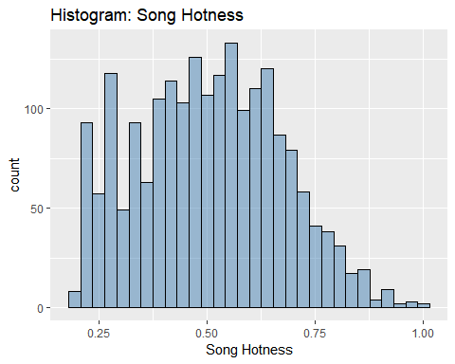

##Function to create descriptive statistics for song hotness  
descriptive_stats2 <- function(vector) { library(moments)   
 result <- c(Mean=mean(vector),  
 Median=median(vector),  
 Min = min(vector),  
 Max = max(vector),  
 SD = sd(vector),  
 Quantile = quantile(vector, probs = c(0.25,.50,0.75, 0.95)),  
 Skewness = skewness(vector) )  
 print(result)   
}  
descriptive_stats2(cmbomusic3$song.hotttnesss)

## Mean Median Min Max SD   
## 0.5039199 0.5057510 0.1938578 1.0000000 0.1669179   
## Quantile.25% Quantile.50% Quantile.75% Quantile.95% Skewness   
## 0.3775316 0.5057510 0.6269086 0.7849625 0.1292387

cmbomusic3$song.hotness.label <- ifelse( cmbomusic3$song.hotttnesss >=0.64787976, "Hot",ifelse(cmbomusic3$song.hotttnesss >= 0.43437984 & cmbomusic3$song.hotttnesss <0.64787976, "Warm", ifelse( cmbomusic3$song.hotttnesss <0.43437984, "Cold","Else")))  
unique(cmbomusic3$song.hotness.label)

## [1] "Warm" "Cold" "Hot"

cmbomusic3$song.hotttnesss.label <- as.factor(cmbomusic3$song.hotttnesss.label)   
str(cmbomusic3)

## 'data.frame': 2005 obs. of 20 variables:  
## $ artist.name : Factor w/ 4409 levels "!!!","(hed) p.e.",..: 1569 3117 481 3760 3755 3401 4027 2450 673 1260 ...  
## $ latitude : num 37.2 37.2 43.6 37.2 41.9 ...  
## $ location : Factor w/ 1046 levels " "," NC"," UbA!, Minas Gerais",..: 705 705 943 705 191 157 260 182 705 851 ...  
## $ longitude : num -63.9 -63.9 -79.4 -63.9 -87.6 ...  
## $ loudness : num -4.5 -13.5 -8.58 -5.27 -11.94 ...  
## $ release.id : int 611336 358182 135122 372309 228326 709879 706005 28723 234425 322532 ...  
## $ release.name : Factor w/ 7830 levels "'60s Pop Number 1's",..: 4351 4930 4773 2513 4638 6728 250 2592 2080 1021 ...  
## $ song.hotttnesss : num 0.605 0.266 0.405 0.684 0.414 ...  
## $ song.id : Factor w/ 9996 levels " Polovtsian Dances / Rimsky-Korsakov: Russian Easter",..: 2424 3378 3278 9107 2728 5229 5725 3564 7853 6226 ...  
## $ tatums_confidence : num 1 0.121 0.377 0.238 0.462 0.461 0.84 0.537 1 0.228 ...  
## $ tatums_start : num 0.1358 1.226 0.0505 0.0573 0.1384 ...  
## $ tempo : num 129.7 86.6 119.8 150.1 110.2 ...  
## $ terms : Factor w/ 459 levels "","8-bit","acid jazz",..: 325 300 103 205 393 192 382 284 434 43 ...  
## $ terms_freq : num 0.887 0.96 1 1 0.985 ...  
## $ time_signature : num 4 4 4 4 3 4 4 4 4 5 ...  
## $ time_signature_confidence: num 0.562 0.487 0.756 0.931 0.353 0.731 0.744 0.496 0.445 0.551 ...  
## $ title : Factor w/ 9705 levels "","'57 Chevrolet",..: 2531 6311 2692 1313 2036 7586 1157 3506 5627 8284 ...  
## $ year : int 2007 1984 1987 2004 1972 2007 2003 1995 2006 2009 ...  
## $ song.hotttnesss.label : Factor w/ 5 levels "Cool","Frigid",..: 3 2 4 3 4 4 5 5 3 4 ...  
## $ song.hotness.label : chr "Warm" "Cold" "Cold" "Hot" ...

cmbomusic3$song.hotttnesss.label <- ifelse( cmbomusic3$song.hotttnesss >=0.6011861, "Hot",ifelse(cmbomusic3$song.hotttnesss >= 0.453858 & cmbomusic3$song.hotttnesss <0.6011861, "Warm", ifelse(cmbomusic3$song.hotttnesss >=0.3807423 & cmbomusic3$song.hotttnesss < 0.453858, "Tepid",ifelse(cmbomusic3$song.hotttnesss >=0.3252656 & cmbomusic3$song.hotttnesss <0.3807423, "Cool",ifelse(cmbomusic3$song.hotttnesss < 0.3252656, "Frigid","Else")))))  
unique(cmbomusic3$song.hotttnesss.label)

## [1] "Hot" "Frigid" "Tepid" "Warm" "Cool"

cmbomusic3$song.hotttnesss.label <- as.factor(cmbomusic3$song.hotttnesss.label)   
str(cmbomusic3)

## 'data.frame': 2005 obs. of 20 variables:  
## $ artist.name : Factor w/ 4409 levels "!!!","(hed) p.e.",..: 1569 3117 481 3760 3755 3401 4027 2450 673 1260 ...  
## $ latitude : num 37.2 37.2 43.6 37.2 41.9 ...  
## $ location : Factor w/ 1046 levels " "," NC"," UbA!, Minas Gerais",..: 705 705 943 705 191 157 260 182 705 851 ...  
## $ longitude : num -63.9 -63.9 -79.4 -63.9 -87.6 ...  
## $ loudness : num -4.5 -13.5 -8.58 -5.27 -11.94 ...  
## $ release.id : int 611336 358182 135122 372309 228326 709879 706005 28723 234425 322532 ...  
## $ release.name : Factor w/ 7830 levels "'60s Pop Number 1's",..: 4351 4930 4773 2513 4638 6728 250 2592 2080 1021 ...  
## $ song.hotttnesss : num 0.605 0.266 0.405 0.684 0.414 ...  
## $ song.id : Factor w/ 9996 levels " Polovtsian Dances / Rimsky-Korsakov: Russian Easter",..: 2424 3378 3278 9107 2728 5229 5725 3564 7853 6226 ...  
## $ tatums_confidence : num 1 0.121 0.377 0.238 0.462 0.461 0.84 0.537 1 0.228 ...  
## $ tatums_start : num 0.1358 1.226 0.0505 0.0573 0.1384 ...  
## $ tempo : num 129.7 86.6 119.8 150.1 110.2 ...  
## $ terms : Factor w/ 459 levels "","8-bit","acid jazz",..: 325 300 103 205 393 192 382 284 434 43 ...  
## $ terms_freq : num 0.887 0.96 1 1 0.985 ...  
## $ time_signature : num 4 4 4 4 3 4 4 4 4 5 ...  
## $ time_signature_confidence: num 0.562 0.487 0.756 0.931 0.353 0.731 0.744 0.496 0.445 0.551 ...  
## $ title : Factor w/ 9705 levels "","'57 Chevrolet",..: 2531 6311 2692 1313 2036 7586 1157 3506 5627 8284 ...  
## $ year : int 2007 1984 1987 2004 1972 2007 2003 1995 2006 2009 ...  
## $ song.hotttnesss.label : Factor w/ 5 levels "Cool","Frigid",..: 3 2 4 3 4 4 5 5 3 4 ...  
## $ song.hotness.label : chr "Warm" "Cold" "Cold" "Hot" ...

cmbomusic3$song.hotttnesss.label <- ifelse( cmbomusic3$song.hotttnesss >=0.6011861, "Hot",ifelse(cmbomusic3$song.hotttnesss >= 0.453858 & cmbomusic3$song.hotttnesss <0.6011861, "Warm", ifelse(cmbomusic3$song.hotttnesss >=0.3807423 & cmbomusic3$song.hotttnesss < 0.453858, "Tepid",ifelse(cmbomusic3$song.hotttnesss >=0.3252656 & cmbomusic3$song.hotttnesss <0.3807423, "Cool",ifelse(cmbomusic3$song.hotttnesss < 0.3252656, "Frigid","Else")))))  
unique(cmbomusic3$song.hotttnesss.label)

## [1] "Hot" "Frigid" "Tepid" "Warm" "Cool"

str(cmbomusic3)

cmbomusic3$song.hotttnesss.label <- as.factor(cmbomusic3$song.hotttnesss.label)   
cmbomusic3$song.hotttnesss.label <- as.factor(cmbomusic3$song.hotttnesss.label)   
str(cmbomusic3)

## 'data.frame': 2005 obs. of 20 variables:  
## $ artist.name : Factor w/ 4409 levels "!!!","(hed) p.e.",..: 1569 3117 481 3760 3755 3401 4027 2450 673 1260 ...  
## $ latitude : num 37.2 37.2 43.6 37.2 41.9 ...  
## $ location : Factor w/ 1046 levels " "," NC"," UbA!, Minas Gerais",..: 705 705 943 705 191 157 260 182 705 851 ...  
## $ longitude : num -63.9 -63.9 -79.4 -63.9 -87.6 ...  
## $ loudness : num -4.5 -13.5 -8.58 -5.27 -11.94 ...  
## $ release.id : int 611336 358182 135122 372309 228326 709879 706005 28723 234425 322532 ...  
## $ release.name : Factor w/ 7830 levels "'60s Pop Number 1's",..: 4351 4930 4773 2513 4638 6728 250 2592 2080 1021 ...  
## $ song.hotttnesss : num 0.605 0.266 0.405 0.684 0.414 ...  
## $ song.id : Factor w/ 9996 levels " Polovtsian Dances / Rimsky-Korsakov: Russian Easter",..: 2424 3378 3278 9107 2728 5229 5725 3564 7853 6226 ...  
## $ tatums_confidence : num 1 0.121 0.377 0.238 0.462 0.461 0.84 0.537 1 0.228 ...  
## $ tatums_start : num 0.1358 1.226 0.0505 0.0573 0.1384 ...  
## $ tempo : num 129.7 86.6 119.8 150.1 110.2 ...  
## $ terms : Factor w/ 459 levels "","8-bit","acid jazz",..: 325 300 103 205 393 192 382 284 434 43 ...  
## $ terms_freq : num 0.887 0.96 1 1 0.985 ...  
## $ time_signature : num 4 4 4 4 3 4 4 4 4 5 ...  
## $ time_signature_confidence: num 0.562 0.487 0.756 0.931 0.353 0.731 0.744 0.496 0.445 0.551 ...  
## $ title : Factor w/ 9705 levels "","'57 Chevrolet",..: 2531 6311 2692 1313 2036 7586 1157 3506 5627 8284 ...  
## $ year : int 2007 1984 1987 2004 1972 2007 2003 1995 2006 2009 ...  
## $ song.hotttnesss.label : Factor w/ 5 levels "Cool","Frigid",..: 3 2 4 3 4 4 5 5 3 4 ...  
## $ song.hotness.label : chr "Warm" "Cold" "Cold" "Hot" ...

#View the number of Cold/Warm/Hot labels   
 table(cmbomusic3$song.hotttnesss.label)

##   
## Cool Frigid Hot Tepid Warm   
## 171 337 603 276 618

cmbomusic3$song.hotness.label <- ifelse( cmbomusic3$song.hotttnesss >=0.64787976, "Hot",ifelse(cmbomusic3$song.hotttnesss >= 0.43437984 & cmbomusic3$song.hotttnesss <0.64787976, "Warm", ifelse( cmbomusic3$song.hotttnesss <0.43437984, "Cold","Else")))  
unique(cmbomusic3$song.hotness.label)

## [1] "Warm" "Cold" "Hot"

## Features

#View the number of Cold/Warm/Hot labels   
table(music$artist.hotttnesss.label)

##   
## Cold Hot Warm   
## 1180 1579 2889

#View the number of Frigid/Cool/Tepid/Warm/Hot labels   
table(music$artist.hotness.label)

##   
## Cool Frigid Hot Tepid Warm   
## 1444 973 278 1566 1387

#Plot artists latitude and longitude  
plot(music$latitude,music$longitude)

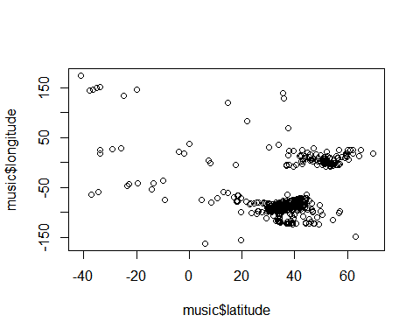

cmbomusic3$song.hotness.label <- as.factor(cmbomusic3$song.hotness.label)   
cmbomusic3$song.hotness.label <- as.factor(cmbomusic3$song.hotness.label)   
str(cmbomusic3)

## 'data.frame': 2005 obs. of 20 variables:  
## $ artist.name : Factor w/ 4409 levels "!!!","(hed) p.e.",..: 1569 3117 481 3760 3755 3401 4027 2450 673 1260 ...  
## $ latitude : num 37.2 37.2 43.6 37.2 41.9 ...  
## $ location : Factor w/ 1046 levels " "," NC"," UbA!, Minas Gerais",..: 705 705 943 705 191 157 260 182 705 851 ...  
## $ longitude : num -63.9 -63.9 -79.4 -63.9 -87.6 ...  
## $ loudness : num -4.5 -13.5 -8.58 -5.27 -11.94 ...  
## $ release.id : int 611336 358182 135122 372309 228326 709879 706005 28723 234425 322532 ...  
## $ release.name : Factor w/ 7830 levels "'60s Pop Number 1's",..: 4351 4930 4773 2513 4638 6728 250 2592 2080 1021 ...  
## $ song.hotttnesss : num 0.605 0.266 0.405 0.684 0.414 ...  
## $ song.id : Factor w/ 9996 levels " Polovtsian Dances / Rimsky-Korsakov: Russian Easter",..: 2424 3378 3278 9107 2728 5229 5725 3564 7853 6226 ...  
## $ tatums_confidence : num 1 0.121 0.377 0.238 0.462 0.461 0.84 0.537 1 0.228 ...  
## $ tatums_start : num 0.1358 1.226 0.0505 0.0573 0.1384 ...  
## $ tempo : num 129.7 86.6 119.8 150.1 110.2 ...  
## $ terms : Factor w/ 459 levels "","8-bit","acid jazz",..: 325 300 103 205 393 192 382 284 434 43 ...  
## $ terms_freq : num 0.887 0.96 1 1 0.985 ...  
## $ time_signature : num 4 4 4 4 3 4 4 4 4 5 ...  
## $ time_signature_confidence: num 0.562 0.487 0.756 0.931 0.353 0.731 0.744 0.496 0.445 0.551 ...  
## $ title : Factor w/ 9705 levels "","'57 Chevrolet",..: 2531 6311 2692 1313 2036 7586 1157 3506 5627 8284 ...  
## $ year : int 2007 1984 1987 2004 1972 2007 2003 1995 2006 2009 ...  
## $ song.hotttnesss.label : Factor w/ 5 levels "Cool","Frigid",..: 3 2 4 3 4 4 5 5 3 4 ...  
## $ song.hotness.label : Factor w/ 3 levels "Cold","Hot","Warm": 3 1 1 2 1 3 3 3 2 3 ...

#View the number of Cold/Warm/Hot labels   
table(cmbomusic3$song.hotness.label)

##   
## Cold Hot Warm   
## 705 414 886

#View the number of Frigid/Cool/Tepid/Warm/Hot labels   
 table(cmbomusic3$song.hotttnesss.label)

##   
## Cool Frigid Hot Tepid Warm   
## 171 337 603 276 618

#Plot artists latitude and longitude  
 plot(cmbomusic3$latitude,cmbomusic3$longitude)

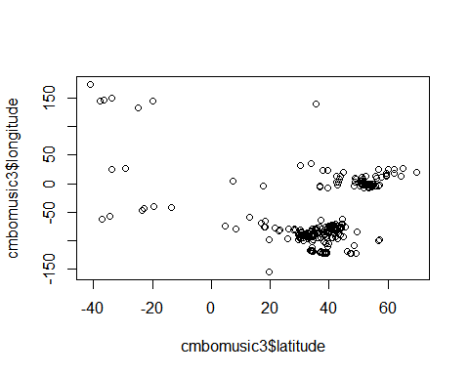

#Plot artist hotttnesss  
#hist(music$artist.hotttnesss,breaks=20)  
#hist(music$artist.hotness,breaks=20)

#THIS IS INCOMPLETE CODE FOR PLOTTING ADDITIONAL DATA… #Create a map of the world mapWorld <- borders(“world”, colour=“gray50”, fill=“white”)

#Code from <https://rpubs.com/spoonerf/global_map> #Need to figure out what to put in locs locs<-read.csv(“my_locations.csv”) locs<- sp_dups<-data.frame(ddply(locs,.(Longitude,Latitude),nrow)) sp_dups $loc_{i}d<-1:length(sp_{d}ups$ Longitude) sp_dups_df<-merge(sp_dups, locs, by=c(“Longitude”,“Latitude”))

loc<-data.frame(sp_dups_df $Longitude,sp_{d}ups_{d}f$ Latitude,sp_dups_df$V1) loc<-unique(loc) colnames(loc)<-c(“Longitude”, “Latitude”, “V1”)

coordinates(loc)<-c(“Longitude”,“Latitude”) proj4string(loc) <- CRS(“+proj=longlat”)

loc_df<-data.frame(loc)

theme_opts <- list(theme(panel.grid.minor = element_blank(), panel.grid.major = element_blank(), panel.background = element_blank(), plot.background = element_rect(fill=“white”), panel.border = element_blank(), axis.line = element_blank(), axis.text.x = element_blank(), axis.text.y = element_blank(), axis.ticks = element_blank(), axis.title.x = element_blank(), axis.title.y = element_blank(), plot.title = element_text(size=22)))

library(maps) library(mapdata)

ggplot(data=loc_df, aes(Longitude, Latitude, group=NULL,fill=NULL,size=V1))+#, fill=hole)) + borders(fill=“light grey”,colour=“light grey”)+ geom_point(color=“black”,alpha=I(7/10))+ scale_size(range=c(1,7), guide = “legend”,labs(size=“No. of Populations”))+ coord_equal()+ theme_opts

## Methods

#Do analysis to determine hot/warm/cold artists based on hotttnesss  
#The ramdom forest analysis is from a training video by Bharatendra Rai   
#at https://www.youtube.com/watch?v=dJclNIN-TPo  
#Data Partition - ind = independent samples  
#The code below runs in console but not R Markdown  
set.seed(123)  
ind<- sample(2,nrow(music), replace=TRUE,prob=c(0.7,0.3))  
train <- music[ind==1,]  
test <- music[ind==2,]  
#Run randomForest on 3 levels  
library(randomForest)

## randomForest 4.6-14

## Type rfNews() to see new features/changes/bug fixes.

##   
## Attaching package: 'randomForest'

## The following object is masked from 'package:ggplot2':  
##   
## margin

set.seed(222)  
rf <- randomForest(music[,-21:-22],music[,21])  
print(rf)

##   
## Call:  
## randomForest(x = music[, -21:-22], y = music[, 21])   
## Type of random forest: classification  
## Number of trees: 500  
## No. of variables tried at each split: 4  
##   
## OOB estimate of error rate: 20.18%  
## Confusion matrix:  
## Cold Hot Warm class.error  
## Cold 728 4 448 0.3830508  
## Hot 6 1289 284 0.1836605  
## Warm 200 198 2491 0.1377639

attributes(rf)

## $names  
## [1] "call" "type" "predicted"   
## [4] "err.rate" "confusion" "votes"   
## [7] "oob.times" "classes" "importance"   
## [10] "importanceSD" "localImportance" "proximity"   
## [13] "ntree" "mtry" "forest"   
## [16] "y" "test" "inbag"   
##   
## $class  
## [1] "randomForest"

rf$confusion

## Cold Hot Warm class.error  
## Cold 728 4 448 0.3830508  
## Hot 6 1289 284 0.1836605  
## Warm 200 198 2491 0.1377639

#Run randomForest on 5 levels  
library(randomForest)  
set.seed(222)  
rf2 <- randomForest(music[,-21:-22],music[,22])  
print(rf2)

##   
## Call:  
## randomForest(x = music[, -21:-22], y = music[, 22])   
## Type of random forest: classification  
## Number of trees: 500  
## No. of variables tried at each split: 4  
##   
## OOB estimate of error rate: 35.64%  
## Confusion matrix:  
## Cool Frigid Hot Tepid Warm class.error  
## Cool 845 175 0 387 37 0.4148199  
## Frigid 279 620 0 73 1 0.3627955  
## Hot 1 2 56 15 204 0.7985612  
## Tepid 339 45 0 982 200 0.3729246  
## Warm 21 6 10 218 1132 0.1838500

attributes(rf2)

## $names  
## [1] "call" "type" "predicted"   
## [4] "err.rate" "confusion" "votes"   
## [7] "oob.times" "classes" "importance"   
## [10] "importanceSD" "localImportance" "proximity"   
## [13] "ntree" "mtry" "forest"   
## [16] "y" "test" "inbag"   
##   
## $class  
## [1] "randomForest"

rf2$confusion

## Cool Frigid Hot Tepid Warm class.error  
## Cool 845 175 0 387 37 0.4148199  
## Frigid 279 620 0 73 1 0.3627955  
## Hot 1 2 56 15 204 0.7985612  
## Tepid 339 45 0 982 200 0.3729246  
## Warm 21 6 10 218 1132 0.1838500

#Run randomForest again with tune mtry data from below  
#rfx <- randomForest(artist.hotness.label ~.,data=music,ntree=200,mtry=8,importance=TRUE,proximity=TRUE)  
#Prediction & Confusion Matrix - train data  
#library(caret)  
#p1<-predict(rfx,train)  
#confusionMatrix(p1,train)  
#Predition & Confusion Matrix - test data  
#p2<-predict(rfx,test)  
#confusionMatrix(p2,test$artist.hotness.label)  
#Error rate of Random Forest  
plot(rf)

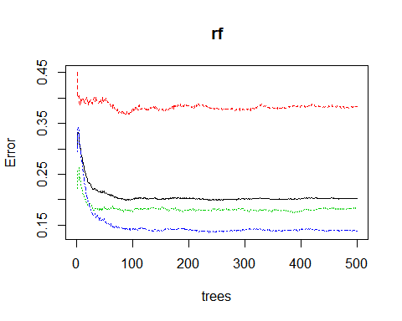

plot(rf2)

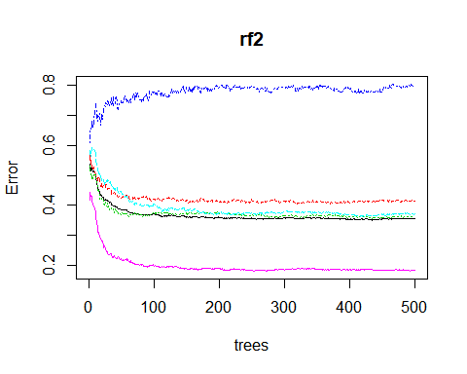

#The error rate is not improving after ~100 trees  
#Tune mtry  
#t <- tuneRF(train[,-21],train[,21],  
# stepFactor=.5,  
# plot=TRUE,  
# ntreeTry=200,  
# trace=TRUE,  
# improve=0.05)  
#No. of nodes for the trees  
hist(treesize(rf),  
 main="Number of Nodes for the Trees",  
 col="green")

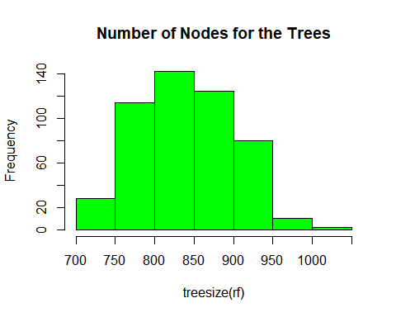

hist(treesize(rf2),  
 main="Number of Nodes for the Trees",  
 col="green")

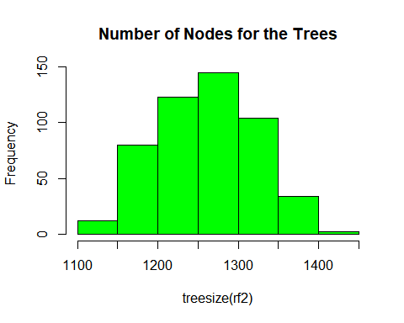

# Variable Importance  
# Familiarity is much more important than the other variables. Should it be removed and run again?  
varImpPlot(rf,  
 sort=T,  
 n.var=10,  
 main="Top 10 - Variable Importance")

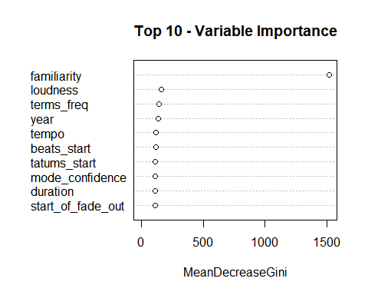

importance(rf)

## MeanDecreaseGini  
## bars_confidence 107.58378  
## beats_confidence 94.47263  
## beats_start 114.60290  
## duration 111.20674  
## end_of_fade_in 88.18414  
## familiarity 1520.73102  
## key 70.97697  
## key_confidence 107.84287  
## latitude 80.31500  
## longitude 80.00661  
## loudness 160.85558  
## mode_confidence 112.40895  
## start_of_fade_out 109.94686  
## tatums_confidence 100.29904  
## tatums_start 113.12138  
## tempo 118.86929  
## terms_freq 142.67373  
## time_signature 31.82993  
## time_signature_confidence 81.87304  
## year 133.56141

varUsed(rf)

## [1] 22981 20248 24173 23234 18362 42545 16709 23076 13678 13543 26260  
## [12] 23733 23098 21580 23800 24889 17934 7870 18132 13527

varImpPlot(rf2,  
 sort=T,  
 n.var=10,  
 main="Top 10 - Variable Importance")

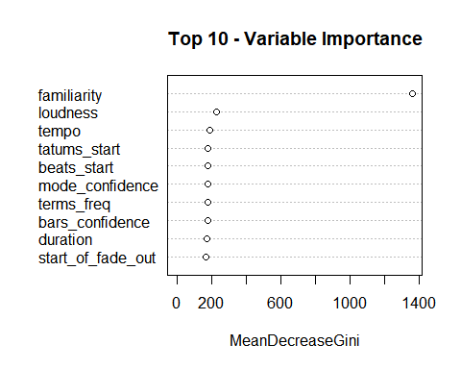

importance(rf2)

## MeanDecreaseGini  
## bars_confidence 174.77925  
## beats_confidence 153.37570  
## beats_start 176.89591  
## duration 168.58389  
## end_of_fade_in 141.16350  
## familiarity 1362.55235  
## key 115.59861  
## key_confidence 167.04577  
## latitude 114.97836  
## longitude 118.58999  
## loudness 227.38098  
## mode_confidence 176.77603  
## start_of_fade_out 167.99820  
## tatums_confidence 160.88208  
## tatums_start 178.93330  
## tempo 186.65606  
## terms_freq 176.06618  
## time_signature 51.64041  
## time_signature_confidence 134.38659  
## year 167.90690

varUsed(rf2)

## [1] 35548 31313 36142 34492 28373 59265 26210 34634 19869 20060 39304  
## [12] 36051 34736 33307 36125 37324 26336 12053 28255 20695

#Mulit-dimenstional Scaling Plot  
#The code below causes R to lock up...  
#MDSplot(rf,train$artist.hotttnesss.label)  
  
  
cmbomusic4 <- na.omit(cmbomusic3)  
cmbomusic5 <- cmbomusic4[-c(1,3,7:9,13,17,20)]  
str(cmbomusic5)

## 'data.frame': 2005 obs. of 12 variables:  
## $ latitude : num 37.2 37.2 43.6 37.2 41.9 ...  
## $ longitude : num -63.9 -63.9 -79.4 -63.9 -87.6 ...  
## $ loudness : num -4.5 -13.5 -8.58 -5.27 -11.94 ...  
## $ release.id : int 611336 358182 135122 372309 228326 709879 706005 28723 234425 322532 ...  
## $ tatums_confidence : num 1 0.121 0.377 0.238 0.462 0.461 0.84 0.537 1 0.228 ...  
## $ tatums_start : num 0.1358 1.226 0.0505 0.0573 0.1384 ...  
## $ tempo : num 129.7 86.6 119.8 150.1 110.2 ...  
## $ terms_freq : num 0.887 0.96 1 1 0.985 ...  
## $ time_signature : num 4 4 4 4 3 4 4 4 4 5 ...  
## $ time_signature_confidence: num 0.562 0.487 0.756 0.931 0.353 0.731 0.744 0.496 0.445 0.551 ...  
## $ year : int 2007 1984 1987 2004 1972 2007 2003 1995 2006 2009 ...  
## $ song.hotttnesss.label : Factor w/ 5 levels "Cool","Frigid",..: 3 2 4 3 4 4 5 5 3 4 ...

cmbomusic5$song.hotness.label <- as.factor(cmbomusic4$song.hotness.label)   
rf3 <- randomForest(cmbomusic5[,-12:-13],cmbomusic5[,13])  
rf3

##   
## Call:  
## randomForest(x = cmbomusic5[, -12:-13], y = cmbomusic5[, 13])   
## Type of random forest: classification  
## Number of trees: 500  
## No. of variables tried at each split: 3  
##   
## OOB estimate of error rate: 53.67%  
## Confusion matrix:  
## Cold Hot Warm class.error  
## Cold 299 27 379 0.5758865  
## Hot 77 67 270 0.8381643  
## Warm 259 64 563 0.3645598

print(rf3)

##   
## Call:  
## randomForest(x = cmbomusic5[, -12:-13], y = cmbomusic5[, 13])   
## Type of random forest: classification  
## Number of trees: 500  
## No. of variables tried at each split: 3  
##   
## OOB estimate of error rate: 53.67%  
## Confusion matrix:  
## Cold Hot Warm class.error  
## Cold 299 27 379 0.5758865  
## Hot 77 67 270 0.8381643  
## Warm 259 64 563 0.3645598

attributes(rf3)

## $names  
## [1] "call" "type" "predicted"   
## [4] "err.rate" "confusion" "votes"   
## [7] "oob.times" "classes" "importance"   
## [10] "importanceSD" "localImportance" "proximity"   
## [13] "ntree" "mtry" "forest"   
## [16] "y" "test" "inbag"   
##   
## $class  
## [1] "randomForest"

rf3$confusion

## Cold Hot Warm class.error  
## Cold 299 27 379 0.5758865  
## Hot 77 67 270 0.8381643  
## Warm 259 64 563 0.3645598

plot(rf3)

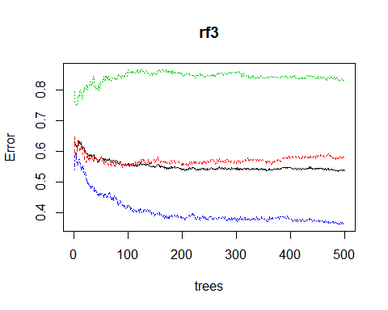

hist(treesize(rf3),  
 main="Number of Nodes for the Trees",  
 col="blue")

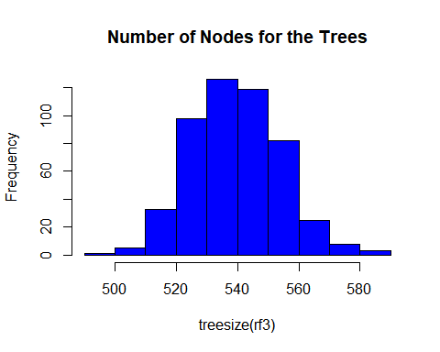

varImpPlot(rf3,  
 sort=T,  
 n.var=10,  
 main="Top 10 - Variable Importance")

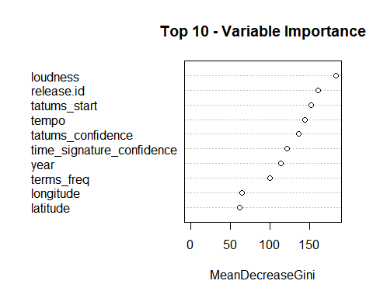 ## Results

## Conclusion

## Appendices