IST687 Final Project: Music Classification Analysis

**Authors:**

Juan Castro

John Fields

Courtney Smith

Jeremy Wallner

Table of Contents

Overview 1

Data 1

Data Collection 1

Data Summary 1

Artist Dataset 1

Songs Dataset 2

Data Import & Cleaning 3

Data Exploration 4

Data Visualization 5

Artist Popularity Distribution 5

Song Popularity Distribution 6

Location 6

Artist Location by Popularity 7

Song Location by Popularity 7

Predictive Modeling 7

Summary 7

Linear Regression 7

Random Forest 9

Results 11

Linear Regression 11

Random Forest 12

Conclusion 13

Appendix (Rmarkdown Code) 14

Related Work 14

Dataset 14

Features 26

Create a map of the world mapWorld 29

Methods - Linear Regression 31

Methods - Random Forest 37

# Overview

The Million Song Dataset (MSD) is a collection of audio data and metadata for a million popular music tracks. The data is made freely available to encourage research on algorithm development, as well as help new researchers get started in the Music Information Retrieval (MIR) field.

The purpose of this project is to analyze the Million Song Database to predict “Hot”, or popular, artists and songs based on the attributes such as familiarity, artist location, loudness, terms used, etc. The analysis was done using R software on a 10,000-track subset of the data.

While we tested three different models in an attempt to accurately predict artist/song popularity, the Random Forest model provided the most accurate results - we were able to predict popular artists with ~80% accuracy, and popular songs with ~48% accuracy.

# Data

## Data Collection

As the original Million Song Dataset (MSD) is incredibly large (~280GB), we based this analysis on a subset of 10,000 songs (1.8GB) for ease of data parsing, manipulation and modeling. The dataset was downloaded from [CORGIS](https://think.cs.vt.edu/corgis/csv/music/music.html).

## Data Summary

### Artist Dataset

The dataset contains 36 variables and 9,996 observations. The table below identifies the various fields and provides a description for each as defined by [millionsongdataset.com](http://millionsongdataset.com/pages/field-list/).

|  |  |
| --- | --- |
| Field Name | Description |
| artist.hotttnesss | algorithmic estimation |
| artist.id | echo nest ID |
| artist.name | artist name |
| artist_mbtags | tags from musicbrainz.org |
| artist_mbtags_count | tag counts from musicbrainz.org |
| bars_confidence | confidence measure |
| bars_start | beginning of bars, usually on a beat |
| beats_confidence | confidence measure |
| beats_start | result of beat tracking |
| duration | in seconds |
| end_of_fade_in | seconds at the beginning of the song |
| familiarity | algorithmic estimation |
| key | key the song is in |
| key_confidence | confidence measure |
| latitude | latitude |
| location | location name |
| longitude | longitude |
| mode_confidence | confidence measure |
| release.id | album ID |
| release.name | album name |
| similar | echo nest artist IDs (sim. algo. unpublished) |
| song.hotttnesss | algorithmic estimation |
| song.id | Echo Nest song ID |
| start_of_fade_out | time in sec |
| tatums_confidence | confidence measure |
| tatums_start | smallest rhythmic element |
| tempo | estimated tempo in bpm |
| terms | echo nest tags |
| terms_freq | echo nest tags freqs |
| time_signature | estimate of number of beats per bar, e.g. 4 |
| time_signature_confidence | confidence measure |
| title | song title |
| year | song release year from musicbrainz or 0 |
| artist.hotttnesss.label | artist popularity level as assigned by this team |

### Songs Dataset

The dataset contains 20 variables and 2,037 observations. The table below identifies the various fields and provides a description for each as defined by [millionsongdataset.com](http://millionsongdataset.com/pages/field-list/).

|  |  |
| --- | --- |
| Field Name | Description |
| artist.name | artist name |
| latitude | latitude |
| location | location name |
| longitude | longitude |
| loudness | overall loudness in db |
| release.id | album ID |
| release.name | album name |
| song.hotttnesss | algorithmic estimation |
| song.id | Echo Nest song ID |
| tatums_confidence | confidence measure |
| tatums_start | smallest rhythmic element |
| tempo | estimated tempo in bpm |
| terms | echo nest tags |
| terms_freq | echo nest tags freqs |
| time_signature | estimate of number of beats per bar, e.g. 4 |
| time_signature_confidence | confidence measure |
| title | song title |
| year | song release year from musicbrainz or 0 |
| song.hotttnesss.label | song popularity level as assigned by this team (5 levels) |
| song.popularity.label | song popularity level as assigned by this team (3 levels) |

## Data Import & Cleaning

After downloading the dataset, we wrote code to import the dataset and review its structure. We quickly found that we did not need all 36 columns, and identified several to remove to make the data easier to work with.

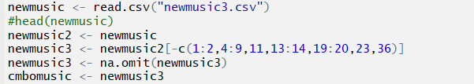

Additionally, we manually created two sets of artist popularity levels – one set containing 3 values and the second containing 5, in order to run our model on both sets to see if one methodology resulted in a more precise prediction. Lastly, we ran code to omit NAs from out dataset.

*3-Value Methodology:*

We manually reviewed the distribution of artist popularity numeric values, and assigned labels according to the skewness of the data. For example, the mean artist popularity value is 0.407, so for the purposes of labeling we presumed that anything ~15% higher than the mean would be considered “hot”, or popular.

* Hot (>.4590)
* Warm (<.4590 and >.3357)
* Cold (<.3357)

*5-Value Methodology:*

We created a more granular labeling method to see if we could more precisely measure the popularity level of an artist or song. We created various quantiles (95%, 75%, 50%, 25%) based on the artist popularity values and assigned labels as follows:

* Hot: >95% Quantile (0.6011861)
* Warm: >75% Quantile (0.453858)
* Tepid: >50% Quantile (0.3807423)
* Cool: >25% Quantile (0.3252656)
* Frigid: <25% Quantile (0.3252656)

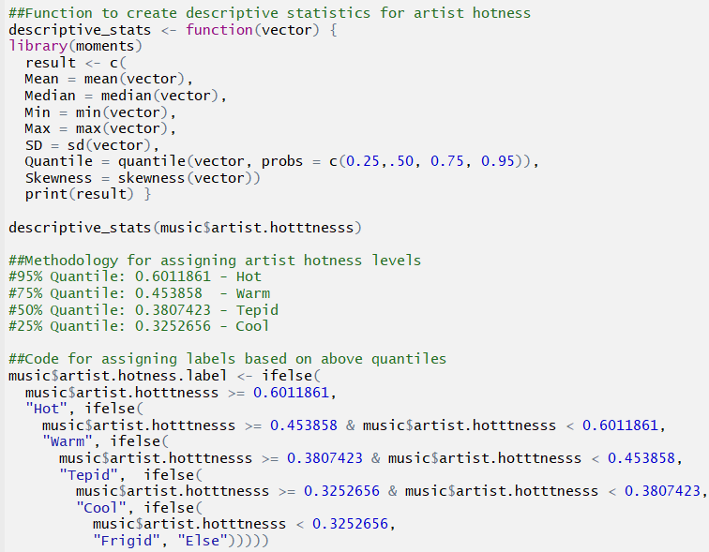

## Data Exploration

After importing and cleaning the data, we began analyzing the dataset by computing basic statistics at the aggregate as well as for each individual variable. Statistics include mean, median, min, max, standard deviation, quantiles, and skewness. This allows us to get a preliminary understanding of the data properties and identify any potential patterns or outliers in the data.

#### Descriptive Statistics

##### Artist Popularity Dataset:

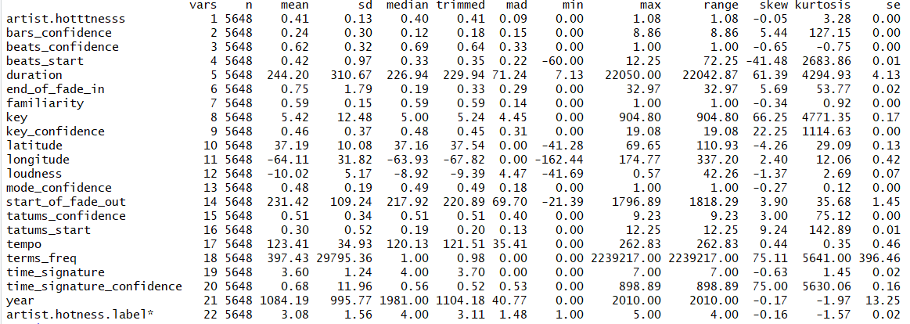



##### Song Popularity Dataset:

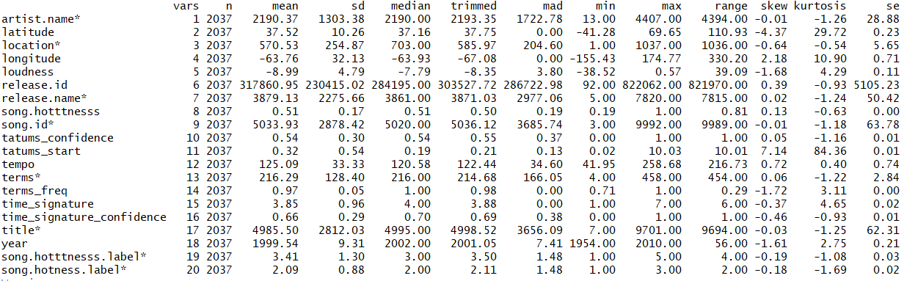



## Data Visualization

We plotted various fields to get a visual sense of how the observations in our dataset are distributed and identify any trends in our data.

### Artist Popularity Distribution

The histogram below shows the distribution and frequency of artist popularity ratings in our dataset. As previously mentioned, we used the visual distribution of artist hotness (or popularity) to create the 3 popularity categories (hot, warm, cold).

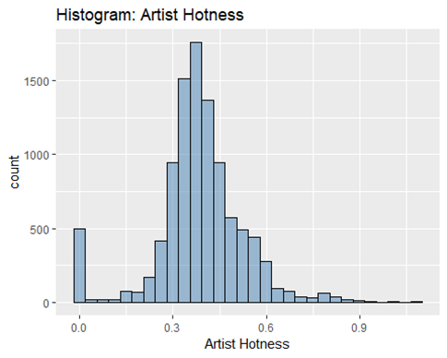

### Song Popularity Distribution

The histogram below shows the distribution and frequency of song popularity ratings in our dataset. Again, we used the visual distribution of song hotness (or popularity) to create the 3 popularity categories (hot, warm, cold).

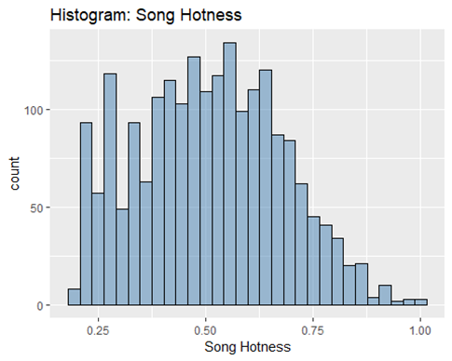

## Location

We wanted to get an understanding of where top artists or songs originate to determine if this might be a factor when predicting popularity. As visualized in the two maps below, we observe that the majority of popular artists/songs originate from the United States and Europe.

### Artist Location by Popularity

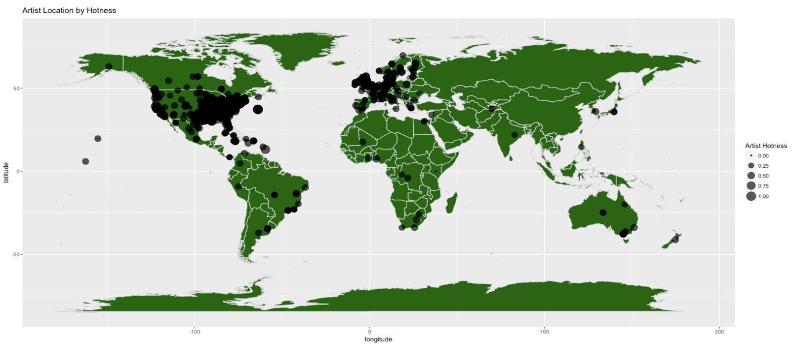

### Song Location by Popularity

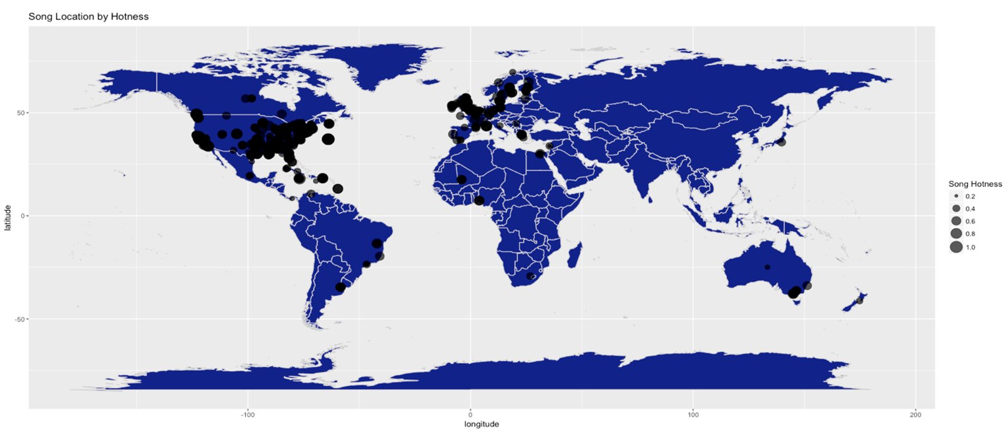

# Predictive Modeling

## Summary

We selected two ML models, Linear Regression and Random Forest, to try to accurately predict artist and song popularity with >=80% accuracy, and determine which model worked best for our purposes.

### Linear Regression

#### Artist Popularity:

For the initial linear artist popularity regression, a model with all the variables was ran; this gave us insignificant P-values all around. We started taking out the ones that seemed to have too high of a P-value, and ended with a simpler model of 3 variables; year, familiarity and longitude.

Below is the correlation matrix for this model:  
  
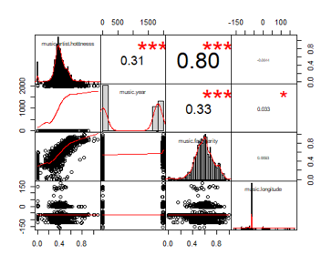

#### Song Popularity:

For the song popularity the variables that were showing significance ended up being less; loudness and tempo were the only two variables with significant   
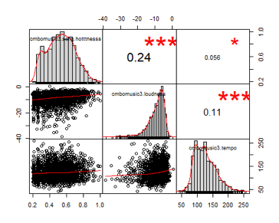

### Random Forest

The second model we selected to try to predict Artist/Song popularity was the Random Forest model. While we ran this two different ways (predicting popularity based on three labels or five) to determine which approach would result in the lowest error rate, we only included the method that resulted in the highest accuracy rate (3 labels).

#### Artist Popularity:

We found that familiarity was the most important variable when predicting Artist popularity.

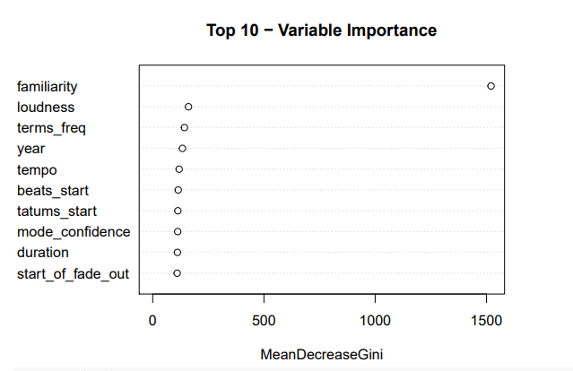

Additionally, our error rate did not improve after ~100 trees.

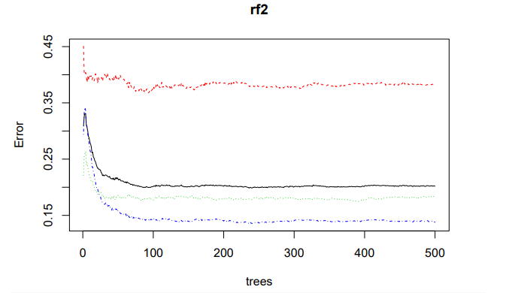

#### Song Popularity:

We found that Loudness was the most important variable when predicting song popularity.

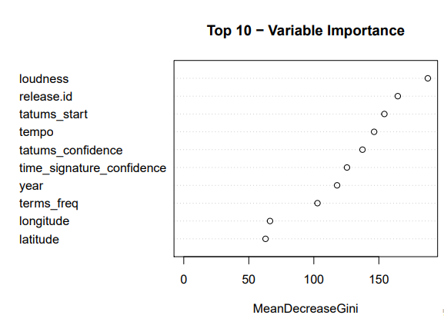

Similar to our Artist RF model, our error rate did not improve after ~100 trees.

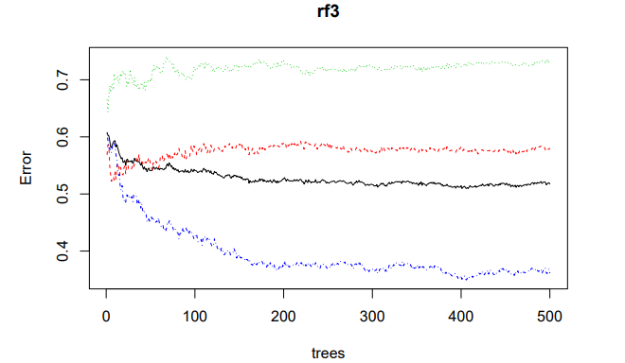

## Results

### Linear Regression

#### Artist Popularity:

The results from the regression pointed towards “year” and “familiarity” as being the most influential variable amongst the Artist regression in a positive way. Longitude had a negative effect on the popularity, with a not so significant P-value, still curious that as the longitude increased, the popularity of the artist would be smaller. The linear regression gave us an adjusted R-squared of .64, not ideal but higher than expected with such few variables that were significant.

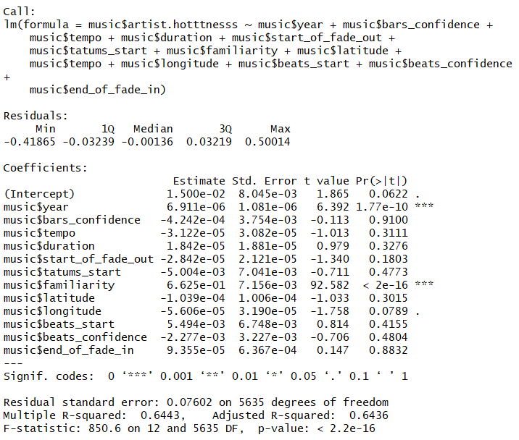

#### Song Popularity:

For the Song popularity regression, “loudness” was the most influential variable; with a positive effect on the “popularity” of the song. All together the R-Squared was still low = .05

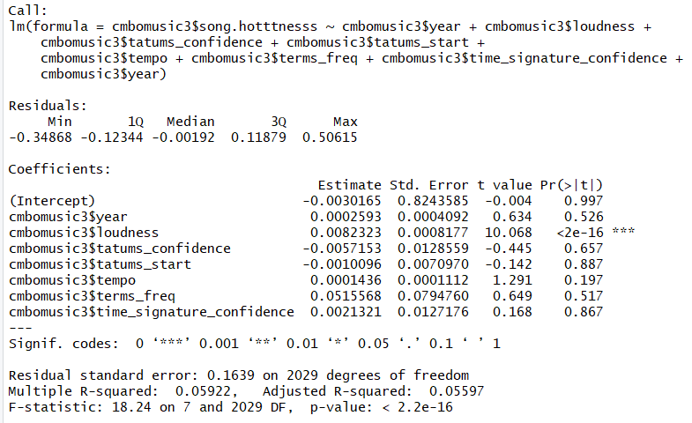

### Random Forest

#### Artist Popularity:

We were able to predict artist popularity with ~80% accuracy.

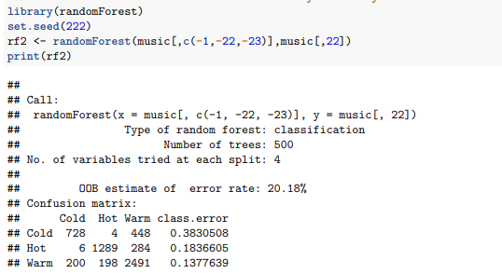

#### Song Popularity:

We were not as successful at predicting song popularity – we were only able to achieve ~48% accuracy.

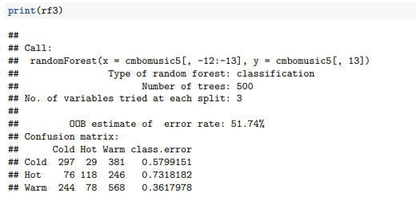

# Conclusion

In summation, the analysis presented in this paper highlights the steps taken to import and cleanse data within the R environment, perform exploratory analysis to better understand the data, as well as identify trends and outliers. Additionally, we ran two predictive models to determine which method would best predict artist popularity. We were able to most accurately predict artist and song hotness using the Random Forest model vs. Using Linear Regression. However, while our song prediction accuracy was higher for RF vs LR, the accuracy still fell below our threshold (~48% accuracy vs. 80% goal), so we were unable to provide meaningful results in terms of song popularity prediction.

Appendix (Rmarkdown Code)

## Related Work

Thierry Bertin-Mahieux, Daniel P.W. Ellis, Brian Whitman, and Paul Lamere. The Million Song Dataset. In Proceedings of the 12th International Society for Music Information Retrieval Conference (ISMIR 2011), 2011.

## Dataset

*#New code from Courtney to change from 3 to 5 categories of artist hotness*  
music <- **read.csv**("/Users/johnfields/Library/Mobile Documents/com~apple~CloudDocs/Syracuse/IST687/GitHub Music Project/newmusic.csv")  
*#music <- read.csv("~/Intro data science/Music project/newmusic.csv")*  
*#setwd("X:/Users/Courtney/Downloads")*  
*#music <- read.csv("music.csv")*  
**str**(music)

## 'data.frame': 9996 obs. of 36 variables:  
## $ artist.hotttnesss : num 0.402 0.417 0.343 0.454 0.402 ...  
## $ artist.id : Factor w/ 3885 levels "AR009211187B989185",..: 1269 2353 2168 715 3606 2128 1249 129 857 2506 ...  
## $ artist.name : Factor w/ 4409 levels ":Blacks On :Blondes",..: 682 3796 3560 67 1569 1891 3204 4168 3117 802 ...  
## $ artist_mbtags : Factor w/ 277 levels "","0.333","60s",..: 1 52 1 262 1 1 1 1 1 1 ...  
## $ artist_mbtags_count : num 0 1 0 1 0 0 0 0 0 0 ...  
## $ bars_confidence : num 0.643 0.007 0.98 0.017 0.175 0.121 0.709 0.142 0.806 0.047 ...  
## $ bars_start : num 0.585 0.711 0.732 1.306 1.064 ...  
## $ beats_confidence : num 0.834 1 0.98 0.809 0.883 0.438 0.709 0.234 0.44 1 ...  
## $ beats_start : num 0.585 0.206 0.732 0.81 0.136 ...  
## $ duration : num 219 148 177 233 210 ...  
## $ end_of_fade_in : num 0.247 0.148 0.282 0 0.066 ...  
## $ familiarity : num 0.582 0.631 0.487 0.63 0.651 ...  
## $ key : num 1 6 8 0 2 5 1 4 4 7 ...  
## $ key_confidence : num 0.736 0.169 0.643 0.751 0.092 0.635 0 0 0.717 0.053 ...  
## $ latitude : num 37.2 35.1 37.2 37.2 37.2 ...  
## $ location : Factor w/ 1046 levels " "," NC"," UbA!, Minas Gerais",..: 157 584 705 517 705 705 720 150 705 705 ...  
## $ longitude : num -63.9 -90 -63.9 -63.9 -63.9 ...  
## $ loudness : num -11.2 -9.84 -9.69 -9.01 -4.5 ...  
## $ mode : int 0 0 1 1 1 1 1 0 1 0 ...  
## $ mode_confidence : num 0.636 0.43 0.565 0.749 0.371 0.557 0 0.16 0.652 0.473 ...  
## $ release.id : int 300848 300822 514953 287650 611336 41838 25824 8876 358182 692313 ...  
## $ release.name : Factor w/ 7830 levels " Lazy Afternoon En Anglais",..: 2191 1746 3535 2334 4351 4744 1565 2468 4930 6081 ...  
## $ similar : Factor w/ 2837 levels "AR00K8N11C8A41687B",..: 2408 2225 1145 304 2331 1313 1101 1500 2577 715 ...  
## $ song.hotttnesss : num 0.602 NA NA NA 0.605 ...  
## $ song.id : Factor w/ 9996 levels " Polovtsian Dances / Rimsky-Korsakov: Russian Easter",..: 5350 1014 9225 5465 2424 9456 5094 3118 3378 7971 ...  
## $ start_of_fade_out : num 219 138 172 217 199 ...  
## $ tatums_confidence : num 0.779 0.969 0.482 0.601 1 0.136 0.467 0.292 0.121 1 ...  
## $ tatums_start : num 0.285 0.206 0.421 0.563 0.136 ...  
## $ tempo : num 92.2 121.3 100.1 119.3 129.7 ...  
## $ terms : Factor w/ 459 levels "","8-bit","acid jazz",..: 216 34 372 327 325 396 45 330 300 46 ...  
## $ terms_freq : num 1 1 1 0.989 0.887 ...  
## $ time_signature : num 4 4 1 4 4 3 1 3 4 4 ...  
## $ time_signature_confidence: num 0.778 0.384 0 0 0.562 0.454 0 0.408 0.487 0.878 ...  
## $ title : Factor w/ 9705 levels ""," -start ID-",..: 3572 7526 481 7474 2531 8282 4347 2194 6311 4001 ...  
## $ year : int 0 1969 0 1982 2007 0 0 0 1984 0 ...  
## $ artist.hotttnesss.label : Factor w/ 3 levels "Cold","Hot","Warm": 3 3 3 3 3 3 1 2 1 3 ...

**colnames**(music)[1] <- "artist.hotttnesss"  
*#Plot of the variables*  
**library**(ggplot2)

## Registered S3 methods overwritten by 'ggplot2':  
## method from   
## [.quosures rlang  
## c.quosures rlang  
## print.quosures rlang

**library**(reshape2)  
*#understand the structure of the data*  
*#install.packages("psych")*  
**library**(psych)

##   
## Attaching package: 'psych'

## The following objects are masked from 'package:ggplot2':  
##   
## %+%, alpha

**describeBy**(music,)

## Warning in describeBy(music, ): no grouping variable requested

## vars n mean sd median trimmed mad min max range skew kurtosis se  
## artist.hotttnesss 1 9996 0.39 0.14 0.38 0.39 0.09 0.00 1.08 1.08 -0.15 2.52 0.00  
## artist.id* 2 9996 1905.96 1122.20 1881.50 1900.72 1429.23 1.00 3885.00 3884.00 0.03 -1.20 11.22  
## artist.name* 3 9996 2205.03 1269.94 2194.00 2206.58 1623.45 1.00 4409.00 4408.00 -0.01 -1.19 12.70  
## artist_mbtags* 4 9996 50.06 79.27 1.00 33.38 0.00 1.00 277.00 276.00 1.43 0.64 0.79  
## artist_mbtags_count 5 9996 0.52 0.88 0.00 0.34 0.00 0.00 9.00 9.00 2.78 11.94 0.01  
## bars_confidence 6 9996 0.24 0.29 0.12 0.19 0.15 0.00 8.86 8.86 3.83 79.87 0.00  
## bars_start 7 9996 1.07 1.72 0.79 0.84 0.57 0.00 59.74 59.74 13.28 279.96 0.02  
## beats_confidence 8 9996 0.61 0.32 0.69 0.64 0.33 0.00 1.00 1.00 -0.64 -0.74 0.00  
## beats_start 9 9996 0.43 0.81 0.33 0.35 0.22 -60.00 12.25 72.25 -39.88 3172.34 0.01  
## duration 10 9996 240.63 246.13 223.06 226.88 73.82 1.04 22050.00 22048.96 69.93 6165.39 2.46  
## end_of_fade_in 11 9996 0.76 1.86 0.20 0.33 0.30 0.00 43.12 43.12 7.30 97.45 0.02  
## familiarity 12 9996 0.57 0.16 0.56 0.57 0.15 0.00 1.00 1.00 -0.26 0.64 0.00  
## key 13 9996 5.37 9.67 5.00 5.25 4.45 0.00 904.80 904.80 80.41 7473.90 0.10  
## key_confidence 14 9996 0.45 0.33 0.47 0.45 0.31 0.00 19.08 19.08 17.62 988.01 0.00  
## latitude 15 9996 37.16 9.54 37.16 37.45 0.00 -41.28 69.65 110.93 -4.16 29.64 0.10  
## location* 16 9996 596.91 238.96 705.00 616.26 65.23 1.00 1046.00 1045.00 -0.84 -0.07 2.39  
## longitude 17 9996 -63.93 30.90 -63.93 -67.56 0.00 -162.44 174.77 337.20 2.38 11.88 0.31  
## loudness 18 9996 -10.49 5.40 -9.38 -9.84 4.75 -51.64 0.57 52.21 -1.36 2.86 0.05  
## mode 19 9996 0.69 0.46 1.00 0.74 0.00 0.00 1.00 1.00 -0.83 -1.32 0.00  
## mode_confidence 20 9996 0.48 0.19 0.49 0.48 0.18 0.00 1.00 1.00 -0.27 0.09 0.00  
## release.id 21 9996 370953.83 236766.22 333100.50 364626.38 294894.33 0.00 823599.00 823599.00 0.18 -1.15 2368.14  
## release.name* 22 9996 3921.32 2257.12 3902.50 3923.69 2899.22 1.00 7830.00 7829.00 0.00 -1.20 22.58  
## similar* 23 9996 1416.79 822.48 1402.00 1418.57 1077.85 1.00 2837.00 2836.00 0.00 -1.20 8.23  
## song.hotttnesss 24 5648 0.34 0.25 0.36 0.34 0.27 0.00 1.00 1.00 -0.03 -1.04 0.00  
## song.id* 25 9996 4998.50 2885.74 4998.50 4998.50 3705.02 1.00 9996.00 9995.00 0.00 -1.20 28.86  
## start_of_fade_out 26 9996 229.89 112.04 213.88 218.25 71.55 -21.39 1813.43 1834.82 3.47 28.74 1.12  
## tatums_confidence 27 9996 0.51 0.33 0.50 0.51 0.40 0.00 9.23 9.23 1.84 45.95 0.00  
## tatums_start 28 9996 0.30 0.51 0.19 0.21 0.13 0.00 12.25 12.25 8.76 122.92 0.01  
## tempo 29 9996 122.90 35.20 120.16 121.09 34.87 0.00 262.83 262.83 0.41 0.48 0.35  
## terms* 30 9996 215.27 129.18 214.00 212.02 169.02 1.00 459.00 458.00 0.15 -1.20 1.29  
## terms_freq 31 9996 224.98 22396.64 1.00 0.98 0.00 0.00 2239217.00 2239217.00 99.95 9989.00 224.01  
## time_signature 32 9996 3.56 1.27 4.00 3.65 0.00 0.00 7.00 7.00 -0.59 1.17 0.01  
## time_signature_confidence 33 9996 0.60 8.99 0.55 0.51 0.53 0.00 898.89 898.89 99.69 9954.58 0.09  
## title* 34 9996 4863.28 2799.10 4859.50 4864.67 3586.41 1.00 9705.00 9704.00 0.00 -1.20 28.00  
## year 35 9996 935.08 996.67 0.00 917.89 0.00 0.00 2010.00 2010.00 0.13 -1.98 9.97  
## artist.hotttnesss.label* 36 9996 2.19 0.85 2.00 2.24 1.48 1.00 3.00 2.00 -0.37 -1.53 0.01

**ggplot**(data = **melt**(music), mapping = **aes**(x = value)) **+** **geom_histogram**(bins = 20) **+** **facet_wrap**(**~**variable, scales = 'free_x')

## Using artist.id, artist.name, artist_mbtags, location, release.name, similar, song.id, terms, title, artist.hotttnesss.label as id variables

## Warning: Removed 4348 rows containing non-finite values (stat_bin).

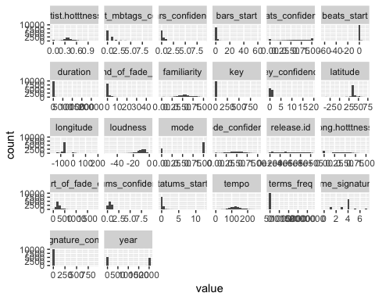

*#New code from Jeremy importing of song list*  
*#newmusic <- read.csv("~/Intro data science/Music project/newmusic3.csv")*  
newmusic <- **read.csv**("/Users/johnfields/Library/Mobile Documents/com~apple~CloudDocs/Syracuse/IST687/GitHub Music Project/newmusic3.csv")  
*#head(newmusic)*  
newmusic2 <- newmusic  
newmusic3 <- newmusic2[**-c**(1**:**2,4**:**9,11,13**:**14,19**:**20,23,36)]  
newmusic3 <- **na.omit**(newmusic3)  
cmbomusic <- newmusic3  
*##Artist Hotness Histogram*  
**library**(ggplot2)  
**ggplot**(music, **aes**(x=artist.hotttnesss)) **+** **geom_histogram**(color="black", fill="steelblue", alpha=0.5) **+** **xlab**("Artist Hotness") **+** **ggtitle**("Histogram: Artist Hotness")

## `stat_bin()` using `bins = 30`. Pick better value with `binwidth`.

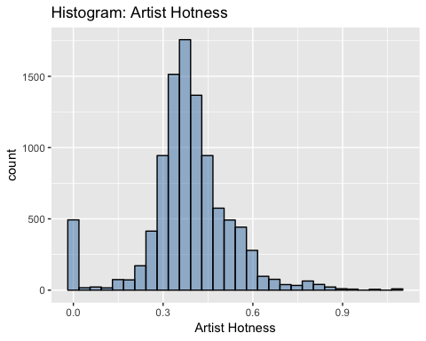

*##Function to create descriptive statistics for artist hotness*  
descriptive_stats <- **function**(vector) { **library**(moments)   
 result <- **c**(Mean=**mean**(vector),  
 Median=**median**(vector),  
 Min = **min**(vector),  
 Max = **max**(vector),  
 SD = **sd**(vector),  
 Quantile = **quantile**(vector, probs = **c**(0.25,.50,0.75, 0.95)),  
 Skewness = **skewness**(vector) )  
 **print**(result)   
}  
**descriptive_stats**(music**$**artist.hotttnesss)

## Mean Median Min Max SD Quantile.25% Quantile.50% Quantile.75% Quantile.95% Skewness   
## 0.3857065 0.3807564 0.0000000 1.0825026 0.1434688 0.3255062 0.3807564 0.4539300 0.6011861 -0.1483509

*##Methodology for assigning artist hotness levels - uses quantiles from descriptitive_statistics function*  
*#95% Quantile: 0.6011861 - Hot*  
*#75% Quantile: 0.453858 - Warm*  
*#50% Quantile: 0.3807423 - Tepid*  
*#25% Quantile: 0.3252656 - Cool*  
*##Code for assigning labels based on above quantiles*  
music**$**artist.hotness.label <- **ifelse**(music**$**artist.hotttnesss **>=**0.6011861, "Hot",  
 **ifelse**(music**$**artist.hotttnesss **>=**0.453858 **&** music**$**artist.hotttnesss **<**0.6011861, "Warm",  
 **ifelse**(music**$**artist.hotttnesss **>=**0.3807423 **&** music**$**artist.hotttnesss **<**0.453858, "Tepid",  
 **ifelse**(music**$**artist.hotttnesss **>=**0.3252656 **&** music**$**artist.hotttnesss **<**0.3807423, "Cool",  
 **ifelse**(music**$**artist.hotttnesss **<** 0.3252656, "Frigid","Else")))))  
**unique**(music**$**artist.hotness.label)

## [1] "Tepid" "Cool" "Warm" "Frigid" "Hot"

*#End of new code from Courtney*  
*#Prior to importing, a new column artist.hotttnesss.label was adding with*   
*#Hot(>.4590), Warm(<.4590 and >.3357), Cold(<.3357). Four rows with blanks in*   
*#famiiarity were also deleted.*

music <- **na.omit**(music)  
*#Copy original data to a new dataframe music1 and exclude unneeded data*  
music <- music[**-c**(2**:**5,7,16,19,21**:**25,30,34)]  
music**$**artist.hotness.label <- **as.factor**(music**$**artist.hotness.label)   
**str**(music)

## 'data.frame': 5648 obs. of 23 variables:  
## $ artist.hotttnesss : num 0.402 0.402 0.332 0.296 0.352 ...  
## $ bars_confidence : num 0.643 0.175 0.806 0.873 0.018 0.013 1 0.507 0.125 0.03 ...  
## $ beats_confidence : num 0.834 0.883 0.44 0.873 1 0.699 1 0 0.768 1 ...  
## $ beats_start : num 0.585 0.136 1.226 0.112 0.429 ...  
## $ duration : num 219 210 270 219 245 ...  
## $ end_of_fade_in : num 0.247 0.066 5.3 2.125 0.357 ...  
## $ familiarity : num 0.582 0.651 0.427 0.36 0.545 ...  
## $ key : num 1 2 4 5 7 9 10 7 8 7 ...  
## $ key_confidence : num 0.736 0.092 0.717 0.354 0.07 0.205 0 1 0.041 0.725 ...  
## $ latitude : num 37.2 37.2 37.2 35.2 37.2 ...  
## $ longitude : num -63.9 -63.9 -63.9 -80 -63.9 ...  
## $ loudness : num -11.2 -4.5 -13.5 -10.02 -7.54 ...  
## $ mode_confidence : num 0.636 0.371 0.652 0.485 0.686 0.305 0.198 0.829 0.516 0.756 ...  
## $ start_of_fade_out : num 219 199 259 207 227 ...  
## $ tatums_confidence : num 0.779 1 0.121 0.229 0.728 1 0.774 0.377 0.767 0.238 ...  
## $ tatums_start : num 0.285 0.136 1.226 0.112 0.173 ...  
## $ tempo : num 92.2 129.7 86.6 146.8 118 ...  
## $ terms_freq : num 1 0.887 0.96 0.956 1 ...  
## $ time_signature : num 4 4 4 1 4 4 1 4 5 4 ...  
## $ time_signature_confidence: num 0.778 0.562 0.487 0 0.835 0 0.319 0.756 0.579 0.931 ...  
## $ year : int 0 2007 1984 0 0 0 0 1987 0 2004 ...  
## $ artist.hotttnesss.label : Factor w/ 3 levels "Cold","Hot","Warm": 3 3 1 1 3 3 1 3 1 2 ...  
## $ artist.hotness.label : Factor w/ 5 levels "Cool","Frigid",..: 4 4 1 2 1 1 2 4 1 5 ...

*##SONG HOTNESS HISTOGRAM From Jeremy*  
cmbomusic[cmbomusic**==**0]<- NA  
*#cmbomusic2 <- cmbomusic[-c(5,6)]*  
cmbomusic3 <- **na.omit**(cmbomusic)  
cmbomusic3**$**song.hotttnesss.label <- **ifelse**( cmbomusic3**$**song.hotttnesss **>=**0.6011861, "Hot",**ifelse**(cmbomusic3**$**song.hotttnesss **>=** 0.453858 **&** cmbomusic3**$**song.hotttnesss **<**0.6011861, "Warm", **ifelse**(cmbomusic3**$**song.hotttnesss **>=**0.3807423 **&** cmbomusic3**$**song.hotttnesss **<** 0.453858, "Tepid",**ifelse**(cmbomusic3**$**song.hotttnesss **>=**0.3252656 **&** cmbomusic3**$**song.hotttnesss **<**0.3807423, "Cool",**ifelse**(cmbomusic3**$**song.hotttnesss **<** 0.3252656, "Frigid","Else")))))  
**unique**(cmbomusic3**$**song.hotttnesss.label)

## [1] "Hot" "Tepid" "Cool" "Warm" "Frigid"

cmbomusic3 <- cmbomusic3[**-c**(2**:**3,12)]  
**ggplot**(cmbomusic3, **aes**(x=song.hotttnesss)) **+** **geom_histogram**(color="black", fill="steelblue", alpha=0.5) **+** **xlab**("Song Hotness") **+** **ggtitle**("Histogram: Song Hotness")

## `stat_bin()` using `bins = 30`. Pick better value with `binwidth`.

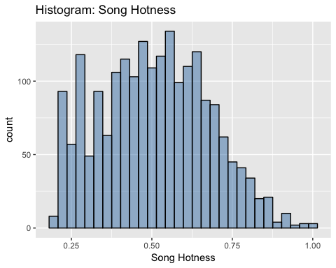

*##Function to create descriptive statistics for song hotness*  
descriptive_stats2 <- **function**(vector) { **library**(moments)   
 result <- **c**(Mean=**mean**(vector),  
 Median=**median**(vector),  
 Min = **min**(vector),  
 Max = **max**(vector),  
 SD = **sd**(vector),  
 Quantile = **quantile**(vector, probs = **c**(0.25,.50,0.75, 0.95)),  
 Skewness = **skewness**(vector) )  
 **print**(result)   
}  
**descriptive_stats2**(cmbomusic3**$**song.hotttnesss)

## Mean Median Min Max SD Quantile.25% Quantile.50% Quantile.75% Quantile.95% Skewness   
## 0.5073226 0.5096410 0.1938578 1.0000000 0.1686679 0.3827233 0.5096410 0.6301876 0.7900643 0.1304601

cmbomusic3**$**song.hotness.label <- **ifelse**( cmbomusic3**$**song.hotttnesss **>=**0.64787976, "Hot",**ifelse**(cmbomusic3**$**song.hotttnesss **>=** 0.43437984 **&** cmbomusic3**$**song.hotttnesss **<**0.64787976, "Warm", **ifelse**( cmbomusic3**$**song.hotttnesss **<**0.43437984, "Cold","Else")))  
**unique**(cmbomusic3**$**song.hotness.label)

## [1] "Hot" "Cold" "Warm"

cmbomusic3**$**song.hotttnesss.label <- **as.factor**(cmbomusic3**$**song.hotttnesss.label)   
**str**(cmbomusic3)

## 'data.frame': 2037 obs. of 20 variables:  
## $ artist.name : Factor w/ 4408 levels ":Blacks On :Blondes",..: 3571 3380 1641 2281 3260 140 128 2194 3424 1968 ...  
## $ latitude : num 47.6 37.2 53.5 37.2 37.2 ...  
## $ location : Factor w/ 1043 levels ""," UbA!, Minas Gerais",..: 856 703 557 283 703 859 604 703 604 703 ...  
## $ longitude : num -122.33 -63.93 -2.25 -63.93 -63.93 ...  
## $ loudness : num -9.31 -6.08 -9.62 -10.54 -14.01 ...  
## $ release.id : int 15964 114401 186364 171807 512792 583091 192588 92902 15316 777947 ...  
## $ release.name : Factor w/ 7829 levels ". . . Till Then",..: 715 5751 1083 3597 921 909 372 5021 2205 914 ...  
## $ song.hotttnesss : num 0.654 0.43 0.346 1 0.694 ...  
## $ song.id : Factor w/ 9995 levels "SOAAAQN12AB01856D3",..: 3 6 7 11 15 16 19 24 29 37 ...  
## $ tatums_confidence : num 0.898 1 0.445 0.388 0.484 0.873 0.408 0.284 0.992 1 ...  
## $ tatums_start : num 0.1569 0.0346 0.089 0.1008 0.2263 ...  
## $ tempo : num 131 114 102 151 123 ...  
## $ terms : Factor w/ 458 levels "","8-bit","acid jazz",..: 10 216 8 37 301 198 107 77 329 37 ...  
## $ terms_freq : num 1 1 1 0.998 0.82 ...  
## $ time_signature : int 4 5 4 3 4 4 4 4 4 3 ...  
## $ time_signature_confidence: num 0.59 0.583 0.097 1 0.369 1 1 0.866 0.919 0.741 ...  
## $ title : Factor w/ 9704 levels "","-start ID-",..: 7342 6931 9501 3916 539 4665 6981 7116 3031 3620 ...  
## $ year : int 1991 2005 1988 1970 1977 2009 2008 2007 1998 2010 ...  
## $ song.hotttnesss.label : Factor w/ 5 levels "Cool","Frigid",..: 3 4 1 3 3 3 3 1 3 3 ...  
## $ song.hotness.label : chr "Hot" "Cold" "Cold" "Hot" ...

cmbomusic3**$**song.hotttnesss.label <- **ifelse**( cmbomusic3**$**song.hotttnesss **>=**0.6011861, "Hot",**ifelse**(cmbomusic3**$**song.hotttnesss **>=** 0.453858 **&** cmbomusic3**$**song.hotttnesss **<**0.6011861, "Warm", **ifelse**(cmbomusic3**$**song.hotttnesss **>=**0.3807423 **&** cmbomusic3**$**song.hotttnesss **<** 0.453858, "Tepid",**ifelse**(cmbomusic3**$**song.hotttnesss **>=**0.3252656 **&** cmbomusic3**$**song.hotttnesss **<**0.3807423, "Cool",**ifelse**(cmbomusic3**$**song.hotttnesss **<** 0.3252656, "Frigid","Else")))))  
**unique**(cmbomusic3**$**song.hotttnesss.label)

## [1] "Hot" "Tepid" "Cool" "Warm" "Frigid"

cmbomusic3**$**song.hotttnesss.label <- **as.factor**(cmbomusic3**$**song.hotttnesss.label)   
**str**(cmbomusic3)

## 'data.frame': 2037 obs. of 20 variables:  
## $ artist.name : Factor w/ 4408 levels ":Blacks On :Blondes",..: 3571 3380 1641 2281 3260 140 128 2194 3424 1968 ...  
## $ latitude : num 47.6 37.2 53.5 37.2 37.2 ...  
## $ location : Factor w/ 1043 levels ""," UbA!, Minas Gerais",..: 856 703 557 283 703 859 604 703 604 703 ...  
## $ longitude : num -122.33 -63.93 -2.25 -63.93 -63.93 ...  
## $ loudness : num -9.31 -6.08 -9.62 -10.54 -14.01 ...  
## $ release.id : int 15964 114401 186364 171807 512792 583091 192588 92902 15316 777947 ...  
## $ release.name : Factor w/ 7829 levels ". . . Till Then",..: 715 5751 1083 3597 921 909 372 5021 2205 914 ...  
## $ song.hotttnesss : num 0.654 0.43 0.346 1 0.694 ...  
## $ song.id : Factor w/ 9995 levels "SOAAAQN12AB01856D3",..: 3 6 7 11 15 16 19 24 29 37 ...  
## $ tatums_confidence : num 0.898 1 0.445 0.388 0.484 0.873 0.408 0.284 0.992 1 ...  
## $ tatums_start : num 0.1569 0.0346 0.089 0.1008 0.2263 ...  
## $ tempo : num 131 114 102 151 123 ...  
## $ terms : Factor w/ 458 levels "","8-bit","acid jazz",..: 10 216 8 37 301 198 107 77 329 37 ...  
## $ terms_freq : num 1 1 1 0.998 0.82 ...  
## $ time_signature : int 4 5 4 3 4 4 4 4 4 3 ...  
## $ time_signature_confidence: num 0.59 0.583 0.097 1 0.369 1 1 0.866 0.919 0.741 ...  
## $ title : Factor w/ 9704 levels "","-start ID-",..: 7342 6931 9501 3916 539 4665 6981 7116 3031 3620 ...  
## $ year : int 1991 2005 1988 1970 1977 2009 2008 2007 1998 2010 ...  
## $ song.hotttnesss.label : Factor w/ 5 levels "Cool","Frigid",..: 3 4 1 3 3 3 3 1 3 3 ...  
## $ song.hotness.label : chr "Hot" "Cold" "Cold" "Hot" ...

cmbomusic3**$**song.hotttnesss.label <- **ifelse**( cmbomusic3**$**song.hotttnesss **>=**0.6011861, "Hot",**ifelse**(cmbomusic3**$**song.hotttnesss **>=** 0.453858 **&** cmbomusic3**$**song.hotttnesss **<**0.6011861, "Warm", **ifelse**(cmbomusic3**$**song.hotttnesss **>=**0.3807423 **&** cmbomusic3**$**song.hotttnesss **<** 0.453858, "Tepid",**ifelse**(cmbomusic3**$**song.hotttnesss **>=**0.3252656 **&** cmbomusic3**$**song.hotttnesss **<**0.3807423, "Cool",**ifelse**(cmbomusic3**$**song.hotttnesss **<** 0.3252656, "Frigid","Else")))))  
**unique**(cmbomusic3**$**song.hotttnesss.label)

## [1] "Hot" "Tepid" "Cool" "Warm" "Frigid"

**str**(cmbomusic3)

## 'data.frame': 2037 obs. of 20 variables:  
## $ artist.name : Factor w/ 4408 levels ":Blacks On :Blondes",..: 3571 3380 1641 2281 3260 140 128 2194 3424 1968 ...  
## $ latitude : num 47.6 37.2 53.5 37.2 37.2 ...  
## $ location : Factor w/ 1043 levels ""," UbA!, Minas Gerais",..: 856 703 557 283 703 859 604 703 604 703 ...  
## $ longitude : num -122.33 -63.93 -2.25 -63.93 -63.93 ...  
## $ loudness : num -9.31 -6.08 -9.62 -10.54 -14.01 ...  
## $ release.id : int 15964 114401 186364 171807 512792 583091 192588 92902 15316 777947 ...  
## $ release.name : Factor w/ 7829 levels ". . . Till Then",..: 715 5751 1083 3597 921 909 372 5021 2205 914 ...  
## $ song.hotttnesss : num 0.654 0.43 0.346 1 0.694 ...  
## $ song.id : Factor w/ 9995 levels "SOAAAQN12AB01856D3",..: 3 6 7 11 15 16 19 24 29 37 ...  
## $ tatums_confidence : num 0.898 1 0.445 0.388 0.484 0.873 0.408 0.284 0.992 1 ...  
## $ tatums_start : num 0.1569 0.0346 0.089 0.1008 0.2263 ...  
## $ tempo : num 131 114 102 151 123 ...  
## $ terms : Factor w/ 458 levels "","8-bit","acid jazz",..: 10 216 8 37 301 198 107 77 329 37 ...  
## $ terms_freq : num 1 1 1 0.998 0.82 ...  
## $ time_signature : int 4 5 4 3 4 4 4 4 4 3 ...  
## $ time_signature_confidence: num 0.59 0.583 0.097 1 0.369 1 1 0.866 0.919 0.741 ...  
## $ title : Factor w/ 9704 levels "","-start ID-",..: 7342 6931 9501 3916 539 4665 6981 7116 3031 3620 ...  
## $ year : int 1991 2005 1988 1970 1977 2009 2008 2007 1998 2010 ...  
## $ song.hotttnesss.label : chr "Hot" "Tepid" "Cool" "Hot" ...  
## $ song.hotness.label : chr "Hot" "Cold" "Cold" "Hot" ...

cmbomusic3**$**song.hotttnesss.label <- **as.factor**(cmbomusic3**$**song.hotttnesss.label)   
cmbomusic3**$**song.hotttnesss.label <- **as.factor**(cmbomusic3**$**song.hotttnesss.label)   
**str**(cmbomusic3)

## 'data.frame': 2037 obs. of 20 variables:  
## $ artist.name : Factor w/ 4408 levels ":Blacks On :Blondes",..: 3571 3380 1641 2281 3260 140 128 2194 3424 1968 ...  
## $ latitude : num 47.6 37.2 53.5 37.2 37.2 ...  
## $ location : Factor w/ 1043 levels ""," UbA!, Minas Gerais",..: 856 703 557 283 703 859 604 703 604 703 ...  
## $ longitude : num -122.33 -63.93 -2.25 -63.93 -63.93 ...  
## $ loudness : num -9.31 -6.08 -9.62 -10.54 -14.01 ...  
## $ release.id : int 15964 114401 186364 171807 512792 583091 192588 92902 15316 777947 ...  
## $ release.name : Factor w/ 7829 levels ". . . Till Then",..: 715 5751 1083 3597 921 909 372 5021 2205 914 ...  
## $ song.hotttnesss : num 0.654 0.43 0.346 1 0.694 ...  
## $ song.id : Factor w/ 9995 levels "SOAAAQN12AB01856D3",..: 3 6 7 11 15 16 19 24 29 37 ...  
## $ tatums_confidence : num 0.898 1 0.445 0.388 0.484 0.873 0.408 0.284 0.992 1 ...  
## $ tatums_start : num 0.1569 0.0346 0.089 0.1008 0.2263 ...  
## $ tempo : num 131 114 102 151 123 ...  
## $ terms : Factor w/ 458 levels "","8-bit","acid jazz",..: 10 216 8 37 301 198 107 77 329 37 ...  
## $ terms_freq : num 1 1 1 0.998 0.82 ...  
## $ time_signature : int 4 5 4 3 4 4 4 4 4 3 ...  
## $ time_signature_confidence: num 0.59 0.583 0.097 1 0.369 1 1 0.866 0.919 0.741 ...  
## $ title : Factor w/ 9704 levels "","-start ID-",..: 7342 6931 9501 3916 539 4665 6981 7116 3031 3620 ...  
## $ year : int 1991 2005 1988 1970 1977 2009 2008 2007 1998 2010 ...  
## $ song.hotttnesss.label : Factor w/ 5 levels "Cool","Frigid",..: 3 4 1 3 3 3 3 1 3 3 ...  
## $ song.hotness.label : chr "Hot" "Cold" "Cold" "Hot" ...

*#View the number of Cold/Warm/Hot labels*   
**table**(cmbomusic3**$**song.hotttnesss.label)

##   
## Cool Frigid Hot Tepid Warm   
## 171 337 629 278 622

cmbomusic3**$**song.hotness.label <- **ifelse**( cmbomusic3**$**song.hotttnesss **>=**0.64787976, "Hot",**ifelse**(cmbomusic3**$**song.hotttnesss **>=** 0.43437984 **&** cmbomusic3**$**song.hotttnesss **<**0.64787976, "Warm", **ifelse**( cmbomusic3**$**song.hotttnesss **<**0.43437984, "Cold","Else")))  
**unique**(cmbomusic3**$**song.hotness.label)

## [1] "Hot" "Cold" "Warm"

## Features

*#View the number of Cold/Warm/Hot labels*   
**table**(music**$**artist.hotttnesss.label)

##   
## Cold Hot Warm   
## 1180 1579 2889

*#View the number of Frigid/Cool/Tepid/Warm/Hot labels*   
**table**(music**$**artist.hotness.label)

##   
## Cool Frigid Hot Tepid Warm   
## 1444 973 278 1566 1387

*#Plot artists latitude and longitude*  
**plot**(music**$**latitude,music**$**longitude)

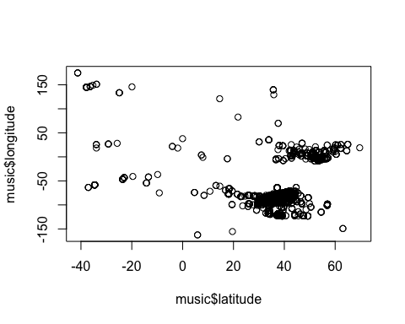

cmbomusic3**$**song.hotness.label <- **as.factor**(cmbomusic3**$**song.hotness.label)   
cmbomusic3**$**song.hotness.label <- **as.factor**(cmbomusic3**$**song.hotness.label)   
**str**(cmbomusic3)

## 'data.frame': 2037 obs. of 20 variables:  
## $ artist.name : Factor w/ 4408 levels ":Blacks On :Blondes",..: 3571 3380 1641 2281 3260 140 128 2194 3424 1968 ...  
## $ latitude : num 47.6 37.2 53.5 37.2 37.2 ...  
## $ location : Factor w/ 1043 levels ""," UbA!, Minas Gerais",..: 856 703 557 283 703 859 604 703 604 703 ...  
## $ longitude : num -122.33 -63.93 -2.25 -63.93 -63.93 ...  
## $ loudness : num -9.31 -6.08 -9.62 -10.54 -14.01 ...  
## $ release.id : int 15964 114401 186364 171807 512792 583091 192588 92902 15316 777947 ...  
## $ release.name : Factor w/ 7829 levels ". . . Till Then",..: 715 5751 1083 3597 921 909 372 5021 2205 914 ...  
## $ song.hotttnesss : num 0.654 0.43 0.346 1 0.694 ...  
## $ song.id : Factor w/ 9995 levels "SOAAAQN12AB01856D3",..: 3 6 7 11 15 16 19 24 29 37 ...  
## $ tatums_confidence : num 0.898 1 0.445 0.388 0.484 0.873 0.408 0.284 0.992 1 ...  
## $ tatums_start : num 0.1569 0.0346 0.089 0.1008 0.2263 ...  
## $ tempo : num 131 114 102 151 123 ...  
## $ terms : Factor w/ 458 levels "","8-bit","acid jazz",..: 10 216 8 37 301 198 107 77 329 37 ...  
## $ terms_freq : num 1 1 1 0.998 0.82 ...  
## $ time_signature : int 4 5 4 3 4 4 4 4 4 3 ...  
## $ time_signature_confidence: num 0.59 0.583 0.097 1 0.369 1 1 0.866 0.919 0.741 ...  
## $ title : Factor w/ 9704 levels "","-start ID-",..: 7342 6931 9501 3916 539 4665 6981 7116 3031 3620 ...  
## $ year : int 1991 2005 1988 1970 1977 2009 2008 2007 1998 2010 ...  
## $ song.hotttnesss.label : Factor w/ 5 levels "Cool","Frigid",..: 3 4 1 3 3 3 3 1 3 3 ...  
## $ song.hotness.label : Factor w/ 3 levels "Cold","Hot","Warm": 2 1 1 2 2 2 2 1 3 2 ...

*#View the number of Cold/Warm/Hot labels*   
**table**(cmbomusic3**$**song.hotness.label)

##   
## Cold Hot Warm   
## 707 440 890

*#View the number of Frigid/Cool/Tepid/Warm/Hot labels*   
**table**(cmbomusic3**$**song.hotttnesss.label)

##   
## Cool Frigid Hot Tepid Warm   
## 171 337 629 278 622

*#Plot artists latitude and longitude*  
**plot**(cmbomusic3**$**latitude,cmbomusic3**$**longitude)

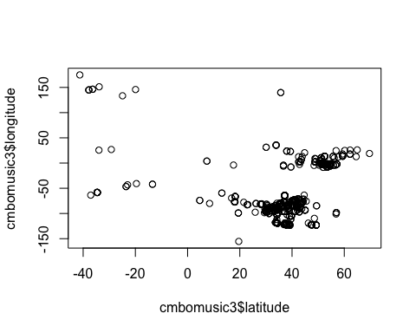

*#Plot artist hotttnesss*  
*#hist(music$artist.hotttnesss,breaks=20)*  
*#hist(music$artist.hotness,breaks=20)*

## Create a map of the world mapWorld

<- borders(“world”, colour=“gray50”, fill=“white”)

*#New code from John for creating a map of the world showing latitude/longitude and artist hotness*  
*#Code based on info from https://rpubs.com/spoonerf/global_map*  
**library**(dplyr)

##   
## Attaching package: 'dplyr'

## The following objects are masked from 'package:stats':  
##   
## filter, lag

## The following objects are masked from 'package:base':  
##   
## intersect, setdiff, setequal, union

loc<-**data.frame**(music**$**longitude,music**$**latitude,music**$**artist.hotttnesss)  
loc<-**unique**(loc)  
**colnames**(loc)<-**c**("longitude", "latitude","artist hotness")  
loc_df<-**data.frame**(loc)  
**library**(maps)  
**library**(mapdata)  
**library**(ggplot2)  
ahworld <- **ggplot**(data=loc_df, **aes**(longitude, latitude, group=NULL,fill=NULL,size=artist.hotness))**+***#, fill=hole)) +*   
 **borders**(fill="dark green",colour="light grey")**+**  
 **geom_point**(color="black",alpha=**I**(7**/**10))**+**  
 **scale_size**(range=**c**(1,7), guide = "legend",**labs**(size="Artist Hotness"))**+**  
 **coord_equal**()**+** **ggtitle**("Artist Location by Hotness")  
ahworld

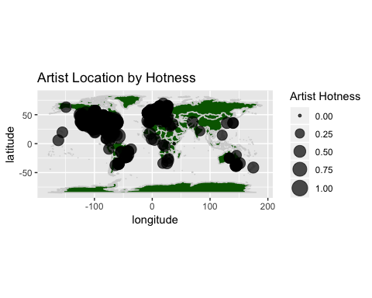

*#New code from John for creating a map of the world showing latitude/longitude and artist hotness*  
*#Code based on info from https://rpubs.com/spoonerf/global_map*  
**library**(dplyr)  
songlc<-**data.frame**(cmbomusic3**$**longitude,cmbomusic3**$**latitude,cmbomusic3**$**song.hotttnesss)  
songlc<-**unique**(songlc)  
**colnames**(songlc)<-**c**("longitude", "latitude","song hotness")  
songlc_df<-**data.frame**(songlc)  
**library**(maps)  
**library**(mapdata)  
**library**(ggplot2)  
songlc_dfwrld <- **ggplot**(data=songlc_df, **aes**(longitude, latitude, group=NULL,fill=NULL,size=song.hotness))**+***#, fill=hole)) +*   
**borders**(fill="dark blue",colour="light grey")**+**  
 **geom_point**(color="black",alpha=**I**(7**/**10))**+**  
 **scale_size**(range=**c**(1,7), guide = "legend",**labs**(size="Song Hotness"))**+**  
 **coord_equal**()**+** **ggtitle**("Song Location by Hotness")  
  
songlc_dfwrld

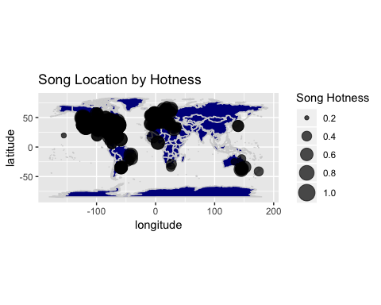

## Methods - Linear Regression

**library**("PerformanceAnalytics")

## Loading required package: xts

## Loading required package: zoo

##   
## Attaching package: 'zoo'

## The following objects are masked from 'package:base':  
##   
## as.Date, as.Date.numeric

## Registered S3 method overwritten by 'xts':  
## method from  
## as.zoo.xts zoo

##   
## Attaching package: 'xts'

## The following objects are masked from 'package:dplyr':  
##   
## first, last

##   
## Attaching package: 'PerformanceAnalytics'

## The following objects are masked from 'package:moments':  
##   
## kurtosis, skewness

## The following object is masked from 'package:graphics':  
##   
## legend

*#code from Juan*  
*#Artist prediction*  
lm1 <- **lm**(formula = music**$**artist.hotttnesss **~** music**$**year **+** music**$**bars_confidence **+**music**$**tempo **+** music**$**duration **+** music**$**start_of_fade_out **+** music**$**tatums_start **+** music**$**familiarity **+** music**$**latitude **+**   
music**$**tempo **+** music**$**longitude **+** music**$**beats_start **+** music**$**beats_confidence **+** music**$**end_of_fade_in)   
*#removed music$bars_start which was causing an error*  
   
*#Songs with labels*  
lm2 <- **lm**(cmbomusic3**$**song.hotttnesss **~** cmbomusic3**$**year **+** cmbomusic3**$**loudness **+** cmbomusic3**$**tatums_confidence **+** cmbomusic3**$**tatums_start **+** cmbomusic3**$**tempo **+** cmbomusic3**$**terms_freq **+** cmbomusic3**$**time_signature_confidence **+** cmbomusic3**$**year **+** **factor**(cmbomusic3**$**song.hotttnesss.label) **+** **factor**(cmbomusic3**$**song.hotness.label))   
  
*#Songs no labels*  
lm3 <- **lm**(cmbomusic3**$**song.hotttnesss **~** cmbomusic3**$**year **+** cmbomusic3**$**loudness **+** cmbomusic3**$**tatums_confidence **+** cmbomusic3**$**tatums_start **+** cmbomusic3**$**tempo **+** cmbomusic3**$**terms_freq **+** cmbomusic3**$**time_signature_confidence **+** cmbomusic3**$**year)  
  
  
**summary**(lm1)

##   
## Call:  
## lm(formula = music$artist.hotttnesss ~ music$year + music$bars_confidence +   
## music$tempo + music$duration + music$start_of_fade_out +   
## music$tatums_start + music$familiarity + music$latitude +   
## music$tempo + music$longitude + music$beats_start + music$beats_confidence +   
## music$end_of_fade_in)  
##   
## Residuals:  
## Min 1Q Median 3Q Max   
## -0.41865 -0.03239 -0.00136 0.03219 0.50014   
##   
## Coefficients:  
## Estimate Std. Error t value Pr(>|t|)   
## (Intercept) 1.500e-02 8.045e-03 1.865 0.0622 .   
## music$year 6.911e-06 1.081e-06 6.392 1.77e-10 ***  
## music$bars_confidence -4.242e-04 3.754e-03 -0.113 0.9100   
## music$tempo -3.122e-05 3.082e-05 -1.013 0.3111   
## music$duration 1.842e-05 1.881e-05 0.979 0.3276   
## music$start_of_fade_out -2.842e-05 2.121e-05 -1.340 0.1803   
## music$tatums_start -5.004e-03 7.041e-03 -0.711 0.4773   
## music$familiarity 6.625e-01 7.156e-03 92.582 < 2e-16 ***  
## music$latitude -1.039e-04 1.006e-04 -1.033 0.3015   
## music$longitude -5.606e-05 3.190e-05 -1.758 0.0789 .   
## music$beats_start 5.494e-03 6.748e-03 0.814 0.4155   
## music$beats_confidence -2.277e-03 3.227e-03 -0.706 0.4804   
## music$end_of_fade_in 9.355e-05 6.367e-04 0.147 0.8832   
## ---  
## Signif. codes: 0 '***' 0.001 '**' 0.01 '*' 0.05 '.' 0.1 ' ' 1  
##   
## Residual standard error: 0.07602 on 5635 degrees of freedom  
## Multiple R-squared: 0.6443, Adjusted R-squared: 0.6436   
## F-statistic: 850.6 on 12 and 5635 DF, p-value: < 2.2e-16

**summary**(lm2)

##   
## Call:  
## lm(formula = cmbomusic3$song.hotttnesss ~ cmbomusic3$year + cmbomusic3$loudness +   
## cmbomusic3$tatums_confidence + cmbomusic3$tatums_start +   
## cmbomusic3$tempo + cmbomusic3$terms_freq + cmbomusic3$time_signature_confidence +   
## cmbomusic3$year + factor(cmbomusic3$song.hotttnesss.label) +   
## factor(cmbomusic3$song.hotness.label))  
##   
## Residuals:  
## Min 1Q Median 3Q Max   
## -0.091973 -0.025431 -0.000346 0.019615 0.262749   
##   
## Coefficients:  
## Estimate Std. Error t value Pr(>|t|)   
## (Intercept) 7.378e-01 2.254e-01 3.273 0.00108 **   
## cmbomusic3$year -1.955e-04 1.119e-04 -1.747 0.08071 .   
## cmbomusic3$loudness 4.688e-04 2.289e-04 2.048 0.04070 *   
## cmbomusic3$tatums_confidence 5.998e-04 3.520e-03 0.170 0.86473   
## cmbomusic3$tatums_start -3.365e-04 1.940e-03 -0.174 0.86226   
## cmbomusic3$tempo 3.435e-05 3.042e-05 1.129 0.25891   
## cmbomusic3$terms_freq 2.783e-03 2.177e-02 0.128 0.89827   
## cmbomusic3$time_signature_confidence 4.067e-03 3.476e-03 1.170 0.24217   
## factor(cmbomusic3$song.hotttnesss.label)Frigid -9.418e-02 4.209e-03 -22.373 < 2e-16 ***  
## factor(cmbomusic3$song.hotttnesss.label)Hot 2.351e-01 7.613e-03 30.877 < 2e-16 ***  
## factor(cmbomusic3$song.hotttnesss.label)Tepid 5.401e-02 4.676e-03 11.550 < 2e-16 ***  
## factor(cmbomusic3$song.hotttnesss.label)Warm 1.374e-01 7.112e-03 19.321 < 2e-16 ***  
## factor(cmbomusic3$song.hotness.label)Hot 1.504e-01 7.127e-03 21.103 < 2e-16 ***  
## factor(cmbomusic3$song.hotness.label)Warm 3.659e-02 5.961e-03 6.139 9.96e-10 ***  
## ---  
## Signif. codes: 0 '***' 0.001 '**' 0.01 '*' 0.05 '.' 0.1 ' ' 1  
##   
## Residual standard error: 0.04478 on 2023 degrees of freedom  
## Multiple R-squared: 0.93, Adjusted R-squared: 0.9295   
## F-statistic: 2067 on 13 and 2023 DF, p-value: < 2.2e-16

**summary**(lm3)

##   
## Call:  
## lm(formula = cmbomusic3$song.hotttnesss ~ cmbomusic3$year + cmbomusic3$loudness +   
## cmbomusic3$tatums_confidence + cmbomusic3$tatums_start +   
## cmbomusic3$tempo + cmbomusic3$terms_freq + cmbomusic3$time_signature_confidence +   
## cmbomusic3$year)  
##   
## Residuals:  
## Min 1Q Median 3Q Max   
## -0.34868 -0.12344 -0.00192 0.11879 0.50615   
##   
## Coefficients:  
## Estimate Std. Error t value Pr(>|t|)   
## (Intercept) -0.0030165 0.8243585 -0.004 0.997   
## cmbomusic3$year 0.0002593 0.0004092 0.634 0.526   
## cmbomusic3$loudness 0.0082323 0.0008177 10.068 <2e-16 ***  
## cmbomusic3$tatums_confidence -0.0057153 0.0128559 -0.445 0.657   
## cmbomusic3$tatums_start -0.0010096 0.0070970 -0.142 0.887   
## cmbomusic3$tempo 0.0001436 0.0001112 1.291 0.197   
## cmbomusic3$terms_freq 0.0515568 0.0794760 0.649 0.517   
## cmbomusic3$time_signature_confidence 0.0021321 0.0127176 0.168 0.867   
## ---  
## Signif. codes: 0 '***' 0.001 '**' 0.01 '*' 0.05 '.' 0.1 ' ' 1  
##   
## Residual standard error: 0.1639 on 2029 degrees of freedom  
## Multiple R-squared: 0.05922, Adjusted R-squared: 0.05597   
## F-statistic: 18.24 on 7 and 2029 DF, p-value: < 2.2e-16

*#Artist hotness correlation*  
cor1 <- **data.frame**(music**$**artist.hotttnesss, music**$**year, music**$**familiarity, music**$**longitude)  
**cor**(cor1)

## music.artist.hotttnesss music.year music.familiarity music.longitude  
## music.artist.hotttnesss 1.000000000 0.31443416 0.800773449 -0.004446176  
## music.year 0.314434159 1.00000000 0.333867762 0.032639949  
## music.familiarity 0.800773449 0.33386776 1.000000000 0.009304099  
## music.longitude -0.004446176 0.03263995 0.009304099 1.000000000

*#install.packages("PerformanceAnalytics")*  
**library**(PerformanceAnalytics)  
**chart.Correlation**(cor1, histogram=TRUE, pch=10, cex.labels=2.9)

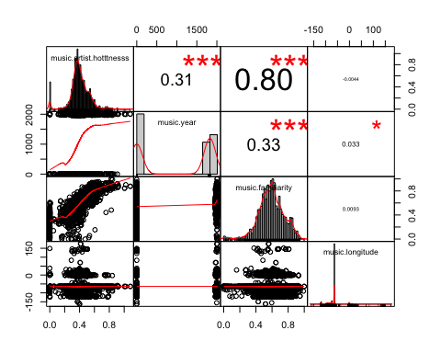

*#Song hotness correlation*  
cor2 <- **data.frame**(cmbomusic3**$**song.hotttnesss, cmbomusic3**$**loudness, cmbomusic3**$**tempo)  
**cor**(cor2)

## cmbomusic3.song.hotttnesss cmbomusic3.loudness cmbomusic3.tempo  
## cmbomusic3.song.hotttnesss 1.00000000 0.2406421 0.05570821  
## cmbomusic3.loudness 0.24064215 1.0000000 0.11259809  
## cmbomusic3.tempo 0.05570821 0.1125981 1.00000000

**chart.Correlation**(cor2, histogram=TRUE, pch=10, cex.labels=2.9)

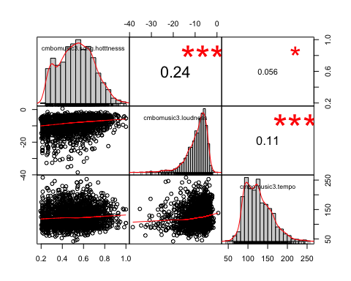

## Methods - Random Forest

*#Do analysis to determine hot/warm/cold artists based on hotttnesss*  
*#The ramdom forest analysis is from a training video by Bharatendra Rai*   
*#at https://www.youtube.com/watch?v=dJclNIN-TPo*  
*#Data Partition - ind = independent samples*  
*#The code below runs in console but not R Markdown*  
*#set.seed(123)*  
*#ind<- sample(2,nrow(music), replace=TRUE,prob=c(0.7,0.3))*  
*#train <- music[ind==1,]*  
*#test <- music[ind==2,]*  
*#Run randomForest on 3 levels*  
*#library(randomForest)*  
*#John commented out rf because it is running against the same file (music) as rf2*  
*#set.seed(222)*  
*#rf <- randomForest(music[,c(-1,-21,-22)],music[,21])*  
*#print(rf)*  
*#attributes(rf)*  
*#rf$confusion*  
*#Run randomForest on 5 levels*  
*#John added -1 to remove the hotness variable from the rf*  
**library**(randomForest)

## randomForest 4.6-14

## Type rfNews() to see new features/changes/bug fixes.

##   
## Attaching package: 'randomForest'

## The following object is masked from 'package:dplyr':  
##   
## combine

## The following object is masked from 'package:psych':  
##   
## outlier

## The following object is masked from 'package:ggplot2':  
##   
## margin

**set.seed**(222)  
rf2 <- **randomForest**(music[,**c**(**-**1,**-**22,**-**23)],music[,22])  
**print**(rf2)

##   
## Call:  
## randomForest(x = music[, c(-1, -22, -23)], y = music[, 22])   
## Type of random forest: classification  
## Number of trees: 500  
## No. of variables tried at each split: 4  
##   
## OOB estimate of error rate: 20.18%  
## Confusion matrix:  
## Cold Hot Warm class.error  
## Cold 728 4 448 0.3830508  
## Hot 6 1289 284 0.1836605  
## Warm 200 198 2491 0.1377639

**attributes**(rf2)

## $names  
## [1] "call" "type" "predicted" "err.rate" "confusion" "votes" "oob.times" "classes" "importance" "importanceSD" "localImportance" "proximity" "ntree" "mtry" "forest" "y" "test" "inbag"   
##   
## $class  
## [1] "randomForest"

rf2**$**confusion

## Cold Hot Warm class.error  
## Cold 728 4 448 0.3830508  
## Hot 6 1289 284 0.1836605  
## Warm 200 198 2491 0.1377639

*#Error rate of Random Forest*  
*#plot(rf)*  
**plot**(rf2)

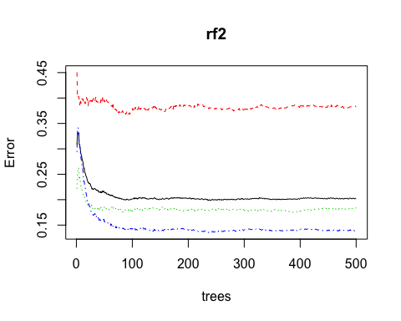

*#The error rate is not improving after ~100 trees*  
*# Variable Importance*  
*# Familiarity is much more important than the other variables.*  
*#varImpPlot(rf,sort=T,n.var=10,main="Top 10 - Variable Importance")*  
*#importance(rf)*  
*#varUsed(rf)*  
**varImpPlot**(rf2,  
 sort=T,  
 n.var=10,  
 main="Top 10 - Variable Importance")

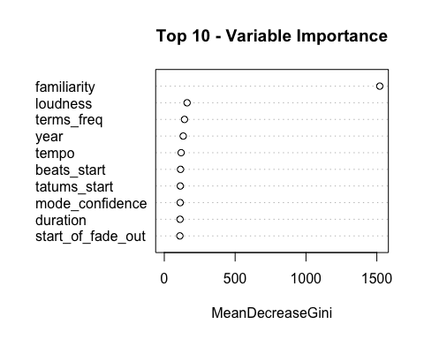

**importance**(rf2)

## MeanDecreaseGini  
## bars_confidence 107.58378  
## beats_confidence 94.47263  
## beats_start 114.60290  
## duration 111.20674  
## end_of_fade_in 88.18414  
## familiarity 1520.73102  
## key 70.97697  
## key_confidence 107.84287  
## latitude 80.31500  
## longitude 80.00661  
## loudness 160.85558  
## mode_confidence 112.40895  
## start_of_fade_out 109.94686  
## tatums_confidence 100.29904  
## tatums_start 113.12138  
## tempo 118.86929  
## terms_freq 142.67373  
## time_signature 31.82993  
## time_signature_confidence 81.87304  
## year 133.56141

**varUsed**(rf2)

## [1] 22981 20248 24173 23234 18362 42545 16709 23076 13678 13543 26260 23733 23098 21580 23800 24889 17934 7870 18132 13527

cmbomusic4 <- **na.omit**(cmbomusic3)  
cmbomusic5 <- cmbomusic4[**-c**(1,3,7**:**9,13,17,20)]  
**str**(cmbomusic5)

## 'data.frame': 2037 obs. of 12 variables:  
## $ latitude : num 47.6 37.2 53.5 37.2 37.2 ...  
## $ longitude : num -122.33 -63.93 -2.25 -63.93 -63.93 ...  
## $ loudness : num -9.31 -6.08 -9.62 -10.54 -14.01 ...  
## $ release.id : int 15964 114401 186364 171807 512792 583091 192588 92902 15316 777947 ...  
## $ tatums_confidence : num 0.898 1 0.445 0.388 0.484 0.873 0.408 0.284 0.992 1 ...  
## $ tatums_start : num 0.1569 0.0346 0.089 0.1008 0.2263 ...  
## $ tempo : num 131 114 102 151 123 ...  
## $ terms_freq : num 1 1 1 0.998 0.82 ...  
## $ time_signature : int 4 5 4 3 4 4 4 4 4 3 ...  
## $ time_signature_confidence: num 0.59 0.583 0.097 1 0.369 1 1 0.866 0.919 0.741 ...  
## $ year : int 1991 2005 1988 1970 1977 2009 2008 2007 1998 2010 ...  
## $ song.hotttnesss.label : Factor w/ 5 levels "Cool","Frigid",..: 3 4 1 3 3 3 3 1 3 3 ...

cmbomusic5**$**song.hotness.label <- **as.factor**(cmbomusic4**$**song.hotness.label)   
rf3 <- **randomForest**(cmbomusic5[,**-**12**:-**13],cmbomusic5[,13])  
rf3

##   
## Call:  
## randomForest(x = cmbomusic5[, -12:-13], y = cmbomusic5[, 13])   
## Type of random forest: classification  
## Number of trees: 500  
## No. of variables tried at each split: 3  
##   
## OOB estimate of error rate: 51.74%  
## Confusion matrix:  
## Cold Hot Warm class.error  
## Cold 297 29 381 0.5799151  
## Hot 76 118 246 0.7318182  
## Warm 244 78 568 0.3617978

**print**(rf3)

##   
## Call:  
## randomForest(x = cmbomusic5[, -12:-13], y = cmbomusic5[, 13])   
## Type of random forest: classification  
## Number of trees: 500  
## No. of variables tried at each split: 3  
##   
## OOB estimate of error rate: 51.74%  
## Confusion matrix:  
## Cold Hot Warm class.error  
## Cold 297 29 381 0.5799151  
## Hot 76 118 246 0.7318182  
## Warm 244 78 568 0.3617978

**attributes**(rf3)

## $names  
## [1] "call" "type" "predicted" "err.rate" "confusion" "votes" "oob.times" "classes" "importance" "importanceSD" "localImportance" "proximity" "ntree" "mtry" "forest" "y" "test" "inbag"   
##   
## $class  
## [1] "randomForest"

rf3**$**confusion

## Cold Hot Warm class.error  
## Cold 297 29 381 0.5799151  
## Hot 76 118 246 0.7318182  
## Warm 244 78 568 0.3617978

**plot**(rf3)

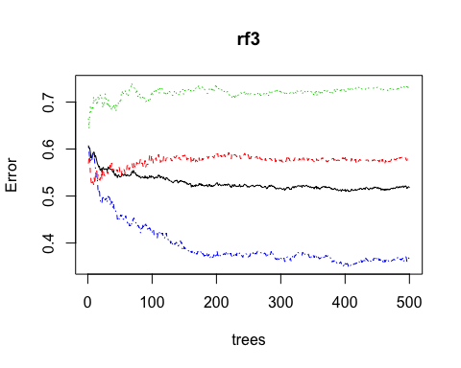

**varImpPlot**(rf3,  
 sort=T,  
 n.var=10,  
 main="Top 10 - Variable Importance")

