**What’s due:**

Submit an analysis **before the live class in week 8**. Suggested length is five pages, but should not exceed ten pages, single-spaced, 12-point font. Use Excel to analyze the data and document your results in a Word document.

This is a group assignment; each student should upload a copy of the assignment to the Learning Management System. The paper must be a Microsoft Word document. You should also submit the Excel spreadsheet with the regression and optimization analysis. Submit both your Word and Excel files.

1. Regression analysis (40%)  
   a. Graph the percent purchased against price (5%)

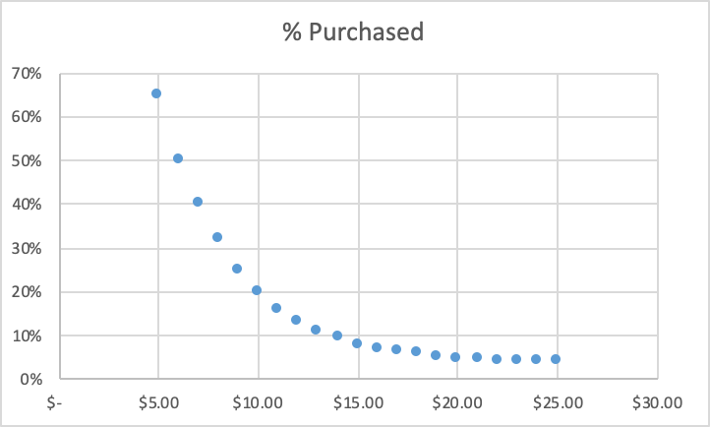

The regression analysis graph is a visual representation of sales plotted against the selling price of the book. The graph shows that as the price of the book increases, the percentage of sales decreases.

b. Perform a regression using power regression to determine the predicted %  
column.

1. Graph the new curve (5%)

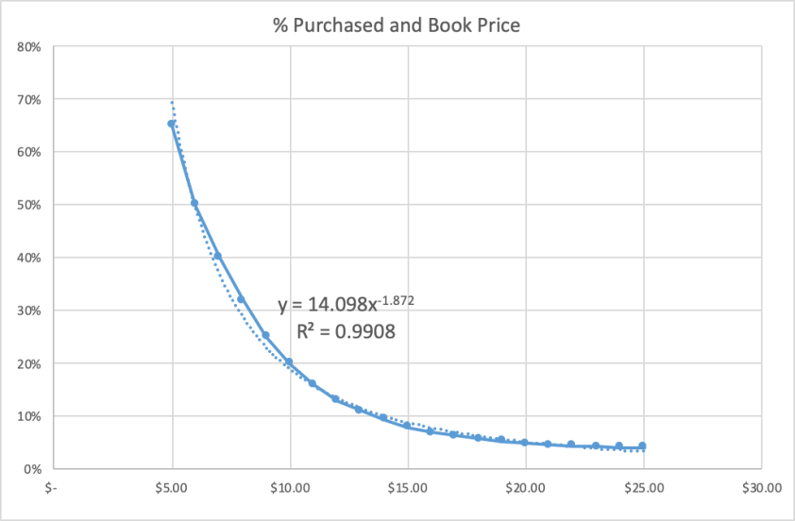

With the use of the sales of Harry Potter Book 7, it is possible to plot a power regression curve to predict the sales of the planned sequel. The trend provides the prediction equation which will allow further analysis.

1. Estimate the equation of the line (5%): The equation of the power regression line is Y= 14.098x-1.872 . The Y variable represents the percent purchased while the x variable represents the book price. Utilizing this equation assists with the prediction of expected percent purchased with varying book prices in order to establish the most successful price for the new book.
2. What does the R2 mean? (5%): The R2 value of .9908 indicates that 99.08% of the dependent variable (% purchased) is explained by the independent variable (book price). With such a high R2 value, we can forecast that setting the price of the book is imperative to a successful purchase percentage
3. Assuming there are 100,000 customers who visit your website and the publisher cost is $5.00, estimate the number of books sold (predicted sales column) (5%)
4. Calculate the revenue column (price * predicted sales) (5%)
5. Calculate the profit column ((price – book cost) * predicted sales) (5%)
6. Use conditional formatting to highlight the profit values for all prices (5%)

The table below includes the predicted number of books sold, revenue, and profit dependent on varying book prices (items c-f requested above).

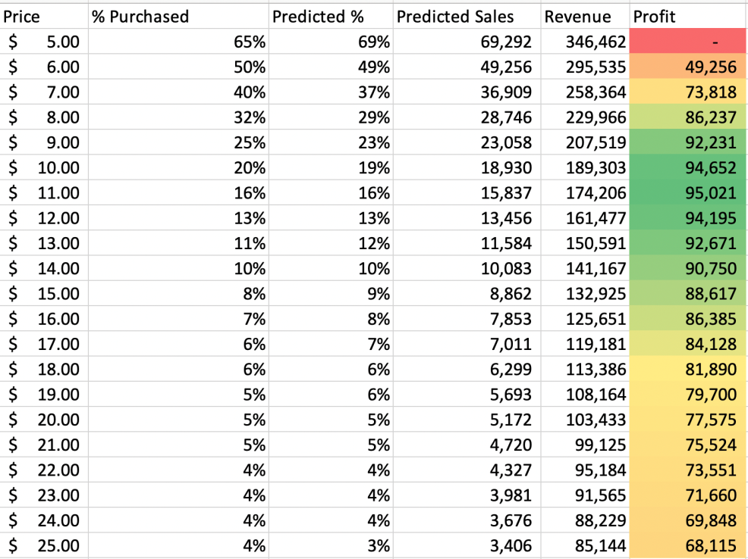

Once the data is plotted and the equation is known, it is possible to calculate predicted sales and revenue based on varying the selling price. The model above assumes a straight book cost of $5 regardless of sales. Conditional formatting provides a visual to see the optimal selling price based on predicted revenue. This value is approximately $11 per book. This helps establish a baseline for additional analysis by providing approximate optimal selling price along with expected revenue and sales.

1. Optimization analysis (with constraints) (30%)
   1. Calculate the price point for the highest profit possible
      * + 1. The publisher will sell the books to you at $5.00 each with no minimum order (10%)
          2. The publisher has agreed to sell you the books at $4.50 each if you sell at least 30,000 (10%)
          3. The publisher has agreed to sell you the books at $4.00 each if you sell at least 50,000 (10%)
   2. Run a constrained optimization for each of the above situations to determine which cost point (from the publisher) and price (to your customer) maximizes your profit. Which cost point should you accept from the publisher?

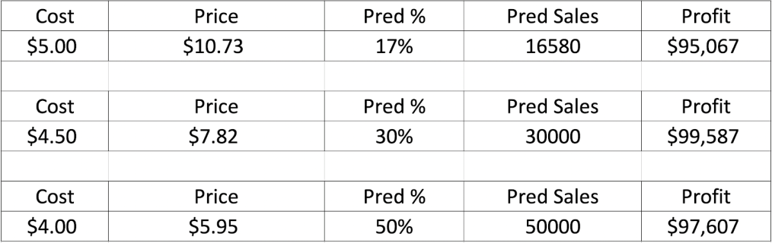

Based on the constrained optimization analysis above, The Book Emporium should purchase 30,000 books at a cost of $4.50 each and sell the books for $7.82.  This will yield the maximum expected profit of $99,587 (see chart below for a comparison of profit and selling price).

1. Discussion (30%)
   1. What are the risks of using Harry Potter 7 data in predicting your new demand curve for the Harry Potter sequel? (15%)

Using the historical data from Harry Potter 7 has risks since this book broke records for sales and past performance is not a guarantee of future results.  However, this is a great opportunity to connect with loyal customers and draw in new customers who are fans of the Harry Potter book series. Using this data could also limit our analysis as the assumption is based on 100,000 customers. Given the success of Harry Potter Book 7, it is possible that this number could be far higher than the 100,000 which would skew our analysis and potentially limit our optimized revenue. If the demand prediction is too low, there is the risk of not selecting the lower book price with a higher minimum purchase threshold. The same is true if the prediction is too high and the decision is made to go with a lower book cost with a minimum purchase and sales aren’t such that could support the requirements.

Another risk of using the Harry Potter 7 data is the potential to not understand the impact of recent innovations from on-line competitors such as Amazon. Recent “buying assistant” innovations such as Alexa could drive more business to Amazon since it’s a convenient and easy way to Buy Harry Potter 8 along with other items. Amazon has also continued to implement more sophisticated pricing strategies which may not be accounted for in the historical data that was used in the constrained optimization analysis in Section 2.

* 1. What other data would you like to have to perform your analysis? (15%)

In order to have more confidence in the prediction model used to maximize profits from book sales, the following information would be beneficial prior to releasing the optimization model to the client.

Knowing the geographical location and country for the website is crucial for several reasons. While the plot of the books largely took place at Hogwarts, the movies were filmed in England. While all the books have been very successful, it would be beneficial to know where the website company is located to know the potential demographics of the forecasted 100,000 customers considering purchase. Knowing the physical location and potential customer base could also provide instrumental data on country demographics, GDP, unemployment rates and other key criteria to assist with determining the fluidity of economic prosperity and willingness to purchase frivolous items for pleasure/entertainment. Much of this data could be extracted using Google Analytics. From this platform, data in regards to demographics and site usage could be obtained which would further increase the validity of the proposal.

Understanding the percentage of Book Emporium sales online vs. in-store would also be beneficial in determining the marketing and pricing strategy for the Harry Potter Sequel. The data only included online sales through the website but if Book Emporium also has a "brick and mortar" location then a different marketing and pricing strategy could be deployed to attract customers to the store where higher prices would likely be achieved compared to on-line shopping where it is easier to do pricing comparisons.

It would also be very beneficial to obtain the pre-release book sale data to understand the sales already achieved to assist with setting the release price for the book. Harry Potter, through books 1-7, has become a trademark in and of itself, with corresponding movies, action figures, play sets, Disney theme park destinations, etc. Knowing the demand growth/decline from the last movie and other commercially sold items (action figures, costumes, posters, etc.) will assist in modeling demand for the Harry Potter brand. The amount of time that has elapsed between Book 7 and the Sequel would also support this argument. The fan base diminishes as more time elapses due loss of interest and the introduction of new storylines.

In summary, book price is extremely important in determining percentage of customers of bookemporium.com who will buy the next sequel (as is expected). This can be seen in the very high R2 value calculated using the regression analysis of percent purchased vs. price. However, booksellers act as a middleman between publishers and buyers, and must keep publisher constraints in mind in addition to customer demand when trying to maximize profit. Running a constrained optimization using the conditions in part 2a, it was determined that in order to both maximize profit and meet publisher requirements, The Book Emporium should purchase 30,000 books with a price tag of $4.50 each and sell the books for $7.82. These price points yielded the highest expected profit among each of the constraints, at $99,587. However, even after using these analytical tools to pinpoint the optimal price given the publisher conditionals, using past data is not a guaranteed way to predict the future due to many reasons, and a certain amount of risk will still be undertaken by the seller. One such risk could be emerging competition from other companies such as Amazon, where advancements such as Alexa’s “buying assist” options may draw customers away from The Book Emporium due to convenience and ease of use. Another risk might be the dying out of Harry Potter “buzz”. Regardless of what these unpredictable factors are, many of them can be somewhat mitigated when more data is introduced. For example, examining the sales within the whole Harry Potter franchise (including movies, video games, toys, etc.) may help establish just how excited people might be for an 8th book. The more data that is gathered, the more accurate and confident a prediction can be.