SCM 651 Homework 2- Wednesday 7:00PM EDT

Team 71- Group Members: Amber Mosal, Elizabeth Rettig, John Fields, Kelly VanSanford, Michael O’Keefe

Use Google analytics to analyze the data to identify patterns and opportunities. Your goal is to recruit the best United States students, measured by GMAT scores, but you are limited to a budget of $100,000. The budget must cover advertising costs, but no Whitman administration costs.

**1. What were the time frames for each marketing campaign? How much was spent on each campaign? What was the effectiveness of previous campaigns? (40%)**

a. whitman.syr.edu

b. MBA Marketing – Full-time

c. MBA Marketing – iMBA

d. Delta

The cost and time frames for each marketing campaign are detailed in the table below.

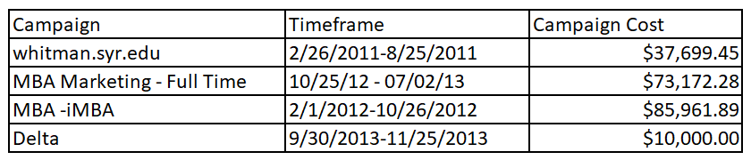

It should be noted that we chose to limit the end date for the MBA Marketing - Full Time campaign due to the high volume of clicks coming specifically from Campaign ID Whit MBA Display. When reviewing the data we found 3 additional clicks that could be attributed to the campaign; 1 click and 2 clicks on July 11th and 17th, respectively. We discussed the possibility that the end date should be July 18th, 2013 given these additional clicks. However, we chose to eliminate them as the increase in clicks from July 2, 2013 to July 18, 2013 was strictly from Whit MBA Display. We felt that these were likely residual clicks due to bookmarking of the page and not a continued effort from the campaign. Below details out the differences we discovered in the varied end dates.

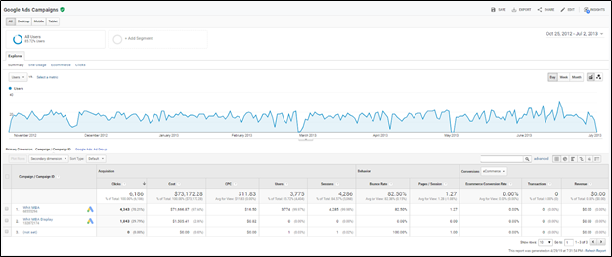

*Campaign Dates: October 25, 2012 through July 2, 2013

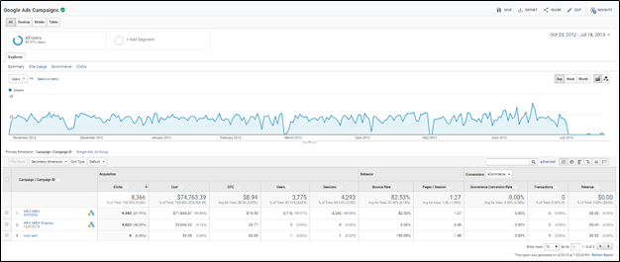

*Campaign Dates: October 25, 2012 through July 18, 2013

This change affected, most notably, the cost per clicks (CPC) and total campaign cost. The table below details out the differences the date change made on the overall campaign. It further proves the theory that the extended time added no sufficient value as there were no additional users, sessions, and it didn’t affect the bounce rate. While it did drive down the CPC, we felt this was a manipulation of the data and not a true representation of the campaign. Additional information on the differences between Whit MBA and Whit MBA Display would provide valuable insight into our theory which would allow for further analysis.

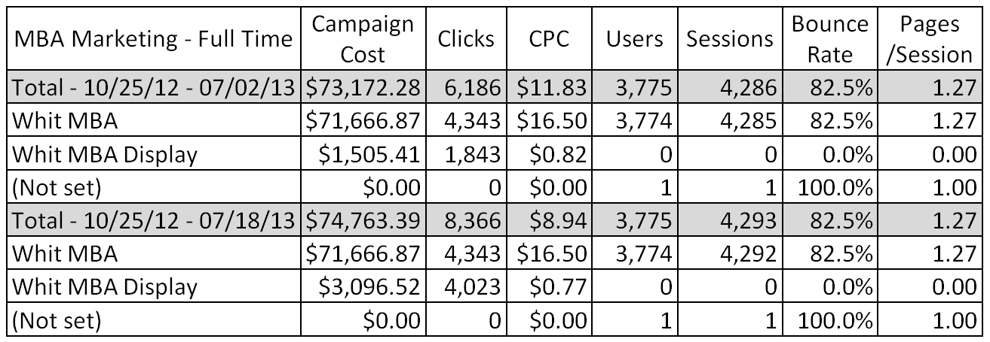

When evaluating the effectiveness of a campaign, the number of sessions, pages per session, session duration and bounce rate are all useful tools. These categories allow you to understand how engaged the audience is with the content on the site. A high bounce rate indicates that the user is not engaged enough to click past the first page. While the pages per session and duration indicates, on average, how far a user navigated before leaving and how long they spent on the site, respectively. When we compare the 3 online campaigns in the order given, we see a trend that would indicate that each campaign got progressively more expensive, with a higher bounce rate and decreased average session duration. However, when the 3 online campaigns are placed in chronological order, the trend does not hold. The oldest campaign, titled whitman.syr.edu had the lowest campaign cost, CPC and bounce rate. It had the highest number of sessions and pages per session. The second campaign, MBA- iMBA, had the highest campaign cost, CPC and bounce rate. With the third campaign, MBA Marketing - Full Time, falling between the two. When we compare the 3 online campaigns we see that based on the factors described campaign whitman.syr.edu would be considered the most effective and MBA Marketing - Full Time would be the least effective. There was a fourth print campaign, Delta, which had the lowest campaign cost of the 4 campaigns but the highest, by a significant margin, CPC. However, we considered this to be the most effective campaign when reviewing the pages per session, average session duration and bounce rate. We based this on the effort the user would have needed to extend to get to the site in the first place. The ad would have been on a plane with no or limited internet access. They would have had to remember the advertisement, get to internet access, go to the site and explore. The pages per session was 44.8% higher and the bounce rate was 42.5% lower than the highest campaign. We further hypothesized that the types of users being recruited from this form of paper advertisement would likely be a candidate that pursued further discussions about the offerings of Syracuse University and would extend beyond the data gathered through the campaigns. The table below shows the details of each campaign.

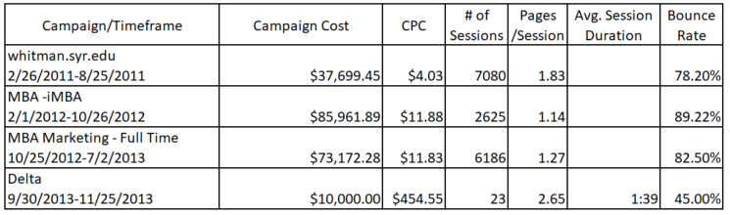

**2. Identify the key aspects of a United States campaign for next year (20%)**

**a. In which geographic region would you advertise? Which states? Why?**

To identify the key aspects of the US campaign for next year, we reviewed the audience of each of the previous campaigns looking at aspects such as geographic location, time frame usage, and keywords. New York pulled in the most sessions for every previous campaign with California running second. During the iMBA Marketing - Full Time campaign for example, 716 sessions or 39%, were from New York and 520 or 29%, were from California. The exception to this pattern was the Delta ad, where 68% of traffic to the whitman.syr.edu site came from New York. It should be noted that the bounce rate with users from New York was slightly less than California (~80% vs ~83%), whereas the pages per session was slightly higher (1.37 vs 1.25). Users from New York are more engaged with the content, given their average session duration was 51 seconds vs 28 for California. When a deeper analysis of specifically iMBA Marketing - Full Time campaign was performed, Georgia stood out in terms of bounce rate, 79.19%, pages/session, 1.35, and session duration, 45 seconds even though it didn’t fall within the top 5 states in terms of clicks. While the number of users only accounted for 3% of total, it would seem those users are engaged.

When viewing all the campaigns together, the top states for all 3 online campaigns included New York, California, Texas, and New Jersey. All of these states fell in the top 5 in terms of clicks for every online campaign. The table below provides a summary of the number of sessions, new users, bounce rate, pages/session, and avg. session duration for these four states. In terms of the next marketing campaign, these states specifically should be targeted.

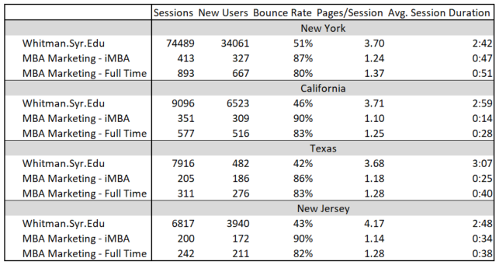

**b. What key words would you use? Why?**

When reviewing the keywords for the campaigns, we found 15 unique combinations across all campaigns. “Online MBA” gathered the most clicks with 6,431 total, followed by “MBA” with 2,078. When choosing keywords it’s important to remember that the more specific a keyword the cheaper the cost of the campaign will be but the less likely it will be for a user to type the specific keyword. “MBA” is considered a very generic keyword. It would generate the most clicks but would also be the most expensive. “SU MBA” would be less generic and thus cheaper but it would be less likely to generate the greatest number of clicks. The cost of ad campaigns is determined by the number of bidders for the specific keyword. As many colleges and universities offer MBAs, the keyword “MBA” would have the highest number of bidders which would drive up the price. “SU MBA” is very specific and would be least expensive as it’s likely only Syracuse University would bid on that specific keyword. Although, from a competitors standpoint, it would be beneficial to bid on this keyword to drive cost up for SU but also as an attempt to ‘steal’ users away. We would also employ a strategy that would put us in the 4th spot and not 1st. This will provide the same benefits with a reduced cost.

Given the above, some keywords that could be considered would be “MBA GMAT”. It’s generic, would drive a higher price but would appeal to a broad range of users. The downside to this is if you actually search for this the results are more geared towards GMAT waivers. The cost to the campaign would be high and would not target the audience we are looking for. “MBA GMAT Requirements” would be another, slightly more specific, cheaper option that would still be generic enough to generate clicks but generated similar search results. From a marketing standpoint, an option could be “MBA GMAT score”. While this is specific and would typically be searched by users just starting their MBA journey, it would be less expensive and would put Syracuse University in the minds of those users. The ad would take the user to the specific GMAT requirements for the MBA along with possible resources to help prospective students get started.

Ultimately, as options with “GMAT” in the keyword geared the search results towards waivers, it may be more beneficial to stick with “AACSB MBA” or “Top MBA Programs”. This type of search may also be more appealing to top scoring GMAT candidates; ie: speak to their egos. Had additional information in regards to the campaigns on other programs been available, additional keyword options could have been explored; such as “AACSB Analytics”.

**c. Which days of the week and what time of day would you advertise? Why?**

A trend of the data showed a spike from Friday to Saturday which then began a relatively consistent downward trend towards the following Friday. The exception being that Sunday is the busiest day of the week for new users. For all instances of the campaign, the best time to advertise began at 5 pm and continued towards 11:00 pm. For the MBA Marketing - Full Time campaign the largest amount of sessions occured Sunday between 5pm and 11pm of 666, with 641 of those being new users. Saturday was the next highest frequented day with 617 sessions, 583 of those being new users. Friday showed the least amount of activity for the whole week with 457 sessions, and 437 new users. The assumption behind the more active times is that most users are busy and/or tired during the week and don’t have time to research MBA programs. The rest of the days of the week fall in between the sessions noted above.

The table below shows the results of all online campaigns. This data was not available for the Delta campaign.

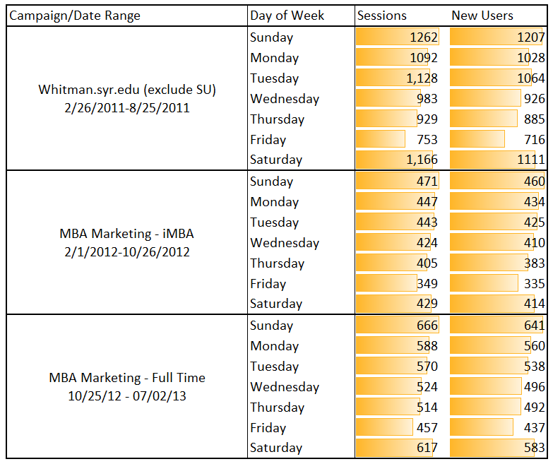

The trends shown in the table are expected to continue. Therefore, the best options for advertising would be from Saturday - Tuesday, between 5:00-11:00pm EDT. This would allow the campaign to run during the more active timeframes and minimize costs.

**3. Identify the costs for your advertising campaigns (10%)**

**a. By region**

Costs of the campaign should be proportionally divided between the four states; New York, California, Texas, and New Jersey. The $100,000 is a small amount compared the projected $36.55 CPC (see chart below for predicted 2019 CPC data). The breakdown would be 75% for New York, 10% for California, 8% for Texas and 7% for New Jersey. This works well with the higher engagement seen from New York and historically, the northeast has higher GMAT scores compared to the West. We would also propose a direct mail campaign targeting recent GMAT participants with high scores. Assuming the administrative costs are covered outside the costs of the marketing campaign, the cost of this program would be the cost for the GMAT list. Initial research indicates we can obtain this information for around $1 per participant. We would focus this campaign regardless of region and propose a budget of $6,500, or 6.5%. The percentage was derived from the user engagement percentage increase of the Delta campaign compared to the previous online campaigns and falls in line with the strategy of not allocating too high of a percentage for the direct mail pilot project. This would leave $93,500 to be split, approximately, $70,125 for New York, $9,350 for California, $7,480 for Texas, and $6,545 for New Jersey.

**b. By degree program**

Given the historical effectiveness of the various campaigns, it would be most beneficial to target the online MBA program. The Full Time campaign didn’t do as well as the iMBA campaign and combined with the target time of day and day of week, leads us to believe our campaign should be targeted towards working professionals. Since the campaign is already limiting the scope by focusing on students with high GMAT scores, further limiting it to a more specialized program may make the campaign less successful. In addition, our decision was also based on the success of the whitman.syr.edu campaign.

**4. How would you measure performance of your decisions after implementation? (20%)**

A successful campaign will result in higher admissions and GPA overall. To gauge the analytics, a successful campaign requires speedier website design and loading capabilities, which were recently completed. Overall webpage time should be lower than the average load time for the Delta, Marketing and iMBA programs. Other factors for campaign performance would be clicks, sessions, pages/session, cost per click, session duration and bounce rate. Assuming success, this should decrease the average bounce rate and increase the pages/session and session duration, as prospective students will not become frustrated with a slow site and have more confidence in a quality MBA program. The overall cost per click should decrease with an expected uptick in the number of sessions, pages/session and longer durations. The expected result is a higher percentage of administration department engagement with new prospective students. To have a true measure of performance, the ad would need to collect data on the GMAT score of the user. A regression analysis of the cost per clicks, indicates we would expect to see a CPC for this new campaign of $36.55, when compared to the previous campaigns. We believe this is a good starting point for the campaign but recognize there is a 33% margin of error for this number. The regression analysis performed was on a very small set of data points. In addition, these data points were taken from campaigns that spanned various time frames and the number was extrapolated out well past a sound point. Thus, success would be improving upon this cost by increasing the number of sessions thus, driving the CPC down. The graph below plots the information used in the regression model along with the addition of a trendline to show how we believe the CPC will increase.

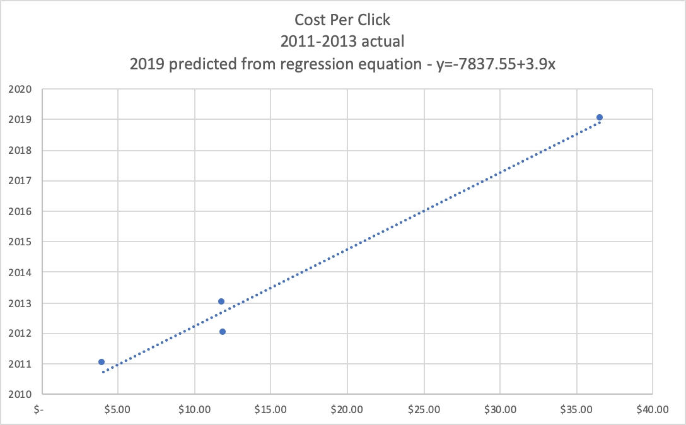

By also spending approximately 6.5% of the overall budget on a targeted direct mailing campaign to the highest GMAT performance individuals in the country, the expectation is that we also recruit and retain students that will increase the overall GMAT statistical averages of the program.

**5. What other factors or considerations are important? What other data would help in**

**developing an Internet advertising strategy, if you could collect it? (10%)**

There are several considerations that would have been helpful in developing the internet strategy. For instance access to GMAT data, Syracuse degree programs, admission rates and other campaigns would have been helpful information during the campaign development.

Admissions rates for each of the campaigns would have been helpful in understanding how well the campaign did in relation to increasing admissions for the university. We would have looked for the data to be broken down by campaign, program selection, and geographical location. Access to this information would have supported our decisions on state and keyword selection. It would have also provided a better understanding of how the campaign related to actual recruitment strategies for the university.

Additional data around SU’s current percentage breakdown by degree program would also have been beneficial when deciding which program to target. A trend analysis of this data would have added credibility with keyword generation and region. Overall admissions and program information would assist with developing the marketing campaign to increase program position ranking by recruiting and retaining students with higher GMAT scores into the program.

Data around the keyword generation, how that specific keyword was derived, and intent would have been helpful as well; although that may be more qualitative data than quantitative. This type of data would have helped us further shape the keyword search. In addition, it would have been beneficial to have key word searches sorted by year through 2018/2019 on more recent campaigns to see if keyword trends changed overtime.

As the goal of the campaign was directly related to GMAT scores, access to this information would have been extremely beneficial. Some specific key data points that would help narrow the focus of the campaign include: data about the current SU GMAT average vs. the national average, breakdown of national average by state, specific program GMAT average, as well as information about the scores of the users for each campaign. The information about the SU scores vs. national average would have helped us understand what scores we should be looking to target. We believe the majority of the top ranked GMAT test scoring candidates are likely to attend Ivy League schools, however, knowing the baseline would have helped shape the campaign and target the top tiered candidates. Information relating to SU program or degree and GMAT scores would have focused the keyword search to target the existing highest ranked programs. Of all the additional data that could have been captured, we believe the most useful and the one piece we would have chosen above all other options, would have been data about the GMAT scores for the users of each campaign. This would have provided great insights into the users the current campaigns brought in. All of this additional information would have allowed us to better focus our campaign efforts to produce the greatest results; ie: recruit the students with the highest scores.

In addition, it would be helpful to have a list of all internet platforms and associated advertising cost averages to see if advertising on other social media sites (LinkedIn, Facebook, etc.) might be a more efficient and cost effective way of targeting high GMAT scoring candidates at a reduced rate.