**Lab #1**

**Similarity Transformation**

Image 1:

|  |  |
| --- | --- |
| **Linear Parameters** | |
| A | 0.011900345291064388 |
| B | -8.201523670845944e-07 |

|  |  |
| --- | --- |
| **Non-Linear Parameters** | |
| delta X | -122.02106658407746 |
| delta Y | 123.5194188719563 |
| scale | 0.011900345319326168 |
| theta | -6.891836713359218e-05 |

|  |  |  |
| --- | --- | --- |
|  | **Residuals** | |
|  | rx | ry |
|  | -0.02201928 | 0.00325566 |
|  | 0.00814344 | -0.00970481 |
|  | 0.00749126 | -0.00799414 |
|  | 0.00933476 | 0.01244288 |
|  | -0.00948903 | -0.01385582 |
|  | 0.00851353 | 0.00640585 |
|  | -0.00071906 | -0.00362487 |
|  | -0.00125562 | 0.01307524 |
| **RSME** | 0.0103624113 | 0.0096218145 |

**Transformation Residuals:**

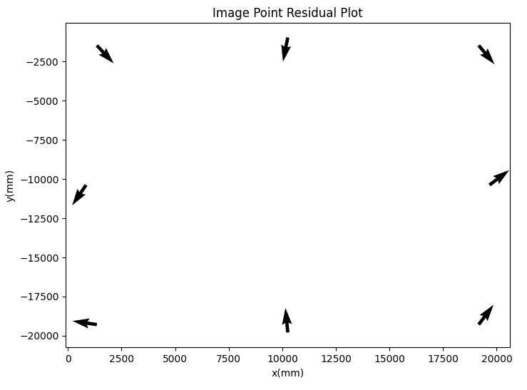

Image 2:

|  |  |
| --- | --- |
| **Linear Parameters** | |
| A | 0.011900560590614725 |
| B | 7.929957611461198e-06 |

|  |  |  |
| --- | --- | --- |
| **Non-Linear Parameters** | | |
| delta X | -122.19148942643244 |
| delta Y | 123.50773873701652 |
| scale | 0.01190056323268441 |
| theta | 0.0006663515031398629 |

|  |  |  |
| --- | --- | --- |
|  | **Residuals** | |
|  | rx | ry |
|  | -0.01149715 | -0.00079116 |
|  | 0.00952796 | -0.00863624 |
|  | -0.00695469 | -0.00810964 |
|  | -0.00002244 | 0.00958280 |
|  | 0.00629211 | -0.00843917 |
|  | 0.00463133 | 0.00992026 |
|  | 0.00618257 | 0.00291809 |
|  | -0.00815969 | 0.00355507 |
| **RSME** | 0.0073923864 | 0.0072766039 |

**Transformation Residuals:**

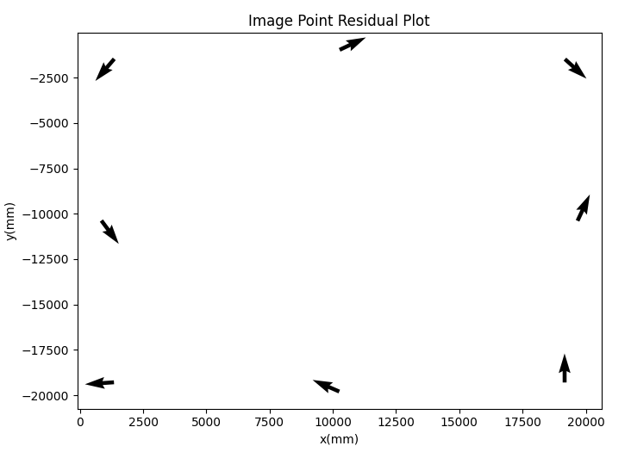

**Affine Transformation**

Image 1:

|  |  |
| --- | --- |
| **Linear Parameters** | |
| A | 0.011899426266928173 |
| B | 2.9976774439538446e-07 |
| C | -1.3405013290104452e-06 |
| D | 0.011901264695956251 |

|  |  |  |  |
| --- | --- | --- | --- |
|  | **Residuals** | | |
|  | rx | ry |
|  | -0.00919658 | -0.00029857 |
|  | -0.00467785 | -0.00615038 |
|  | 0.01104291 | 0.00482938 |
|  | 0.00578124 | -0.00038110 |
|  | -0.00083769 | -0.00895958 |
|  | -0.00013732 | 0.00150928 |
|  | -0.00561595 | 0.00502821 |
|  | 0.00364125 | 0.00442276 |
| **RSME** | 0.0061982466 | 0.0048577279 |

|  |  |
| --- | --- |
| **Non-Linear Parameters** | |
| delta X | -122.01704301790505 |
| delta Y | 123.53429666924897 |
| theta | -0.00011265260133301382 |
| Scale X | 0.011899426342433654 |
| Scale Y | 0.011901264699731509 |
| delta | -8.746471147506922e-05 |

**Transformation Residuals:**

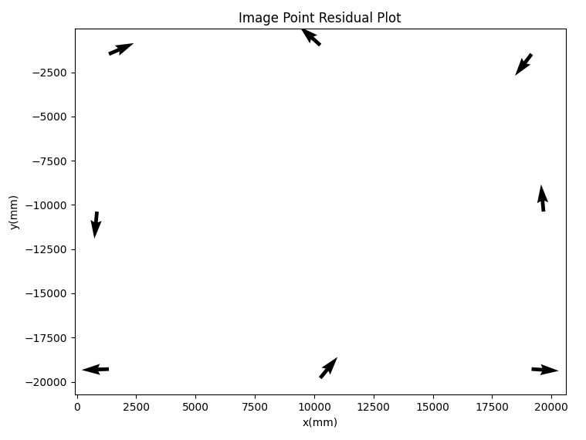

Image 2:

|  |  |
| --- | --- |
| **Linear Parameters** | |
| A | 0.011900088285313321 |
| B | -8.456447779618067e-06 |
| C | 7.403491422691079e-06 |
| D | 0.01190103306007299 |

|  |  |  |
| --- | --- | --- |
|  | **Residuals** | |
|  | rx | ry |
|  | -0.00260047 | -0.00030380 |
|  | 0.00063179 | -0.00912382 |
|  | -0.00744257 | 0.00078797 |
|  | 0.00046544 | 0.00068544 |
|  | 0.01073407 | -0.00348187 |
|  | 0.00018888 | 0.00496268 |
|  | 0.00122419 | 0.00736117 |
|  | -0.00320133 | -0.00088777 |
| **RSME** | 0.0048704880 | 0.0046924648 |

|  |  |
| --- | --- |
| **Non-Linear Parameters** | |
| delta X | -122.19211044565907 |
| delta Y | 123.5180472905358 |
| theta | 0.0006221374404963093 |
| Scale X | 0.011900090588307996 |
| Scale Y | 0.011901036064497045 |
| delta | -8.842661841425235e-05 |

**Transformation Residuals:**

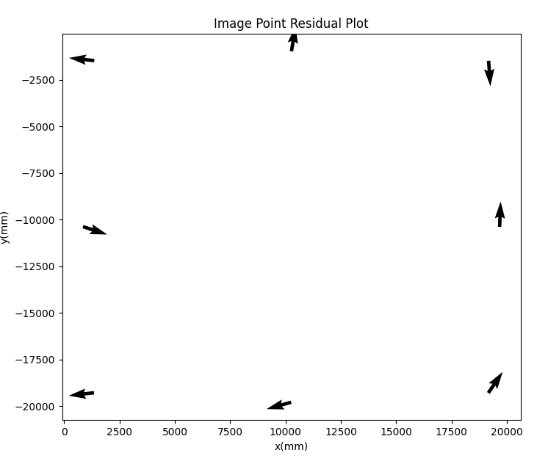

**Projective Transformation**

Image 1:

|  |  |
| --- | --- |
| **Linear Parameters** | |
| A | 0.011899732951937627 |
| B | 2.9978635866588186e-07 |
| C | -1.3405211789106213e-06 |
| D | 0.011901571374376804 |

|  |  |  |
| --- | --- | --- |
|  | **Residuals** | |
|  | rx | ry |
|  | -0.00491437 | 0.00217308 |
|  | -0.00039500 | -0.00367894 |
|  | 0.00746852 | 0.00409349 |
|  | 0.00220721 | -0.00111716 |
|  | -0.00029656 | -0.01202081 |
|  | 0.00040408 | -0.00155118 |
|  | -0.00686542 | 0.00635347 |
|  | 0.00239154 | 0.00574805 |
| **RSME** | 0.0041542495 | 0.0056631955 |

|  |  |
| --- | --- |
| **Non-Linear Parameters** | |
| delta X | -122.02143728211016 |
| delta Y | 123.53441906740015 |
| theta | -0.00011265136609824447 |
| Scale X | 0.011899733027443399 |
| Scale Y | 0.011901264699731509 |
| delta | -8.746256126127167e-05 |
| out of plane inclination | -1.6981132050401598e-09,  -4.161073366984031e-09 |

**Transformation Residuals:**

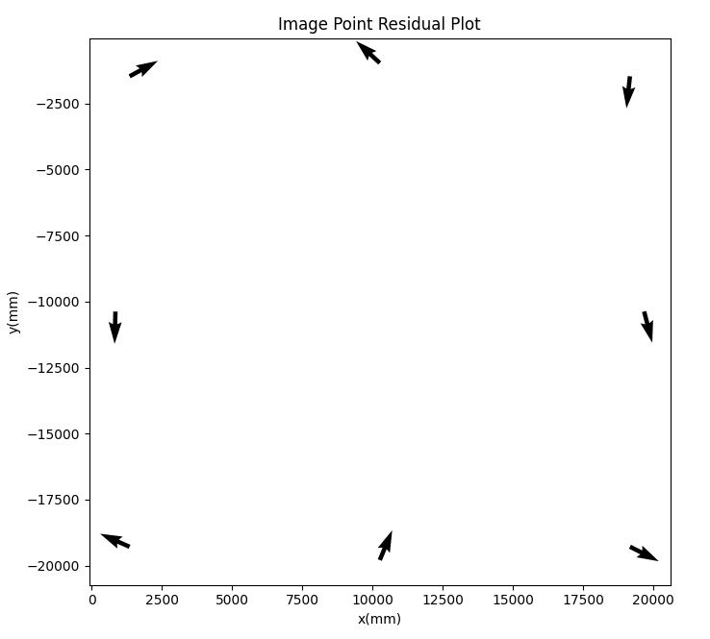

Image 2:

|  |  |
| --- | --- |
| **Linear Parameters** | |
| A | 0.011899813026750236 |
| B | -8.456250027531595e-06 |
| C | 7.403307477712062e-06 |
| D | 0.011900757797657747 |

|  |  |  |
| --- | --- | --- |
|  | **Residuals** | |
|  | rx | ry |
|  | -0.00306072 | 0.00088660 |
|  | 0.00017142 | -0.00793318 |
|  | -0.00638181 | -0.00073841 |
|  | 0.00152601 | -0.00084099 |
|  | 0.01119188 | -0.00288934 |
|  | 0.00064695 | 0.00555497 |
|  | 0.00016583 | 0.00710457 |
|  | -0.00425957 | -0.00114422 |
| **RSME** | 0.0049535563 | 0.0044153712 |

|  |  |
| --- | --- |
| **Non-Linear Parameters** | |
| delta X | -122.19034233291353 |
| delta Y | 123.51578296663504 |
| theta | 0.0006221363735640753 |
| Scale X | 0.011899815329683743 |
| Scale Y | 0.011900760802010777 |
| delta | -8.84275038056584e-05 |
| out of plane inclination | -1.4380597632738742e-09,  8.063798463750913e-10 |

**Transformation Residuals:**

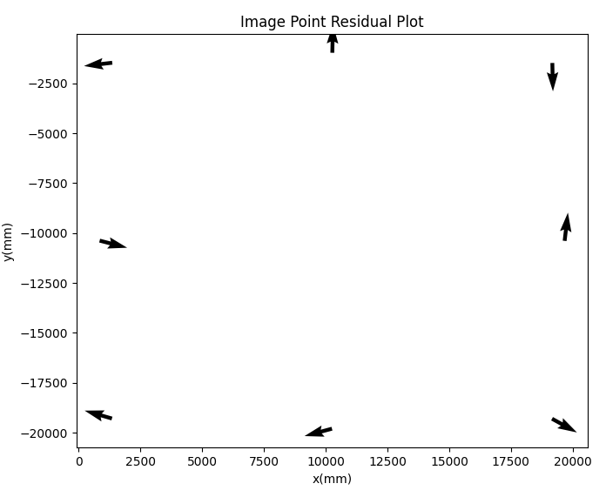

Questions:

1. For each of the Tasks above, are there any noticeable patterns in the residuals for any of the transformations and for any of the images?

The RMS of the residuals (rx, ry) decrease comparing the similarity transformation to affine transformation to projective transformation.

1. Do the two images have comparable transformation parameters in each of the above tasks? If no, why would there be differences in the derived transformation values?

Between the two images for each transformation, their linear and non-linear parameters are fairly close to each other.

1. Given the results from Tasks 1, 2 and 3, which transformation should be used for observations from this camera/comparator system? Justify your answer and explain your reasoning.

Since the projective transformation has the smallest values in residual RMS, it would be the best transformation used for observations from this camera/comparator system. In general, projective transformation provides more information than similarity and affine transformations. Similarity transformations only has delta x and y, rotation, and scale. Affine transformations have delta x and y as well, scale in x and y, rotation, and non-orthogonality of comparator axes. Projective transformations have the same information as affine transformations but with two additional parameters, out-of-plane inclinations.