**Lab #2**

Image 1:

* Fiducial Coordinate System from Affine Transformation

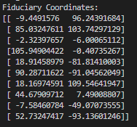

* Principal Point Offset

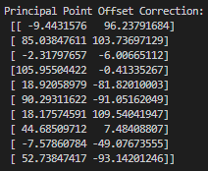

* Radial Lens Distortion Correction

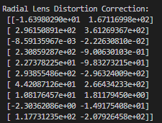

* Decentering Lens Distortion Correction

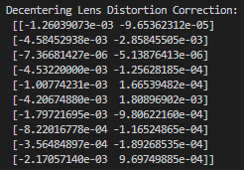

* Atmospheric Refraction Correction

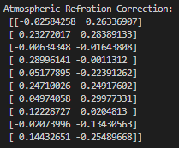

* Total Correction

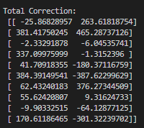

* Maximum Value Correction
* Radial and Tangential Distortion on a 2mm by 2mm.grid
* Atmospheric Refraction on a 2mm by 2mm grid

Image 2:

* Fiducial Coordinate System from Affine Transformation

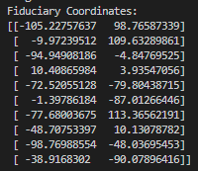

* Principal Point Offset

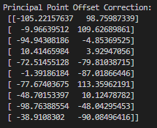

* Radial Lens Distortion Correction

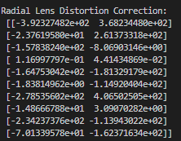

* Decentering Lens Distortion Correction

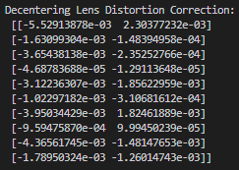

* Atmospheric Refraction Correction

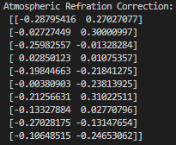

* Total Correction

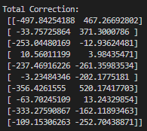

* Maximum Value Correction
* Radial and Tangential Distortion on a 2mm by 2mm.grid
* Atmospheric Refraction on a 2mm by 2mm grid

Questions:

* Given the results from task 5. Which of the corrections are significant, and why? What are the magnitudes of these corrections in ground coordinates?