**Lab #5**

Tasks 1:

A.) Points 100, 104, 105, 200.

Image 27

|  |  |
| --- | --- |
| XC (m) | 99.1813 |
| YC (m) | -628.2502 |
| ZC (m) | 1842.2475 |
| ω (°) | -0.2151 |
| ϕ (°) | 1.4566 |
| κ (°) | 90.1951 |

Image 28

|  |  |
| --- | --- |
| XC (m) | 105.1158 |
| YC (m) | -170.3082 |
| ZC (m) | 1833.9863 |
| ω (°) | -0.4713 |
| ϕ (°) | 0.5106 |
| κ (°) | 88.461 |

B.) Points 100, 104, 105, 200, 201.

Image 27

|  |  |
| --- | --- |
| XC (m) | 99.2689 |
| YC (m) | -628.2943 |
| ZC (m) | 1842.2306 |
| ω (°) | -0.2124 |
| ϕ (°) | 1.4612 |
| κ (°) | 90.1958 |

Image 28

|  |  |
| --- | --- |
| XC (m) | 105.1261 |
| YC (m) | -170.2981 |
| ZC (m) | 1833.9808 |
| ω (°) | -0.472 |
| ϕ (°) | 0.511 |
| κ (°) | 88.4608 |

C.) Points 100, 104, 105, 200, 201, 202.

Image 27

|  |  |
| --- | --- |
| XC (m) | 99.2712 |
| YC (m) | -628.3206 |
| ZC (m) | 1842.22 |
| ω (°) | -0.2102 |
| ϕ (°) | 1.4616 |
| κ (°) | 90.1957 |

Image 28

|  |  |
| --- | --- |
| XC (m) | 105.222 |
| YC (m) | -170.4222 |
| ZC (m) | 1834.0193 |
| ω (°) | -0.4619 |
| ϕ (°) | 0.5171 |
| κ (°) | 88.4607 |

D.) All

Image 27

|  |  |
| --- | --- |
| XC (m) | 99.2627 |
| YC (m) | -628.3256 |
| ZC (m) | 1842.2276 |
| ω (°) | -0.2102 |
| ϕ (°) | 1.4609 |
| κ (°) | 90.195 |

Image 28

|  |  |
| --- | --- |
| XC (m) | 105.1891 |
| YC (m) | -170.4356 |
| ZC (m) | 1834.0609 |
| ω (°) | -0.4598 |
| ϕ (°) | 0.5149 |
| κ (°) | 88.4618 |

Task 2:

S = 5000, σobs = 15 µm

c = 153.358 mm

xmax = 161.645 mm

Task 3:

A.A.) Points 100, 104, 105, 200.

*Standard Deviation*

Image 27

|  |  |
| --- | --- |
| XC (m) | 0.5061 |
| YC (m) | 0.3765 |
| ZC (m) | 0.1272 |
| ω (°) | 0.0292 |
| ϕ (°) | 0.0288 |
| κ (°) | 0.0061 |

Image 28

|  |  |
| --- | --- |
| XC (m) | 0.427 |
| YC (m) | 0.374 |
| ZC (m) | 0.2016 |
| ω (°) | 0.0277 |
| ϕ (°) | 0.0208 |
| κ (°) | 0.009 |

A.B.) Points 100, 104, 105, 200, 201.

*Standard Deviation*

Image 27

|  |  |
| --- | --- |
| XC (m) | 0.2906 |
| YC (m) | 0.354 |
| ZC (m) | 0.1107 |
| ω (°) | 0.0267 |
| ϕ (°) | 0.0175 |
| κ (°) | 0.005 |

Image 28

|  |  |
| --- | --- |
| XC (m) | 0.2246 |
| YC (m) | 0.316 |
| ZC (m) | 0.149 |
| ω (°) | 0.0238 |
| ϕ (°) | 0.0123 |
| κ (°) | 0.0057 |

A.C.) Points 100, 104, 105, 200, 201, 202.

*Standard Deviation*

Image 27

|  |  |
| --- | --- |
| XC (m) | 0.2669 |
| YC (m) | 0.3362 |
| ZC (m) | 0.1016 |
| ω (°) | 0.0252 |
| ϕ (°) | 0.0164 |
| κ (°) | 0.0045 |

Image 28

|  |  |
| --- | --- |
| XC (m) | 0.2041 |
| YC (m) | 0.2563 |
| ZC (m) | 0.1367 |
| ω (°) | 0.019 |
| ϕ (°) | 0.0107 |
| κ (°) | 0.0057 |

A.D.) All

*Standard Deviation*

Image 27

|  |  |
| --- | --- |
| XC (m) | 0.2535 |
| YC (m) | 0.324 |
| ZC (m) | 0.0924 |
| ω (°) | 0.0244 |
| ϕ (°) | 0.0154 |
| κ (°) | 0.0042 |

Image 28

|  |  |
| --- | --- |
| XC (m) | 0.2018 |
| YC (m) | 0.2492 |
| ZC (m) | 0.1289 |
| ω (°) | 0.0186 |
| ϕ (°) | 0.0106 |
| κ (°) | 0.0055 |

B.A.) Points 100, 104, 105, 200

Image 27

|  |  |  |  |  |  |  |  |
| --- | --- | --- | --- | --- | --- | --- | --- |
| **Correlation Coefficient Matrix** | | | | | | | |
|  | XC (m) | YC (m) | ZC (m) | ω (°) | ϕ (°) | κ (°) |
| XC (m) | 1 | -0.5819 | -0.7132 | 0.6492 | 0.9952 | 0.7198 |
| YC (m) | -0.5819 | 1 | 0.8441 | -0.9914 | -0.6328 | -0.2941 |
| ZC (m) | -0.7132 | 0.8441 | 1 | -0.8798 | -0.7502 | -0.4335 |
| ω (°) | 0.6492 | -0.9914 | -0.8798 | 1 | 0.6974 | 0.3531 |
| ϕ (°) | 0.9952 | -0.6328 | -0.7502 | 0.6974 | 1 | 0.6968 |
| κ (°) | 0.7198 | -0.2941 | -0.4335 | 0.3531 | 0.6968 | 1 |

Image 28

|  |  |  |  |  |  |  |  |
| --- | --- | --- | --- | --- | --- | --- | --- |
| **Correlation Coefficient Matrix** | | | | | | | |
|  | XC (m) | YC (m) | ZC (m) | ω (°) | ϕ (°) | κ (°) |
| XC (m) | 1 | 0.3347 | -0.6037 | -0.3313 | 0.9886 | -0.8906 |
| YC (m) | 0.3347 | 1 | -0.8851 | -0.9932 | 0.2292 | -0.4376 |
| ZC (m) | -0.6037 | -0.8851 | 1 | 0.9058 | -0.5219 | 0.6514 |
| ω (°) | -0.3313 | -0.9932 | 0.9058 | 1 | -0.2249 | 0.4416 |
| ϕ (°) | 0.9886 | 0.2292 | -0.5219 | -0.2249 | 1 | -0.8467 |
| κ (°) | -0.8906 | -0.4376 | 0.6514 | 0.4416 | -0.8467 | 1 |

B.B.) Points 100, 104, 105, 200, 201

Image 27

|  |  |  |  |  |  |  |  |
| --- | --- | --- | --- | --- | --- | --- | --- |
| **Correlation Coefficient Matrix** | | | | | | | |
|  | **XC (m)** | **YC (m)** | **ZC (m)** | **ω (°)** | **ϕ (°)** | **κ (°)** |
| **XC (m)** | 1 | -0.5682 | -0.6227 | 0.6071 | 0.9891 | 0.5427 |
| **YC (m)** | -0.5682 | 1 | 0.8275 | -0.9941 | -0.6396 | -0.1355 |
| **ZC (m)** | -0.6227 | 0.8275 | 1 | -0.8555 | -0.6804 | -0.218 |
| **ω (°)** | 0.6071 | -0.9941 | -0.8555 | 1 | 0.6768 | 0.166 |
| **ϕ (°)** | 0.9891 | -0.6396 | -0.6804 | 0.6768 | 1 | 0.4946 |
| **κ (°)** | 0.5427 | -0.1355 | -0.218 | 0.166 | 0.4946 | 1 |

Image 28

|  |  |  |  |  |  |  |  |
| --- | --- | --- | --- | --- | --- | --- | --- |
| **Correlation Coefficient Matrix** | | | | | | | |
|  | **XC (m)** | **YC (m)** | **ZC (m)** | **ω (°)** | **ϕ (°)** | **κ (°)** |
| **XC (m)** | 1 | -0.1455 | -0.1193 | 0.1424 | 0.9738 | -0.6996 |
| **YC (m)** | -0.1455 | 1 | -0.8606 | -0.9921 | -0.2904 | -0.1227 |
| **ZC (m)** | -0.1193 | -0.8606 | 1 | 0.894 | 0.0085 | 0.2976 |
| **ω (°)** | 0.1424 | -0.9921 | 0.894 | 1 | 0.2884 | 0.137 |
| **ϕ (°)** | 0.9738 | -0.2904 | 0.0085 | 0.2884 | 1 | -0.5983 |
| **κ (°)** | -0.6996 | -0.1227 | 0.2976 | 0.137 | -0.5983 | 1 |

B.C.) Points 100, 104, 105, 200, 201, 202

Image 27

|  |  |  |  |  |  |  |  |
| --- | --- | --- | --- | --- | --- | --- | --- |
| **Correlation Coefficient Matrix** | | | | | | | |
|  | **XC (m)** | **YC (m)** | **ZC (m)** | **ω (°)** | **ϕ (°)** | **κ (°)** |
| **XC (m)** | 1 | -0.6714 | -0.6915 | 0.6956 | 0.9918 | 0.444 |
| **YC (m)** | -0.6714 | 1 | 0.8179 | -0.9952 | -0.7124 | -0.2099 |
| **ZC (m)** | -0.6915 | 0.8179 | 1 | -0.8403 | -0.7201 | -0.2434 |
| **ω (°)** | 0.6956 | -0.9952 | -0.8403 | 1 | 0.736 | 0.2197 |
| **ϕ (°)** | 0.9918 | -0.7124 | -0.7201 | 0.736 | 1 | 0.4107 |
| **κ (°)** | 0.444 | -0.2099 | -0.2434 | 0.2197 | 0.4107 | 1 |

Image 28

|  |  |  |  |  |  |  |  |
| --- | --- | --- | --- | --- | --- | --- | --- |
| **Correlation Coefficient Matrix** | | | | | | | |
|  | **XC (m)** | **YC (m)** | **ZC (m)** | **ω (°)** | **ϕ (°)** | **κ (°)** |
| **XC (m)** | 1 | 0.0179 | -0.2684 | -0.0407 | 0.9775 | -0.7619 |
| **YC (m)** | 0.0179 | 1 | -0.8442 | -0.9888 | -0.0858 | -0.1686 |
| **ZC (m)** | -0.2684 | -0.8442 | 1 | 0.8939 | -0.1806 | 0.3347 |
| **ω (°)** | -0.0407 | -0.9888 | 0.8939 | 1 | 0.0637 | 0.1892 |
| **ϕ (°)** | 0.9775 | -0.0858 | -0.1806 | 0.0637 | 1 | -0.6749 |
| **κ (°)** | -0.7619 | -0.1686 | 0.3347 | 0.1892 | -0.6749 | 1 |

B.D.) All

Image 27

|  |  |  |  |  |  |  |  |
| --- | --- | --- | --- | --- | --- | --- | --- |
| **Correlation Coefficient Matrix** | | | | | | | |
|  | **XC (m)** | **YC (m)** | **ZC (m)** | **ω (°)** | **ϕ (°)** | **κ (°)** |
| **XC (m)** | 1 | -0.6460 | -0.6515 | 0.6717 | 0.9916 | 0.4949 |
| **YC (m)** | -0.6460 | 1 | 0.8183 | -0.9953 | -0.6910 | -0.2575 |
| **ZC (m)** | -0.6515 | 0.8183 | 1 | -0.8411 | -0.6758 | -0.2620 |
| **ω (°)** | 0.6717 | -0.9953 | -0.8411 | 1 | 0.7161 | 0.2576 |
| **ϕ (°)** | 0.9916 | -0.6910 | -0.6758 | 0.7161 | 1 | 0.4598 |
| **κ (°)** | 0.4949 | -0.2575 | -0.2620 | 0.2576 | 0.4598 | 1 |

Image 28

|  |  |  |  |  |  |  |  |
| --- | --- | --- | --- | --- | --- | --- | --- |
| **Correlation Coefficient Matrix** | | | | | | | |
|  | **XC (m)** | **YC (m)** | **ZC (m)** | **ω (°)** | **ϕ (°)** | **κ (°)** |
| **XC (m)** | 1 | 0.0217 | -0.2533 | -0.0356 | 0.9783 | -0.7660 |
| **YC (m)** | 0.0217 | 1 | -0.8600 | -0.9903 | -0.0979 | -0.2249 |
| **ZC (m)** | -0.2533 | -0.8600 | 1 | 0.9018 | -0.1410 | 0.3610 |
| **ω (°)** | -0.0356 | -0.9903 | 0.9018 | 1 | 0.0850 | 0.2281 |
| **ϕ (°)** | 0.9783 | -0.0979 | -0.1410 | 0.0850 | 1 | -0.6799 |
| **κ (°)** | -0.7660 | -0.2249 | 0.3610 | 0.2281 | -0.6799 | 1 |

C.A.) Points 100, 104, 105, 200.

Residuals and RMS

|  |  |  |  |  |
| --- | --- | --- | --- | --- |
|  | **Image 27** | | **Image 28** | |
| **ID** | **vX** | **vY** | **vX** | **vY** |
| **100** | -0.0008 | 0.0046 | -0.0013 | 0.0033 |
| **104** | 0.0061 | 0.0043 | 0.0002 | 0.0026 |
| **105** | -0.0032 | -0.0054 | 0.0011 | -0.0022 |
| **200** | -0.0021 | -0.0035 | 0 | -0.0037 |
|  |  |  |  |  |
| **RMS** | 0.0036 | 0.0045 | 0.0008 | 0.003 |

C.B.) Points 100, 104, 105, 200, 201.

Residuals and RMS

|  |  |  |  |  |
| --- | --- | --- | --- | --- |
|  | **Image 27** | | **Image 28** | |
| **ID** | **vX** | **vY** | **vX** | **vY** |
| **100** | 0.0021 | 0.0072 | -0.0013 | 0.0031 |
| **104** | 0.0079 | 0.0051 | -0.0001 | 0.0028 |
| **105** | 0.0010 | -0.0043 | 0.0011 | -0.0023 |
| **200** | -0.0001 | -0.0033 | -0.0004 | -0.0037 |
| **201** | -0.0109 | -0.0046 | 0.0007 | 0.0000 |
|  |  |  |  |  |
| **RMS** | 0.0061 | 0.0051 |  |  |

C.C.) Points 100, 104, 105, 200, 201, 202.

Residuals and RMS

|  |  |  |  |  |
| --- | --- | --- | --- | --- |
|  | **Image 27** | | **Image 28** | |
| **ID** | **vX** | **vY** | **vX** | **vY** |
| **100** | 0.0016 | 0.0077 | -0.0028 | 0.0061 |
| **104** | 0.0078 | 0.0034 | -0.008 | -0.0007 |
| **105** | 0.0004 | -0.0047 | -0.0003 | 0.0003 |
| **200** | -0.0005 | -0.0035 | 0.0013 | -0.0054 |
| **201** | -0.0111 | -0.0052 | -0.0007 | 0.0034 |
| **202** | 0.0017 | 0.0024 | 0.0105 | -0.0037 |
|  |  |  |  |  |
| **RMS** | 0.0056 | 0.0048 | 0.0055 | 0.0039 |

C.D.) All

Residuals and RMS

|  |  |  |  |  |
| --- | --- | --- | --- | --- |
|  | **Image 27** | | **Image 28** | |
| **ID** | **vX** | **vY** | **vX** | **vY** |
| **100** | 0.0013 | 0.0075 | -0.0032 | 0.0067 |
| **104** | 0.0096 | 0.005 | -0.0082 | 0.0041 |
| **105** | 0.0011 | -0.0019 | -0.0047 | 0.0058 |
| **200** | -0.0009 | -0.0033 | 0.0013 | -0.0059 |
| **201** | -0.0106 | -0.0046 | -0.0013 | 0.0028 |
| **202** | 0.0035 | 0.0031 | 0.0108 | -0.0008 |
| **203** | -0.0042 | -0.0057 | 0.0054 | -0.0127 |
|  |  |  |  |  |
| **RMS** | 0.0058 | 0.0047 | 0.006 | 0.0065 |

Task 4:

Image 27 Standard Deviation Changes:

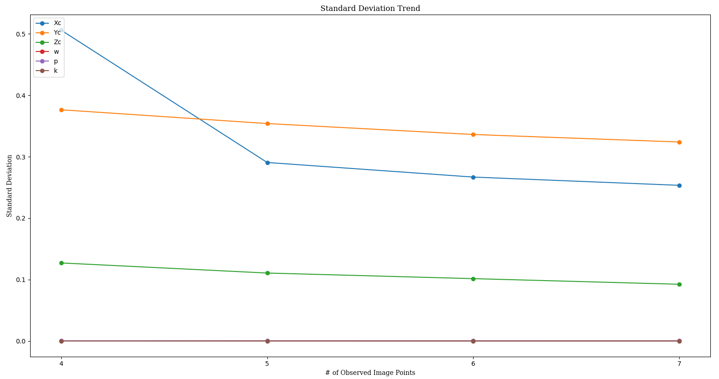

Image 28 Standard Deviation Changes:

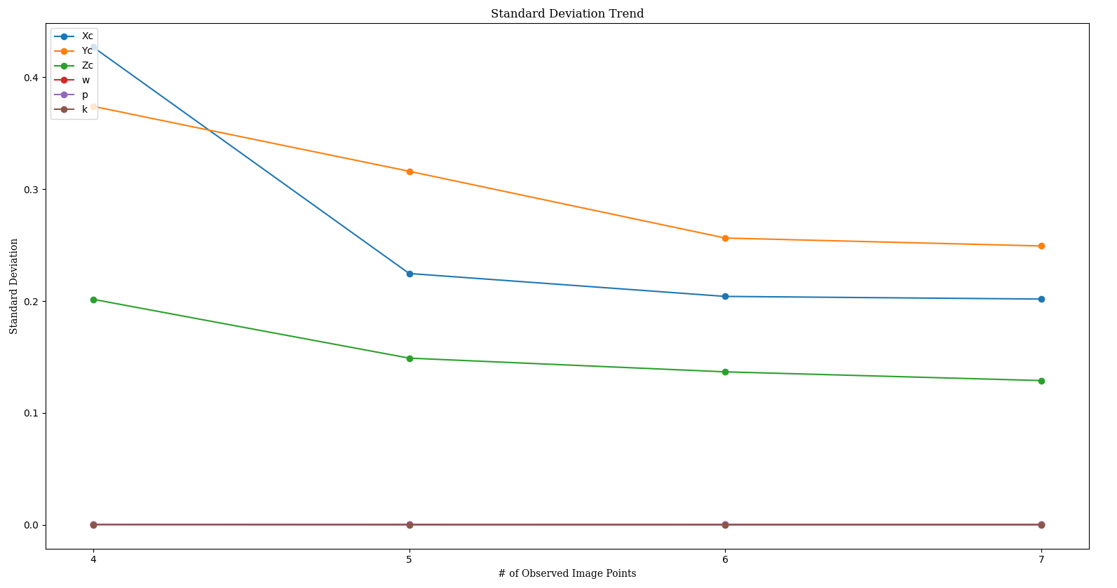

Image 27 Correlation Coefficient Changes:

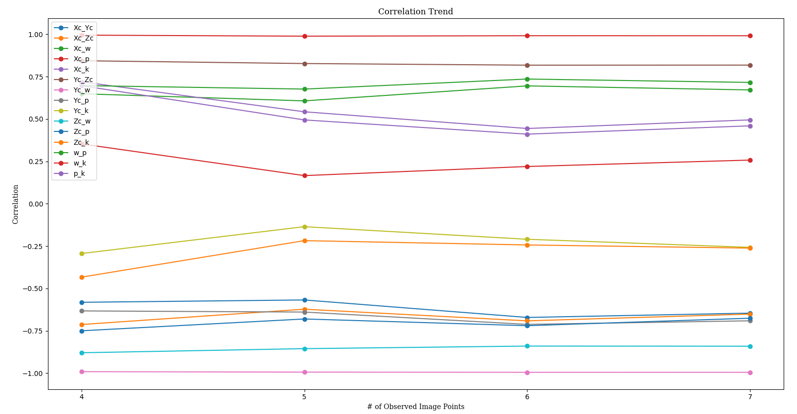

Image 28 Correlation Coefficient Changes:

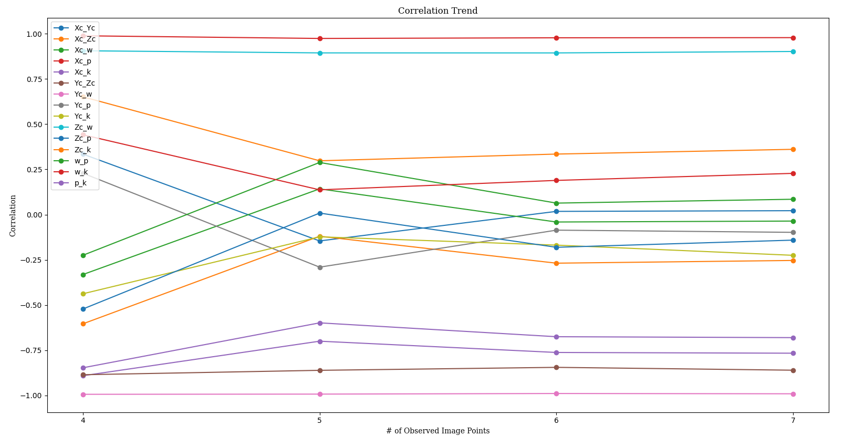

Task 5: