**Sentiment Analysis and Recommender Systems Impact on the Business Environment**

**James Getsinger**

University of North Carolina Charlotte

April 20, 2018

**ABSTRACT**

Businesses are prone to risk from the mass amounts of information that are found on social media platforms, online review websites, and other Internet websites. Reputation management has been shown to be a key driver in business success, thus it is important that businesses stay up to date with the newest ways that customers are discussing purchases and experiences. The problem facing many business analysts is how to navigate through all various platforms and noise, extract the information businesses are interested in, and transform it into something that is useful. Sentiment analysis is one type of analysis that is useful in gauging customer’s reactions to products and experiences. This can be applied to reviews, social media posts, or other data left by a customer. After determining how a customer feels about a product, recommender systems can be used to help steer customers to other products that a customer may be interested in. By combining the use of sentiment analysis and recommender systems, businesses are able to better harness and react to the customer data that is widespread on the Internet. This paper experiments on a Yelp data review set and provides a recommender system for users, surveys the prevalent sentiment analysis algorithms and recommender systems being used today, as well as, explores how businesses can utilize these and other similar technologies to their benefit.

**1 INTRODUCTION**

Businesses today must be able to properly address customer concern and respond to viral negative sentiment. The plethora of online review websites allow users to voice frustration over a greater medium than has been possible in the past. In an effort to better facilitate customer’s problem, in this paper, I have chosen to study a dataset consisted of Yelp reviews confined to Phoenix, Arizona. The area of Phoenix, Arizona provides a snapshot of online reviews of local businesses and is a sizable amount of data for analysis in this process.

Yelp is an online platform used by consumers to describe their experience at various businesses. The entire Yelp dataset is quite large as it covers areas all over the world. There has been a lot of academic research that has been done in regards to text processing and recommendation systems based on user reviews to Yelp. As the data is publicly available and provides a formal schema, it is an ideal candidate for text processing.

When a customer forms a complaint or leaves a negative review on a business in a Yelp review, there is an opportunity to better engage the customer and give them feedback. Some business owners utilize the respond feature in Yelp to interact with users while others make changes behind the scenes. To better address customer’s sentiment, my proposal in this paper is to analyze the reviews for sentiment and provide a recommendation to the user to another establishment in the same category based upon other user reviews. While this won’t necessarily be useful for a business reviewing their own reviews, it could prove useful to businesses that want to grab market share by targeting similar businesses in the area that have received negative reviews. Recommendation system in this paper will concentrate on analyzing the dataset and finding similarity between targeted user and other users with similar interest. By finding others that shared positive sentiment and review of experiences at a business, it is easier to predict that a targeted user will enjoy the business as well.

**2 RELATED WORK**

Previous work into this subject have studied the reviews for content but not provided a user with a recommendation to another establishment based upon their sentiment towards a business in the same category. Some have formed prediction systems to predict what a user would rate an establishment based upon other reviews [1]. This prediction has been based on total review ratings, but not on the content in the review itself.

Other work has looked at Yelp reviews in order to identify subtopics that are in demand among customers [2]. This was done by analyzing review dataset and using a Latent Dirichlet Allocation to determine what subtopics are prevalent among reviewers to various categories.

As Yelp is such a large dataset, there has been a lot of analysis performed through various means. The idea of analyzing reviews for sentiment analysis is researched rarely but has been done previously to understand the sentiment tendency of reviews from word frequency [3]. Sentiment analysis allows one to go beyond the base 5-star rating system and determine more about the emotion of the customer towards their experience at the business. The approach proposed in this paper is to use the sentiment as a variable to be used with the text of the review in predicting whether another customer would enjoy a business.

**3 DATASET**

The dataset used in the study is comprised of a collection of Yelp reviews in Phoenix, Arizona[4]. The entire dataset analyzed consists of 229,907 Yelp reviews across many categories. In order to prove the research being performed, focus was narrowed to businesses in the Coffee & Tea category.

During the preprocessing stage, to eliminate noise of businesses that may be new or not widely known, businesses with less than 20 reviews were filtered out as it requires at least 20 reviews to get a good idea of overall user’s sentiment. After preprocessing and cleaning the dataset, a total of 3,197 unique reviews were analyzed for content. To get more unbiased reviews, users who have posted less than 5 total reviews to Yelp were also filtered out. Users who leave fewer than 5 total reviews could signify that they are new to Yelp or do not use the platform very much. By focusing on dedicated users, the results of the analysis are more reliable. After performing the filtering, the entire dataset studied contains 2577 unique reviews across 30 different stores in the Coffee & Tea category of Phoenix, AZ. This provides a good basis to perform tests and form prediction models based on user reviews.

Analysis was run on the dataset to gather features that are useful in uncovering sentiment. Sentiment is studied in order to provide a recommendation based upon similar user’s predicted experience at the business. While star rating gives a glimpse into how a user classified their experience, sentiment goes deeper in determining whether a low rating was due to one mix up or a much bigger problem. Bigrams were used to determine most common words used in reviews for the various businesses. These Bigrams can be useful in getting the main point of emphasis of users’ reviews and can be used when giving recommendations of businesses that excel in the qualities a targeted user is looking for among businesses in the category. For example, if a customer is looking for the best tea in the area, businesses that have the most users leaving positive reviews about the tea would be recommended. Bigrams also provide the common themes that customers wrote on their experience. In analyzing common words along with sentiment, businesses can determine what specific items people like the most from the highest reviewed businesses as compared to the lowest reviewed businesses. This can help marketing strategies and help in determining what changes need to be made in order to get higher positive feedback from consumers.

**4 EXPERIMENT SENTIMENT**

Sentiment analysis was performed on the Yelp review dataset of businesses in the Coffee & Tea category. There are various ways to perform sentiment analysis on a piece of text. Sentiment refers to the polarity of the text, whether it be positive, negative, or neutral. The Yelp review text is pretty standard and there is no distinguishable feature that would enhance the sentiment analysis if programmed specifically. Therefore, for this process, the TextBlob package was used as a way to score the polarity of the reviews on a scale of 0 to 1[5]. TextBlob processes natural language and is able to determine the sentiment of a piece of text based upon various features like word choice, punctuation, and parts of speech.

In order to validate the sentiment performed, I chose to use the root mean squared error(RMSE). The RMSE is used to determine how much error there is among two datasets. This measurement provides a way to determine whether the sentiment is being correctly measured by the TextBlob package. The formula for RMSE takes the predicted outcome minus the actual outcome over all the reviews and returns the error. In my processing, I created a training and test dataset. Testing this on the dataset I compared the star rating left by users and the sentiment rating determined by TextBlob. The RMSE determined was 1.55887978868e-16. Because this number is close to 0, it is a very accurate measurement of sentiment.

Figure 1 shows the sentiment across various businesses. This graphic was created in Weka 3.8.1[6]. The X axis shows the sentiment from 0 to 1 and the Y axis is the different businesses being studied. Most businesses received an overall positive sentiment while there was a more noticeable negative sentiment in some businesses. The 2nd worst business according to the chart was Starbucks Coffee.

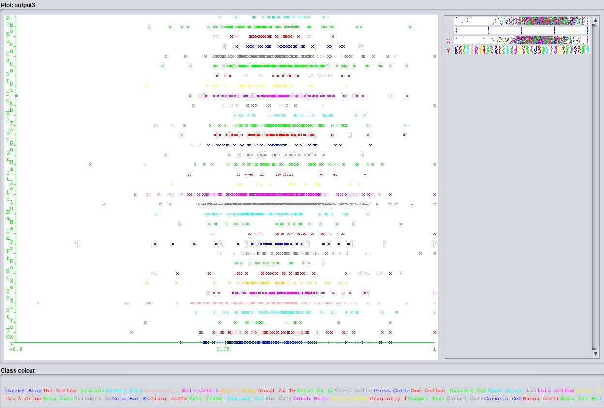

Figure 2 shows the best 10 businesses by Average Sentiment

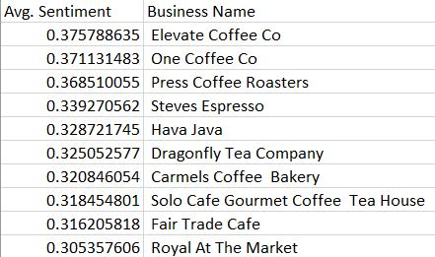

Figure 2 shows the worst 10 businesses by Average Sentiment

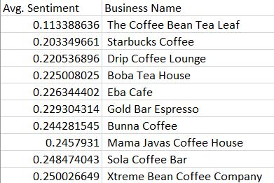

**5 RECOMMENDER SYSTEM**

The sentiment across the various businesses and the average sentiment of a particular user are helpful in creating a recommendation system for targeted users. When it comes to recommender systems, there are two main types being used today, content-based and collaborative recommendation [7]. Content-based recommendation systems are based on a user’s past history. In this case a content-based recommendation system would be based on past reviews by a specific user.

The other type of recommendation system that is more applicable to the dataset being studied is collaborative based recommendation system. Collaborative based recommendation systems are based on other users with similar interests of the target user. For the Yelp dataset, collaborative based recommendation system can be performed by analyzing the reviews of the various establishments and determining what text and sentiment was left by users. Using this information, a recommender system can be created that recommends businesses that show signs of being one that the targeted user is interested in.

The recommender system implemented gives a user a recommendation based upon their review content and the content of other businesses in the same category. For this research, bigrams were created to find businesses that had the highest amount of positive reviews for specific items. If a user left a bad review for a specific item, then a different establishment is recommended based on overall sentiment and likelihood of the person leave a positive mention on a specific item. The likelihood ratio provides a good measurement to determine if a person will share the same experience that others have on specific items [8]. By recommending a business in the same category that excels in the item the customer is frustrated in, the higher the likelihood that the recommendation will lead to a positive interaction among the customer and the recommended business.

A recommender system to best provide a prediction of whether a user is going to like a business or not was based upon the sentiment by other user’s reviews and likelihood of specific items in a positive mention. Using this information, it is possible to analyze a person’s thoughts on a business and determine what star rating they would most likely give for another business. This information can be used in providing an alternative establishment if a customer leaves negative sentiment at the business.

**6 IMPLICATIONS**

The research performed in this paper is useful to others looking to respond to customer complaints, as well as, marketing agencies looking to target customers who may be interested in trying out different businesses in the category. Market share is a pivotal aspect of business so if there is an opportunity that presents itself, businesses would be wise to target customers who are disgruntled with another business in the same category. This is due to the fact that businesses are already aware that customers are interested due to them leaving a Yelp review in the category, in this case Coffee & Tea. Since they are interested in this category, providing them a recommendation to their own similar business has a higher likelihood of the customer trying them out.

This research can also be used by businesses to investigate their reputation on the Internet. Handling customer complaints in a timely manner and implementing positive aspects that customers mention of other businesses in the same category allows a business to make necessary changes to ensure success.

Further researchers are able to use the information contained here to further study how user’s sentiment and business reviews are able to be used to determine whether a user with similar interest to a user studied would enjoy their experience at a particular business. This information can also be used by business analysts to further understand what consumers most are interested in and determine any trends in a particular business category based upon common words used in reviews.

**7 CONCLUSION**

Through the research performed, it is evident that there is a strong similarity between the sentiment of a user’s review and their star rating on Yelp based on the RSME score obtained. By analyzing reviews for common themes across businesses in a category, one is able to get a glimpse into what customers are most happy or unhappy about in their experience. Combining the sentiment of the review with the text allows one to get an overall picture of how a business is handling its reputation management online.

The two main type of recommender systems are collaborative and content-based. For this study, collaborative was chosen due to the fact that there would not be a lot of existing data for a user on a particular business to perform content-based recommendations. Recommendation systems based upon users with similar interests to a targeted user can be formed to best determine whether a user would enjoy their experience at a particular business. In this case, using other user’s sentiment towards a business and the likelihood in which they mention specific items, one is able to recommend a business that excels in providing positive experiences when people purchase a specific item.

The research performed is able to help business analysts make informed decisions on customer behavior and discover trends that are forming across various business categories. The Yelp platform allows one to easily access the data and should prove useful in sustaining positive growth among businesses.

**REFERENCES**

[1] Jason Ting, Swaroop Indra Ramaswamy. Yelp Recommendation System

[2] James Huang, Stephanie Rogers, Eunkwang Joo. Improving Restaurants by Extracting Subtopics from Yelp Reviews

[3] Boya Yu, Jiaxu Zhou, Yi Zhang, Yunong Cao. Identifying Restaurant Features via Sentiment Analysis on Yelp Reviews

[4] Data.world. (2018). data.world. [online] Available at: https://data.world/brianray/yelp-reviews [Accessed 24 Feb. 2018].

[5] Textblob.readthedocs.io. (2018). TextBlob: Simplified Text Processing — TextBlob 0.15.1 documentation. [online] Available at: http://textblob.readthedocs.io/en/dev/index.html [Accessed 18 Mar. 2018].

[6] Machine Learning Group at the University of Waikato(2018). [online] Available at: https://www.cs.waikato.ac.nz/ml/index.html [Accessed 21 Apr. 2018].

[7] Marko Balabanovic and Yoav Shoham. Content-Based, Collaborative Recommendation

[8] Manning, Christopher D., and Hinrich Schutze. Foundations of Statistical Natural Language Processing. Cambridge, MA: MIT, 1999. Print.