Jordan Grotz
RBE 549 Computer Vision
9/17/2023
Lab 4 Report

Intro
The purpose of this lab was to become familiar with geometric transforms on images using opencv. With these images transformed, we would then apply Harris corner detection and the SIFT algorithm to find keypoints. From this we could compare how each feature detector worked given the geometric transformations. The code used to create these images is found in the file lab4.py

Results
Figure 1 shows the original image and each geometric transform for the images. These are all contained on a subplot. Figure 2 shows the Harris corner detection applied to each of the images in figure 1. Lastly, figure 3 shows the SIFT keypoint features shown on each of the images from figure 1. The png files are also included with the submission if a closer look at each image is desired.
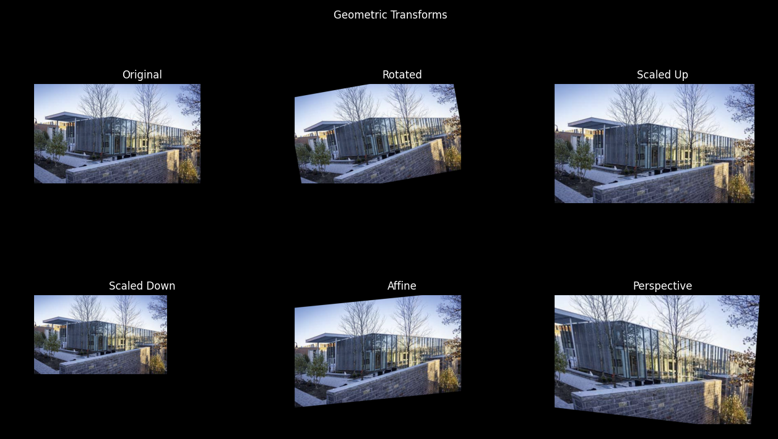Figure 1: Six Geometric Transforms
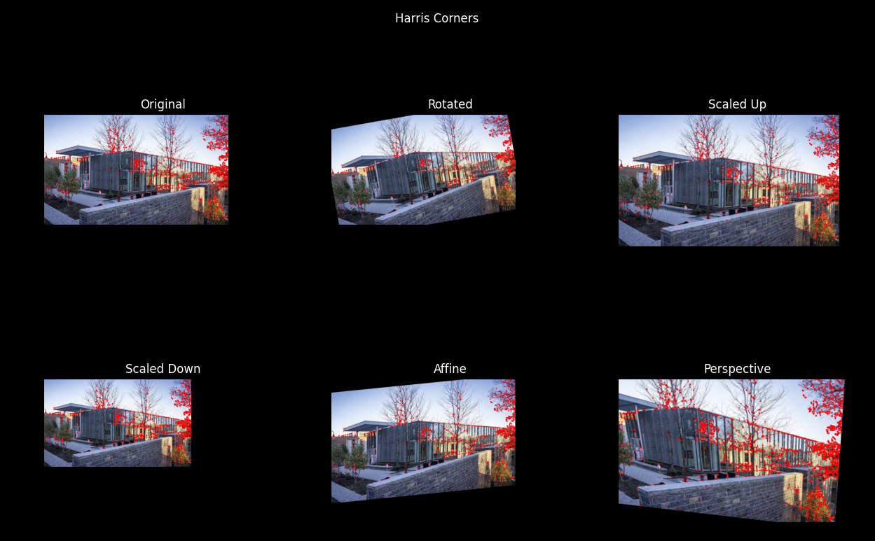Figure 2: Six Transformed Images with Harris Corner Detection
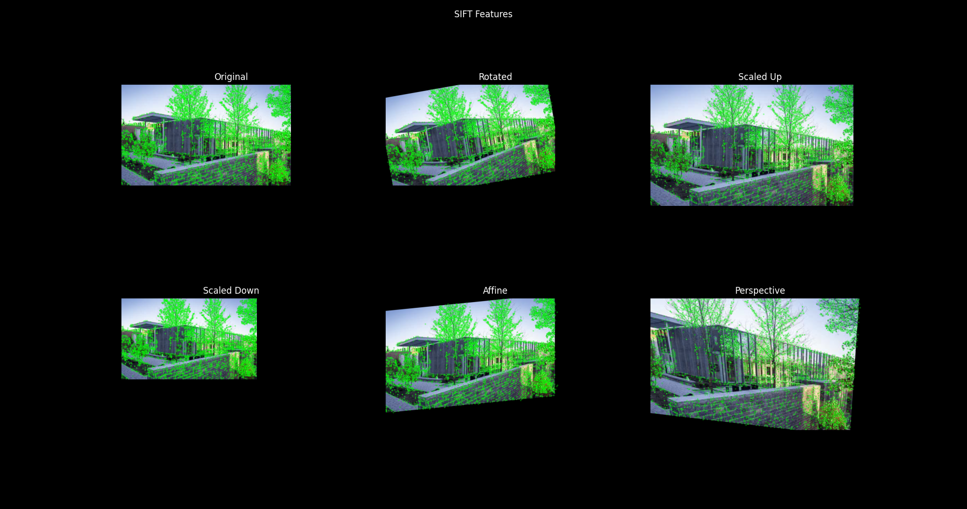Figure 3: Six Transformed Images with SIFT Features

Discussion
For the Corner detection, the keypoints were located at the corners of objects as expected. Given the image is a very rectangular shape, these occurred along the surface on the building (such as window corners). It is known that the harris corners are not great a scale variance. The 20% scale change in this example did not greatly impact the number of points located, but it would seem that the top of the building could have a reduction of points as the scale decreased. Less orthogonal structures might see more of a shift in points. Not many points were located on the front brick structure, however, the perspective transformation brought out some keypoints on that structure. This might not be ideal for image comparison.
For SIFT, a huge number of keypoints were detected on each image. This could have been reduced by setting a threshold for the value of the keypoint. However, from visual analysis, the highlighted keypoints were maintained through each geometric transformation. The SIFT algorithm even had points on the front brick structure, which the harris corner did not detect. The SIFT algorithm is able to produce much more stable and numerous keypoints than the harris corner detector.

