Hadoop Terminology
Yarn
Core of the Hadoop Architekcure, provides resource management, allows several processing engines, for example Spark for In-Memory or Hive for SQL.
Tenant / Multi-Tenancy
Concept in Software Architecture, means that a single instance of a software runs on a server and serves multiple “Tenants”.Tenants are groups of users/VMs(?) that have access to that resource. Not quite hadoop specific, maybe achieved through HDFS?
DFS
Distributed filesystem. Hadoop supports more than HDFS it seems.
NameNode
Yarn-Specific stuff
Resource-Manager (RM)
Central authority for for giving out resources. Has a central and global view of available cluster resources. Can enforce fairness, capacity and and locality across tenants. Jobs are submitted to the RM via some protocol, credentials are checked then. The resource manager is a pure scheduler, e.g. no fault tolerance and so on.
Node-Manager (NM)
The RM assigns containers to a specific node. To do that, the RM communicates with a specific deamon called the Node Manager. The RM obtains its global view from snapshots communicated by the NM.
Application-Master (AM)
Basically the key point in the YARN concept. Obtains resources from the central ResourceManager and monitors the execution of single jobs via the NodeManagers. The ApplicationMaster also handles fault tolerance instead of the ResourceManager. There is one instance of an AM per application.
“Head” of a job. Does the follwing things:
- Manages all lifecycle aspects of an application
- Managing execution flow (reducers against output of maps)
- Handling faults and does local optimizations.
Basically runs user written code (language doesn't matter) and communicates via protobuf with the RM and NM.
Overview of YARN-Architecture
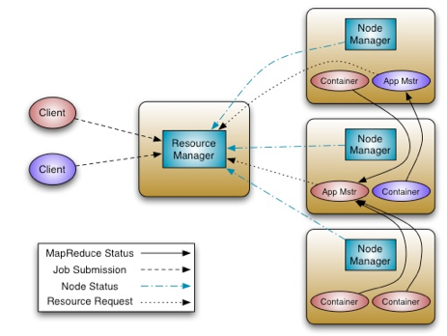

Overview of Map-Reduce
