Min Thu

SPRINT 1 – DOCUMENTATION VISUAL PROTOTYPING, DATA BASE DESIGN AND DATA STRUCTURE SELECTION

Contents

Goals and Deliverables 2

Visual Prototyping 2

Tools and Methods 3

Styling Choices 3

Design Iterations 4

Database Schema 6

# Goals and Deliverables

The objective of the sprint was to create a visual prototype of the web application, aswell as a documented database schema, the initial data structure and algorithms plans to support efficient local data storage and retrieval

Planned Work

* Visual Prototyping, creating the necessary user flow diagrams, visual prototype of the included pages
* Database Schema Design – define entities, relationships and indexing strategies for optimal query searching
* Algorithm Selection – By recognising the function of the query search and storage, we shortlist any standard data structure and algorithms for storage and retrieval that are commonly used.
* Prototype Validation – testing the database schema and selected data structure with sample data for performance

Actual Deliverables

* Produced a high fidelity prototype
* Established a structured ERD Diagram to define the entities, relationships involved
* Shortlisted common data structures and algorithms
* Created a test database and ran a benchmark to check performance of the schema

# Visual Prototyping

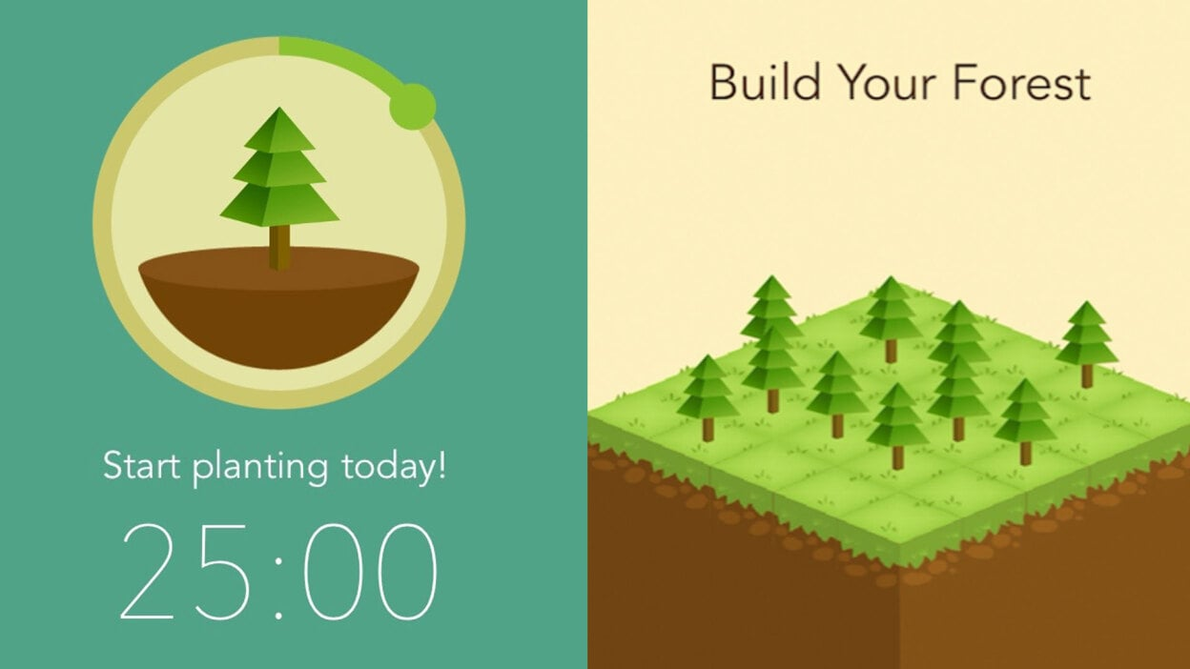Before implementing visual designs of the web app, It was necessary to investigate similar applications that aligned with the web application’s goals and motivation. This was necessary to conceptualise the design in order to create a clean and intuitive design, addressing the goals of the project outline.

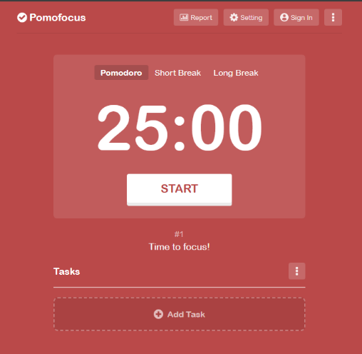The figures shown are the applications that inspired the web app development, by using simple colour schematics and thematic of nature elements, it connotates serenity and mindfulness. The minimalistic design is visually appealing and not overwhelming which reinforces this idea of mindfulness. Through this investigation, I adopted neutral and lighter tones to create a calming visual experience. Additionally I incorporated nature imagery to further reinforce the idea of mindfulness and well-being. This minimalistic approach ensures the design remains visually appealing without overwhelming the user, aligning with the core principles of mindfulness and focus.

Figure 2 Forest APP design

Figure 2 Pomofocus.io design

## Tools and Methods

To design a visual prototype, I used Figma which offered browser based design tools to create user interfaces.

Using Figma made designing the prototype more streamline by utilising Figma’s design systems, components and styles.

The Frame tool acted as a foundational structure for the app screen, I was able to differentiate and design individual screens such as the timer and journal entry interfaces.

As it was a component based design system, creating reusable elements streamlined the design process (An example would be the backdrop elements used, aswell as the header, titles)

The Auto layout simplified resizing and modification as they adjusted dynamically.

## Styling Choices

To ensure consistency across interfaces, I had developed a colour palette and complementary fonts to ensure user interface was seamless and transitional upon observation.

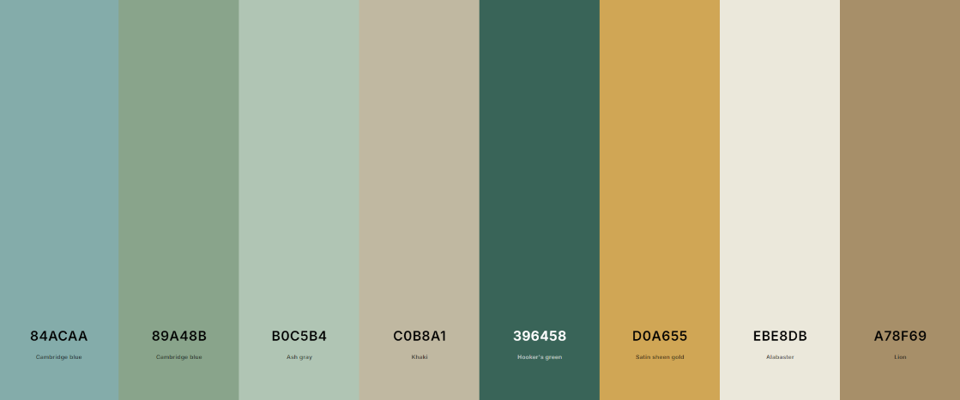

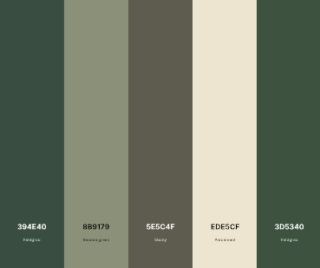

## Design Iterations

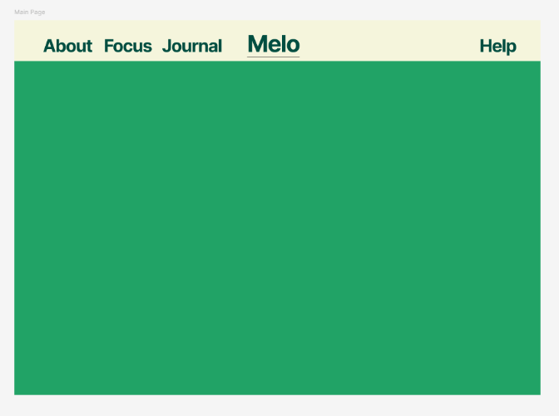 The initial design, however the colour was too sharp and contrasting so another choice was adopted.

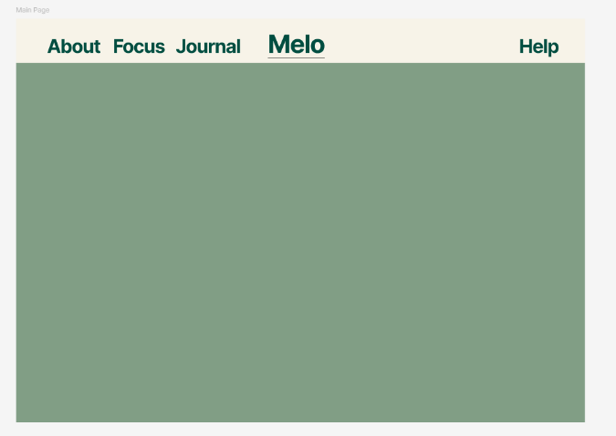A warmer and washed colour was adopted to make it easier to look at, the lighter contrast to the text opted for a visually appealing interface

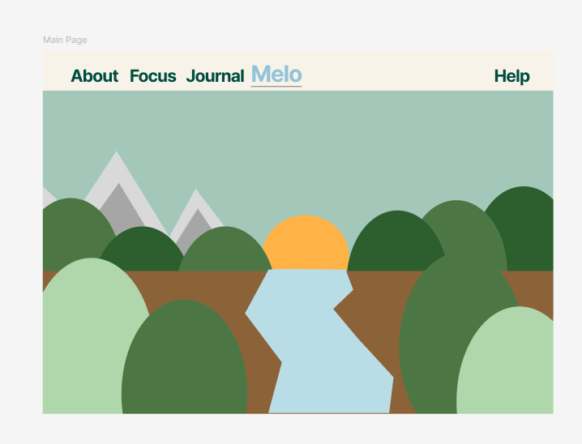

I then began adding themes of nature aswell as a change in the header to indicate which page the user was currently on

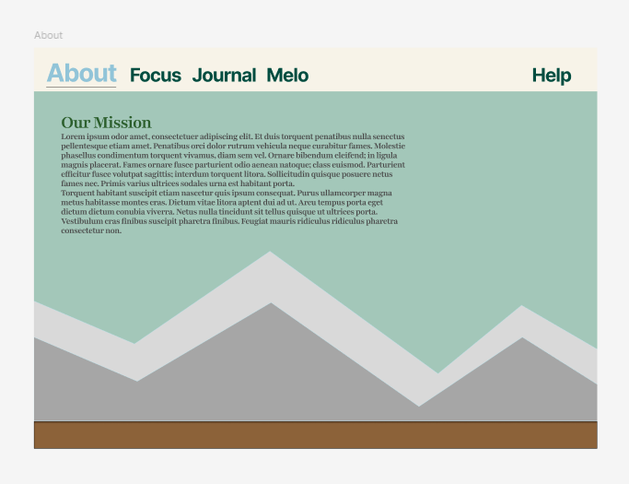Reusing assets of the main page, a mountain scenery was creating using the simple shape tool provided by Figma, The font Playfair Display was used to compliment Inter, which was the main font I used for bolder and bigger titles.

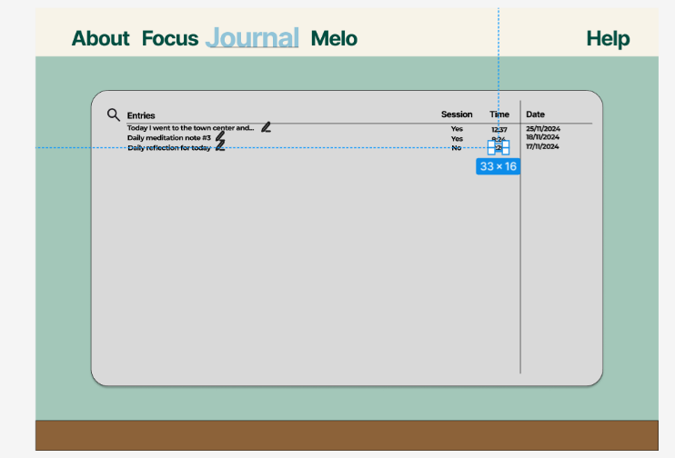

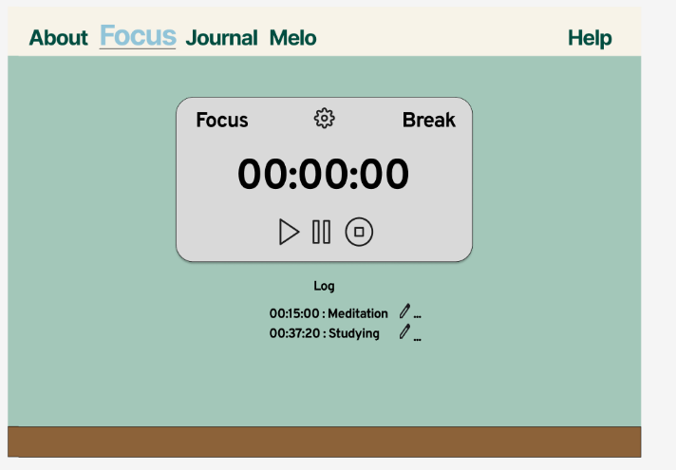

Overall, the use of lighter tones and neutral colours and nature imagery effectively reflects the app’s purpose. The designs given serves as a foundation for the app’s front end development, ensuring consistent visual identity throughout the implementation process.

I was happy with the outcome given that Figma was a software I was unfamiliar with, I hope the next time I use Figma I can use more of the features available to me and dynamically add depth to the page, by giving some form of interactivity (such as the button asset provided by Figma)

Given the time frame I am given to complete the sprint, I would like to invest more time in wire framing before creating high fidelity prototypes to clarify layout and functionality and allocate more time to refining designs by incorporating a feedback session at each design stage.

# Database Schema

The objective of this task was to conceptualise the database structure by identifying key entities and their relationships to ensure efficient data management for the application

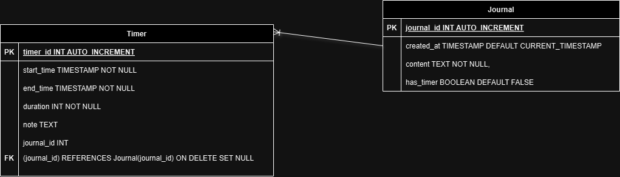

* Timer

The primary key used to identify each session was timer_id

Start_time and end_time was used to track session startand end, duration calculated the duration of the session.

Note is an optional text field to add any additional details

Journal_id is a foreign key that links the timer to a journal entry

* Journal

Similar to the timer entity, journal_id is a unique identifier for each journal entry

Created_at is a timestamp to mark when the entry was created

Content contains the text content of the journal entry

Has_timer is a Boolean indicating if the journal is linked to a timer

The relationship between the entities is described to be “one to many”, as a single journal entry can have multiple associated timers but a timer can be optionally linked to a journal entry.

**ON DELETE SET NULL** ensures referential intregity by setting the journal_id null in the Timer table if a journal entry that is associated to the timer is deleted.

This simple schema design allows efficient retrieval and storage by allowing timers and journals to exist independently with an associated unique identifier, integrity is ensured through foreign key constraints.

## Validation Testing