**CS590BD Big Data Analysis**

**LAB 5**

* ***Game app seleted***

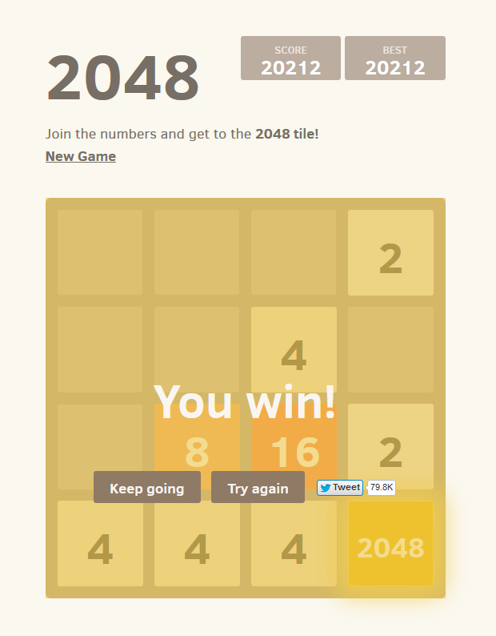

-This game recognizes right , left , top and bottom motions these can be operated using touch event.

* Replacing existing touch event with sensor based event.
* We have generated 4 sequence files for training our application,

-sensorleft.seq

-sensoright.seq

-sensortop.seq

-sensorbottom.seq

* Training process starts,Below screenshots explains..

***Train Success***

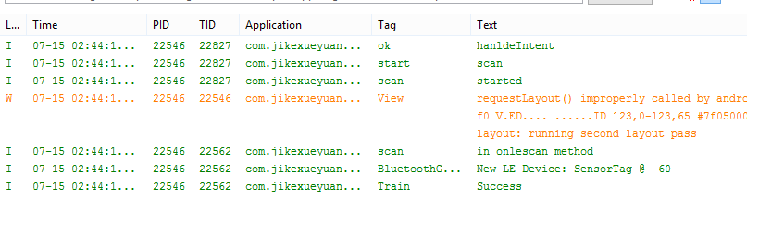

***Left***

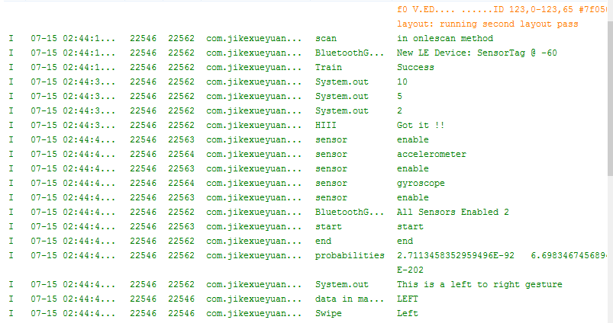

***Right***

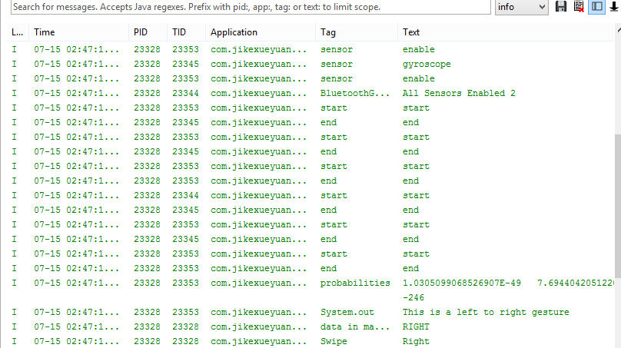

***UP***

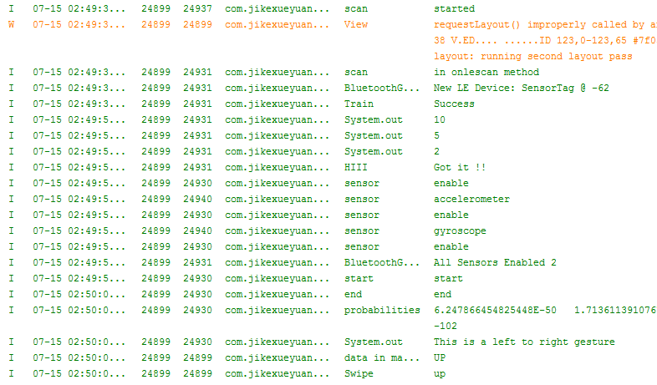

***DOWN***

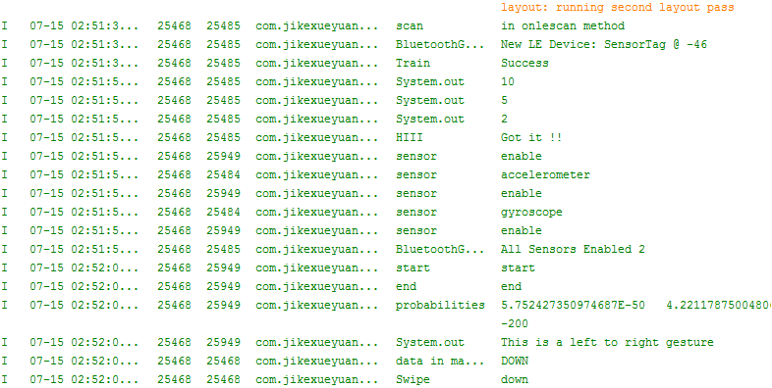

***Snippet changes***

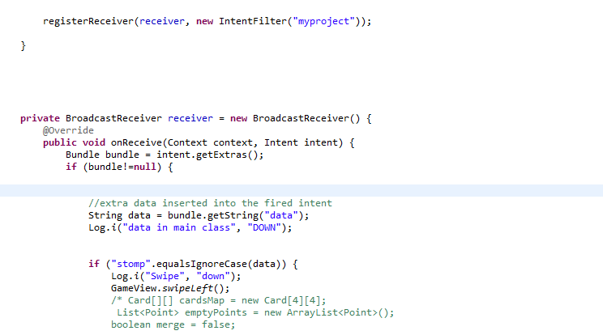

* ***Our Game app have 6 classes*:**

-Mainactivity.java {handles touch event and sensor motion}

-Card.java

-GameView.java

-ConnectionService.java {handles sensor based activity}

- Testgesture.java {trains motion activity}

-SensorTag.java {generates vector values}

* ***Here our game starts using Sensor activity***:

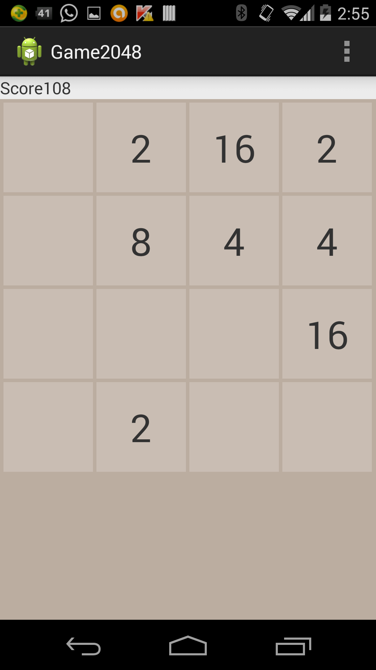

By**: Sandeep BLV**

**Jeevana T**