**CS590BD BIG DATA ANALYSIS**

**LAB6**

* **Task 1**

***Activity recognition (gesture recognition) ->{left,right,top,bottom,punch)***

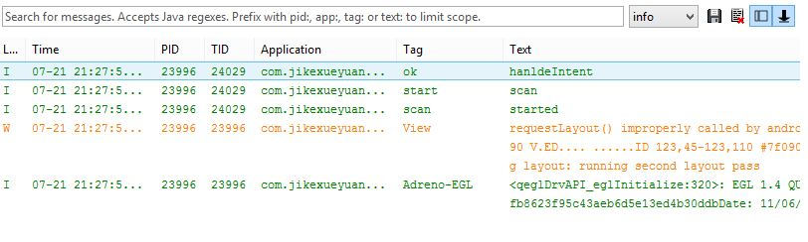

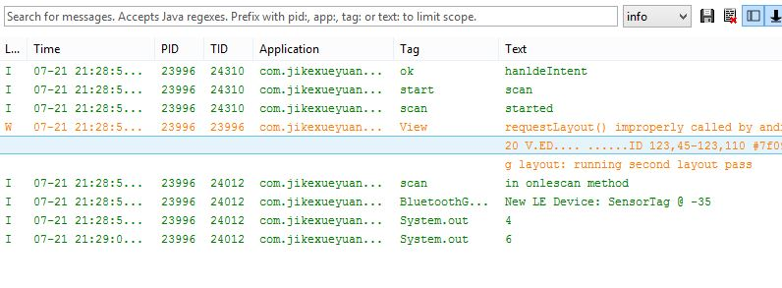

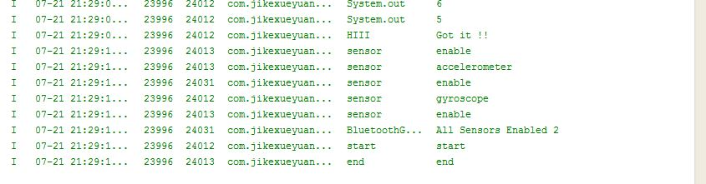

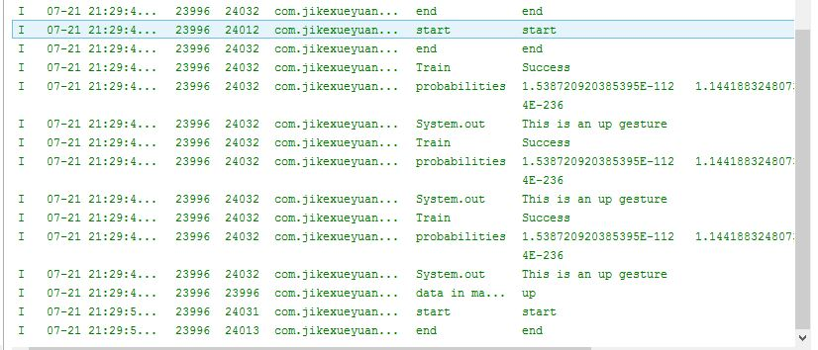

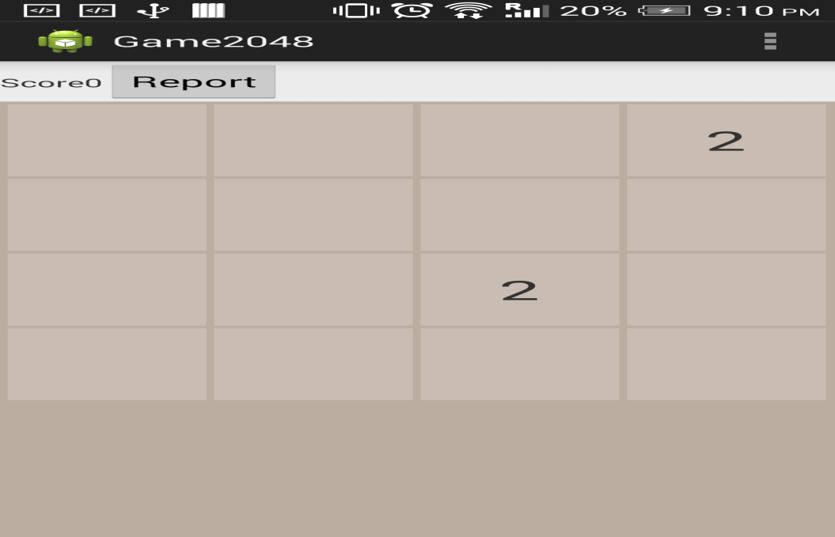

* ***Task 2 & 3***

***Generating Report based on usage of gesture and no. of times particular(left,right,top,bottom,punch) gesture used.***

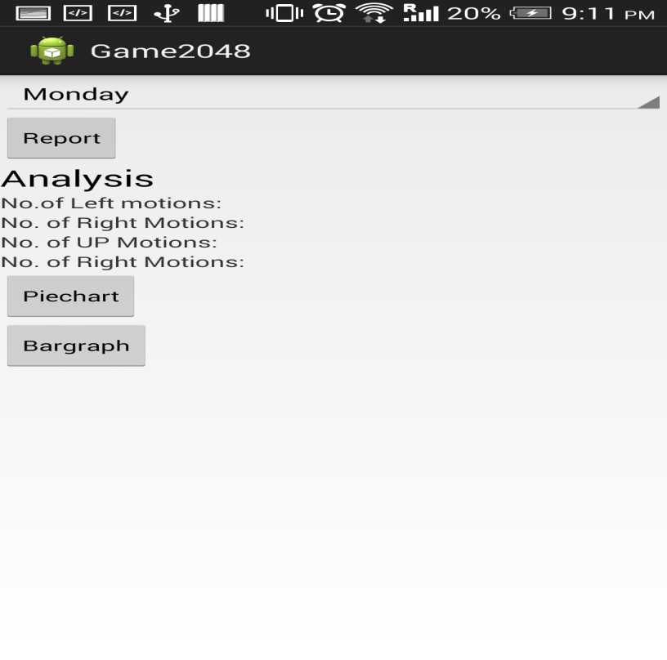

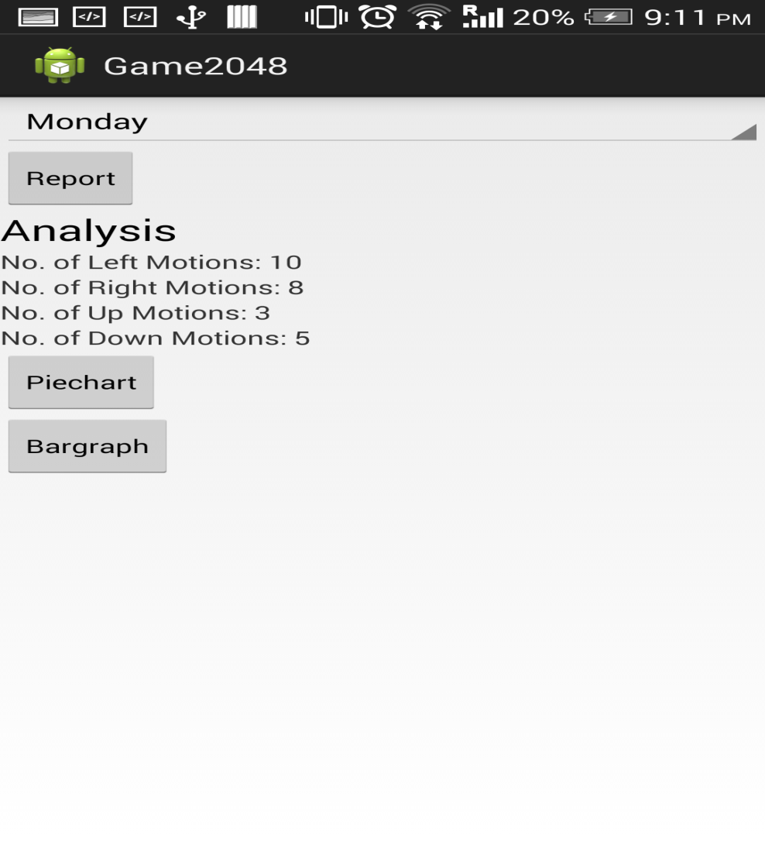

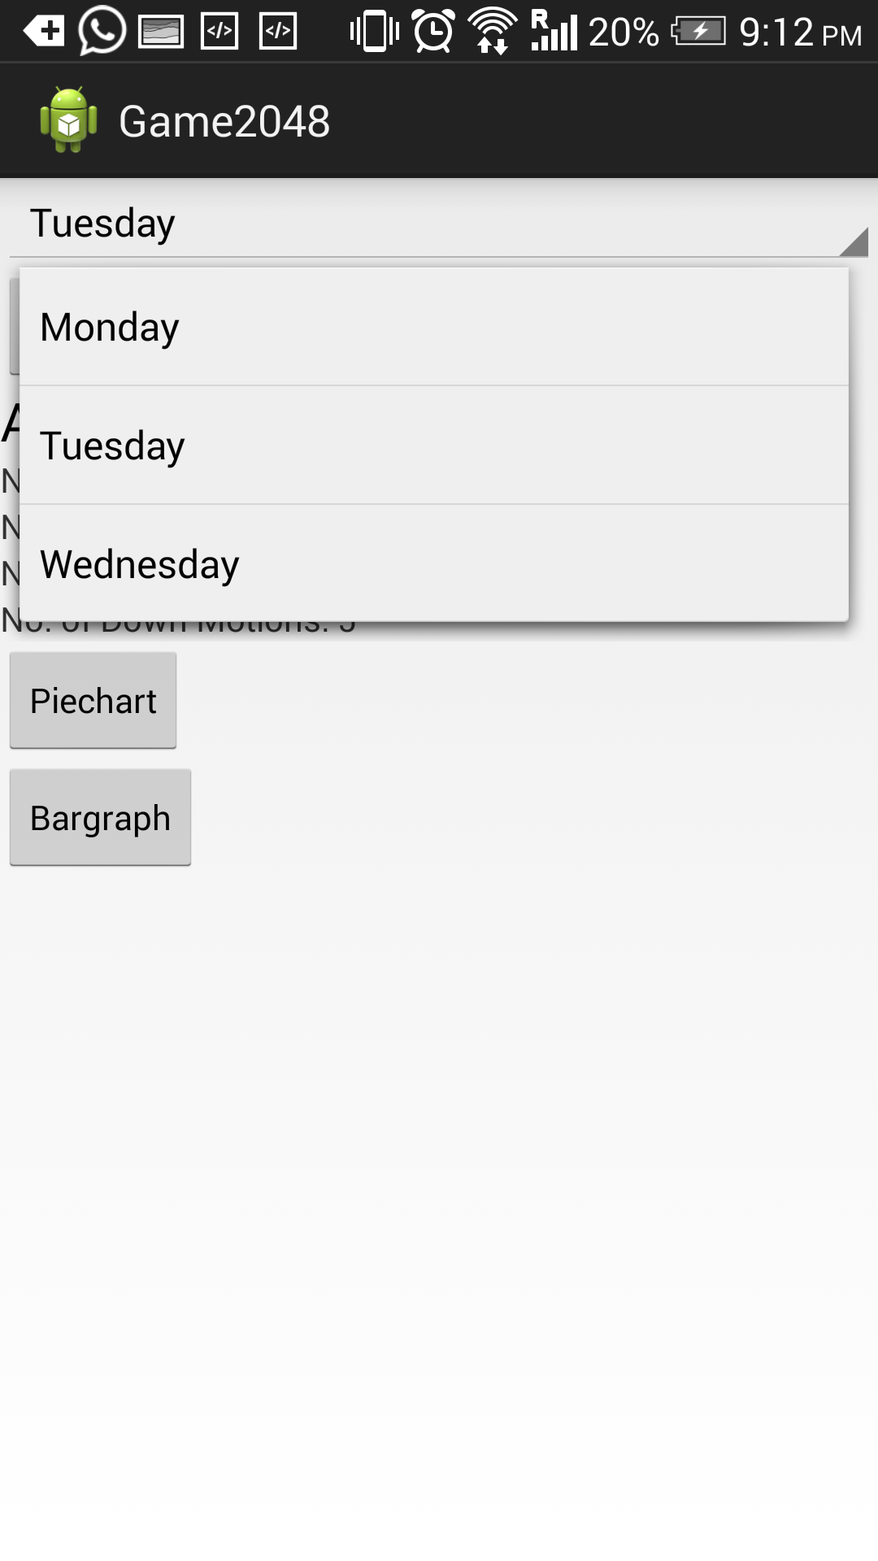

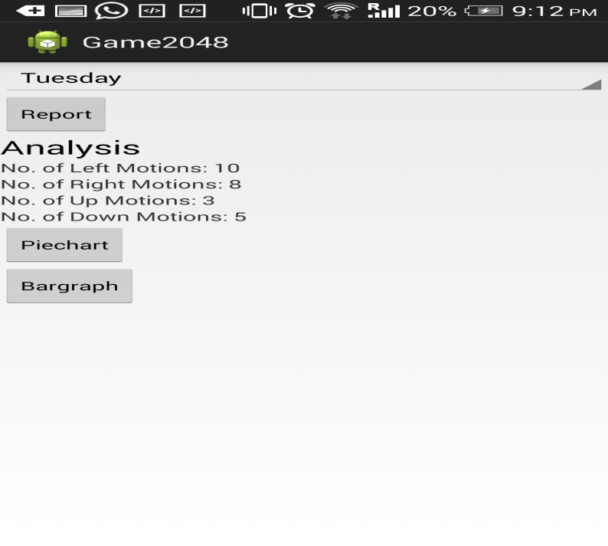

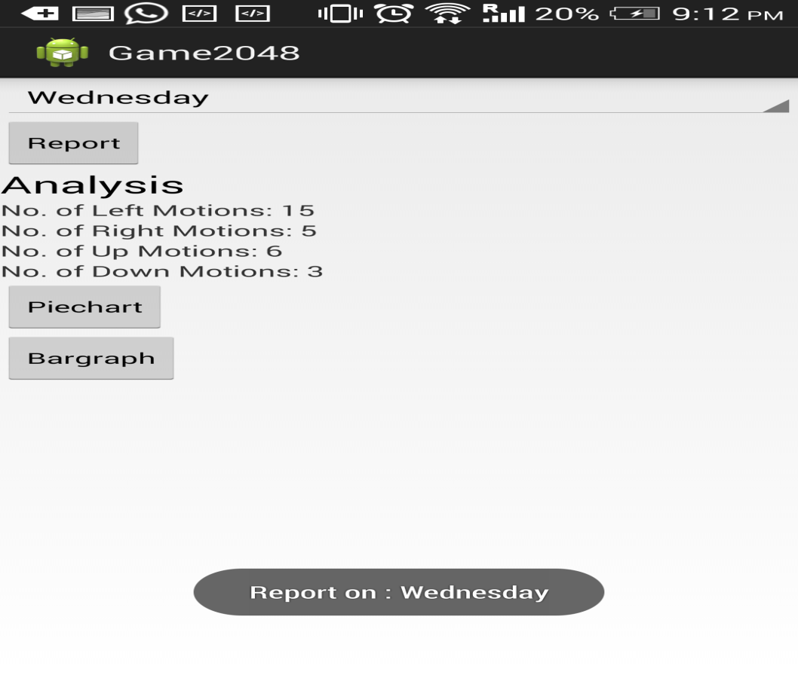

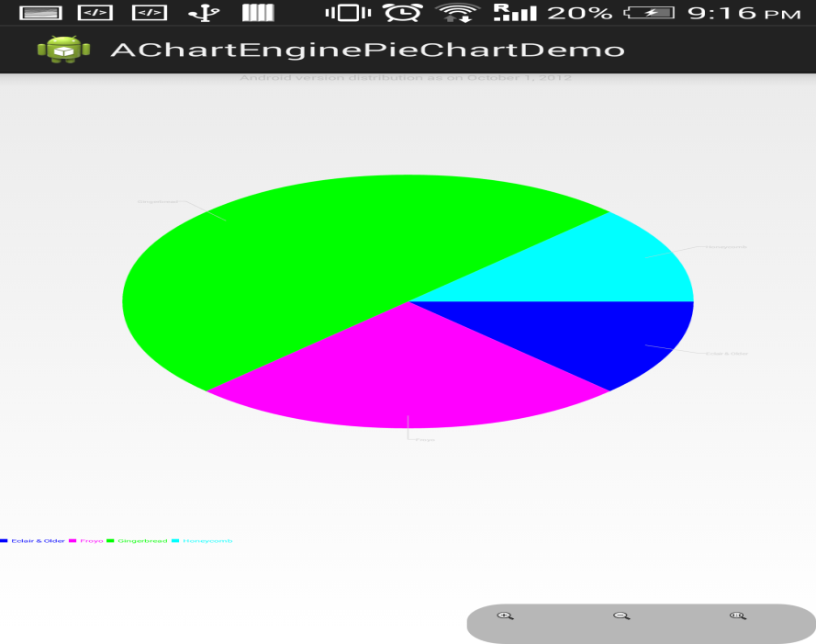

**Based on number of times each gesture used(left,right,up,down,punch)**

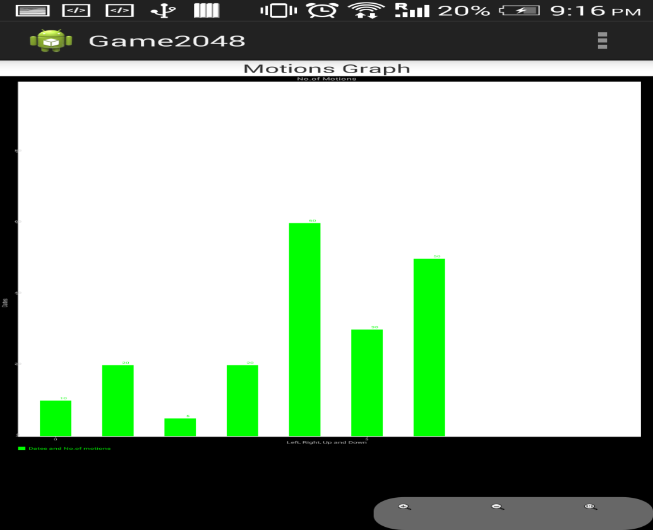

**Based on motion**