Anthropogenic climate change has been a hot topic amongst scientists and the public for the past decade. A few of the primary questions associated with climate change relate to how scientists know that climate change is caused by humans and where and when the effects of climate change will be seen. Both of these questions require an understanding about what causes the climate to change over time. Earth’s climate is a complex dynamic system and has changed constantly throughout Earth’s history. Being able to separate the climate’s natural fluctuations from the change caused by anthropogenic activity is essential to being able to accurately predict and detect future changes in climate.

**Natural Variability**

**1.1.1 What is Natural Variability?**

One of the primary challenges of assessing the impact of anthropogenic influence on Earth’s climate is a lack of understanding of the natural fluctuations of the climate system. Internal climate variability is simply how Earth’s climate varies in time without any external forcing. External forcing can be natural in source, including volcanic eruptions, and solar forcing, or anthropogenic, including human emissions of greenhouse gases and human caused land use changes. The term *natural variability* on the other hand is typically used to refer to fluctuations in Earth’s climate caused solely by natural forcing (internal or external), and not including anthropogenic influence.

Natural variations in the climate system, also referred to as ‘climatic noise’, (Madden, [1976](https://link.springer.com/article/10.1007/s00382-010-0977-x#CR26); Schneider and Kinter, [1994](https://link.springer.com/article/10.1007/s00382-010-0977-x#CR35); Wunsch, [1999](https://link.springer.com/article/10.1007/s00382-010-0977-x#CR46); Feldstein, [2000](https://link.springer.com/article/10.1007/s00382-010-0977-x#CR15)) are a result of non-linear dynamical and biological processes in the atmosphere and ocean operating on a variety of spatial and temporal scales. The most common example of natural variability is the El Nino-Southern Oscillation (ENSO), which is a result from the non-linear interactions between the atmosphere and ocean in the Equatorial Pacific. While ENSO is perhaps the most famous of all the atmospheric climatic modes of variability, there are multiple modes of variability in the atmosphere and ocean which interact with each other.

A further complicating matter is that climate variations happen on all timescales: paleo-climatic, centennial, multi-decadal, decadal, inter-annual, and seasonal, in addition to on all spatial scales from regional to global. Global variability on long timescales is generally the best understood, however regional variability is generally the most important when it comes to understanding and interpreting recent trends in observational data.

**1.1.2 Why is natural variability important?**

Quantification of natural variability is important to climate science for many reasons. First, natural variability is key to determine *climate predictability*. Climate predictability was first defined in 1975 (Academy of sciences publication, 1975) as a measure of signal-to-noise, where the signal is any potentially predictable long-term (> 1 year) climate feature, and the noise is natural variability. Having an estimate of natural variability allows us to answer the question – how large does a trend need to be in order to detect it? Without an idea of what the natural variability of a given feature is, it is nearly impossible to determine if a signal lies within the noise of the climate system.

Another reason quantifying natural variability is important relates to *projection uncertainty*. Characterizing uncertainty for climate change projections is important for purposes of detection and attribution and for strategic approaches to adaptation and mitigation (Deser et al, 2012). Uncertainty in future climate change comes from three main sources: forcing, climate model response, and internal variability (Lovenduski et al 2015, Hawkins and Sutton [2009](https://link.springer.com/article/10.1007/s00382-010-0977-x#CR17); Tebaldi and Knutti [2007](https://link.springer.com/article/10.1007/s00382-010-0977-x#CR42)).

A final example of where understanding natural variability is important is in the evaluation of global climate models. Because of observational limitations and the inability to experiment on the entire earth system, climate models are developed and used to further our knowledge of the planet and climate system. Climate models are typically validated against the mean state of a given climate feature. For example, to assess the accuracy of the ocean module in a climate model, one might compare the average sea surface temperature (SST) in a pre-industrial control model run to the average of many years of SST observations from similar period (via proxy records). While this method is useful for assessing the *mean state* of the climate model, it does not give any information about the *variability* of the model. The model could have vastly larger variance than the observations, which would not be captured by comparing the means.

**1.1.3 What are the challenges associated with quantifying natural variability?**

One of the largest challenges with estimating natural variability is a lack of observational estimates. In an ideal situation, scientists would be able to quantify natural variability using observations of the Earth system. However, because natural variability operates on all time and spatial scales, this would require millions of observations across the entire globe. Global natural variability over thousands of years is estimated using proxy records of Earth’s climates; however, regional variability on shorter timescales (decadal to multi-decadal) is much more of a challenge to quantify because it requires finer resolution of observations.

To supplement the limited observational estimates of natural variability, scientists often turn to global climate models to quantify natural variability. Unlike observational records, global climate models have a consistent spatial and temporal resolution. Global climate models can also be used to simulate multiple realizations of Earth’s climate over thousands of years, to generate a statistical distribution of climate variability in absence of external forcing. Because no single climate model is a perfect representation of Earth’s dynamical and biological processes, multiple models are often employed to reduce the uncertainty due to model configuration. This method of quantifying natural variability also comes with challenges. Primarily, global climate models are very computationally expensive and require extensive resources and time to generate a simulation. Additionally, to best quantify natural variability, multiple simulations without any anthropogenic forcing should be performed. Because of the emphasis on simulating future change, fewer resources have traditionally been put toward conducting non-anthropognically forced simulations.

In this thesis, natural variability in both physical fields (winds and temperature) and biogeochemically active fields (carbon and oxygen) is examined across multiple scales.

* 1. **Background**

As the largest reservoir for carbon and heat in the Earth system on decadal-to-centennial timescales (Figure 1), the ocean has a great amount of influence on global climate variability. It is estimated that on timescales of many thousands of years, the ocean should absorb

approximately 85% of all anthropogenic carbon emissions (Archer et al. 2009). Ocean circulation plays a critical component to how much carbon and heat the ocean absorbs.

* + 1. **Surface Mixed Layer**

The atmosphere and ocean primarily interact through gas exchange in the surface mixed layer of the ocean. This top layer of the ocean is mixed and stirred by the overlying atmospheric winds. This mechanical forcing acts to create a layer that is nearly uniform with respect to the vertical tracer gradient. Gas exchange between the atmosphere and ocean is determined by atmosphere-ocean disequilibrium. For oceanic heat content, it is the disequilibrium between the atmosphere temperature and mixed layer ocean temperature that determines if heat is transfer between the two mediums. For carbon dioxide, it is the partial pressure of CO2, pCO2, that drives the gas exchange between the atmosphere and ocean.

Tracer concentrations in the surfaced mixed layer are balanced by this atmosphere-ocean gas exchange at the surface, lateral and vertical advection of the tracers, and tracer diffusion. Lateral advection is primarily driven by the winds at the surface whereas vertical advection typically acts through entrainment at the base of the mixed-layer. Entrainment occurs when the depth of the mixed layer varies with time (typically the seasonal cycle). While diffusive fluxes in the surface mixed layer are usually much smaller compared to the other terms (Levy et al., 2013).

* + 1. **Ocean Circulation**

The circulation of the surface ocean is primarily driven by the meridional gradient in the zonal surface winds. Because the zonal winds vary with latitude, the winds impart local vorticity (i.e. spin) into the ocean. This momentum, combined with the Earth’s rotation (planetary vorticity, i.e. Coriolis force), sets up circular flow pattern in the ocean basins with anti-cyclonic flow in the subtropical-gyres (counter-clockwise in the NH) and cyclonic flow in the tropical and polar gyres (clockwise in the NH) with intensification on the westward side of the ocean basin (Figure 2). This balance between the vorticity imparted by the wind-stress and the planetary vorticity is referred to as Sverdrup’s balance (Sverdrup 1947).

Southern Ocean is unique because it is the only area in the global Oceans where the ocean extends around the entire globe. Additionally, this ocean is aligned with the over-lying sub-tropical westerly jet. The result is a surface current which wraps around the entire globe, the Antarctic Circumpolar Current, with an average strength of 130 Sv. Via Ekman pumping, the westerly winds over the Southern Ocean transport water northwards that forces water from depth up to the surface, causing shoaling of isopycnals (density surfaces). Due to the northward volume transport of water, the Southern Ocean forms a key area in the large-scale overturning circulation in the ocean.

While it’s the interaction of the oceanic surface waters and the atmosphere that drive the air-ocean exchange of tracers, it’s the transport of these tracers into the deep ocean that allows the ocean to function as such a substantial sink for atmospheric quantities (most notably carbon and heat). This exchange of surface water into the deeper ocean, requires a substantial change in density (densification), while the exchange of deep water to the surface typically requires strong mechanical forcing (i.e. wind forcing). Because of these requirements, this surface-deep water exchange localized to only a few places in the global ocean – usually in the high latitudes.

* + 1. **Southern Ocean Circulation**

The Southern Ocean is defined as the stretch of oceans south of 55S. This ocean is the only body of water that stretches around the entire globe. Because of this unique characteristic, coupled with the strong overlying winds, and high latitude location, the Southern Ocean is one of the most important oceans for regulating global climate. Recent estimates suggest that the Southern Ocean is responsible for XXX of the heat uptake and ### of the carbon uptake (Frolicher and Sabine…).

The Southern Ocean is important to global climate because of its rather unique dynamics (Figure 3). The overlying Southern Hemisphere Westerly jet drives subsurface Ekman transport towards the north. This northward flowing water is colder than the water it encounters (and therefore denser) and subsequently sinks into the interior to form Antarctic Intermediate Water - a process known as ventilation. Closer to the Antarctic continent, overlaying easterly winds drive the surface water towards the south where waters interact with the Antarctic sea ice and dense water is formed (formation of Antarctic Bottom Water). The resulting divergence of water at the surface of the Southern Ocean allows for deep water (primarily North Atlantic Deep Water) to rise to the surface and interact with the atmosphere (Figure 4). This process of water rising to the surface, interacting with the atmosphere, and subsequently sinking back into the interior is the reason why the Southern Ocean is so influential on global climate.

The North Atlantic Deep Water (NADW) that rises to the surface is relatively high in dissolved inorganic carbon (DIC) and has relatively low temperature. Therefore, when it interacts with the atmosphere, the net result is a flux of carbon out of the ocean, and into the atmosphere along with a flux of heat into the ocean. When the surface water moves northward towards the equator and southward towards the Antarctic continent, the high nutrient water allows for increased biological utilization of carbon, and a flux of carbon from the atmosphere into the ocean. The net result is a net flux of both carbon and heat into the ocean in the Southern Ocean (references…).

This chapter gives an idea of how complex and interrelated the atmosphere and ocean climate system is, and why understanding natural climate oscillations is so important. In the next section, the detailed aims of this thesis are discussed, and the structure is outlined.

* 1. **Thesis Aims**

This thesis takes an investigative look at the multi-decadal natural variability of three important components of the climate system: the SH westerly jet, oceanic carbon and heat content, and North Atlantic oxygen and age. These three components of the atmosphere and ocean variability were selected because of the important role they have in the response of the global climate system.

The Southern Hemisphere westerly jet is incredibly important for driving the Southern Ocean circulation, which has strong influence on global climate. Recent studies suggest that anthropogenic ozone depletion and greenhouse gas induced warming has already had an impact on the SH westerly jet through a strengthening and shift towards the Antarctic continent. In this Chapter 2, we utilize XX state-of-the-art global climate models from modeling centers around the world to quantify the natural variability in the SH westerly jet. We then compare the model-estimated natural variability to the recently observed trends in the jet strengthening and pole-ward shift. Our results suggest that a combination of natural variability and anthropogenic forcing are required to explain the observed trends in the SH westerly jet.

Chapter 3 turns to the role of natural variability in the Southern Ocean on the global oceanic heat and carbon budget. Many models show periodic convection in this region with global implications for the climate (deLavergne et al., Cabre et al.). We use multiple simulations from a coarse-resolution climate model to explore the temporal variability of oceanic carbon and heat and investigate how this variability is impacted by these deep convective events in the Southern Ocean.

Chapter 4 builds on this idea that biological and physical responses to changes in circulation may differ. We focus on an observational data set in the North Atlantic and look at how changes in oxygen and oxygen utilization relate to changes in ventilation age. Age and oxygen are generally thought to have a strong negative correlation because of biological utilization in the ocean interior. This presumed relationship is often times used in ocean biogeochemistry and oceanography to estimate changes in biological activity and ocean circulation. We show that in the observational record and in a global climate model simulation, along Line W in the North Atlantic this expected relationship between age and oxygen is more complicated due to the different spatial structure of sources of apparent oxygen utilization and age in the deep ocean.

Finally, a summary and implications for future work are shared in Chapter 5.

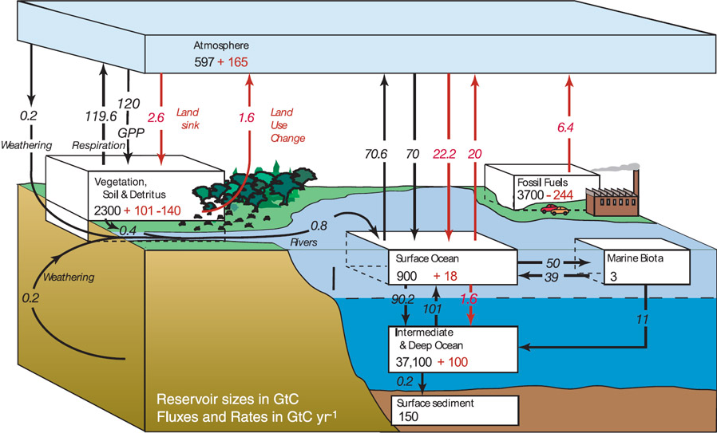

Figure 1: Schematic showing magnitude of carbon reservoirs (boxes) and fluxes into and out (arrows) of each reservoir. Black number indicate contribution from natural sources. Red numbers indicate contribution from anthropogenic activities (IPCC AR4 WG1).

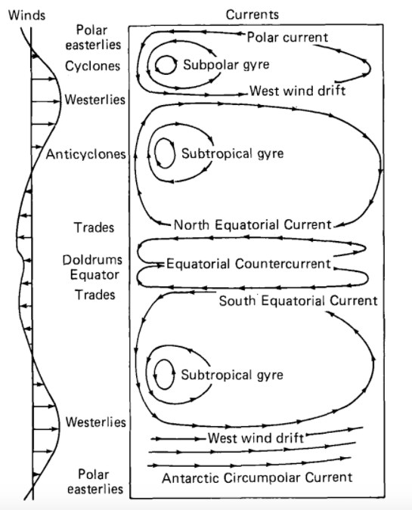

Figure : Schematic representation of circulation in the ocean gyres of the Pacific Ocean as driven by wind stress curl (Apel, 1988 Figure 6.3.6).

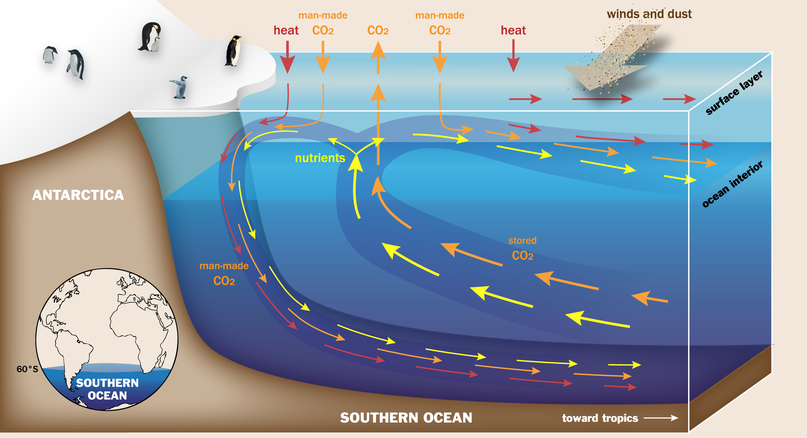

Figure 3: Schematic depicting Southern Ocean circulation. Figure by Ilissa Ocko, courtesy of Princeton University.