Investigating the relationship between age and oxygen on observational Line W

**1. Introduction**

Background:

* Long-term changes in ocean ventilation are often reconstructed from changes in chemical distributions in the deep ocean (e.g. Sarnthein et al., Paleoceanography, 1994). Unclear whether such shifts record changes in distribution of watermasses or rates of flow.
* Likely that shorter-term changes in ventilation are occurring (reference some papers about variability in Labrador sea convection such as Van Aken et al., any results from RAPID report), but impact on biogenically active tracers is not well characterized. Few time series exist.
* Idea to use oxygen measurements as a proxy for age in assessing oceanic ventilation.
* Oxygen is consumed as a watermass moves through the ocean, tracer age increases as water moves away from the surface. This should result in a negative relationship between age and oxygen.
* *Gnanadesikan et al.*, 2012 show a robust relationship between the simulated change in age and change in oxygen in response to a global warming forcing (*Gnanadesikan et al*, 2012 – figure 3)… but how do we get age?
* CFCs can be used to infer the age of water, however there are complications. Hard to reconcile ages given by different tracers. As CFCs have been regulated no longer provide information.
* CFC measurements are not ubiquitous and we do often do not have as long of an observational record.

Paper Aim:

* Investigate the relationship between age and oxygen in the North Atlantic on Line W, spot where we have both CFCs and oxygen.
* Can dissolved oxygen be used as a proxy for tracer age? Why it might not be-
  + Oxygen and tracer age might not always be correlated, particularly if mixing changes watermass contributions.
  + Temperature dependence on circulation means that if warm periods have faster circulation age and oxygen would be anticorrelated.
  + Deeper mixed layers associated with stronger convection and overturning might be less equilibrated.
  + Changes in the rate of decomposition driven by floristic changes in ecosystems (Rivero-Calle et al., 2015) or changes in the rate of primary production might cause oxygen changes.

**2. Methods**

Observational Data

* Observational data information, cruise, ect.
* Mean age calculation
* Data regridding

Model Simulation

* Model information
  1. GFDL ESM2Mc (*Galbraith et al.,* 2011), coarse resolution version of GFDL ESM2M (*Dunne at al.,* 2012).
  2. Quantify important N. Atlantic climatologies (MOC, T,S,O2)
* Regridding to Line W
  1. In order to compare with Line W observations, model was interpolated to Line W.
  2. Figure showing interpolation and climatologies (Figure 1)
* Variables/quantities
  1. Ideal age, ect.

**3. Results**

***3.1. Observations***

A. Discussion of mean age and oxygen observations – Figure 2.

* In general, appears to be a negative relationship.
* Relatively increased oxygen at the surface along with age tracer at zero (makes since given contact with atmosphere).
* Age increases with depth (reaching local maxima just below the 27.5 neutral density surface.) Oxygen local minima also right along the 27.5 neutral density surface. Relate to AAIW vs. NADW circulation.
* Hints of breakdown in negative relationship. Oxygen increases with depth after minima along 27.5 while age first decreases and then increases. Explicable through vertical gradient in remineralization (less remineralization expected at depth) and watermass structure. I’d bring the model up here as well.

B. Age-Oxygen *temporal* correlation – Figure 3(a)

* Largely see the anticipated negative correlation relationship between age and oxygen, with exception of two regions:
* Positive correlation region within the ventilated thermocline, between neutral density surfaces 27.0 and 27.5.
* Larger positive correlation region slightly deeper in the water column between depths 750-2000 dbars.
* Not entirely confident with the spatial extent of these positive correlation regions – not much data past a distance of 400 km.
* Question here is how much of the change at a fixed point is basically changing where we are along this curve- i.e. watermass changes rather than rate of flow changes. More on this below.

C. Age-AOU correlation – Figure 3(b)

* We also examine the age-AOU correlation in order see if the positive correlation seen in the age-oxygen correlation is due to solubility influences.
* The upper region of positive correlation from Figure 3(a), which would now be negative in the age-AOU relationship, mostly disappears.
  + Suggesting that some temperature influence on the region of positive correlation from the age-oxygen correlation.
* The deeper region of anomalous correlation however is still apparent in the age-AOU correlation.

D. Age-Oxygen Scatterplot – Figure 4(a)

* S-shape in Age-oxygen scatterplot.
* Roughly follows depth.
  + - * Upper region of positive correlations occur just before the minimum in oxygen concentration – just at the ‘bend’ in the S-shape.
* **Not sure what else to discuss with this figure. This may be where we get the watermass change vs. rate change.**

E. Age-Oxygen Scatterplot – Figure 4(b)

* **Also not sure what to discuss with this figure.**

F. Vertical Profile and Gradients of Age and Oxygen – Figure 5.

* Not sure that I’ll keep this figure not terribly enlightening.

** End this section with proposed hypothesis of why positive correlation occurs (isopycnal heave) and discuss that we will examine age-oxygen relationship in model simulation, which has greater temporal and spatial resolution/extent.

***3.2. Comparison of Observations with Model Simulation***

A. Climatology of age and oxygen – Figure 6.

* Modeled ideal age and oxygen match up with observations pretty

well.

* Offset between the depth of the age maximum and oxygen

minimum.

* This is roughly consistent with observations (Figure 2 and 5).
* Could be important in setting up the region of positive correlation.

B. Age-Oxygen Correlation – Figure 7

* Model simulation shows similar upper region of positive

correlation.

* Positive correlation region occurs on/around neutral density surface 27.0.
* ‘Missing’ deeper region of positive correlation.

C. Age-AOU Correlation – Figure 7

* Model simulation consistent with observations. Anomalous correlation region is diminished when removing temperature influence.

D. Age-Oxygen/AOU Scatterplot – Figure 8

* Similar shape to observational data.
* Positive correlation occurs in the bend, near the oxygen minimum.
* The shape of the relationship roughly follows depth (approximate depths are indicated on the figure).
* The figure suggests that the positive correlation could be due to vertical motion acting on the gradients in age and oxygen.

***3.3 Mechanisms causing positive Age-Oxygen Correlation.***

A. Upper positive correlation region

* Hypothesis: Positive correlation occurs when vertical motion of isopycnal surfaces coincides same-sign vertical gradient in age and oxygen (in this case a positive vertical gradient).

B. Correlation of age and oxygen on isopycnal surfaces – Figure 9

* Figure 9 shows the correlation between age and oxygen on the average depth of the isoycnal surface (with heave) and the correlation on the isopycnal surface itself.
* Figure 9 shows that the region of positive correlation seen in the Line W cross section occurs on the average isopycnal depth 27.0 (Figure 9 (e)).
* The positive correlation is not seen in Figure 9 (f) however, suggesting that the correlation is due to the heaving is the isopycnal surface.
* Could be due to increased vertical isopycnal motion, or greater depth off-set of oxygen minimum and age maximum.
* The region of positive correlation is very spatially isolated – only occurring in the one region at one depth level.
* While the positive correlation is not seen elsewhere on the average isopycnal surfaces, the correlation is reduced (just not positive).

C. Comparison with ‘Line 40N’

* To diagnose why this reduced/positive correlation between age and oxygen exists in this area, we compare Line W with a region with strong negative correlation between age and oxygen.
* The region chosen extends from Cape Cod along longitude line 40N and follows a region of strong negative correlation. We will refer to this at ‘Line 40N’. Note that this specific line does not exist in the ship-based observational record.

D. Comparison with ‘Line 40N’ – Figure 10

* We compare the climatology of age and oxygen for both Line W and hypothetical Line 40N in Figure 10.
* Line 40N is significantly more stratified, with stronger vertical gradients in age and oxygen.
* Additionally we compare the age-oxygen correlation on each transect. As suggested by Figure 9, Line 40N has no region of positive correlation as seen on Line W. In the ventilated thermocline, the age-oxygen relationship is strongly negatively correlated.
* Finally Figure 10 compares the vertical profiles of age and oxygen along both lines. There appears to be less of a vertical off-set between the age maximum and oxygen minimum on Line 40N compared with Line W.

E. Diagnosing contributions to positive correlation. – Figure 11

* Figure 9 demonstrated that the positive correlation on line W is likely due to vertical heaving of the isopycnal surfaces acting on the background gradient in age and oxygen. In Figure 11 we examine this further.
* Figure 11 (a) and (b) show the vertical gradient for age and oxygen for Line W and Line 40N respectively. Line W shows a depth region where both the vertical gradients in age and oxygen are positive (600-800m depth), where the age and oxygen correlation are both positive.
* Line 40N also has a similar region where the gradients are both positive, although the gradients are smaller (about half) than Line W.
* Figure 11 (c) shows the standard deviation of neutral density as a function of depth for Line W (black line) and Line 40N (green line). The standard deviations are similar, through Line W is slightly more… not sure that its enough to significantly cause more vertical heaving of the isopycnal surfaces.
* Figure 11 (d) shows the correlation as a function of depth for comparison with (a) – (c).
* These results suggest that the vertical gradients in age and oxygen along with the vertical movement of the isopycnal surfaces are not substantially different between the two lines and is therefore not the primary reason for the positive correlation along Line W.

F. Contribution of along-isopycnal variability. – Figure 12

* I believe that the reason we do not see a positive correlation along Line 40N is because the along-ispycnal variability is stronger than the vertical motion variability. Working on something like Figure 12 to shows this.
* Figure 12 shows the magnitude of spice and heave contributions to age and oxygen variability.

where the first term on the right hand side refers to the spice contribution and the second term on the right hand side refers to the heave contribution. Along line 40N, the spice contribution is much larger than along Line W.

G. Circulation Influences.

* This region of positive correlation seems to occur at the center of the N. Atlantic gyre – would like to include a circulation Figure to explore this (like Figure 2.3.6 on page 39 in Ocean Biogeochemical Dynamics textbook).

**4. Conclusions**

Main Points:

1. Age and oxygen are positively correlated in a small region along Line W.
2. This positive correlation is rather localized, and is likely due to the vertical heaving of isopycnals acting on the background gradients in age and oxygen and relatively small horizontal mixing.
3. This suggests that in most of the ventilated thermocline, oxygen can be used as a proxy for age?? Maybe…

Figures:

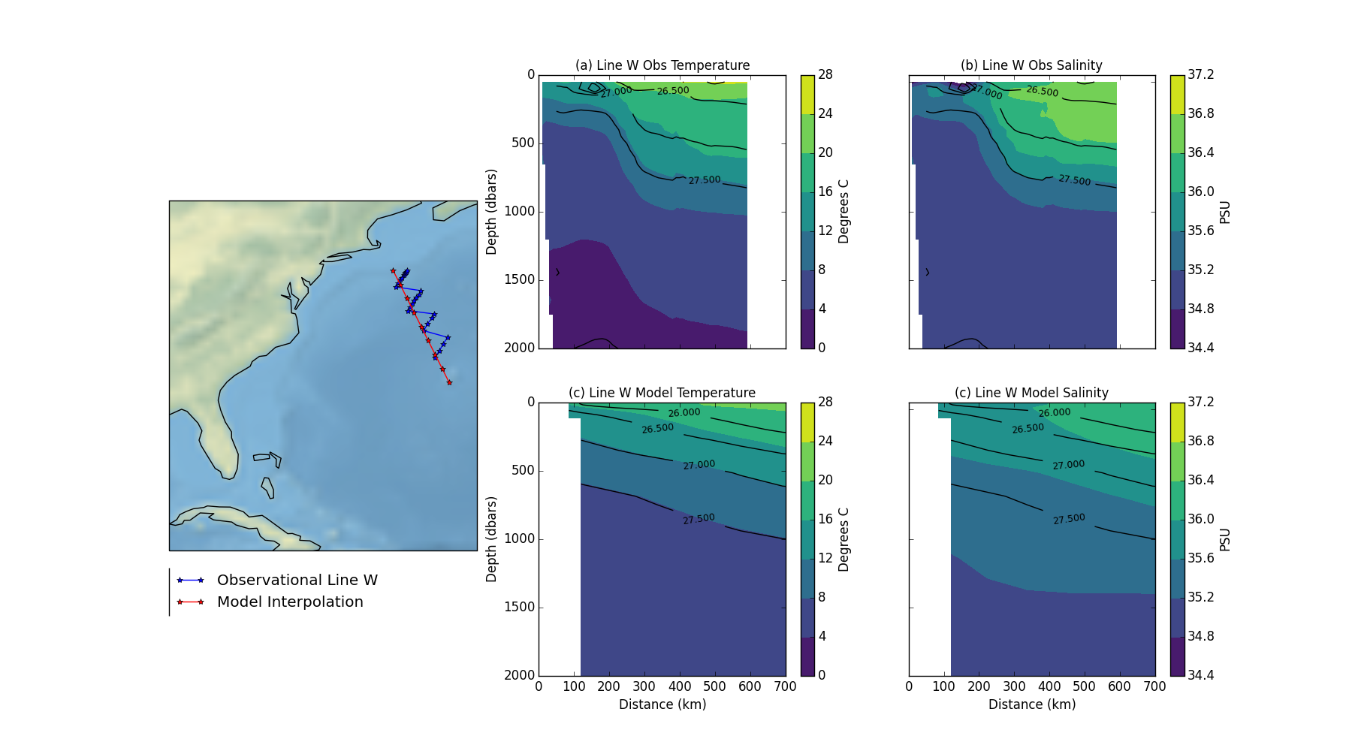

Figure 1: Observational Line W and model interpolation. (a) and (b) climatologies of observational temperature and salinity. (c) and (d) Line W interpolated model temperature and salinity.

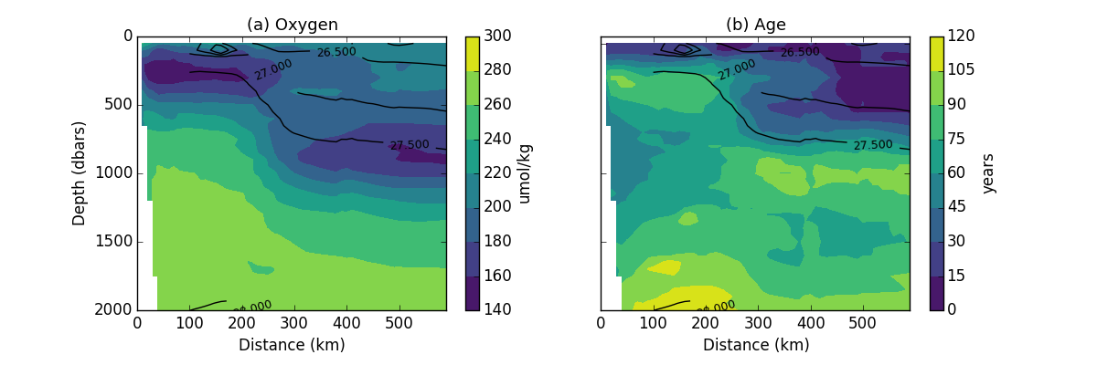

Figure 2: (a) Oxygen climatology and (b) age climatology from observations along Line W. Contour lines show average neutral density.

1

2

3

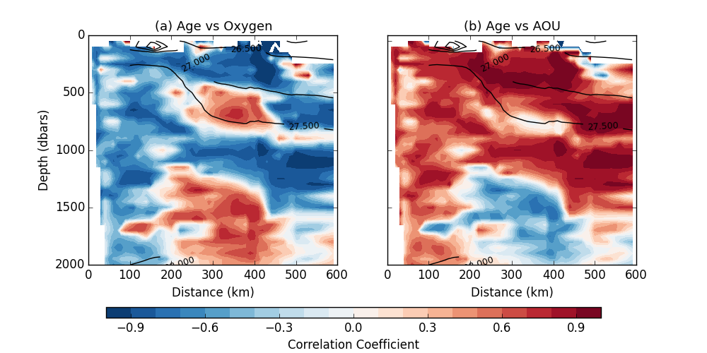

Figure 3: Pearson correlation coefficients for age versus (left) oxygen and (right) AOU for Line W observations. Contour lines indicate average neutral density climatology.

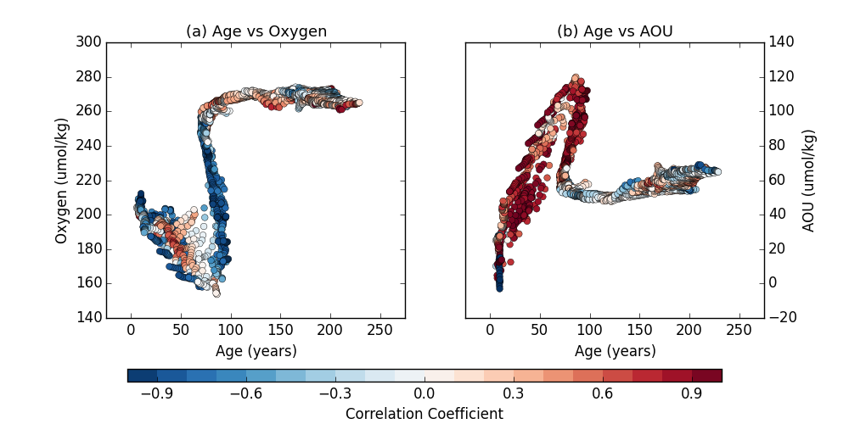

Figure 4: Scatter plot of age versus (a) oxygen and (b) AOU. Colors indicate correlation coefficient of given relationship.

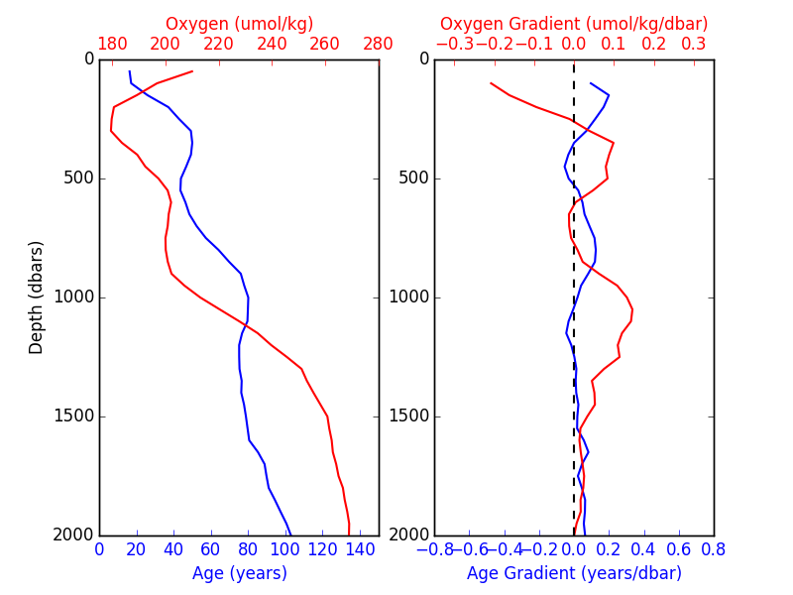

Figure 5: (left) oxygen and age vertical profiles. (left) oxygen and age vertical gradients.

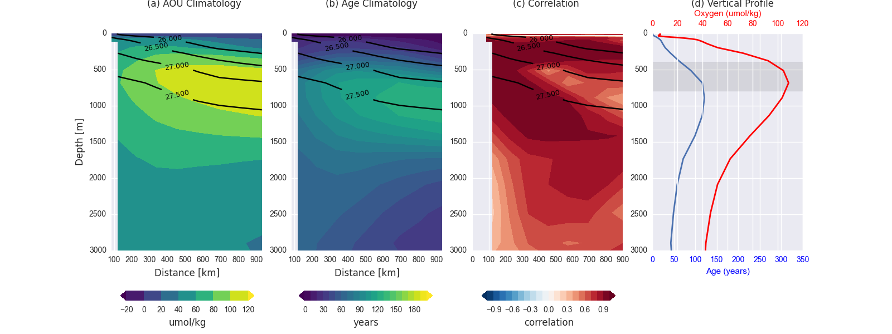

Figure 6: (a) oxygen and (b) age climatology from ESM2Mc interpolated to Line W. Contours indicate average neutral density surfaces.

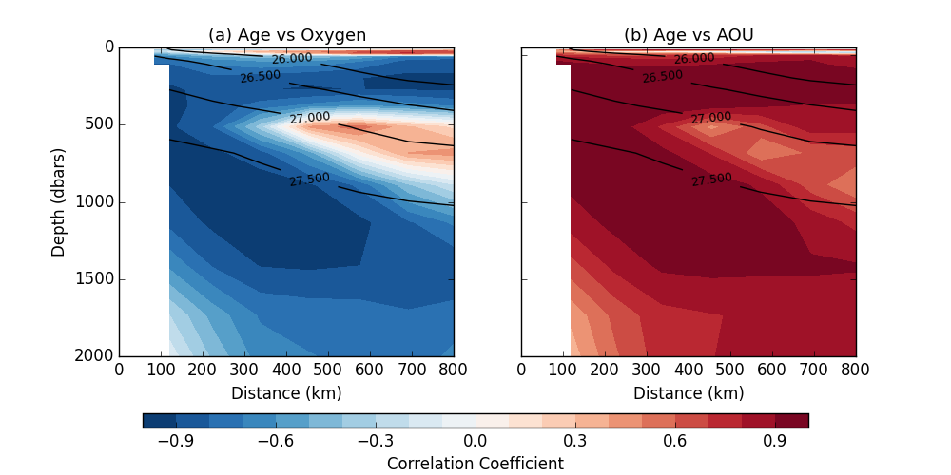

Figure 7: Correlation between age and (a) oxygen, and (b) AOU along Line W in ESM2Mc.

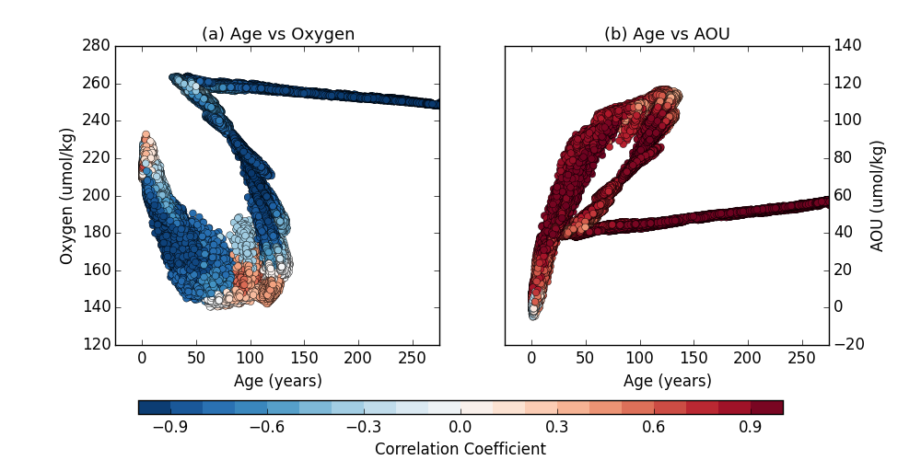

Figure 8: Scatter plot of age versus (a) oxygen and (b) AOU along Line W in ESM2Mc. Colors correspond to the the Pearson correlation coefficient.

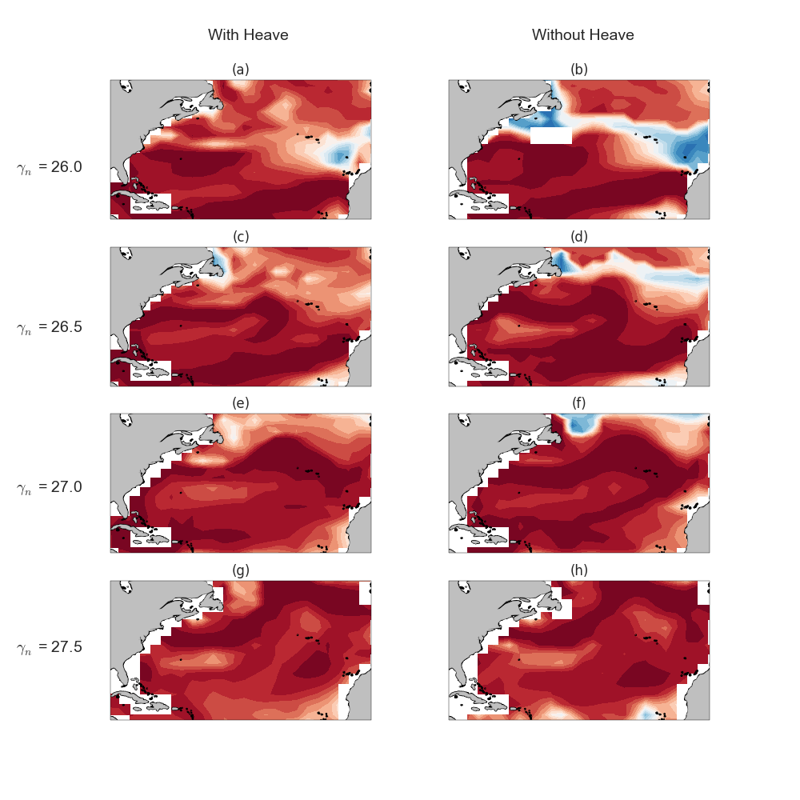

Figure 9: Correlation between age and oxygen on various isopycnal surfaces. Left column indicate correlation calculated on average depth of the isopycnal surface, and therefore including contributions from isopycnal heave. Right column shows correlation calculated on the isopycnal surface and does not include controbutions from heave.

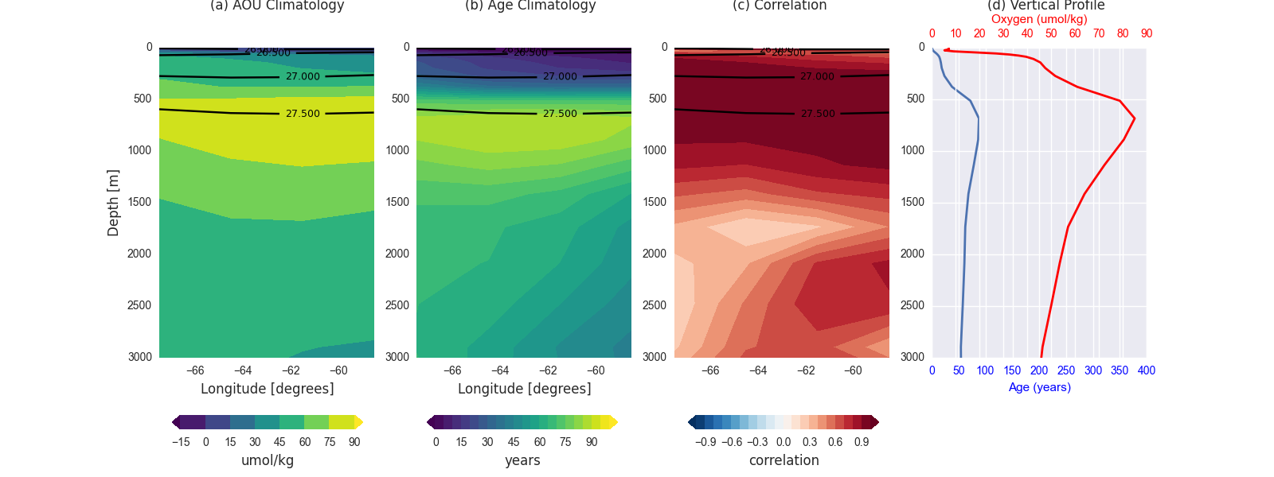

Figure 11: (a) Line W vertical gradients of oxygen and age. (b) Line 40B vertical gradients in oxygen and age. (b) Standard deviation of neutral density for Line W (black) and Line 40N (green). (d) Correlation along line W and Line 40N.

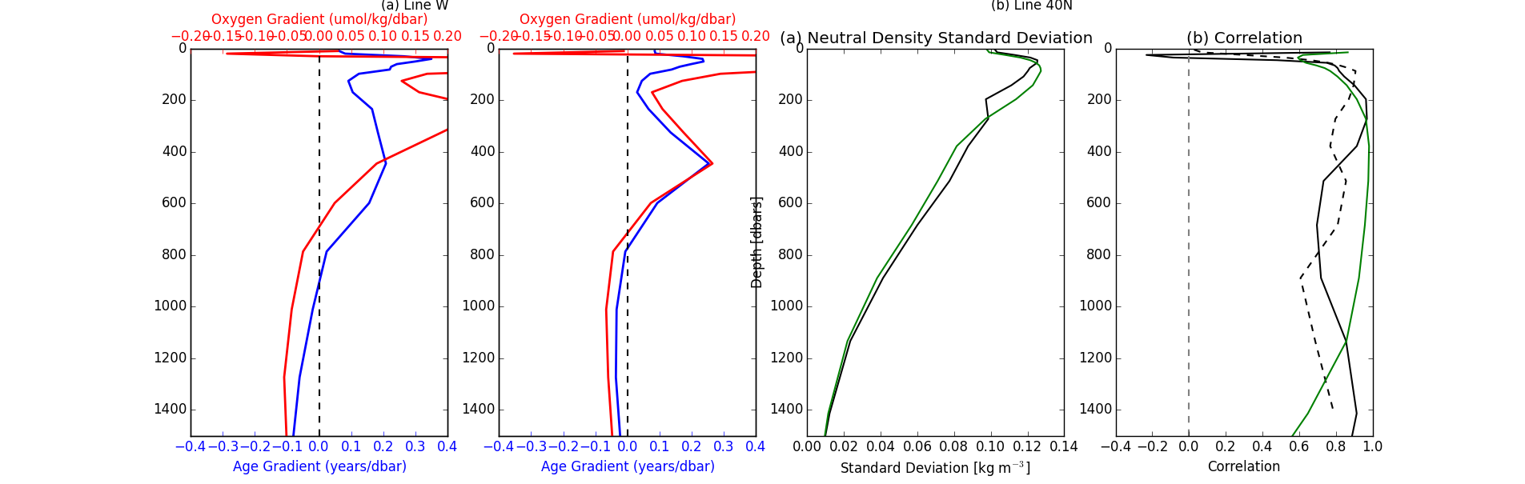

Figure 10: Top: Climatologies, age-oxygen correlation, and oxygen and age vertical profiles for Line W. Bottom: Climatologies, age-oxygen correlation and vertical profiles for Line 40N.

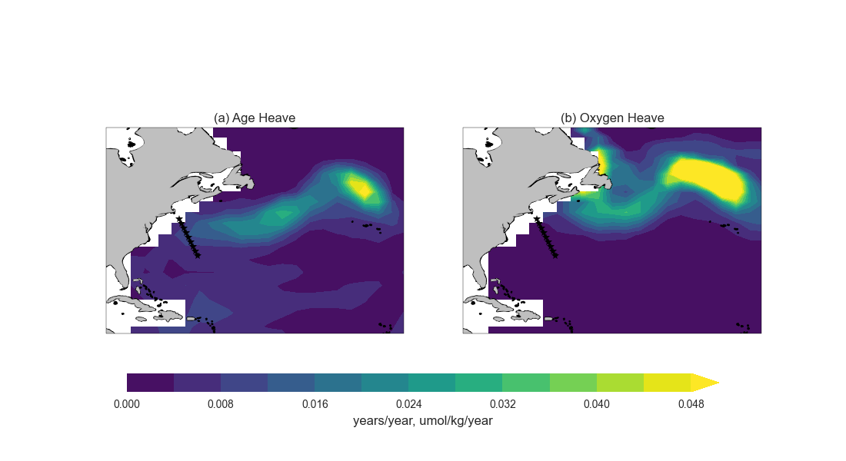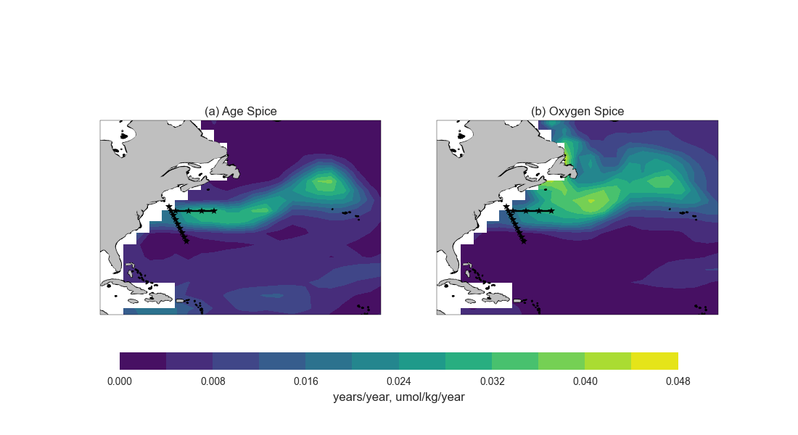

Figure 12: Top: Standard deviation of age and oxygen heave components. Bottom: Standard deviation of age and oxygen spice components.