NATS Tech Lab

Extensible Application Shell

STATUS PROPOSED — DESIGN REVIEW |  | OWNER NATS TECH LAB |  | LAST UPDATED AUGUST 27, 2026

Authors | OpenAI Codex
Reviewers | Project owner and architecture reviewers
Related docs | Companion shell plan and design chat; CLAUDE.md; shared/unifi-theme/LAYOUT.md
Scope | Runtime-discovered Vue shell design and the later boundary for migrating three applications.

1. Abstract
Review outcome: conditionally recommended. Evolve lab-shell into a neutral Vue 3 host that validates a curated, versioned plugin registry before lazily loading independently built feature remotes. The shell owns routing, global UI providers, authorization gates, and host-defined extension points; plugins own feature UI, domain state, and credential-scoped NATS lifecycles.
The design must preserve the three current applications’ behavior and UniFi presentation while allowing compatible plugins to change without a host rebuild. Approval is conditional on a Phase 1 proof that resolves shared-provider, state-identity, transport-singleton, endpoint-routing, failure-isolation, and lifecycle-cleanup risks. It does not yet authorize migration.

2. Goals and Non-Goals
Goals | Non-goals
Load compatible feature plugins at runtime without host source changes or rebuilds. | Migrate any of the three current applications during this design phase.
Preserve one UniFi shell, addressable routes, authorization gates, and deterministic contribution order. | Support arbitrary third-party code or create a browser security sandbox.
Isolate load, activation, render, and cleanup failures while preserving existing NATS trust boundaries. | Replace backend/NATS authorization, service discovery, or the shared design system.
Prove independent build/deployment and 1920×1080 visual fidelity before migration begins. | Guarantee hot replacement, heterogeneous frameworks, or server-side rendering in Phase 1.

3. Background and Problem Statement
lab-shell and the Admin, Tech Lab Operator, and SeaFreight Flow frontends are separate Vue/Vite applications. Each feature app recreates AppShell, router-like view state, PrimeVue, Pinia, toasts, theme, and locale wiring. Their current composition prevents a unified navigation and deep-link experience, and independently deployed feature code cannot contribute to a shared frame.
The repository also exposes hazards that a host must make explicit: duplicate Pinia store IDs, a mutable shared refdata transport singleton, origin-relative API paths, global i18n ownership, and distinct NATS identities. The governing invariant is metadata before code: validate identity, compatibility, permissions, and target slots before loading a remote implementation.

4. Proposed Architecture

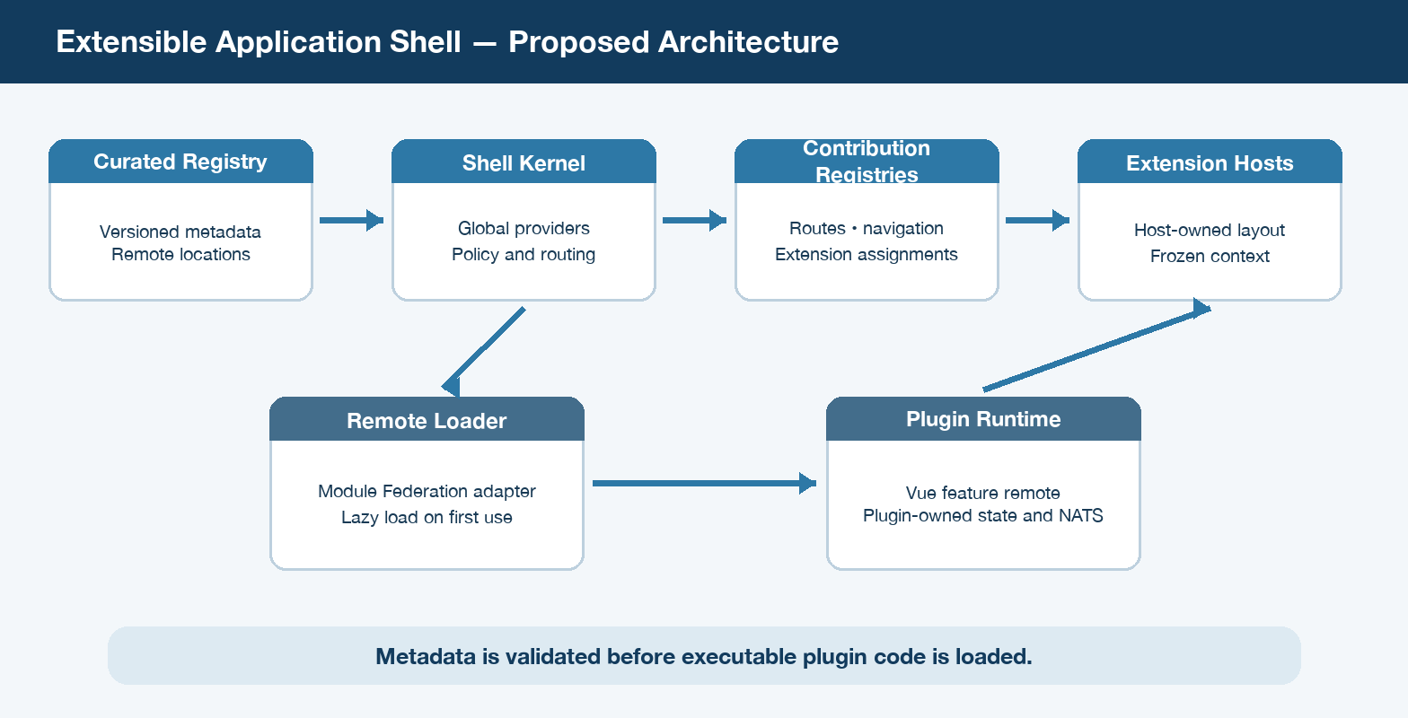
Figure 1. Proposed application-shell architecture and executable-code boundary.

Core components

Component | Responsibility | Primary storage | Failure behavior
Curated Registry | Declares plugin identity, compatibility, remote location, permissions, routes, navigation, and extension assignments. | Versioned static or platform-served JSON | Unavailable or invalid registry yields built-ins plus an explicit degraded state; invalid entries are isolated.
Shell Kernel | Owns router, global UI providers, UniFi frame, authorization gates, diagnostics, and session registry snapshot. | Browser memory and shell configuration | Kernel startup failure is terminal and visible; it never silently delegates global ownership to a plugin.
Contribution Registries | Validate and index focused route, navigation, topbar, footer, and extension-point contributions. | Immutable in-memory indexes | Duplicate or incompatible entries are rejected without blocking valid siblings.
Remote Loader | Resolves Module Federation remotes behind a shell-owned adapter and activates each accepted plugin once. | Versioned remote bundles and loader cache | Timeout/load/activation failure is local, observable, and retryable; no partial registration remains.
Plugin Runtime | Renders feature components and owns domain state, endpoint adapters, watchers, and credential-scoped NATS connections. | Plugin-owned stores and existing services | Render errors show a host fallback; disposal closes resources and sibling plugins continue.

5. Request Lifecycle
- The shell boots once with the router, Pinia, PrimeVue, UniFi theme, toast outlet, locale, and global error boundaries.
- It fetches the curated registry and validates schema version, unique IDs, allowed origins, shell API compatibility, and contribution shapes.
- It evaluates shell-visible permissions and indexes navigation, route, and extension metadata without executing remote plugin code.
- The router installs namespaced lazy route proxies; extension hosts resolve ordered assignments only for the active view and context.
- On first use, the shell loader resolves the declared Module Federation remote and exposed module, then activates that plugin exactly once.
- A host-owned boundary renders the contribution with a versioned, readonly context. Load, activation, and render failures remain local and retryable.
- Navigation and contribution telemetry records outcome and latency. Disposal closes plugin-owned watchers and connections; Phase 1 upgrades use page reload.

6. API and Data Contracts

Curated frontend plugin registry (proposed schema)

Field | Type | Required | Description
schemaVersion | string | Yes | Version of the aggregated registry schema; unsupported major versions fail closed.
plugins[].id | namespaced string | Yes | Stable globally unique plugin identity used for policy, diagnostics, and lifecycle.
version / shellApiVersion | semver strings | Yes | Pins plugin release and declares its compatible shell contract range.
remote | object | Yes | Allowlisted HTTPS entry, Module Federation name, exposed module, and export.
contributions.routes | array | No | Namespaced paths, titles, permission requirements, and lazy component references.
navigation[] | array | No | Contribution entries with ordered labels, icons, route targets, groups, and permissions.
extensions[] | array | No | Typed contribution entries targeting compatible, versioned host-owned extension points.

Contract guarantees

- Registry metadata is validated before any nominated remote executes; incompatible entries fail closed and do not block valid siblings.
- Plugin and contribution IDs are globally unique, namespaced, and deterministically ordered; duplicate IDs reject the conflicting contribution.
- Each contribution captures plugin version, shell API version, contribution kind, and any versioned host extension-point target.
- Registry permissions drive shell UI visibility and access gates, but are never the source of truth for backend or NATS authorization.
The versioned schema or interface definition will be published under
lab-shell/ after design approval and updated with each contract release.

7. Consistency, Idempotency, and Replay

The accepted registry snapshot is immutable for a browser session. Plugin activation is idempotent per plugin ID and version, while route and extension registries reject duplicate contribution IDs. Remote replacement and registry-version changes require reload in the first release, avoiding mixed code or policy versions. Failure recovery may retry a load, but must not duplicate registrations or side effects.
Scenario | Expected behavior | Reasoning
Duplicate plugin or contribution ID | Reject the conflicting entry; retain other validated entries. | Namespaced uniqueness prevents nondeterministic routing, rendering, and lifecycle state.
Registry unavailable or malformed | Start safe built-ins only and expose a degraded diagnostic state. | No unvalidated remote executes, while shell recovery and operator visibility remain available.
Remote load, activation, or render failure | Show a local error with bounded retry; keep shell and siblings operational. | Transactional registration and host error boundaries prevent partial state and broad blast radius.
Registry changes during a session | Continue with the accepted snapshot; reload to adopt replacements. | A session never mixes contract, policy, metadata, and executable versions.

8. Security and Privacy Considerations

- Only platform-curated, allowlisted HTTPS remote locations may nominate executable code; trusted first-party plugins are not a sandbox boundary.
- The shell applies UI permission gates to navigation, routes, and extensions, while services and NATS permissions remain authoritative.
- Existing Admin, Operator, and SeaFreight credentials and NATS connections remain separate; no registry entry contains credentials or secrets.
- Registry, loader, and plugin logs exclude tokens, NATS credentials, certificate material, and sensitive message payloads; diagnostics use stable IDs.
- Use CSP, origin allowlists, HTTPS, immutable versioned assets, and integrity/provenance controls. The shell introduces no new personal-data store.

9. Operational Readiness
Signal | SLO or alert | Owner | Launch gate
Registry acceptance rate | Target and alert thresholds established during the Phase 1 proof. | Shell owner | Required
Route and extension load latency | Measure registry fetch and first-use remote-load percentiles; set budgets from proof data. | Shell owner | Required
Plugin load / activation / render failures | Alert thresholds by failure class established before migration rollout. | Shell and plugin owners | Required
Registry-to-deployment drift | Alert when metadata names an unavailable, unexpected, or incompatible artifact. | Platform owner | Required
Disposal and integrity checks | Automated navigation, retry, cleanup, and credential-boundary checks on every release. | Shell and plugin owners | Required
Rollout constraint: ship behind an explicit feature flag; prove one independent remote, failure injection, deep-link refresh, rollback, and no-host-rebuild deployment before any real-app migration.

10. Alternatives Considered

Alternative | Why it was considered | Why it was not selected
Eager plugin activation | Simple imperative registration at shell startup. | Executes code before policy/route evaluation and makes startup cost proportional to installed plugins.
Compile-time feature imports | Strong local typing and the least runtime machinery. | Every plugin change requires a host source change, rebuild, and coordinated release.
single-spa orchestration | Mature lifecycle model for heterogeneous framework applications. | Adds a second orchestration model while every known application already uses Vue 3.
Iframes or web components | Stronger visual/runtime isolation or framework neutrality. | Conflicts with the shared UniFi frame and complicates routing, context, accessibility, and state integration.

11. Open Questions
- Does the demo catalog remain built-in, become a plugin, or leave the target product?
- Who produces, hosts, approves, and rolls back the registry; what signing or integrity control is mandatory?
- Which locale and refdata services are shell-global, and how are persisted preferences migrated without state leakage?
- Confirm route namespaces, migration order, unload/retry behavior, and the recommended SeaFreight-first sequence.

12. Decision and Next Steps
Conditionally approve a metadata-first, Vue-only Phase 1 proof in lab-shell. First approve the proposed business rules and resolve the nine approval questions in the companion plan; then produce shell mockups and implement the registry, loader adapter, focused contribution registries, and one independent proof remote. Do not begin real-app migration until failure isolation, no-host-rebuild deployment, permissions, deep links, cleanup, and 1920×1080 UniFi fidelity are demonstrated and reviewed.
Milestone | Deliverable | Exit criteria
M0 | Approved rules, design choices, and shell mockups. | Project owner resolves all nine design-gate questions.
M1 | Shell kernel, registry contract, focused registries, and independent proof remote. | No-host-rebuild deployment, deep links, permissions, lazy load, failures, cleanup, and UniFi fidelity pass review.
M2 | Migrate SeaFreight Flow as the recommended first real plugin. | Behavior, tenant NATS lifecycle, endpoints, localization, and capability-complete mockup are accepted.
M3–M4 | Migrate Admin and Tech Lab Operator in separately approved phases. | Each preserves its credential boundary, features, UI behavior, tests, and rollback path.

External patterns reviewed: OpenMRS O3 metadata-first loading, Grafana host-owned versioned extension points, Backstage typed extensions, Eclipse Theia focused contribution registries, and Module Federation for Vite.

