# MIS581_Capstone_Thesis
MIS581 Capstone Thesis code from SAS Enterprise Miner

This model is using a public dataset from Kaggle to predict the average daily rate of a city hotel based on the available variables. The thesis null hypothesis is the average daily rate cannot be predicted by 2 specific variables: the customer type and the lead time. The manually selected variables regression model is using variables easily explained without any anonymization. The model selected variables regression is using the variables with the highest R value to predict the average daily rate.

Here is the diagram for my model:

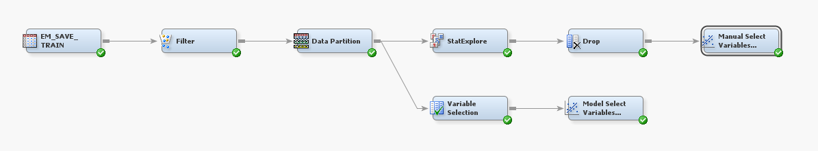

The code entered here is the train and/or score code coming directly from SAS® Enterprise Miner™. This code has not been modified in any way and is a direct copy and paste of the code provided from SAS® Enterprise Miner™ for the nodes within the model.

