Jacob Thompson

11/08/23

Module 5.2 - MySQL Functions

**DAYNAME()** - This function returns the name of the weekday for a given date. For me personally, this could be useful to figure out if certain holidays will fall on my workdays to see if I should take vacation or not.

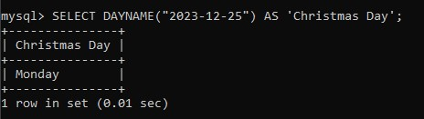

**LEAST()** - This will return the smallest value of the given arguments. This could be useful to find the shortest time or cheapest price.

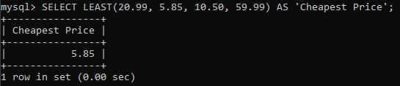

**FORMAT()** - Used to format a number with commas and the given amount of decimal places. For example, FORMAT(1000.234, 2) would output “1,000.23.” This could be useful for displaying any value in a more readable format (prices, population, etc..).

