Jacob Thompson

11/26/23

Module 8 – Movies: Update and Delete

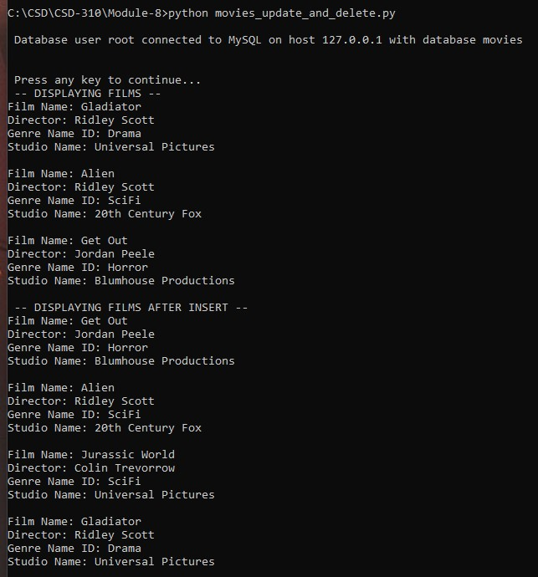

Continued next page...

