Embayment Diffuser: Instruction Manual

Table of Contents

Setting Up *Embayment Diffuser* in MATLAB 2

Running *Embayment_Diffuser_Line* 2

Running *Embayment_Diffuser_Map* 5

References 11

# Setting Up *Embayment Diffuser* in MATLAB

We have developed a script that allows a user to extract information from diffusion-limited concentration gradients in embayments. The files are available for download at:

* GitHub website: https://github.com/jthompson2710/Embayment_Diffuser
* Publication DOI: XXX.

After you have downloaded the .zip file, extract the files and move them into the same MATLAB directory. MATLAB 2019a or newer is required to run the program.

There are two versions of *Embayment Diffuser:*

1. *Embayment_Diffuser_Line*   
   The 1D version for modeling data collected along linear transects
2. *Embayment_Diffuser_Map*

The 2D version for modeling data collected as maps

This instruction manual is separated into 2 sections, the first for *Embayment_Diffuser_Line* on pages 2 to 4, and the second for *Embayment_Diffuser_Map* on pages 5 to 7. We recommend users begin processing data with *Embayment_Diffuser_Line*. The code is simpler and runs in 10’s of seconds. In our experience *Embayment_Diffuser_Line* allowed us to narrow parameter space to improve the efficiency of later 2D modeling with *Embayment_Diffuser_Map*.

Let’s get started!

# Running *Embayment_Diffuser_Line*

1. Prepare Input Files - *Embayment_Diffuser_Line* will read data only if it is formatted correctly in a Microsoft Excel (.xlsx) or comma-separated values (.csv) file. Data should be arranged in 3 columns, each with a single header.   
   1. The first column “A” is the spatial position along the transect in microns. The “0” micron position should be the exterior, or mouth. Subsequent positions are deeper into the interior of the embayment. Any step size for the spatial resolution will work but it must be consistent.
   2. The second column “B” is H2O content in wt.%.
   3. The third column “C” is CO2 content in ppm.

We provide an example file to help guide new users (1D_Example.xlsx). By default, all input files need to be in the same working directory as the model files.

1. Before you run the model, we recommend you review a few lines of code. There are 3 lines that will control how the model runs: Lines 13 to 15.

*13 runformat = 1;*

*14 saveout = 1;*

*15 match = 2;*

Line 13 allows the user to choose the GUI version if “runformat = 1”. More advanced users may prefer to just work in the code. In that case set “runformat = 0”.   
  
Line 14 allows the user to choose if the output files will be automatically saved. “saveout = 1” will save results whereas changing to “saveout = 0” will not save any output files.

Line 15 is the most important choice as it allows the user to choose if the model will try to match both H2O and CO2 (keep default “match = 2”), just H2O (change to “match = 0”), or just CO2 (changeto “match = 1”).

1. Run the model.   
   1. If “runformat = 1” is selected, a pop up will open that allows the user to select the input file. Click the file once and then click the “Open” button.
   2. A second pop up will then appear (see below). This box allows the user to set specific, initial conditions for modeling. These values should be constrained geologically, or be part of your parameter search. The model treats these inputs as set values, and they are not iteratively explored. This box also allows the user to establish error bars and set the file name for saving output files.

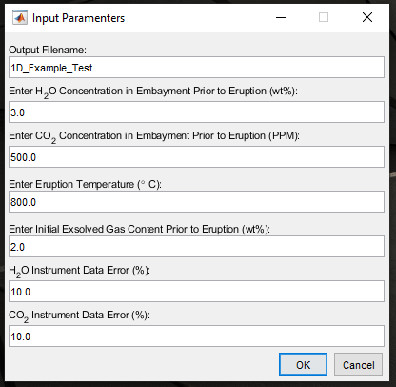

1. The model will now search for the best diffusive timescale for the data. The Command Window will update with a string of numbers. Those numbers are the diffusive timescale in hours. The model first climbs to higher and higher number of hours until it produces a result slower than the data. Then the model hours decrease until a result is found that is faster than the data. The process repeats with a smaller increment of time iteratively until the best solution is found.

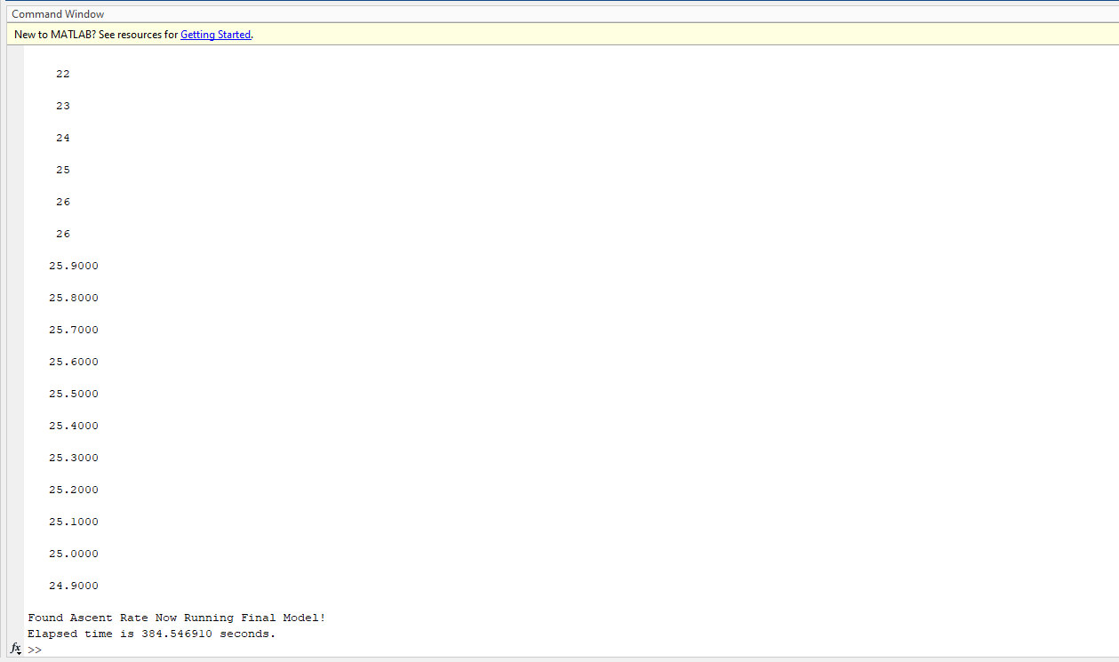

1. The model is now finished. At the conclusion of the *Embayment_Diffuser_Line* model, a visualization of the best-fit model results against the instrument data based on the starting condition will be displayed.

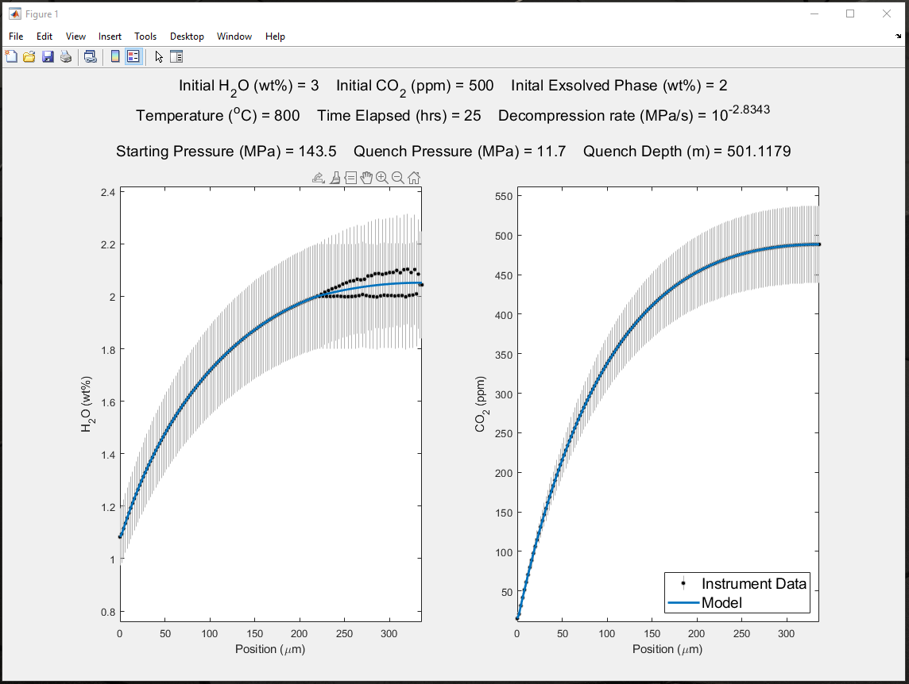

# Running *Embayment_Diffuser_Map*

1. Prepare Input Files - *Embayment_Diffuser_Map* will read data only if it is formatted correctly in a Microsoft Excel (.xlsx) or comma-separated values (.csv) file. Data should be arranged in 4 columns, each with a single header.   
   1. The first column “A” is the spatial position in the x (horizontal) direction of the embayment map in microns. The lowest micron position should be the far left extent of the embayment map. Any step size for the spatial resolution will work but it must be consistent.
   2. The second column “B” is the spatial position in the y (vertical) direction of the embayment map in microns. The lowest micron position should be the exterior, or mouth of the embayment. Subsequent positions are deeper into the interior of the embayment. Any step size for the spatial resolution will work but it must be consistent.
   3. The third column “C” is H2O content in wt.%.
   4. The fourth column “D” is CO2 content in ppm.

We provide an example file to help guide new users (2D_Example.xlsx). By default, all input files need to be in the same working directory as the model files.

1. Before you run the model, we recommend you review a few lines of code. There are 3 lines that will control how the model runs: Lines 16 to 19.

*16 runformat = 1;*

*17 saveout = 1;*

*18 match = 2;*

*19 maskmatch = 2;*

Line 16 allows the user to choose the GUI version if “runformat = 1”. More advanced users may prefer to just work in the code. In that case set “runformat = 0”.   
  
Line 17 allows the user to choose if the output files will be automatically saved. “saveout = 1” will save results whereas changing to “saveout = 0” will not save any output files.

Line 18 is the most important choice as it allows the user to choose if the model will try to match both H2O and CO2 (keep default “match = 2”), just H2O (change to “match = 0”), or just CO2 (changeto “match = 1”).

Line 19 allows the user to choose what data the model uses to create the masks of the embayments. H2O data (change to “maskmatch = 0”), or CO2 data (changeto “maskmatch = 1”).

1. Run the model.
2. If “runformat = 1” is selected:
   1. A pop up will open that allows the user to select the input file. Click the file once and then click the “Open” button.
   2. A second pop up will then appear (see below). This box allows the user to set specific, initial conditions for modeling. These values should be constrained geologically, or be part of your parameter search. The model treats these inputs as set values, and they are not iteratively explored. This box also allows the user to establish error bars and set the file name for saving output files.

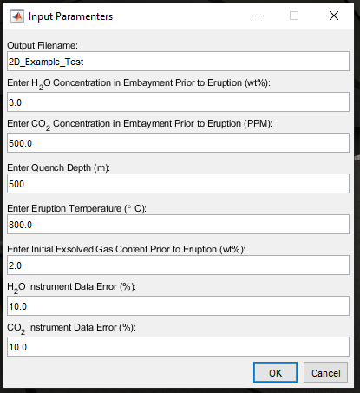

1. The user will then need to draw a mask to define the boundary of the embayment and exterior within the crystal, as well as mark the location of the embayment opening (neck) to the exterior.

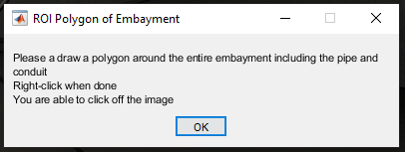

* 1. To draw the embayment-exterior mask, left click around the boundary with the crystal and right click when done to complete the polygon. It is possible to click off the image, this is useful when wanting to select the pixel on the edge of the image. It is important to make sure the mask extends to and covers the bottom of the image (again clicking off the image is useful here).

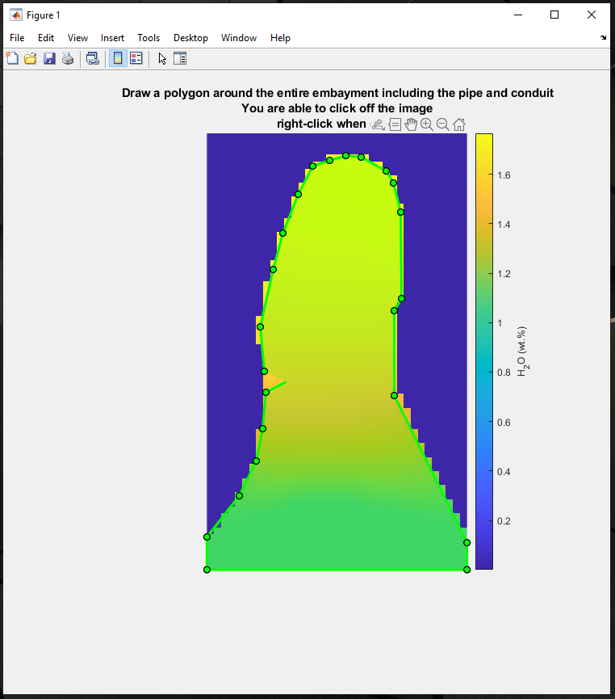

* 1. The embayment opening (neck) transect will then be requested. The transect must completely span the entire image (left to right) even if the opening does not. To successful achieve this, it is suggested to first click off the image adjacent to where the opening is located. A similar right-click off to the right of the image can be performed to complete the transect.

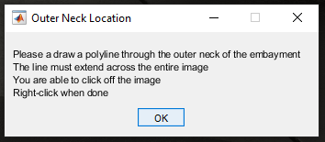

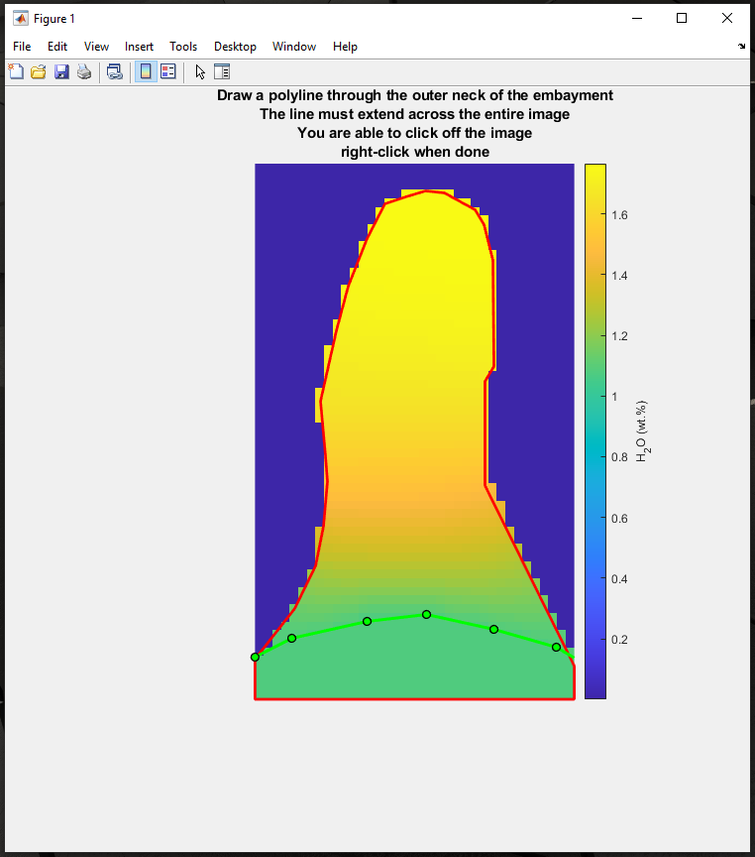

* 1. When the mask and transect are complete, they are saved as a mask file for later use or subsequent rerun of same embayment to prevent a new mask from being needed each time the same embayment is modeled. However, if either the mask or transect are unsatisfactory, they can be redrawn by deleting the corresponding mask file in the working directory and rerunning the entire model.

1. The model will now search for the best diffusive timescale for the data in two dimensions. The Command Window will update with a string of numbers. Those numbers are the diffusive timescale in hours. The model first climbs to higher and higher number of hours until it produces a result slower than the data. Then the model hours decrease until a result is found that is faster than the data. The process repeats with a smaller increment of time iteratively until the best solution is found.



1. When the model has found the best solution, a 1D transect will be requested to visualize a 1D profile through the 2D embayment results.

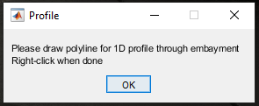

* 1. The transect is drawn in a similar fashion as the opening/neck transect, however the transect does not have to begin or end at the edge of the image. The transect can have almost any morphology.

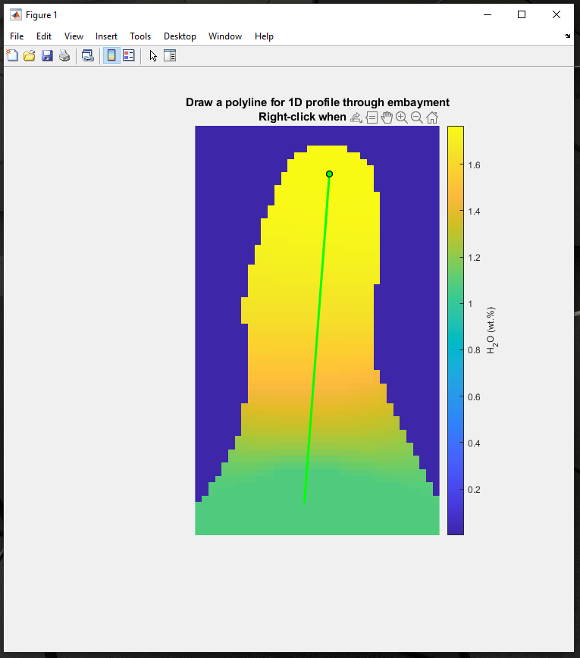

Additionally, a none iteratively exploring diffusive timescale version of the map (2D) model is included: *Embayment_Diffuser_Map_Simple*. This can be run in a similar fashion as the *Embayment_Diffuser_Map* model, with the addition of ascent duration being constrained by the user as an input value. This simpler version is included to allow users to explore parameter space with more freedom.

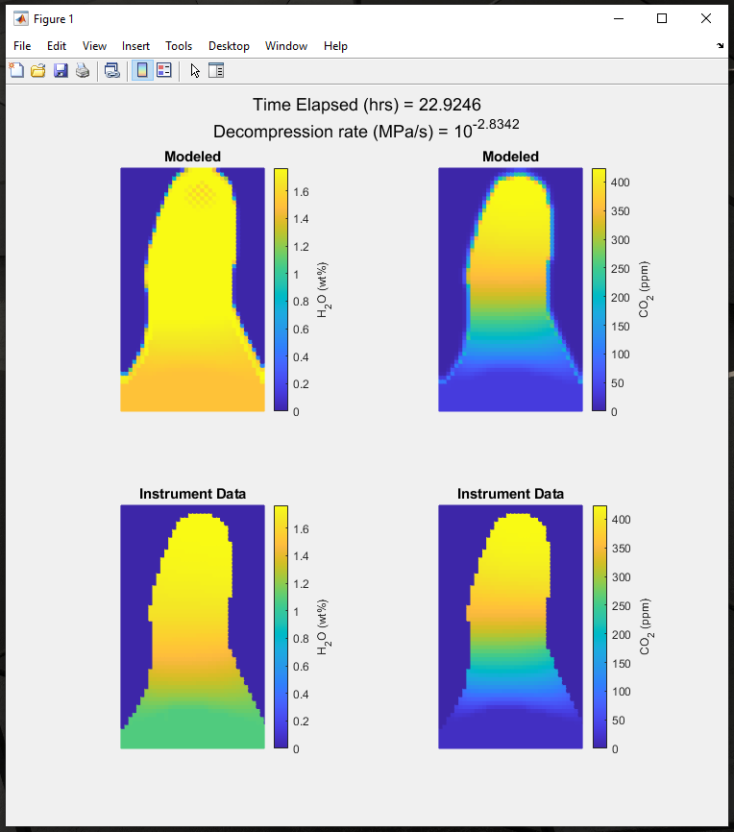

1. At the conclusion of the *Embayment_Diffuser_Map* models, a visualization of the best-fit model results against the instrument data based on the starting condition in both 1D and 2D will be displayed.

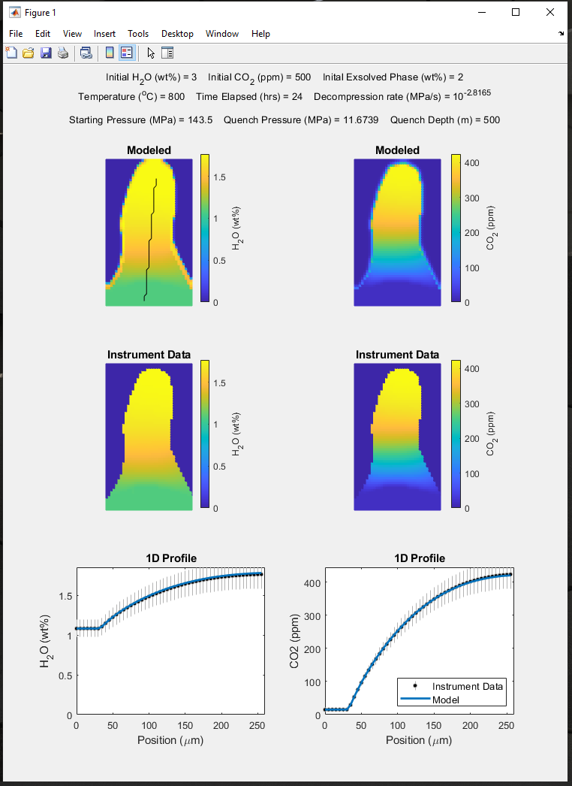

The final result visualizations will be automatically saved if the “saveout” option is set to *1*. The model input and output results will also be saved in tables. Please be aware, if the same embayment is run subsequent times without the output file name being changed the output files will be overwritten.

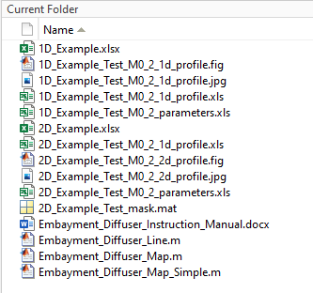

# References

Zhang, Y., & Ni, H. (2010). Diffusion of H, C, and O components in silicate melts. Reviews in Mineralogy and Geochemistry, 72(1), 171-225.

Ni, H., & Zhang, Y. (2008). H2O diffusion models in rhyolitic melt with new high pressure data. Chemical Geology, 250(1-4), 68-78.

Zhang, Y., Xu, Z., Zhu, M., & Wang, H. (2007). Silicate melt properties and volcanic eruptions. Reviews of Geophysics, 45(4).

Liu, Y., A. T. Anderson, and C. J. N. Wilson (2007). Melt pockets in phenocrysts and decompression rates of silicic magmas before fragmentation, J. Geophys. Res., 112, B06204.