Winnipeg Varsity High School Soccer League

Jenna G. Tichon

Feb 14, 2022

## Introduction

In this report, we are trying to see how many points teams in the Winnipeg Varsity High School Soccer League typically scored based on the number of games they won throughout the season.

In the table below we can find the collected data for the 2021 spring league for the 6 teams.

|  |  |
| --- | --- |
| Points | Wins |
| 13 | 7 |
| 19 | 8 |
| 25 | 8 |
| 28 | 9 |
| 29 | 12 |
| 33 | 11 |

To examine the distributions, let’s look at a scatterplot of the wins plotted on point scored and histograms to show the individual distributions of points and wins.

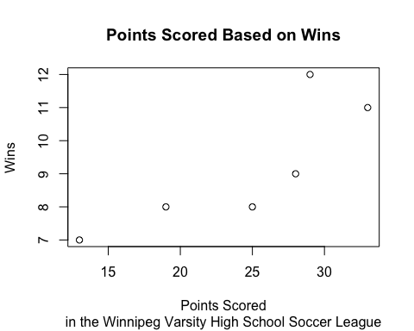

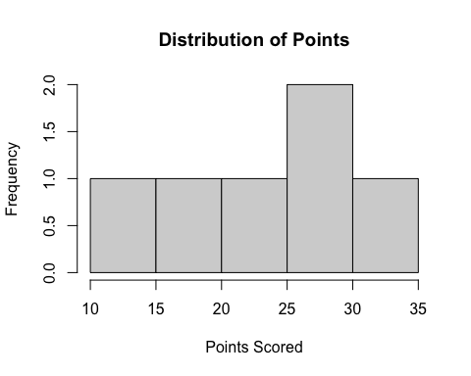

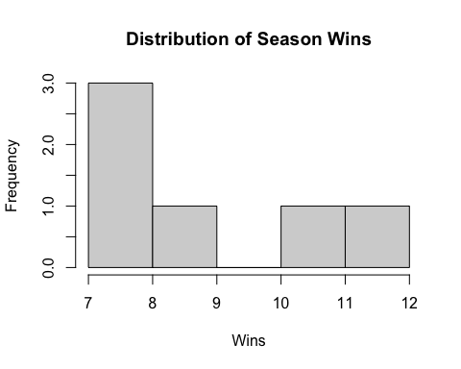

From the scatterplot, we can see that the number of wins increases based on the number of points scored. Based on the histograms, the distribution of number of points scored looks fairly uniform while the distribution of the number of wins is right-skewed.

## Numerical Summary

Now that we know the shapes, we can examine some numerical summaries which have been calculated in R and then re-summarized below the R calculations.

# Means  
mean(win)

## [1] 9.166667

mean(point)

## [1] 24.5

# Standard Deviations  
sd(win)

## [1] 1.94079

sd(point)

## [1] 7.314369

# Correlation and Coefficient of Determination  
cor(win,point)

## [1] 0.8241958

cor(win,point)^2

## [1] 0.6792987

# Max and Minimum Values  
max(win)

## [1] 12

min(win)

## [1] 7

max(point)

## [1] 33

min(point)

## [1] 13

We can summarize the stats in the following table:

|  |  |  |
| --- | --- | --- |
| Statistic | Wins | Points |
| Mean | 9.167 | 24.5 |
| Standard Deviation | 1.941 | 7.314 |
| Max | 12 | 7 |
| Min | 33 | 13 |

We also have that the correlation, $r$, is 0.8242 and the coefficient of determination, $r^{2}$, is 0.6793.

## Conclusion

In conclusion, we can see that the teams with more wins in the Winnipeg Varisty High School Soccer League tended to score more points. While the number of wins was fairly uniform, the teams that won more games scored marginally more wins per game.