Zave Timsina

Professor: Sarah North

User Interface Engineering Section 2 fall 2018

10/24/2018

Prototype-Design of Interface for ATM

We were asked to make an Automatic Teller Machine (ATM) using Java, C++, Visual Basic.net or any languages or apps that we were comfortable with. The Instructions specifically told us to make an atm only for kids between 14 to 15. To do this project in a real-life situation, we would have to create a data base and we would need to be able to protect the data we collect of our customers. I strongly believe that there shouldn’t be that difference with the kid’s ATM and adult’s ATM because if the ATM is in public places then why not broaden your field of customers and make it work for adults as well. Kids at the age of 14 or 15 will be either in middle school or high school so they can use an ATM that adults use. If I were to use this prototype with proper data base systems like a real business does then one of the disadvantages would be that I would have less customers because I made this atm just for kids. However, we would not need as much amount of money as we do on this atm to run it because one person can only take out 20 dollars.

I made a small prototype of at ATM interface, which holds only one account using Java. I thought it would be appropriate to use the keypad as well to put in the pin number. The only account that it holds represents a kid’s saving’s account that can be accessed using the red color card that will be presented right below the slots of ATM prototype. It is fairly simple and it give’s instructions to what to do after you click on the red card. Below I have included step by step pictures on how my atm prototype works. Its pin is 1234.

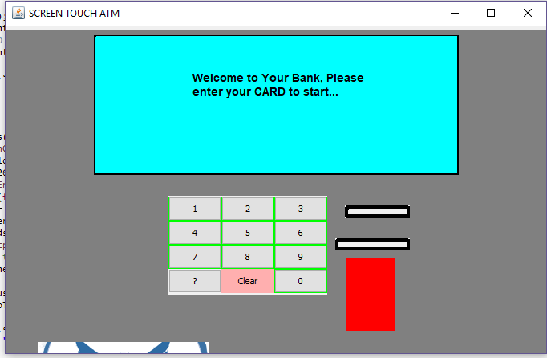\

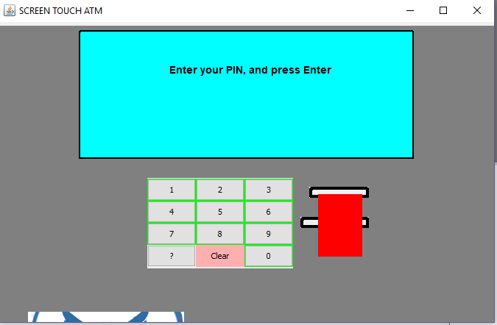

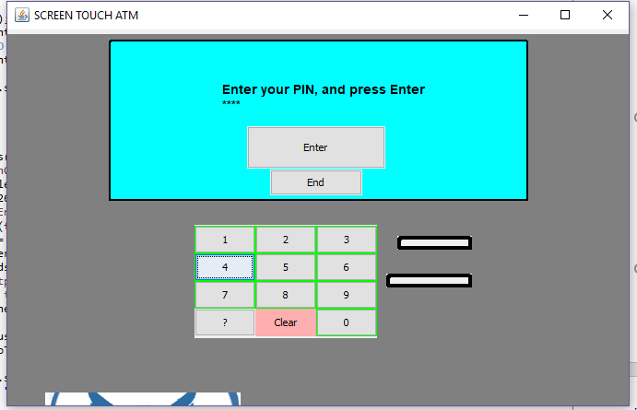

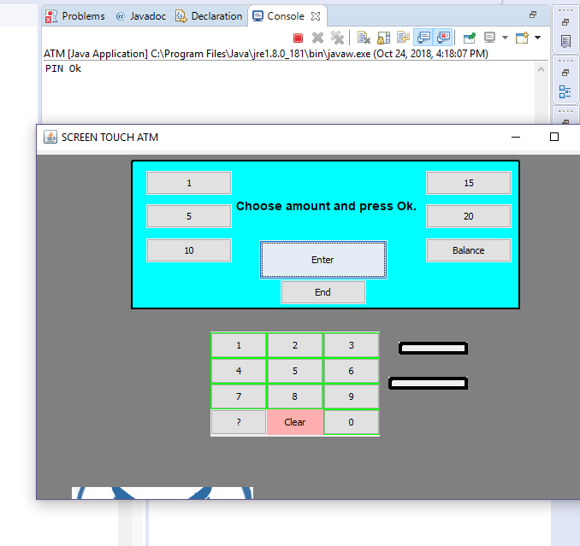

After this you can simple press on the balance to see the balance, and other amount to withdraw it. You can withdraw amount less than 15 dollars only.