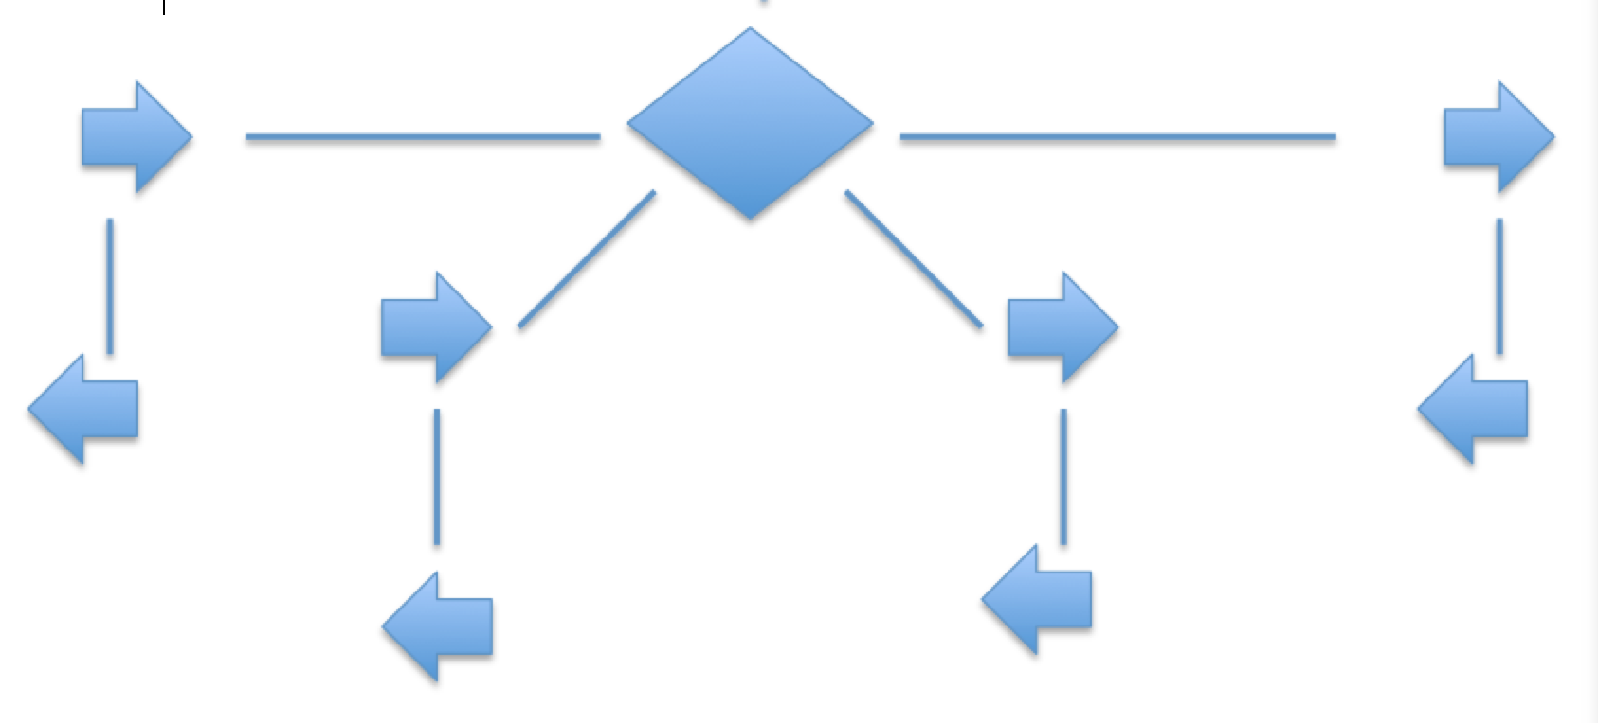

Q2

Q2

Q2

Q2

+10

+10

+10

+10

-6

-6

-6

-6

-6

-6

-6

-6

-6

-6

-6

-6

+5

-3

-3

-3

d

d

d

d

c

c

c

c

b

b

b

a

a

a

a

d

c

b

a

Q1

end

start

b