Master Data Governance
Business Blueprint

Customer | KBC Global Services
Project title | MDG – Master Data Governance  Business Blueprint Document

This document serves as a detailed description of the solution design. The document was prepared through the cooperation of both parties, and both parties are familiar with this document. Both parties have approved this document as a binding document for the implementation phase of the project.

Approved:

KBC group: | con4PAS, a.s.:
Name:  Jakub Nemeček | Name:  Petra Terbrová
Signature: | Signature:

Content

1 Content 2
2 Goal of project 4
2.1 KBC’s Objectives and Expectations in the Context of Future Phases 4
3 Current process description 6
3.1 BE AS IS – Creation of BP 6
3.2 CZ/SK AS IS – Creation of BP 6
4 New business process definition 8
4.1 System overview 8
4.2 General process in MDG for all countries 9
4.3 Creation of BP in MDG 12
4.3.1 Creation of CZ/SK BP 12
4.3.2 Creation of BE BP 14
4.3.3 Creation of Ultimate parent 15
4.4 Change of BP 17
4.4.1 Change of BP from CZ/SK 17
4.4.2 cVerify validation process 18
4.4.3 Change of BP from BE 19
4.4.4 Change of BPs which are shared between CZ/SK and BE 20
4.4.5 Change of Ultimate parent 22
4.5 Deactivation of BP 24
4.6 Deduplication and matching for initial load 25
4.6.1 Country deduplication 26
4.6.2 Cross country matching 28
4.7 Data in MDG 29
4.7.1 Multi-alphabet support 32
4.8 Design of MDG 32
4.8.1 Application Search BP 33
4.8.2 Applications Create BP and Change BP 34
4.8.3 Application Display BP 36
4.8.4 Application Search requests 38
4.9 Authorizations 40
4.9.1 Process roles 40
4.9.2 Authorization objects 41
4.9.3 Authorization roles 41
4.9.4 Fiori roles 42
5 Integration 43
5.1 Highlights 43
5.1.1 Integration with SAP CZ 43
5.1.2 Integration with BE and non-SAP 43
5.2 Interfaces 44
5.2.1 IF-MAINTAIN 45
5.2.2 IF-READ 45
5.2.3 IF-UPDATE 46
5.2.4 IF-NOTIFY 46
5.3 SAP CZ 46
5.3.1 cVerify change process 47
5.4 BE 48
5.5 CLM 48
5.6 TPRM 49
6 Project management 50
6.1 Project plan 50
6.2 Project risks 50
7 Open issues 52
7.1 Prepare environment for MDG - new standalone system 52
7.2 Cyrillic and other alphabets 53
7.2.1 Using alphabet 53
7.2.2 Cyrillic in SAP BE 54
7.3 MDG Attribute for TPRM 55
7.4 TPRM integration with MDG 55
7.5 Deduplication and matching 56
7.6 Integration SAP CZ with MDG via SOAP 56
7.7 Central user management 56
7.8 Change of BPs which are shared between CZ/SK and BE 57
7.9 Only vendors are in system SAP BE 57
8 Attachments 57
9 Prerequisites 58
9.1 Prerequisites for starting the Realize phase 58
9.2 Prerequisites for deduplication and matching 59
10 Abbreviations used 60
11 Change request 60

Goal of project

The aim of the project is to create a central database of business partners, which will serve to consolidate them within the distributed SAP and non-SAP environment at KBC.

According to KBC requirements, a limited scope is being implemented rather than the full scope specified in the RFP. This limited scope is referred to as the first phase. The continuation of the project, i.e. the second phase, will be agreed separately.

The first phase of the project includes the deployment of SAP MDG for the Czech Republic, Slovakia and Belgium.

The requirements of the Czech Republic and Slovakia differ from those of Belgium. The Czech Republic and Slovakia require SAP MDG to function as a central system for BP management, containing key data and main data for establishing/changing BPs and replicating them to related systems.

Solution Benefits:
- Centralized Data Management
- Improved Data Quality and Consistency
- Streamlined Processes and Governance
- Regulatory Compliance and Risk Reduction
- Efficient System Integration

Belgium requires that the BP management process remain the same in Belgium and that SAP MDG accept requests for creation and modification from the SAP BE system. This approach is feasible but there is a risk of data inconsistency.

In the first phase of the project (limited scope), the implementation will be reduced to SAP systems that belong to countries CZ/SK, BE and cross company systems CLM and TPRM. The reason for limitation of the scope is requirement of KBC to reduce the implementation of MDG project to align date of GO Live with CLM for Belgium i.e. 9.11.2026.

KBC’s Objectives and Expectations in the Context of Future Phases
- KBC’s Objectives and Expectations in the Context of Future Phases are:
- Since KBC does not have one unified 3rd party database within KBC Group, users face issues with data duplicate entries: the same counter party can be created multiple times in the various Master Systems (PSN [BE], SAP [CZ/IM]) or within the same Master System.
- For CLM and the TPRM Reporting Tool it is crucial to keep unique third-party identifiers (IDs), mainly for transparent, correct and simple reporting.
- The MDG tool enables unique third-party identification and deduplication across multiple systems to resolve data duplication issues. It solves third-party data deduplications and guards the data uniqueness. The MDG tool will be an essential building block for Third Party processes across KBC Group such as Third Party (Risk) Management.

Current process description

BE AS IS – Creation of BP

Suppliers create registration and maintain their own data in Ariba. Vendor Management Officer (VMO) or Stamdatabeheer displays supplier´s registration in Ariba. Creation is mainly done by Stamdatabeheer for all procurement related parties, but also other parties can create entries in PSN. Then is done initial check if BP exists in PSN and creation of the vendor in PSN. PSN will generate PSN Number which is manually inserted by VMO to Ariba in Z-field. For creation of BP in SAP BE, VMO must enter PSN and push a button which will trigger the transfer of data from PSN to SAP BE. Data are transferred via IDoc.

BP is also created manually in TPRM.

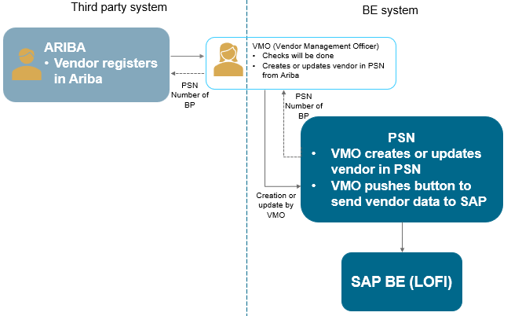
Figure 1: BE AS IS Process overview

CZ/SK AS IS – Creation of BP

Request for creation of BP (vendor) is received via structured email. Robot validates if all criteria are covered and whether request is for CZ so that he can process the request. If yes, the robot validates the request against registers and checks scoring (FILIP, ARES, etc). When checks are successful and scoring is in order, robot processes the creation of BP in SAP. Robot can automatically create the BP and extend company code data. If BP contains bank data, the responsible person is notified by mail to validate it. In case request is missing data, is for foreign partner or check/scoring are insufficient, the request is processed manually by the HK KZ. For manual creation of BP (customer) is responsible Client Acceptance team.

Requests for SK BP (vendor, customer) are manually processed by SK Accounting department.

Once BP is created, he is replicated to CLM. BP is also created in TPRM. All existing BPs are manually validated through KBC blacklists twice a year. Key attributes of BPs are periodically checked and updated using cVerify.

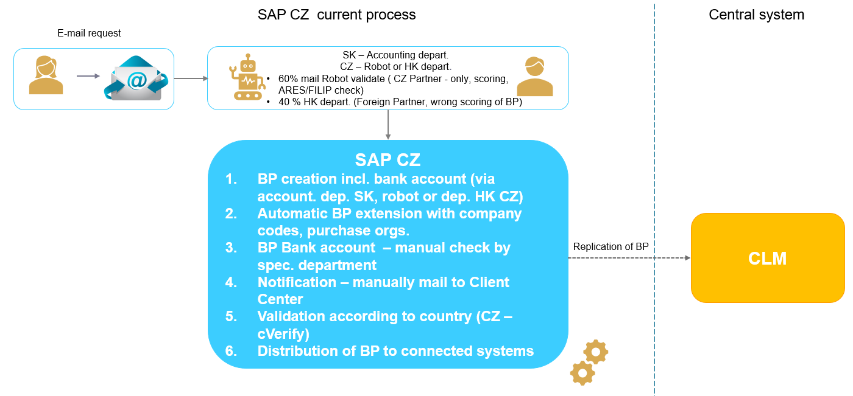
Figure 2: CZ AS IS Process overview

New business process definition

System overview
This is scheme of systems which consume data from MDG.
Detail integration scheme is in chapter 5.

System | Role of system
SAP MDG | Master system with gold record
SAP CZ | Local SAP system CZ/SK
PSN | BP Master for BE
SAP BE | Local SAP system BE
CLM | Consumer for Contract creation
TPRM | Consumer for Regulatory Reporting

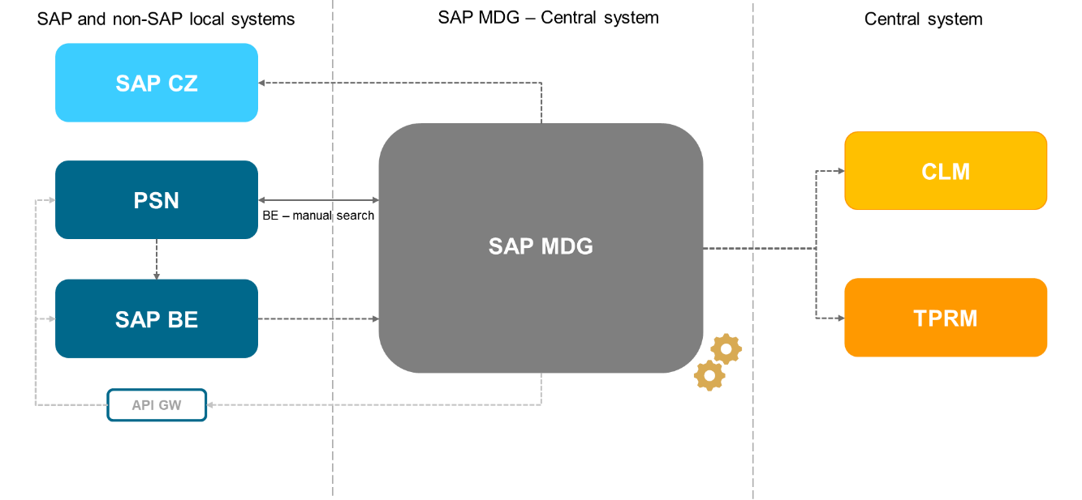
Figure 3: System overview

General process in MDG for all countries

The picture below describes the overall process of Business Partner creation with role Vendor or Customer within limited scope. It visualizes which systems will be involved in the process and connection between them. The process goal is to ensure deduplicated vendors and clean data due to integration of MDG. Clean data will be replicated to applications CLM and TPRM.

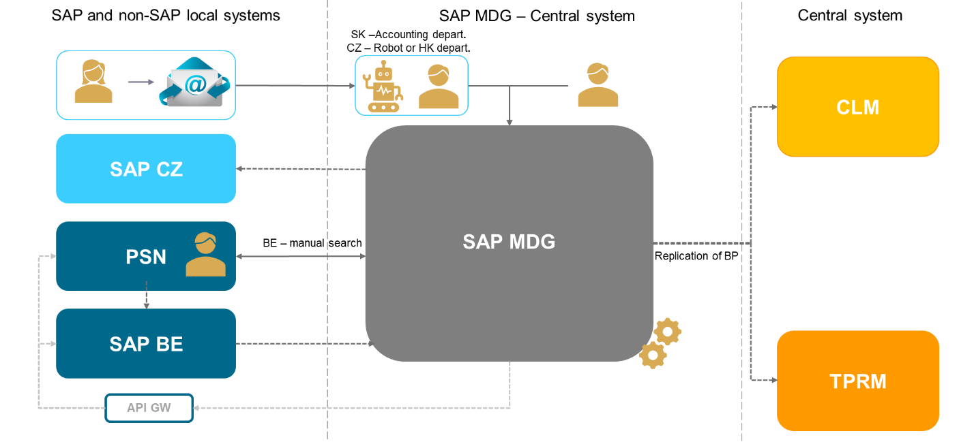
Figure 4: General process MDG

Steps in process | Description of steps
User | Process users:  - User from HK department (CZ)  - User from SK accounting department  - User from BE (for manual check in MDG)  - Technical user from SAP BE  - Technical user from SAP CZ (for cVerify processes)  - Technical users (Robot) – each robot has his own technical user  - MDG central administrator
Initial process outside MDG | Initial process outside of MDG system will remain the same for CZ and BE.
MDG process | Creating MDG request:  - Robot CZ  - Manual creation of request from CZ/SK  - Entry from SAP BE (integration)  Clearing process ensuring deduplication and matching of BPs will be validating entered data.  If any error occurs in MDG, while validation, acceptance or distribution of data are in process it will be reviewed by MDG administrator.  Processing MDG request:  - Draft – Initial status when request is created by user and not send to In process. This means that the user has saved the draft and will return to it later to complete it and submit it to the process (status: In process). The user, who creates the draft, can delete the draft. A deleted draft cannot be retrieved; it will be permanently deleted. Deletion is only possible until the request is sent to the process.  - In process – MGD data are being created/changed (GID generated, data changed). This status is initiated by the user who submitted the request to the process. Based on program logic, the system processes the request – i.e., deduplication, matching, and creation of a GID record – and moves the request to the next status, which can be Request finished or Error.  - Error – Any error occurs in request processing. The user (not technical user) who created the request is notified about the status via email and can edit the data in the request based on the error log and resubmit it to be processed again (status: In process, or cancel the request status: Cancelled).  - Cancelled – Terminal status when request has been cancelled.  - Request Finished – All MDG data are successfully saved. The next statuses are Replication in process or Finished.  - Replication in process – Replication to connected systems is in progress. If this status persists, the administrator must check outbound queue. After successful queue reprocessing, the status will be set to Completed.  - Finished – Terminal status when data from MDG are replicated to connected systems.  Notice: Created request will be neither subject to approval nor validated in registries (validation takes place before creation of request).
Replication | GID record will be replicated from MDG to:  - CLM – integrated with MDG  - TPRM – integrated with MDG  - SAP CZ – integrated with MDG  - API GW – send data from MDG
Searching in MDG | Users can search in MDG database without creating requests. SAP BE users will use searching for validation if the BP exists or not in MDG.
Recommendation | KBC must ensure that creation and changes in MDG are not enabled to be performed in connected systems to secure centralized data management.  BE processes are exceptions.
Notice | - MDG central administrator will solve errors (e.g., reprocess failed data replications….)  - If BE initiates the creation or change of BP and the request is erroneous, BE must ensure that the data in the PSN and SAP BE systems are reconciled based on the current entry in the MDG for the relevant BP.

The following scheme summarizes MDG request status.
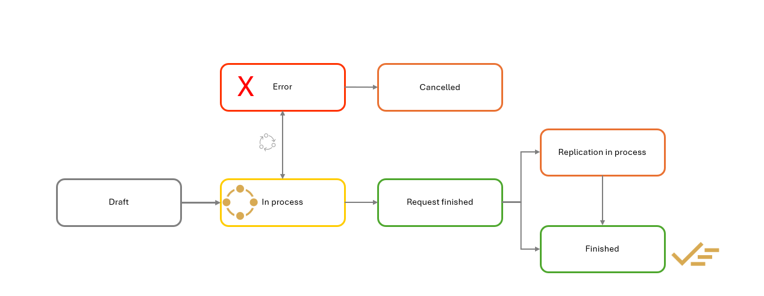
Figure 5: Request status schema

Creation of BP in MDG

Creation of CZ/SK BP
The following scheme illustrates the process of creating CZ/SK BP.

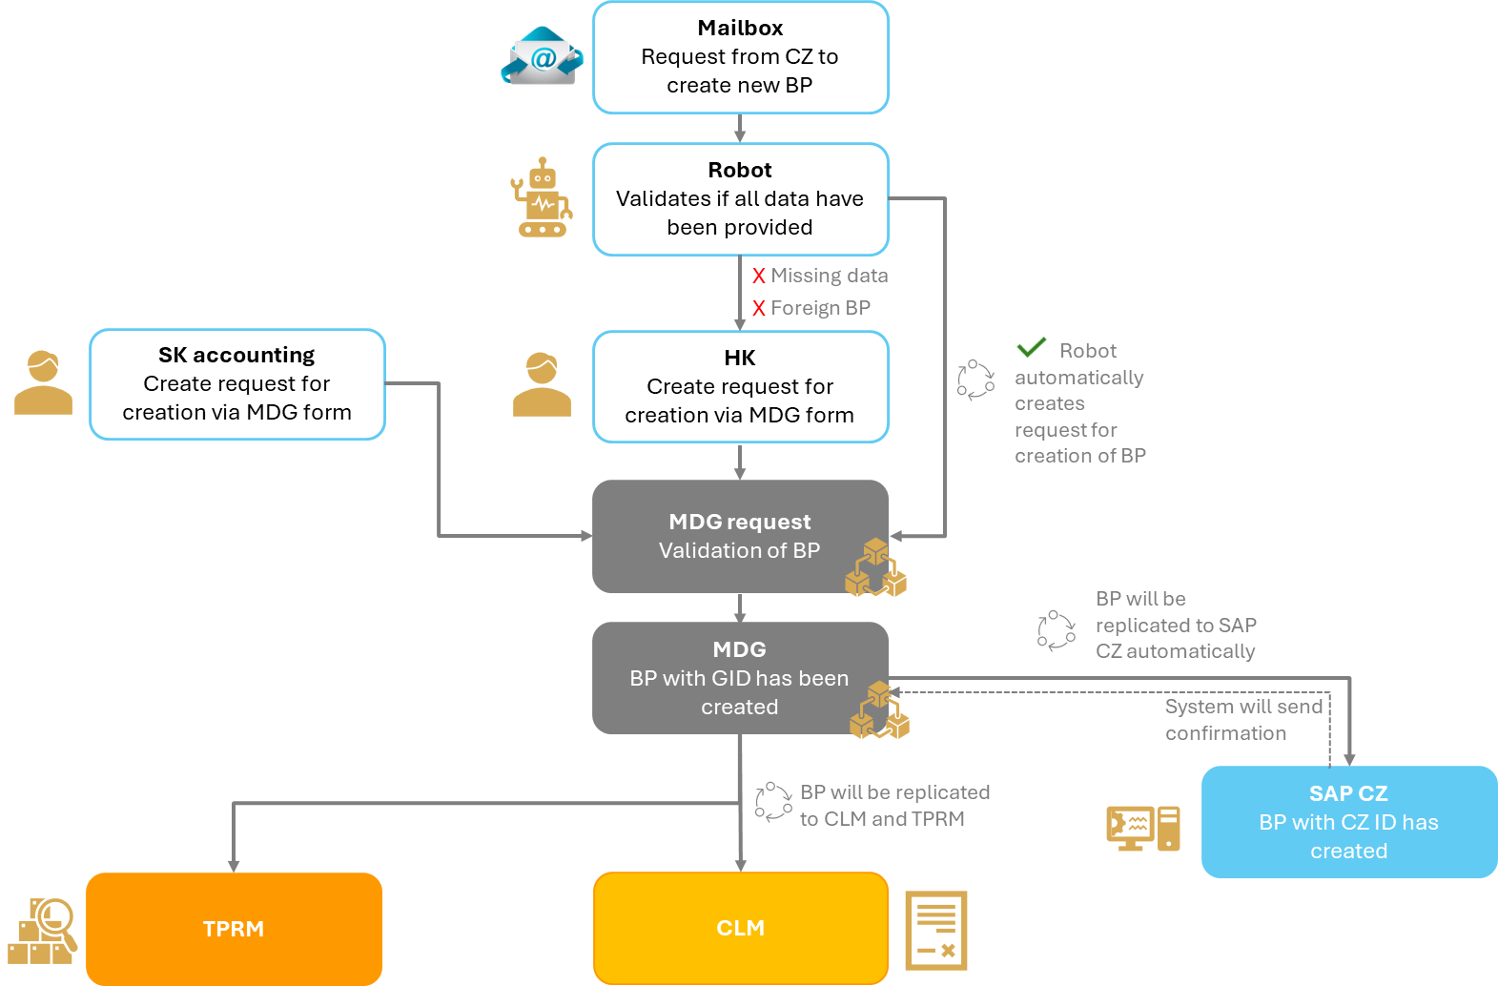
Figure 6: Creation of CZ/SK BP

Steps in process | Description of steps
User | Process users:  - User from HK department (CZ)  - User from SK accounting department  - Technical users (Robot) – each robot has his own technical user  - MDG central administrator
Initial process outside MDG | Process outside of MDG system will remain the same i.e. structured email for creation of vendor will be processed by Robot and Hradec Králové department. Robot and users from Hradec Králové (process foreign or BPs that failed validation while processed by robot) will validate the data against the registers. If the validations for creation are successful, the MDG process can start.  Client Acceptance team from CZ will continue to collect data for BP customer in the current manner, including performing manual checks in the registry.  SK Accounting will continue to collect data for BP (vendor or customer) in the current manner, including performing manual checks in the registry.
MDG process | Creating MDG request:  Robot:  - The robot will send the validated data to a web service, which will ensure that the request is created. It means the request will be created automatically. Web service gives the Robot information about the number of ID request or error messages. Request will be in status ‘In process’.  Users:  - Users will create a request. It is recommended that they first check whether the BP already exists in the MDG database before creating the request.  - They can save the request before submitting, i.e., create a draft.  - Once users submit a request for processing, the request will be assigned a request number and status ‘In process’. When the request is submitted for processing, basic duplicate checks will be performed based on numerical unique identifier (VAT number, DUNS, etc.).  Note: Natural persons in SAP CZ are maintained as organizations, and they will be maintained in such way in MDG.  Processing MDG request:  - A request to create a BP will not be subject to approval.  - A request with the status ‘In process’ will undergo a deduplication process.  - If the deduplication process is successful – that is, if no duplicates are found – a GID record will be created in the MDG and replicated to the connected systems.  - If a data-related issue arises (process-related), notification will be sent to hk-kz@csob.cz. The user will be able to cancel or reprocess the request.  - If a technical issue arises with a request, the administrator will be notified so they can resolve the issue. The user will be able to cancel or reprocess the request (replication reprocess).
Replication | Created GID record will be replicated from MDG to:  - SAP CZ – according to GID record BP and appropriate role (vendor or customer) will be created via SAP function and return the local ID BP to MDG  - CLM – integrated with MDG  - TPRM – integrated with MDG
Following steps in local SAP system | Follow up process in SAP CZ:  Robot or users will finalize the creation of BP in SAP CZ.

Creation of BE BP
The following scheme illustrates the process of creating BE BP.

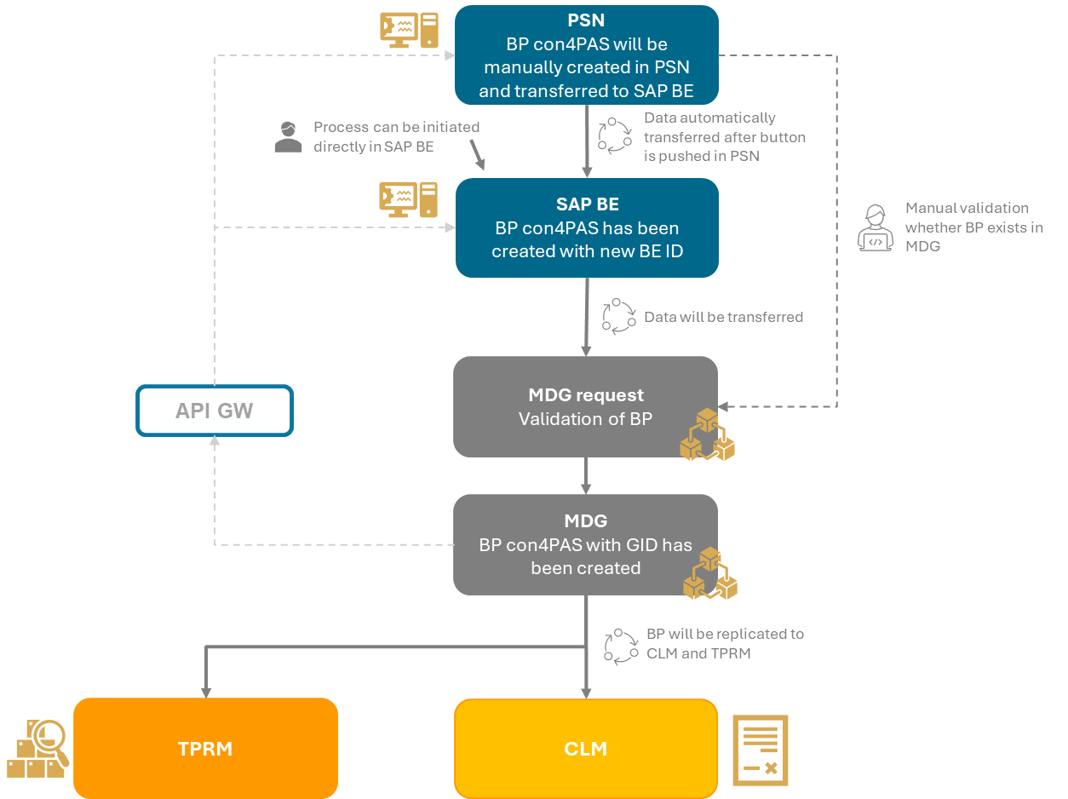
Figure 7: Creation of BE BP

Steps in process | Description of steps
User | Process users:  - User from BE (for manual check in MDG)  - Technical user from SAP BE  - MDG central administrator
Initial process outside MDG | Before any steps of creation will be performed, user needs to enter MDG and manually verify whether the BP already has existing record. If data do not exist, the user creates a new record in the PSN system and the record is then transferred to SAP BE or directly creates BP in SAP BE.
MDG process | Creating MDG request:  Technical user SAP BE  - Creation of BP will be transferred from SAP BE to MDG via integration. Data from the integration will be received under technical user and will create request in MDG. If error occurs during creation, the request will return error message. If creation is successful, request will have status ‘In process’.  - Notification about process errors will be sent to shared mail: stamdatabeheer@kbc.be.  Processing MDG request is similar as for CZ:  - A request to create a BP will not be subject to approval.  - A request with the status ‘In process’ will undergo a deduplication process.  - If the deduplication process is successful – that is, if no duplicates are found – a GID record will be created in the MDG which will also store the local ID from SAP BE and status of request will change to status ‘Request finished’.  - If a data-related issue occurs (during the process), e-mail will be triggered to stamdatabeheer@kbc.be and to the API GW. The request will be automatically marked as ‘Cancelled’.  - If a technical issue arises within a request, the administrator will be notified to resolve the issue. The error message will be sent to API GW.
Replication | Created GID record will be replicated from MDG to:  - CLM – integrated with MDG  - TPRM – integrated with MDG  - API GW – send data from MDG
Following steps in local systems | - Following steps in local systems are fully in BE competency and are not driven by MDG project.

Creation of Ultimate parent
Ultimate parent is a special kind of BP which is superior to other BP and which does not need to have any roles assigned to it. The ultimate parent is created only in MDG and is replicated only to TPRM (unless later roles assignment).

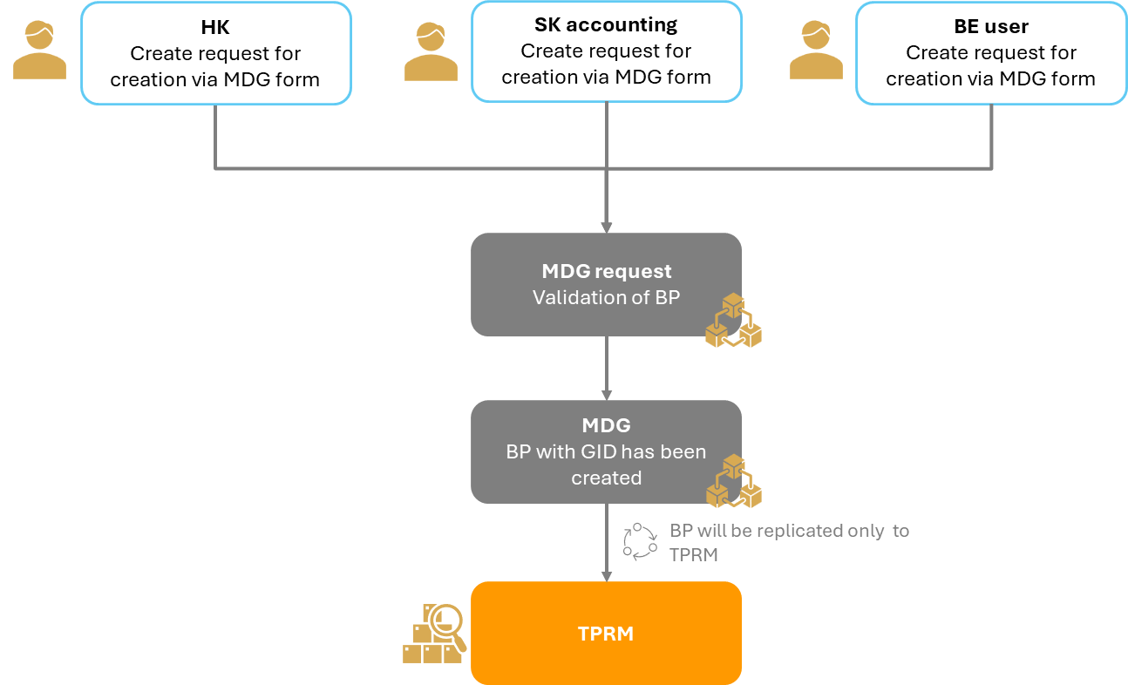
Figure 8: Ultimate parent creation overview

Steps in process | Description of steps
User | Process users:  - User from CZ/SK  - User from BE  - MDG central administrator
MDG process | Creating MDG request:  The user creates a request that will be distinguished the Ultimate parent by the "origin system" attribute. The "origin system" attribute will user set to MDG.  The other attributes of the form will be the same, except for the option to select BP roles.  The request of creating Ultimate parent can only be created in MDG.  If the ultimate parent is created with the role of supplier or customer, the creation process will be the same as for other business partners, including replication to connected systems.  outlined in the chapters 4.3.1 and 4.3.2.  Processing MDG request is the same as for CZ.  - See chapter 4.3.1
Replication | Created GID record will be replicated from MDG to:  - TPRM – integrated with MDG
Notes | - Visualization of relations between BP is not expected.  - When the BP (with assigned ultimate parent) is replicated into TPRM, the ultimate parent for replication will be determined like the “highest” ultimate parent from MDG.  - The processes for creation of subcontractors are the same as for the ultimate parent, but no links are to be foreseen in MDG.

Change of BP

Change of BP from CZ/SK
The following scheme illustrates the process of changing CZ/SK BP, which does not exist in another country.

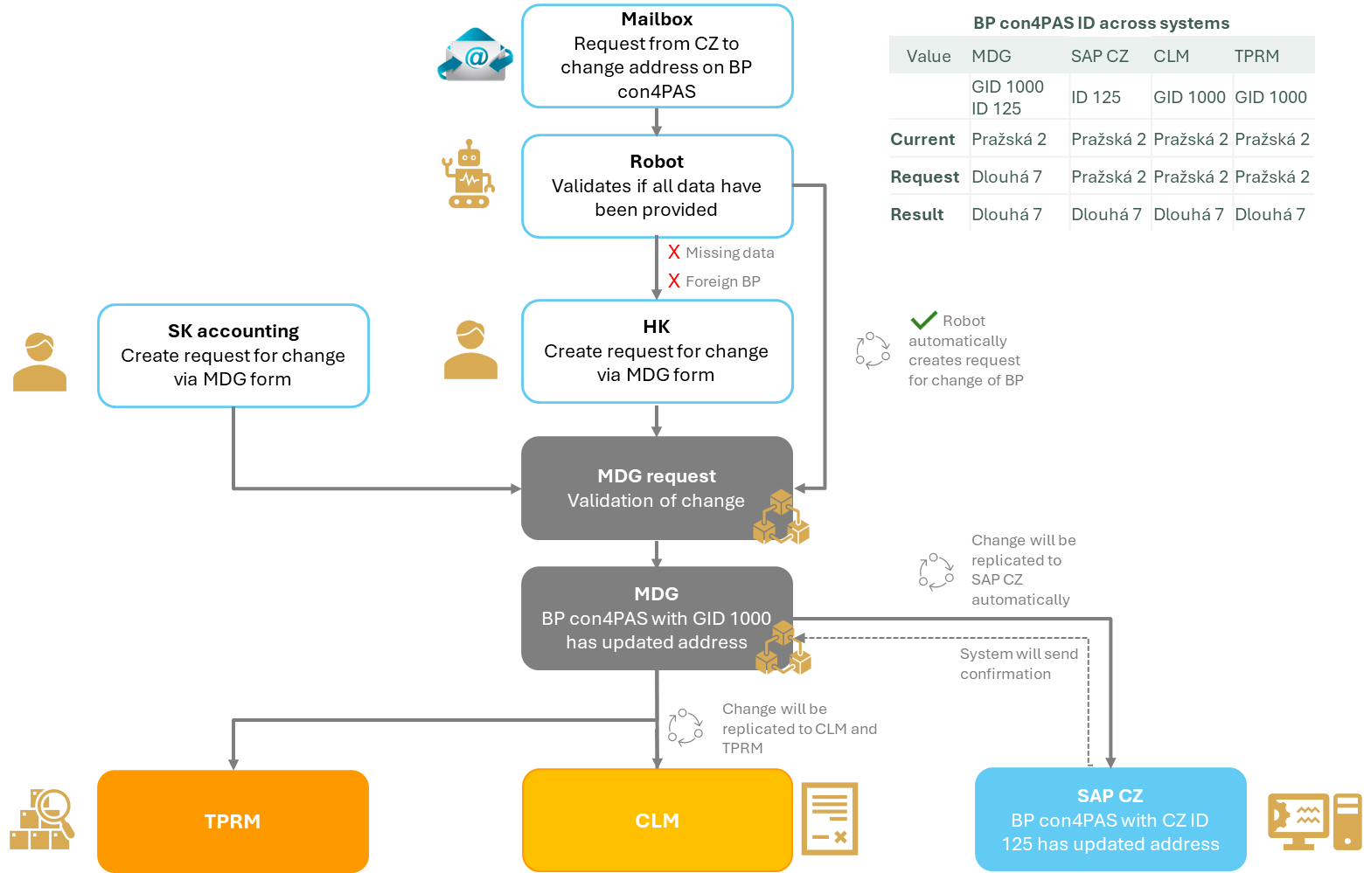
Figure 9: Change of CZ BP

Steps in process | Description of steps
User | Process users:  - User from HK department (CZ)  - User from SK accounting department  - Technical users (Robot)  - MDG central administrator
Initial process outside MDG | Process outside of MDG system will remain the same as for creation.
MDG process | Creating MDG request:  A request to modify a BP will allow to change fields in the MDG system that are editable; these may be either optional or required. Filling in an empty field will also be considered as a change.  The following unique mandatory fields will not be subject to modification and will be only displayed in the change request:  - Business partner grouping (BU_GROUP)  - Business Partner Category (TYPE)  - Country/Region Key (COUNTRY)  - Roles (VENDOR – if filled)  - Roles (Customer – if filled)  - Dun & Bradstreet number – (DUNS – if filled)  - LEI Code (LEI_CODE – if filled)  - EUID (EUID if filled)  - TAXNUM_TAB (0..n) (create new allowed, no change of existing)  Request will be created:  - Automatically by Robot  - Manual by users:  - HK Department  - SK accounting department  Processing MDG request:  It will be the same as in Creation process, see chapter 4.3.1.
Replication | Changed GID record will be replicated from MDG to:  - CLM - will be integrated with MDG  - TPRM - will be integrated with MDG  - SAP CZ - will be integrated with MDG
Notice | The role of MDG central administrator user will have the possibility to edit non-changeable data or disconnect local ID from GID record.

cVerify validation process

Steps in process | Description of steps
Users | Process users:  - Current users in SAP CZ  - User in MDG – technical user
Process in SAP CZ | SAP CZ will continue to use the existing functionality. cVerify will log changes to customer tables and will take effect only after user approval. The program-driven transfer of updated data to BP will remain in its current state.
Interface | Interface – see chapter 5.3.1.
Process in MDG | Creating MDG request:  After BP save in SAP CZ, data will be routed to SAP MDG, where individual requests will be generated and automatically approved or follow process according to chapter 4.4.4.  Processing MDG request:  Will be the same as in Creation process, see chapter 4.3.1.

Change of BP from BE
The following scheme illustrates the process of changing BE BP, which does not exist in another country.

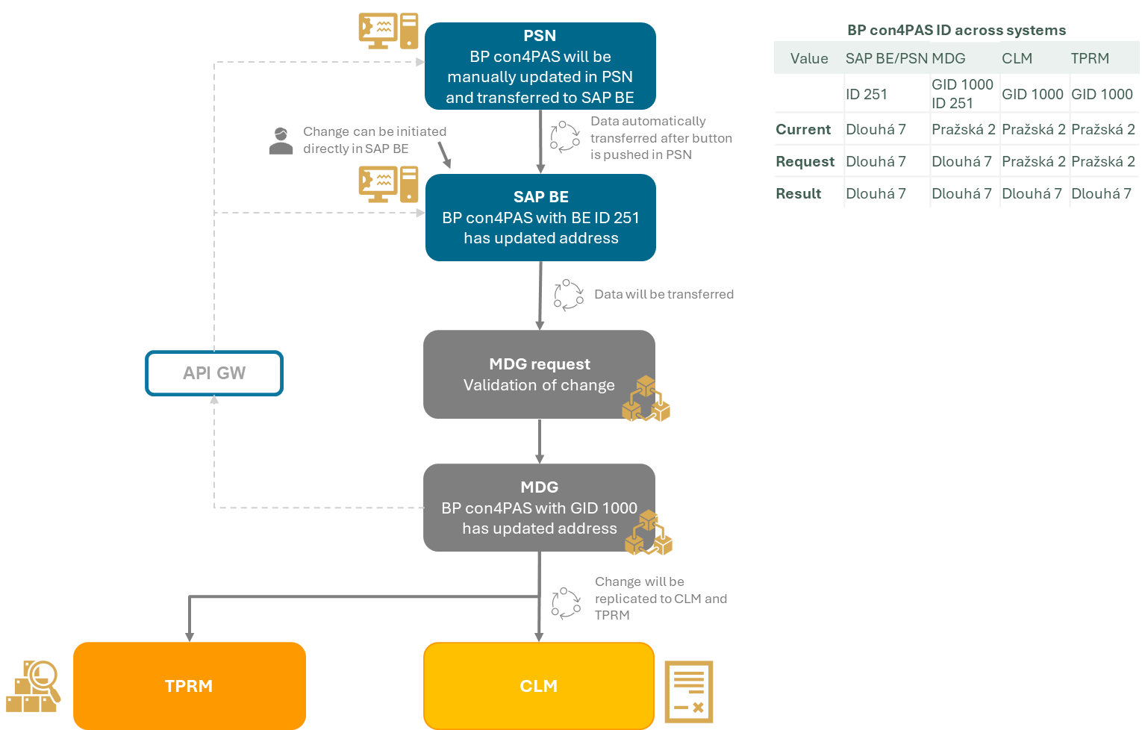
Figure 11: Change of BE BP

Steps in process | Description of steps
User | Process users:  - User from BE (for manual check in MDG)  - Technical user from SAP BE  - MDG central administrator
Initial process outside MDG | Process outside of MDG system will remain the same.
MDG process | Creating MDG request:  Automatically created request by technical user via integration.  Processing MDG request:  Will be the same as in chapter 4.3.2  Notification about process errors will be sent to shared mail: stamdatabeheer@kbc.be and to the API GW.
Replication | Changed GID record will be replicated from MDG to:  - CLM - will be integrated with MDG  - TPRM - will be integrated with MDG  - API GW – send data from MDG

Change of BPs which are shared between CZ/SK and BE
The following scheme illustrates the process of change initiated in CZ for CZ/SK and BE BP.

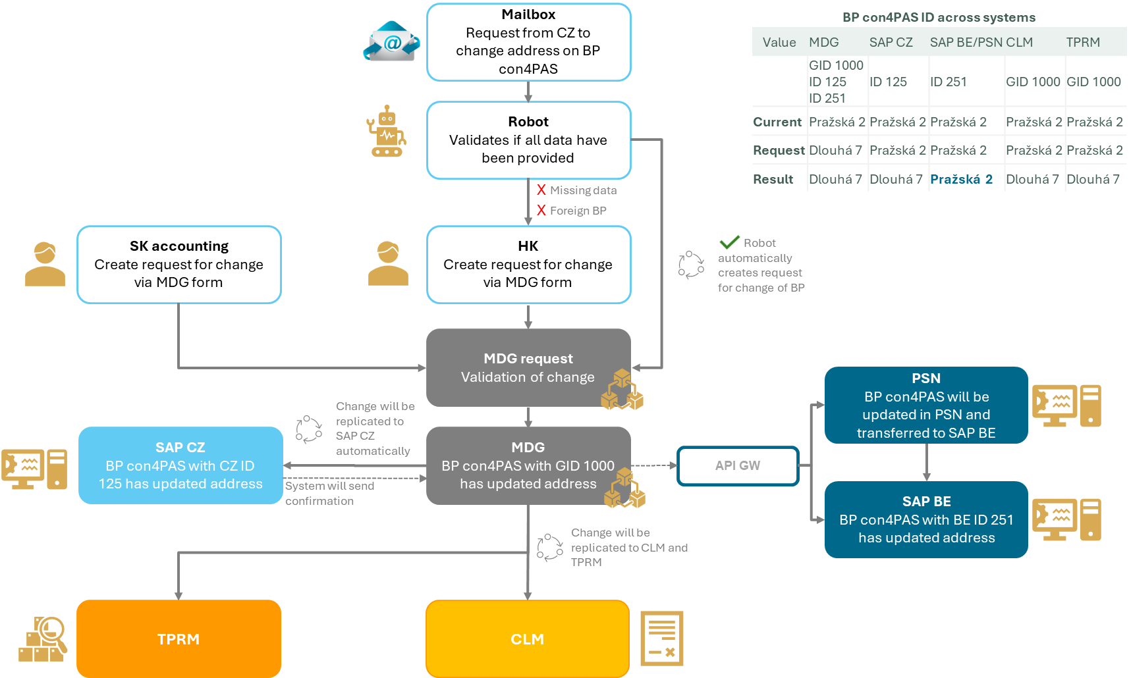
Figure 12: Change of BP for both countries initiated from CZ

The following scheme illustrates the process of change initiated in BE for CZ/SK and BE BP.

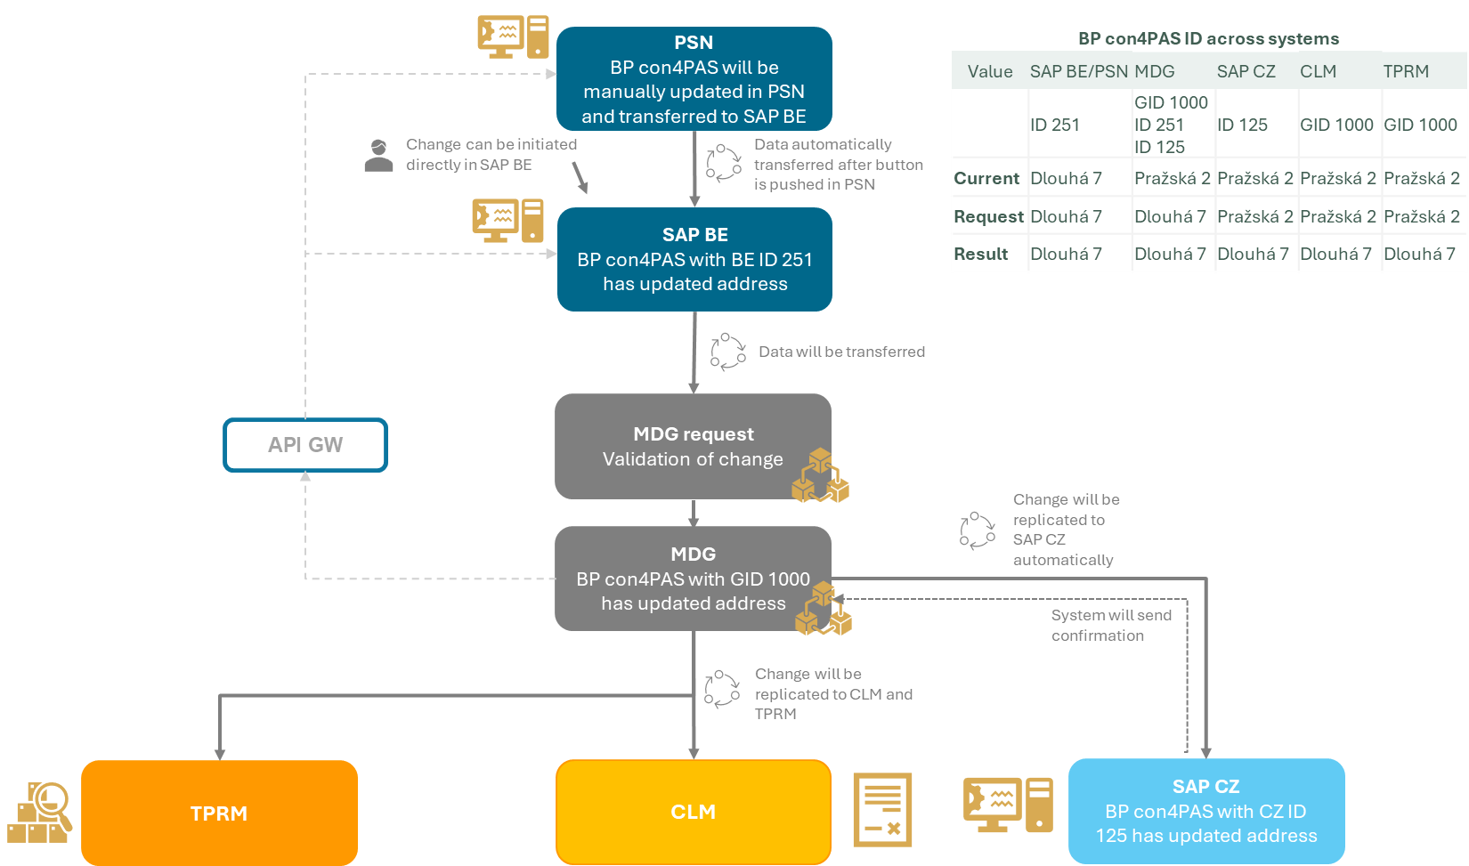
Figure 13: Change of BP for both countries initiated from BE

Steps in process | Description of steps
User | Process users:  - User from BE (for manual check in MDG)  - Technical user from SAP BE  - MDG central administrator  - User from HK department (CZ)  - User from SK accounting department  - Technical users (Robot)
MDG process | Creating MDG request for change will be done according to the description in above chapters 4.4.  The change may concern a business partner (BP) that is common to CZ/SK and BE. This scenario applies if the BP in question exists in the local systems of these countries and is classified under a GID.  The following steps will determine whether the change affects KID data or local data. If the change affects local data, no further action is required.  If the change affects KID data, it is recommended to involve an approver from the country that is not the initiator of the request.  The master record will be updated, when approvers approve the change. Groups of approvers will be designated for each country. For approval, it will be sufficient for one approver from the designated group in that country to approve the change. However, the request must be approved by all countries for which the BP is shared.  If he does not approve the change, the process of the request will end. The Gold record will not be changed.  If BE initiates the changes and the request is rejected, BE must ensure that the data in the PSN and SAP systems are reconciled based on the current entry in the MDG for the relevant BP.  Processing MDG request:  Will be the same as in chapters above.  Notification about BE process errors will be sent to shared mail: stamdatabeheer@kbc.be and to the API GW.  If a data-related issue arises (CZ process-related), notification will be sent to hk-kz@csob.cz. The user will be able to cancel or reprocess the request.
Replication | Changes on BP will be replicated to:  - SAP CZ - will be integrated with MDG  - CLM - will be integrated with MDG  - TPRM - integrated with MDG  - API GW – send data from MDG

Change of Ultimate parent
The following procedure describes possible changes to the ultimate parent company.

Steps in process | Description of steps
User | Process users:  - User from HK department (CZ)  - User from SK accounting department  - User from BE  - Technical user from SAP BE  - MDG central administrator
MDG process | Creation of MDG request  Changing data without specifying roles (supplier, customer).  - User creates manually a change request, data which will be change in MDG  The ultimate parent becomes a supplier or a customer.  - User from the HK (CZ) department or a user from the SK accounting department creates a request in MDG, adds a role (supplier or customer), and changes the source system to SAP CZ, which triggers GID replication to the connected systems.  - Automatically created request from SAP BE – The creation of a business partner will be transferred from SAP BE to MDG via integration. Data from the integration will be received under a technical user and will create a request in MDG. If a match with record of the ultimate parent is found during request processing, the data will be updated and the source system will be changed to BE.  Attention: The data of the Ultimate parent record in MDG will be overwritten with BE data  Processing of MDG request:  Principle of processing error will be the same as in chapter 4.3.1 and 4.3.2:  - Notification about BE process errors will be sent to shared mail: stamdatabeheer@kbc.be and to the API GW.  - If a data-related issue arises (CZ process-related), notification will be sent to hk-kz@csob.cz. The user will be able to cancel or reprocess the request.
Replication | Changes will be replicated to system according to type of change:  Changing data without specifying roles  TPRM – integrated with MDG  The ultimate parent becomes a supplier or a customer:  SAP CZ - will be integrated with MDG*  - CLM - will be integrated with MDG  - TPRM – integrated with MDG  - API GW – send data from MDG*  * Depends on what country was the partner extended for.
Notice | If the ultimate parent was created with the role of supplier or customer, the change process will be the same as for other business partners, including replication to connected systems.  The processes for creation of subcontractors are the same as for the parent, but no links are to be foreseen in MDG.

Deactivation of BP

Deactivation of BP in MDG can be only set up if all processes and documents related to the BP (purchase orders, contracts, invoices, sales orders...) are no longer active in connected systems.

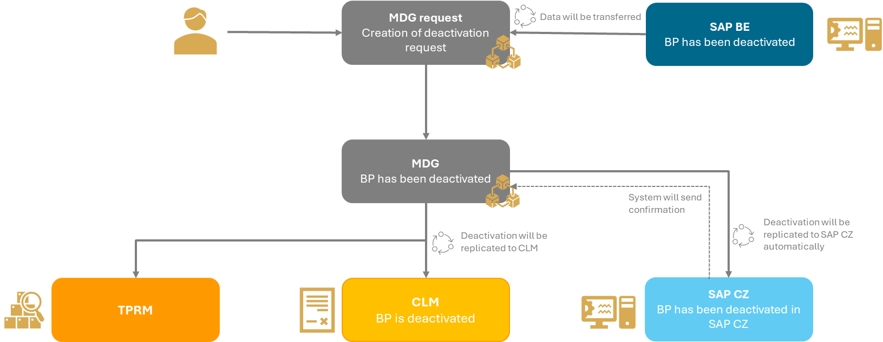
Figure 14: Deactivation process

Steps in process | Description of steps
User | Process users:  - User with deactivation role  - MDG Administrator  - Technical user from SAP BE
Initial process outside MDG | KBC must have initial process which ensures BP doesn’t have active documents or ongoing processes in relevant systems.  ! This check must be performed before the MDG process begins, as this validation is not part of the MDG tasks.
MDG process | Creating MDG request:  User with deactivation role  - User will set in the change request deactivation flag, which is country specific.  - In case the user changes other fields apart the deactivation flag, these changes will be discarded.  Technical user from SAP BE  - Deactivation of BP will be transferred from SAP BE to MDG.  - If error occurs during request creation, the message about process error will be sent to e-mail address: stamdatabeheer@kbc.be
Replication | Changes on BP will be replicated to:  - CLM - will be integrated with MDG  - SAP CZ - will be integrated with MDG  - fields XDELE and XBLCK will be set up in main BP data
Notice | - If the BP is deactivated in MDG for specific country, no further changes will be replicated to the system of this country.  - Blocking of supplier/customer in local system has no impact on MDG.

Deduplication and matching for initial load
Upload of BP initial data from connected source systems should be:
- File Upload
- Replication with DRF through IF-MAINTAIN on SAP BTP

Picture below describes process of unique values or controlled duplicates identification which will lead to creation of GID in MDG.

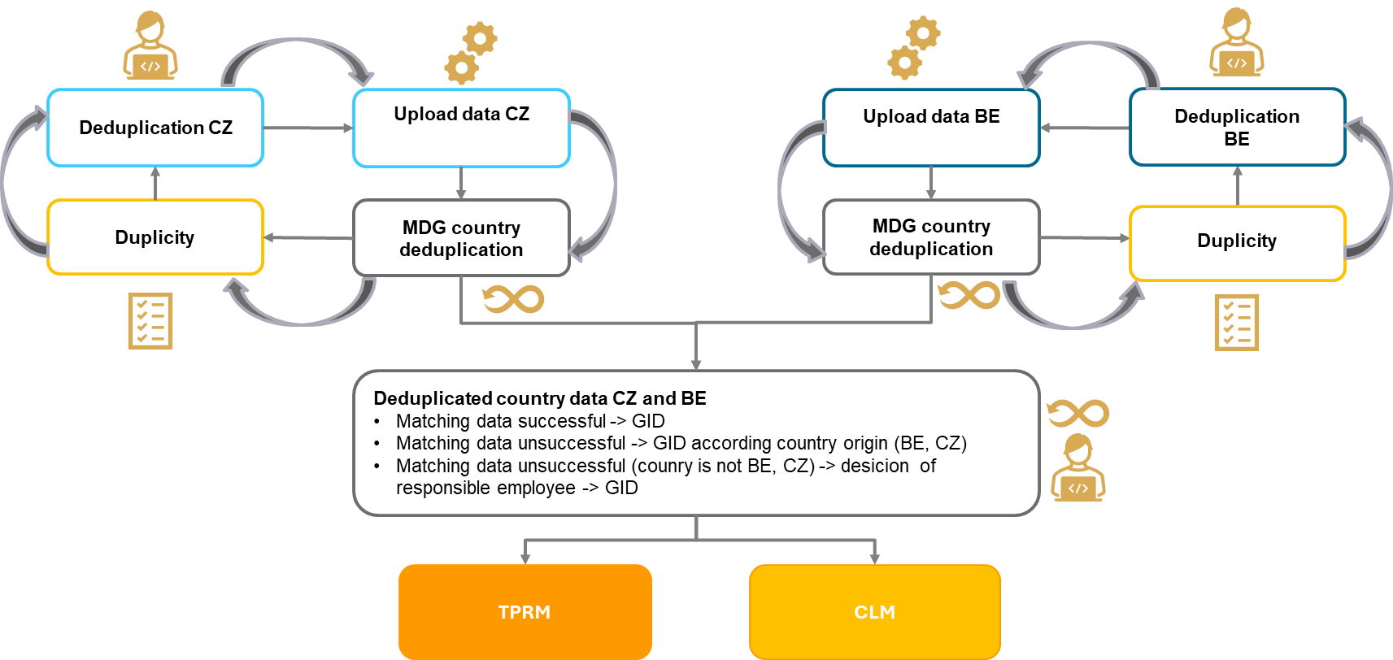
Figure 15: Deduplication and matching process overview

Country deduplication
Steps in process | Description of steps
User | Process users:  - Technical users (initial load to MDG)  - Users responsible for removal of duplicates in local systems
Process | - Entry:  - Load of valid BP data from SAP systems to MDG
- Standardization of input data for deduplication and matching of following fields
  - Company name
  - Name of person
  - Postal code
  - City
  - Street

Rules for standardization:
- Company name
  - Concatenated from fields NAME_ORG1, NAME_ORG2, NAME_ORG3 and NAME_ORG4
  - Special characters will be replaced:
    - & with “AND”
    - @ with “AT”
    - + with “PLUS”
  - All non-alphanumeric characters will be deleted (if name has no alphanumeric characters, name will be unchanged).
  - All country specific characters will be removed and replaced with standard Latin characters.
  - Converted to Upper-case
  - Removed legal form identifier (e.g., SRO, AS, NV, …)
  - Delete multiple spaces

- Name of person
  - Concatenated from NAME_FIRST, NAME_LAST
  - Deleted all non-alphanumeric characters (“-” replaced by space)
  - All country specific characters will be removed and replaced with standard Latin characters
  - Delete multiple spaces

- Postal code
  - Deleted all non-alphanumeric characters

- City
  - Deleted all non-alphanumeric characters (“-” replaced by space)
  - All country specific characters will be removed and replaced with standard Latin characters
- Street
  - Deleted all non-alphanumeric characters (“-” replaced by space)
  - All country specific characters will be removed and replaced with standard Latin characters

- Country deduplication
- Deduplication of each country separately to identify unique records.
- Progressive pairing of specified fields enables identification of single or multiple duplicates. When duplicate is identified by one of the values, the process will continue to compare remaining data with database to reveal all possible duplicates.
- Duplicates are identified based on percentage match.
- When duplicates are identified, MDG will summarize analysis and responsible users will be informed.

List of KIDs to be compared for company deduplication:
- Unique identifiers (greater weight):
  - Company ID or Tax Number VAT number
  - DUNS
  - LEI Code
- Standardized fields:
  - Name of organization
  - City postal code
  - City
  - Street

List of KIDs to be compared for person deduplication:
- Unique identifiers (greater weight):
  - Company ID
  - EUID
- Standardized fields:
  - First name + Last name
  - City postal code
  - City
  - Street

- Remove duplicates from local systems
- Responsible users will have to remove duplicates in local system, update incorrect data or report controlled duplicate (in case of partners from CZ system, the duplicates must be resolved also in CLM system.)

- Repeat services to load data into SAP MDG
- All above steps will be repeated until system does not identify duplicates (except controlled duplicates).

Result | MDG identified unique values per separate country and process of cross country matching will start.

Cross country matching

Steps in process | Description of steps
User | Process users:  - Users responsible for identification of cross country records.
MDG process | Input:  - Data from Country deduplication process in MDG  - Data will have already standardized fields
Matching evaluation:
- Matching will compare unique data from separate countries and match them.

List of KIDs to be compared for company matching:
- Unique identifiers:
  - Country
  - Company ID or Tax Number VAT number
  - DUNS
  - LEI Code
- Standardized fields:
  - Name of organization
  - Unified City postal code
  - City
  - Street

List of KIDs to be compared for person matching:
- Unique identifiers:
  - Country
  - Company ID
  - EUID
- Standardized fields:
  - First name + Last name
  - City postal code
  - City
  - Street

Creation in MDG data
- In case of no match, that means the BP is unique and exists in only system of one country, the MDG record will be created.
- In case of exact match, that means that the BP exists in SAP BE and SAP CZ and both records are exactly the same, the MDG record will be created.
- In case of match which is not exact, that means the BP exists in SAP BE and SAP CZ, but all data are not matching, KBC will manually compare and select data for creation of MDG record (responsible persons).
  - MDG record will be created according to the country of origin (BP from CZ will be created according to SAP CZ data, in opposite BP from BE will be created according to SAP BE data)
  - If the country of origin is neither CZ nor BE, the responsible person must decide from which Country will be the MDG record created.

Result | MDG will have deduplicated database of BPs matched in one record consolidated from cross country data.
Replication | Unique records will be replicated from MDG to CLM and TPRM systems.

Data in MDG

Data in MDG can be divided into several groups
- KID – Key Identification Data – these are common data that are replicated into all connected systems.

- Country dependent fields – fields, that are not KID and that can differ for each country connected to MDG.

- Mandatory fields – these fields are mandatory for BP creation and can be either KIDs or country dependent fields. Mandatory fields can be a constant prefilled to interface or UI.

Fields which specify address (including partner name) will support multi-alphabets variants (see chapter 4.7.1) and therefore they cannot be considered as country dependent.

The picture below shows the binding between KID fields and country dependent fields.

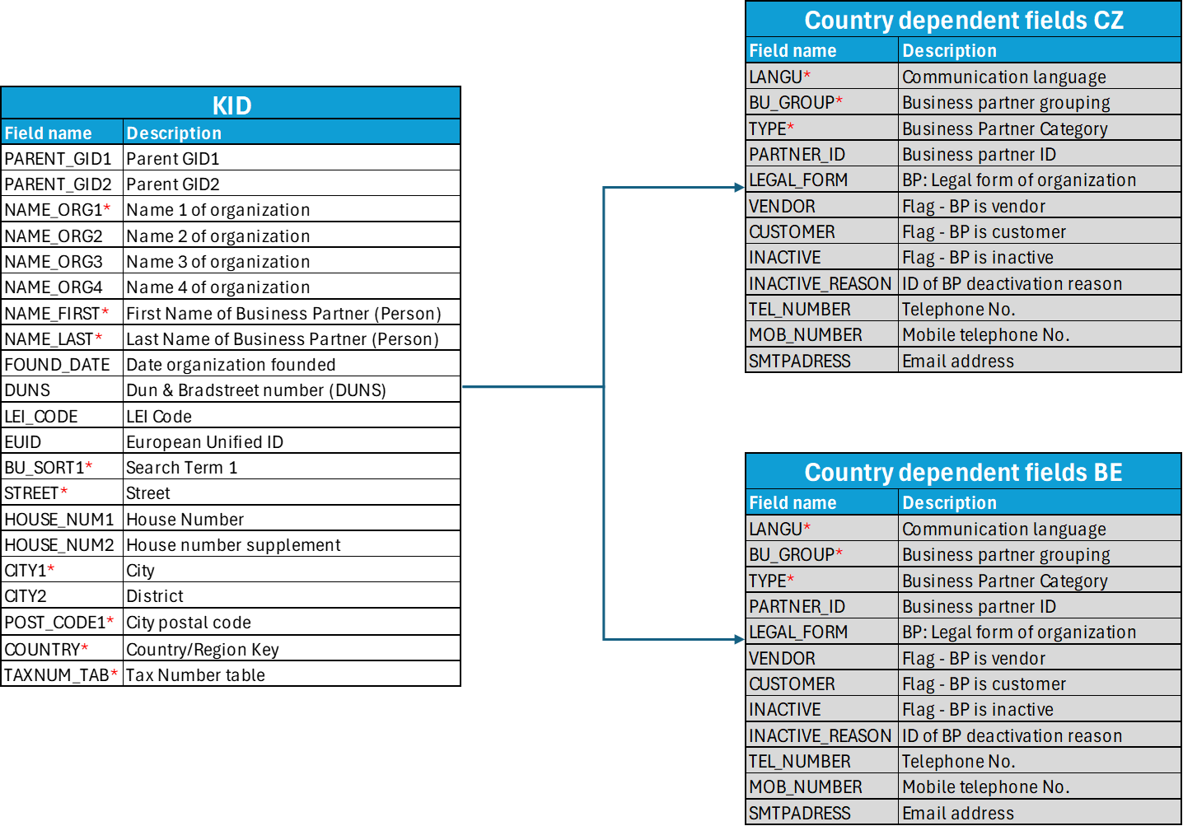
Figure 16: KID and country dependent fields

Note: The field PARTNER (BP ID in connected system) will be editable in MDG request for BP creation in case the field BU_GROUP will contain a value which corresponds to external number interval in SAP (e.g. BU_GROUP = “FU” for SAPCZ).

Following example shows how data will look like for CZ and for BE. KID data are the same, but country dependent data can differ for each country.

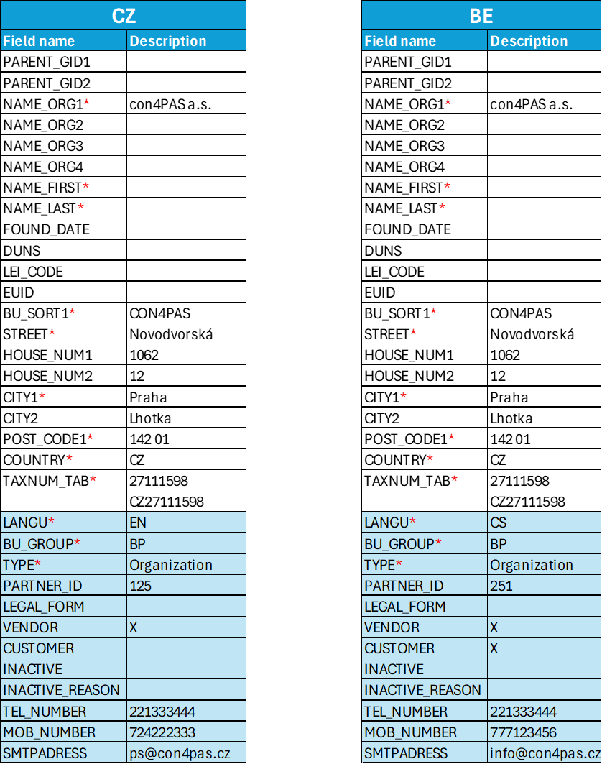
Figure 17: KID and country dependent fields - example

The complete list of KID data and country specific fields is attached in attachment No 1.

Besides fields mentioned above, which can be filled by the user, the request will contain also technical fields that determine who created the request and when, status of the request, the GID (global ID) in case of change request.

Fieldname | Type | Length | Description
REQUEST_ID | Char | 32 | ID of request
REQUEST_TYPE | Char | 1 | Type of request (create / update)
GID | Char | 10 | Unique ID in MDG
STATUS | Char | 3 | Status of the request
LOGSYS | Char | 10 | ID of connected system (logical system) which will be automatically determined according to the selected country and BP existence
CREATED_BY | Char | 12 | Username of the creator
CREATED_AT | Dec | 15 | Date and time of the request creation (RRRRMMDDhhmmss)
CHANGED_BY | Char | 12 | Username of the changer
CHANGED_AT | Dec | 15 | Date and time of the request change (RRRRMMDDhhmmss)

Multi-alphabet support
Apart from Latin alphabet, the MDG will support also other alphabets (e.g. Cyrillic).

The address variant with the NATION field set to <space> must always be filled in, even if no other address variant is required.

For maintenance of the other alphabets there will be available a structure which will contain alphabet specific address including business partner name with additional field “NATION”.

Supported alphabets are listed in chapter 5.2

Fields for which the multi-alphabet support is available:
Fieldname | Description
NAME_ORG1 | Name 1 of organization
NAME_ORG2 | Name 2 of organization
NAME_ORG3 | Name 3 of organization
NAME_ORG4 | Name 4 of organization
NAME_FIRST | First Name of Business Partner (Person)
NAME_LAST | Last Name of Business Partner (Person)
BU_SORT1 | Search Term 1
STREET | Street
HOUSE_NUM1 | House Number
HOUSE_NUM2 | House number supplement
CITY1 | City
CITY2 | District
POST_CODE1 | City postal code
COUNTRY | Country/Region Key

Design of MDG
For partner maintenance there will be available new customer SAP Fiori applications:

Application | Description
Search BP | Application for search business partners. From this application, user can:  - Display BP master record including all country dependent data  - Create request for change partner (link to application Change BP)  - Create request for create partner (link to application Create BP)
Create BP | Application to submit a request for the creation of a business partner
Change BP | Application to submit a request for the change of a business partner
Search requests | Application for search request. From this application, user will be able to:  - Open application “Search BP”  - Display request  - Change request  - Cancel request

Application by user role:
Role | Applications | Description
Requestor | Search BP  Create BP  Change BP  Search requests | Standard user can search all BP, create request for Create/Change BP, search own requests
Administrator | Change BP  Search requests | Administrator can change BP including fields which are not editable by standard user, search all requests, cancel request

Application Search BP
The application Search BP will be designed as follows:

Figure 18: Search BP - application
Searching will be performed only by KID fields listed in following table, so that each result corresponds to only one MDG record.

Fieldname | Description
PARTNER_GID | Global ID
TAX_NUMBER | Tax number or company ID
NAME | Name of the organization or name of the person
COUNTRY | Address country
CITY | City
STREET | Street

Into “NAME” field, user can enter a value for both the company name and the full name of the person.

Into “TAX_NUMBER” field, user can enter all available types of tax numbers according to standard SAP customizing (company ID or VAT numbers).

Table of results will display only KID fields. The field TAX_NUMBER will display all tax numbers (including company ID) concatenated in one string separated by “,”.

User will be able to:
- Display found partner by clicking on GID (represented by link).
- Change, enhance for specific country and inactivation functions will be available in detail of BP (buttons).
- Create new partner by pushing the button “New”.

Applications Create BP and Change BP
The design of the Application Create BP and Change BP will be almost the same however some fields in Application Change BP will not be changeable (see chapter 4.4.1).

Application will be designed as follows:
Figure 19: Application Create BP
Section for alphabet-specific address detail will appear after pushing the button “+” in section “Address variants”. In this section, user must choose the alphabet in which will be the address variant maintained.

Figure 20: Address variant detail

Fields:
- “Requesting country” will be prefilled according to user’s country settings. Change of this fields will be restricted by roles.
- “Created by” will be prefilled according to user, who creates the request. For BE request there will be technical users.
- “Language” will be prefilled according to program logic for CZ/SK countries:
  - If a company registration address is in CZ – language CS
  - If a company registration address is in SK – language SK
  - If a company registration address is not CZ or SK – language EN

User will be able to:
- Save draft – save currently edited request to complete it later
- Submit (request) – release the request for further processing
- Discard the request by closing the application

Application Display BP
Partner display application, shown in the picture below, will display all MDG data related to the GID including country specific data. All fields will be inactivated.

Figure 21: Application Display BP
Section for address variant detail will appear after selecting specific “Nation” in section “Address variants”

Figure 22: Address variant detail
Section for “Country specific details” will appear after selecting specific country in section “Country specific data overview”.

Figure 23: Country specific detail

Application Search requests
The application Search requests will be designed as follows:
Figure 24: Application Search requests
User with role Administrator will be able to search all MDG requests, other users will be allowed to search only their own MDG requests.

All users will be able to:
- Open the application “Search BP”.
- Display request detail by clicking at the Request ID (represented by link).
- Change or cancel request will be available from application display request.

Display request screen will be designed as follows:
Figure 25: Application Display requests

Authorizations

Users onboarding in MDG system (including role assignment) is in KBC responsibility.

Process roles
Process roles | Description
Requester | Authorizations for actions:  - Search for BP in MDG  - Create request for BP creation or BP change.  - Delete own request (if allowed by request status)  - Search, display and change his own request (if allowed by request status)  Types of users involved into MDG processes:  - User from HK department (CZ)  - User from SK accounting department  - User from BE (for manual creation of Ultimate parent)
Administrator | User whose responsibility is to resolve protentional issues in request processing. Authorizations for actions:  - Search for BP in MDG  - Search, display and change all request (if allowed by request status)  - Delete request (if allowed by request status)  - Change some of non-changeable fields (see chapter 4.4.1) when changing request  - Reprocess requests in status “Error”.  Types of users involved into MDG processes:  - MDG central administrator  - User with deactivation role
Reviewer | User who can only search and display BPs in MDG but is not permitted to work with requests in any way.  Types of users involved into MDG processes:  - User from BE (for manual check in MDG)
Communication user | Authorizations for actions:  - Search for BP in MDG  - Create request for BP creation or BP change.  - SOAP services call  Types of users involved into MDG processes:  - Technical user (Robot)  - Technical user for cVerify  - Technical user from SAP BE
MDG technical user | Authorizations for actions:  - Search for BP in MDG  - Change request for BP creation or BP change.  - SOAP services call  - Send email  - Manage processing queues (SMQ*)  Types of users involved into MDG processes:  - Technical users of MDG internal process

Authorization objects
Object | Description
ZMDG_ORIGIN | Authorization object for connected system  Parameter:  - LOGSYS  - ACTVT – display, create, change, extend, deactivate
ZMDG_REQ | Authorization object for request (whose object can be manipulated with)  Parameters:  - USER - request owner  - ACTVT – display, create, change, delete

Authorization roles
Role | Description
ZMDG_ADMIN | ZMDG_REQ  - USER = *  - ACTVT = *
ZMDG_ADMIN_GLOB | ZMDG_ORIGIN  - LOGSYS = *  - ACTVT = *
ZMDG_ADMIN_CZ | ZMDG_ORIGIN  - LOGSYS = CZ  - ACTVT = *
ZMDG_ADMIN_BE | ZMDG_ORIGIN  - LOGSYS = BE  - ACTVT = *
ZMDG_USER | ZMDG_REQ  - USER = SY-UNAME  - ACTVT = *  IWSV  G4BA  S_SERVICE
ZMDG_USER_CZ | ZMDG_ORIGIN  - LOGSYS = CZ  - ACTVT = *  ZMDG_ORIGIN  - LOGSYS = *  ACTVT = display, extend
ZMDG_BP_SEARCH | ZMDG_ORIGIN  - LOGSYS = *  - ACTVT = display
ZMDG_COMM | ZMDG_ORIGIN  - LOGSYS = *  - ACTVT = *  ZMDG_REQ  - USER = *  - ACTVT = *  S_RFC  S_SERVICE
ZMDG_TECH | ZMDG_ORIGIN  - LOGSYS = *  - ACTVT = *  ZMDG_REQ  - USER = *  - ACTVT = *  S_RFC  S_SERVICE  S_OC_SEND

Process role | Authorization role
Administrator | ZMDG_USER, ZMDG_ADMIN, ZMDG_ADMIN_GLOB
Optional: Country admin CZ | ZMDG_USER, ZMDG_ADMIN, ZMDG_ADMIN_CZ
Optional: Country admin BE | ZMDG_USER, ZMDG_ADMIN, ZMDG_ADMIN_BE
Requester | ZMDG_USER, ZMDG_USER_CZ
Reviewer | ZMDG_USER, ZMDG_BP_SEARCH
Communication user | ZMDG_COMM
MDG technical user | ZMDG_TECH

Fiori roles

Assignee of Fiori application to the process role.

Process role | Fiori Application
Administrator | Change BP  Search requests
Requester | Search BP  Create BP  Change BP  Search requests
Reviewer | Search BP

Integration

Highlights

MDG is designed to have the possibility to be integrated with KBC systems and processes of BP maintain.
New integration interfaces will be created within MDG and SAP BTP to fulfil the ability of integration.
Integration of all connected systems will be using SOAP Web Services through SAP Integration Suite in SAP BTP.
Integration interfaces data structure is described in Attachment No 2.
Conversions between different communication protocols (SOAP <-> REST/File/Email) will be in SAP BTP.
Implementation of integration interfaces in SAP BTP and connected systems is in KBC responsibility.

Integration with SAP CZ

Integration with non-SAP systems will be using Web Services through SAP Integration Suite in SAP BTP.
Mapping between source and target protocol and interface structure will be done in BTP integration iFlow.

- Inbound interface for creation of MDG request (IF-MAINTAIN)
  - SAP CZ – cVerify change process of BP
  - ROBOT – Create/Change BP via request from ROBOT

- Inbound interface to read BP data from MDG (IF-READ)
  - Interface can be used to read BP data from MDG

- Outbound updates to connected systems (IF-UPDATE)
  - SAP CZ (BTP) – To receive BP changes from MDG
  - CLM (BTP) – To receive BP changes from MDG
  - TPRM (BTP) – To receive BP changes from MDG

- Outbound notification to connected systems from async req. processing (IF-NOTIFY)
  - CZ (BTP) – To receive notification when new BP is created in MDG to continue with BP postprocessing in SAP CZ

Integration with BE and non-SAP

Integration with non-SAP systems will be using Web Services through SAP Integration Suite in SAP BTP.
Mapping between source and target protocol and interface structure will be done in BTP integration iFlow.

- Inbound interface for creation of MDG request (IF-MAINTAIN)

  - BE (SAP BE) – Create/Change BP via request from DRF framework within SAP BE

- Inbound interface to read BP data from MDG (IF-READ)
  - Interface can be used to read BP data from MDG

- Outbound updates to connected systems (IF-UPDATE)
  - BE (API GW) – To receive BP changes from MDG
  - CLM (BTP) - To receive BP changes from MDG
  - TPRM (BTP) - To receive BP changes from MDG

- Outbound notification to connected systems from async req. processing (IF-NOTIFY)

  - BE (API GW) - To receive notification when new BP is Created/Updated including created GID or process errors

Interfaces

MDG Integration API interfaces overview:

Inbound:

  - IF-MAINTAIN – Interface to maintain BP in MDG
(SOAP interface published in SAP BTP)
    - Create – Create new BP
    - Update – Update or extend existing BP
    - Deactivate – Mark BP as deleted (inactive) on country level

- IF-READ – API to read master data from MDG
    - Return KID data including, duplicities, local SAP IDs and tax numbers

Outbound:

- IF-UPDATE – Interface to update BP in connected systems
(SOAP interface published in SAP BTP)
    - Information about BP Create, Change (Update, Extend, Deactivate)

  - IF-NOTIFY – Asynchronous response interface
(SOAP interface published in SAP BTP)
    - Receive result from request processing at the end of MDG process including return code, error messages and GID for new BP

Alphabet codes for NATION field in ADDRESS.

NATION | Description
 | Default
A | Arabic
B | Hebrew
C | Chinese
D
G | Greek
H | Hangul
I | International LATIN
K | Kanji
M | Chinese traditional
N | Katakana
R | Cyrillic
T | Thai
Z

IF-MAINTAIN

MDG interface for BP maintain operation which will cover whole BP lifecycle, published in SAP BTP

Key input parameters do determine which BP should be Created/Updated
KEY_GROUP1 – relevant for all operations
- LOGSYS – Request ID originator (Source system ID)
- PARTNER_ID – Partner ID from origin country if already exist

Parameters are in detail described in Attachment No. 2. Parameters marked as “Input” are relevant for the operation, “N/A” parameters are not relevant/accepted for the operation.
All operations all relevant for requesting system (country).

Parameters:
- OPERATION - Determine requested operation
- C – Create new BP
- U – Update existing BP or extend for requesting system
- D – Deactivate BP for requesting system
- REQSYS – Unique identification of request source system
- LOGSYS – Unique identification of destination system in which BP will be created (Empty if LOGSYS is the same as DSTSYS)
- PARTNER_ID – BP ID from local system (LOGSYS)
- PARTNER – Partner data structure (KID + country dependent data)
- ADDRESS – Address partner data in different alphabets, space “ ” for default address
- TAXNUM – Table with partner tax numbers
- DUPLICITY – Linking table for controlled duplicities identification

IF-READ

Interface for reading all BP relevant data from MDG.
Partners can be read by local BP ID from source system (Partner ID) or by global ID (GID).
Return structure contains all BP data from MDG.

Input parameters for reading partner from MDG:

KEY_GROUP1
- LOGSYS – Request ID originator (Source system ID)
- PARTNER_ID – Partner ID from origin country if already exist
KEY_GROUP2
- PARTNER_GID – MDG Partner GID

IF-UPDATE

Interface will be implemented in SAP BTP, form MDG will be data send through this interface in case of any BP data change in MDG.
The message will be always sent to the CLM and then routed to corresponding systems based on the LOGSYS in the table PARTNERS[1..n].

IF-NOTIFY

Asynchronous response interface from MDG which will be published in SAP BTP and can be implemented in connected systems for receiving response from asynchronous operations from requests processing in MDG.
Notify message will contain local SAP Partner ID, GID, return code and messages from request processing.
KBC is responsible for implementation of this interface in connected systems if requested including API GW in BE environment.

SAP CZ

DRF must be extended with create change request via IF-MAINTAIN in SAP BTP to ensure all changes on BP in SAP CZ will be replicated to the MDG, including cVerify process.
SAP CZ will be notified with IF-UPDATE when BP changes in MDG.

In case any error occurs, MDG request will remain in status Replication in process and MDG administrator will be notified.

Prerequisites:
- IF-UPDATE must be implemented to receive BP create/change from MDG

- Prepare BTP integration for interfaces IF-MAINTAIN, IF-UPDATE and IF-NOTIFY
- Extend ROBOT for calling IF-MAINTAIN published in SAP BTP
- Implement iFlow in SAP BP for interface IF-NOTIFY with logic extending BP in SAP CZ with data from ROBOT request

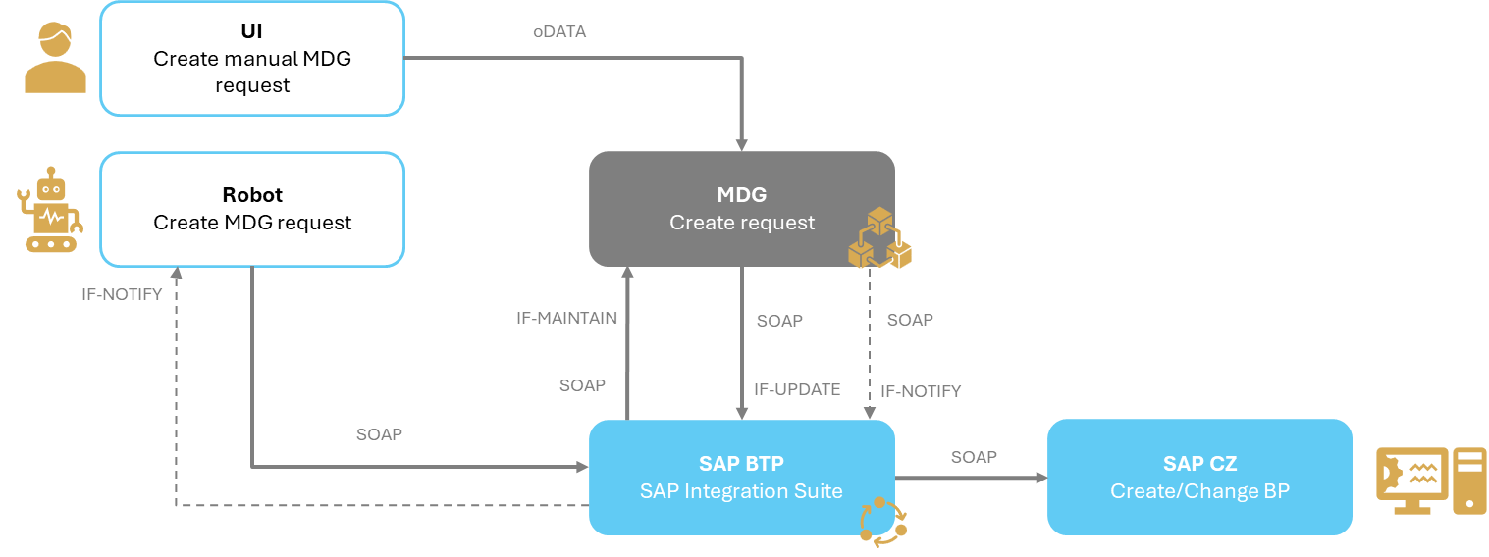
Figure 26: Integration of SAP CZ

cVerify change process

cVerify process can remain unchanged.

After manual approval and direct data change in SAP CZ, DRF will replicate the change of BP to MDG via integration API IF-MAINTAIN on SAP BTP. So, the change request in MDG will be created after data changes in SAP CZ are completely saved.

No data of BP will be replicated back from MDG to SAP CZ after the standard process finished in MDG.

Prerequisites for SAP CZ:

- Implement IF-MAINTAIN in SAP BTP
- Send changes with DRF to SAP BTP after BP save process

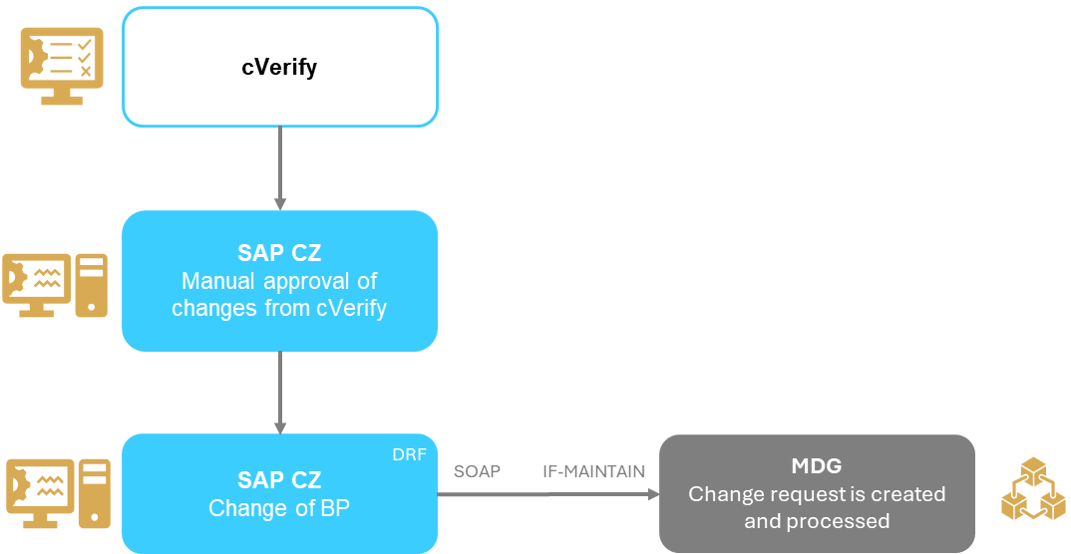
Figure 27: Integrations in cVerify process

BE

DRF must be extended with create change request via IF-MAINTAIN in SAP BTP to ensure all changes on BP in SAP BE will be replicated to the MDG.
API GW in BE will be notified with IF-UPDATE when BP change in MDG and with IF-NOTIFY in case any errors occur in MDG.

Prerequisites:
- Extend DRF to call SAP BTP in SAP BE
- Interfaces IF-UPDATE and IF-NOTIFY must be implemented in SAP BTP
- Prepare API GW for receiving message from interfaces IF-UPDATE and IF-NOTIFY

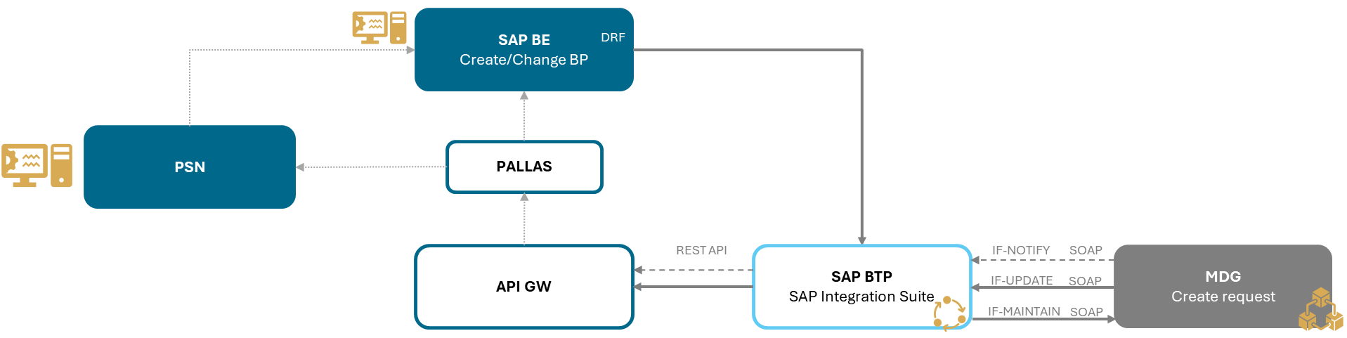
Figure 28: Integrations of BE environment

CLM

Integration between MDG and CLM will be trough SAP BTP and new integration interface IF-UPDATE which will cover whole BP lifecycle.
Current integration from SAP CZ to CLM must be de-implemented.
New integration from MDG to CLM will be implemented.
When BP will be created/changed in MDG, change data will be replicated to the CLM at the end of the change process through IF-UPDATE interface.
Information for which country is BP relevant is in table PARTNERS[1..n], this table contains system identification, local SAP Partner ID and flag if partner is active or inactive in the system.

Prerequisites:
- CLM must be prepared for country dependent extension/deactivation
- Interface IF-UPDATE must be implemented in SAP BTP

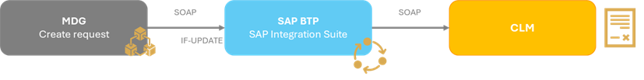
Figure 29: Integrations of CLM

TPRM

Integration between MDG and TPRM will be trough SAP BTP and new integration interface IF-UPDATE which will cover whole BP lifecycle.
When BP will be created/changed in MDG, change data will be replicated to the TPRM at the end of the change process trough IF-UPDATE interface.
All BP data from MDG will be sent through this interface to SAP BTP.

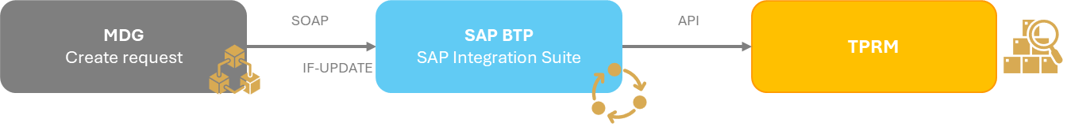
Figure 30: Integrations of TPRM

Project management

Project plan

The new proposal is based on narrowing the scope and the assumption that the prerequisites will be met in a timely manner on the part of KBC.

Project phase | Implementation phase | Duration (in weeks) | Date start | Date end
Prepare | Implementation and planning | 1 | 02.02.2026 | 08.02.2026
Explore | Analysis | 12 | 09.02.2026 | 03.05.2026
Realize | Configuration | 17 | 04.05.2026 | 30.08.2026
Realize | Development | 17 | 04.05.2026 | 30.08.2026
Realize | Integration | 17 | 04.05.2026 | 30.08.2026
Realize | Testing | 6 | 31.08.2026 | 11.10.2026
Deploy | Training | 2 | 12.10.2026 | 25.10.2026
Deploy | Deploy | 2 | 12.10.2026 | 25.10.2026
Run | Pilot Phase | 12 | 26.10.2026 | 17.01.2027
Run | Go-live and Babysitting (post go-live support) | 12 | 26.10.2026 | 17.01.2027

Project risks

The following risks are necessary to mitigate:

Risk | Impact | Risk level * | Mitigation
Meet the prerequisites by the specified deadlines | Significant impact on the project timing | H | Regularly check that prerequisites are met
Prepare environment for MDG - new standalone system | Significant impact on the project timing | H | Start MDG in separate client of SAP CZ.  Plan the migration to stand alone environment after the MDG has been stabilized on production system. The reason is to adhere to the project schedule and milestones.
Cyrillic and other alphabet – according to open issues | • Inconsistent opinions and the need to use multiple alphabets in addition to the TPRM system.  • Inconsistent opinions on whether it is mandatory to have a record of a single BP in both Latin and Cyrillic, or whether using a single alphabet is sufficient.  • There is no established process for determining who would be responsible for ensuring accurate translations and transcriptions into languages such as Greek, Japanese, etc. | H | Standardizing requirements across systems and ensuring system readiness  SAP BE: clean up the data (do not mix Cyrillic and Latin in one BP record)  Decide on change request – CHR01
MDG Attribute for TPRM | Inability to design processes in MDG due to the failure to provide complete requirements including processes in connected systems. | H | Descope any additional attributes that are not listed in the Blueprint as of April 30, 2026  Decide on change request – CHR02
TPRM integration with MDG | Significant impact on the project timing | H | Confirm suggested integration of MDG with TPRM asap
Deduplication and matching | Significant impact on the project timing  Data quality | H | Set up process and responsible person
Changes to the scope must be halted – architecture and integration dependencies must be final, otherwise there is a risk that the project schedule will need to be revised. | Significant impact on the project timing | H | Implement change management
Changes to processes related to the robot | Impact on the project timing  Process changes | M | Processing without a robot, or maintaining the existing robot workflow with integration into SAP CZ and replication of the BP to MDG via an interface IF-MAINTAIN
Integration SAP CZ with MDG via SOAP | Process changes -> Changes to Blueprint  Impact on the project timing  Impact on capacity con4PAS and KBC | H | Keep RFC integration

S – small risk
M – medium risk
H – high risk

Open issues
KBC must ensure that outstanding issues are resolved and confirm that they will be addressed within the specified deadlines; otherwise, there is a risk of a significant impact on the project schedule.

Open issue | Description | Resolution date | Status
Prepare environment for MDG - new standalone system | Chapter 7.1 | 3.5.2026 | Resolved  3.5.2026
Cyrillic and other alphabet | Chapter 7.2 | 6.5.2026 | Unresolved
MDG Attribute for TPRM | Chapter 7.3 | 6.5.2026 | Unresolved
TPRM integration with MDG | Chapter 7.4 | 6.5.2026 | Resolved 12.05.2026
Deduplication and matching | Chapter 7.5 | 6.5.2026 | Unresolved
Integration SAP CZ with MDG via SOAP | Chapter 7.6 | 6.5.2026 | Resolved 12.05.2026
Central user management | Chapter 7.7 | 6.5.2026 | Unresolved
Change of BPs which are shared between CZ/SK and BE | Chapter 7.8 | 6.5.2026 | Resolved 12.05.2026
Only vendors are in system SAP BE | Chapter 7.9 | 6.5.2026 | Resolved 12.05.2026

Prepare environment for MDG - new standalone system
Resolution:
KBC chose variant 1 (described below).

MDG was to be implemented in a separate client in SAP CZ system. The con4PAS proposal for implementing the functionality also took this environment into account.

On 23.04.2026 was announced by KBC BE that MDG should have a separate system for MDG.

Variant 1: MDG will be in a separate client within the SAP CZ system
Advantages:
- Can be transferred to another SAP environment with no additional effort by copying the client.
- A separate, independent environment from SAP CZ.

Disadvantages:
- Managing two clients, user maintenance.

Variant 2: MDG will be deployed in the same client within the SAP CZ system
Advantages:
- Management of a single client, user maintenance, no additional resources.

Disadvantages:
- Transfer to a separate system is complex; after copying the client to the new system, data outside of MDG must be deleted.
- Environment depends on the SAP CZ client, which contains other modules and functionalities.
- In SAP CZ data remains from MDG.

Variant 3: New Environment for MDG
Advantages:
- A standalone, independent system

Disadvantages:
- The environment is not ready for the start of the implementation phase.
- Additional work within the project (integration, migration of the MDG solution)

Task on KBC side:
- Make decision about variants till 3.5.2026
- If variant 3 is selected, reschedule the project timeline

Cyrillic and other alphabets

Follow up from 12.05.2026:

- TPRM demands the maintenance of BG BP in both Cyrillic and Latin alphabets, as well as BP names in alphabets according to the state of the company.
- MDG will be prepared to maintain multiple alphabets according to the SAP standard. KBC must be able to process the alphabets provided by MDG.
- SAP BE will not be able to provide separate records in Cyrillic and Latin for BG BP. In Nation ( _), where BP is maintained in Latin, some BPs will have a record in Cyrillic.
- KBC proposed the following process change requirements: The BP record will be sent to MDG in Cyrillic, but with an indicator that it is in Latin. In MDG, the request for BP creation/change is to be suspended. Subsequently, the data will be supplemented by a competent person.

From the project perspective, this is a change request CHR01, within which a detailed analysis of the conditions for suspending the request in MDG and determining the process for supplementing data must be carried out.

Using alphabet
State as of 30.4.2026:
The TPRM requires the use of both the Latin and Cyrillic alphabets in cases where the BP record was in Cyrillic only.
In connection with this, con4PAS presented how this can be handled as standard in SAP.

During the meeting on April 23, KBC requested MDG to be able to send the Greek alphabet (for Greece company) to TPRM and for MDG to be prepared for all possible alphabets.

Information from Belgium: They will not use both Cyrillic and Latin character sets in the SAP system in accordance with the SAP standard. They will use only one character set, either Cyrillic or Latin in one record.

Information from the Czech Republic/Slovakia: They will use only the Latin character set in the SAP system but will enter both alphabets in the MDG system.

con4PAS highlighted the goals of MDG, which were established at the beginning of the project: the creation of a GID (golden record), the synchronization of selected attributes to connected systems, and the deduplication process. Currently, KBC requires the use of multiple alphabets, for which local systems are not yet prepared, nor is the CLM system in MDG first phase.

Open issues:
- Inconsistent opinions and the need to use multiple alphabets in addition to the TPRM system.
- Inconsistent opinions on whether it is mandatory to have a record of a single BP in both Latin and Cyrillic, or whether using a single alphabet is sufficient.
- There is no established process for determining who would be responsible for ensuring accurate translations and transcriptions into languages such as Greek, Japanese, etc.
- If Belgium uses only one alphabet and character set—either Cyrillic or Latin—in a single record, and the Czech Republic/Slovakia uses the Latin alphabet, data overwriting may occur; see the image.

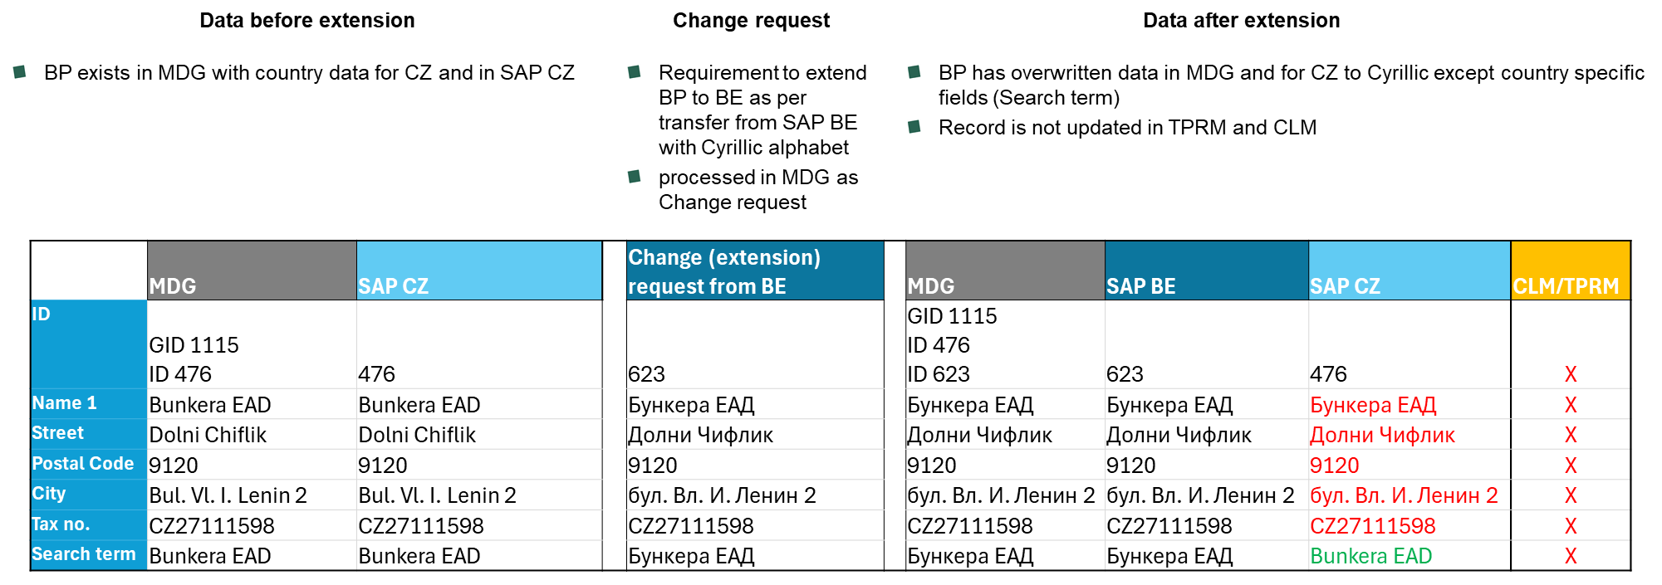
Figure 31: Example of change when BP is in SAP CZ in Latin and in SAP BE in Cyrillic

Impact on the project: Data inconsistencies between systems

Task on KBC side:
- Solve the open issues mentioned above
- Solve the task 78 from CSOB_task_list.xlsx
- Decide about CHR01

Cyrillic in SAP BE
State as of 30.4.2026:
Use of the Cyrillic alphabet – SAP BE uses the Latin alphabet in the BP field Name 1 and the Cyrillic alphabet in fields Name 2, 3, and 4 for BG companies.

Impact on the project: Incorrect data and its replication from MDG to CLM, TPRM and SAP CZ (when the BP is shared)

Task on KBC side:
- Clean up the data in advance (August 31, 2026); all fields of a single BP record must use a single alphabet – prerequisite number 15
- Verify the impact of data cleansing on BE processes and systems.
- Consider rescheduling the project timeline, if the data cannot be cleaned in time

MDG Attribute for TPRM
Follow up from 12.05.2026:
- KBC provided requests for additional attributes required in MDG for TPRM: TPRM Reg requirements for MDG v1.01.docx

Requested changes may have a fundamental impact on the MDG and the proposed processes. Requested changes must be addressed as a Change request CHR02.

State as of 30.4.2026:
From KBC side the Attribute for TPRM, process and purpose are not completely defined. Task to KBC was created on 26.02.2026, number in task list is 39.

con4PAS highlighted that from the MDG perspective, it does not make sense to maintain data that are relevant only to TPRM and not to other connected systems in MDG. The goals of MDG, which were established at the beginning of the project: the creation of a GID (golden record), the synchronization of selected attributes to connected systems, and the deduplication process.

Impact on the project: Process is not confirmed; task is not solved from 26.2.2026

Task on KBC side:
- Confirm the requirement on process
- Solve the task 39 from CSOB_task_list.xlsx – Solved.

TPRM integration with MDG
Resolution:
KBC chose variant 3 proposed by con4PAS. All BP records will be sent from MDG to TPRM via API integrated in SAP BTP (similar approach as for CLM and SAP BE). Initial load will be full scope of data in MDG reusing integration API with special indicator for initial load. After initial load, MDG will send data only after change has been performed in MDG. Details described in chapter 5.6.

Task on KBC side:
- Solve the task 70 from CSOB_task_list.xlsx – Solved.

Deduplication and matching
Follow up from 12.05.2026:
- CZ proposed to follow variant 2 but still must be reviewed and approved by BE.

State as of 30.4.2026:
Deduplication and matching will require preparation on KBC side. Data cleansing on local systems prior to testing.

Task on KBC side:
- Establish processes for BP management – responsible team for data cleansing on local systems.
- Responsible team for deduplication and matching within MDG (in test phase test and production prepare /deploy phase).
- Approval of data discrepancies between BE and CZ – set the process
- Solve the task 74 from CSOB_task_list.xlsx – choose recommended variant 1 or variant 2 according to CSOB__Master_Data_Governace__deduplication_matchingWS8.pdf

Integration SAP CZ with MDG via SOAP
Resolution on 12.05.2026:
- CZ will use only Web services (SOAP). RFC integration will not be implemented. Described in chapter 5.1.1. and 5.3

11th Workshop on 30.04.2026 a new requirement is to not integrate SAP CZ with MDG using RFC but rather using web services via SAP BTP.

Impact on the project:
- Change processes and update Blueprint
- Possible changes to the project plan

Task on KBC side:
- Solve the task 83 from CSOB_task_list.xlsx - Solved

Central user management
State as of 30.4.2026:
Confirm user management

Task on KBC side:
- Solve the task 40 and 41 from CSOB_task_list.xlsx

Change of BPs which are shared between CZ/SK and BE
Resolution on 12.5.2026:
Approval process is required if change has been made on shared BP. Change must be approved by each country before it is updated on BP record.

Define process for shared BPs between CZ/SK and BE.

Only vendors are in system SAP BE
Resolution on 12.5.2026:
KBC confirmed both customers and vendors are in SAP BE.

In SAP BE there are only vendors.

Suggested solution for BE:
If it is necessary to add a customer who is not in SAP BE to the CLM system, SAP BE user can create the customer directly in the MDG system; the MDG system will then replicate the data to CLM and also send it to the API Gateway.

Attachments

Attachment no. | Name | Description
No 1 | Request_data_KID.xlsx | The list of KID data and country specific fields
No 2 | Interface_structure.xlsx | Description of integration interfaces data structure
No 3 | CSOB_task_list.xlsx | Task list
No 4 | CSOB_Integration.xlsx | Overview of systems
No 5 | Annex 1_KBC_Master Data Governance_BRQ Set_20250602.xlsm | Business requirements
No 6 | TPRM Reg requirements for MDG v1.01.docx | TPRM requirements

Prerequisites

The prerequisites must be ensured before the start of the implementation phase or during the implementation phase are summarized in the table below.

These activities must be ensured by KBC and confirmed that implementation will be ensured within the required deadlines otherwise, there is a risk of a significant impact on the project schedule.

Prerequisites for starting the Realize phase

ID | Description | Detail | Timing
1 | Network connectivity (visibility) between SAP and non-SAP systems | Ensure necessary network connections (IPs/ports) between MDG and involved components | Until 03.05.2026
2 | Access to affected SAP systems for Supplier Team | Provide access and authorizations to MDG and involved SAP systems | Until 03.05.2026
3 | Remote access to ČSOB/KBC environment (VPN) for Supplier Team |  | Until 03.05.2026
4 | Connection between connected systems and integration platform | Prepare connections between connected systems including MDG and integration platform (BTP) | Until 03.05.2026
5 | Access to external registers, including licenses, if needed | Detail in slide „Registers“ | Not relevant for 1. Phase
6 | Prepare interfaces to external registers, including technical documentation (in English) | Detail in slide „Registers“ | Not relevant for 1. Phase
7 | Integration platform | Provide integration platform | Until 03.05.2026
8 | SAP systems will support SOAP web Services for data Exchange. The integration platform will convert other communication protocols to/from SOAP. | Prepare all integration interfaces of MDG must be implemented on SAP BTP | Until 03.08.2026
9 | Prepared new client or environment for the MDG application | Prepared new client or environment for the MDG application | Until 03.05.2026
10 | Realization of impact of the new BP process on local systems | Switch Robot interface to SAP MDG  Change the process | Until 03.08.2026
11 | Transfer data from SAP BE to SAP MDG | Implement logic in SAP BE to trigger and transfer creation or change of BP to SAP MDG via SAP BTP | Until 03.08.2026
12 | Ensure development environment for Fiori | Provide access and authorizations to development environment for Fiori | Until 03.05.2026
13 | Mapping from a single BP in MDG to multiple BPs in CLM will be handled at the SAP BTP level. | Mapping from a single BP in MDG to multiple BPs in CLM will be handled at the SAP BTP level. | Until 03.08.2026
14 | TPRM will be prepared to receive and import data from MDG file | TPRM will be prepared to receive and import data from MDG file (MDG structure see Blueprint) | Until 03.08.2026
15 | SAP fields (BP object) should be used in a single language (not possible to use Latin and Cyrillic alphabet in one record), as specified by the SAP standard. | Clean up the data in advance | Until 31.08.2026
16 | Ensure all relevant users can access MDG with sufficient authorizations | All users who will work with MDG must be able to access MDG with sufficient authorizations (users from CZ, BE, SK…) | Until 31.08.2026
17 | cVerify | Implement IF-MAINTAIN interface for MDG notification of BP changes | Until 03.08.2026

Prerequisites for deduplication and matching

ID | Description | Detail | Timing
1 | Preparation of test environment | Copy the SAP CZ production system to the test environment before beginning MDG configuration | Until 03.05.2026
 |  | Prepare the relevant BE test environment  Configure integrations  Verify the functionality of integration services  Start services to load data into SAP | Until 06.09.2026
 |  | Start services to load data into SAP MDG from connected systems | From 07.09.2026 until 25.10.2026
2 | Preparation of production environment | Configure integrations  Verify the functionality of integration services  Start services to load data into SAP MDG from connected systems  Country clearing | From 26.10.2026 until 8.11.2026
3 | Responsible users for deduplication and matching data | Determine responsible users who will perform removal of duplications in local systems and make decision in cross country matching. | From 07.09.2026
4 | BP data must be imported into CLM from MDG for BE | BP data must be first in SAP MDG and then replicated to production CLM for BE. | Before Go live CLM BE

Abbreviations used

Abbreviation | Description
API GW | API Gateway
BP | Business partner
BTP | SAP Business Technology Platform
CLM | Application for Contract Lifecycle Management
CVI | Customer Vendor Integration
GID | Golden ID
HK department | Hradec Králové department
IDOC | Intermediate document (SAP document format for business transaction data transfers)
JSON | JavaScript Object Notation (lightweight data-interchange format)
KID | Key identification data
MDG | Master Data Governance
PSN | Belgium master system for BP maintenance
REST | Representational State Transfer (service type)
RFC | Remote function call
RFP | Request for proposal
SOAP | Simple Object Access Protocol (service type)
TPRM | Application for regulatory reporting
VMO | Vendor Management Officer
WS | Web service

Change request

No. | Description
CHR01 | 7.2 Cyrillic and other alphabets
CHR02 | 7.3 MDG Attribute for TPRM

