1. **Vue Smart Glasses**

<https://www.kickstarter.com/projects/vue/vue-your-everyday-smart-glasses>

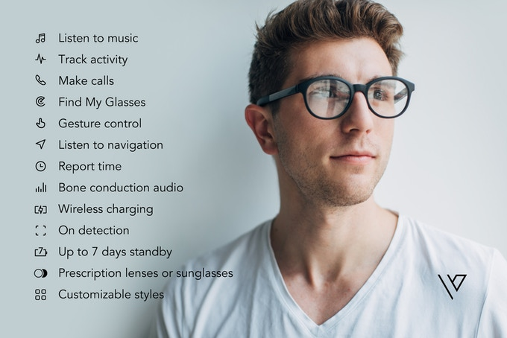



**Product Description:**

Glasses that can assist with more than just your vision. Vue Smart glasses are a trendy new way to help make everyday tasks easier. These glasses can perform functions such as play music, make calls, navigation audio, report time, wireless charging, and other functions listed. This product is offered in prescription, sunglasses, or aesthetic lens. Product is priced at $269.

1. **SenSoria Fitness Socks**

<https://www.askmen.com/fashion/trends/futuristic-fashion.html>

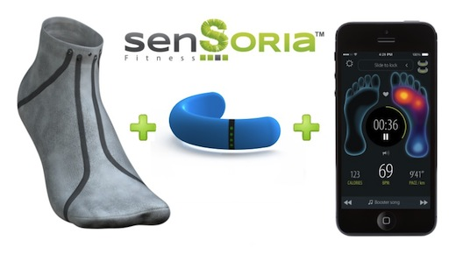

**Product Description:**

How would you like to have the future sitting right at the tip of your toes. Sensoria Fitness socks are like socks you have never seen before. These socks have the ability to track a person’s body data during physical activity. With the use of proprietary textile sensors and Bluetooth devices/apps, these socks are able to improve workout performance. This product is priced at $74. The quality will have you running from excitement.

1. **Smart Coat**

<http://futuristicnews.com/a-new-concept-smart-coat-at-ces-2013/>

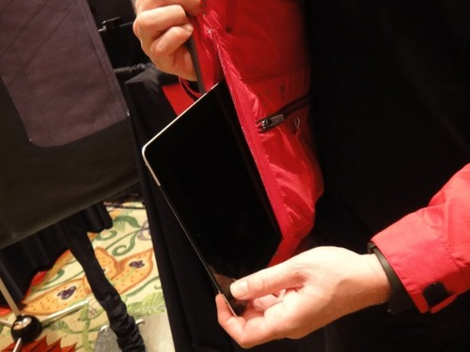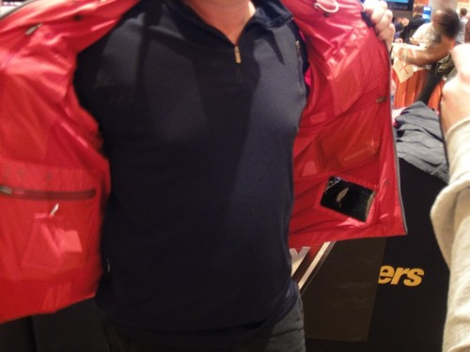

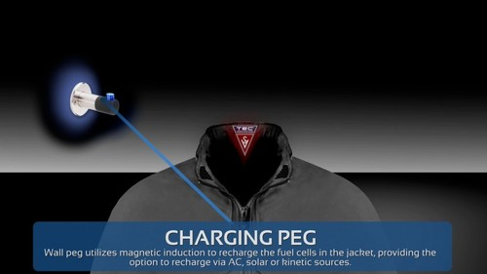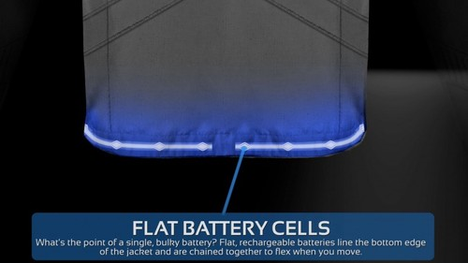

**Product Description:**

With winter right around the corner you need to have the best jacket . The TEC Jacket 2.0 will make you want to throw all your other coats away. This smart-coat is equipped with numerous gadgets that can be used any time any place. Speakers, noise-cancelling microphones, a built in antenna, and a mounted heads up display will make it easy for phone calls and conversation. The smart-coat also has an even heat feature which will regulate your body temperature to your preferred settings. Pricing begins at $275 and will vary within sizes.

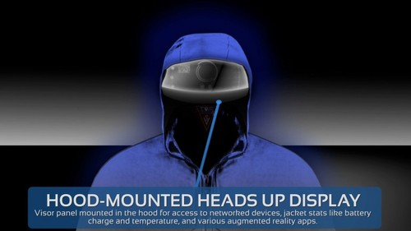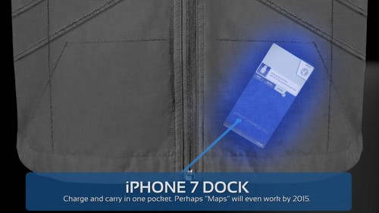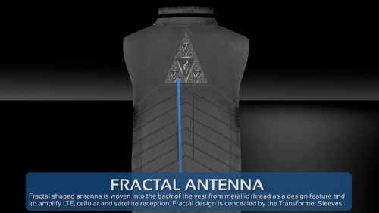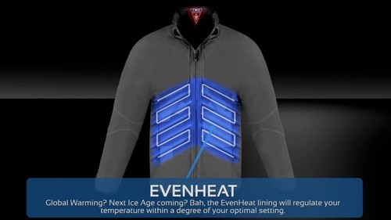

1. **Lechal Haptic Footwear**

<https://www.geek.com/geek-cetera/11-pairs-of-amazing-future-shoes-1635675/>

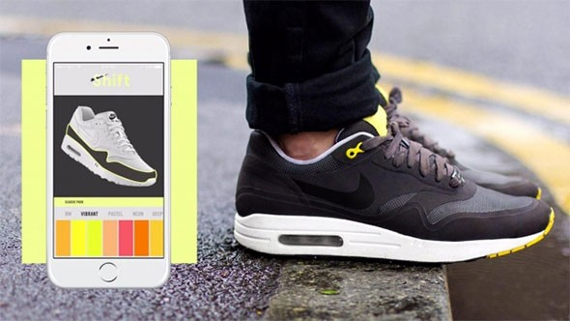

**Product Description:**

Tired of looking down at your phone for directions while walking? With the risk of bumping into someone or possibly getting into an accident, smart-shoes will instantly become your top choice. Lechal haptic footwear has design shoes that will help you navigate to your destination without needing to look at your phone the entire time. With the use of Bluetooth connection, the smartphone app will instruct the shoes to use vibrations to tell you which way to turn. On top of it all, the shoes will also track steps and calories burned. These fashionable shoes are prices at $185 and are offered in both women and men styles.

1. **Under Armour Athletic Wear Touchscreen Abilities**

<http://futuristicnews.com/clothing-with-touchscreen-capabilities/>

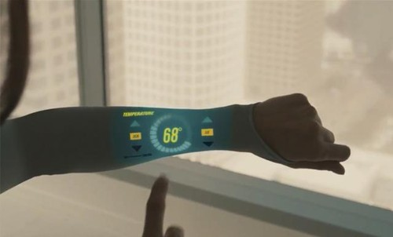

**Product Description:**

Are you tired of using armbands and wrist watches during your workouts? What if you could monitor your body data with the simple touch of your arm? Under Armour has taken a leap in wearable technology and come up with a new design for their clothing. Amour39 is a technological device implemented into fabric that will measure a person’s performance data such as heart rate, calories burned, and the intensity of the workout. The sleeve is a touchscreen interface that will allow the use to see and maneuver around the data. Pricing starts at $235 and will vary depending on the clothing style.