WireWorld Cell-DEVS

SYSC 4906 Assignment 2 Report
Joseph Andrews
101181948

Conceptual Model Description
WireWorld is a two-dimensional cellular automaton introduced by Brian Silverman in 1987 to simulate electronic logic elements and circuits. It is Turning-complete, therefore it can theoretically be used to build a fully functioning computer using the simple grid-based local transition rules. The physical model represents the flow of electrical currents through wires using discrete time steps.

This project adapts a 2005 Cell-DEVS conceptualization of WireWorld originally developed by Abdulelah Al-Sanad, migrating the architecture to the Cadmium v2 C++ simulation framework.

Each cell in the WireWorld grid can exist in four states:

State Value | Description | Visual Representation
0 | Background | Black
1 | Electron Head | Blue
2 | Electron Tail | Red
3 | Wire | Yellow

The state transitions follow strict rules evaluated at each time step based on the cell’s current state and its neighborhood:

- Background cells always remain Background
- Electron Head always becomes the Electron Tail
- Electron Tail always becomes Wire
- Wire becomes an Electron Head only if exactly 1 or 2 of its neighbors are Electron Heads, otherwise it remains as a Wire

Formal Specification

The WireWorld cellular model is formally defined as follows:
$M = \left\{I, X, Y, X_{list}, Y_{list}, η, N, \{m, n\}, C, B, Z, select\right\}$
Where:
- $I = <p^{X}, p^{Y}> where p^{X}=\{ϕ\} and p^{Y}=\{ϕ\}$
- $X = Y = \{0, 1, 2, 3\}$ representing the four elemental states.
- $X_{list}=\{ϕ\}$
- $Y_{list}=\{ϕ\}$
- $η = 100$ representing the default transport delay for the local computation function
- $N$ is the moore neighborhood set: $N=\{(-1,−1),(−1,0),(−1,1),(0,-1),(0,0),(0,1),(1,−1),(1,0),(1,1)\}$
- $\{m, n\}$ define the dimensions of the 2D grid (configured as 20 x 20 in this implementation)
- $C = \{C_{ij}\}$where $i ϵ[1, m] and j ϵ [1, n]$
- $B = \{ϕ\}$
- $Z$ - Translation function
- $select =\{ (-1,-1), (-1,0), (-1,1), (0,-1), (0,0), (0,1), (1,-1), (1,0), (1,1)\};$

Experimental Framework & Execution Analysis

Clock Generator
This scenario consists of a closed loop of wire connected to a straight output wire.

An initial Electron Head and Tail are placed within the loop. As the electron traverses the loop, the output wire detects exactly 1 Electron Head invoking Rule 4. This duplicates the electron, and sends a pulse down the outwire wire.

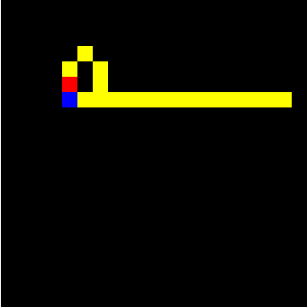
Figure 1: Initial Electron Head and Tail in the loop
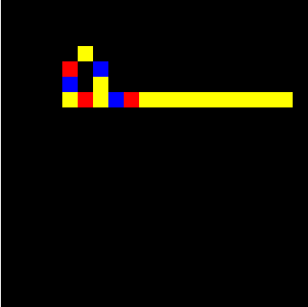
Figure 2: Electron duplicated and sent through the output wire once detected

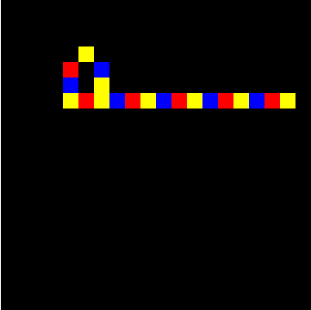
Figure 3: Multiple Electrons being output

Signal Splitter

An Electron going down a single wire splits into 2 at a Y-junction.

When an incoming Electron Head reaches the junction, both branching wires detect 1 neighboring Head. Both branches simultaneously transition to state 1, splitting the signal into two identical outputs.

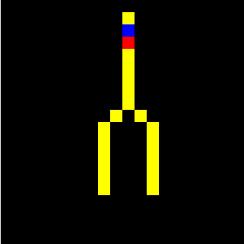
Figure 4: Initial configuration of Electron

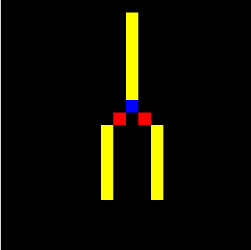
Figure 5: Electron hits junction and splits

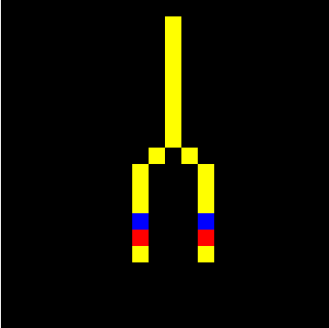
Figure 6: Electron is duplicated

Asymmetric Diode

A diode is constructed using an asymmetric layout of copper wire that forces electrons to interact differently depending on their approach.

Forward Result: Approaching from the correct direction, the electron head goes through the junction because the adjacent wire cells never exceed 2 neighboring cells.

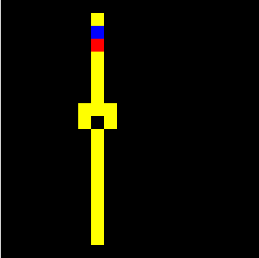
Figure 7: Initial Electron Configuration
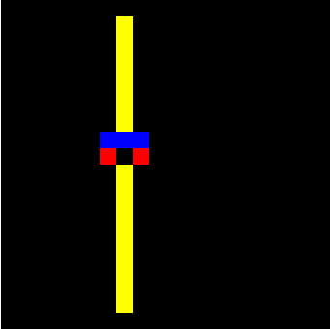
Figure 8: Electron splits through the junction

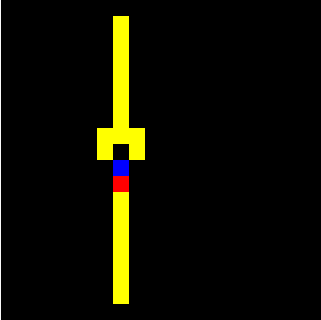
Figure 9: Electron passes through the junction.

Blocked Result: Approaching from the reverse direction, the signal hits the wider side of the junction. At this point the target wire detects 3 simultaneous Electron Heads in its neighborhood, Rule 4 fails and the signal is extinguished.
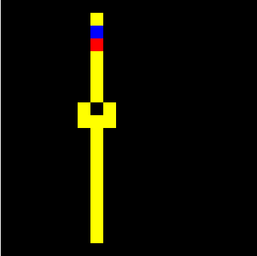
Figure 10: Initial Electron Configuration

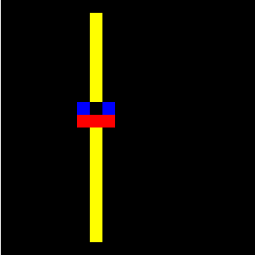
Figure 11: 3 Electrons are detected in the target wires neighborhood
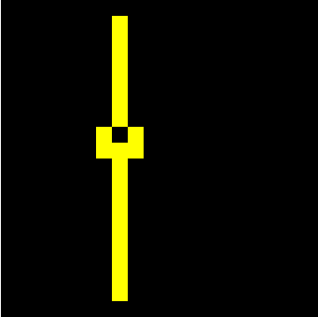
Figure 12: Electron is extinguished

Logic OR Gate

Two inputs wires merge into a single output path.

When a single is sent down Input A, Input B, or both simultaneously, the junction detects either 1 or 2 electron heads. Under Rule 4, the junction transitions to state 1, allowing the signal to go through the output wire.

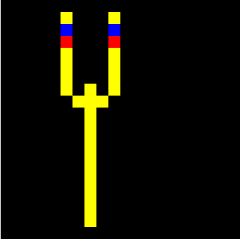
Figure 13: Initial Electron Configuration

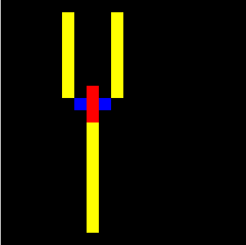
Figure 14: Electron enters junction and is detected by the junction

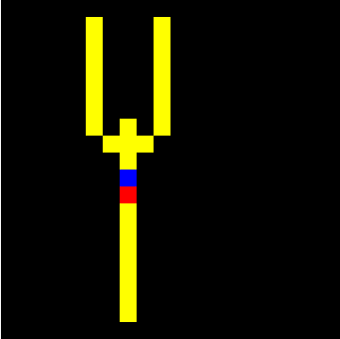
Figure 15: Electron propagates through the output wire

