1. How many unique observations to you have? **with the cleaned data, 366 observations of 12 variables**

2. What information/features/characteristics do you have for each observation? **each observation is the daily recorded weather information and for each observation, there is the: temperature in degrees Fahrenheit (low, high, average), humidity in percentage (low, high average), wind speed in miles per hour (low, high, average), precipitation in inches, and whether an event occurred [rain, snow, fog, etc.]**

3. What are the min/max/mean/median/sd values for each of these features?  
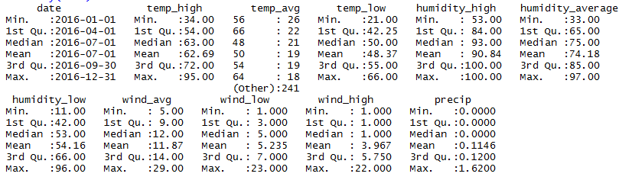

4. What is the distribution of the core features (show a histogram)?  
**temp_high**  
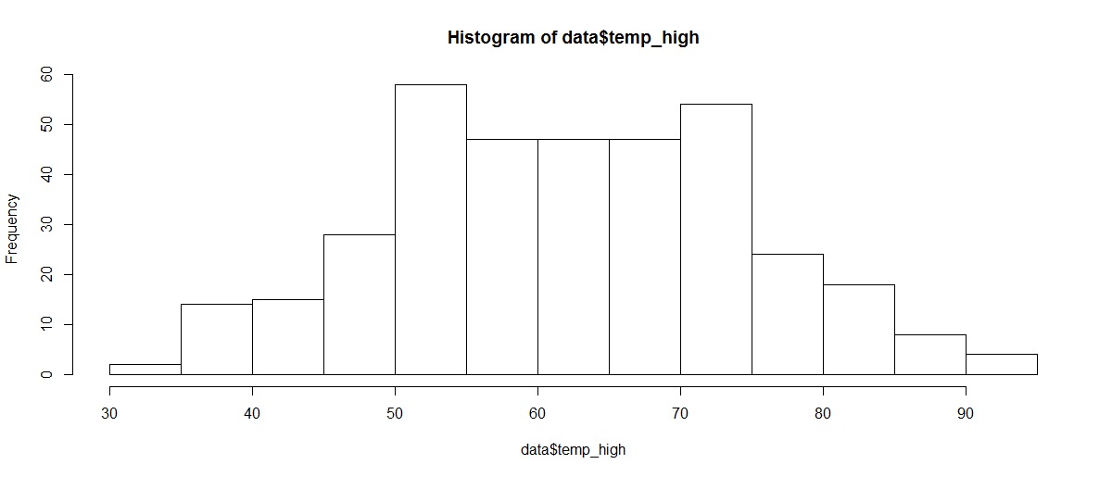

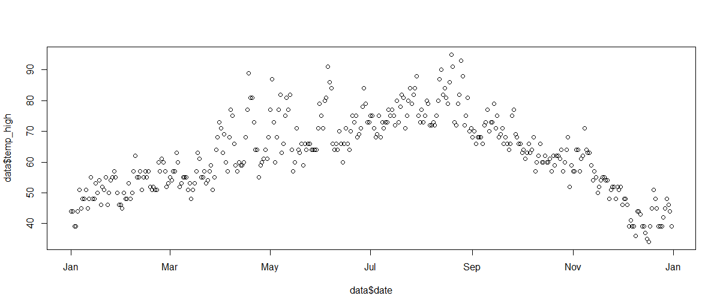

**temp_low**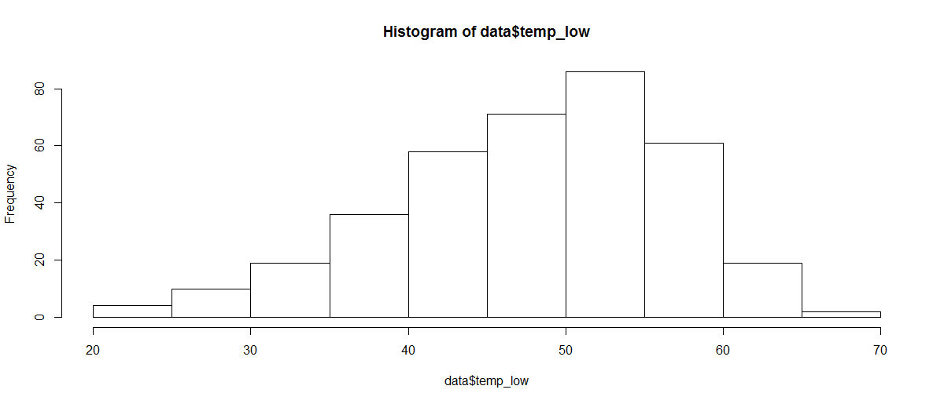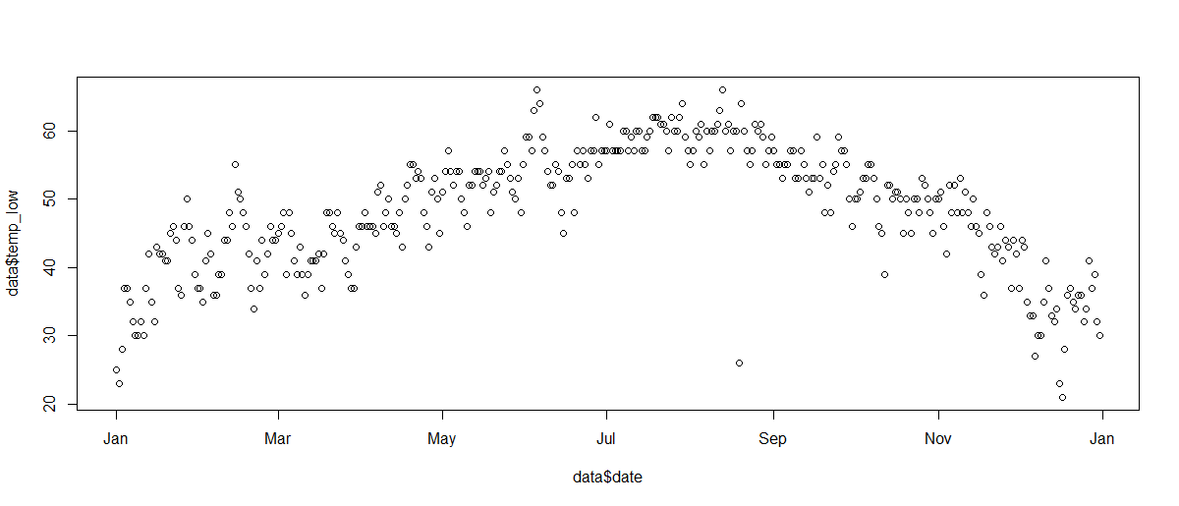

**humidity_avg**

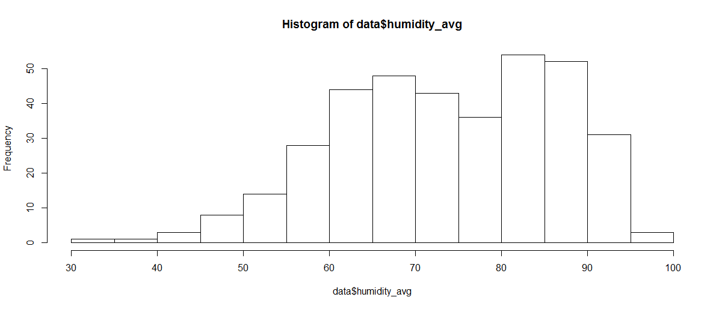

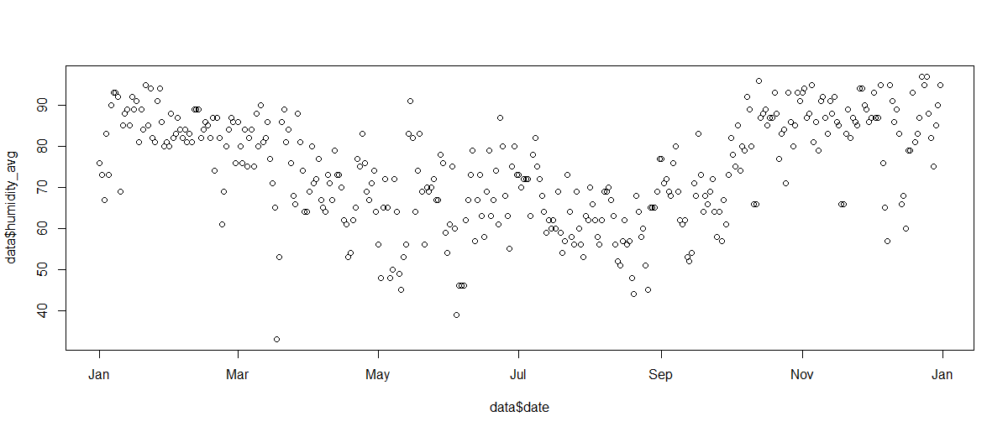

**wind_avg**

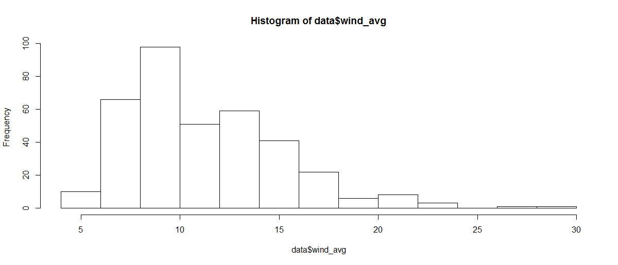

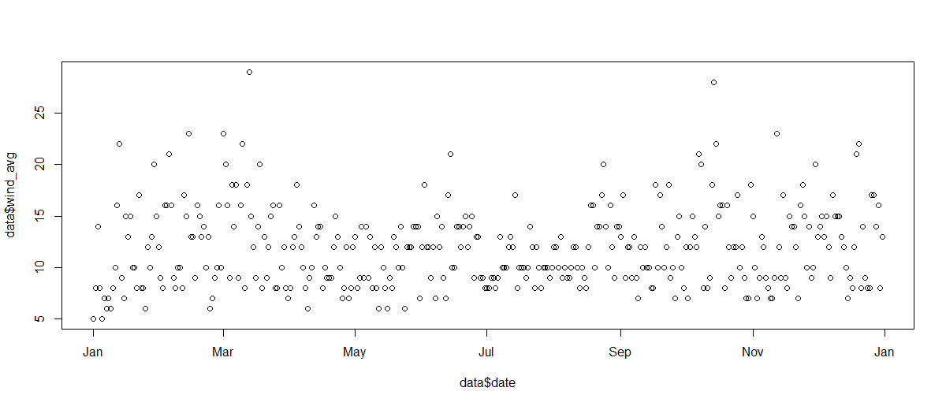

**precip**

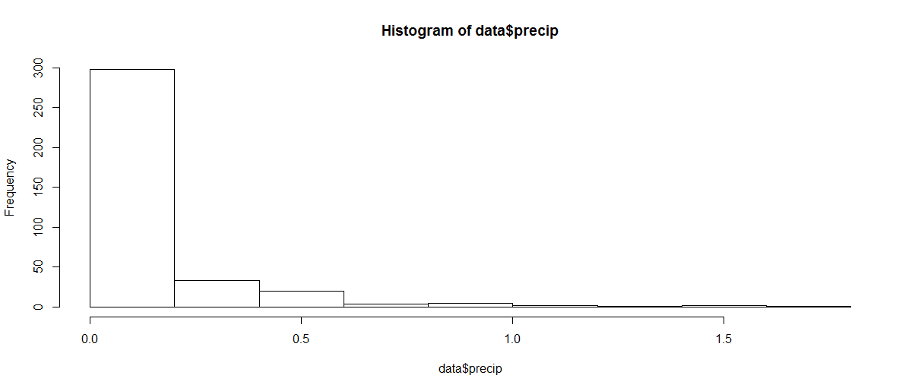

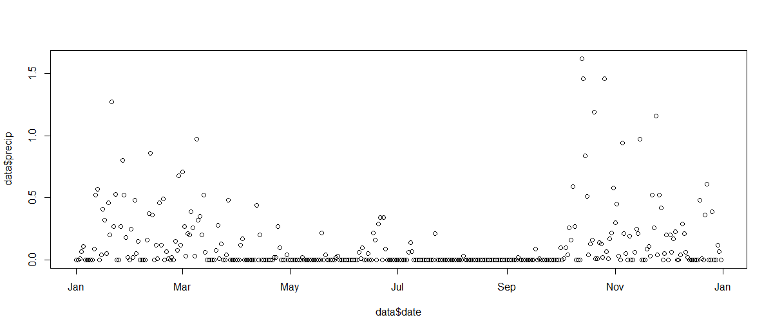

5. Are there obvious trends in the data (over time, across subgroups, etc.), and are the differences statistically significant? **obvious trends include precipitation and temperature trends consistent with the seasons (colder, wetter in the fall/winter months and vice versa)**

6. What are the other salient aspects of the data (e.g. geospatial factors, text content, etc.)

7. Provide a bullet-list of the next 5-10 tasks you will perform in analyzing your dataset

**- possibly integrate time series analyses**

**- integrate evictions data analyses with weather**

**- integrate resources data analyses with weather**

**- integrate deaths data analyses with weather**

**- run regressions to generate correlations**