SUBMISSION TYPE
Poster
TITLE
Measuring AI-Adopter Types: Comparison of Traditional vs. AI-Facilitated Procedures
SHORTENED TITLE
AI-Adopters
ABSTRACT
This exploratory study compared three approaches to generating items for Callari and Puppione’s (2025) qualitatively derived AI-user types: ChatGPT, AI-GENIE, and industrial-organizational psychology subject-matter experts. Traditional (EFA) and network psychometric (EGA) analyses revealed noteworthy differences in factor structure and communities across item-generation procedures.
WORD COUNT
2835
Measuring AI-Adopter Types: Comparison of Traditional vs. AI-Facilitated Procedures
Artificial intelligence (AI) has the potential to alter the fundamental design and experience of work. The Job Characteristics Model (Hackman & Oldham, 1975, 1976) proposes that core job characteristics shape critical psychological states and, ultimately, important employee outcomes, and emerging research suggests that digitization may substantially alter these characteristics. For example, digital technologies may automate repetitive tasks, but they may also fragment work, limit skill use, or diminish employees’ sense of ownership over their work. Arora and Garg’s (2025) review of meaningful work in the digital age identifies autonomy, skill variety, feedback, task significance, and task identity as job characteristics affected by workplace digitization. As such, as AI’s role in the design and performance of work grows it is important to understand how employees engage with the technology. The present research makes two key contributions to our understanding of AI in the workplace: Our first aim is to create a measure of AI adopter “type” as recently defined by Callari and Puppione (2025). Second, we approach scale development via a novel “competition” of three approaches, (1) comparing traditionally-derived subject matter expert ratings, (2) with LLM-derived procedures including prompting via ChatGPT and (3) through a dedicated R package (AI-GENIE). The contributions are both practical (a measure of AI adopter type) and methodological (combining semantic as well as quantitative indicators of measure quality).
AI Use in the Workplace
Conceptualizing and measuring employee AI use is challenging. Existing research operationalizes AI use in terms of the extent or intensity it is used to perform work. For example, Zhang et al. (2026) measure AI usage with items assessing the degree to which employees use AI in carrying out their job functions. Increasing AI integration may alter employees’ routines, role boundaries, autonomy, and skills, suggesting that the potential impact of AI use likely goes beyond frequency or intensity. Two employees could report similarly high levels of AI use while interacting with the technology in fundamentally different ways. One employee may primarily use AI to automate routine administrative work, another may use it to generate and refine ideas, and still another may engage with AI iteratively as a source of expertise or cognitive challenge. Accordingly, understanding AI-enabled work may require measures that capture how they incorporate AI into their work.
Callari and Puppione (2025) provide such a framework for distinguishing forms of AI use. Drawing on qualitative data from employees who use Microsoft 365 Copilot at their jobs, they identified three ideal types of AI users and labeled these types as: Efficiency-Seeking, Pragmatic Integrators, and Collaborative Optimisers. These categories imply qualitatively different relationships between AI and features of work including autonomy, skill utilization, cognitive effort, and decision-making. The Callari and Puppione (2025) framework suggests that AI use is not a uniform behavior but rather is best considered multidimensional. Yet, translating qualitative ideal types into quantitative measures presents a challenge.
Ideal types represent recurring patterns of behavior and experience, but they do not necessarily correspond to distinct psychological constructs. Additional work is needed to determine whether AI user types such as those presented by Callari and Puppione (2025) can be measured with survey items. Interestingly, the measurement of AI use is potentially enriched by recent technological developments. For a long time, the scale development process has relied on the efforts of researchers and subject-matter experts to turn construct definitions to survey items measuring the construct. Now, generative AI provides tools for producing surveys that measure constructs from idea generation to item testing. However, the question of whether survey items produced by generative AI can properly measure constructs remains.
The Current Study
The present study is an exploratory comparison of three approaches to developing items intended to assess employees’ orientations toward workplace AI use. Specifically, we develop items based on Callari and Puppione’s (2025) ideal AI user types via (a) ChatGPT, (b) AI-GENIE, and (c) industrial-organizational psychology subject-matter experts (SMEs). We evaluate the internal consistency, underlying factor structure, and implied semantic groupings of each item set. In doing so, this study has two primary objectives: first, to provide evidence regarding whether qualitatively derived forms of human–AI interaction can be operationalized as quantitative constructs, and second, to examine whether different approaches to item generation yield comparable representations of those constructs. More broadly, establishing how employees differ in their use of AI represents an important step toward understanding how AI may reshape established features of job design and the psychological experience of work.
Research Question 1: Does one instrument development procedure (ChatGPT, AI-GENIE, or SMEs) yield a more coherent structure than others?
Research Question 2: Can a combination of traditional and contemporary analyses provide a richer understanding of scale structure than either approach alone?
Method
Procedure
After reading a brief description of the online survey purpose and providing consent, students were asked to think of the context where they use AI the most frequently (for example, as a student or as an employee) and to keep that role in mind for the entire survey. Respondents were presented items in fixed ordering (grouped sequentially within item development procedure), followed by a few demographic questions. Responses to all AI-Adopter items were provided along a shared 5-point Likert-type scale ranging from 1 (Strongly Disagree) to 5 (Strongly Agree). Following the survey, respondents were debriefed and offered course credit for their time.
Participants
One hundred twenty-four undergraduate students responded (M_{age} = 21.58, SD = 5.61). The students were given the choice of 50 different majors to choose from, with the greatest representation being Psychology at 38.71%, with a second largest group being Construction majors (15.32%). When asked, “Which context did you have in mind as you responded to the statements in this survey?”, 79.03% indicated “school”, 12.9% indicated “work”, and 7.26% stated “other”.
Materials
Items were generated based on the three themes uncovered by Callari and Puppione (2025) in their qualitative study on the way employees perceive meaningful work in tasks co-generated by Microsoft 365 Copilot. They identified three ideal types, including an Efficiency-Seeking Type (perceives the AI tool as a straightforward task-assistance tool), a Pragmatic Integrator Type (perceives the AI tool as a smarter assistant), and a Collaborative Optimiser Type (perceives the AI tool as an expert-like teammate). Three different methods of item generation were used (and compared) here.
Expert-Generated Items. Three of the researchers independently generated 6–8 items per dimension. Combined lists of items were discussed by dimension, and the initial list of 57 candidate items was reduced to k = 18 through consensus evaluation of item clarity and content domain coverage.
ChatGPT-Generated Items. The following prompt was input into ChatGPT: “I need your help with generating a tentative list of survey items. I am reading the attached paper for the third time. I am interested in the three AI user ideal types and the survey items that could be generated to measure an employee’s propensity toward one type or another.” Eight items were generated per dimension, along with rationale for those item choices (total k = 24).
AI-GENIE-Generated Items. AI-GENIE is a tool for automated item development and validation using large language models and network psychometrics (Russell-Lasalandra et al., 2026). The following initial prompt was input, “You are an expert scale developer and methodologist who writes high quality and succinct (although with a use a 7th grade reading level) items based on the overarching definition of AI Adopter Type as articulated in Callari and Puppione (2025): ‘Three Ideal Types were identified: Ideal Type (1) – the Efficiency-Seeking Type – perceives AI as a straightforward task-assistance tool, Ideal Type (2) – the Pragmatic Integrator Type – views AI as a smarter assistant, and Ideal Type (3) – the Collaborative Optimiser Type – considers AI an expert-like teammate.’” Definitions of all three of the above dimensions, as well as example descriptors were provided as part of the prompt. Thirty items were initially generated. Combined lists of items were discussed by the researchers by dimension, and the most unique and clearly-written items were retained for the survey (total k = 21). All study items, prompts, and materials are available on a publicly accessible repository [hidden for blind review].
Results
Traditional Analyses
Inter-scale correlations as well as scale means and standard deviations are presented in Table 1. Here, the Efficiency Seeking scales exhibit the least intra-dimension agreement (correlations across item-generation methodologies ranging from r_{GPT–SME} = .14, ns to r_{GPT–Genie} = .51, p < .001). Pragmatic Integrator and Collaborative Optimiser scales exhibited consistently higher intra-dimension associations (ranging from a low of r_{Genie(CO)–SME(CO)} = .76, p < .001 to a high of r_{Genie(PI)–SME(PI)} = .84, p < .001). Lack of association with “other” scale dimensions was most prominent with the Efficiency Seeking scales, particularly so for the ChatGPT developed scale (and to a lesser degree, the SME-derived scale; e.g., the average magnitude of correlation was smallest).
Individual scale alphas were predominantly within the .8 to .9 range, although two scales exhibited suppressed values (the ChatGPT Efficiency Seeking scale α = .69 and the SME Efficiency Seeking scale α = .59). Note that: 1) these are the two scales that also exhibited the lowest average inter-scale associations (see Table 1), and 2) the numbers of items differed across scales (k_{ChatGPT} = 6, k_{SME} = 7, and k_{AI-GENIE} = 8). All scale αs are presented in Table 2.
Exploratory factor analyses (EFAs) were also conducted within item sets. One-, two-, and three-factor solutions were estimated for each item set using maximum likelihood estimation and an oblique Quartimin rotation. Following Hu and Bentler’s (1999) guidelines, model fit was evaluated using multiple indicators. The results presented here focus only on the three-factor models.
The three-factor model for the ChatGPT-generated items returned the weakest structural evidence (χ²(207) = 347.09, p < .001, RMSEA = .084, 90% CI [.068, .099], CFI = .879, TLI = .838, and SRMR = .053). Factors 1 and 2 were significantly correlated (r = .48, p < .05), while Factor 3 did not have a significant correlation with Factor 1 (r = −.03) or Factor 2 (r = −.15). Visual representation of loadings is presented in Figure 1.
The three-factor solution for the SME-generated items demonstrated the strongest overall model fit of the three item-generation approaches, χ²(150) = 183.17, p = .034, RMSEA = .048, 90% CI [.015, .071], CFI = .962, TLI = .947, and SRMR = .050. All three factors were significantly correlated at the 5% level threshold (p < .05). Factor 1 correlated .44 with Factor 2 and .64 with Factor 3, while Factors 2 and 3 correlated .46. Overall, the three-factor model provided strong fit, although, like the AI-GENIE items, loadings did not create three distinct item groupings (see Figure 2).
The AI-GENIE-generated items demonstrated fair fit to the three-factor solution, χ²(150) = 207.64, p = .001, RMSEA = .064, 90% CI [.041, .084], CFI = .960, TLI = .944, and SRMR = .036. Item loading patterns provided partial support, with several non-hypothesized associations and substantive cross-loadings (see Figure 3 for a visual representation). Factors 1 and 2 exhibited a significant correlation (r = .76, p < .05), whereas the correlations of Factor 3 with Factors 1 (r = .30) and 2 (r = .29) did not approach statistical significance. Overall, the three-factor model demonstrated relatively good fit, the loading pattern suggests two somewhat clear factors with item cross-loadings and an ambiguous third factor.
Taken together, these results point toward the ChatGPT-generated items as exhibiting the weakest traditional (empirical) evidence, with the observed structure largely not conforming to the theoretical associations. Additionally, the ChatGPT-generated items demonstrated worse model fit than the corresponding SME and AI-GENIE item sets, although none of the approaches satisfactorily converged on hypothesized associations (e.g., all extracted solutions exhibited a greater-than-desired number of cross-loadings and/or non-hypothesized item-dimension associations).
Network Psychometric Analyses
Network Psychometrics has provided not merely a newer philosophical lens on psychological measurement, but it has also introduced novel empirical procedures (Borsboom, 2022; Borsboom & Cramer, 2013; Epskamp et al., 2018). Exploratory graph analysis (EGA) is a procedure that, similar to traditional factor analysis, is aimed at discovering how items on a psychological measure group together. Each item is treated as a node, and the strength of the unique association between items (after accounting for all other items) is shown as an edge; items that remain strongly linked tend to form clusters. A community-detection algorithm then identifies those clusters, which are interpreted as the dimensions or factors of the construct. An EGA plot therefore shows both the estimated structure and the item membership of each dimension in one figure.
Exploratory Graph Analyses do not specify factors in advance. Instead they estimate a network directly among items via semantic association, and the results of these are presented in Figures 4, 5, and 6. Each line is a regularized partial correlation (EBICglasso), meaning the relationship between two items after controlling for all the other items. Thicker lines are stronger associations, and the line colour shows whether the association is positive or negative. Weak relationships are shrunk to zero and dropped. The Walktrap algorithm then detects communities: groups of items that are more tightly connected to each other than to the rest of the network. Unlike in the EFA plots, the node colours here mark these empirically detected communities, not the intended subscales. The number of communities is the EGA estimate of the dimensionality of each item set.
Discussion
The purpose of this study was twofold: 1) to create a measure of AI adopter type consistent with the Callari and Puppione (2025) trichotomy, and 2) to compare approaches to developing items, both at the item development stage (3 methods) and also at the structural evaluation stage (traditional and network psychometric analyses). The first research question asked whether one instrument development procedure (ChatGPT, AI–GENIE, or SMEs) yields a more coherent structure than others. The second research question asked whether a combination of traditional and contemporary analyses provides a richer understanding of scale structure than does either approach alone.
First, all three procedures did result in a measure of AI adopter type. The results of the traditional analyses suggest that the SME-generated items demonstrated the best fit, followed by AI-GENIE and then ChatGPT. However, items did not load cleanly as expected within dimensions. The semantic exploratory graph analyses help resolve this pattern when viewed alongside the EFA visuals. Across item sets, the Efficiency Seeking items were the most distinct, forming communities composed mostly of Efficiency Seeking items in all three networks (e.g., all eight ChatGPT Efficiency Seeking items fell into a single community). In contrast, Pragmatic Integrator and Collaborative Optimiser items loaded together on a shared factor in all three EFAs and frequently shared EGA communities (e.g., the largest SME community combined six Pragmatic Integrator and four Collaborative Optimiser items). Only the AI-GENIE network separated most Collaborative Optimiser items from most Pragmatic Integrator items. Thus, with respect to Research Question 1, the SME items yielded the best-fitting structure, but no procedure produced three cleanly separated types.
One interpretation of this pattern is that the three ideal types may not represent three dimensions, but rather three different levels of AI comfort: introductory, intermediate, and expert. If AI adoption is a matter of degree rather than type, then measures derived from three different methodologies may reasonably be expected to not differentiate greatly, as reflected in the strong correlations among the Pragmatic Integrator and Collaborative Optimiser scales (.71 to .86; Table 1), and to result in muddled structures when a three-factor solution is imposed on the data (as in the EFAs).
Implications
One of the theoretical contributions we make is to explore the ways AI is being used at present. Callari and Puppione (2025) presented three ideal types of AI users that we based our quantitative scale creation on. The somewhat unusual EFA representations (e.g., Figure 1) were specified in an attempt to accommodate both analytical approaches, such that EFA associations could be digested in a similar manner to EGA relationships. Conferring with these visuals, as well as one–factor solutions (not presented in this current paper) led that authors to consider the possibility that the Callari and Puppione (2025) typology may not be the best representation of AI adopter variability, but rather, we can conceptualize AI use on a continuum of expertise, whereby greater levels of expertise are evidenced by a higher degree of AI collaboration. This construct may therefore benefit from further theoretical specification before additional psychometric refinement. Practically, a measure ordered by degree might serve as a diagnostic of employee readiness for AI adoption and integration. Methodologically, and relevant to Research Question 2, the two analytic lenses were complementary: EFA fit indices ranked the item sets, whereas EGA communities revealed which items clustered together and where the intended types converged.
Limitations & Future Directions
We note a number of limitations that future study/comparisons would benefit from. First, for this SIOP submission, we present a modest sample size. An additional study comparing these three procedures with a larger sample size is warranted. In addition, this first pilot sample was obtained from university students who were asked to keep one context in mind as they responded to the survey. The majority of respondents indicated they had school in mind, whereas a smaller percentage had work in mind. Future research should incorporate full time employees across industries, and account for degree of AI integration within their workplaces. Finally, longitudinal designs are needed to tease apart whether these patterns reflect different types of AI adopters or different stages of AI adoption.
Conclusion
The present findings suggest that the conceptualization of AI adopter type may be better structured as differences of AI adopter degree (e.g., novice, intermediate, or expert) than as qualitatively distinct types. In addition, mutual consideration of traditional and newer lenses for scale development provided greater insight into the structure of these item sets than consideration of either approach in isolation would have. As organizations increasingly turn to generative AI to support measurement, comparing AI-facilitated and expert-driven item generation through both lenses offers a useful template for future scale development.
References
Arora, N., & Garg, N. (2025). Meaningful work in the digital age-a comprehensive review and framework. Human Resource Development International, 28(2), 169–193.
Borsboom, D. (2022). Possible futures for network psychometrics. Psychometrika, 87(1), 253–265.
Borsboom, D., & Cramer, A. O. (2013). Network analysis: An integrative approach to the structure of psychopathology. Annual Review of Clinical Psychology, 9(1), 91–121.
Callari, T. C., & Puppione, L. (2025). Meaningful work as shaped by employee work practices in human-AI collaborative environments: A qualitative exploration through ideal types. European Journal of Innovation Management, 28(10), 5001–5027.
Epskamp, S., Maris, G., Waldorp, L. J., & Borsboom, D. (2018). Network psychometrics. The Wiley Handbook of Psychometric Testing: A Multidisciplinary Reference on Survey, Scale and Test Development, 953–986.
Hackman, J. R., & Oldham, G. R. (1975). Development of the job diagnostic survey. Journal of Applied Psychology, 60(2), 159.
Hackman, J. R., & Oldham, G. R. (1976). Motivation through the design of work: Test of a theory. Organizational Behavior and Human Performance, 16(2), 250–279.
Hu, L., & Bentler, P. M. (1999). Cutoff criteria for fit indexes in covariance structure analysis: Conventional criteria versus new alternatives. Structural Equation Modeling: A Multidisciplinary Journal, 6(1), 1–55.
Russell-Lasalandra, L. L., Christensen, A. P., & Golino, H. (2026). Generative psychometrics via AI-GENIE: Automatic item generation and validation with network-integrated evaluation. Behavior Research Methods, 58(8), 217.
Zhang, Y., Lai, Z., Liu, X., & Sun, H. (2026). How artificial intelligence (AI) usage affects employees’ workplace well-being: A job demands-resources perspective. Personnel Review, 1–18.
Table 1
Means, Standard Deviations, and Correlations Among the Nine Subscales
 | 1 | 2 | 3 | 4 | 5 | 6 | 7 | 8 | M | SD
1. GPT (ES) | — |  |  |  |  |  |  |  | 3.66 | 0.62
2. SME (ES) | .14 | — |  |  |  |  |  |  | 2.54 | 0.59
3. AI-GENIE (ES) | .51*** | .49*** | — |  |  |  |  |  | 3.16 | 0.98
4. GPT (PI) | .58*** | .46*** | .74*** | — |  |  |  |  | 3.63 | 0.88
5. SME (PI) | .41*** | .58*** | .76*** | .78*** | — |  |  |  | 3.26 | 0.91
6. AI-GENIE (PI) | .38*** | .52*** | .84*** | .77*** | .84*** | — |  |  | 3.22 | 0.97
7. GPT (CO) | .37*** | .42*** | .74*** | .80*** | .79*** | .86*** | — |  | 3.18 | 0.91
8. SME (CO) | .35*** | .51*** | .64*** | .71*** | .81*** | .75*** | .81*** | — | 2.88 | 0.84
9. AI-GENIE (CO) | .38*** | .54*** | .80*** | .72*** | .80*** | .85*** | .83*** | .76*** | 2.85 | 0.96
Note. GPT = ChatGPT-generated items; SME = subject-matter-expert-generated items; AI-GENIE = AI-GENIE-generated items; ES = Efficiency Seeking; PI = Pragmatic Integrator; CO = Collaborative Optimiser.
* p < .05. ** p < .01. *** p < .001.
Table 2
Internal Consistency Reliability (Cronbach’s α) of the Nine Subscales
Item-Generation Procedure | Subscale | α
ChatGPT | Efficiency Seeking | .69
 | Pragmatic Integrator | .88
 | Collaborative Optimiser | .88
SME | Efficiency Seeking | .59
 | Pragmatic Integrator | .89
 | Collaborative Optimiser | .81
AI-GENIE | Efficiency Seeking | .90
 | Pragmatic Integrator | .90
 | Collaborative Optimiser | .90
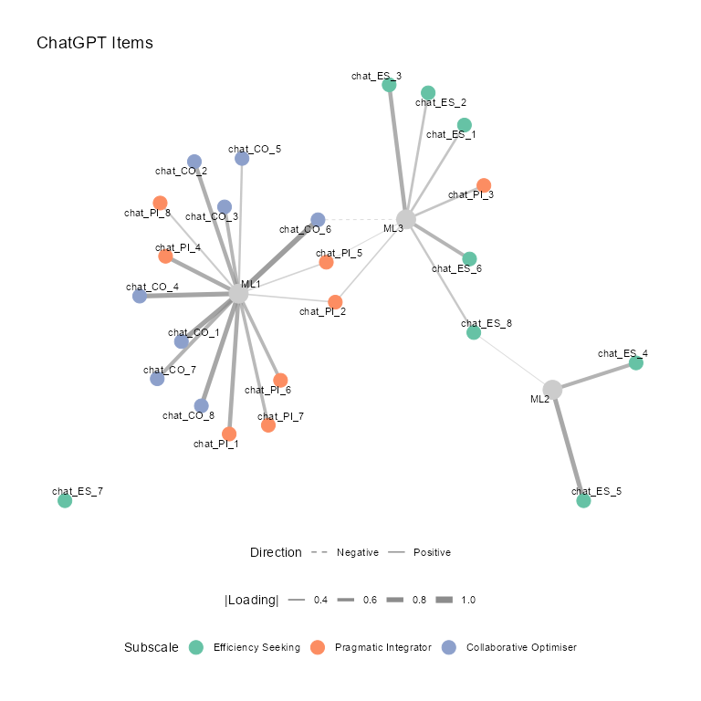
Figure 1. Exploratory Factor Analysis Loading Network for ChatGPT-Generated Items (Three-Factor Solution)
Note. Each figure shows the results of an exploratory factor analysis as a network. The large grey nodes are the extracted factors. The smaller colored nodes are the survey items, and their color shows which subscale the item was written for: Efficiency Seeking, Pragmatic Integrator, or Collaborative Optimiser. A line between an item and a factor means the item loads on that factor at |.30| or higher. Thicker, darker lines mean stronger loadings, and dashed lines mean negative loadings. If the items worked as intended, each factor would be surrounded by a cluster of items of a single color, and each item would connect to only one factor. Factors that collect items of mixed colors, or items that connect to several factors (cross-loadings), suggest the intended three-type structure is not holding up.
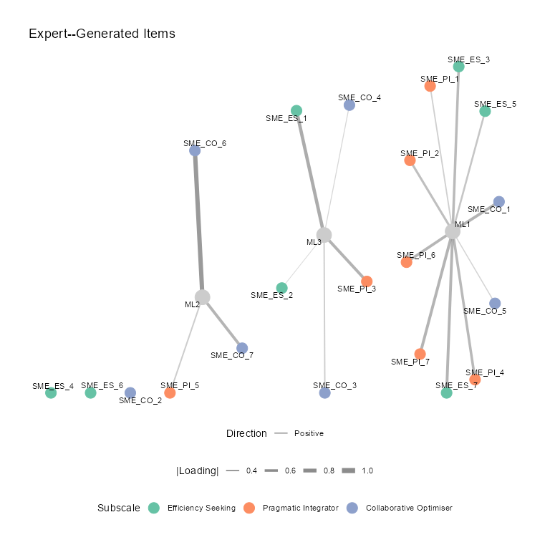
Figure 2. Exploratory Factor Analysis Loading Network for Expert-Generated Items (Three-Factor Solution)
Note. See Figure 1 note.
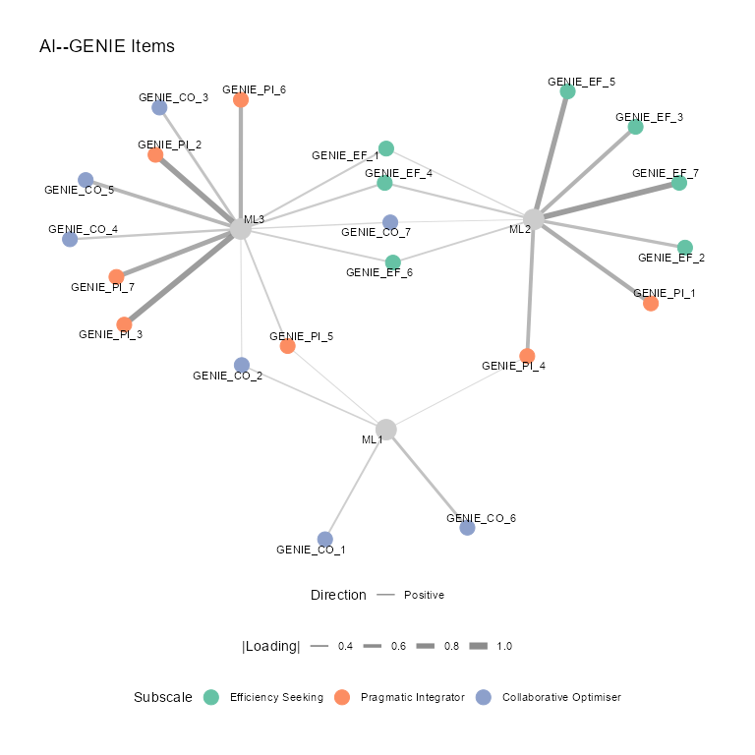
Figure 3. Exploratory Factor Analysis Loading Network for AI-GENIE-Generated Items (Three-Factor Solution)
Note. See Figure 1 note.
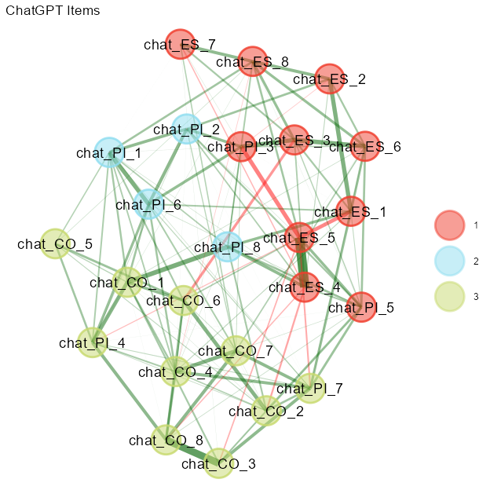
Figure 4. Exploratory Graph Analysis of ChatGPT-Generated Items
Note. Edges are regularized partial correlations (EBICglasso); green edges are positive and red edges are negative, and thicker edges are stronger. Node colors mark the communities detected by the Walktrap algorithm, not the intended subscales.
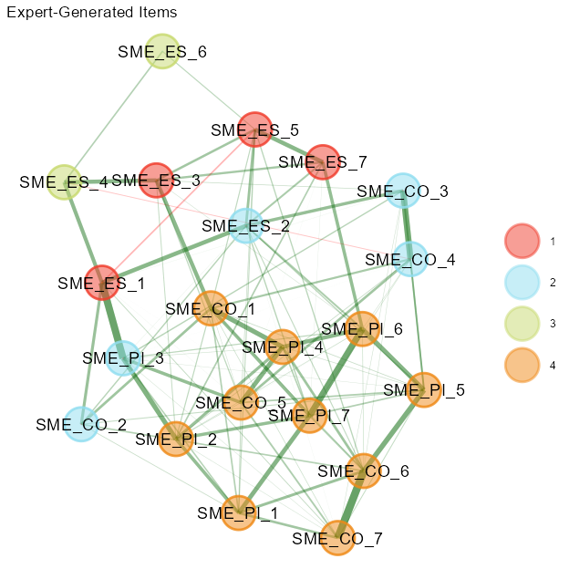
Figure 5. Exploratory Graph Analysis of Expert-Generated Items
Note. See Figure 4 note.
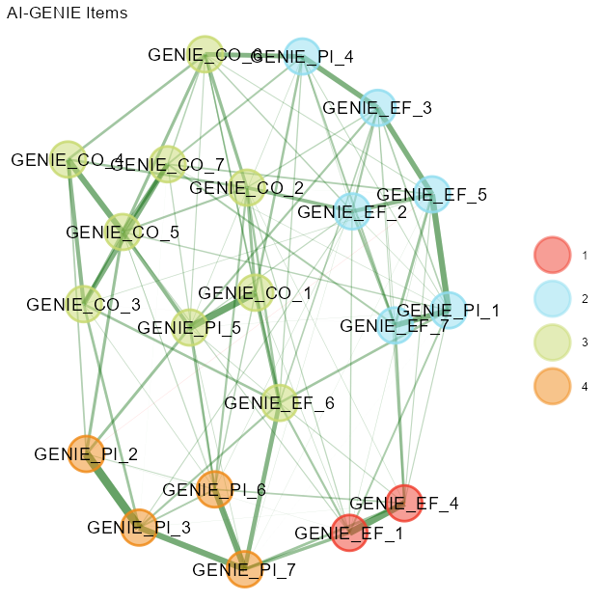
Figure 6. Exploratory Graph Analysis of AI-GENIE-Generated Items
Note. See Figure 4 note.

