Engagement vs. Attitude: Measurement Invariance across Item Orderings

Casey Osorio-Duffoo2, Renata Garcia Prieto Palacios Roji1, Morgan Russell1, & John Kulas1

1 Montclair State University

2 Harver

Author note

Add complete departmental affiliations for each author here. Each new line herein must be indented, like this line.

Enter author note here.

Correspondence concerning this article should be addressed to Casey Osorio-Duffoo, 1 Normal Ave, Montclair, NJ 07043. E-mail: [caseyosorio@gmail.com](mailto:caseyosorio@gmail.com)

Abstract

The most common current definition of attitudinal engagement implicates sub-dimensions of vigor, dedication, and absorption. The tripartite model of attitudes specifies cognitive, behavioral, and affective components. The current study investigates measurement invariance across a new measure of engagement that intentionally crosses the substantive and attitudinal components. Through counterbalancing the order of item presentation, we provide response cues regarding structural priority. Analyses of measurement invariance reveal that…

*Keywords:* Engagement, engagement

*Word count:* X

Engagement vs. Attitude: Measurement Invariance across Item Orderings

The roots of employee (aka work; e.g., Schaufeli & Bakker, 2010) engagement research likely started with theoretical expansions of forms of employee participation (see, for example, Ferris & Hellier, 1984) and job involvement (e.g., Elloy, Everett, & Flynn, 1991). This exploration extended into broader considerations of attitudes and emotions (Staw, Sutton, & Pelled, 1994) and were informed by further exploration of the dimensionality of constructs such as organizational commitment (Meyer & Allen, 1991). The 1990’s saw focused development and refinement (for example, a dissertation; Leone (1995) or actual semantic reference; William A. Kahn (1990)). Staw et al. (1994) investigated the relationships between *positive emotions* and favorable work outcomes, and although they do not use the word, “engagement”, their distinction between felt and expressed emotion likely held influence upon the burgeoning interest in the engagement construct.

Clear in this history is the specification of engagement as a work *attitude*.

Although occasionally referred to as residing on the opposing pole to *burnout* (Maslach & Leiter, 2008), these two constructs are currently most commonly conceptualized as being distinct (Goering, Shimazu, Zhou, Wada, & Sakai, 2017; Kim, Shin, & Swanger, 2009; Schaufeli, Taris, & Van Rhenen, 2008; Timms, Brough, & Graham, 2012), although certainly not universally (Cole, Walter, Bedeian, & O’Boyle, 2012; Taris, Ybema, & Beek, 2017). Comparing the two, Goering et al. (2017) concluded that they have a moderate (negative) association, but also distinct nomological networks. Schaufeli et al. (2008) investigated both internal and external association indicators, concluding that engagement and burnout (as well as *workaholism*) should be considered three distinct constructs.

Burnout can be defined as a psychological syndrome characterized by exhaustion (low energy), cynicism (low involvement), and inefficacy (low self-efficacy), which is experienced in response to chronic job stressors (e.g., Leiter & Maslach, 2004; Maslach & Leiter, 1997). Alternatively, engagement refers to an individual worker’s involvement and satisfaction as well as enthusiasm for work (Harter, Schmidt, & Hayes, 2002). Schaufeli and Bakker (2003) further specify a “positive, fulfilling, work-related state of mind that is characterized by vigor, dedication, and absorption” (p. 74). Via their conceptualization, vigor is described as high levels of energy and mental resilience while working. Dedication refers to being strongly involved in one’s work and experiencing a sense of significance, enthusiasm, inspiration, pride, and challenge. Absorption is characterized by being fully concentrated and happily engrossed in one’s work, whereby time passes quickly and one has difficulties with detaching oneself from work (Schaufeli, Salanova, González-Romá, & Bakker, 2002). The dimension of absorption has been noted as being influenced in conceptual specification by (Csikszentmihalyi, 1990)’s concept of “flow”.

Regarding measurement, Gallup is widely acknowledged as an early pioneer in the measurement of the construct (see, for example, Coffman & Harter, 1999). The Utrecht Work Engagement Scale (UWES) is another self-report questionnaire developed by Schaufeli and Bakker (2003) that directly assesses the vigor, dedication, and absorption elements.

## 0.1 Attitudes

TRIPARTITE MODEL–work here

The first, to our knowledge, use of the word “engagement” as a construct came in William A Kahn (1990), defining it as: “the harnessing of organization members’ selves to their work roles; in engagement, people employ and express themselves physically, cognitively, and emotionally during role performances.” Although this definition was quickly bypassed by subsequent papers (see, for example, (Baumruk, 2004) and (Shaw, 2005), who framed it in terms of one’s cognitive and affective *commitment* to one’s organization), William A Kahn (1990)’s definition is notable in that it conforms to the then-ascendant tripartite model of attitudes proposed by Rosenberg (1960). This model frames attitudes as latent variables that manifest cognitively, affectively and behaviorally.

Although falling out of favor in the decades following its construction, interest in the tripartite model was revived by Kaiser and Wilson (2019),

## 0.2 Item order as a multidimensional assessment response cues

Response cues in general and order effects in particular have their root in Cognitive Psychology, with the bulk of studies occurring in the early days of Cognitive Psychology (e.g., the 1960’s on). Primacy and recency (whether an item is presented at the beginning or end of a list) are known to elicit differences in response (e.g., Krosnick & Alwin, 1987). This effect has also been noted in methodological contexts in the form of differential carryover effects. For example, the order of presentation of samples in a product taste test (see, for example, Dean, 1980). Ackerman, Spray, Reckase, and Carlson (1989) found only small differences in response patterns when presenting *test* items in a fixed versus random ordering. Mashburn, Meyer, Allen, and Pianta (2014) experimentally controlled the presentation of rated material, finding higher indices of reliability and validity of ratings when content was administered randomly (e.g., order effects were controlled for).

Knowles (1988) and Hamilton and Shuminsky (1990) both administered exhaustively crossed orderings of items, noting better item discrimination (e.g., corrected item-total correlations) *later* in the assessment, regardless of actual item content. Steinberg (1994) provides a description of this effect: “…literature converges on the view that responding repeatedly to items representing a single, unidimensional psychological construct increases the accessibility of relevant beliefs or feelings, which in turn, increases the relation between the item resopnse and the underlying construct.” (p. 341) This statement could be rephrased as: location serves as a response cue. “This attentional focus influences item responses through such processes as item interpretation and ease of retrieval of relevant feelings that are applied to the item” (Steinberg, 1994, p. 341).

Steinberg (1994) looked at order effects in personality measurement,

Weinberg, M. K., Seton, C., & Cameron, N. (2018). The Measurement of Subjective Wellbeing: Item-Order Effects in the Personal Wellbeing Index—Adult. Journal of Happiness Studies, 19(1), 315–332. <https://doi-org.ezproxy.montclair.edu/10.1007/s10902-016-9822-1>

(**???**) examine the effects of randomized items and domains in the Personal Wellbeing Index (PWI) in measure subjective wellbeing (SWB). (**???**) conduct two studies one, looking at the PWI comparing its usual general-specific format to a modified format, furthermore, the order of the domain items will stay the same, while the general items will be random in question order. In the second study, (**???**) randomized the domain items while the general items will be the same to standard scale order. In (**???**), study 1 showed no results between general specific format and the modified format, however in study 2, they did find that presenting the random order effects did have lower means, then fixed order effects. (**???**) present many different reasons for this outcomes, which could be those in the random order effect group had more participant experiencing high levels of wellbeing, and the other explanation is that changing order of items of PWI could affect the score. (**???**) conducted a multiple regression analysis which showed that random order group account for 9% more variance in GLS than the fixed order group and conducted a confirmatory factor analysis showing that the fixed order groups was not a good model fit.

(**???**) looked at item order effects in self-report measures of aggression perpetration and victimization. (**???**) provides a descriptions of two general biases in self-report measures, which are the subject’s biases, and bias in wording, order, or format of items in the measure. In previous studies, there was an item order effect and item group effect in the measure that shows participants’ response and psychometric properties of an aggression measure. # citation from other articles (Dietz & Jasinski, 2007; Shorey, Woods, & Cornelius, 2016). ######### In (**???**), the findings shows that there is an item order affect in the reported frequency of aggression perpetration. It shows that item order can influence a person self-report in aggression perpetration and victimization, showing that there are methodological issue that have to be consider when developing and utilizing measure of aggression and victimization. This methodological issues can still be applicable to other measure such as workplace engagement, since we also look at people’s behaviors, cognitive, and emotions.

This model is not without criticism, however. Some critics question its structural validity by pointing out that vigor, dedication and absorption all correlate highly with each other (Kulikowski, 2017).

The present article explores two methods for constructing a scale that incorporates both the substantive and attitudinal models into one, a more classical one based on corrected item-total correlations and one based on modification indices.

Existing measures include Soane et al. (2012)

Our conceptualization of work engagement is a mental state wherein employees: a) feel energized (*Vigor*), b) are enthusiastic about the content of their work and the things they do (*Dedication*), and c) are so immersed in their work activities that time seems compressed (*Absorption*). We further decompose each of these facets into three attitudinal components: d) feeling (e.g., affect), e) thought (e.g., cognition), and f) action (e.g., behavior). Development and construct validation of the focal 18-item measure of engagement is described in Russell, Ossorio Duffoo, Garcia Prieto Palacios Roji, and Kulas (2022) whereas the current study on administrative response cues in the form of order of item presentation. The expectation is that either model (attitudinal or substantive) will exhibit stronger factorial validity when item administration parallels latent structure.

# 1 Methods

## 1.1 Participants

Data was obtained from two sources. In the first sampling, 282 individuals responded to a snowball sampling initiated by Industrial and Organizational Psychology faculty and graduate students. There were four counterbalanced orderings of item presentations within this administration, as well as an additional 18 contextual items - this sample constituted the original scale development sample, and at the time of administration the additional contextual items were candidates for item retention. In the second data collection initiative, Qualtrics panels were solicited along with 2 additional contextual items. These respondents included 343 working adults who responded to attitudinally clustered items and 404 working adults who responded to substantively clustered items.

## 1.2 Materials

Our 18-item engagement measure was crafted to be intentionally complex (each item is intended to load on two constructs). This complexity, however, derives from a crossing of the attitudinal components of affect, cognition, and behavior with the substantive engagement components of vigor, dedication, and absorption. Within the current investigation, we realized $α$’s of 0.81 (Absorption), 0.91 (Dedication), 0.78 (Vigor), 0.78 (Affect), 0.89 (Cognition), and 0.83 (Behavior). The 6-point response scale is: Strongly Disagree, Disagree, Somewhat Disagree, Somewhat Agree, Agree, Strongly Agree. The item stems as well as their scale assocation are presented in Table XX.

Table 1:

*Focal items and their scale associations*

|  |  |  |
| --- | --- | --- |
| Substantive | Attitudinal | Item |
| Absorption | Cognitive | Item 1. I’m able to concentrate on my work without distractions |
| Absorption | Cognitive | Item 3. Time passes quickly while I’m working |
| Absorption | Affective | Item 5. I enjoy thinking about work even when I’m not at work |
| Absorption | Affective | Item 8. I love starting my workday |
| Absorption | Behavioral | Item 10. I have to be reminded to take breaks while I’m at work |
| Absorption | Behavioral | Item 11. I never miss a work deadline |
| Vigor | Cognitive | Item 14. Thinking about work saps my energy |
| Vigor | Cognitive | Item 16. I’m able to maintain good levels of energy throughout the workday |
| Vigor | Affective | Item 17. I enjoy spending time completing my job tasks |
| Vigor | Affective | Item 19. I feel motivated to go beyond what is asked of me at work |
| Vigor | Behavioral | Item 21. When work is slow I find ways to be productive |
| Vigor | Behavioral | Item 22. I express enthusiasm for my job while at work |
| Dedication | Cognitive | Item 26. I believe this company cares about my career goals |
| Dedication | Cognitive | Item 28. This organization challenges me to work at my full potential |
| Dedication | Affective | Item 31. I feel proud of my accomplishments within this organization |
| Dedication | Affective | Item 32. My job makes me feel like I’m part of something meaningful |
| Dedication | Behavioral | Item 34. I embrace challenging situations at work |
| Dedication | Behavioral | Item 35. I speak positively about this organization to others |

## Warning: package 'lavaan' was built under R version 4.0.5

# 2 Results

We used R (Version 4.0.3; R Core Team, 2021) and the R-packages *apaTables* (Version 2.0.8; Stanley, 2021), *dplyr* (Version 1.0.2; Wickham et al., 2021), *DT* (Version 0.16; Xie, Cheng, & Tan, 2021), *forcats* (Version 0.5.0; Wickham, 2021a), *ggplot2* (Version 3.3.2; Wickham, 2016), *kableExtra* (Version 1.3.1; Zhu, 2021), *labourR* (Version 1.0.0; Kouretsis, Bampouris, Morfiris, & Papageorgiou, 2020), *lavaan* (Version 0.6.8; Rosseel, 2012), *magrittr* (Version 2.0.1; Bache & Wickham, 2020), *papaja* (Version 0.1.0.9997; Aust & Barth, 2020), *purrr* (Version 0.3.4; Henry & Wickham, 2020), *readr* (Version 1.4.0; Wickham & Hester, 2020), *sem* (Version 3.1.11; Fox, Nie, & Byrnes, 2020; Epskamp, 2019), *semPlot* (Version 1.1.2; Epskamp, 2019), *stringr* (Version 1.4.0; Wickham, 2019), *tibble* (Version 3.1.0; Müller & Wickham, 2021), *tidyr* (Version 1.1.2; Wickham, 2021b), and *tidyverse* (Version 1.3.0; Wickham, Averick, et al., 2019) for all our analyses.

The omnibus CFA’s, regardless of item ordering, across 1025 respondents showed fair fit for both the substantive ($χ_{substantive}^{2}$ =995.34, *df*=132, *RMSEA*=0.09) as well as attitudinal structures ($χ_{attitudinal}^{2}$ =1,103.47, *df*=132, *RMSEA*=0.09). Additional fit indices for the two models are presented in Table XX. Figures 1 and 2 present the omnibus models visually (standardized coefficients displayed). Note that the primary source of misfit for both models within the omnibus analysis is item 14, which is the lone reverse-coded item within the inventory, “Thinking about work saps my energy”.

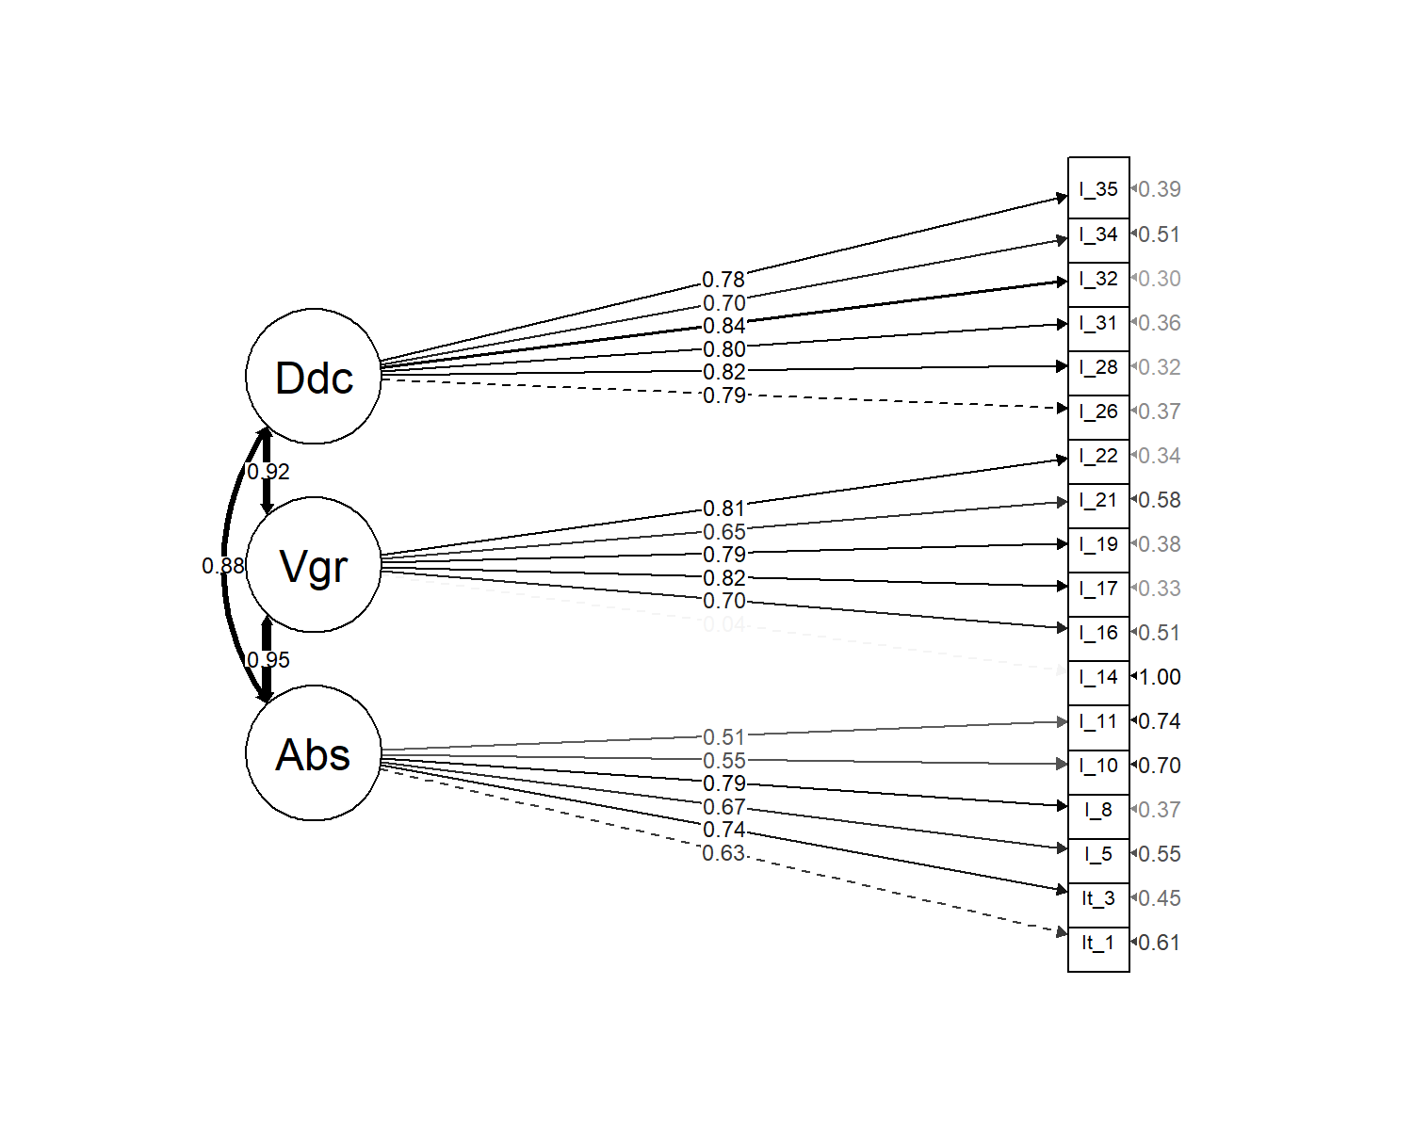

*Figure* *1.*  Omnibus Confirmatory Factor Analysis substantive structure.

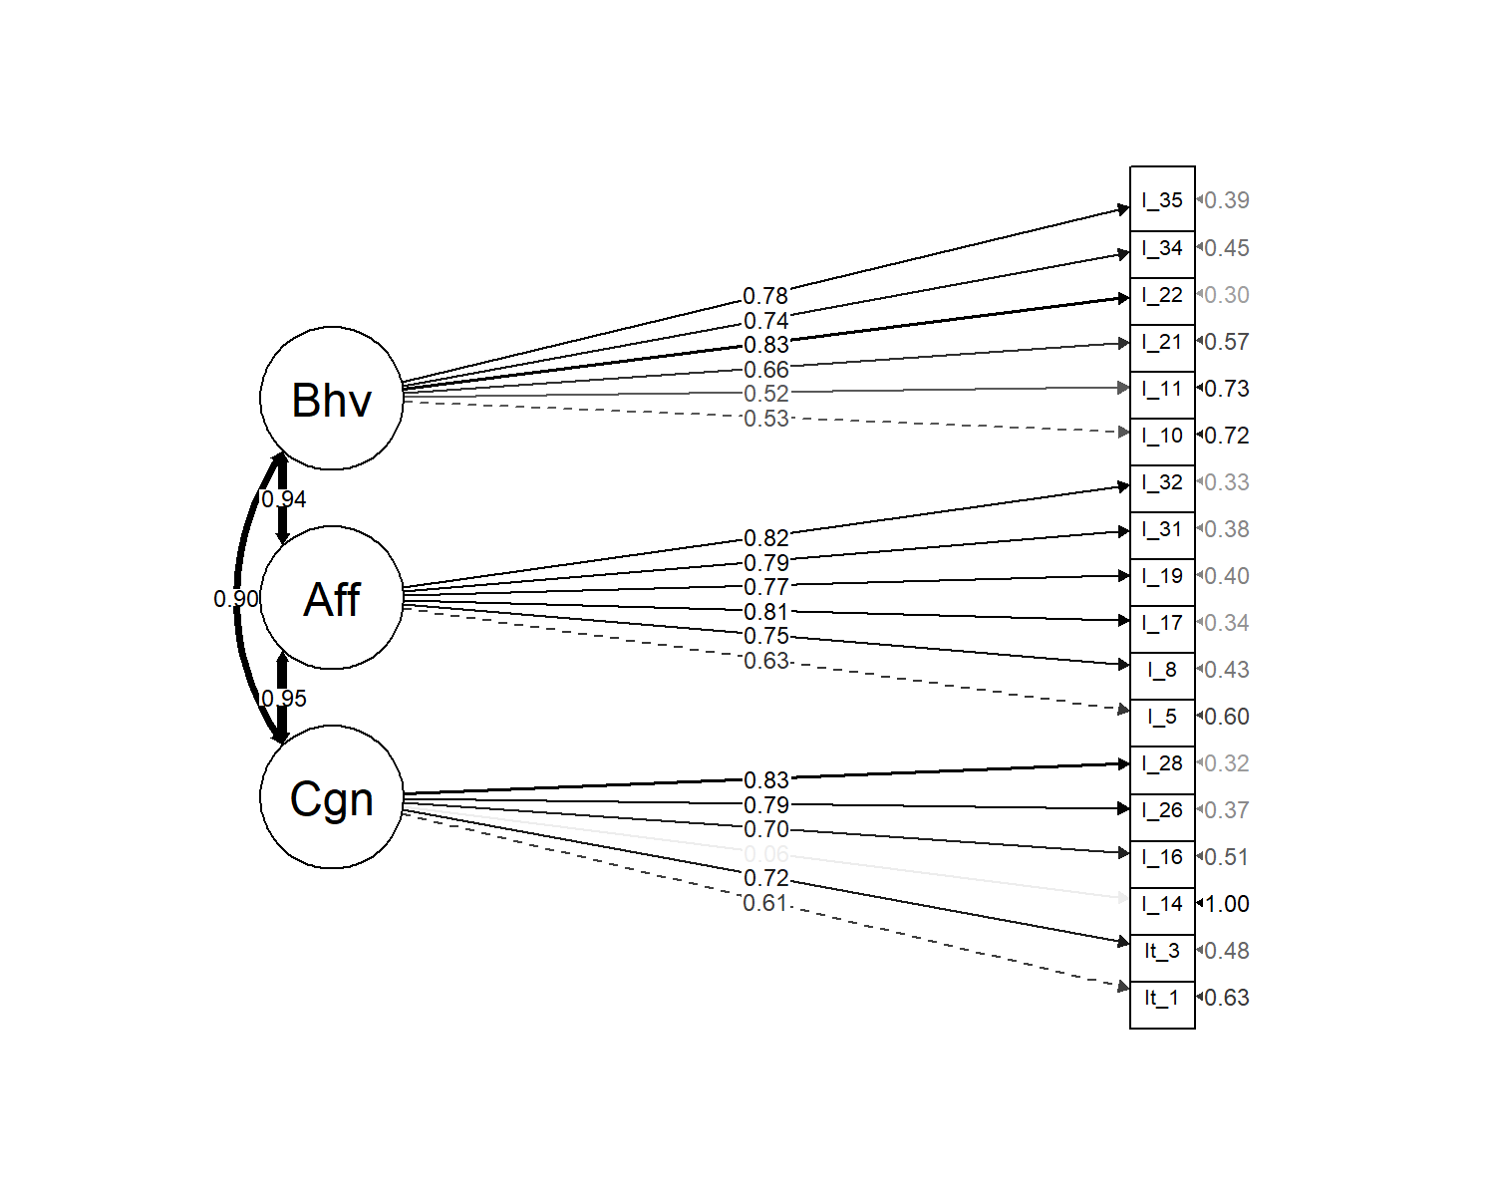

*Figure* *2.*  Omnibus Confirmatory Factor Analysis attitudinal structure.

|  |  |  |  |  |  |  |  |  |
| --- | --- | --- | --- | --- | --- | --- | --- | --- |
| Condition | Model | $χ^{2}$ | *df* | RMSEA | SRMR | CFI | TLI | AIC |
| Condition 1 | 3-factor substantive | 300.86 | 132 | 0.14 | 0.11 | 0.68 | 0.63 | 3,282.88 |
|  | 3-factor attitudinal | 290.33 | 132 | 0.14 | 0.11 | 0.70 | 0.65 | 3,272.35 |
| Condition 2 | 3-factor substantive | 310.01 | 132 | 0.15 | 0.10 | 0.71 | 0.66 | 3,257.45 |
|  | 3-factor attitudinal | 322.52 | 132 | 0.15 | 0.10 | 0.69 | 0.64 | 3,269.96 |
| Condition 3 | 3-factor substantive | 252.07 | 132 | 0.12 | 0.10 | 0.78 | 0.74 | 3,510.32 |
|  | 3-factor attitudinal | 275.74 | 132 | 0.13 | 0.10 | 0.73 | 0.69 | 3534 |
| Condition 4 | 3-factor substantive | 224.96 | 132 | 0.10 | 0.09 | 0.82 | 0.79 | 3,421.64 |
|  | 3-factor attitudinal | 228.99 | 132 | 0.10 | 0.09 | 0.81 | 0.78 | 3,425.66 |
| Condition 5 | 3-factor substantive | 549.80 | 132 | 0.10 | 0.05 | 0.90 | 0.89 | 14,932.57 |
|  | 3-factor attitudinal | 497.90 | 132 | 0.10 | 0.04 | 0.92 | 0.90 | 14,880.67 |
| Condition 6 | 3-factor substantive | 468.02 | 132 | 0.09 | 0.05 | 0.91 | 0.90 | 17,953.02 |
|  | 3-factor attitudinal | 610.60 | 132 | 0.10 | 0.06 | 0.88 | 0.86 | 18,095.61 |
| Overall | 3-factor substantive | 995.34 | 132 | 0.09 | 0.05 | 0.91 | 0.90 | 46,915.05 |
|  | 3-factor attitudinal | 1,103.47 | 132 | 0.09 | 0.05 | 0.90 | 0.88 | 47,023.18 |

Table 2:

*Unit-weighted scale intercorrelations (all conditions).*

|  |  |  |  |  |  |  |  |
| --- | --- | --- | --- | --- | --- | --- | --- |
|  | 1 | 2 | 3 | 4 | 5 | $M$ | $SD$ |
| 1. Absorption | - |  |  |  |  | 4.00 | 1.02 |
| 2. Vigor | .76*** | - |  |  |  | 4.23 | 0.90 |
| 3. Dedication | .76*** | .80*** | - |  |  | 4.41 | 1.12 |
| 4. Affect | .81*** | .84*** | .85*** | - |  | 4.09 | 0.95 |
| 5. Cognition | .87*** | .86*** | .89*** | .79*** | - | 4.16 | 1.12 |
| 6. Behavior | .84*** | .83*** | .84*** | .71*** | .81*** | 4.39 | 0.96 |

*Note.* * p < 0.05; ** p < 0.01; *** p < 0.001

### 2.0.1 Condition effects.

The order of item presentation was: 1) random within substantive dimension, 2) random within attitudinal dimension, 3) parcels of substantive within attitudinal (36-item attitudinal context), 4) parcels of attitudinal within substantive (36-item substantive context), 5) parcels of substantive within attitudinal (20-item attitudinal context), and 6) parcels of attitudinal within substantive (20-item substantive context). For example, in condition 1, the first items presented were all associated with one attitudinal dimension (for example, “Affect”). Once the Affect item list was fully exhausted, the respondent was then administered the full set of Behavioral items, and once these were completed the respondent was then administered the Cognitive item set[1]. We view these orderings as cues regarding factor structure, and anticipated empirical factor structures to reflect these cues. The effects did emerge, but were quite moderate (for example, $Δχ_{Cond1}^{2}$ = 9.55, $ΔAIC_{Cond1}$ = 10.53). Given the variety of item orderings administered, this should be considered somewhat comforting regarding the effect of contextual embeddedness within multidimensional inventories. To further explore degree of similarity, we applied explicit tests of measurement invariance.

#### 2.0.1.1 Measurement invariance.

Because our six conditions were obtained across two different sampling procedures, we apply our analyses of measurement invariance twice - first investigating the four conditions administered within our initial snowball sampling and then secondly also extending to the follow-up Qualtrics panel respondents.

We looked at structural invariance as well as latent means (Meredith, 1993; Steinmetz, Schmidt, Tina-Booh, Wieczorek, & Schwartz, 2009).

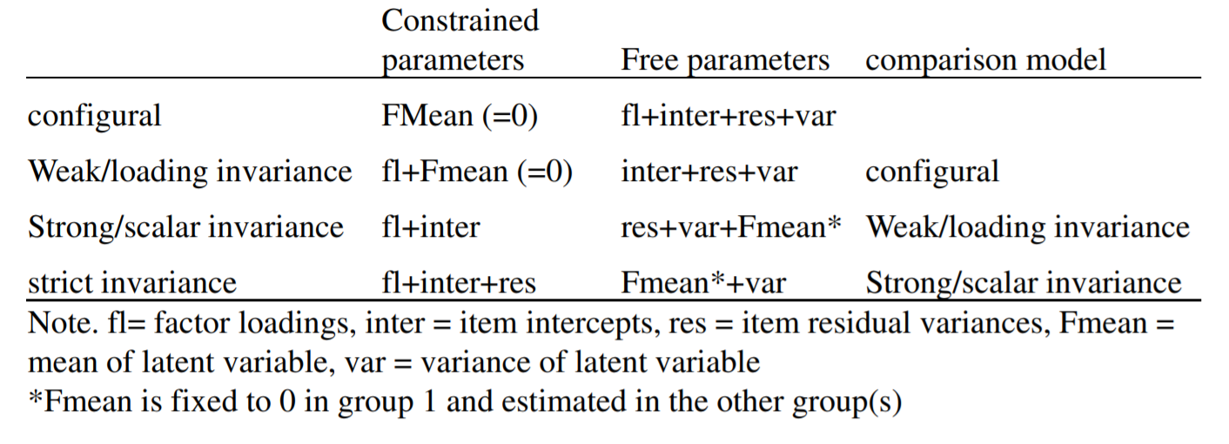

*Figure* *3.*  Steps for measurement invariance (as recommended by Xu, 2012).

## Warning in lav_object_post_check(object): lavaan WARNING: covariance matrix of latent variables  
## is not positive definite in group 2;  
## use lavInspect(fit, "cov.lv") to investigate.

## Warning in lav_object_post_check(object): lavaan WARNING: covariance matrix of latent variables  
## is not positive definite in group 3;  
## use lavInspect(fit, "cov.lv") to investigate.

## Warning in lav_object_post_check(object): lavaan WARNING: covariance matrix of latent variables  
## is not positive definite in group 2;  
## use lavInspect(fit, "cov.lv") to investigate.

## Warning in lav_object_post_check(object): lavaan WARNING: covariance matrix of latent variables  
## is not positive definite in group 3;  
## use lavInspect(fit, "cov.lv") to investigate.

## Warning in lav_object_post_check(object): lavaan WARNING: covariance matrix of latent variables  
## is not positive definite in group 2;  
## use lavInspect(fit, "cov.lv") to investigate.

## Warning in lav_object_post_check(object): lavaan WARNING: covariance matrix of latent variables  
## is not positive definite in group 3;  
## use lavInspect(fit, "cov.lv") to investigate.

(#tab:measinv.pilot.att)

*Measurement invariance summary statistics (attitudinal structure).*

|  |  |  |  |  |  |  |  |
| --- | --- | --- | --- | --- | --- | --- | --- |
|  | Df | AIC | BIC | Chisq | Chisq diff | Df diff | Pr(>Chisq) |
| configural.a | 528 | 13,645.98 | 14,453.38 | 1,117.59 | NA | NA | NA |
| weak.a | 573 | 13,614.45 | 14,262.50 | 1,176.06 | 58.48 | 45 | 0.09 |
| strong.a | 618 | 13,569.48 | 14,058.18 | 1,221.09 | 45.03 | 45 | 0.47 |
| strict.a | 672 | 13,538.35 | 13,835.82 | 1,297.96 | 76.87 | 54 | 0.02 |

*Note.* * p < 0.05; ** p < 0.01; *** p < 0.001

## Warning in lav_object_post_check(object): lavaan WARNING: covariance matrix of latent variables  
## is not positive definite in group 1;  
## use lavInspect(fit, "cov.lv") to investigate.

## Warning in lav_object_post_check(object): lavaan WARNING: covariance matrix of latent variables  
## is not positive definite in group 3;  
## use lavInspect(fit, "cov.lv") to investigate.

## Warning in lav_object_post_check(object): lavaan WARNING: covariance matrix of latent variables  
## is not positive definite in group 1;  
## use lavInspect(fit, "cov.lv") to investigate.

## Warning in lav_object_post_check(object): lavaan WARNING: covariance matrix of latent variables  
## is not positive definite in group 3;  
## use lavInspect(fit, "cov.lv") to investigate.

## Warning in lav_object_post_check(object): lavaan WARNING: covariance matrix of latent variables  
## is not positive definite in group 1;  
## use lavInspect(fit, "cov.lv") to investigate.

## Warning in lav_object_post_check(object): lavaan WARNING: covariance matrix of latent variables  
## is not positive definite in group 3;  
## use lavInspect(fit, "cov.lv") to investigate.

## Warning in lav_object_post_check(object): lavaan WARNING: covariance matrix of latent variables  
## is not positive definite in group 1;  
## use lavInspect(fit, "cov.lv") to investigate.

## Warning in lav_object_post_check(object): lavaan WARNING: covariance matrix of latent variables  
## is not positive definite in group 4;  
## use lavInspect(fit, "cov.lv") to investigate.

(#tab:measinv.pilot.sub)

*Measurement invariance summary statistics (substantive structure).*

|  |  |  |  |  |  |  |  |
| --- | --- | --- | --- | --- | --- | --- | --- |
|  | Df | AIC | BIC | Chisq | Chisq diff | Df diff | Pr(>Chisq) |
| configural.s | 528 | 13,616.29 | 14,423.69 | 1,087.90 | NA | NA | NA |
| weak.s | 573 | 13,588.39 | 14,236.44 | 1,150.00 | 62.10 | 45 | 0.05 |
| strong.s | 618 | 13,546.51 | 14,035.20 | 1,198.12 | 48.12 | 45 | 0.35 |
| strict.s | 672 | 13,521.28 | 13,818.74 | 1,280.89 | 82.77 | 54 | 0.01 |

*Note.* * p < 0.05; ** p < 0.01; *** p < 0.001

## Warning in lav_object_post_check(object): lavaan WARNING: covariance matrix of latent variables  
## is not positive definite in group 2;  
## use lavInspect(fit, "cov.lv") to investigate.

## Warning in lav_object_post_check(object): lavaan WARNING: covariance matrix of latent variables  
## is not positive definite in group 3;  
## use lavInspect(fit, "cov.lv") to investigate.

## Warning in lav_object_post_check(object): lavaan WARNING: covariance matrix of latent variables  
## is not positive definite in group 2;  
## use lavInspect(fit, "cov.lv") to investigate.

## Warning in lav_object_post_check(object): lavaan WARNING: covariance matrix of latent variables  
## is not positive definite in group 3;  
## use lavInspect(fit, "cov.lv") to investigate.

## Warning in lav_object_post_check(object): lavaan WARNING: covariance matrix of latent variables  
## is not positive definite in group 2;  
## use lavInspect(fit, "cov.lv") to investigate.

## Warning in lav_object_post_check(object): lavaan WARNING: covariance matrix of latent variables  
## is not positive definite in group 3;  
## use lavInspect(fit, "cov.lv") to investigate.

(#tab:measinv.siop2.att)

*Measurement invariance summary statistics (attitudinal structure [6 conditions]).*

|  |  |  |  |  |  |  |  |
| --- | --- | --- | --- | --- | --- | --- | --- |
|  | Df | AIC | BIC | Chisq | Chisq diff | Df diff | Pr(>Chisq) |
| configural.a2 | 792 | 46,694.26 | 48,335.92 | 2,226.09 | NA | NA | NA |
| weak.a2 | 867 | 46,739.78 | 48,021.43 | 2,421.61 | 195.52 | 75 | 0.00 |
| strong.a2 | 942 | 46,937.41 | 47,859.05 | 2,769.24 | 347.63 | 75 | 0.00 |
| strict.a2 | 1032 | 46,976.26 | 47,465.88 | 2,988.09 | 218.85 | 90 | 0.00 |

*Note.* * p < 0.05; ** p < 0.01; *** p < 0.001

## Warning in lav_object_post_check(object): lavaan WARNING: covariance matrix of latent variables  
## is not positive definite in group 1;  
## use lavInspect(fit, "cov.lv") to investigate.

## Warning in lav_object_post_check(object): lavaan WARNING: covariance matrix of latent variables  
## is not positive definite in group 3;  
## use lavInspect(fit, "cov.lv") to investigate.

## Warning in lav_object_post_check(object): lavaan WARNING: covariance matrix of latent variables  
## is not positive definite in group 1;  
## use lavInspect(fit, "cov.lv") to investigate.

## Warning in lav_object_post_check(object): lavaan WARNING: covariance matrix of latent variables  
## is not positive definite in group 3;  
## use lavInspect(fit, "cov.lv") to investigate.

## Warning in lav_object_post_check(object): lavaan WARNING: covariance matrix of latent variables  
## is not positive definite in group 4;  
## use lavInspect(fit, "cov.lv") to investigate.

## Warning in lav_object_post_check(object): lavaan WARNING: covariance matrix of latent variables  
## is not positive definite in group 1;  
## use lavInspect(fit, "cov.lv") to investigate.

## Warning in lav_object_post_check(object): lavaan WARNING: covariance matrix of latent variables  
## is not positive definite in group 3;  
## use lavInspect(fit, "cov.lv") to investigate.

## Warning in lav_object_post_check(object): lavaan WARNING: covariance matrix of latent variables  
## is not positive definite in group 4;  
## use lavInspect(fit, "cov.lv") to investigate.

## Warning in lav_object_post_check(object): lavaan WARNING: covariance matrix of latent variables  
## is not positive definite in group 1;  
## use lavInspect(fit, "cov.lv") to investigate.

## Warning in lav_object_post_check(object): lavaan WARNING: covariance matrix of latent variables  
## is not positive definite in group 4;  
## use lavInspect(fit, "cov.lv") to investigate.

(#tab:measinv.siop2.sub)

*Measurement invariance summary statistics (substantive structure [6 conditions]).*

|  |  |  |  |  |  |  |  |
| --- | --- | --- | --- | --- | --- | --- | --- |
|  | Df | AIC | BIC | Chisq | Chisq diff | Df diff | Pr(>Chisq) |
| configural.s2 | 792 | 46,573.88 | 48,215.54 | 2,105.71 | NA | NA | NA |
| weak.s2 | 867 | 46,623.18 | 47,904.83 | 2,305.01 | 199.30 | 75 | 0.00 |
| strong.s2 | 942 | 46,773.49 | 47,695.13 | 2,605.32 | 300.31 | 75 | 0.00 |
| strict.s2 | 1032 | 46,818.51 | 47,308.13 | 2,830.34 | 225.01 | 90 | 0.00 |

*Note.* * p < 0.05; ** p < 0.01; *** p < 0.001

(#tab:measinv.siop3.att)

*Measurement invariance summary statistics (attitudinal structure [Qualtrics only]).*

|  |  |  |  |  |  |  |  |
| --- | --- | --- | --- | --- | --- | --- | --- |
|  | Df | AIC | BIC | Chisq | Chisq diff | Df diff | Pr(>Chisq) |
| configural.a2 | 264 | 33,048.28 | 33,557.42 | 1,108.50 | NA | NA | NA |
| weak.a2 | 279 | 33,046.22 | 33,488.37 | 1,136.44 | 27.94 | 15 | 0.02 |
| strong.a2 | 294 | 33,085.13 | 33,460.29 | 1,205.35 | 68.91 | 15 | 0.00 |
| strict.a2 | 312 | 33,100.74 | 33,395.51 | 1,256.96 | 51.61 | 18 | 0.00 |

*Note.* * p < 0.05; ** p < 0.01; *** p < 0.001

(#tab:measinv.siop3.sub)

*Measurement invariance summary statistics (substantive structure [Qualtrics only]).*

|  |  |  |  |  |  |  |  |
| --- | --- | --- | --- | --- | --- | --- | --- |
|  | Df | AIC | BIC | Chisq | Chisq diff | Df diff | Pr(>Chisq) |
| configural.s2 | 264 | 32,957.60 | 33,466.74 | 1,017.81 | NA | NA | NA |
| weak.s2 | 279 | 32,941.43 | 33,383.58 | 1,031.65 | 13.84 | 15 | 0.54 |
| strong.s2 | 294 | 32,969.93 | 33,345.09 | 1,090.15 | 58.50 | 15 | 0.00 |
| strict.s2 | 312 | 32,956.32 | 33,251.08 | 1,112.54 | 22.39 | 18 | 0.22 |

*Note.* * p < 0.05; ** p < 0.01; *** p < 0.001

# 3 Discussion

The item cues did provide slight response cues (attending to individual model fit indices), however, the effect was quite small. Measurement invariance is plausible within our initial four administration conditions, although it is not attained across all six conditions. This is possibly attributable to differences in sampled population (in addition to the possibility that this difference is attributable to item orderings),

# 4 References

Ackerman, T. A., Spray, J. A., Reckase, M. D., & Carlson, J. E. (1989). *A comparison of the effects of random versus fixed order of item presentation via the computer*. AMERICAN COLL TESTING PROGRAM IOWA CITY IA.

Aust, F., & Barth, M. (2020). *papaja: Create APA manuscripts with R Markdown*. Retrieved from <https://github.com/crsh/papaja>

Bache, S. M., & Wickham, H. (2020). *Magrittr: A forward-pipe operator for r*. Retrieved from <https://CRAN.R-project.org/package=magrittr>

Baumruk, R. (2004). The missing link: The role of employee engagement in business success, *47*, 48–52.

Coffman, C., & Harter, J. (1999). A hard look at soft numbers. *Position Paper, Gallup Organization*.

Cole, M. S., Walter, F., Bedeian, A. G., & O’Boyle, E. H. (2012). Job burnout and employee engagement: A meta-analytic examination of construct proliferation. *Journal of Management*, *38*(5), 1550–1581.

Csikszentmihalyi, M. (1990). *Flow: The psychology of optimal experience* (Vol. 1990). Harper & Row New York.

Dean, M. L. (1980). Presentation order effects in product taste tests. *The Journal of Psychology*, *105*(1), 107–110.

Elloy, D. F., Everett, J. E., & Flynn, W. R. (1991). An examination of the correlates of job involvement. *Group & Organization Studies*, *16*(2), 160–177. <https://doi.org/10.1177/105960119101600204>

Epskamp, S. (2019). *SemPlot: Path diagrams and visual analysis of various sem packages’ output*. Retrieved from <https://CRAN.R-project.org/package=semPlot>

Ferris, R., & Hellier, P. (1984). Added value productivity schemes and employee participation. *Asia Pacific Journal of Human Resources*, *22*(4), 35–44. <https://doi.org/10.1177/103841118402200406>

Fox, J., Nie, Z., & Byrnes, J. (2020). *Sem: Structural equation models*. Retrieved from <https://CRAN.R-project.org/package=sem>

Goering, D. D., Shimazu, A., Zhou, F., Wada, T., & Sakai, R. (2017). Not if, but how they differ: A meta-analytic test of the nomological networks of burnout and engagement. *Burnout Research*, *5*, 21–34.

Hamilton, J. C., & Shuminsky, T. R. (1990). Self-awareness mediates the relationship between serial position and item reliability. *Journal of Personality and Social Psychology*, *59*(6), 1301.

Harter, J. K., Schmidt, F., & Hayes, T. (2002). Business-unit-level relationship between employee satisfaction, employee engagement, and business outcomes: A meta-analysis. *The Journal of Applied Psychology*. <https://doi.org/10.1037/0021-9010.87.2.268>

Henry, L., & Wickham, H. (2020). *Purrr: Functional programming tools*. Retrieved from <https://CRAN.R-project.org/package=purrr>

Kahn, W. A. (1990). Psychological conditions of personal engagement and disengagement at work. *Academy of Management Journal*, *33*(4), 692–724.

Kahn, W. A. (1990). Psychological conditions of personal engagement and disengagement at work. *Academy of Management Journal*, *33*(4), 692–724.

Kaiser, F. G., & Wilson, M. (2019). The Campbell Paradigm as a Behavior-Predictive Reinterpretation of the Classical Tripartite Model of Attitudes. *European Psychologist*, *24*(4), 359–374. <https://doi.org/10.1027/1016-9040/a000364>

Kim, H. J., Shin, K. H., & Swanger, N. (2009). Burnout and engagement: A comparative analysis using the Big Five personality dimensions. *International Journal of Hospitality Management*, *28*(1), 96–104. <https://doi.org/10.1016/j.ijhm.2008.06.001>

Knowles, E. S. (1988). Item context effects on personality scales: Measuring changes the measure. *Journal of Personality and Social Psychology*, *55*(2), 312.

Kouretsis, A., Bampouris, A., Morfiris, P., & Papageorgiou, K. (2020). *LabourR: Classify multilingual labour market free-text to standardized hierarchical occupations*. Retrieved from <https://CRAN.R-project.org/package=labourR>

Krosnick, J. A., & Alwin, D. F. (1987). An evaluation of a cognitive theory of response-order effects in survey measurement. *Public Opinion Quarterly*, *51*(2), 201–219.

Kulikowski, K. (2017). Do we all agree on how to measure work engagement? Factorial validity of utrecht work engagement scale as a standard measurement tool–a literature review. *International Journal of Occupational Medicine and Environmental Health*, *30*(2), 161–175.

Leiter, M., & Maslach, C. (2004). Areas of worklife: A structured approach to organizational predictors of job burnout. In *Research in occupational stress and well-being* (Vol. 3, pp. 91–134). <https://doi.org/10.1016/S1479-3555(03)03003-8>

Leone, D. R. (1995). *The relation of work climate, higher order need satisfaction, need salience, and causality orientations to work engagement, psychological adjustment, and job satisfaction* (PhD thesis). ProQuest Information & Learning.

Mashburn, A. J., Meyer, J. P., Allen, J. P., & Pianta, R. C. (2014). The effect of observation length and presentation order on the reliability and validity of an observational measure of teaching quality. *Educational and Psychological Measurement*, *74*(3), 400–422.

Maslach, C., & Leiter, M. (1997). What causes burnout. *Maslach C, Leiter MP. The Truth About Burnout: How Organizations Cause Personal Stress and What to Do About It. San Francisco, CA: Josey-Bass Publishers*, 38–60.

Maslach, C., & Leiter, M. P. (2008). Early predictors of job burnout and engagement. *Journal of Applied Psychology*, *93*(3), 498–512.

Meredith, W. (1993). Measurement invariance, factor analysis and factorial invariance. *Psychometrika*, *58*(4), 525–543.

Meyer, J. P., & Allen, N. J. (1991). A three-component conceptualization of organizational commitment. *Human Resource Management Review*, *1*(1), 61–89.

Müller, K., & Wickham, H. (2021). *Tibble: Simple data frames*. Retrieved from <https://CRAN.R-project.org/package=tibble>

R Core Team. (2021). *R: A language and environment for statistical computing*. Vienna, Austria: R Foundation for Statistical Computing. Retrieved from <https://www.R-project.org/>

Rosenberg, M. J. (1960). *Cognitive, affective, and behavioral components of attitudes*. *Attitude organization and change*.

Rosseel, Y. (2012). lavaan: An R package for structural equation modeling. *Journal of Statistical Software*, *48*(2), 1–36. Retrieved from <https://www.jstatsoft.org/v48/i02/>

Russell, M., Ossorio Duffoo, C., Garcia Prieto Palacios Roji, R., & Kulas, J. (2022). Development of an intentional bifactor measure of engagement. In *The seattle edition of siop* (pp. 1–14). SIOP.

Schaufeli, W., & Bakker, A. (2010). The conceptualization and measurement of work engagement. In W. Schaufeli, A. Bakker, & M. Leiter (Eds.), *Work engagement: A handbook of essential theory and research* (pp. 10–24). New York: Psychology Press.

Schaufeli, W. B., & Bakker, A. B. (2003). UWES–utrecht work engagement scale: Test manual. *Unpublished Manuscript: Department of Psychology, Utrecht University*, *8*.

Schaufeli, W. B., Salanova, M., González-Romá, V., & Bakker, A. B. (2002). The measurement of engagement and burnout: A two sample confirmatory factor analytic approach. *Journal of Happiness Studies*, *3*(1), 71–92.

Schaufeli, W. B., Taris, T. W., & Van Rhenen, W. (2008). Workaholism, burnout, and work engagement: Three of a kind or three different kinds of employee well-being? *Applied Psychology*, *57*(2), 173–203.

Shaw, K. (2005). An engagement strategy process for communicators. *Strategic Communication Management*, *9*(3), 26.

Soane, E., Truss, C., Alfes, K., Shantz, A., Rees, C., & Gatenby, M. (2012). Development and application of a new measure of employee engagement: The isa engagement scale. *Human Resource Development International*, *15*(5), 529–547.

Stanley, D. (2021). *ApaTables: Create american psychological association (apa) style tables*. Retrieved from <https://CRAN.R-project.org/package=apaTables>

Staw, B. M., Sutton, R. I., & Pelled, L. H. (1994). Employee positive emotion and favorable outcomes at the workplace. *Organization Science*, *5*(1), 51–71.

Steinberg, L. (1994). Context and serial-order effects in personality measurement: Limits on the generality of measuring changes the measure. *Journal of Personality and Social Psychology*, *66*(2), 341–349.

Steinmetz, H., Schmidt, P., Tina-Booh, A., Wieczorek, S., & Schwartz, S. H. (2009). Testing measurement invariance using multigroup cfa: Differences between educational groups in human values measurement. *Quality & Quantity*, *43*(4), 599–616.

Taris, T. W., Ybema, J. F., & Beek, I. van. (2017). Burnout and engagement: Identical twins or just close relatives? *Burnout Research*, *5*, 3–11.

Timms, C., Brough, P., & Graham, D. (2012). Burnt-out but engaged: The co-existence of psychological burnout and engagement. *Journal of Educational Administration*, *50*(3), 327–345.

Wickham, H. (2016). *Ggplot2: Elegant graphics for data analysis*. Springer-Verlag New York. Retrieved from <https://ggplot2.tidyverse.org>

Wickham, H. (2019). *Stringr: Simple, consistent wrappers for common string operations*. Retrieved from <https://CRAN.R-project.org/package=stringr>

Wickham, H. (2021a). *Forcats: Tools for working with categorical variables (factors)*. Retrieved from <https://CRAN.R-project.org/package=forcats>

Wickham, H. (2021b). *Tidyr: Tidy messy data*. Retrieved from <https://CRAN.R-project.org/package=tidyr>

Wickham, H., Averick, M., Bryan, J., Chang, W., McGowan, L. D., François, R., … Yutani, H. (2019). Welcome to the tidyverse. *Journal of Open Source Software*, *4*(43), 1686. <https://doi.org/10.21105/joss.01686>

Wickham, H., François, R., Henry, L., & Müller, K. (2021). *Dplyr: A grammar of data manipulation*. Retrieved from <https://CRAN.R-project.org/package=dplyr>

Wickham, H., & Hester, J. (2020). *Readr: Read rectangular text data*. Retrieved from <https://CRAN.R-project.org/package=readr>

Xie, Y., Cheng, J., & Tan, X. (2021). *DT: A wrapper of the javascript library ’datatables’*. Retrieved from <https://CRAN.R-project.org/package=DT>

Zhu, H. (2021). *KableExtra: Construct complex table with ’kable’ and pipe syntax*. Retrieved from <https://CRAN.R-project.org/package=kableExtra>

1. Across conditions, the order of presentation of item “blocks” was also randomized. For example, not all respondents in Condition 1 was administered the Affect item block first - roughly 1/3 was presented the Behavioral block first and roughly 1/3 was presented the Cognitive block first.