The Experience of O*Net Work Experiences as Demands and Resources

**Abstract**

We often discuss job characteristics as either resources or demands. However, the stress appraisal literature would suggest this is possibly incorrect. This project explores O*Net job characteristics in the context of the job-demands-resource theory. 568 workers ranging in industry provided ratings to O*Net job characteristics in terms of relevance as well as perceptions of: 1) challenge, 2) hindrance, and 3) resources. Findings suggest job characteristics should not be universally conceptualized as an objective resource or demand.

Keywords FILL IN

**The Experience of O*Net Work Experiences as Demands and Resources**

The job demands-resources model (Demerouti et al., 2001) and later job demands-resources theory (Bakker & Demerouti, 2017) have inspired a plethora of study on the process and experience of job stress and employee motivation in recent decades. In the current project, we draw attention to a basic question regarding a key assumption we make regarding this process - that of the objective nature of job characteristics as either demands or resources. The major contribution of this project is to document whether job characteristics (pulled from O*NET) should be interpreted as possibly vacillating between resources *and* demands.

**The Job Demands-Resources Theory**

The job demands-resources *theory* is an extension of the well-known job demands-resources model put forth by Demerouti and colleagues in 2001 (Demerouti et al., 2001). The job demands-resources *model* has been so heavily studied that a number of meta-analyses have been possible (e.g., Crawford et al., 2010; Halbesleben, 2010; Nahrgang et al., 2011). The theory generated by the model integrates both the job design and job stress literatures to help explain the conditions under which a job would result in employee stress vs. motivation (Bakker & Demerouti, 2014). Per the job demands-resources theory, both work environment and job characteristics can be modeled via job demands and resources. Demerouti et al. (2001) define job demands broadly as components of a job that require sustained effort, and as such, produce psychological or physiological strain (e.g., high work pressure is frequently cited as a demand). Resources, on the other hand, are physical, psychological, social, or organizational aspects of the job that may help an employee achieve work goals, reduce job demands, or promote personal growth and development (Demerouti et al., 2001). Experiencing an element of one’s job as a resource or demand activates one of two distinct processes: either health impairment (demands) or motivation (resources; Bakker & Demerouti, 2014). Job characteristics perceived to be demanding or effortful are frequently associated with negative outcomes such as exhaustion (e.g., Bakker et al., 2003) or stress. On the other hand, job characteristics perceived as resources (fulfil psychological needs) are associated with positive organizational outcomes like engagement and motivation (Bakker et al., 2007).

**Challenge-Hindrance Framework**

Cavanaugh et al. (2000) distinguished between two forms of demands: challenges and hindrances. Challenge demands promote mastery, personal growth, and future gains. Hindrance demands, in contrast, inhibit growth, learning and goal achievement. One nagging question is whether people perceive demands as challenges vs. hindrances, or whether all demands are under a larger “demands” category. Evidence suggests the employees do distinguish between challenge and hindrance stressors (e.g., A. B. Bakker & Sanz-Vergel, 2013; Gerich, 2017; Webster et al., 2011). For example, Bakker and Sanz-Vergel (2013) found that perceived work pressure was most commonly perceived as a hindrance demand, and emotional demands as more of a challenge demand.

## Objective vs. Subjective Nature of Demands and Resources: The Role of Appraisal

Searle and Auton (2015) note that the majority of the research on workplace demands is based on *a priori* classifications of demands. However, the stress experience, or process, described early by Lazarus and Folkman (1984), is grounded in the assumption that individual appraisals of stressors/demands vary. Their transactional theory of stress and coping states that people continuously appraise stimuli in their environments. An appraisal is the cognitive process whereby meaning is assigned to a stimulus. If a stimulus is appraised as a stressor (threat, challenge, potentially harmful), emotional distress leads to coping of some kind. This action to cope is also associated with another appraisal about the outcome itself and the process continues if the outcome is not appraised as favorable (Lazarus & Folkman, 1984). The stress appraisal process suggests that classifying a job characteristic or environmental condition as an objective demand or resource might be in error.

We next consider the (limited) empirical evidence on this topic. First, some relatively recent research suggests that job demands and resources may not be universally appraised or assigned as such. Starting with job demands, Webster and colleagues (2011) studied workload, role ambiguity, and role conflict demands, and found that while each could be appraised primarily as challenges or hindrances demands, they could also simultaneously be perceived as being both a challenge and hindrance to different degrees. While their study did include resources, it nonetheless points to individual differences on how people perceive stressors at work. Although part of a much larger study on retirement, Sonnega and colleagues (2018) compared self-reported (subjective) ratings of degree of physical demand, stress, and need for intense concentration from the Health and Retirement Study with objective ratings from O*Net. Their findings again suggest that perhaps our perceptions of job demands (and resources) may be subject to a greater level of individual difference than assumed.

Next, considering resources, Schmitz et al. (2019) captured subjective and objective resources in their study of retirement as well. Correlations of composite variables for the resources of autonomy (r = .12), recognition of work (r = .07), decision freedom (r = .08), and advancement (r = -.01), while significant, certainly do not reflect high levels of overlap. We do acknowledge as well, that demands and resources are not necessarily consistent across days, or seasons, for many employees. Downes et al. (2021) meta-analysis addresses this dynamic in depth.

## Current Study and Hypotheses

The current study aims to explore the degree to which O*Net defined job characteristics are considered demands and resources. Given previous theoretical and empirical findings, it seems quite plausible that the broader field’s *a prior*i assignment of job elements to a “demand” or “resource” category may in fact be overly simplistic.

New ones:

*Hypothesis 1:* Job characteristics differ in variability/stability regarding subjective worker perception as a demand or resource.

*Hypothesis 2*: Job characteristics are not uniquely categorized as a resource or demand, but rather, some job characteristics are rated highly as both a resource and a demand.

# Methods

## Participants

A total of 568 respondents were retained for analyses here following data screening/cleaning. Regarding tenure:, 13.57% had been in their referent job less than 6 months, 19.20% between 6 months and a year, 49.12% between one and five years, 13.27% between 5 and 10 years, and 4.87% more than 10 years.

Ages ranged from 18 to 65 with an average of 28.18 years old (*SD* = 7.53). The survey offered a free-field gender identity category, although the sample predominantly self-identified as female (52.58%) or male (46.83%). Jobs were classified into the International Standard Classification of Occupations (ISCO) via the package labourR (Kouretsis et al., 2020).

## Materials

### Characteristics, Demands, and Resources.

We used 98 statements taken directly from O*NET’s “activity” and “context” classifications. Regarding work activities, O*Net specifies 41 elements that are grouped into categories of “Information Input” (5 statements), “Interacting with Others” (17 statements), “Mental Processes” (10 statements) and “Work Output” (9 statements). The 57 “Work context” statements are grouped within dimensions of “Interpersonal Relationships” (14 statements), “Physical Work Conditions” (30 statements), and “Structural Job Characteristics” (13 statements).

Each of the 98 descriptors has potentially unique response categories, see here for example. Although the wording is often unique, the O*Net scaling is consistently 1 (low) to 5 (high). We retained the verbatim O*NET wording to capture characteristics of relevance for each respondent. Subsequent to these self-evaluations, each respondent who agreed that the element had *at least some relevance* to their job was also asked to rate that element in terms of, 1) …this aspect of your job is a resource that can be functional in achieving work goals, reduce job demands, or stimulate personal growth/development, 2) …this aspect of your job is a challenge that can promote mastery, personal growth, or future gains, and 3) …this aspect of your job is a hindrance that can inhibit personal growth, learning, and work goal attainment.

**Procedure**

The data for this study were collected through Prolific, a data collection platform. An email was sent to a random subset of all eligible participants in the Prolific respondent pool, notifying them about their eligibility for the study based on their demography. The requirements to participate in this study included being 18 or older and holding either a full-time or part-time job. Participants then voluntarily chose to respond to the survey. Participants were asked to think about their primary job while answering the survey, and upon completion each participant was compensated in the amount of six US dollars.

**Results**

Data were first screened for completeness and careless responding. Of the 785 Prolific panel individuals who initially accessed the survey link, 112 indicated that they were not interested (our survey was estimated to be possibly 45 minutes to complete), had more than 200 missing responses, or had 20 or more identical consecutive sequential responses (Yentes & Wilhelm, 2021). Applying a further screen regarding attention checks (there were four attention

checks embedded throughout, asking respondents to indicate a specific answer) resulted in the retention of 568 respondents who constitute the current SIOP sample.

Each of the three hypotheses is explored next. Throughout these presentations please note that our focus on “top 10” categories is in the interest of space. First, H1 predicted that job characteristics would differ in variability (or stability) regarding worker perception as a demand or resource. What is widely seen as a resource and challenge tends to be more universally agreed upon (range of lowest 10 resource standard deviations is 0.70 to 0.88 and the range of lowest 10 challenge standard deviations is 0.79 to 0.87. As can be seen in Figures 1-3 overall, however, there is considerable disagreement regarding the degree to which job elements are considered hindrances, with the 10 elements showing the greatest agreement still ranging in standard deviations from 1.32 to 1.41, providing support for H1.

Hypothesis 2 predicted that job characteristics would not uniquely be categorized as a resource or demand, but rather, some job characteristics would be rated highly as both a resource and a demand. To narrow the scope of comparisons, the top 10 resources, challenge demands, and hindrance demands are presented here. See Figures 1-3, overall. Interestingly, there is some overlap between the highest rated resource and job challenge categories (e.g., “develop specific goals and plans to prioritize, organize, and accomplish work”). In fact, 7 out of 10 of the highest rated resources and challenge demands across workers were shared. However, we do not see such a pattern regarding hindrance stressors, which constitute a fully unique list compared to job characteristics rated as resources and/or challenge stressors. Interestingly, not all of the top hindrance characteristics were physical in nature. For example, the 3rd highest rated hindrance demand was using email. A list of the top 10 hindrance demands is also presented in Figure 1 overall. Descriptively, the pattern generally suggests support for H2.

Hypotheses 3a and 3b predicted that some of the variability in evaluation of job characteristics could be attributable to the work being done. The scope of this comparison was again constrained to the top 10 demands and resources reported by skilled and knowledge workers (see Tables 1-3). Within the top 10 challenge demands, there is overlap between those reported by knowledge and skilled workers. For example, “using either control mechanisms or direct physical activity to operate machines or processes” was rated as the top challenge demand for both groups. Out of the 10 job characteristics identified as top challenge demands for each group, 8 were shared between the two groups of workers. Regarding the top 10 hindrance demands identified by each group, 9 of the hindrance demands overlapped for both groups. For example, both groups identified “bending or twisting your body”, “use electric email”, and “wearing common protective or safety equipment” within their top three. There is also some overlap between the job characteristics perceived as resources by both knowledge and skilled workers. For example, “developing constructive and cooperative working relationships with others, and maintaining them over time” and “providing guidance and direction to subordinates” were in the top four resources for both. Out of the 10 characteristics singled out in the analysis, 7 were reported as top resources by both knowledge and skilled workers.

In addition to these descriptive results, a series of independent-samples t-tests compared ratings of the top resources, challenge and hindrance demands. Interestingly, there were few differences in the ratings of the top 10 resources, challenge demands, and hindrance demands. Of these, the top 3 resources and challenge demands were rated higher by skilled workers, whereas the top 2 hindrance demands were rated higher by knowledge workers for the characteristic regarding convincing others to make a purchase or change their minds. In sum, these results suggest partial support for H3a-c.

# Discussion

The major contribution of the current project was to document broadly whether O*Net job context and characteristics could simultaneously be classified as resources and as demands. Three primary predictions were made regarding 1) variability/stability in ratings of job characteristics as resources, challenge demands, and hindrance demands, 2) overlap in ratings of characteristics as resources and demands (i.e., characteristics that are rated as *both* demands and resources), and 3) differences based on worker type (i.e., which job context and characteristics are rated the highest across jobs for knowledge and service workers). The findings generally suggest there is greater consensus/less variability regarding ratings of job characteristics deemed resources and challenge demands, but much greater variability in those characteristics rated as hindrances. Further, many of the same job characteristics were rated as resources and challenge demands, but the highest rated hindrance demands were distinct characteristics that did not overlap with the top 10 list of resources and challenge demands. Lastly, we did see considerable overlap in the top 10 resources that emerged from those classified as knowledge and skill workers.

These findings provide support for moving away from the *a priori* classification of job characteristics as either demands or resources, toward the individual appraisal and categorization of job characteristics dependent on contextual information (as suggested by Lazarous & Folkman, 1984). Moreover, demands should be further broken down into either challenges or hindrances to fully understand how they impact work outcomes. Building on the research conducted by Webster and colleagues (2011), there are not only characteristics of work that may be identified as both challenge and hindrance demands, but they can be simultaneously perceived as challenge demands and resources. This suggests that overcoming or managing challenge demands may serve the same purpose as a resource, such as increasing motivation and engagement with their work. The overlap between the classification of resources suggests that there might be job characteristics that universally serve as resources to varying degrees depending on the type of work.

Of potentially interesting value, these ratings could be another piece of information used by O*Net along with job descriptions. For example, the classification of characteristics for each job as rated by role incumbents could be included. This would allow job seekers to gain a better understanding of the commonly perceived demands and resources of a particular job. For organizations, it may be helpful to understand how employees classify the characteristics of their jobs within their work environment. Specifically, how demands are categorized in order to address hindrance demands and utilize challenge demands to improve work attitudes (e.g., job satisfaction and engagement) and decrease turnover.

**Limitations and Future Directions**

This project can serve as a springboard for several additional directions for research. We focused here only on two job categorizations: knowledge and skill workers. A fruitful next step would be to explore job categories at a much more granular level to look for patterns within industry/job categories. For the purposes of this project, we explored the top resources, challenge and hindrance demands. However, it would be interesting to also explore these ratings within person. Lastly, to continue building our understanding of job demands and resources, ratings of these characteristics should be explored in relation to important organizational outcomes.

**Conclusion**

This project explored O*Net job characteristics within the content of job demands and resources. With a focus on the top 10 rated job characteristics, in sum, we found 1) there was greater consensus/less variability regarding ratings of resources and challenge demands, but much greater variability in those characteristics rated as hindrances, 2) many of the same job characteristics were rated as resources and challenge demands, but were distinct for job characteristics rated as hindrances, and 3) the job characteristics that emerged at the top of the list were largely similar for knowledge and skill workers.

**References**

Aust, F., & Barth, M. (2020). *papaja: Create APA manuscripts with R Markdown*. Retrieved from https://github.com/crsh/papaja

Bakker, A. B., & Demerouti, E. (2014). Job demands–resources theory. *Wellbeing: A Complete Reference Guide*, 1–28.

Bakker, A. B., & Demerouti, E. (2017). Job demands–resources theory: Taking stock and looking forward. *Journal of Occupational Health Psychology*, *22*(3), 273.

Bakker, A. B., Hakanen, J. J., Demerouti, E., & Xanthopoulou, D. (2007). Job resources boost work engagement, particularly when job demands are high. *Journal of Educational Psychology*, *99*(2), 274.

Bakker, A., Demerouti, E., & Schaufeli, W. (2003). Dual processes at work in a call centre: An application of the job demands–resources model. *European Journal of Work and Organizational Psychology*, *12*(4), 393–417.

Bakker, A. B., & Sanz-Vergel, A. I. (2013). Weekly work engagement and flourishing: The role of hindrance and challenge job demands. *Journal of Vocational Behavior, 83*(3), 397–409.

Barth, M. (2021). *tinylabels: Lightweight variable labels*. Retrieved from https://github.com/mariusbarth/tinylabels

Cavanaugh, M. A., Boswell, W. R., Roehling, M. V., & Boudreau, J. W. (2000). An empirical examination of self-reported work stress among US managers. *Journal of Applied Psychology, 85*(1), 65.

Crawford, E. R., LePine, J. A., & Rich, B. L. (2010). Linking job demands and resources to employee engagement and burnout: A theoretical extension and meta-analytic test. *Journal of Applied Psychology*, *95*(5), 834.

Demerouti, E., Bakker, A. B., Nachreiner, F., & Schaufeli, W. B. (2001). The job demands-resources model of burnout. *Journal of Applied Psychology*, *86*(3), 499.

Dictionary of Occupational Titles (US), A. P. for the, & Service, U. S. E. (1993). *The new dot: A database of occupational titles for the twenty-first century*. US Department of Labor, Employment; Training Administration, US Employment Service.

Downes, P. E., Reeves, C. J., McCormick, B. W., Boswell, W. R., & Butts, M. M. (2021). Incorporating job demand variability into job demands theory: A meta-analysis. *Journal of Management*, *47*(6), 1630–1656.

Gerich, J. (2017). The relevance of challenge and hindrance appraisals of working conditions for employees’ health. *International Journal of Stress Management, 24*(3), 270.

Halbesleben, J. R. (2010). A meta-analysis of work engagement: Relationships with burnout, demands, resources, and consequences. *Work Engagement: A Handbook of Essential Theory and Research*, *8*(1), 102–117.

Kouretsis, A., Bampouris, A., Morfiris, P., & Papageorgiou, K. (2020). *LabourR: Classify multilingual labour market free-text to standardized hierarchical occupations*. Retrieved from https://CRAN.R-project.org/package=labourR

Lazarus, R. S., & Folkman, S. (1984). *Stress, appraisal, and coping*. Springer publishing company.

Nahrgang, J. D., Morgeson, F. P., & Hofmann, D. A. (2011). Safety at work: A meta-analytic investigation of the link between job demands, job resources, burnout, engagement, and safety outcomes. *Journal of Applied Psychology*, *96*(1), 71.

R Core Team. (2020). *R: A language and environment for statistical computing*. Vienna, Austria: R Foundation for Statistical Computing. Retrieved from https://www.R-project.org/

Schmitz, L. L., McCluney, C. L., Sonnega, A., & Hicken, M. T. (2019). Interpreting Subjective and Objective Measures of Job Resources: The Importance of Sociodemographic Context. *International Journal of Environmental Research and Public Health*, *16*(17), 3058. https://doi.org/10.3390/ijerph16173058

Searle, B. J., & Auton, J. C. (2015). The merits of measuring challenge and hindrance appraisals. *Anxiety, Stress, & Coping*, *28*(2), 121–143.

Selye, H. (1936). A syndrome produced by diverse nocuous agents. *Nature, 138*(3479), 32–32.

Sonnega, A., Helppie-McFall, B., Hudomiet, P., Willis, R. J., & Fisher, G. G. (2018). A Comparison of Subjective and Objective Job Demands and Fit With Personal Resources as Predictors of Retirement Timing in a National U.S. Sample. *Work, Aging and Retirement*, *4*(1), 37–51. https://doi.org/10.1093/workar/wax016

Webster, J. R., Beehr, T. A., & Love, K. (2011). Extending the challenge-hindrance model of occupational stress: The role of appraisal. *Journal of Vocational Behavior*, *79*(2), 505–516.

Yentes, R. D., & Wilhelm, F. (2021). *Careless: Procedures for computing indices of careless responding*.

**Table 1**

*Top 10 Resource Job Characteristics with the Least Variability*

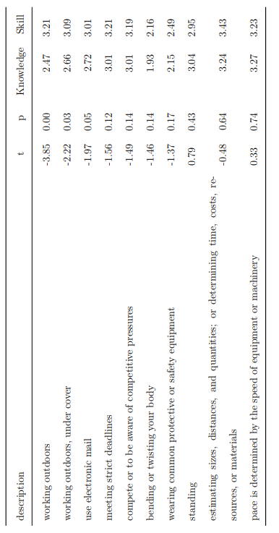

**Table 2**

## *Top 10 Challenge Demand Job Characteristics with the Least Variability*

## 

**Table 3**

*Top 10 Hindrance Demand Job Characteristics with the Least Variability*

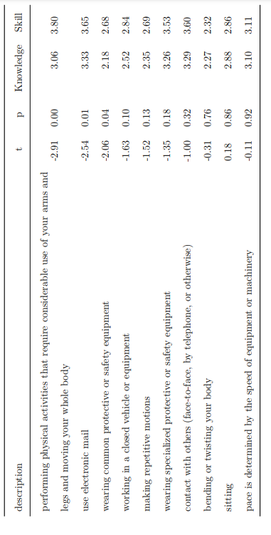

## Figure 1

## *Top 10 Resources, Divided by Skilled versus Knowledge Workers*

## 

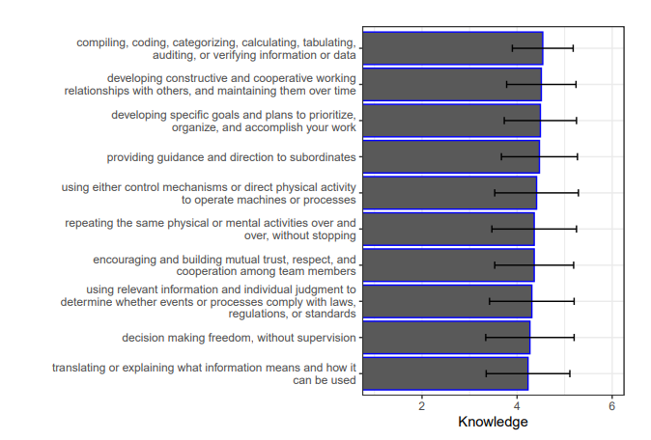

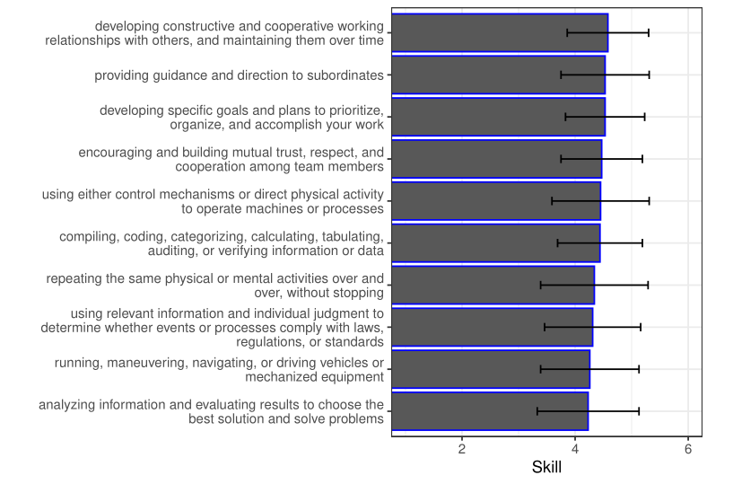

## Figure 2

## *Top 10 Challenge Demands, Divided by Skilled versus Knowledge Workers*

## 

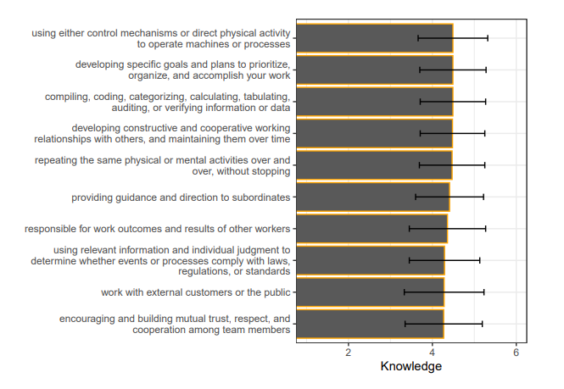

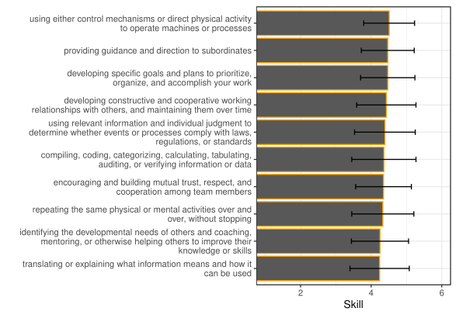

## Figure 3

## *Top 10 Hindrance Demands, Divided by Skilled versus Knowledge Workers*

## 

