Testing the JD-R Theory: Using the Content of the O*Net

Alicia A. Stachowski1 & John T. Kulas2

1 University of Wisconsin - Stout

2 eRg

Author note

Add complete departmental affiliations for each author here. Each new line herein must be indented, like this line.

Enter author note here.

The authors made the following contributions. Alicia A. Stachowski: Conceptualization, Writing - Original Draft Preparation, Writing - Review & Editing; John T. Kulas: Writing - Review & Editing.

Correspondence concerning this article should be addressed to Alicia A. Stachowski, Postal address. E-mail: [stachowskia@uwstout.edu](mailto:stachowskia@uwstout.edu)

Testing the JD-R Theory: Using the Content of the O*Net

The Job Demands-Resources Theory [JD-R; Demerouti et al. (2001)] has received wide support across contexts and varied research questions. We extend the literature by 1) exploring the interaction between *perceptions* of job demands and resources on the outcome of stress using job characteristics in the popular O*Net and 2) by considering also the appraisal of demands as challenge or hindrance stressors. Here, respondents made a series of evaluations that used: direct O*Net terminology (both descriptor and response option), and JD-R influenced ratings of demand and hindrance stressors. Prior to a description of results, a brief overview of both the JD-R theory, the stress appraisal process, and O*Net, is provided.

## The Job demands-Resources Theory

The job demands-resources theory is an expansion of the well-studied job demands-resources model (Demerouti et al., 2001). One of the major advantages of the job demands-resources theory is that it allows us to model both work environment and job characteristics via job resources and demands, which are thoroughly documented by job in O*Net. *Resources* are defined as physical, psychological, social, or organizational aspects of the job that may help an employee achieve work goals, reduce job demands, or promote personal growth and development (Demerouti et al., 2001). *Demands*, on the other hand, include components of a job that require sustained effort, and as such, produce psychological or physiological strain (e.g., high work pressure; Demerouti et al. (2001)).

Cognitively, the perception of an element of one’s job as a resource or demand activates one of two unique processes: health impairment (resulting from demands) or motivation [resulting from resources; (**bakker2014job?**)]. Demanding job characteristics are frequently associated with negative outcomes (e.g., A. Bakker et al., 2003), whereas job characteristics deemed resources have been associated with positive organizational outcomes like engagement and motivation (A. B. Bakker et al., 2007). However, a related line of research emphasizes a distinction between two types of demands - that of “challenge” and “hindrance” demands, suggesting that employees may evaluate stressors in different ways.

## Objective vs. Subjective Nature of Demands and Resources: The Role of Appraisal

The stress literature speaks to the key consideration of the way employees appraise situations or circumstances - in this case, our focus will be on work characteristics. The transactional theory of stress and coping suggests that people cognitively appraise stimuli in their environments on a continuous basis (**lazarus1984stress?**). For example, two employees both informed that they need to step in and assume the responsibilities of a coworker in their absence may react differently to this job demand. One may feel quite paralyzed by the added or novel tasks, while the other may embrace it as an exciting new challenge. The terms associated with the two different appraisals of the same stressor are “challenge” and “hindrance” demands (**cavanaugh2000empirical?**) Challenge demands promote mastery, personal growth, and future gains. Hindrance demands, by definition, inhibit growth, learning and goal achievement. Perhaps not surprisingly, challenge stressors are typically associated with positive outcomes, whereas hindrance stressors are associated with more negative outcomes (e.g., **cavanaugh2000empirical?**). Our focus here will be on the connection between hindrance demands specifically, and their association with reported stress. More specifically, our interest here is whether or not the negative hindrance association we typically observe between demands and stress can be buffered by perceived resources.

(**searle2015merits?**) note that much of our research on workplace demands is based on apriori classifications of demands. For instance, we assume that generally, time pressure is a negative demand on an employee. However, the stress experience, or process, described early on by (**lazarus1984stress?**) is grounded in the assumption that individual appraisals of stressors/demands vary. Their transactional theory of stress and coping states that people continuously appraise stimuli in their environments. An appraisal is the cognitive process whereby meaning is assigned to a stimulus. If a stimulus is appraised as a stressor (threat, challenge, potentially harmful), emotional distress leads to coping of some kind. This action to cope is also associated with another appraisal about the outcome itself and the process continues if the outcomes is not appraised as favorable (**lazarus1984stress?**). As such, the stress appraisal process suggests that classifying a job characteristic or environmental condition as an objective demand or resource might be in error.

We next consider the empirical evidence on the subjective nature of demands and resources. First, as hinted at above, some research suggests that job demands and resources may not be universally appraised or assigned as such. Starting with job demands, (**webster2011extending?**) studied workload, role ambiguity, and role conflict demands, and found that while each could be appraised primarily as a challenge or hindrance demand, they could also simultaneously be perceived as being *both* a challenge and hindrance to different degrees. While their study not did include resources, it documents individual differences in how people perceive stressors at work. Although not the primary focus of their paper, Sonnega et al. (2018) compared self-reported (subjective) ratings of degree of physical demand, stress, and need for intense concentration from the Health and Retirement Study with objective ratings from O*Net. Correlations physical demand (r = .52), stress (r = .10), and need for intense concentration (r = .14), again suggesting perhaps that our objective ratings of job demands (and resources) may be subject to a greater level of individual difference than we tend to think. While the above two studies provide evidence for variability in perception of demands, Schmitz et al. (2019) captured subjective and objective resources in their study of retirement. Correlations of composite variables between subjective and objective measures for the resources of autonomy (r = .12. p > .01), recognition of work (r = .07, p > .01), and decision freedom (r = .08, p > .01), while significant, certainly do not reflect high levels of overlap. We do acknowledge as well, that demands and resources are not necessarily consistent across days, or seasons, for many employees. (**downes2021incorporating?**) meta-analysis addresses this reality in depth, although it is beyond the scope of this project.

Thus, while it is cleaner to be able to categorize job characteristics as *either* a demand or a resource, the above research suggests that individual appraisal is an important consideration. It is quite possible that one person experiences high work pressure (commonly cited as a demand in the literature) as a hindrance stressor and thus experiences strain, and another thrives in a fast-paced pressured role and would thus find the environment motivating. Here, we asked respondents to rate all of the job characteristics in terms of hindrances, challenges, and resources.

## Value of exploring the O*Net Resource

First, the Occupational Information Network (O*NET; onetonline.org) contains a comprehensive description of occupations (**peterson2001understanding?**). This widely accessed database houses hundreds of standardized and occupation-specific descriptors most occupations in the US and these descriptions are continually updated. These data, and the tools provided for free on the website (e.g., Career Exploration Tools, “My Next Move,” Toolkit for Business) are frequently used by counselors, students, human resources departments, and researchers to assist potential applicants discover the skills and training they need for the job of their choice. It is also useful to employers by providing them with information with which to craft job descriptions and help employees determine what skills are needed for promotion. We utilized statements taken from O*NET [“activity” and “context” classifications](https://www.O*NETonline.org/find/descriptor/result/4.A.1.b.3) (e.g., items related to information input, interacting with others, physical work conditions, structural job characteristics).

# Current Study and Hypotheses

These data were taken from a larger study on JD-R theory as it applies to O*NET items, particularly Proposition 3 of the JD-R model - that job resources can buffer the impact of job demands on strain. The interaction between job resources and demands has been heavily studied with regard to a range of outcomes. For example A. B. Bakker et al. (2010) found that resources (e.g., learning opportunities, autonomy, leader support) predicted both task enjoyment and organizational commitment even under conditions of high demands. Much of the research, however, has focused on stress/strain and burnout outcomes. For example, A. B. Bakker et al. (2005) found that job resources lessen the impact of demands on burnout in a large sample of employees working in higher education, and Xanthopoulou et al. (2007) found similar patterns in a sample of home care organization employees.

Our specific interest in the current study is in whether or not *perceptions* of hindrance demands are postitively related to perceived stress, and whether or not this relationship is moderated by perceived resources. The Job demands-Resources theory would suggest resources would buffer this relationship. In fact, a rather large body of empirical evidence supports this assertion (e.g., see A. B. Bakker & Demerouti, 2017 for a historical review). We do have some existing evidence that this occurs with other outcomes beyond stress. For example, Tadić et al. (2015) found that daily hindrance job demands were negatively related to both positive affect and engagement in a sample of primary school teachers. Daily job resources, in this sample, buffered the relationships between hindrances and affect and engagement. Here, we propose that perceived resources generally, as opposed to daily, would also buffer the relationship between perceived hindrance stressors and, in this, case, perceived stress. The following two predictions are made:

*H1. There is a positive relationship between perceived hindrance stressors and stress.*

*H2. The relationship between mean perceived hindrances and stress will be moderated by resources such that this relationship is diminished as perceived resources increase.*

# Methods

### Participants.

We sampled from a Prolific panel, resulting in 785 individuals who initially 166 accessed the survey link. Of those, 112 indicated that they were not interested, had more 167 than 200 missing responses, or had 20 or more identical consecutive sequential responses 168 (Yentes & Wilhelm, 2021). There were a total of 568 respondents, of which 13.57% had been in their referent job less than 6 months, 19.20% between 6 months and a year, 49.12% between one and five years, 13.27% between 5 and 10 years, and 4.87% more than 10 years.Their ages ranged from 18 to 65 with an average of 28.18 years old (*SD* = 7.53). Over half, 52.58% identified as female, and 46.83% identified as male.

# Materials

*Resources and Hindrances*. To guage resources and hindrances, we used 98 statements taken directly from O $​^{*}$*Net’s “activity” and “context” classifications. Each of the 98 descriptors has potentially unique response categories, but scaling was consistently 1 (low) to 5 (high). Subsequent to these self-evaluations, respondents were asked to rate elements in terms of resources (“…this aspect of your job is a resource that can be functional in achieving work goals, reduce job demands, or stimulate personal growth/development”), challenges, (…this aspect of your job is a challenge that can promote mastery, personal growth, or future gains“) and hindrances (”…this aspect of your job is a hindrance that can inhibit personal growth, learning, and work goal attainment"). For each category (e.g., resources), a means was computed across items that applied to one’s role, and thus, mean scores could range from 1 to 5.

*Stress*. Three items taken from the Copenhagen Psychosocial Questionnaire ((**burr_third_2019?**)) captured stress (e.g., “How often have you had problems relaxing because of your job?”). Responses were made on a 5-point scale ranging from “not at all” to “all the time.” Alpha was .85 in this sample.

## Procedure

The data presented here were part of a larger study on the Job-demands Resources Model using O*Net. Data were collected through Prolific, a data collection platform. An email was sent to a random subset of all eligible participants in the Prolific respondent pool, notifying them about their eligibility for the study based on demographic information. Eligibility requirements included being 18+ and holding either a full-time or part-time job. Participants then voluntarily chose to respond to the survey. The survey was conducted online via Qualtrics with an estimated completion time of 40-45 minutes. Participants were asked to think about their primary job while answering the survey, and the items they were presented with depended on the specific job characteristics they initially specified. Thus, if a respondent indicated that 5 of the characteristics were not part of their job, they were not subsequently asked to rate the level of resource, challenge, or hindrance a given item presented to them. For items that were a part of their jobs, they were then asked to report how much a characteristic was a resource, and then how much each characteristic was a hindrance, and finally, how much each item was a challenge. Participants were compensated for their participation in this study in the amount of six dollars through Prolific.

# Results

##   
## ********************* PROCESS for R Version 4.1.1 *********************   
##   
## Written by Andrew F. Hayes, Ph.D. www.afhayes.com   
## Documentation available in Hayes (2022). www.guilford.com/p/hayes3   
##   
## ***********************************************************************   
##   
## PROCESS is now ready for use.  
## Copyright 2022 by Andrew F. Hayes ALL RIGHTS RESERVED  
## Workshop schedule at http://haskayne.ucalgary.ca/CCRAM  
##

##   
## ********************* PROCESS for R Version 4.1.1 *********************   
##   
## Written by Andrew F. Hayes, Ph.D. www.afhayes.com   
## Documentation available in Hayes (2022). www.guilford.com/p/hayes3   
##   
## ***********************************************************************   
##   
## Model : 1   
## Y : stress   
## X : overall.hindrance  
## W : overall.resource   
##   
## Sample size: 568  
##   
##   
## ***********************************************************************   
## Outcome Variable: stress  
##   
## Model Summary:   
## R R-sq MSE F df1 df2 p  
## 0.1311 0.0172 0.7790 3.2876 3.0000 564.0000 0.0205  
##   
## Model:   
## coeff se t p LLCI ULCI  
## constant 1.2688 1.0055 1.2618 0.2075 -0.7063 3.2439  
## overall.hindrance 0.8336 0.4031 2.0677 0.0391 0.0417 1.6254  
## overall.resource 0.3319 0.2518 1.3181 0.1880 -0.1627 0.8264  
## Int_1 -0.1918 0.1024 -1.8725 0.0616 -0.3929 0.0094  
##   
## Product terms key:  
## Int_1 : overall.hindrance x overall.resource   
##   
## Test(s) of highest order unconditional interaction(s):  
## R2-chng F df1 df2 p  
## X*W 0.0061 3.5064 1.0000 564.0000 0.0616  
## ----------  
## Focal predictor: overall.hindrance (X)  
## Moderator: overall.resource (W)  
##   
## Conditional effects of the focal predictor at values of the moderator(s):  
## overall.resource effect se t p LLCI ULCI  
## 3.2983 0.2010 0.0802 2.5065 0.0125 0.0435 0.3586  
## 3.7402 0.1163 0.0534 2.1759 0.0300 0.0113 0.2213  
## 4.2063 0.0269 0.0594 0.4535 0.6503 -0.0897 0.1435  
##   
## Moderator value(s) defining Johnson-Neyman significance region(s):  
## Value % below % above  
## 3.8196 55.6338 44.3662  
##   
## Conditional effect of focal predictor at values of the moderator:  
## overall.resource effect se t p LLCI ULCI  
## 1.0149 0.6389 0.3003 2.1276 0.0338 0.0491 1.2288  
## 1.2078 0.6020 0.2809 2.1433 0.0325 0.0503 1.1536  
## 1.4006 0.5650 0.2615 2.1608 0.0311 0.0514 1.0785  
## 1.5935 0.5280 0.2421 2.1807 0.0296 0.0524 1.0035  
## 1.7863 0.4910 0.2228 2.2034 0.0280 0.0533 0.9287  
## 1.9791 0.4540 0.2037 2.2293 0.0262 0.0540 0.8540  
## 2.1720 0.4170 0.1846 2.2592 0.0243 0.0545 0.7796  
## 2.3648 0.3801 0.1657 2.2937 0.0222 0.0546 0.7055  
## 2.5577 0.3431 0.1470 2.3336 0.0200 0.0543 0.6318  
## 2.7505 0.3061 0.1287 2.3791 0.0177 0.0534 0.5588  
## 2.9434 0.2691 0.1108 2.4292 0.0154 0.0515 0.4867  
## 3.1362 0.2321 0.0937 2.4784 0.0135 0.0482 0.4161  
## 3.3290 0.1951 0.0778 2.5085 0.0124 0.0423 0.3479  
## 3.5219 0.1582 0.0641 2.4667 0.0139 0.0322 0.2841  
## 3.7147 0.1212 0.0543 2.2306 0.0261 0.0145 0.2279  
## 3.8196 0.1011 0.0515 1.9642 0.0500 0.0000 0.2021  
## 3.9076 0.0842 0.0507 1.6605 0.0974 -0.0154 0.1838  
## 4.1004 0.0472 0.0545 0.8662 0.3867 -0.0599 0.1543  
## 4.2933 0.0102 0.0644 0.1589 0.8738 -0.1163 0.1368  
## 4.4861 -0.0267 0.0782 -0.3421 0.7324 -0.1803 0.1268  
## 4.6790 -0.0637 0.0941 -0.6773 0.4985 -0.2485 0.1211  
## 4.8718 -0.1007 0.1112 -0.9054 0.3656 -0.3192 0.1178  
##   
## Data for visualizing the conditional effect of the focal predictor:  
## overall.hindrance overall.resource stress  
## 1.6667 3.2983 2.6985  
## 2.2894 3.2983 2.8237  
## 3.2416 3.2983 3.0151  
## 1.6667 3.7402 2.7039  
## 2.2894 3.7402 2.7763  
## 3.2416 3.7402 2.8871  
## 1.6667 4.2063 2.7096  
## 2.2894 4.2063 2.7264  
## 3.2416 4.2063 2.7520  
##   
## ******************** ANALYSIS NOTES AND ERRORS ************************   
##   
## Level of confidence for all confidence intervals in output: 95  
##   
## W values in conditional tables are the 16th, 50th, and 84th percentiles.

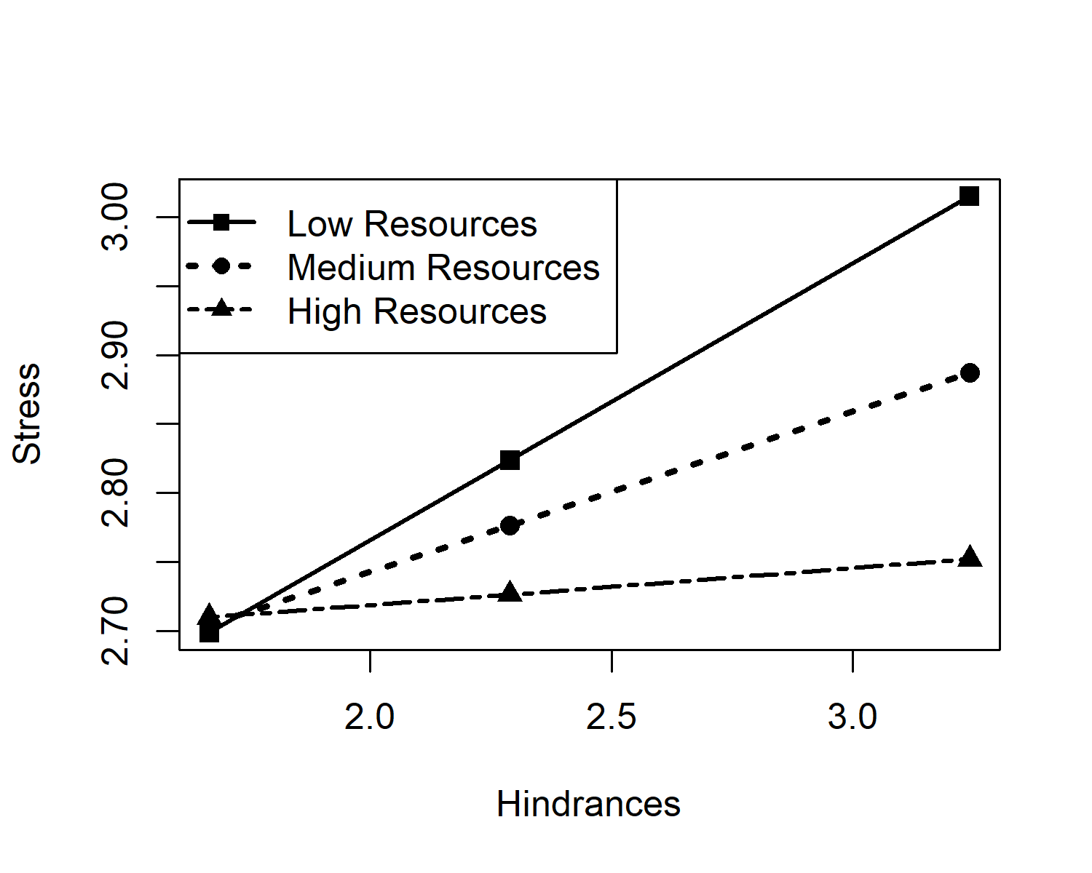

*Figure* *1.*  Interaction between hindrances and resources as predictors of stress

Following data cleaning and preparation, we computed correlations among the study variables. See Table 1. With regard to H1, which predicted a positive association between perceived hindrance stressors and stress, a positive relationship was observed, *r* = , *p* = . Thus, support was found for H1.

Next, to explore H2, a moderated regression including hindrances, resources, and the interaction between them was done using PROCESS, version 4.1.1 (Hayes, 2022). First, the overall regression model including mean hindrances, mean resources, and the interaction between the two variables was significant, F(3, 564) = 3.29, *p* = .020. The interaction between hindrance and resources (uncentered) revealed that the relationship between hindrances and stress was conditional on resources, F(3, 564) = 3.51, *p* = .061, providing tentative support for H2. As can be seen in Figure 1, those with fewer resources show a much stronger positive relationship between hindrances and stress than those with more resources. As such, these results provide some evidence that the resources do moderate the relationship between hindrance stressors

Table 1:

*Results from a regression analysis examining the moderation of resources on the relationship between hindrance demands and stress*

|  |  |  |  |  |
| --- | --- | --- | --- | --- |
| Component | coeff | SE | t | p |
| Constant | 1.27 | 1.01 | 1.26 | 0.21 |
| Hindrance (X) | 0.83 | 0.40 | 2.07 | 0.04 |
| Resource (W) | 0.33 | 0.25 | 1.32 | 0.19 |
| Hindrance x Resource | -0.19 | 0.10 | -1.87 | 0.06 |

*Note.* R2 etc here

# Discussion

The primary goal of this project was to further explore the role of perceived resources on the hindrance-stress relationship. As expected, the results suggest a positive relationship between perceived hindrances and stress (H1). While intuitive, it is important to replicate this finding before we explore the impact of perceived resources, which arguably, is something that employers may have more leverage to control than hindrance stressors. Second, the results serve to support the assertion that resources change the relationship between hindrances and stressors such that the connection between the two is dimished as resources increase (H2). While not hypothesized or presented above, the authors did run a regression on the challenge-stress relationship with resources as a moderator, with the assumption that resources wouldn’t influence a direct relationship, and did find that to be the case. The Job-demands Resources Theory [JD-R; Demerouti et al. (2001)] suggests that resources would buffer the negative impact between demands and stress, and by extension, given the more traditional conceptualization of demands would be aligned with hindrance demands.

These findings have implications worth considering. In a practical sense wihtin the workplace, they speak to the ever present need to ensure employees have sufficient resources. Our project focused on the characteristics of one’s work specifically, and in line with the literature cited above, studied the ratings or perceptions of resources and demands to account for individual differences in the way employees appraise components of their work. From a academic research standpoint, these findings integrate three related literatures: the job-demands resources, stress appraisal, and challenge-hindrance framework to examine the experience of employees across jobs - specifically, the way that resources and hindrance demands interact on the experience of stress. Results align with what all three theories/frameworks would suggest.

## Limitations and Future Directions

Here, we note a number of limitations, but also provide additional directions for future research on this topic. First, while the use of O*Net items is a strength of the paper, practical considerations limited the number of job characteristics we could include in our survey. Because our focus was on O*Net items and our procedure was time and effort intensive, we were unable to inquire about other forms of resources (e.g., supervisor or coworker support) or demands. Thus, future study could explore these sources of support as resources and perhaps even compare the importance of various types of resources and their role in reducing the influence of hindrance stressors. Is it overall perceptions of having more resources that makes up for hindrances, or could it be that certain resources carry more weight? Second, our focus here was on the outcome of stress, but it may also be of value to consider what the interaction between resources and hindrances looks like on other outcomes of interest in a work context (e.g., commitment, motivation, engagement, intent to quit).

# References

Bakker, A. B., & Demerouti, E. (2017). Job demands–resources theory: Taking stock and looking forward. *Journal of Occupational Health Psychology*, *22*(3), 273.

Bakker, A. B., Demerouti, E., & Euwema, M. C. (2005). Job resources buffer the impact of job demands on burnout. *Journal of Occupational Health Psychology*, *10*(2), 170.

Bakker, A. B., Hakanen, J. J., Demerouti, E., & Xanthopoulou, D. (2007). Job resources boost work engagement, particularly when job demands are high. *Journal of Educational Psychology*, *99*(2), 274.

Bakker, A. B., Van Veldhoven, M., & Xanthopoulou, D. (2010). Beyond the demand-control model: Thriving on high job demands and resources. *Journal of Personnel Psychology*, *9*(1), 3.

Bakker, A., Demerouti, E., & Schaufeli, W. (2003). Dual processes at work in a call centre: An application of the job demands–resources model. *European Journal of Work and Organizational Psychology*, *12*(4), 393–417.

Demerouti, E., Bakker, A. B., Nachreiner, F., & Schaufeli, W. B. (2001). The job demands-resources model of burnout. *Journal of Applied Psychology*, *86*(3), 499.

Hayes, A. F. (2022). *Introduction to mediation, moderation, and conditional process analysis: A regression-based approach* (3rd ed.). The Guilford Press.

Schmitz, L. L., McCluney, C. L., Sonnega, A., & Hicken, M. T. (2019). Interpreting Subjective and Objective Measures of Job Resources: The Importance of Sociodemographic Context. *International Journal of Environmental Research and Public Health*, *16*(17), 3058. <https://doi.org/10.3390/ijerph16173058>

Sonnega, A., Helppie-McFall, B., Hudomiet, P., Willis, R. J., & Fisher, G. G. (2018). A Comparison of Subjective and Objective Job Demands and Fit With Personal Resources as Predictors of Retirement Timing in a National U.S. Sample. *Work, Aging and Retirement*, *4*(1), 37–51. <https://doi.org/10.1093/workar/wax016>

Tadić, M., Bakker, A. B., & Oerlemans, W. G. (2015). Challenge versus hindrance job demands and well-being: A diary study on the moderating role of job resources. *Journal of Occupational and Organizational Psychology*, *88*(4), 702–725.

Xanthopoulou, D., Bakker, A. B., Dollard, M. F., Demerouti, E., Schaufeli, W. B., Taris, T. W., & Schreurs, P. J. (2007). When do job demands particularly predict burnout? The moderating role of job resources. *Journal of Managerial Psychology*.