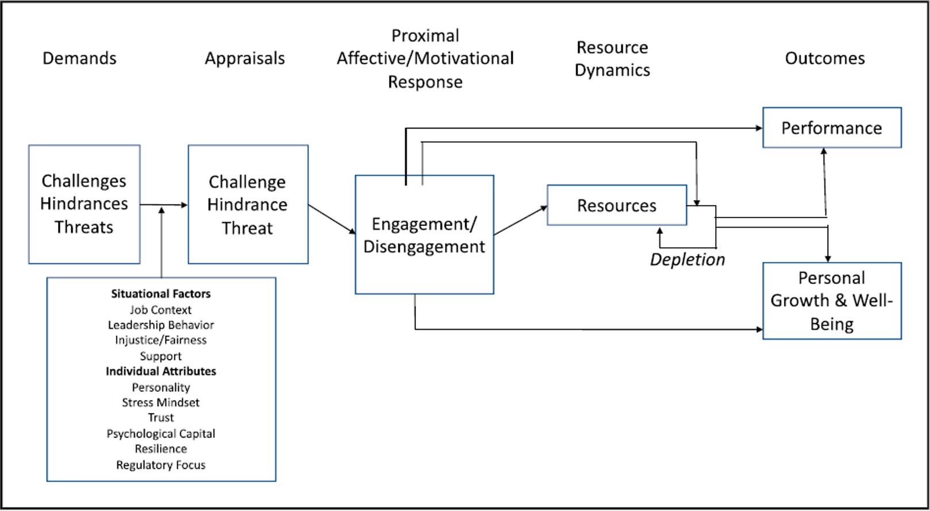

*Figure 1* . LePine’s (2022) revised challenge-hindrance stressor framework.

developing constructive and cooperative working relationships with others, and maintaining them over time

analyzing information and evaluating results to choose the

best solution and solve problems keeping up−to−date technically and applying new knowledge

encouraging and building mutual trust, respect, and

cooperation among team members

being very exact or highly accurate

identifying the developmental needs of others and coaching, mentoring, or otherwise helping others to improve their

knowledge or skills

establishing long−range objectives and specifying the strategies and actions to achieve them

developing specific goals and plans to prioritize, organize, and accomplish your work

2 4 6

Most Agreed Upon as a Challenge

using your hands to handle, control, or feel objects, tools

or controls

monitoring and reviewing information from materials, events, or the environment, to detect or assess problems

keeping or regaining your balance

identifying information by categorizing, estimating, recognizing differences or similarities, and detecting

changes in circumstances or events

working in an open vehicle or equipment

using either control mechanisms or direct physical activity

to operate machines or processes telephone conversations

standing

2 4 6

Most Agreed upon as a Hindrance

developing specific goals and plans to prioritize, organize, and accomplish your work

encouraging and building mutual trust, respect, and

cooperation among team members

analyzing information and evaluating results to choose the

best solution and solve problems

getting members of a group to work together to accomplish

tasks

developing constructive and cooperative working relationships with others, and maintaining them over time identifying the developmental needs of others and coaching, mentoring, or otherwise helping others to improve their

knowledge or skills

assessing the value, importance, or quality of things or

people coordinate or lead others

2 4 6

Most Agreed Upon as a Resource

*Figure 2* . Characteristics percieved most similarly (lowest standard deviations).

wearing common protective or safety equipment

running, maneuvering, navigating, or driving vehicles or

mechanized equipment kneeling, crouching, stooping or crawling

making repetitive motions

working in very hot wor very cold temperatures

working in cramped work spaces

wearing specialized protective or safety equipment

working exposed to sounds and noise levels that are

distracting or uncomfortable

1 2 3 4 5

Least Agreed Upon as a Challenge

working outdoors

running, maneuvering, navigating, or driving vehicles or

mechanized equipment

performing day−to−day administrative tasks such as maintaining information files and processing paperwork

conflict situations you have to face

working in very hot wor very cold temperatures

handling complaints, settling disputes, and resolving grievances and conflicts, or otherwise negotiating with

others

decision making freedom, without supervision

being very exact or highly accurate

1 2 3 4 5

Least Agreed upon as a Hindrance

working indoors in non−controlled environmental conditions

working exposed to sounds and noise levels that are

distracting or uncomfortable

repeating the same physical or mental activities over and

over, without stopping pace is determined by the speed of equipment or machinery

job structured for you, rather than allowing you to determine tasks, priorities, and goals

working outdoors

working in very hot wor very cold temperatures

deal with unpleasant, angry, or discourteous individuals

1 2 3 4 5

Least Agreed Upon as a Resource

*Figure 3* . Characteristics percieved most *DIS* similarly (largest standard deviations).

15

10

Challenge

5

0

15

10

Hindrance

count

5

0

15

10

Resource

5

0

0.8

1.0

sd

1.2

1.4

*Figure 4* . Frequency distribution of standard deviations across characteristics deemed re- sources, challenges, and demands.

Overwork

Job Control

Physical Environment

Participation

Time Pressure

Emotional Demands

Autonomy

Recipient Contact

Team Cohesion

Work Pressure

1 2 3 4 5

1 2 3 4 5

Challenge

Hindrance

Resou

*Figure 5* . Average characteristic rating grouped by literature-implicated categorizations.