# Title

Any notes / paragraphs relevant to what it is that you want to talk about

## Subheading

### Sub-Subheading

library(palmerpenguins)

Warning: package 'palmerpenguins' was built under R version 4.2.3

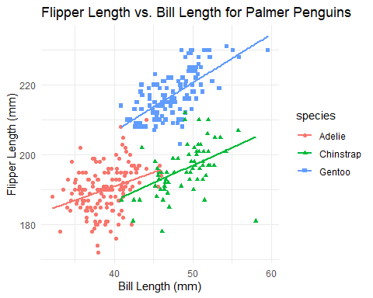

We can also do a basic barplot with ggplot2:

# Basic bar plot with ggplot2  
ggplot(penguins, aes(x=species, y=body_mass_g, fill=species)) +   
 geom_bar(stat="summary", fun="mean") +   
 labs(title="Average Body Mass of Palmer Penguins by Species",  
 x="Species",  
 y="Average Body Mass (g)") +  
 theme_minimal()

Warning: Removed 2 rows containing non-finite values (`stat_summary()`).

