Avi Montanez (adm2jr)

2/3/2017

CS 4102 HW2

On my honor, I have neither given nor received aid on this assignment

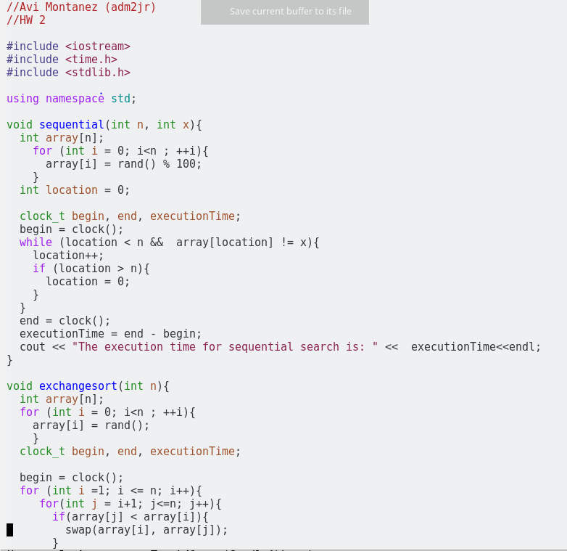

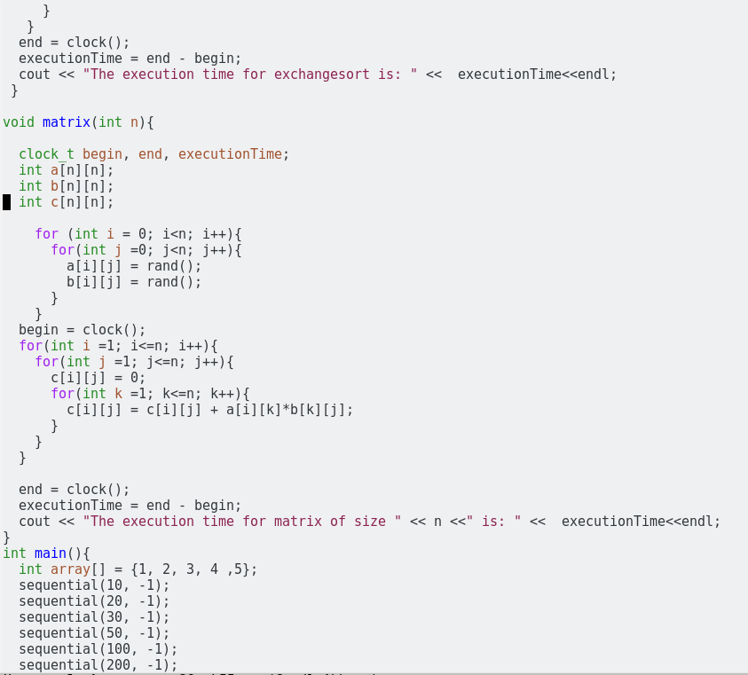

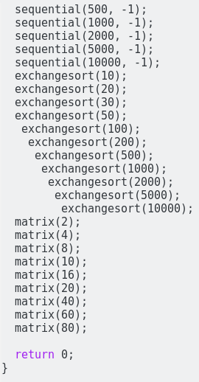

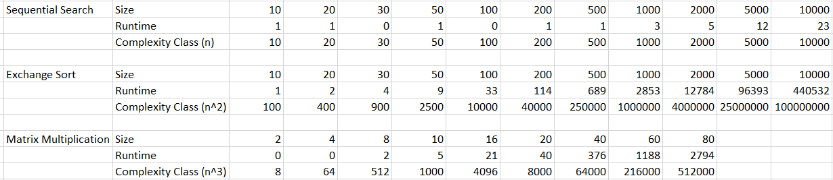

For every single function, it ran much faster than its respective complexity class. I believe this is due to the nature of the length in time of a clock cycle. This may be due to how many computations can be done within the length of one clock tick. Maybe the function behavior would have been different and more consistent with what we learned in class if runtime was measured in seconds or another time unit.