A. 使用Filter驗證用戶端密碼
1. 修改C:\apache-tomcat-7.0.42\webapps\ROOT\WEB-INF\web.xml
<filter>
<filter-name>Simple Filter</filter-name>
<filter-class>MyServlet</filter-class>
<init-param>
<param-name>message</param-name>
<param-value>Hello!</param-value>
</init-param>
</filter>
<filter-mapping>
<filter-name>Simple Filter</filter-name>
<url-pattern>*.jsp</url-pattern>
</filter-mapping>

2. 新增 C:\apache-tomcat-7.0.42\webapps\ROOT\user.html
<html>
<head>
<title></title>
<meta http-equiv="Content-Type" content="text/html; charset=UTF-8">
</head>
<body>
<form action="index.jsp" method="post">
帳號:<input type="text" name="user" value="John"/><br/>
密碼:<input type="password" name="password" value="12345"/><br/>
<input type="submit" value="登入"/>
</form>
</body>
</html>

3. 新增 C:\apache-tomcat-7.0.42\webapps\ROOT\WEB-INF\classes\MyServlet.java並編譯

import java.util.*;
import java.io.*;
import javax.servlet.*;
import javax.servlet.http.*;
import java.security.*;

public class MyServlet implements Filter {
private FilterConfig filterConfig = null;
public void init(FilterConfig filterConfig) {
this.filterConfig = filterConfig;
}
public void doFilter(ServletRequest request, ServletResponse response, FilterChain chain) throws IOException, ServletException
{
String password = ((HttpServletRequest) request).getParameter("password");

if (password!=null && password.equals("opensesame") ) {
chain.doFilter(request, response);
} else {
response.setContentType("text/html");
PrintWriter out = response.getWriter();
out.println("<HTML>");
out.println("<HEAD>");
out.println("<TITLE>");
out.println("Incorrect Password");
out.println("</TITLE>");
out.println("</HEAD>");
out.println("<BODY>");
out.println("<H1>Incorrect Password</H1>");
out.println("Sorry, that password was incorrect.");
out.println("</BODY>");
out.println("</HTML>");
}
}
public void destroy() {
}
}

執行http://localhost:8080/user.html
B. 使用Filter計算程式執行花費時間
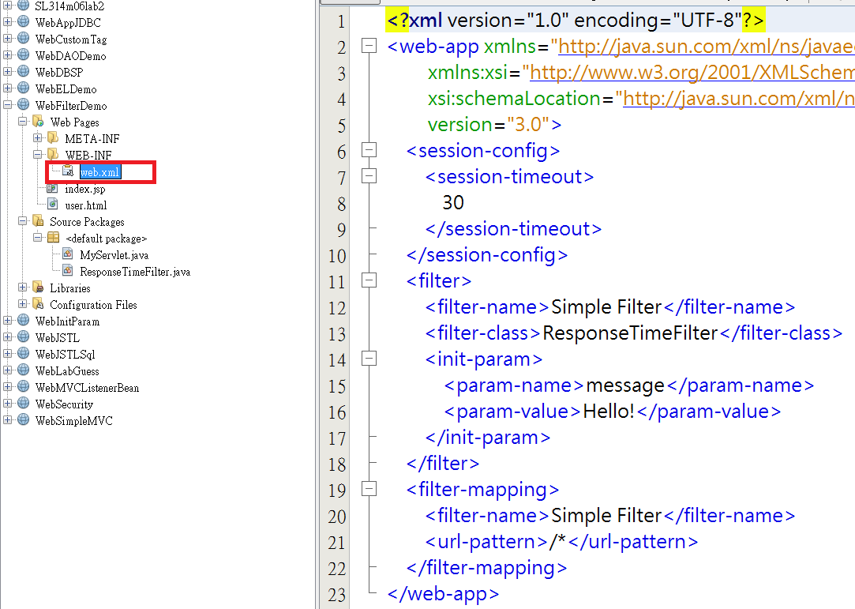
1. 修改 web.xml
<filter>
<filter-name>Time Filter</filter-name>
<filter-class>ResponseTimeFilter</filter-class>
<init-param>
<param-name>message</param-name>
<param-value>Hello!</param-value>
</init-param>
</filter>
<filter-mapping>
<filter-name>Time Filter</filter-name>
<url-pattern>/*</url-pattern>
</filter-mapping>

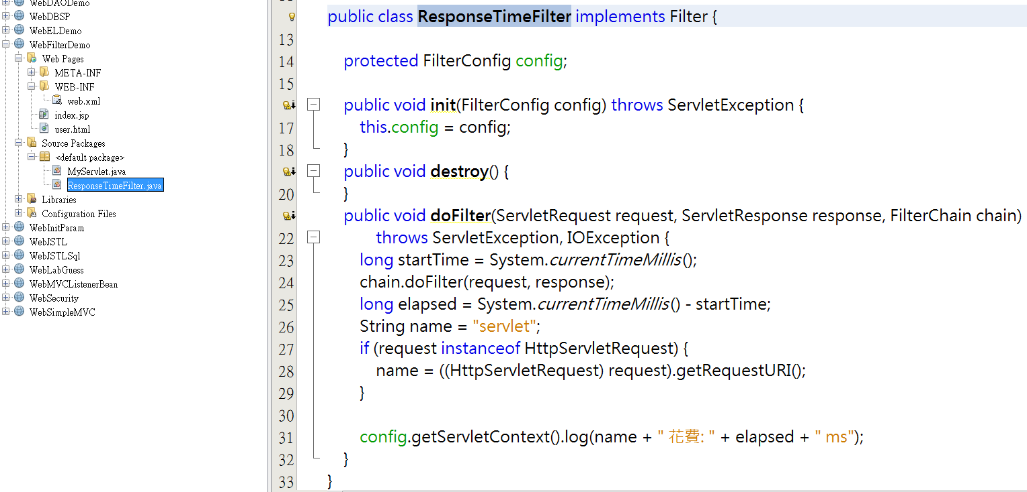
2. 加入ResponseTimeFilter.java程式

import java.io.IOException;
import javax.servlet.Filter;
import javax.servlet.FilterChain;
import javax.servlet.FilterConfig;
import javax.servlet.ServletException;
import javax.servlet.ServletRequest;
import javax.servlet.ServletResponse;
import javax.servlet.http.HttpServletRequest;
public class ResponseTimeFilter implements Filter {
protected FilterConfig config;
public void init(FilterConfig config) throws ServletException {
this.config = config;
}
public void destroy() {
}
public void doFilter(ServletRequest request, ServletResponse response, FilterChain chain) throws ServletException, IOException {
long startTime = System.currentTimeMillis();
chain.doFilter(request, response);
long elapsed = System.currentTimeMillis() - startTime;
String name = "servlet";
if (request instanceof HttpServletRequest) {
name = ((HttpServletRequest) request).getRequestURI();
}

config.getServletContext().log(name + " 花費: " + elapsed + " ms");
}
}

