利用猜數字遊戲撰寫MVC Design Pattern的程式
重點：運用MVC的架構撰寫猜數字的servlet程式(1-10猜一個整數)。
步驟
- 打開檔案總管，找到C:\apache-tomcat-7.0.42\webapps\ROOT，新增資料夾LabGuess。
- C:\apache-tomcat-7.0.42\webapps\ROOT\LabGuess加入index.html
<html>
<head></head>
<body>
<form action="/Fortune" method="post">
猜一個數字(1~10) ?<br/>
<input type="text" name="number" /><br/>
<input type="submit" name="submit" value="Showhand" />
</form>
</body>
</html>
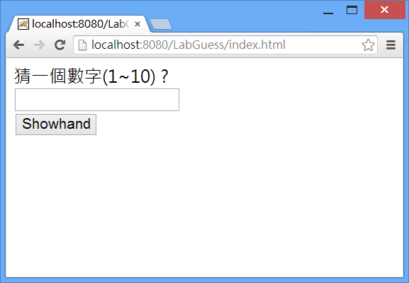

3. 建立Controller GameServlet.java程式

import javax.servlet.http.*;
import java.io.*;
import javax.servlet.ServletException;

public class GameServlet extends HttpServlet {
@Override
public void doPost(HttpServletRequest request,
HttpServletResponse response)
throws ServletException, IOException {
processRequest(request, response);
}
@Override
protected void doGet(HttpServletRequest request, HttpServletResponse response)
throws ServletException, IOException {
processRequest(request, response);
}
public void processRequest(HttpServletRequest request,
HttpServletResponse response)
throws ServletException, IOException {
HttpSession session = request.getSession();
GuessGameLogic gameService=(GuessGameLogic)session.getAttribute("GameService");
if (gameService==null) {
gameService = new GuessGameLogic(1, 10);
session.setAttribute("GameService" , gameService);
}
String guess = request.getParameter("number");
int guessNum = Integer.parseInt(guess);
if ( gameService.isCorrectGuess(guessNum) ) {
generateYouWinResponse(request, response);
session.invalidate();
} else {
int remainder = gameService.getRemainder();
if ( remainder > 0) {
generateTryAgainResponse(request, response, remainder);
} else {
generateTooManyGuessesResponse(request, response);
session.invalidate();
}
}
}
public void generateTryAgainResponse(HttpServletRequest request,
HttpServletResponse response, int remainder)
throws IOException {
String guess = request.getParameter("number");
response.setContentType("text/html");
PrintWriter out = response.getWriter();
out.println("<html><head></head><body>");
out.println("Your guess " + guess + " , and You wrong.</br>");
out.println("You still have " + remainder + " changes.Try again.</br>");
out.println("<a href='/guess.html'>Gogogo!!</a>");
out.println("</body></html>");
out.close();
}
public void generateYouWinResponse(HttpServletRequest request,
HttpServletResponse response)
throws IOException {
response.setContentType("text/html");
PrintWriter out = response.getWriter();
out.println("<html><head></head><body>");
out.println("Congratulations , You win! <BR>");
out.println("**<a href='/ guess.html'>New Game</a>**");
out.println("</body></html>");
out.close();
}
public void generateTooManyGuessesResponse(HttpServletRequest request,
HttpServletResponse response)
throws IOException {
String guess = request.getParameter("number");
response.setContentType("text/html");
PrintWriter out = response.getWriter();
out.println("<html><head></head><body>");
out.println("Your guess " + guess + " , and You wrong.</br>");
out.println("Sorry, You have no change.</br>");
out.println("**<a href='/ guess.html'>New Game</a>**");
out.println("</body></html>");
out.close();
}
}
4. 建立 Model GuessGameLogic.java程式

public class GuessGameLogic {
private int theNumber;
private int remainder = 5;
public GuessGameLogic(int startNumber, int endNumber) {
this.theNumber = generateRandomNumber(startNumber , endNumber);
}
public GuessGameLogic(int startNumber, int endNumber, int remainder) {
this.remainder = remainder;
this.theNumber = generateRandomNumber(startNumber , endNumber);
}
public boolean isCorrectGuess(int guess) {
if (guess == theNumber) {
return true;
} else {
remainder--;
return false;
}
}
private int generateRandomNumber(int startNumber, int endNumber) {
double range = (double) (endNumber - startNumber + 1);
return startNumber + (int) (Math.random() * range);
}
public int getRemainder() {
return remainder;
}
}
5. 修改C:\apache-tomcat-7.0.42\webapps\ROOT\WEB-INF \web.xml
<servlet>
<servlet-name>MyGame</servlet-name>
<servlet-class>GameServlet</servlet-class>
</servlet>
<servlet-mapping>
<servlet-name>MyGame</servlet-name>
<url-pattern>/Fortune</url-pattern>
</servlet-mapping>
6.
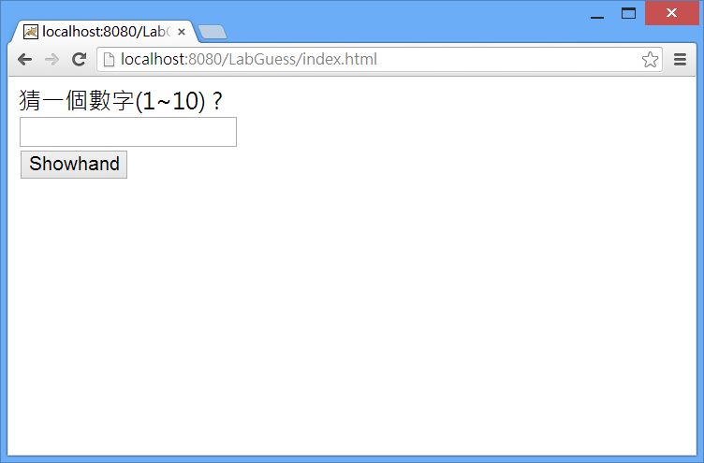

NetBeans-利用猜數字遊戲撰寫MVC Design Pattern的程式
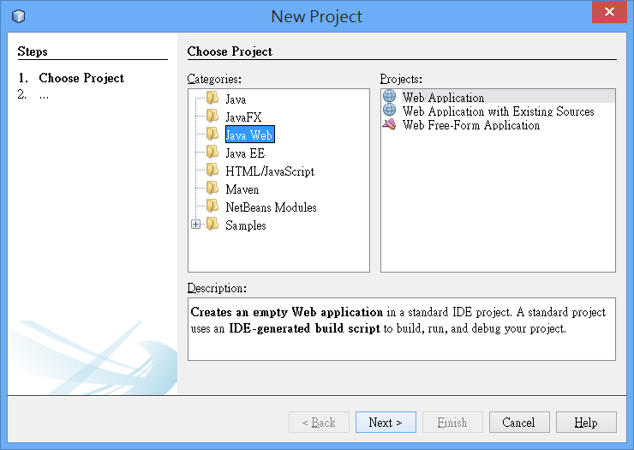
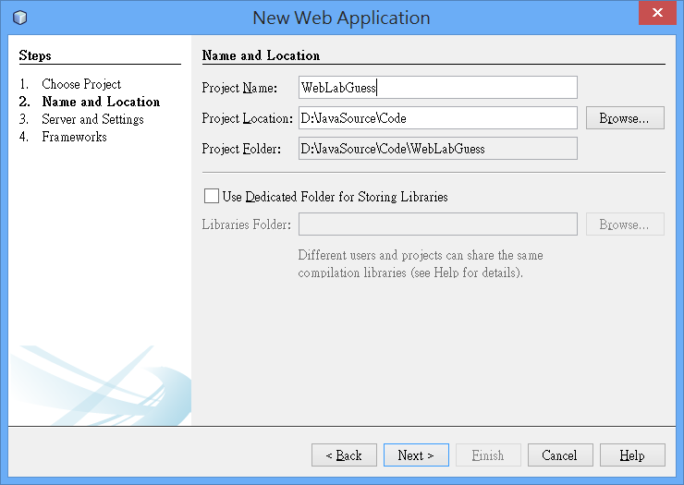
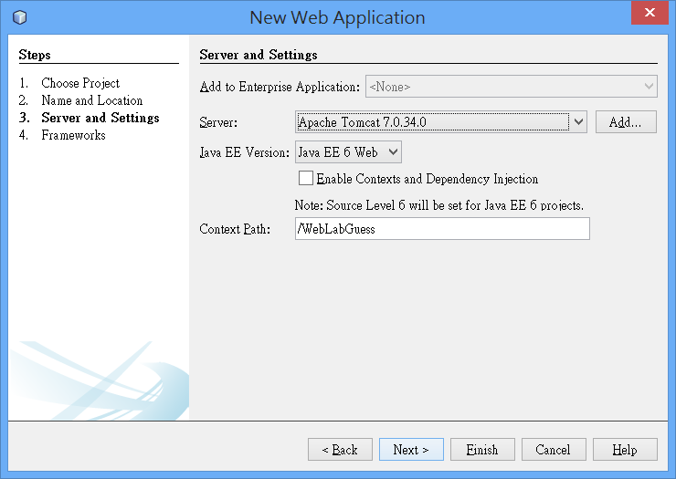
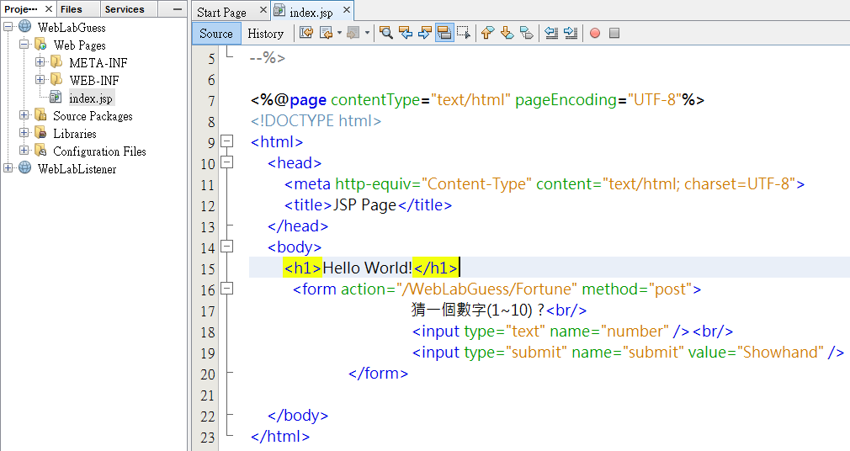

default package建立GuessGameLogic.java
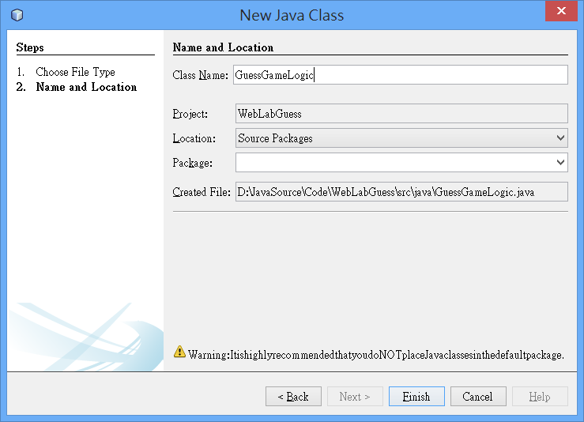
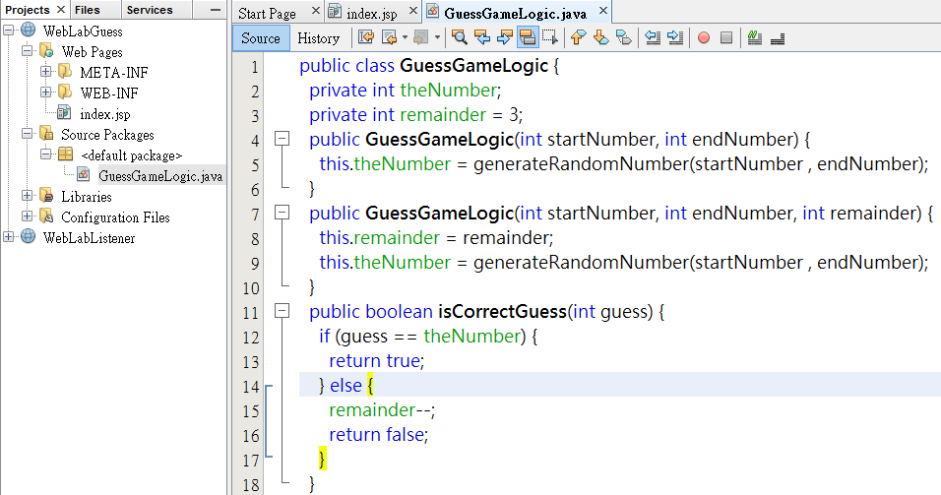

default package建立GameServlet.java
