將猜數字的遊戲改寫成JSP版本
重點：在JSP中如何使用java class與在JSP中如何轉向其他網頁。
步驟
- 打開檔案總管，找到C:\apache-tomcat-7.0.42\webapps\ROOT，新增資料夾LabGuess。
- 在C:\apache-tomcat-7.0.42\webapps\ROOT\WEB-INF\classes下，新增資料夾domain。
3. C:\apache-tomcat-7.0.42\webapps\ROOT\LabGuess 下新增 index.html
<html>
<head></head>
<body>
<form action="Fortune.jsp" method="post">
猜一個數字(1-10) <br/>
<input type="text" name="number" /><br/>
<input type="submit" name="submit" value="Guess" />
</form>
</body>
</html>
3. C:\apache-tomcat-7.0.42\webapps\ROOT\LabGuess 下新增 bingo.jsp
<html>
<head></head>
<body>
Congralutation! You win!</br>
<a href="/LabGuess/index.html">One more time?</a>
</body>
</html>

4. C:\apache-tomcat-7.0.42\webapps\ROOT\LabGuess 下新增 Fortune.jsp

<%@ page session="true" errorPage="errorHandler.jsp" %>
<jsp:useBean id="Fortune" class="domain.GuessGameLogic" scope="session">
<% Fortune.initialize(1 , 10); %>
</jsp:useBean>
<html>
<head></head>
<body>
<%
String guess = request.getParameter("number");
int guessNum = Integer.parseInt(guess);
if (Fortune.isCorrectGuess(guessNum)) {
session.invalidate();
%><jsp:forward page="bingo.jsp" /><%
} else {
int remainder = Fortune.getRemainder();
if (remainder > 0) {
%>The number <%=guess%> is not correct.</br>
You still have <%=remainder%> changes.</br>
<%= Fortune.getHint() %> <br/>
<a href="index.html">Try again</a><%
} else {
session.invalidate();
%><jsp:forward page="noChanges.jsp" /><%
}
}
%>
</body>
</html>

5. C:\apache-tomcat-7.0.42\webapps\ROOT\LabGuess 下新增 noChanges.jsp
<html>
<head></head>
<body>
Bad news , You are incorrect again and You have no change.</br>
<a href="/LabGuess/index.html">New Game</a>
</body>
</html>

6. C:\apache-tomcat-7.0.42\webapps\ROOT\LabGuess 下新增 errorHandler.jsp

<%@ page isErrorPage="true" %>
<html>
<head></head>
<body>
Please enter a number.</br>
<a href="/LabGuess/index.html">Retry</a>
</body>
</html>

6. C:\apache-tomcat-7.0.42\webapps\ROOT\WEB-INF\classes 下新增 GuessGameLogic.java 並編譯
package domain;
public class GuessGameLogic {
private int theNumber;
private int remainder = 10;
private String hint;
public GuessGameLogic() {}
public void initialize(int startNumber, int endNumber) {
this.theNumber = generateRandomNumber(startNumber , endNumber);
}
public boolean isCorrectGuess(int guess) {
if (guess == theNumber) {
return true;
} else {
if(guess > theNumber)
hint="Guess Number to Big";
else
hint="Guess Number to Small";
remainder--;
return false;
}
}
private int generateRandomNumber(int startNumber, int endNumber) {
double range = (double) (endNumber - startNumber + 1);
return startNumber + (int) (Math.random() * range);
}
public int getRemainder() {
return remainder;
}
public String getHint()
{
return hint;
}
}
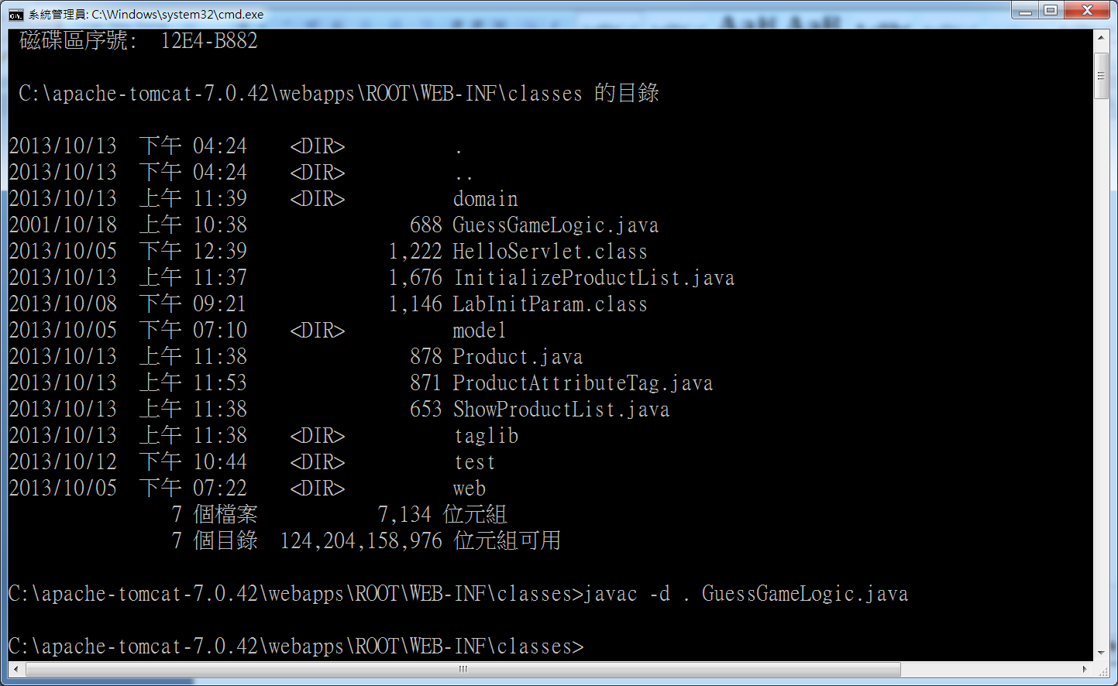
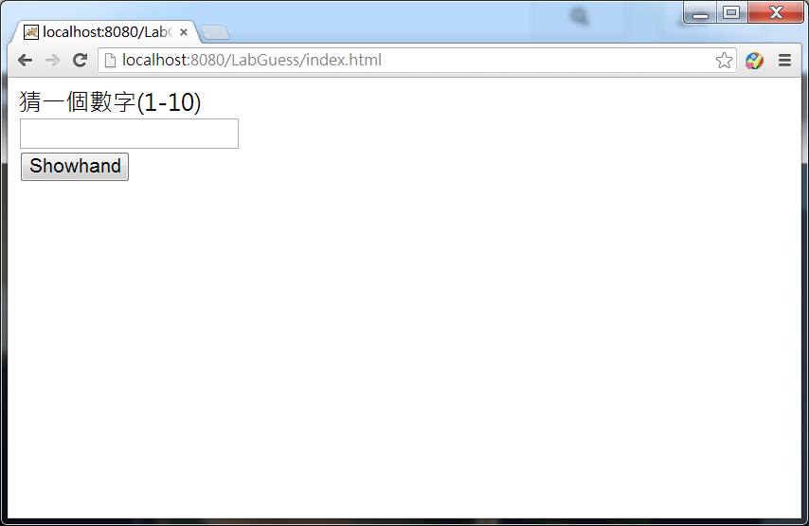

NetBeans將猜數字的遊戲改寫成JSP版本

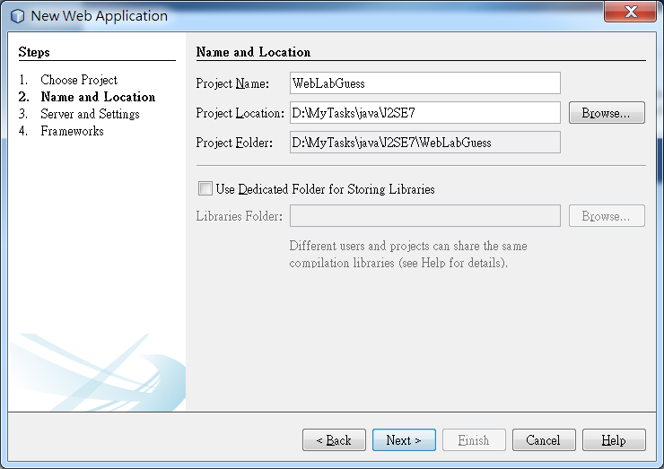
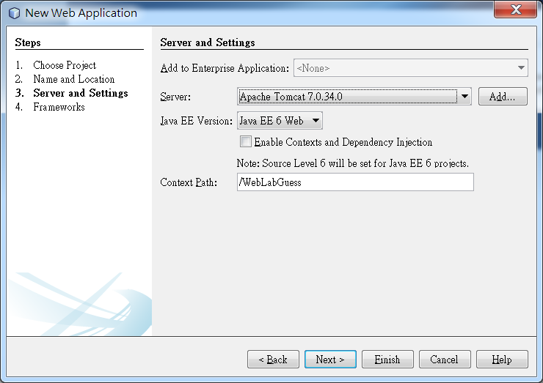
將前面的jsp及html 複製到 Web Pages內
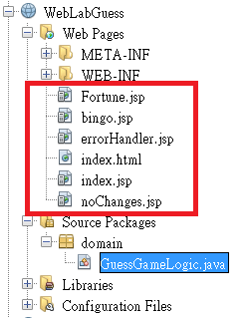

將GuessGameLogic.java 建立在domain套件內
