NetBeans製作JSTL JavaBeans Tags
首先建立一個標準的Java Web專案
定義JavaBeans類別:
規則:
1. 必須定義 package
2. 必須定義封裝方法也就是必須有private欄位並定義set及get方法
例如: 欄位: private String name
方法: public String getName() ; public void setName(String name)
3. 使用時用欄位名稱
檔案名稱Message.java
package test.msg;
public class Message {
private String name;
private String text;
public Message(String n, String t) {
name = n;
text = t;
}
public String getName() {
return name;
}
public void setName(String name) {
this.name = name;
}
public String getText() {
return text;
}
public void setText(String text) {
this.text = text;
}
}

檔案名稱MessageService.java
package test.msg;
public class MessageService {
public Message[] testMessages;
public MessageService() {
testMessages = new Message[3];
testMessages[0] =
new Message("John", "John's message!");
testMessages[1] =
new Message("Mary", "Mary's message!");
testMessages[2] =
new Message("Janet", "Janet's message!");
}
public Message[] getMessages() {
return testMessages;
}
}
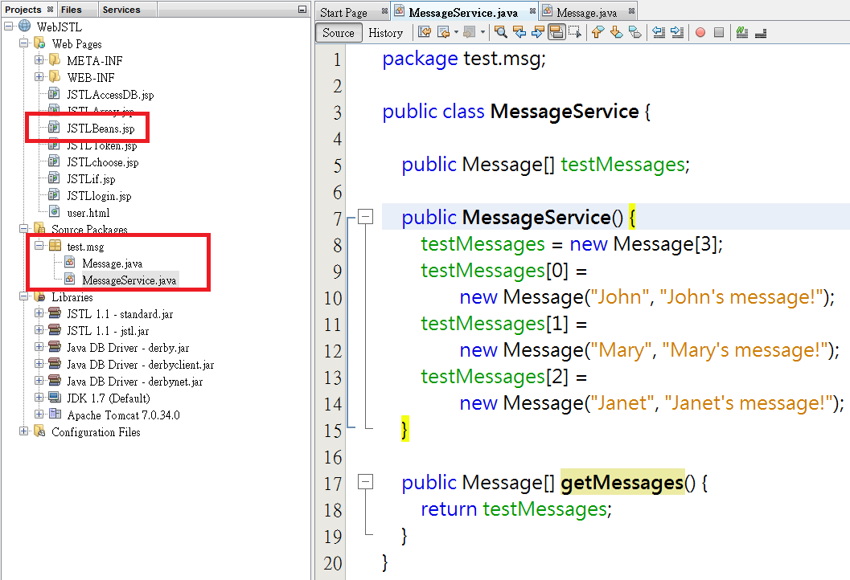
Web Pages加入JSTLBeans.jsp
<%@page contentType="text/html" pageEncoding="UTF-8"%>
<%@taglib prefix="c" uri="http://java.sun.com/jsp/jstl/core"%>
<!DOCTYPE HTML PUBLIC "-//W3C//DTD HTML 4.01 Transitional//EN"
"http://www.w3.org/TR/html4/loose.dtd">
<jsp:useBean id="messageService" class="test.msg.MessageService"/>
<html>
<head>
<meta http-equiv="Content-Type"
content="text/html; charset=UTF-8">
<title>留言版</title>
</head>
<body>
<table style="text-align: left; width: 100%;" border="1">
<tr>
<td>姓名</td><td>訊息</td>
</tr>
<c:forEach var="message" items="${messageService.messages}">
<tr>
<td>${message.name}</td><td>${message.text}</td>
</tr>
</c:forEach>
</table>
</body>
</html>

${messageService.messages} 注意messages為小寫字

製作JSTL JavaBeans Tags直接置入Tomcat Web Container內
1. C:\apache-tomcat-7.0.42\webapps\ROOT\WEB-INF下建立lib資料夾
2. C:\apache-tomcat-7.0.42\webapps\ROOT\WEB-INF\lib資料夾內加入兩個JSTL類別庫standard.jar 及 jstl.jar
3. 將上方Message.java 及 MessageService.java程式編譯
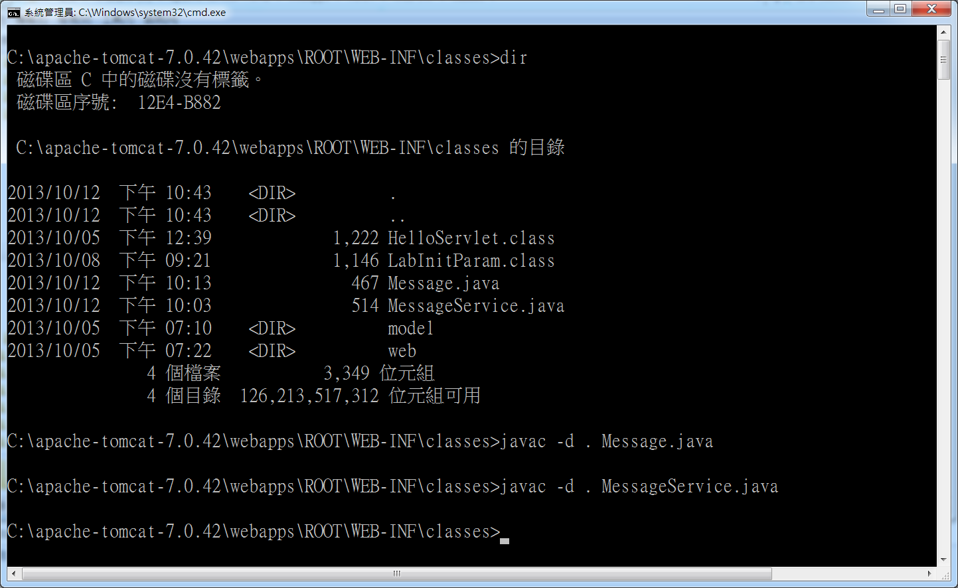
4. 將JSTLBeans.jsp 複製到 C:\apache-tomcat-7.0.42\webapps\ROOT
5. 瀏覽器執行
