**SANTA CLARA UNIVERSITY**

Department of Electrical Engineering

I HEREBY RECOMMEND THAT THE THESIS PREPARED

UNDER MY SUPERVISION BY

**Jonathan Lee** and **Srinivaas Sekaran**

ENTITLED

**Anthrolink: Phased Antenna Arrays and Applications in Wireless Connectivity**

BE ACCEPTED IN PARTIAL FULFILLMENT OF THE REQUIREMENTS

FOR THE DEGREE OF

**BACHELOR OF SCIENCE**

IN

**ELECTRICAL ENGINEERING**

­­­­­­­­­­­­­­­­­­­

Thesis Advisor(s) date

Department Chair(s) (use separate line for each chair) date

**Anthrolink: Phased Antenna Arrays and Applications in Wireless Connectivity**

By

**Jonathan Lee** and **Srinivaas Sekaran**

# SENIOR DESIGN PROJECT REPORT

Submitted to

the Department of Electrical Engineering

of

SANTA CLARA UNIVERSITY

in Partial Fulfillment of the Requirements

for the degree of

Bachelor of Science in Electrical Engineering

Santa Clara, California

May 2017

**Anthrolink: Phased Antenna Arrays and Applications in Wireless Connectivity**

**Jonathan Lee** and **Srinivaas Sekaran**

Department of Electrical Engineering

Santa Clara University

May 2017

**ABSTRACT**

Anthrolink is a next generation communication system that has the potential to connect the next 3 billion individuals to the Internet. It uses phased antenna arrays and algorithms for beam scanning at 5.8 GHz. End-to end system validates key components of a potential 5G network that supports IoT topologies of the future.

Using a sequence of a RF oscillator, beam-forming Butler Matrix, an RF switch, and custom beam-switching algorithms, a new communication proof-of-concept system is produced. This is verified by isolated receiver endpoints that detect RF signals by way of DC output. In such a setup, an energy efficient and resilient communication system is created that is a candidate for IoT applications especially in machine-to-machine communication as well as creating resilient wireless local area networks.

**Acknowledgments**

We would like to thank the following individuals for the indispensible domain knowledge and support in creating Anthrolink:

* Dr. Ramesh Abhari of Santa Clara University, for exceptional advising, critical help in shaping the architecture of the project, and providing RF domain knowledge
* Cindy Phongadith of the Department of Electrical Engineering, for support in procuring OEM components

**Table of Contents**

1. Introduction 1

1.1 | Ethical Considerations for Internet Access 2

1.2 | Technical Motivation and Current Scenario 3

**2. Technical Requirements 3**

**3. Design Solution 3**

3.1 | Beamforming and System Level Overview 4

3.2 | Constraints and System Design Decisions 5

3.3 | Design of Beamforming System: ADS and CST Simulations 6

4. Test Setup 7

5. Measurements and Results 8

6. Safety and Manufacturability 9

7. Sustainability and Environmental Impact 10

8. Further Work11

9. Conclusion12

10. References13

11. Bill of Materials and Cost Breakdown 14

12. Appendix 15

12.1 | Power Measurements 16

12.2 | S-Parameter Measurements 17

12.3 | RF Switch Code 18

12.4 | RF Detection Microcontroller Software 19

**List of Figures**

Introduction 1

Ethical Considerations for Internet Access 2

**Technical Motivation & Current Problems 3**

**Technical Requirements 3**

**Design Solution 3**

System Level Overview and Block Diagrams 4

Constraints and System Design Decisions/Tradeoffs 5

**1 | Introduction**

* 1. **Ethical Considerations for Internet Access**

60% of the world lacks access to the Internet implicating a lack of access to its benefits - education, communication, and opportunities. Addressing this crutch in social mobility is the fundamental goal of our project. Prototyping a next generation machine-to-machine communication system is a major step in the Internet of Things via look-and-link in addition to enabling greater wireless connectivity in rural and urban regions of the planet.

Enabling Internet access to all, and not only to those who can pay the most for Internet, is ethical in and of itself due to its ability to promote human well-being, explained above. By keeping the costs of our transmission model to a minimum, the ethics of our project is enhanced and resonates with the Santa Clara University’s Mission Statement and the IEEE Engineering Code of Ethics.

* 1. **Technical Motivation and Current Scenario**

Technical Motivation

The Internet landscape is becoming increasingly more expensive to break into due to the cost of infrastructure and technical labor. However, Wi-Fi enables Internet connectivity in ways that can be delivered cheaply and with little continuing overhead cost. While we do not propose solving the Internet backbone problem, we suggest a frugal alternative to traditional delivery of copper wire for high speed Internet access.

Furthermore, as current network infrastructure technology faces a spectrum of issues - from network congestion to low bandwidth - a drive to next generation communication is necessary. Prototyping and validating a machine-to-machine communication system not only helps catalyze Internet connectivity - it also helps push progress towards 5G communication.

Problems in Current Market

Current market solutions to the gap in Internet connectivity are plagued with a spectrum of challenges. The two prominent roadblocks are cost and usability. While there are market solutions for wide-scale Internet coverage, they are unviable in connecting rural belts of the planet. WiMAX, the technology behind 4G and 3G, has already been studied to check its viability in increasing global Internet connectivity.

Case studies in Bangladesh reveal that the cost per user for 3G is 10 to 15 times more expensive than that of Wi-Fi local area networks. The infrastructure and upkeep cost of cellular antenna services is massive to provide complete coverage to rural areas of the planet (Press).

In addition to the cost issue, WiMAX is prone to reliability and usability issues. Case studies in Bangladesh have revealed that these networks are plagued with noise, slow bandwidth, and frequent drops in connection (Press). Furthermore, as one tower services a large vicinity, vandalism or component failure can jeopardize the network connection for entire communities.

**2 | Technical Requirements**

**3 | Design Solution**

**3.1 Beamforming and System Level Overview**

Beamforming

Beamforming refers to the practice of combining signals from an array of antennas to create beam patterns that have better signal characteristics than traditional single element antennas. The proliferation of mobile devices and wireless networks have created new problems in the field of wireless communications, such as congestion and lack of bandwidth.

Beamforming solves these problems by concentrating signals in certain directions and only at certain frequencies, reducing interference from outside sources of radiation. This is particularly important in areas where congestion can cause many different frequency bands to overlap, causing severe degradations in performance for wireless networks. The figure below shows the radiation patterns of a non-beamforming transmitter and a beamforming transmitter, illustrating the concept of what electrical steering looks like.

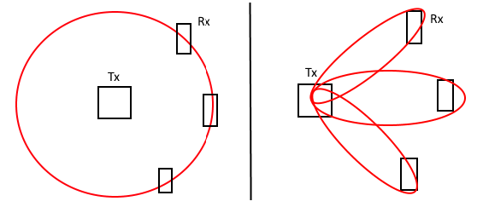

*Figure 1: Comparison of beam patterns: omnidirectional transmitter (left) vs beamforming (right)*

One of the main advantages of beamforming networks that no mechanical parts are needed to change the direction of an antenna or antenna array. The lack of mechanical parts has allowed the miniaturization of antennas and introduction into consumer computing devices, such as access points and routers.

Another advantage is the greater degree of control that a system designer has over the gain and direction of his signal, which enables applications such as device discovery and provides passive benefits such as power savings.

System Level Overview

Anthrolink is a complete antenna array system using a Butler Matrix to validate machine-to-machine communication for applications in wireless connectivity. The system is intended to operate at 5.8 GHz, a frequency that delivers high bandwidth with minimum network congestion, ideal for building resilient wireless networks. Figure 2 gives an overview of the system with components in place, showing the overall signal path and expected system setup.

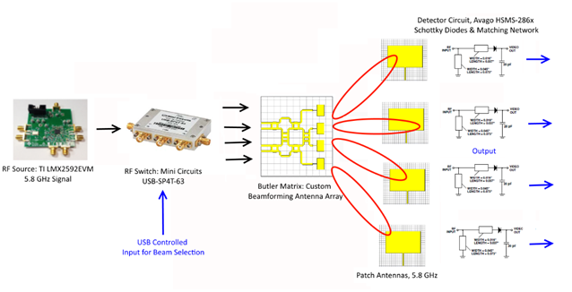

*Figure 2: Overall System Overview*

**3.2 System Design Decisions**

Overview

Anthrolink is designed to work at 5.8 GHz. We expect to create antenna and antenna arrays that are resonant at 5.8 GHz, or have S11 parameters that are less than 10 dB at the center frequency of 5.8 GHz. We want to deliver signal at a distance of a half meter to a number of RF detectors spread out over the range of our beamforming pattern. We expect the beam separation to be approximately 30 degrees between adjacent lobes.

In addition to the above requirements, we will also follow all constraints as stipulated by the FCC rules on transmitter power and interference. We plan to operate in the unlicensed band at 5.8 GHz and will stay below the emission limits of 30 uV/m, as stipulated under part 15 of the FCC rules for unlicensed transmitters.

Transmitter

The transmitter provides a 5.8 GHz signal to the receiving end of the system. As seen in Figure 2, there are several stages in providing a signal output.

The RF source chosen for this project is the Texas Instruments LMX2592EVM because of the range of outputs it supports as well as the ability to fine tune its RF output using software. The board also supports writing programming sequences and other aspects to on-board registers as a means of saving desired settings. The instrument supports an RF output up to +15 dBm.

Switching Control

The RF switch chosen for our system is the Mini Circuits USB-SP4T-63. This RF switch has USB I/O for programming purposes as well as good isolation and switching performance from 1 - 6000 MHz. Purchasing an assembled switch with programming capabilities increases the efficiency of system testing by automating the process. A tradeoff analysis was made. We determined that using an automated switch in lieu of a human operated mechanical relay allows for a system that closer resembles real world applications. In addition, the human operated relay would be inefficient and prone to error due to the nature of the switching needed, as well as the difficulties there would be in designing such a switch for high speed RF operation.

A powerful feature of Anthrolink resides in the software algorithm that controls the programmable switch. To simulate a real world wireless local area network which requires a beamformed signal to be cast at different angles, an algorithm for beam switching needs to be designed.

Expected Results

We expect to be able to integrate our design, which will include the antenna array and a switching control system for the phased array portion, and establish a basic machine to machine link using our antenna array. The data payload will be a known signal generated by our RF oscillator that we send and successfully detect at our RF detector endpoints, in the process demonstrating the beamforming techniques of our system. In effect, a downstream link is created from the transmit side to the receive endpoints.

Using the RF detector portion of the system, we will want to detect individually steered beam signals by way of LED indication. We expect the power of the detected signal to be between -30 and -40 dBm, which will be detected using RF power detectors using the AD8318 chip. The AD8318 is logarithmic RF power detector that outputs a DC voltage that can be used to power a visual indicator such as an LED.

**3.3 Beamformer Design Strategy**

Overview

The design for the phased antenna was carried out using a classic Butler matrix design. The Butler matrix is a compact beamforming network that utilizes phase shifters and crossovers to achieve a multiple beam array. Different phase shifts and beams are created by exciting the array at different ports. An example of a single port excitation is shown below.

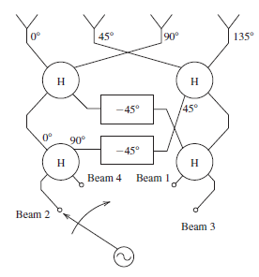

*Fig. 1. Functional Diagram of a Four Beam Butler Matrix Beamformer, Port 1 Excitation*

The Butler matrix utilizes a number of design elements in order to achieve the phase difference desired at the output. The four elements are the 45 degree phase shifter, 90 degree phase shifter, quadrature hybrid coupler, and 4 port crossover. These elements are implemented in microstrip technology and designed using a combination of Agilent ADS and CST for simulation. Select simulation substrate parameters are shown in the table below for the chosen material of FR-4 and design frequency of 5.8 GHz.

*Table #: Butler Matrix Fabrication Parameters*

|  |  |
| --- | --- |
| Parameter | Value |
| Height | 59 mils |
| **εr –** Relative permittivity | 4.3 |
| Conductivity (Copper) | 5.8e7 S/m |
| TanD – Loss tangent | .025 |
| Conductor thickness | 15 micron |
| Microstrip Width | 2.8 mm |

90 Degree Phase Shifter Design

The 90 degree phase shifter for this application was created using microstrip lines connected to two optimal miter bends. In order to mitigate the effects of the mitered bends at the input and output, a quarter wave microstrip line is added at these points for a total of a half wavelength. In the actual manufactured design, these lengths are omitted.

The final microstrip length for this element is found using optimization. The optimization was found starting with a baseline of 1.25 wavelengths total length to fit physical requirements and ease manufacturing requirements.

S12 simulation results show -90 degree phase shift from input to the output.

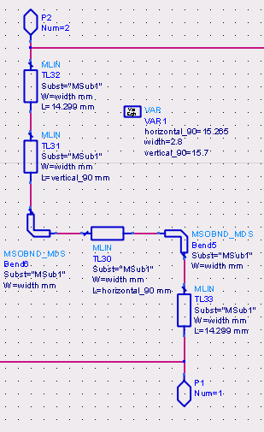

*Fig. 2. 90 Degree Phase Shifter Design in ADS*

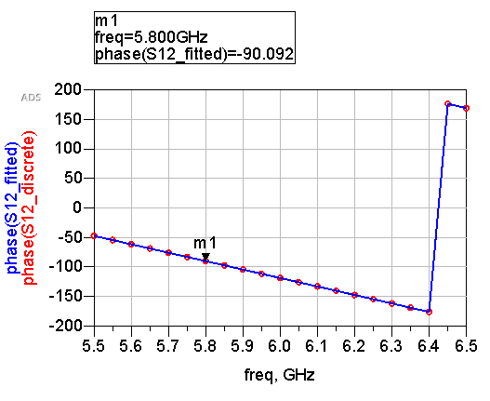

*Fig. 3. S12 Phase, 90 Degree Phase Shifter*

45 Degree Phase Shifter Design

The 45 degree phase shifter is simulated using the same methods as the 90 degree phase shifter. Half wavelength sections are also added to the input and output to mitigate the effect of the mitered bends. The final microstrip length for this element is found using optimization starting with a baseline of 1.125 (eighth) wavelengths total length.

S12 simulation results show -45 degree phase shift from input to the output.

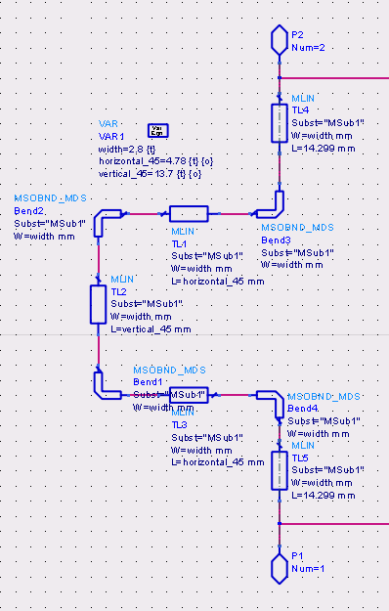

*Fig. 4. 45 Degree Phase Shifter Design in ADS*

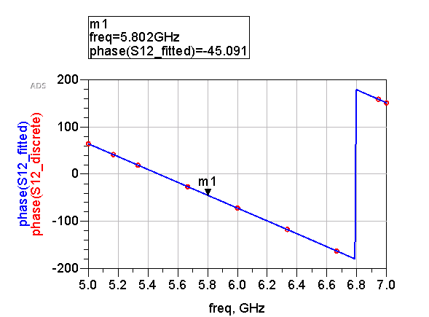

*Fig. 5. S12 Phase for 45 Degree Phase Shifter*

Quadrature Hybrid Design

The quadrature hybrid coupler was created according to the well-known design of a quarter wavelength for each “leg” of the structure. The optimal width of the second section of line was found through optimization using a baseline width of 3.8 mm.

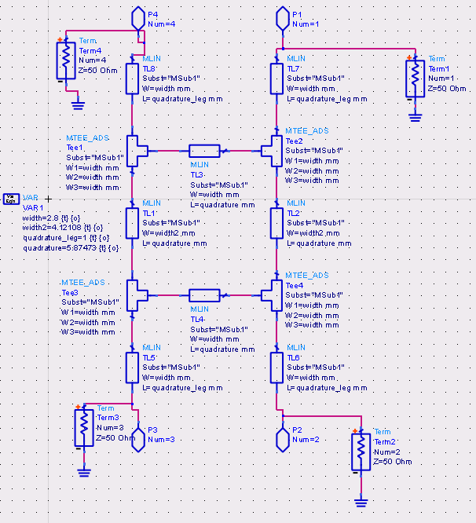

*Fig. 6. Quadrature Hybrid Design in ADS*

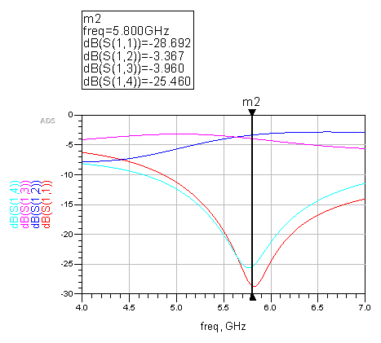

*Fig. 7. S-parameters for Quadrature Hybrid*

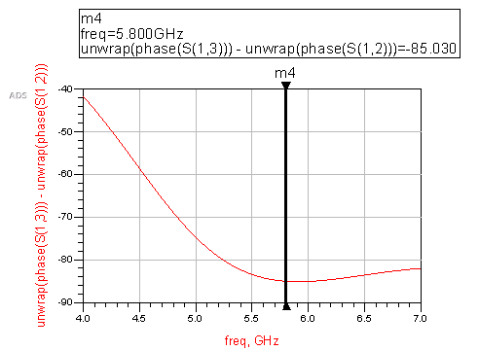

*Fig. 8. Phase Difference, Port 2 and Port 3 of Quadrature Hybrid*

From the plots above, the quadrature hybrid as designed displays good characteristics for the design frequency of 5.8 GHz. The phase difference between port 2 and port 3 of the structure is expected to 90 degrees. As simulated, the design shows a phase difference of 85 degrees, which is close to what is expected out of the quadrature hybrid.

Crossover Design

In order to provide the desired phase shifts at different output ports, a crossover structure is used that provides isolation between input and output ports at opposite ends. The design is derived from the idea of two quadrature hybrids placed back to back to form the two isolating outputs and inputs.

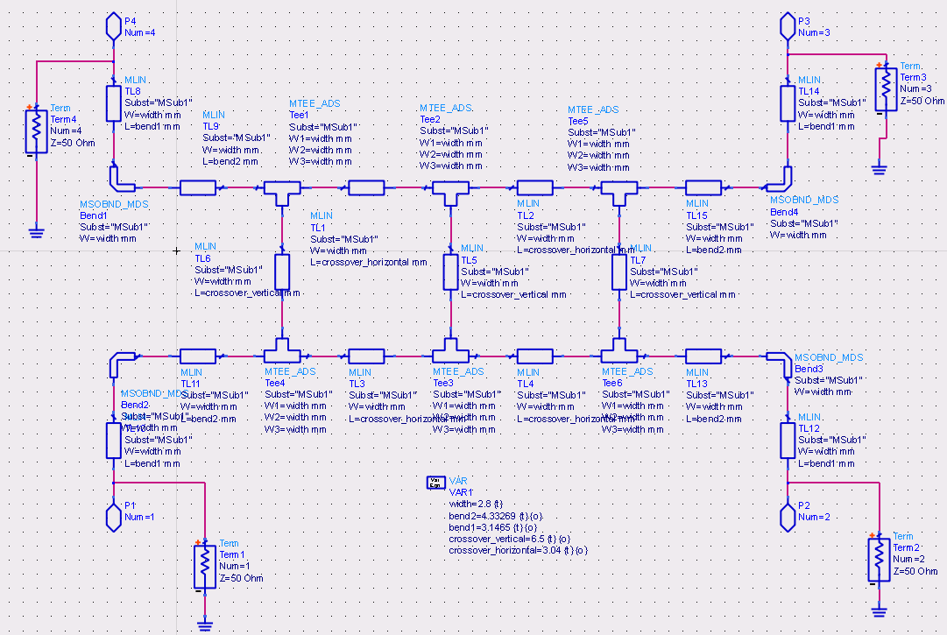

*Fig. 9. Crossover Design in ADS*

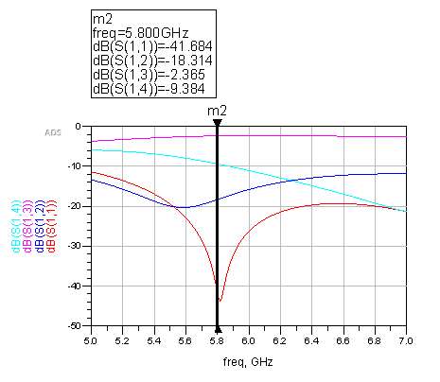

*Fig. 10. S-parameters for Crossover*

The crossover shows good S11 results for the design frequency 5.8 GHz.

**4 | Test Setup**

**5 | Measurements and Results**

**6 | Safety and Manufacturability**

**7 | Sustainability and Environmental Impact**

**7.1 Environmental Sustainability**

The foundation of Anthrolink is rooted in ethical intent and addressing overarching global challenges. Over the course of product development, we have shifted emphasis from solely phased antenna arrays to Anthrolink, a comprehensive system validation that tackles socioeconomic and environmental challenges. Our goals include creating a cost-effective system that is energy efficient while providing resilient networking abilities to the common individual.

While a proof of concept system in 5G beam steering technology has many industrial solutions, our primary intended end users are individuals who lack access to the Internet. Alongside designing an energy efficient Internet of Things communication system, we are designing a solution to address the global inequity in Internet connectivity.

Environmental Considerations

As one of the key goals is energy efficiency, environmental considerations are paramount in the design of Anthrolink. Anthrolink leverages a gamut of off-the-shelf components such as:

* An RF Synthesizer from Texas Instruments
* A Solid State RF Switch from Mini Circuits

Efficient Supply Chain

In using products from large scale manufacturers, we significantly lower our Scope I emissions. Scope I emissions, according to the Greenhouse Gas Protocol, are direct emissions from sources controlled by a particular organization. In other words, we reduce the need to reinvent entire subsystems and their respective components.

Large scale vendors such as Texas Instruments have an optimized supply chain with a large output of products such as the RF Synthesizer, signaling a low greenhouse gas emissions quantity per unit.

By leveraging products from vendors with optimized supply chains, we prevent creating a new supply chain that could potentially be more environmentally harmful, as new ventures have inefficiencies, leading to a more significant environmental impact.

Energy Efficient Products

Another benefit of using vendors to prevent building custom hardware from scratch is added energy efficiency in the manufacturing process. As stated, Fortune 500 corporations such as Texas Instruments have implemented various protocols and systems to reduce inefficiencies from transportation to manufacturing. In an analysis of the requirements to build a custom RF oscillator, it was imperative to order a variety of parts from different vendors. Ordering from various vendors and going through several iterations of building the synthesizer from scratch would force us to have a greater carbon footprint. Furthermore, companies such as Texas Instruments have greater resources to study the energy efficiency of their component and bolster it. They have large research teams focused on maximizing component integration and energy efficiency. By leveraging large vendors for certain hardware subsystems, energy efficiency is maximized.

Operation and Waste

The crux of the Anthrolink system is a phased antenna array. Since this is a passive element, energy efficiency is maximized as beam steering is done with minimal energy input. In the field, the energy usage of the total system will be negligible. Currently, for validating the system, we are driving test equipment with minimal USB power. The RF Synthesizer requires a 3.3 Volt supply. Thus, the operational energy costs are low as energy efficiency is the hallmark of the project.

Durability is a key concern as unreliable and faulty system components lead to material wastage. Anthrolink incorporates passive beam switching as the foundational principle of operation leading to an operation without mechanically moving parts. A system with no moving parts is a system with a long durability and low wastage. In the case of a need for disposal, the system is free from batteries and thus, the active chemical makeup is low. Most components are circuit boards and electronic parts which can be recycled.

**7.2 Social Sustainability**

The Internet infrastructure of today is plagued with issues from heavy overhead cost to low bandwidth. With over 60% of the world lacking Internet connectivity, a low-cost solution for Internet infrastructure is imperative. By validating a low-cost system for next generation communication, we help enable the next market.

The Internet of Things has reached every corner of society including health and manufacturing. Anthrolink is a catalyst for developing countries to adopt these new trends. Thus, Anthrolink embraces social sustainability by helping increase the viability of Internet connectivity for the planet.

Local Area Networks

The majority of the planet lacks access to the Internet - one of the largest gaps in socioeconomic equity. One of the key challenges is the building of Internet infrastructure by developing nations, especially in rural areas. Using phased antenna arrays and economical hardware to beam-steer signals leveraging software drastically reduces the cost of providing connectivity to isolated communities. Rather than lay copper cable to every building in a small village, Anthrolink enables the quick creation of wireless local area networks.

The world, developing nations in particular, are in a state of constant flux. Routing and rerouting physical infrastructure within a locale is unviable and accounts for one of the reasons the majority of the world is unconnected. In nations such as Bangladesh, vandalism to physical infrastructure or component failure have left millions, in a sense, stranded. A sudden loss in Internet connectivity is detrimental to the local economy. Providing a resilient network allows for degradation and scaling without a drop in performance.

Health

Anthrolink, at its core, is about people and connecting people. RF fields operating at below 10 GHz have the potential to cause harm to humans, especially when operated at close range. Studies about the correlation between radio frequency fields and certain forms of cancer are inconclusive but not disproven.

As Anthrolink and derivative technologies would primarily be used in public spaces with many people, health is a consideration. While the amount of energy transmitted is miniscule, we have still ran tests to test for peak power and potential spikes in transmitted energy. Although the health effects of Anthrolink are improbable, our tests signal the holistic approach in crafting a system; Anthrolink is more than a phased antenna array - it is a future communication system validated.

**7.3 Economic Viability**

Anthrolink reduces the cost of deployment and upkeep of Internet infrastructure. Traditional Internet infrastructure requires expensive copper cabling to transmit data from point A to point B. Not only is this deployment monetarily expensive, it requires vast amount of resources from time to technical labor. In a nation with extreme geographical terrain such as Nepal, traditional network deployment is financially unviable.

Operation

A key parameter in determining the profitability of a service or product is the cost of operation. Anthrolink uses phased antenna arrays as the core of the system, providing the benefits of the component:

* Graceful degradation and resilience
* Low power consumption

Phased antenna arrays can accommodate failure compared to other antennas. By allowing for component failure and reliability, this 5G validation system can displace older technologies and quickly gain market share. Through this differentiation and possibility of widespread market adoption, it is possible to quickly become profitable. In rural markets, where Anthrolink is most captivating, there is a strong chance of monopolizing the market using the technology behind Anthrolink. Swift and stable market adoption leads to profitability.

In addition to graceful degradation, phased antenna arrays and its associated components consume less power than current antennas. In this sense, not only are systems that use Anthrolink’s technology cost-effective to deploy, they are cost-effective to maintain. In localities with unreliable power systems, a network infrastructure that does not require large quantities of energy implies an infrastructure that does not require constant technical supervision. Thus, the cost of operation is low due to a unnecessity of technical labor and vast amounts of electrical power.

**7.4 Product Environmental Impact**

Materials Consideration

With a variety of parts and subsystems from an RF synthesizer to an RF detector, the materials selected has a large impact on our collective environmental footprint. We ran several tradeoff analyses on the development of each subsystem. We acknowledged that in building components from the ground up, we risk increased time, material, and cost expenses. Thus, we are leveraging off-the-shelf components for the majority of the system. In procuring parts from established vendors, we minimize our carbon emissions, lower material waste by utilizing an established, effective supply chain.

This utilized method is more viable than the alternative - building custom parts. The alternative choice would be to ship a gamut of packages from a few diodes to a few operational amplifiers. Shipping scores of small parts from multiple vendors is inefficient in terms of energy expenditure, carbon emissions, packaging material, and cost.

As an overarching principle, Anthrolink leans towards the notion of not reinventing the wheel. Using off-the-shelf building blocks, we can create a more efficient manufacturing process and lower our environmental impact. In lieu of building every hardware entity from scratch, the focus is on creating a cohesive system by using custom made software to automate. In addition, the use of software simulation programs before the fabrication process prevented material wastage as CAD tools provided a way to tweak output parameters without the need to iterate through physical entities.

Energy Resources

As with material resources, by using the supply and manufacturing chains of established firms, Anthrolink’s impact is lowered as compared to building a new chain and fabricating components from scratch.  Thus, manufacturing energy use is low - Anthrolink’s processes do not add substantial energy use to the overall system manufacturing impact. As the weight and dimensions of the system are small, shipping a finished system would take little energy and packaging.

In terms of operation energy usage, the hallmark of Anthrolink is its inherent use of the phased antenna array to beam form. As the crux of the system is a passive element, energy use is minimal. Moreover, the other chief component is an energy efficient RF switch that uses C++ algorithms to automate beam switching. Through automation, energy efficiency is increased further.

Product Life and Disposal

Another property of the phased antenna array is that mechanical parts are redundant. Beam forming, beam switching, RF transmission and transmission are all done via electrical means. No moving parts such as a stepper motor frees the system from traditional “wear and tear” usage.

If the system does require replacement, Anthrolink is composed of subsystems that can be further broken down. For example, the RF detector can be broken down into a matching network, resistive-capacitive filter, and an Arduino. The modularity of the overall system implies the possibility to replace a single component without the need to discard the entire system. Software in the RF switch and Arduino can offer insight into the area of issue. Most components can be salvaged for metal and the PCB boards can be recycled at appropriate centers.

**8 | Further Work**

**9 | Conclusion**

**10 | References**

**11 | Bill of Materials and Cost Breakdown**

Parts and Budget Breakdown

Table #: Cost of Fabrication Materials and Services

|  |  |  |
| --- | --- | --- |
| Material | Cost | Notes |
| Copper Tape | $30 | Various sizes |
| PCB Fabrication Costs - Beamformer | $300 | Manufacturer: Bay Area Circuits |
| PCB Fabrication Costs – Patch Antennas | $50 | Manufacturer: ExpressPCB |

Table #: Inventory of Necessary Electronic Components

|  |  |  |  |  |
| --- | --- | --- | --- | --- |
| Component | Manufacturer | Part Number | Cost (Total) | Quantity |
| Schottky Detector Diodes | Avago | HSMS-2860-BLKG | $20 | 20 |
| Misc capacitors, resistors, etc. | Various | N/A | $30 | Varies |
| RF Switch | Mini Circuits | USB-SP4T-63 | $345 | 1 |
| SMA Connectors (F) | Various | N/A | $25 | 15 |
| Microcontroller | Teensy | Teensy-LC | $20 | 2 |
| SMA Cables | Various | N/A | $50 | 6-8 |

**12 | Appendix**

**12.1 Power Measurements**

**12.2 S-Parameter Measurements**

**12.3 RF Switch Code**



**12.4 RF Detector Microcontroller Code**





