# CS 255 System Design Document

Jeffrey McGinty

[Jeffrey.mcginty@snhu.edu](mailto:Jeffrey.mcginty@snhu.edu)

CS-255 Module 7 Project 2

October 18, 2022

## UML Diagrams

### UML Use Case Diagram

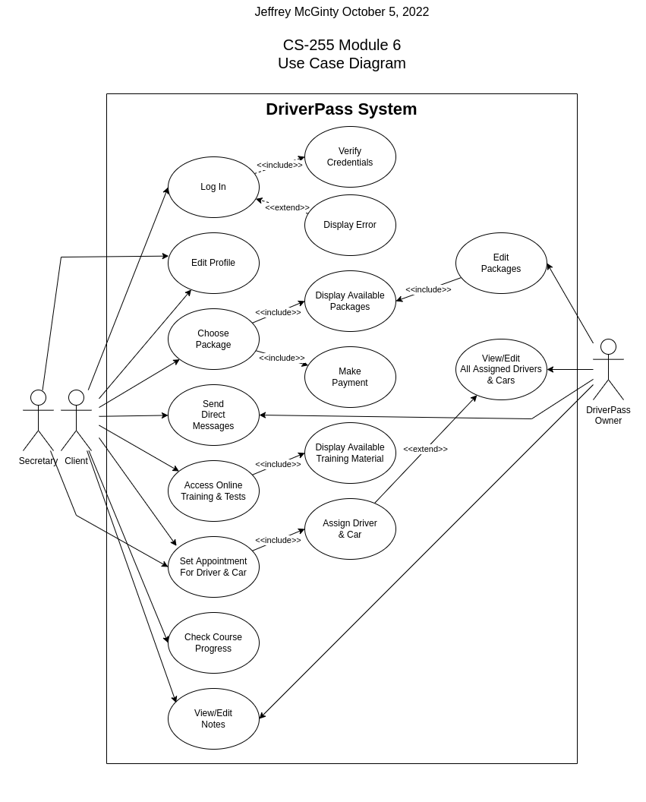

### UML Activity Diagrams

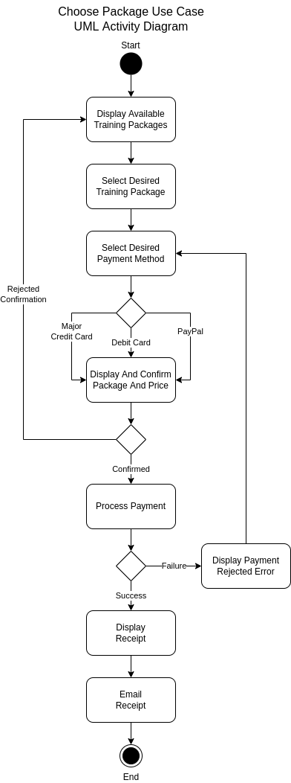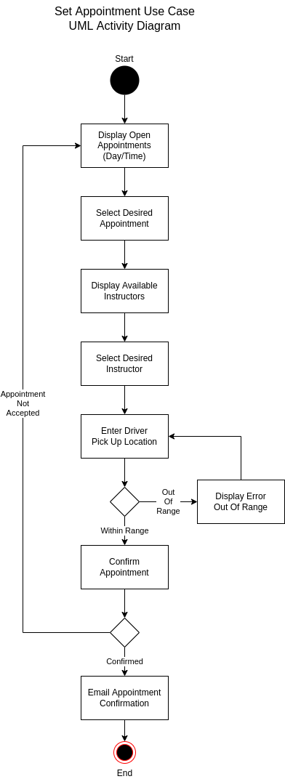

### UML Sequence Diagram

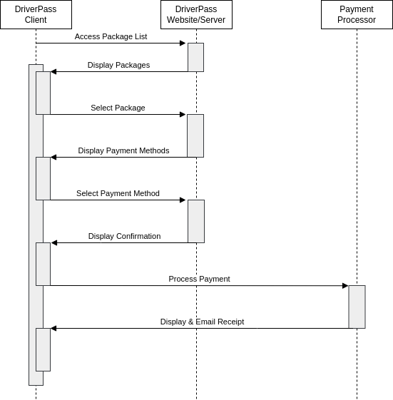

### UML Class Diagram

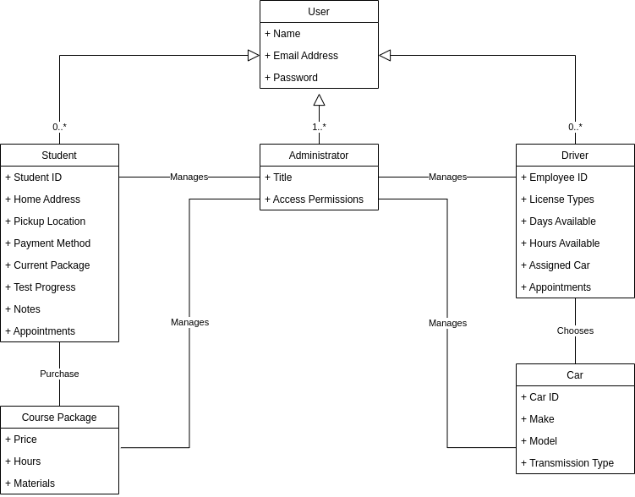

## Technical Requirements

* *Linux-based server or cloud operating environment*
* *Dedicated internet connection*
* *At least 1 online payment processor*
* *Database server installed or available*
* *Users have internet access*
* *Users are using a major web browser*